
LAB 0
EECE 503M-Software Security

27 September 2026
Joseph chahine
ID:202402114

Week 1 – Workspace and Tool Setup
The required workspace and tools were successfully configured for the laboratory. A PortSwigger Web Security Academy account was created, Burp Suite Community Edition was installed and configured, and the browser was configured to proxy traffic through Burp. Docker Desktop was also installed and verified.
The Meridian Service Desk application was successfully built and launched using Docker. The application was accessible locally at http://127.0.0.1:5001, and authentication using the provided seeded accounts was verified.
Evidence:
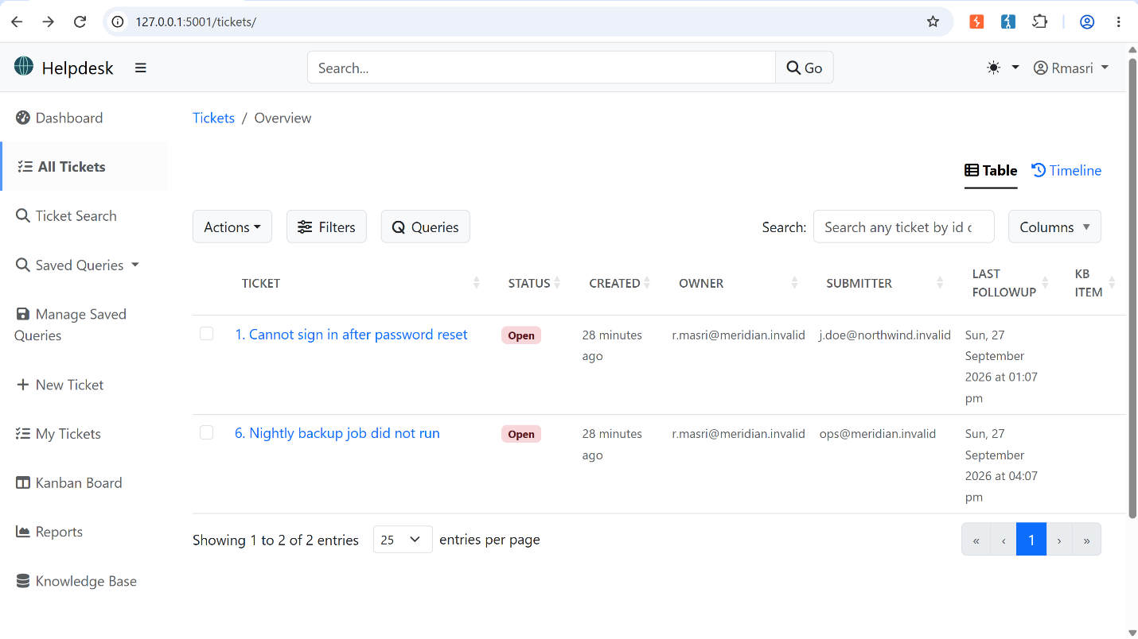
Burp Suite was then used with the Meridian application to practice the main tools required for the course:
- Repeater: A request to /tickets/search/?q=Invoice was captured and resent several times while modifying the search term.
- Intruder: A 20-password wordlist was tested against the rmasri account. Failed attempts returned 200 OK, while the successful authentication attempt could be identified by its different response, specifically 302 Found with a redirect and session cookie.
- Comparer: Login responses for a valid username and a nonexistent username using an incorrect password were compared. The responses were effectively identical apart from dynamic values such as CSRF-related data, indicating that this particular login response does not directly reveal whether the supplied username exists.
- Target Scope: Burp's target scope was restricted to 127.0.0.1:5001 to avoid sending requests to unrelated hosts.
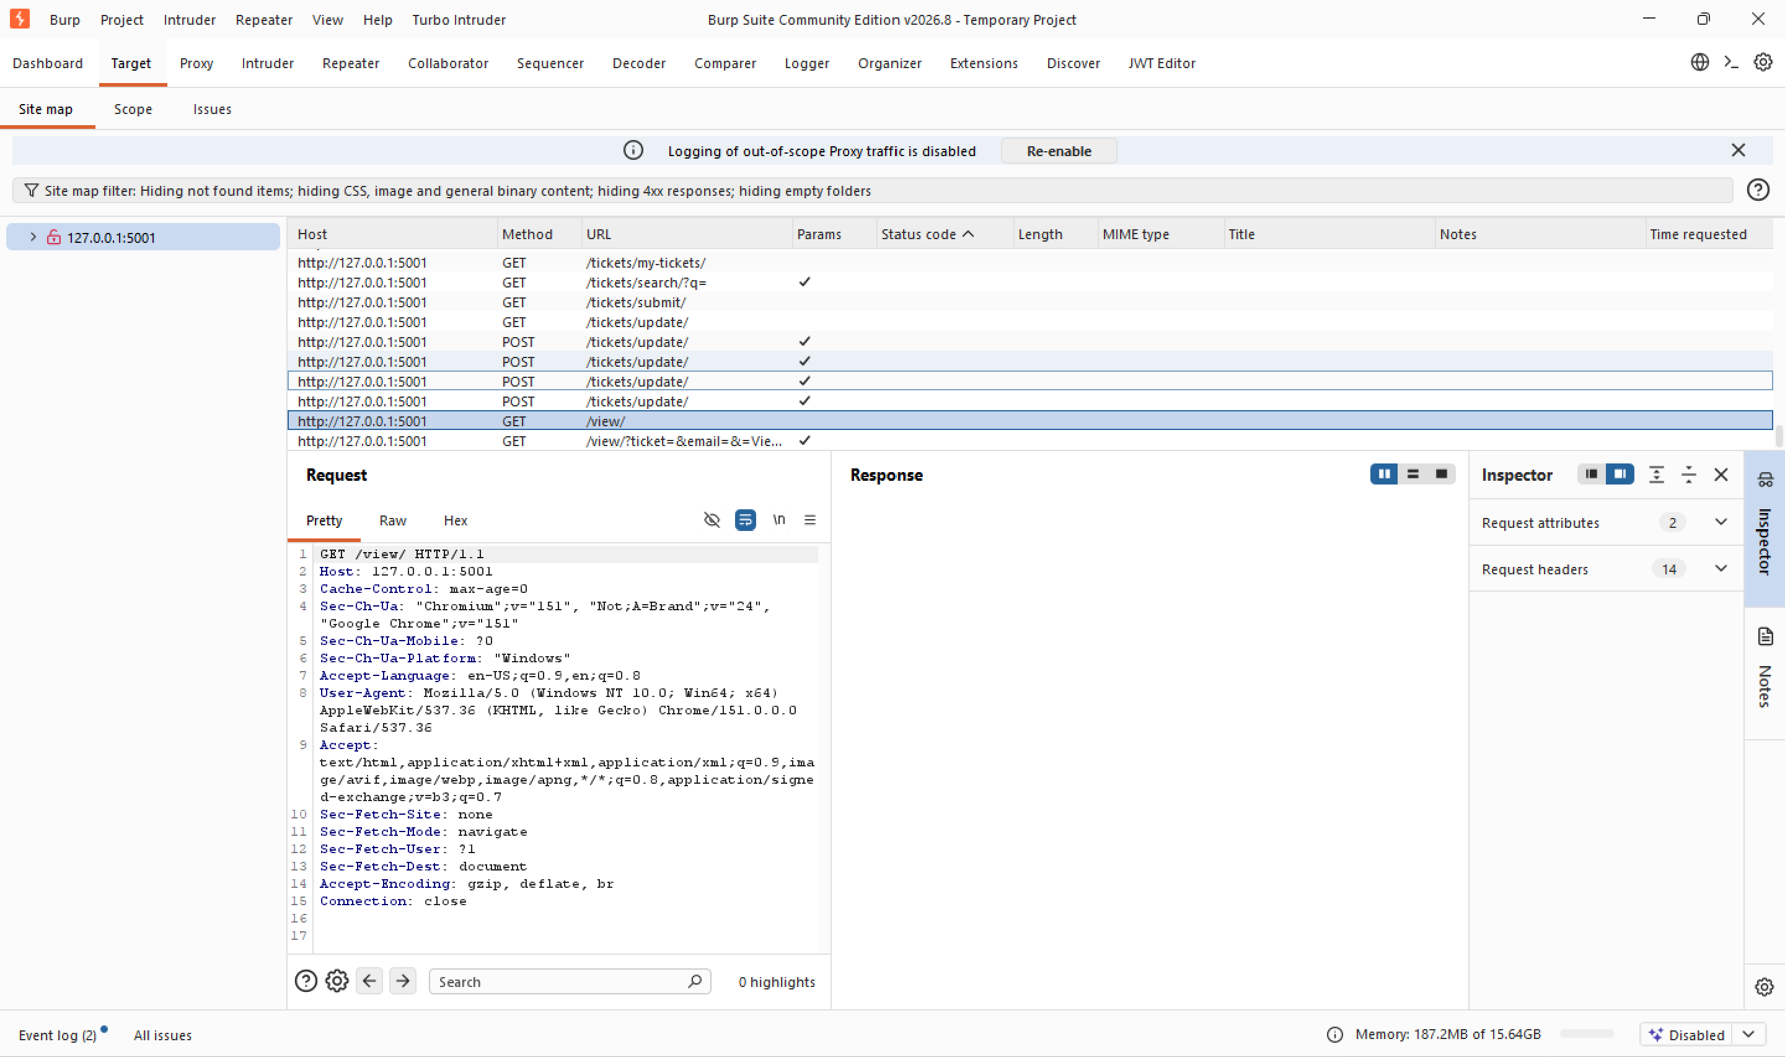
Evidence:

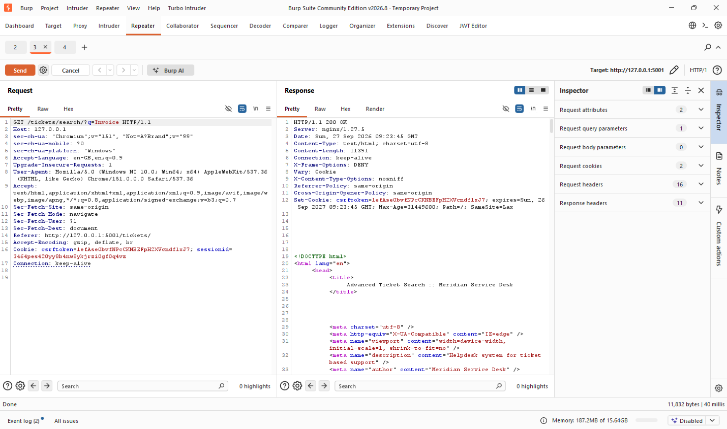

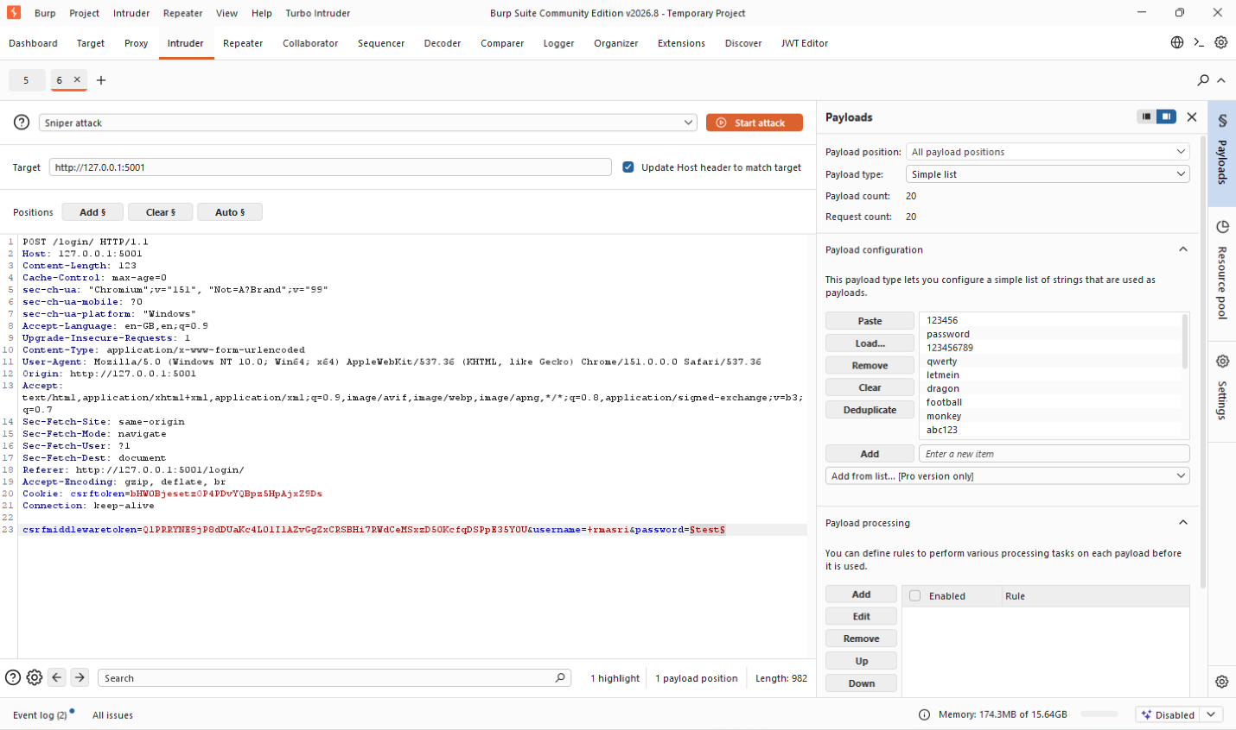

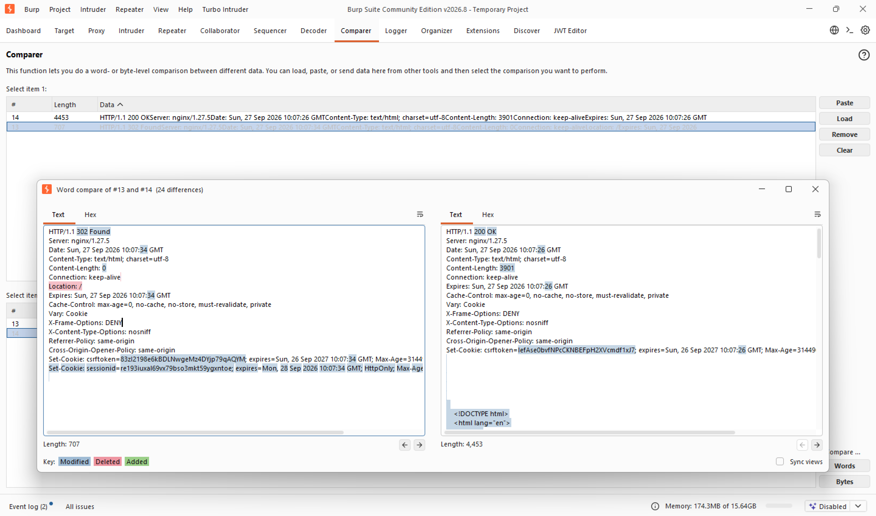
Threat Model – Meridian Service Desk
Data Flow
The main data flow can be represented as:
User → Browser → Web Server / Meridian Application → Database
The application may also communicate with other backend or external services when required by particular application functionality.
Trust Boundaries
The main trust boundaries are:
1. User/Browser → Meridian Application
All information coming from the client must be considered untrusted. This includes URL parameters, form inputs, cookies, HTTP headers, uploaded data, and API requests.
2. Meridian Application → Database
The application must ensure that user-controlled data cannot alter database queries or access information that the user is not authorized to access.
3. Meridian Application → Other Services/Resources
Requests initiated by the server must be controlled so that user input cannot cause unauthorized access to internal or external resources.

STRIDE Analysis
STRIDE Category | Example Threat in Meridian | Possible Mitigation
Spoofing | An attacker attempts to impersonate another user or obtain another user's authenticated session. | Strong authentication, secure session management, and protected session cookies.
Tampering | An attacker modifies request parameters, ticket information, API fields, or other application data. | Server-side validation and authorization checks.
Repudiation | A malicious user performs an action and later denies performing it. | Reliable server-side logging and audit trails.
Information Disclosure | Sensitive ticket, account, session, or server information is exposed to an unauthorized user. | Access control, secure headers, safe error handling, and protection of sensitive data.
Denial of Service | Repeated or expensive requests consume application resources and reduce availability. | Rate limiting, resource limits, and request validation.
Elevation of Privilege | A normal user accesses administrator or agent functionality without the required permissions. | Server-side role and authorization checks for every protected operation.

ZAP Automated Scan
An OWASP ZAP full scan was performed against the Meridian application. ZAP successfully crawled the application and identified 62 HTTP endpoints. The final report contained 0 High, 4 Medium, 7 Low, and 10 Informational alert types.
The four Medium-risk alert types reported by ZAP were:
- Bypassing 403
- Content Security Policy (CSP) Header Not Set
- HTTP Only Site
- Insecure HTTP Method – PUT
The report also identified lower-risk issues including cookies without the HttpOnly flag, missing browser security headers, server version information disclosure, and other informational findings related to authentication and session management.
Evidence:
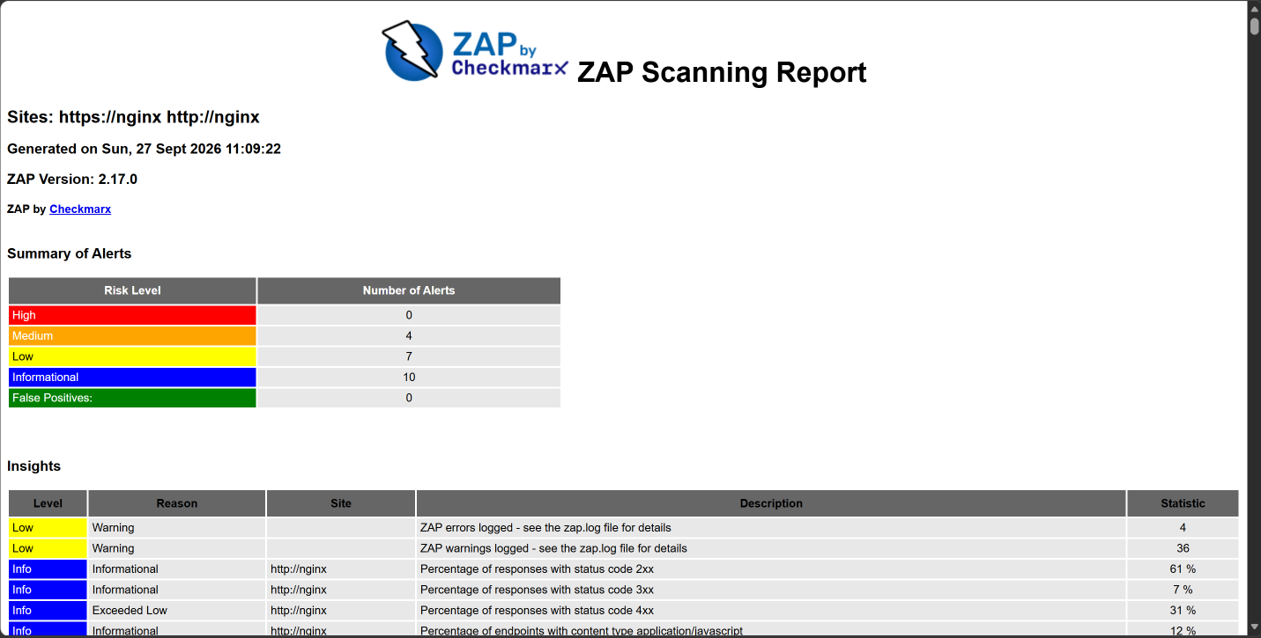

Analysis of the Automated Scan
1. Which course vulnerabilities did ZAP find?
The scan did not report any High-risk alerts. However, it detected several security weaknesses related to security configuration and access control.
The most relevant finding was Bypassing 403. ZAP attempted modified requests and found cases where a request that appeared to target restricted resources produced an HTTP 200 OK response. This relates to the course topic of access control, although the finding would still require manual verification to determine whether unauthorized access actually occurred.
ZAP also detected configuration-related weaknesses such as the absence of a Content Security Policy, use of HTTP without HTTPS, insecure HTTP methods, missing security headers, cookies without HttpOnly, and disclosure of server version information. These findings demonstrate that automated scanners are effective at identifying observable HTTP and configuration weaknesses.
2. Which vulnerabilities did ZAP miss?
Despite Meridian being intentionally vulnerable, ZAP reported no High-risk vulnerabilities. In particular, the scan did not successfully identify major vulnerability classes expected throughout the course, such as:
- SQL injection
- Cross-site scripting as a confirmed exploitable vulnerability
- Command injection
- Server-side request forgery
- Authentication and authorization logic vulnerabilities
- Business-logic vulnerabilities
- Race-condition vulnerabilities
- Insecure deserialization
This means that the automated scan missed more of the application's intentional vulnerabilities than it successfully identified.
3. Why did ZAP miss them?
The missed vulnerabilities can be grouped into several categories.
Authentication and authorization dependent vulnerabilities:
Some vulnerabilities require the scanner to understand which user is logged in, what role that user has, and which actions that user should or should not be allowed to perform. An automated scanner cannot easily determine that an agent, client, or administrator has been granted an inappropriate action simply by examining HTTP responses.
Business-logic vulnerabilities:
These depend on understanding the intended behavior of the application. A scanner can observe that a request succeeded, but it does not necessarily understand whether that action should have been permitted according to the application's business rules.
Workflow and state-dependent vulnerabilities:
Some attacks require a particular sequence of operations, application state, timing, or multiple requests. Race conditions are an example because exploitation depends on carefully coordinating multiple requests rather than simply supplying a malicious value to one parameter.
Specialized or context-dependent vulnerabilities:
Vulnerabilities such as insecure deserialization may require specially crafted application-specific objects or knowledge about how data is processed internally. The lab handout specifically notes that the scanner misses the application's deserialization RCE.
Overall, ZAP is strongest when it can recognize a direct relationship between user-controlled input and a dangerous response or sink. It is much weaker when exploitation requires understanding who the user is, what the user should be allowed to do, application state, or the intended business rules.
4. Misleading or Incorrect Scanner Findings
Not every automated finding should automatically be considered a confirmed vulnerability.
For example, ZAP reported Bypassing 403 because specially modified requests resulted in a 200 OK response. The scanner used headers such as X-Original-URL and interpreted the changed status as evidence that a protected resource might have become accessible.
However, a different HTTP status code alone does not prove that authorization was actually bypassed. The returned content and the user's permissions must be manually examined before concluding that a real access-control vulnerability exists.
This demonstrates why automated scanner results require manual verification. A scanner can recognize suspicious technical behavior, but it does not fully understand the application's intended security policy.

Conclusion
The laboratory demonstrated the difference between manual security testing and automated vulnerability scanning. Burp Suite provided direct control over individual requests through tools such as Repeater, Intruder, and Comparer, while ZAP automatically explored and tested a larger portion of the application.
The ZAP scan successfully discovered 62 HTTP endpoints and several configuration and HTTP-level weaknesses, but it did not identify many of Meridian's intentional application-level vulnerabilities. This shows that automated scanners are useful for quickly finding common and observable weaknesses, but they cannot replace manual testing when vulnerabilities depend on authorization, application logic, workflow, state, or application-specific behavior.

