**A WEB BASED MOTORCYCLE SHOWROOM MANAGEMENT SYSTEM**

**(A Case Study of** **Captain Motorcycle Manufacturing Cooperative Limited)**

**JOSEPH G. MITAMBO**

**BSIT/081J/2016**

**A project submitted to the Institute of Computing and Informatics in partial fulfillment of the requirements of the award of the degree of Bachelor of Science in Information Technology.**

**JULY, 2021**

# **DECLARATION**

This project is my original work and has not been presented for a degree in any other University or for any other award.

Name: JOSEPH G. MITAMBO BSIT/081J/2016

Signature…………………………………… Date……………………………………

SUPERVISOR

I confirm that the work reported in this project was carried out by the candidate under my supervision.

Name: Dr. FULLGENCE MWAKONDO

Signature……………………………… Date ………………………………………

# DEDICATION

This research work is dedicated to my grandmother Mrs. Githui, my aunt Ms. Wanjiku and my spouse Mary Wangari for their inspirational, limitless and underlying love and support.

# **ACKNOWLEDGEMENT**

Firstly, I would like to thank God for giving me the chance to be able to engage in this project. With Him, all things are possible.

Secondly, I wish to express my sincere gratitude to my supervisor Dr. Fullgence Mwakondo for providing me with guidance and direction in carrying this project work. I also wish to thank all my classmates and friends who rendered their help during the period of my project work.

Finally, I express my gratitude to the entire institute of computing and informatics fraternity for their support and the knowledge I gained that helped me fulfil this project.

# **ABSTRACT**

Motorcycle showroom management system is an online electronic software product proposed as a research topic for Captain Motorcycle Manufacturing Cooperative Limited. The aim of this investigation is to develop a web-based system that manages motorcycle details in the showroom of the organization. The project describes the complete process of managing a Bike after selling it to a customer from the company’s display room and adjusting the stock levels. The system will be used to store the details of motorcycles, making updates based on sales, generate inventory and sales reports periodically etc. This project is developed using PHP, HTML, CSS, and JAVASCRIPT web development languages for the frontend and SQL for the backend. XAMPP web server, Object Oriented Programming (OOP) paradigm, and Model View Controller (MVC) design pattern will be used. The system contains user components and admin component. The user components will be used by salespersons, inventory managers, and customers. The administrator will perform tasks such as adding new bikes, changing prices, adding users, generating reports etc. This system runs on multiple terminals, offers a simple graphical user interface to the user and also will connect to a common database(s). The methodology used is RAD.

Table of Contents

DECLARATION ii

DEDICATION iii

ACKNOWLEDGEMENT iv

ABSTRACT v

Table of Contents vi

LIST OF FIGURES viii

LIST OF ACRONYMS AND ABREVIATIONS ix

CHAPTER ONE 1

INTRODUCTION 1

1.0. Background information 1

**1.1. Problem statement** 1

**1.2. Objectives of the study** 2

**1.3. Research questions** 2

**1.4. Significance of the study** 2

**1.5. Limitations of the study** 3

**1.6. Scope of the study** 3

**1.7. Organization of the study** 4

CHAPTER TWO 5

LITERATURE REVIEW 5

**2.0. Introduction** 5

**2.1. Theoretical review** 5

**2.2. Similar systems** 6

**2.2.1. Bajaj East Africa Limited System** 7

**2.2.2. Captain Motors System** 8

**2.2.3. Honda Motorcycle System** 8

**2.3. Critical Review and Research Gap identification** 9

**2.4. Summary** 9

CHAPTER THREE 11

METHODOLOGY 11

**3.1. Introduction** 11

**3.2. Research Design** 11

**3.2.1. Data collection** 11

**3.3. System development methodology** 11

**3.3.1. Rapid Application Development (RAD)** 12

**3.3.1. Methodology justification** 14

**3.4. System requirement analysis** 14

**3.4.1. Functional requirements** 14

**3.4.2. Non – Functional requirements** 15

**3.4.3. Unified Modeling Language (UML) for requirement analysis** 16

**3.4.3.1. Use case modeling** 16

**3.4.3.2. Activity diagrams** 17

**3.4.3.2. Class diagram** 20

**3.5. Database design.** 21

**3.5.1. Table design** 21

**3.6. Testing design.** 22

**3.7. Chapter summary.** 22

CHAPTER FOUR 23

RESEARCH FINDINGS AND DISCUSSION 23

**4.1. Introduction** 23

**4.2. Presentation of findings** 23

**4.2.1. Home screen** 23

**4.2.2. Registration page** 24

**4.2.3. Login screen** 24

**4.2.4. User account screen** 25

**4.2.5. Admin account screen** 25

**4.2.6. Validation** 26

**4.2.7. Sales data entry** 26

**4.2.8. Query output** 27

**4.3. Summary** 28

CHAPTER FIVE 28

SUMMARY, CONCLUSION AND RECOMMENDATIONS 28

**5.0. Introduction** 28

**5.1. Summary** 29

**5.2. Conclusion** 29

**5.3. System limitations** 30

**5.4. Future recommendations** 30

**5.5. Chapter summary** 30

**5.6. Suggestion for further studies** 30

REFERENCES 31

APPENDIXES 32

# **LIST OF FIGURES**

Figure 1: Bajaj East Africa Limited 7

Figure 2: Captain Motorcycle Man. Co. Ltd. 8

Figure 3: Honda Motorcycle Kenya. 9

Figure 4: RAD Model. 12

Figure 5: Use case diagram. 15

Figure 6: Manage stock activity diagram. 16

Figure 7: Register user activity diagram. 17

Figure 8: Make sale activity diagram. 18

Figure 9: Class diagram. 19

Figure 10: Entity relationship diagram. 20

Figure 11: Home Page. 22

Figure 12: Register page. 23

Figure 13: Login page. 23

Figure 14: User account. 24

Figure 15: Admin account. 24

Figure 16: Login fails form. 25

Figure 17: Registration fail form. 25

Figure 18: Data entry form. 26

Figure 19: Query output. 26

Figure 20: Gantt chart. 32

Figure 21: Project budget. 33

# **LIST OF ACRONYMS AND ABREVIATIONS**

MSMS – Motorcycle showroom management system.

PHP – Hypertext preprocessor.

HTML – Hypertext markup language.

CSS – Cascading style sheet.

SQL – Structured query language.

XAMPP – Cross-platform, Apache, MySQL, PHP, Perl.

OOP – Object Oriented Programming.

MVC – Model View Controller.

RAD – Rapid application development.

SDLC – Software development lifecycle.

UPC – Universal Product Code.

NTSA – National transport and safety authority.

SRC – Software requirements document.

UML – Unified modeling language.

DDS – Design document specification.

# **CHAPTER ONE**

# **INTRODUCTION**

# **1.0. Background information**

Using a stock management system, any transaction-oriented business organization can manage inventory, sales, and other activities more efficiently. Every transaction initiated on the system, details of customers, product purchased, product price and data will be managed via the system while also updating inventory levels. Using a computerized system allows accurate inventory control, speeding up transactions and managing products.

Motorcycle showroom management system for Captain Motorcycle manufacturing Cooperative limited is proposed as a topic for this research with the intention of upgrading the current standalone system to a web-based system or online system. This system will enhance smooth management of motorcycle sales and inventory in the showroom for the company.

Motorcycle showroom management system is an application used to manage the business of motorcycles. Service convenience for customers in any organization is a determining factor for its success. A customer needs efficient services which can be enabled by the dealer with efficient technology. Processing customer orders, issuing receipts, customer requests and billing are among the services enabled by an electronic system.

## **1.1. Problem statement**

The problem of the study is the old manual ways of managing stock in the display/showroom by the current system thus causing high insecurity of data and other assets of the organization. The proposed system will automate the management of inventory, keep proper and updated records of the showroom, enhance security of all assets of the organization, and speed up transaction processes of the company.

### **1.2. Objectives of the study**

#### **1.2.0. General objectives**

To develop a user friendly, interactive and efficient web-based system that enable salespersons, sales managers, inventory managers, and administrator to control and manage motorcycle business in the company.

#### **1.2.1. Specific objectives**

1. To analyze the requirements for managing motorcycle stock in the showroom more efficiently.
2. To design a system that will provide better management of motorcycles in the showroom.
3. To implement a system that will automatically generate reports for the daily stock activities and stock levels in the showroom.
4. To test the showroom management system for its functionalities.

### **1.3. Research questions**

1. What are the requirements for managing motorcycles in the showroom?
2. How do we design a system that will provide better management of motorcycles in the showroom?
3. How do we implement a system that will automatically generate reports for stock levels in the showroom?
4. How do we test the system functionalities?

### **1.4. Significance of the study**

This new system that will be developed will help the salespersons, stock and showroom managers to account for each and every motorbike that will be brought in the showroom for sale. The master database will store data of each Bike, retrieving of each transaction and data about inventory of each motorcycle in the showroom, manage the Bike releases after sales and summarize point of sales. The customers will benefit as the system will generate a faster improvisation of work with less time and effort. This system will reduce paper works for the organization and avoid ineffective ways of managing inventory, assist in making the right decisions in the organization in the process of managing sales and stock levels.

## **1.5. Limitations of the study**

**This research, however, is subject to several limitations:**

* Due to time factor the system lacks decision support element such as customer buying patterns behavior where it is not capable to do analysis of data in capture in the database but only retrieves the data in the form of report.
* Limited access to information due to lack of previous research studies on the management of showroom as a topic.

## **1.6. Scope of the study**

In the development of the system the scope has been narrowed down to management of inventory in the showroom and this has enabled the developer to have enough time to conduct research and develop the project. The system has the following aspects;

* Register – Creates user and login credentials.
* Database – temporary transaction database and master database.
* Reports – generates daily and weekly reports.
* Showroom – manages the stock in the display.
* Sales – make sales for the customers.

Research will be conducted only regarding Captain Motorcycle manufacturing cooperative limited and it is estimated research will take roughly three months and the system development will take about four months.

## **1.7. Organization of the study**

This study is organized as follows; Chapter I describes about the background, problem statement, objective of the study, significance of the study, limitation of the study, and the organization of the study. Chapter II deals with literature review with the study of stock management evolution in organizations as stated by Herman Hollerith. The chapter also describe the review of existing systems. Chapter III describes the research methodology used for the study to be accomplished. The chapter explains the research design, development methodology, and system requirements analysis. Chapter IV illustrates the research findings and discussions. Chapter V is the summary, conclusions, and recommendations.

# **CHAPTER TWO**

# **LITERATURE REVIEW**

## **2.0. Introduction**

Literature review refers to the study, survey and evaluation of similar existing systems in relation to the selected area of study. It helps in relating to the existing knowledge, interacting with users and determining their anticipations of the proposed system.

## **2.1. Theoretical review**

In the old days before industrialization came to be, traders were using manual records of their sales and stock. Using the handwritten notes then they would order more stock when the need arise and this was inaccurate and inefficient way of doing business.

When goods were stolen, the merchants would not account for them not until they did physical counts on a regular basis. Due to poor records keeping, there was trouble in making order of goods.

In 1889 a man named Herman Hollerith invented the first punch card that could be read by machines. Harvard University took Hollerith’s idea in the 1930s and created a punch card system for business. This enabled companies to record sales and inventory data and also the companies would tell which goods were being ordered. Unfortunately, the system would not adapt with rising business changes and also it was too costly. As computers become more efficient and cheaper, Universal Product Code (UPC) grew in popularity. In the mid-1990s, companies started experimenting with the inventory management software that would record data as products were scanned in and out of warehoused. The technology evolved into a comprehensive inventory management solution by the early 2000s. (Lockard, 2012)

In the modern days, the implementation of sales management systems has become valuable to organizations in the management of sales and stock. The electronic systems help in keeping records, ensuring security of assets, enhancing integrity, efficiency management of stock and also reduce cost.

According to Sanders (2010), electronic systems are systems where information technology plays a major role. Business organizations then would have it as a requirement to implement these electronic management systems to make work easier and efficient. However, some organizations are still lagging behind in terms of technology and are reluctant to change. Profitable reason being lack of capital and novice users of technology. It is a major requirement and object for any company to maximize profit and minimize loss. The automated systems hence would make work easier, faster, and accurate.

Sales and inventory management system maintain and manage information of products and activities of the company. Data and information in firms accumulate periodically as business organizations grows. Maintaining this data manually becomes obsolete and inefficient which also increases costs of operations. According to Henderson (2004), there are three advantages of using sales and inventory management system which include;

* Time saving.
* Improving accuracy.
* Ensuring consistency.

With the three aspects in businesses, managers are able to coordinate and control operations in a computerized environment hence increasing sales.

## **2.2. Similar systems**

Various sales and inventory management systems have been developed both globally and locally.

However, the existing systems are subject to some limitations and disadvantages which the proposed system aims to perfect. The existing systems includes not more or less of:

## **2.2.1. Bajaj East Africa Limited System**

Bajaj East Africa are global dealers and manufacturers of motorcycles. Bajaj Auto, is ranked as the world's fourth largest three and two-wheeler manufacturer and the Bajaj brand is well-known across several countries in Latin America, Africa, Middle East, South and South East Asia. (The Company, n.d).

The Bajaj motorcycle management system controls and manage the large mass of motorcycles stock manufactured by the company and kept in the store and warehouses but fail to review and manage the motorcycles which are brought in the display/showroom. The showroom is the physical observable room which can be termed as the interface of customers and it should be monitored, maintained, and perfected to meet the preferences and interests of customers as they buy. The showroom should have a way of sorting out the incoming and outgoing motorcycles in the organization. The incoming motorcycles are those which are brought in to the display room from the warehouses and the outgoing motorcycles are those which have been sold to the customers from the display room.

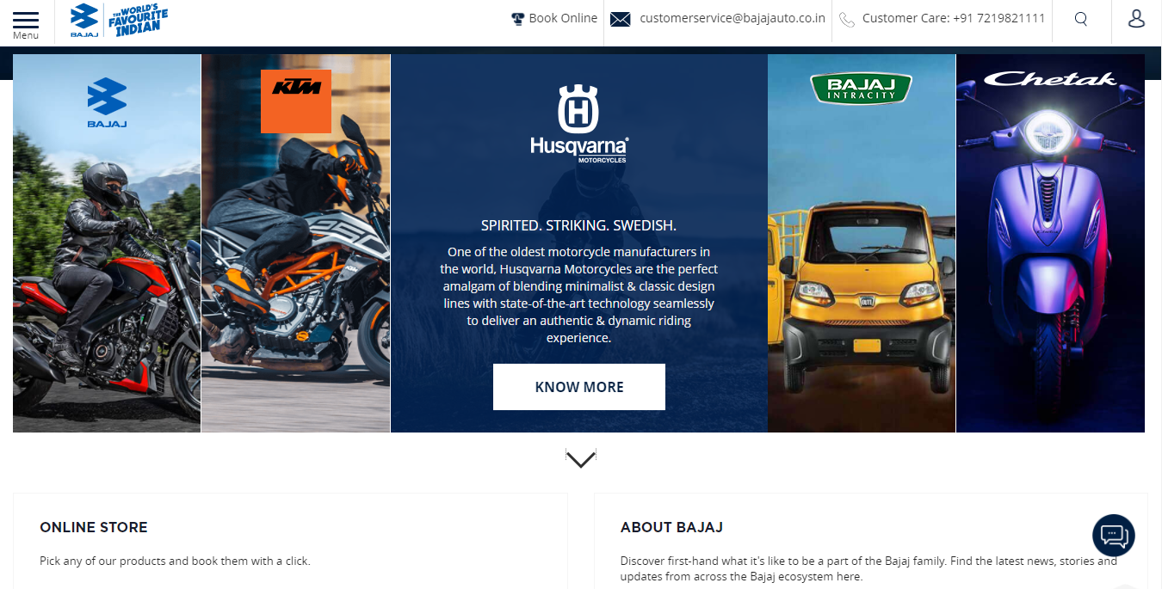

Figure : Bajaj East Africa Limited

## **2.2.2. Captain Motors System**

Captain Motorcycles Company are Kenya best manufacturers and dealers of Captain, Dayun, and Shinery brands of motor bikes. The management of their assets is imperfect and not efficient given that they operate with a Desktop management system. Each user of the system in the entire organization must have the system installed and configured on their computer. The proposed system will be Online/web based which makes operations easy and manageable.

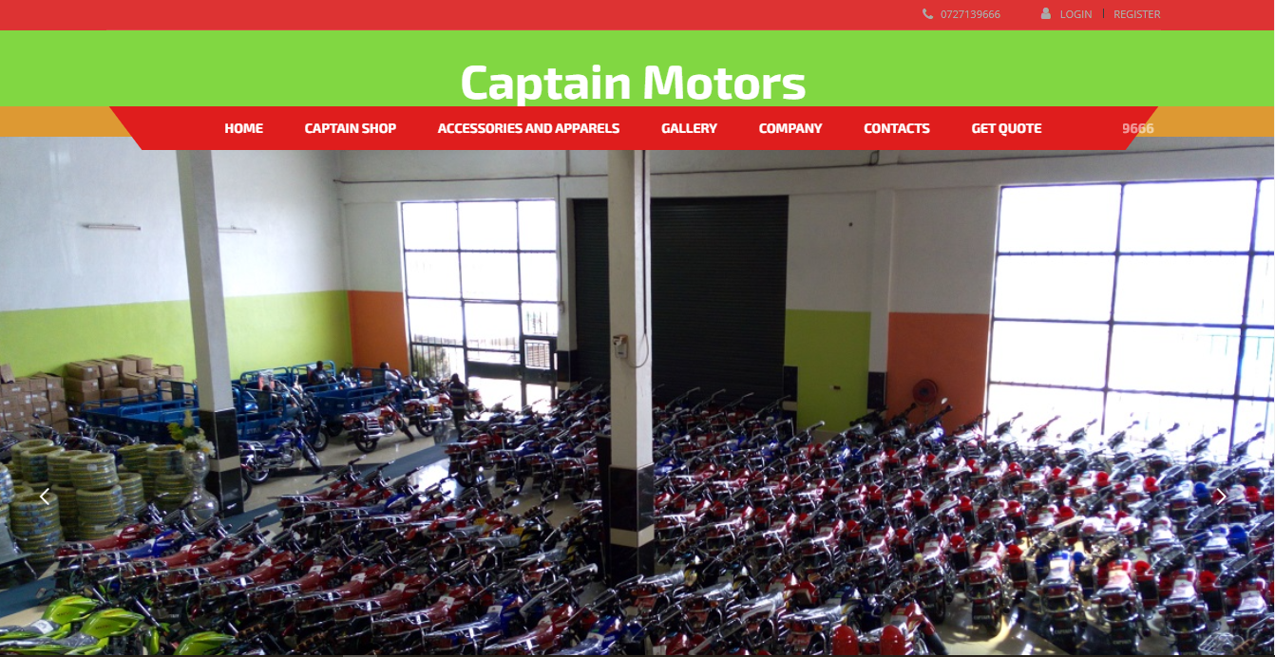

Figure : Captain Motorcycle Man. Co. Ltd.

## **2.2.3. Honda Motorcycle System**

Honda motorcycle Manufacturers Company is located in Kenya which imports, assembles and sell motor bikes across Kenya. The company’s sales system does not take into considerations the need to have stock management and to keep them updated in terms of what to sell at what particular time. Motorcycles are manufactured and allocated their number plates by the National Transport and Safety authority hence the need to sell them on time in parallel to manufacture date to avoid dormancy and being outdated.

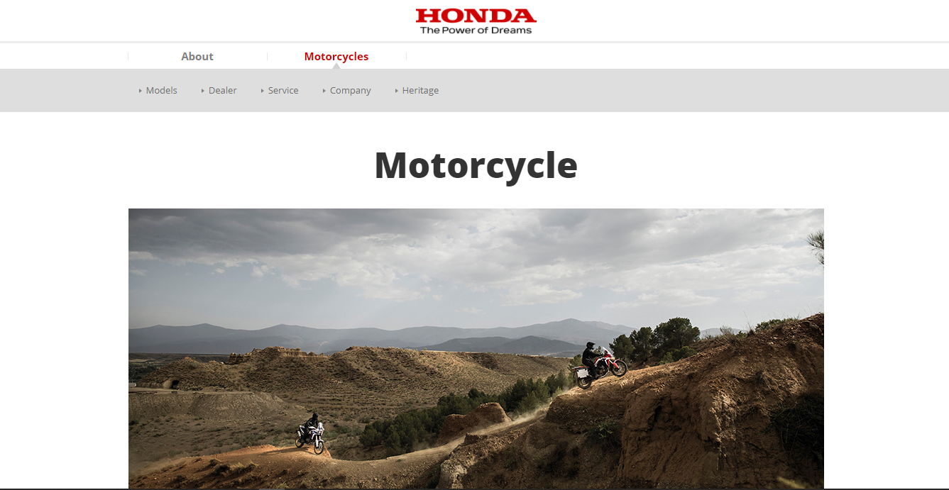

Figure : Honda Motorcycle Kenya.

## **2.3. Critical Review and Research Gap identification**

The proposed system will have an additional module which will purposely control and manage the motorcycles that are in the showroom ready for sale rather than managing the overall stock in warehouses. This will help to avoid having stock that is out of date in terms of sales due to dormancy. Customer’s satisfaction is a major concern. Number plates are allocated seasonally by NTSA hence any customer would need the latest and recent brand. This will be determined by how the placement of motorcycles is done in the storage facilities and to display rooms after assembling them.

## **2.4. Summary**

The implementation of the proposed sales and showroom management system will have advantages and changes will be brought in managing of stock. The project system will have benefits such as; Customer’s satisfaction will be enhanced and increased by the new method of managing stock in the organization, Decision making will be improved and sales of bikes will be accurate and reliable to customers, Profitability will be increased as customer’s satisfaction will lead to more attraction of customers in the company hence increasing sales, Cash flow will be increased as customer’s demand will be met, The system will help in monitoring, controlling and prevent slow moving brands of motorcycles

# **CHAPTER THREE**

# **METHODOLOGY**

## **3.1. Introduction**

Research methodology refers to the specific procedures or techniques that will be used in identification, selection, processing and analyzing data about the proposed project. This chapter will answer the questions;

* How the data will be collected or generated?
* How the data will be analyzed?
* How the system will be designed and developed?

## **3.2. Research Design**

The research design which is a framework of the research methods and techniques that will be used in this study is mixed method design of explanatory research and a case study of captain motorcycle manufacturing cooperative limited. The selected research design in this study is characterized by its reliability, validity, neutrality, generalization and will provide accurate and unbiased insights.

## **3.2.1. Data collection**

Data collection process involves gathering and analyzing information in accordance with requirements specification in order to answer the research questions, testing the hypothesis, and evaluation of outcomes. Data collection techniques to be used in this study are a case study, review of literature, search from internet, use of questionnaires and observations. The internet will provide ample information on existing inventory management systems and related studies while literature review will involve reviewing articles, journals, and published books with similar topics.

## **3.3. System development methodology**

System development methodology, commonly known as SDLC, is the blueprint or a framework that is used to structure, plan, and control the overall process of designing and developing a software system. System development lifecycle (SDLC) is a standard approach in managing a software engineering process and have several distinct phases. Basically the project has four development stages which includes;

1. **Planning and Analysis.**

* Identification of the problem faced by the organization is done and proposing a solution.
* Setting the main purpose, objectives, and scope of the project clearly.
* Organizing activities and setting the time frame of the project.
* Requirements collections and gathering data.
* Analyzing is done and requirements are documented using a software requirements specification document (SRC).

1. **Design**

* Modeling and prototyping is done for the conceptual and logical design of the system.
* Unified modeling (UML) diagrams are designed.
* Internal design of the Architecture and data flow of the product is then defined using a design document specification (DDS).

1. **Development and Testing**

- Actual coding of the system is then done until completion.

- Testing is carried out in parallel with coding.

1. **Deployment and Maintenance.**

**-** The system is tested for user acceptance and released for use in the appropriate market.

- Monitoring and maintenance is done for efficiency.

## **3.3.1. Rapid Application Development (RAD)**

The proposed system project was developed using ‘rapid application development (RAD)’ - based software development life cycle (SDLC). RAD model generally put less efforts in planning tasks and emphasizes on development and prototyping. The methodology incorporates iterative model and prototyping which involves developing with continuously evolving requirements which is also fast and less prone to errors.

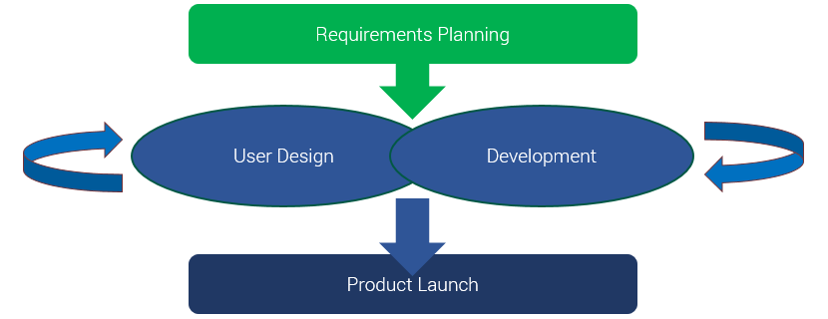

Figure : RAD Model.

The RAD model allows adjustment of the overall development phases of the SDLC which in turn allows faster development of some parts of the software product while involving the user. RAD model involves the following stages;

**Phases of RAD**

1. **Define project requirements.**

At this phase, the stakeholders discuss and define the project requirements i.e. project scope, project goals, constraints, budget and timelines. When the team agrees, the management then makes approval of those requirements and the phase ends.

1. **User Design**.

Designers and developers build models and prototypes of the system at this phase. They work closely with the users of the system to create and improve the prototypes representing all the system inputs, outputs and processes. The clients will work together with developers until the final product is ready.

1. **Development** **and testing.**

The prototypes are converted into working models at this phase. The tasks includes the actual coding and programming the system, unit testing and integration, and the overall system testing. Developers also continue getting feedback from users to improve prototypes and make the best product possible

1. **Product launch.**

At this phase, the product is implemented and placed in operation. The phase involves training the users, data conversion, user testing, and changeover to the new system.

## **3.3.1. Methodology justification**

1. **Flexibility and adaptability.**

Developers and designers are able to make adjustments by having users interact with evolving prototypes. This in turn leads to development of an improved quality product.

1. **Risks control and management.**

In RAD approach, stakeholders are able to focus on early vulnerabilities and discuss on the risk that may occur and their mitigation while ensuring development process is ongoing.

1. **Reduced development time.**

By using incremental and quick iterations development methodologies in RAD approach, development time is reduced which speeds up delivery of the software product. Catastrophic failures are also avoided which are likely experienced by other methods like waterfall.

## **3.4. System requirement analysis**

### **3.4.1. Functional requirements**

The proposed system should be able to:

* Allow user administrator to manage users of the system, that is, register and create accounts for them and update their data in the system.
* Allow the users to check daily, monthly, or annual reports.
* Allow sales persons check the stock level in the showroom.
* Allow inventory manager to manage stock in the showroom

### **3.4.2. Non – Functional requirements**

Non-functional requirements are aspects that defines the operation of the system. They are the constraints, qualities, and attributes of the system. The system developed has the following qualities:

* Security – the system has access control features mainly user login credentials and passwords making it a secure system
* Availability– The system is a web based hence its availability via the internet.
* Maintainability– The system has modules making it easier for maintenance, repair and also update.
* Usability – The system can be used by different categories of users i.e. beginners, non-technical, and experts. The system is user friendly as it has icons, menus and buttons

## **3.4.3. Unified Modeling Language (UML) for requirement analysis**

### 

### **3.4.3.1. Use case modeling**

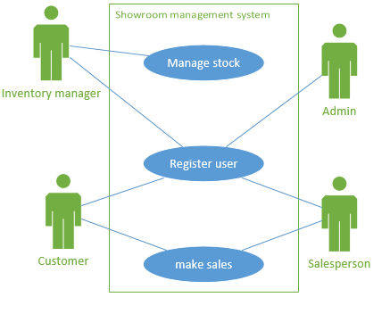

Figure : Use case diagram.

## **3.4.3.2. Activity diagrams**

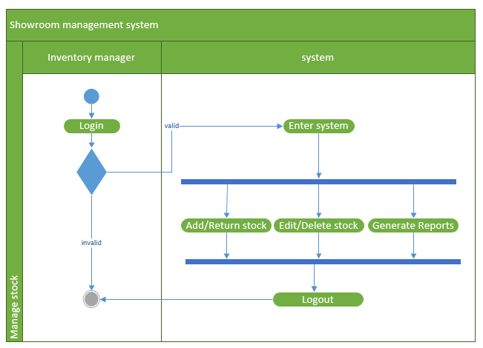Figure : Manage stock activity diagram.

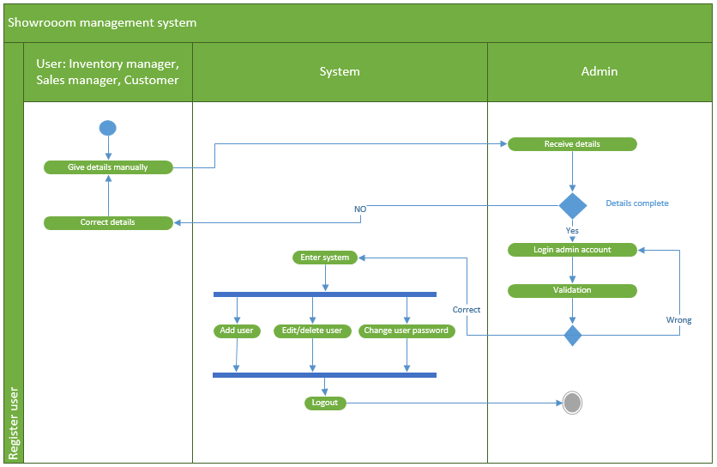

Figure : Register user activity diagram.

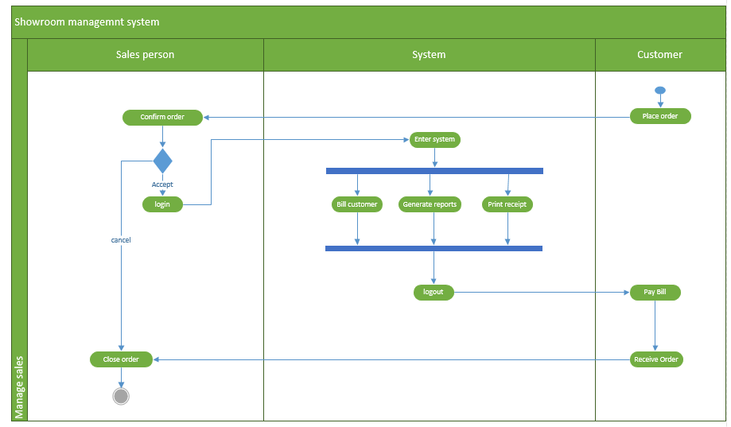

Figure : Make sale activity diagram.

## **3.4.3.2. Class diagram**

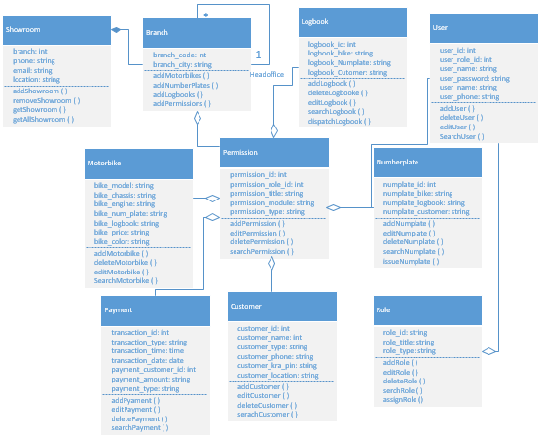

Figure : Class diagram.

## **3.5. Database design.**

### **3.5.1. Table design**

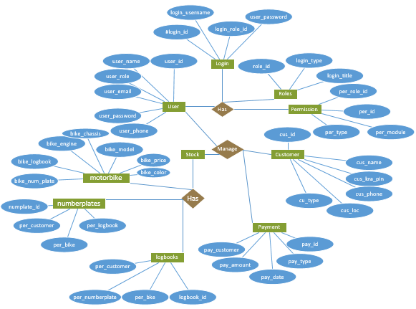

Figure : Entity relationship diagram.

## **3.6. Testing design.**

Testing involves justifying the usability of the software product. The motorcycle showroom management system will be evaluated against requirements gathered from the system specification and users. The proposed system will be tested for verification, validation, and quality assurance using the following testing techniques;

* **Unit testing** – The object oriented approach which will involve testing the individual classes of the software.
* **Subsystem testing** – The object oriented approach which will involve testing each module of the software system.
* **System testing** – will include testing the whole system as a whole.
* **User testing** – which will be carried out by the customer before launching the product.

## **3.7. Chapter summary.**

This chapter has discussed the methodology that will be used to design and develop the proposed showroom management system including the discussion of how the data will be collected, analyzed and the tools to be used. The chapter also has discussed the software lifecycle method to be used in development, the validity and its effectiveness in reference to previous and current case study.

# **CHAPTER FOUR**

# **RESEARCH FINDINGS AND DISCUSSION**

### **4.1. Introduction**

This chapter explains the concepts of implementing the proposed MSMS system and realization of the objectives. The designed system is programmed, coded while testing and the real product is put in operation. This chapter will explain the functionalities of the system using screen shots and the project will be run using XAMPP web server and Google chrome browser.

### **4.2. Presentation of findings**

This section gives the major findings of the research. It is the summary of analyzed data which was presented in the previous chapter and the designed system.

### **4.2.1. Home screen**

Figure 11, shows the home screen of the MSMS system. Every user will be directed to this page after launching the system. The system will be run by entering the IP address of the application system or its domain name in the browser.

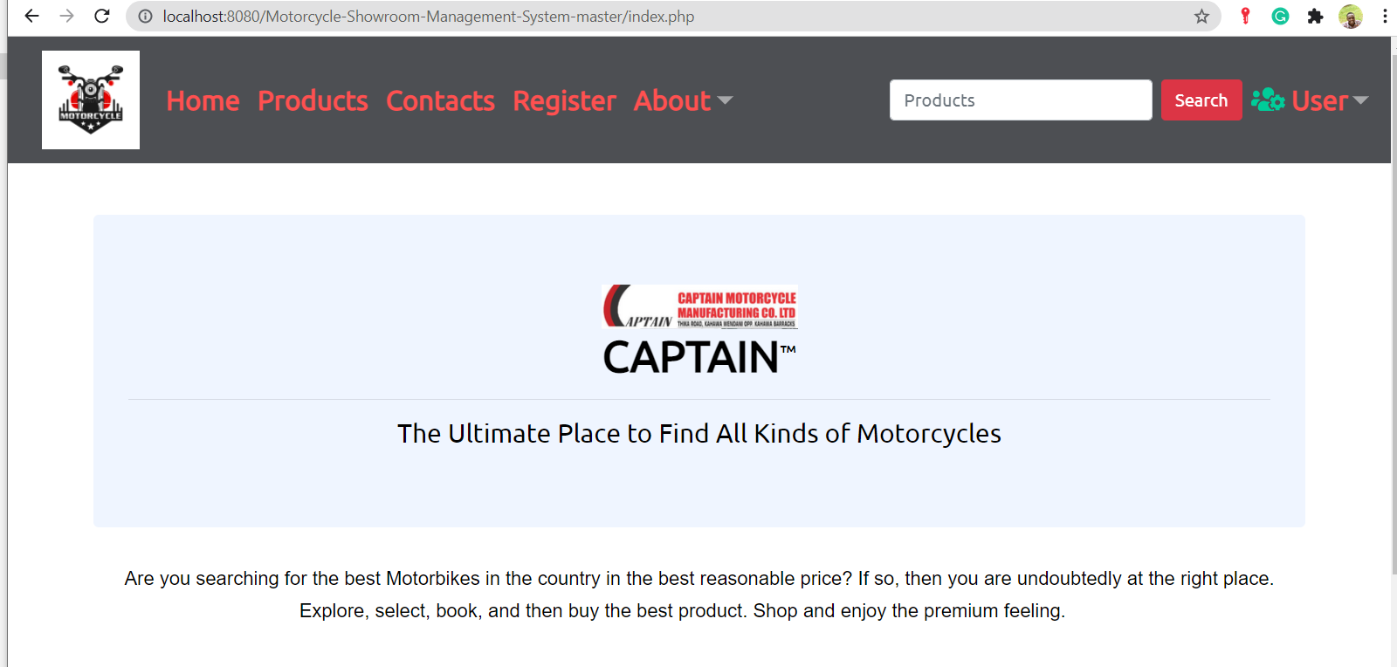

Figure : Home Page.

### **4.2.2. Registration page**

Figure 12.0, shows the registration page for customers or visitors while figure 12.1, shows the page that the administrator uses to register users. The admin registers users and gives them rules.

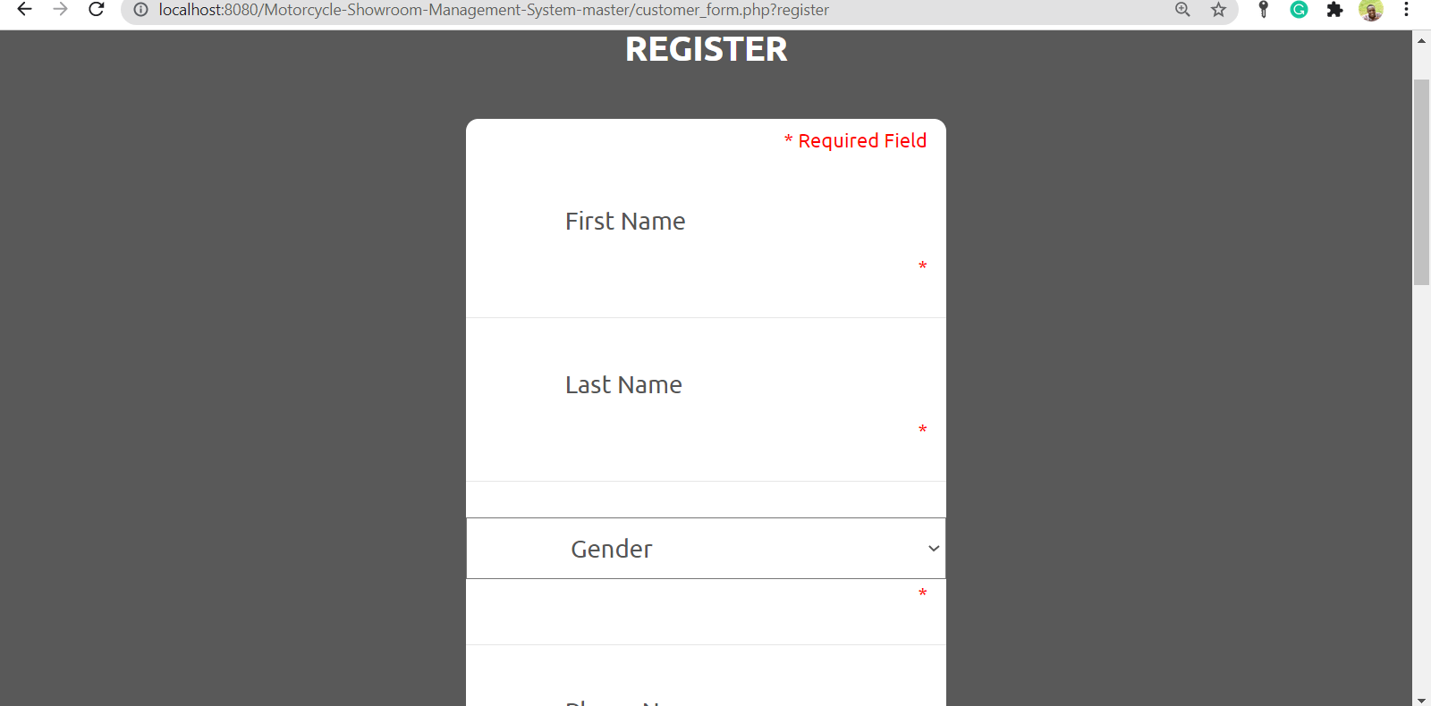

Figure : Register page.

### 

### **4.2.3. Login screen**

Figure 13, shows every user login form. After getting into the home page, the user may click the login button and is required to enter user name and user password in order to interact with the system.

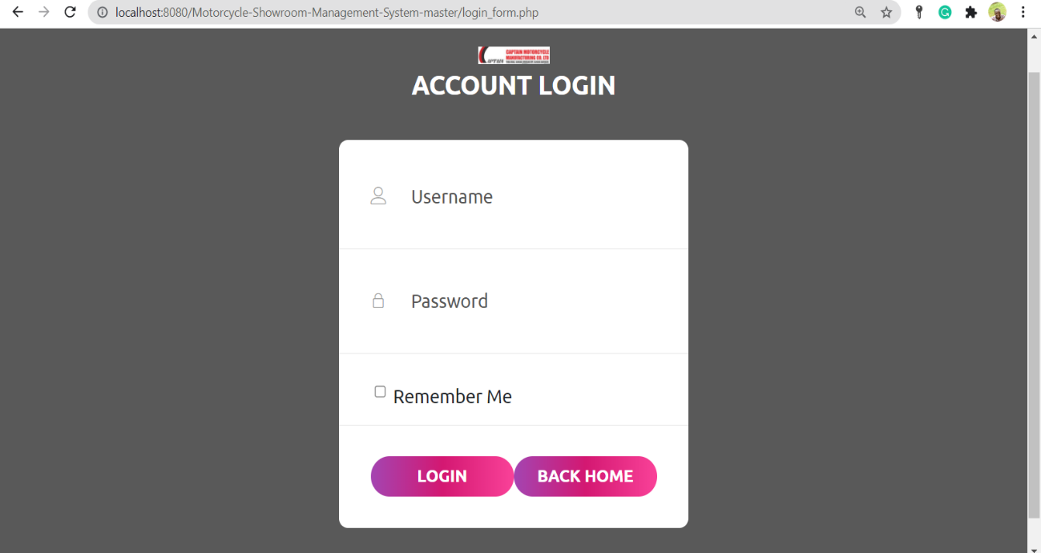

Figure : Login page.

### **4.2.4. User account screen**

Figure 14, shows a user account when logged into the system.

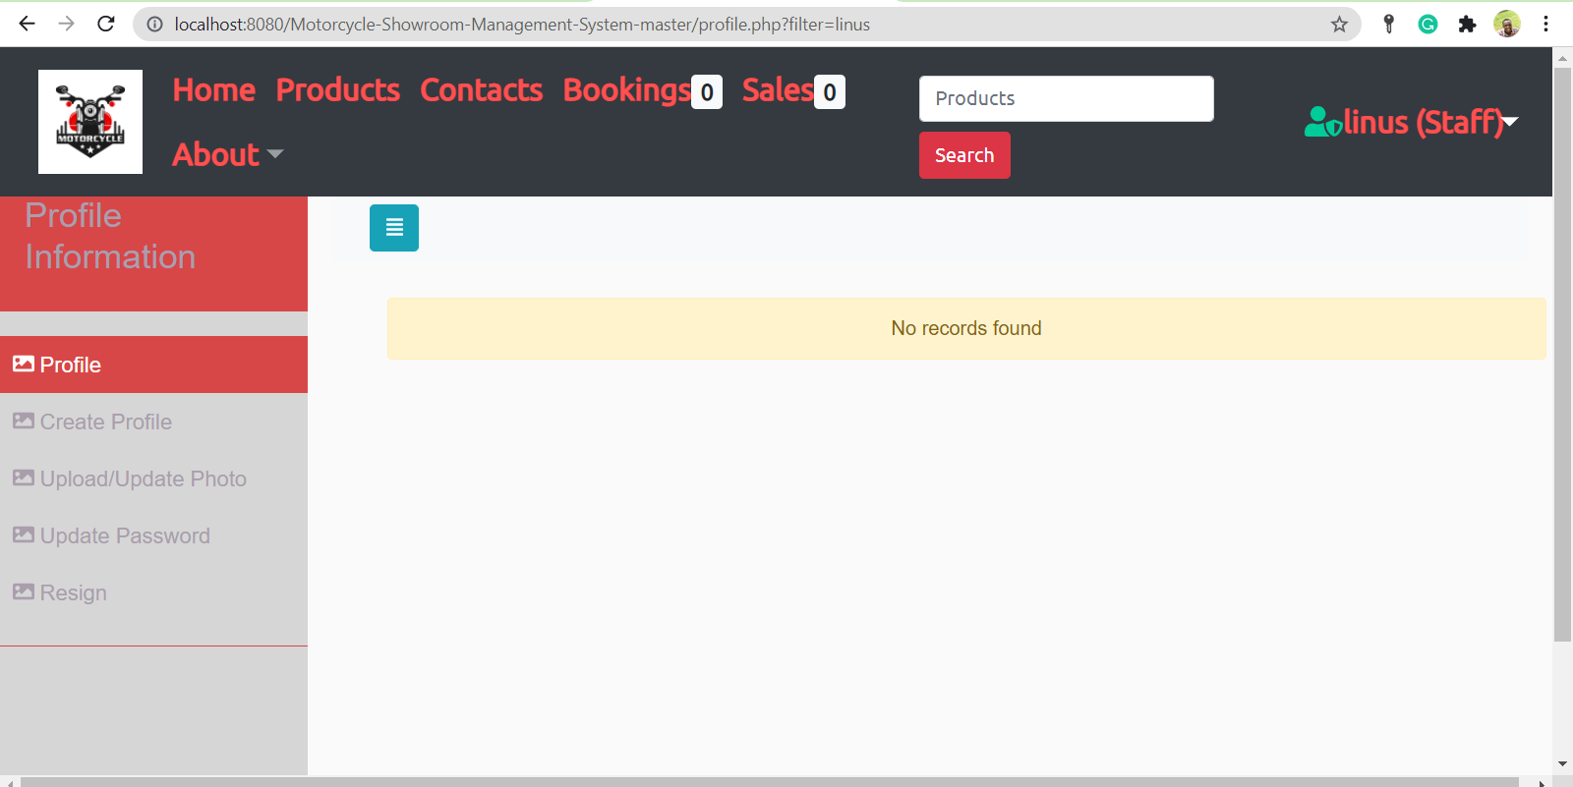

Figure : User account.

### **4.2.5. Admin account screen**

Figure 15, shows the administrator account when logged into the system.

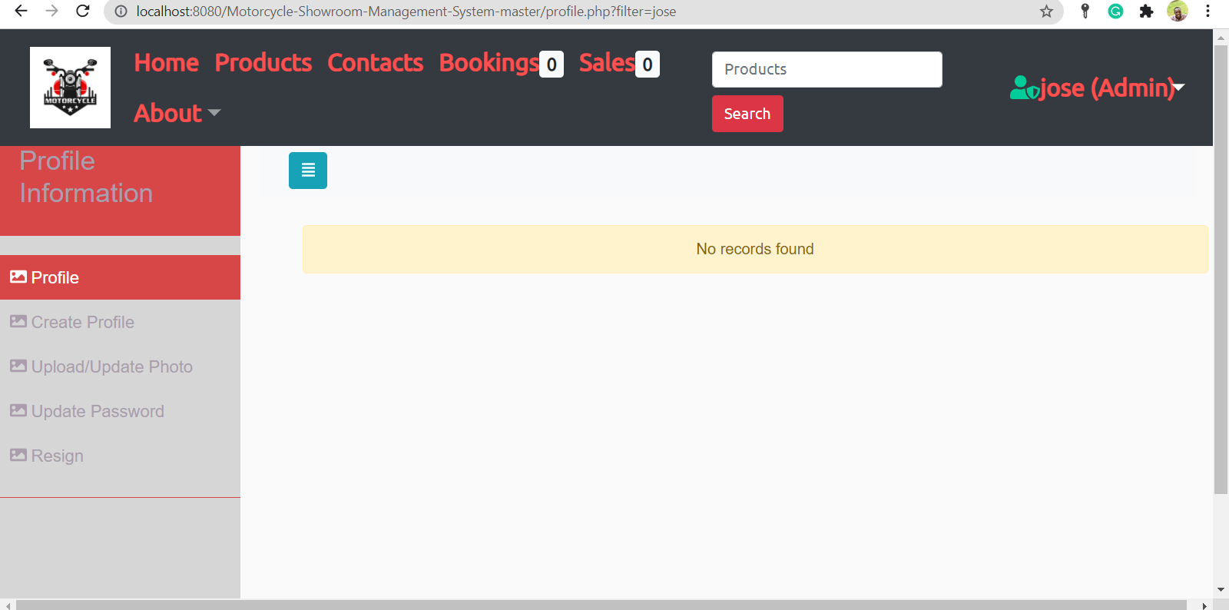

Figure : Admin account.

### **4.2.6. Validation**

Figure 16, shows the errors when the user enters invalid credentials when logging in the system while figure 17, shows error message when the user enters incorrect details while registering.

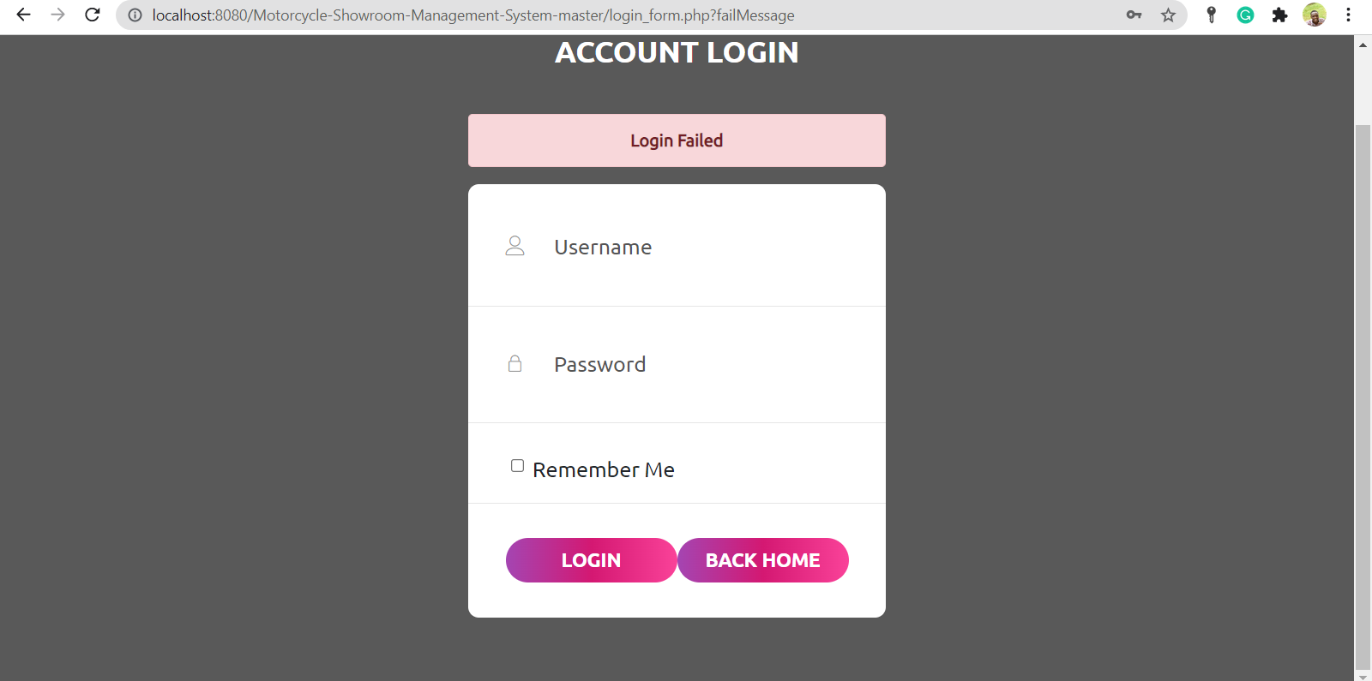

Figure : Login fails form.

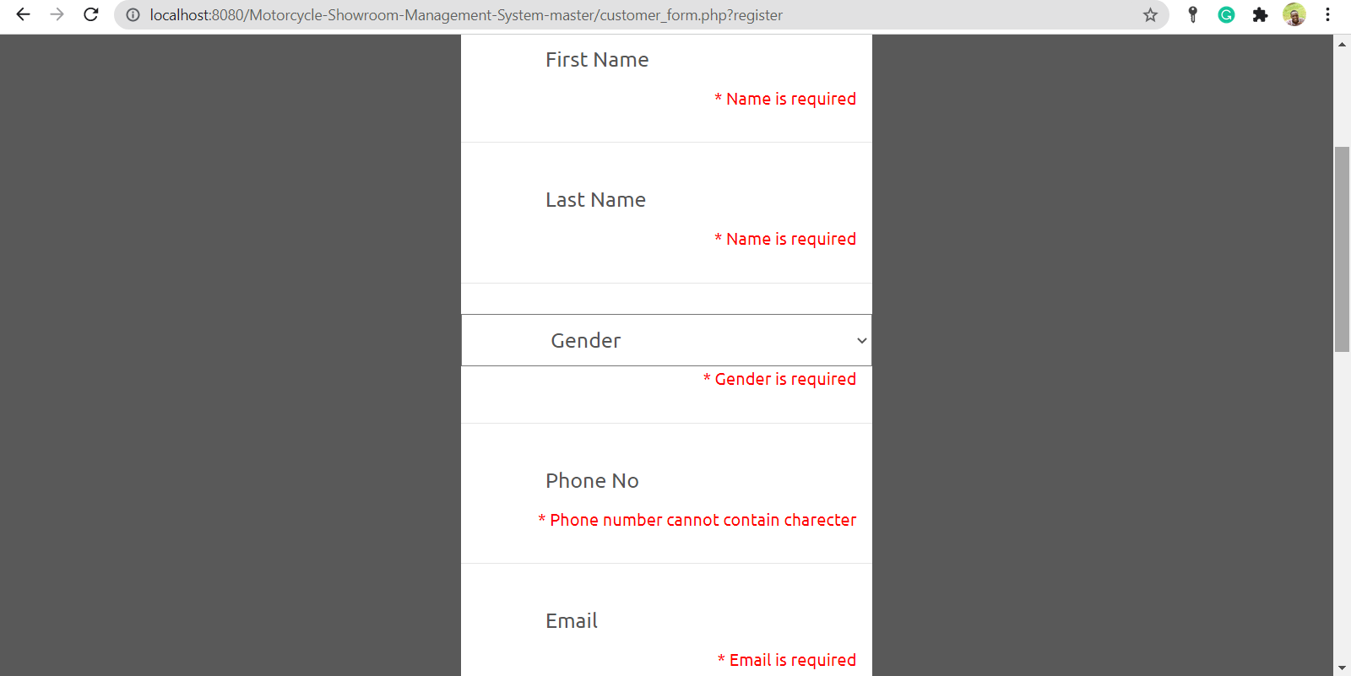

Figure : Registration fail form.

### 

### **4.2.7. Sales data entry**

Figure 18, shows a sales person entering data of a motorcycle stored in the showroom to make a sale to a customer.

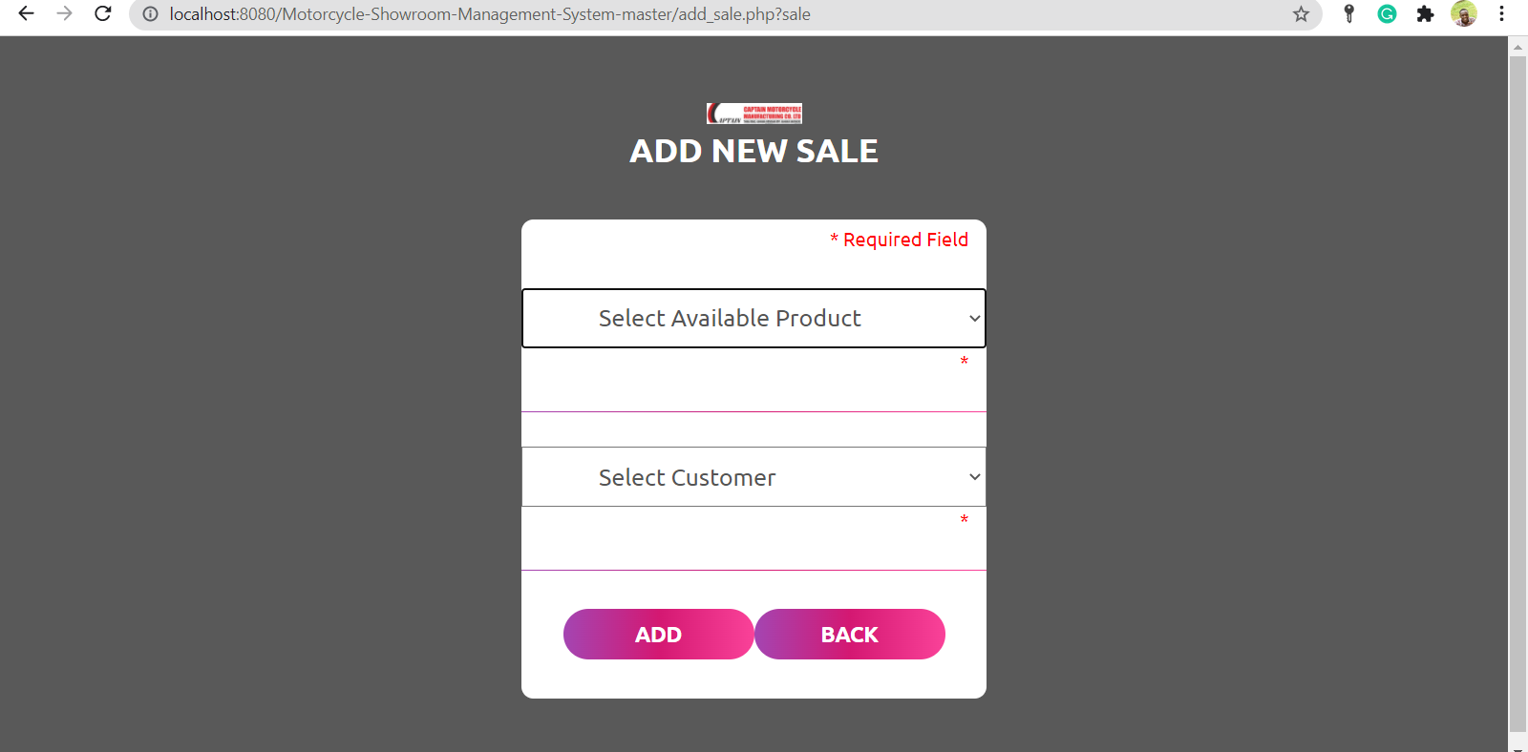

Figure : Data entry form.

### 

### **4.2.8. Query output**

Figure 19, shows data output when a user makes an sql query request from the database.

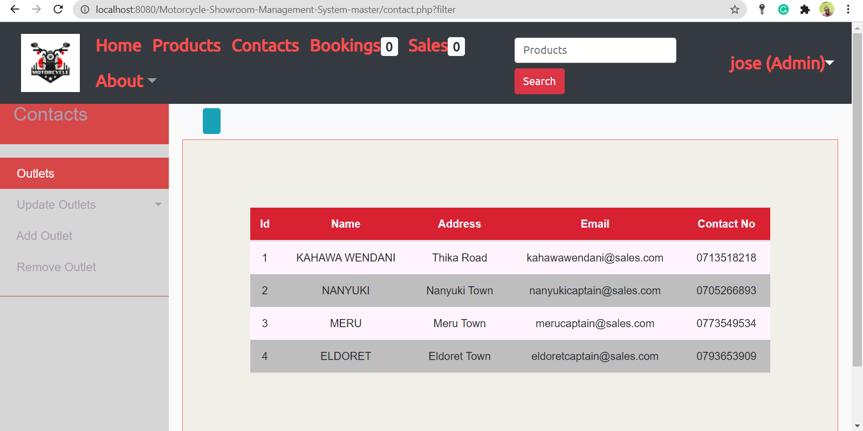

Figure : Query output.

### **4.3. Summary**

This chapter has described how the objectives of the proposed system were achieved. The screenshots shows how the system works for each user i.e. customers, salesperson, inventory manager, and the Admin. For the motorcycle business to run well, the overall functioning of the system illustrates booking motorcycle from the showroom, selling motorcycles from showroom, and managing users.

# **CHAPTER FIVE**

# **SUMMARY, CONCLUSION AND RECOMMENDATIONS**

### **5.0. Introduction**

This chapter explains and presents the summary of the whole project, draws conclusion, and future recommendations. The chapter also illustrates the achievements of the project. Amid many challenge, the project was completed successfully with the help of the project supervisor, family, and friends. Through the guidelines and constructive criticism of the project supervisor, all objectives of the project were achieved and through deep research.

### **5.1. Summary**

The project was completed with the realization of all the objectives laid in chapter one. The requirements for managing motorcycle stock in the showroom were analyzed. The user requirements, system requirements, functional requirements, and non-functional requirements were achieved in the development phase. The system was designed to provide better management of motorcycles in the showroom. After the requirements analysis and designing, the system was implemented. The system was able to automatically generate reports for the daily stock management activities and stock levels in the showroom. Finally, the system was tested for its functionalities.

### **5.2. Conclusion**

This project involved developing of a motorcycle showroom management system to manage and control all the motorcycles to be sold and how to add stock after sales. Proper analysis of the system requirements were carried out and also user requirements. Methodology steps of designing the system followed to meet those requirements. The methodology involved the users through consultations to get their recommendations and comments to match their requirements with the system. User involvement was carried out through implementation and deployment phases. The system design used in this project was rapid application development (RAD). The system was realized by use of developments tools such as PHP development language, HTML, CSS, JAVASCRIPT, SQL, sublime text and XAMPP. The database was created through SQL server while XAMPP created the web services. Continuous testing was done during coding, implementation, and deployment phases. Various testing techniques such as alpha test, beta test, system test, and user test were used. The testing techniques ensured no errors in the system and to ensure the system was ready for use. The current system used in the captain motorcycle manufacturing company is a standalone system, very slow, insecure, and lack stock management efficiency and effectiveness. After the new system was developed, the organization can now shift and upgrade to the new web based showroom management system. The system has much more benefits such as very secure to data, fast in terms of operations and execution, enhanced efficiency and effectiveness and its fit for use.

### **5.3. System limitations**

The system lacks decision support elements such as customer buying patterns behavior where it is not capable to do analysis of data in capture in the database but only retrieve the data in the form of report. The system is also limited to customers who may lack smart devices and internet to access the showroom and do their bookings and hence making payments for the product.

### **5.4. Future recommendations**

The showroom management system was developed to address the challenges of managing stock in the showroom of the current system. The new system addresses most of those challenges where the new system will improve the efficiency of the operations of the current system. Customers can access the showroom online and view the available products hence making bookings. In future recommendations, a mobile application system of the showroom management system would be much convenient for the customers. The system would also be convenient if mobile payments will be integrated with the system to allow customers book motorcycles and make immediate payments.

### **5.5. Chapter summary**

This chapter has described how the system specific objectives have been realized, the recommendations, and also made suggestions of further studies to upgrade and advance on the developed system.

### **5.6. Suggestion for further studies**

Through further research on machine learning and artificial intelligence, the system can be made to have knowledge base for pattern recognitions on sales and make proper predictions.

# 

# **REFERENCES**

Lochard, J. & Lavallée, E. (2017). The comparative effects of independence on trade. *Journal of Comparative Economics*, *43*(3), 613-632.

Sanders, D. A., & Bergasa-Suso, J. (2016). Inferring learning style from the way students interact with a computer user interface and the WWW. *IEEE Transactions on Education*, *53*(4), 613-620.

Handerson, A., Sanford, A., H. & Mullin, J. (2014). Audio channel constraints in video-mediated communication. *Interacting with Computers*, *16*(6), 1069-1094.

Anbalagan, C., & Kanagaraj, K. (2014). A Study on Problems and Prospects of Transport in

Bajaj Special Reference with Auto Rickshaw’s (Bajaj) in Hawassa City, SNNPRS, East Africa. *African International Journal of Research in Management*, *2*(03), 2308-3034.

Thanabalasingam, K. (2015). WEB BASED SHOWROOM MANAGEMENT SYSTEM FOR SINGER-PLUS CHUNNAKAM (WSRMS).

Iftikhar, U., Mahmood, H., Tahir, S., & Qadri, A. (2016). Car Showroom Management System (Doctoral dissertation, University of Management & Technology).

ABDUL ALEEM, R. B. (2016). SALES AND INVENTORY MANAGEMENT SYSTEM.

Anton Dolinsky (2017), Barcodes, sales and inventory control Retrieved 22 Jun 2013 <http://www.almyta.com/Inventory_Management_History_4.asp>

Laudon, Kenneth C. Management Information System, 6th Edition. New Jersey: Prentice-Hall International Company, 2000

Brand, F., McNamee, H., & McGuire, J. A. (2021). TYPO3 Showroom. In The TYPO3 Guidebook (pp. 3-31). Apress, Berkeley, CA.

Ekanayaka, E. W. M. P. (2013). Stock and Sales Management System For SAGO Sports Goods Center.

Hadi, F. C. INTEGRATION SYSTEM XYZ SHOWROOM WITH MICROSOFT DYNAMIC NAVISION.

# **APPENDIXES**

**Appendix A. Time frame**

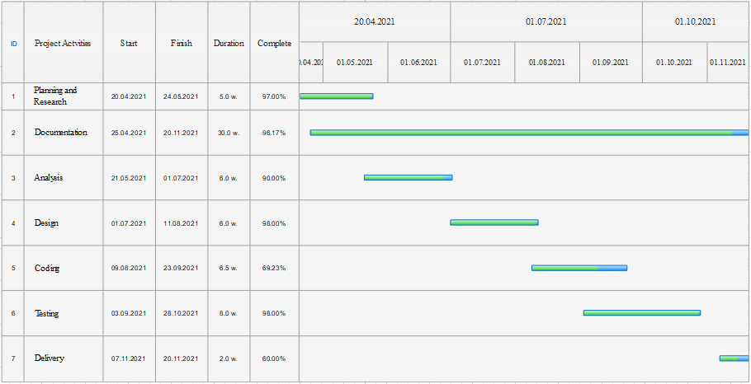

Figure : Gantt chart.

**Appendix B: Budget**

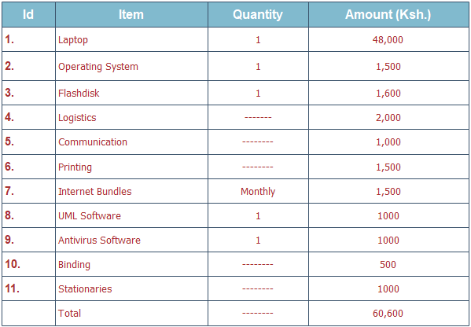

Figure : Project budget.

**Appendix C: Questionnaire**

**Section 1. General information**

Please tick just one textbox for your answer.

a. Current management of stock in the showroom is effective and efficient?

Strongly Agree Agree Disagree Strongly disagree Neutral

b. There is need to upgrade the showroom management system of this company?

Strongly Agree Agree Disagree Strongly disagree Neutral

c. Customers are satisfied when selecting and buying motorbikes from the showroom?

Strongly Agree Agree Disagree Strongly disagree Neutral

d. when new better system is developed and implemented sales will increase and cost will reduce?

Strongly Agree Agree Disagree Strongly disagree Neutral

e. There is delay in transaction processing when using the current system in the company?

Strongly Agree Agree Disagree Strongly disagree Neutral

**Section 2. System operations**

Please tick only one choice

a. The current system is very easy to use?

YES 1 2 3 4 5 NO

b. Most users complain about how the system operates?

True 0% 20% 40% 60% 80% 100% Not true

c. The system is very secure from risks and has no vulnerabilities?

Secure 1 2 3 4 5 Not secure

d. The system has high response time with few errors?

Very high High Low Very low

e. Is there a need to develop a new system to manage stock in the showroom?

Yes No