Joy Joseph

Automation

pack

**Scope:**

To automate Calculator application doing the basic functionalities.

**Prerequisites:**

Eclipse IDE installed system with Java version 8.

**Execution Steps:**

1. Download the shared project.
2. Import the Shared project as an existing Maven Project in Eclipse IDE.
3. Enter the path of the test data in the Base.java file as shown below.

Example:

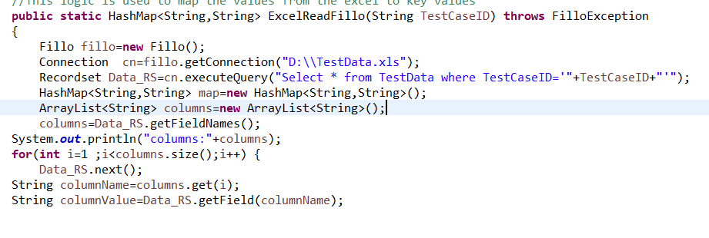

1. Use the following command in the command prompt to start the execution derived from the project location.

**mvn build.**

**mvn test**

1. After completion of the execution you can find the report inside the following location: reports/index.html .