Joseph Joy

Instructions Manual

**Scope:**

To automate Ryanair application for declined payment scenario using Cucumber BDD framework.

**Prerequisites:**

Eclipse IDE installed system with Java version 8.

You have to set Maven path in the Local Variables in order to run the pack from command Line.

**Execution Steps:**

1. Download the shared project.
2. Import the Shared project as an existing Maven Project in Eclipse IDE.
3. Enter the Gmail username and password in the feature file as shown below.

Example:

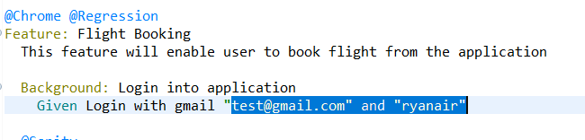

1. Use the following command in the command prompt to start the execution derived from the project location.

**mvn clean test -Durl=” https://www.ryanair.com/ie/en”.**

1. After completion of the execution you can find the report inside the following location: {projectLocation}/ target / courgette-report/index.html .A sample report is given below.

Sample Report:



**Reasons for Selecting BDD:**

BDD is meant to be collaborative. Everyone from the customer to the tester should be able to easily engage in product development. Scenarios focus on the expected behaviors of the product. Each scenario focuses on one specific thing. Behaviors are described in plain language, and any ambiguity can be clarified with a simple conversation or [Example Mapping](https://automationpanda.com/2018/02/27/bdd-example-mapping/). BDD frameworks make it easy to turn scenarios into automated tests. Given-When-Then steps can be reused between scenarios. The underlying implementation for each step does not change. Automation code becomes very modular. Scenario outlines make it easy to run the same scenario with different combinations of inputs. This is a simple but powerful way to expand test coverage without [code duplication](https://automationpanda.com/2017/01/24/why-is-automation-full-of-duplicate-code/), which is the bane of test automation. BDD scenarios are easy to update as the product changes. Modular design makes changes to automation code safer. Moreover I came to know that you are fans of BDD and Cucumber in Ryanair which is one of the many reasons that motivated me to implement it.

**Things handled in this Script:**

1. The script can be run from the command line by passing the URL as an input parameter. Thus, the same script can be used for SIT and UAT testing without and change in the code.
2. Have handled most of the object and all the values have been parameterized.
3. Have implemented various logics, one of them being prioritising a child s seat beside the parent.
4. Code is written in an efficient manner consuming only an average time of 1m 5 sec for the entire flow.

