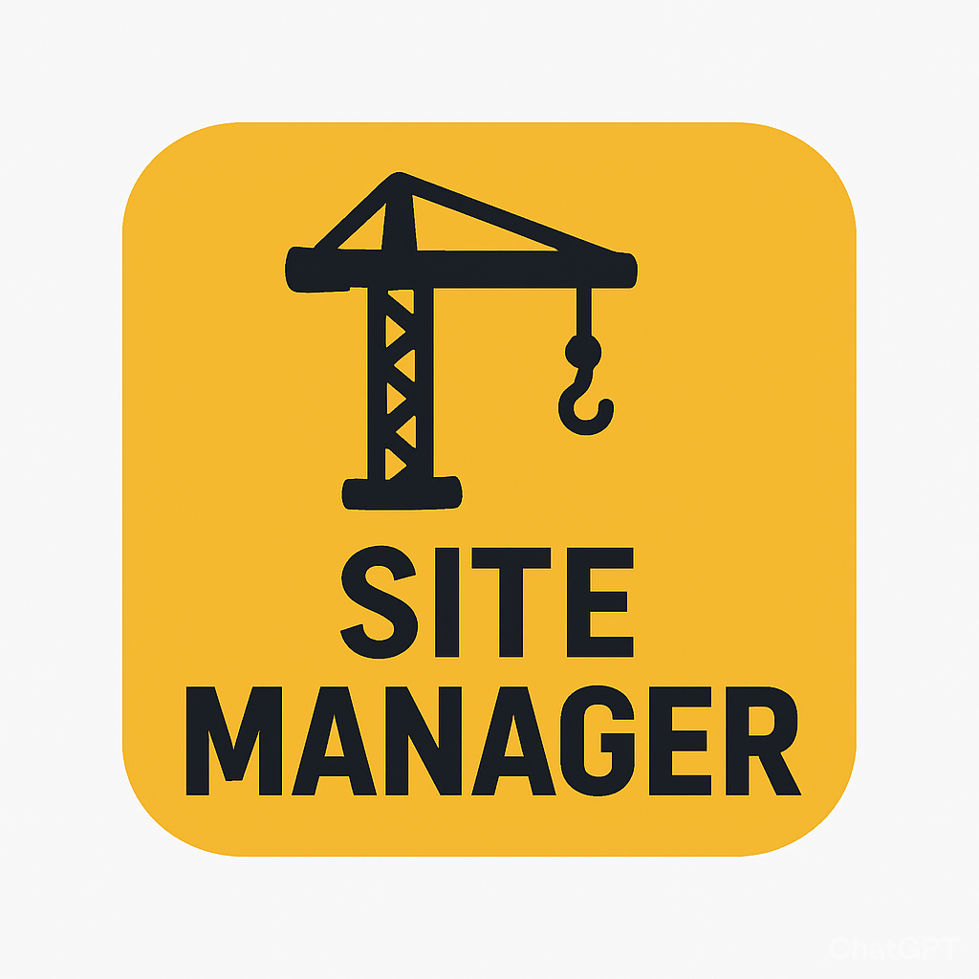

SiteManager
Enrique Garcia,
Kelvin Gordon,
Joseph Koop

Table of Contents

Table of Contents 2
Introduction 1
Prototype 2
Major Usability Problems Addressed 15
Map View 15
Unassigned Resources Card 15
Unassigned Resources Card 16
Enhanced Edit Equipment Section 16
Detailed Project Pages 17

Introduction

Value Proposition

“Right people. Right equipment. Right on time.”

Problem

Construction companies require a digital dashboard to track all projects, employees, and equipment in one centralized location, as current systems often lack real-time visibility, resulting in inefficiencies. Managers frequently have to rely on manual reports, calls, or spreadsheets to understand what resources are available or where progress is being delayed, which slows down operations and leads to scheduling conflicts.

Solution

Our solution is to create a live map that links to projects and shows exactly which employees, equipment, and materials are needed at each location. By combining this information into one dashboard, SiteManager helps construction managers make faster, data-driven decisions, reduce downtime, and improve communication between teams on different sites. The result is a smoother, more efficient workflow that keeps projects on track and on schedule.

Prototype

Figure 1: Webpage Dashboard
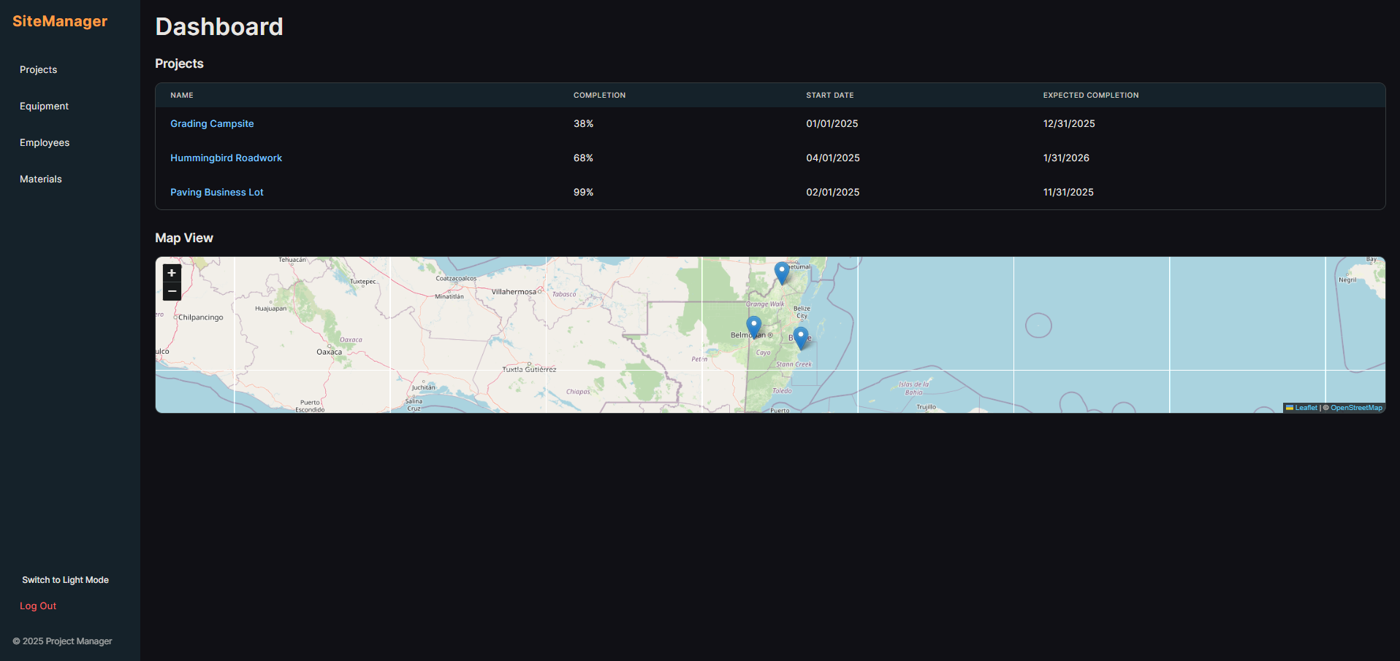

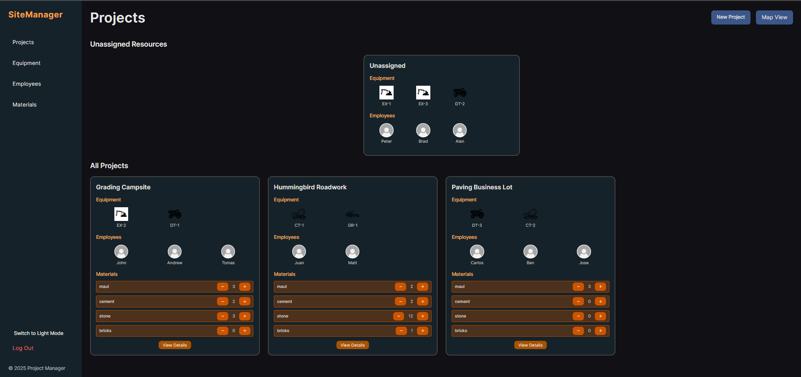
Figure 2: Webpage Projects

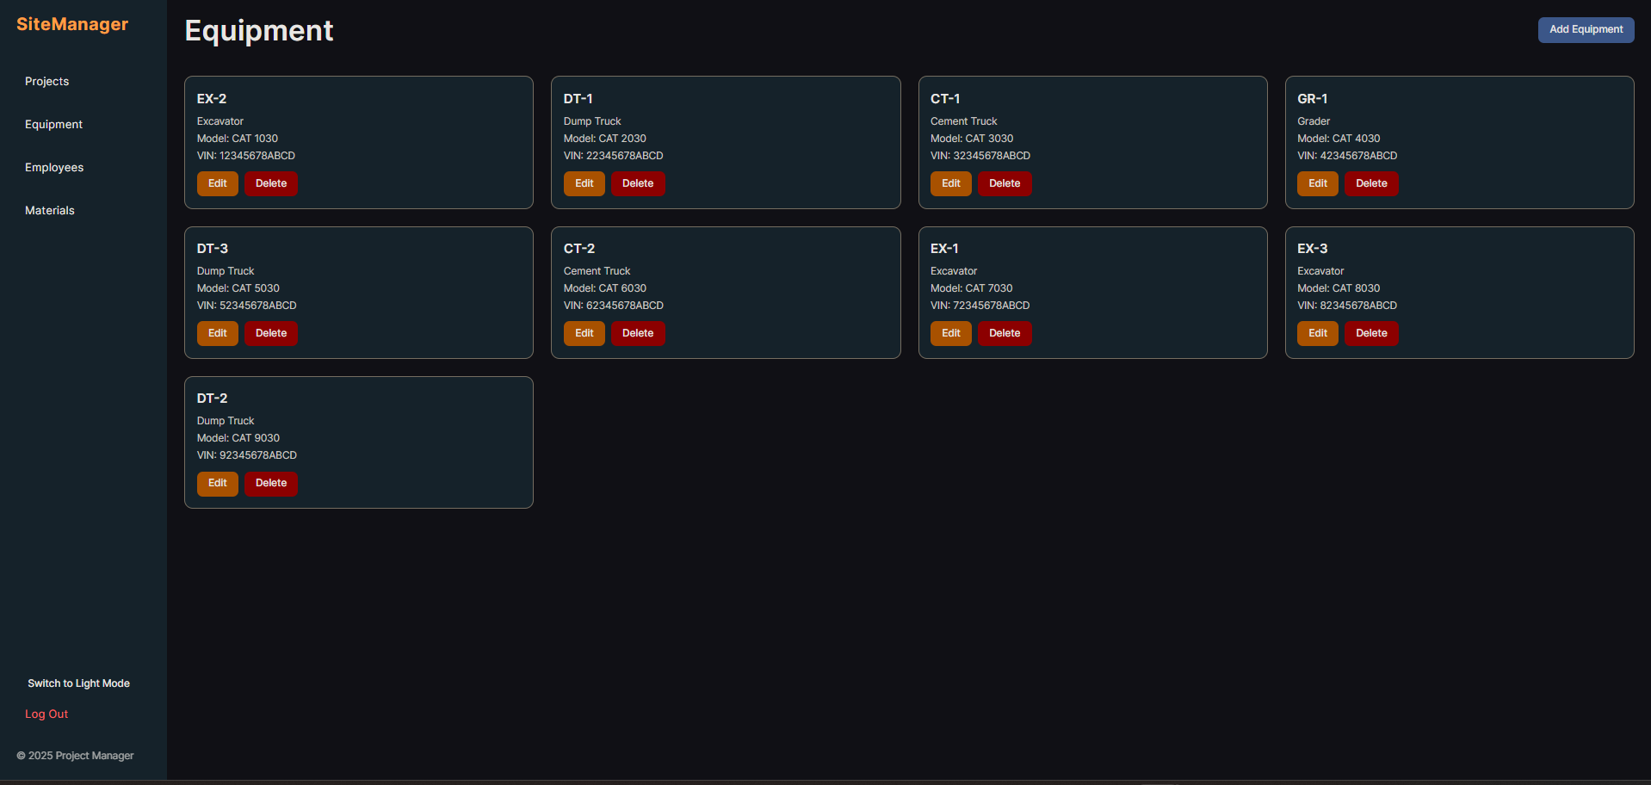
Figure 3: Webpage Equipment

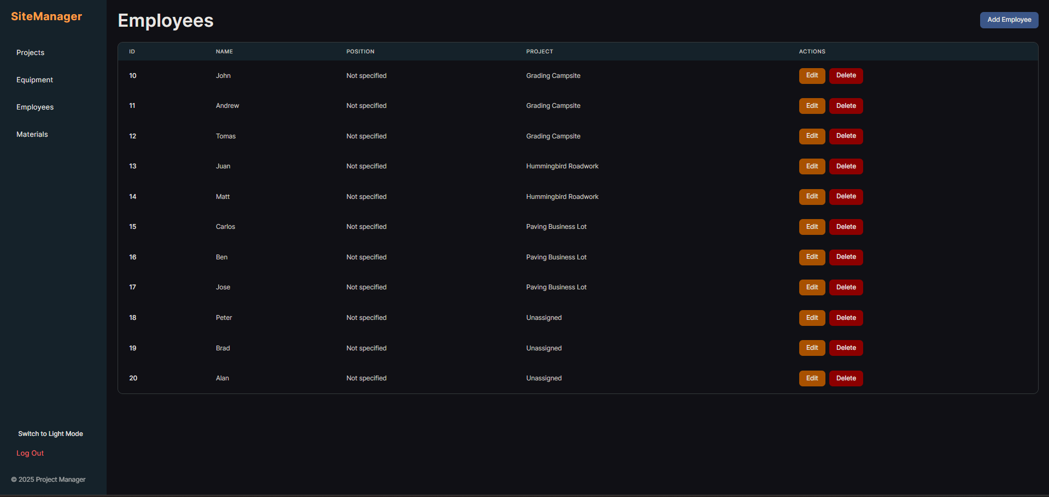
Figure 4: Webpage Employees

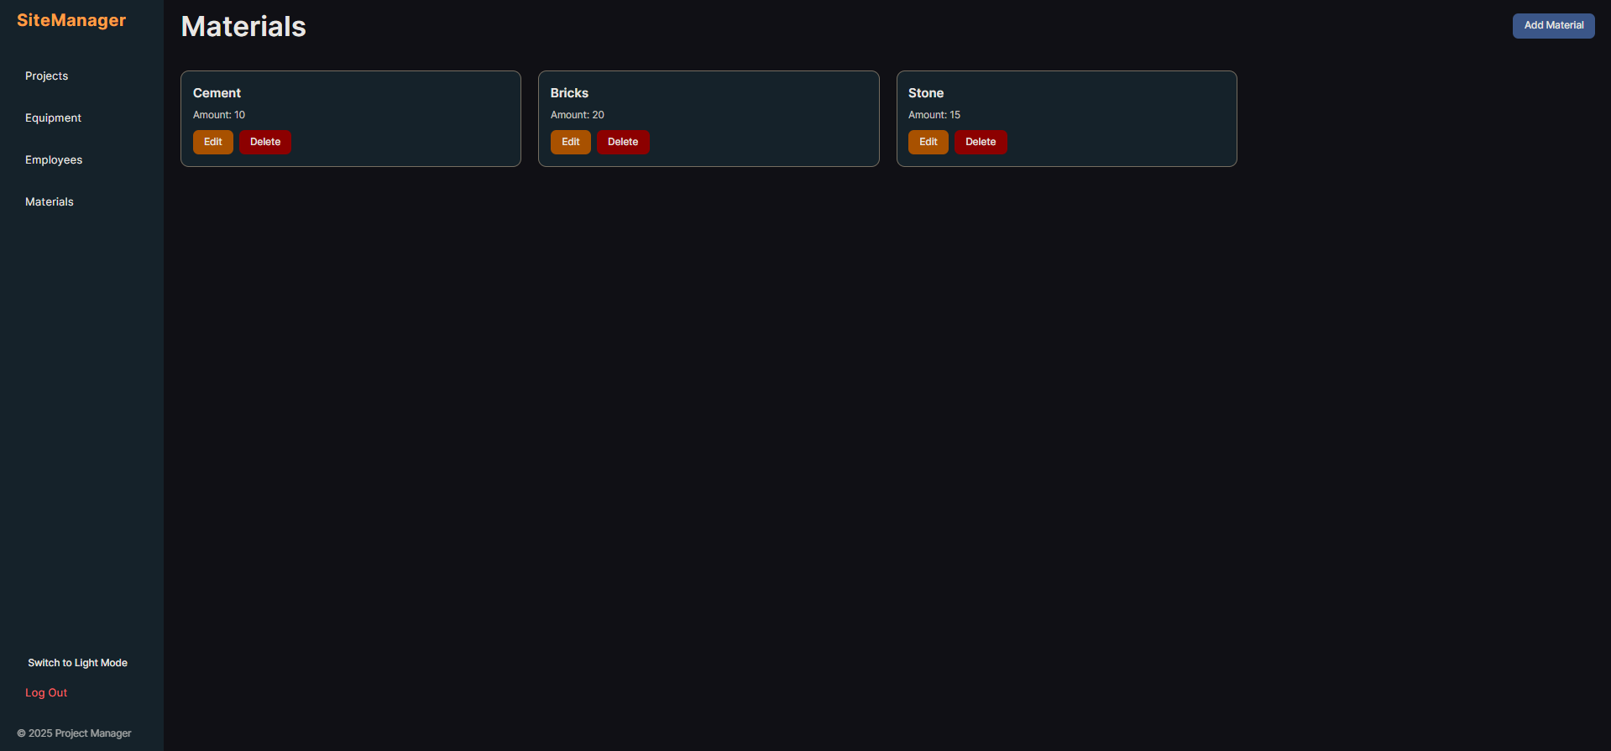
Figure 5: Webpage Materials

Tasks & Final Interface Scenarios

Web:
Task 1 (Easy): Store the list of heavy equipment and their maintenance records and status, allowing the mechanic to edit as required.
Task 2 (Medium): Store the list of all ongoing projects and allow the foreman to see required equipment/materials and upload progress notes.
Task 3 (Difficult/Complex): Show all ongoing projects on an interactive map. Each project contains a list of assigned employees, equipment, and materials that can be edited by the manager.

Why we chose Task 1: Tests fundamental data entry and simple status visualization.
Why we chose Task 2: Tests the application’s ability to link multiple data types onto a single screen.
Why we chose Task 3: Tests the integration of simultaneous multi-entity editing and ensures data consistency across all views.

Storyboard for 3 tasks

- Task 1: Store the list of heavy equipment and their maintenance records and status, allowing the mechanic to edit as required.

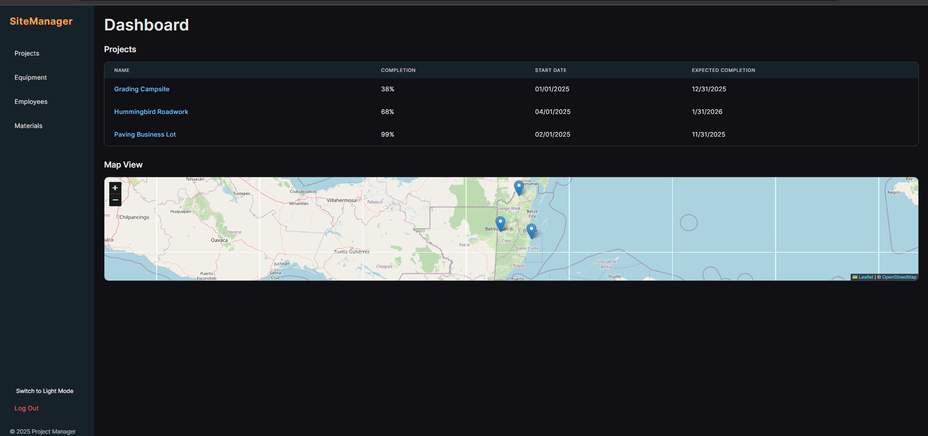 | The user opens the application, and the Site Manager Dashboard is displayed.
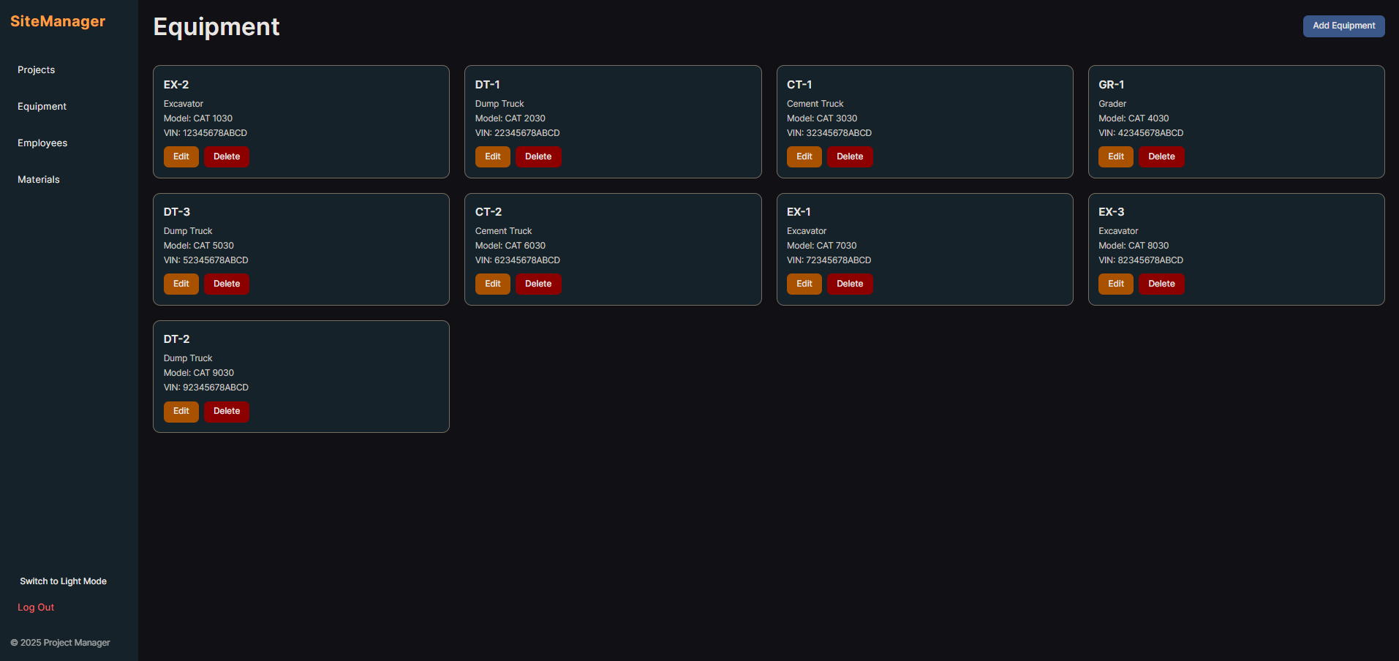 | The user clicks “Equipment” in the sidebar to view the equipment list.
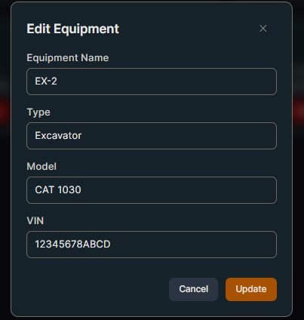 | The User Locates the ‘CAT 1030’ Excavator and clicks the “Edit” button. The user proceeds to change the text in the “VIN” field,
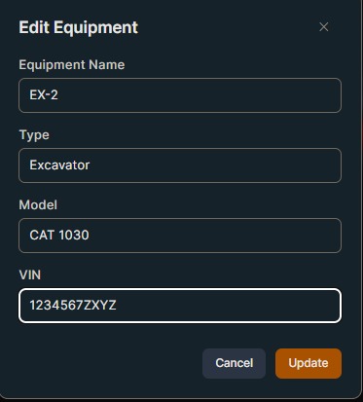 | The user clicks “Update” to save the changes,
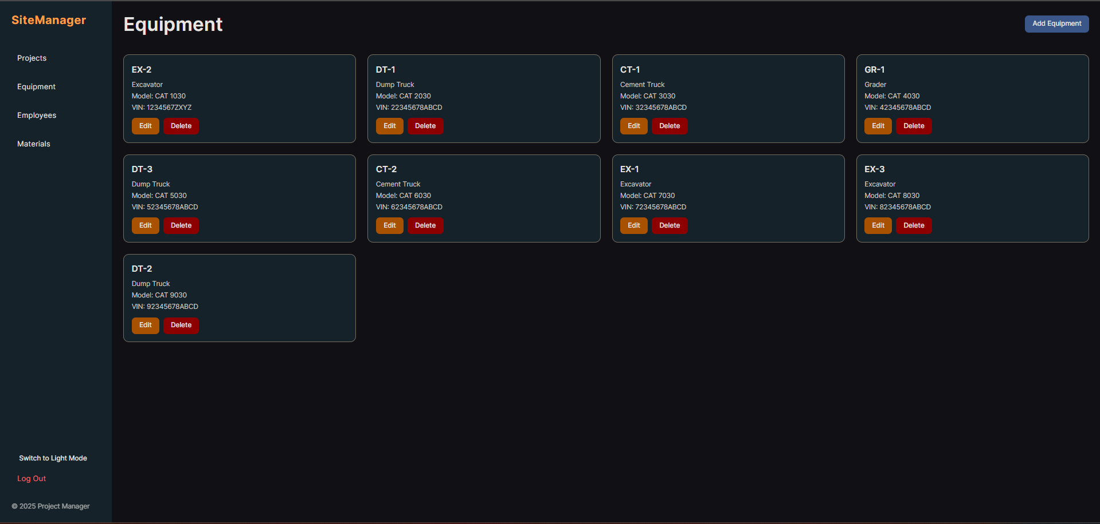 | The Equipment displays the edited version of ‘CAT1030’ Excavator.

- Task 2: Store the list of all ongoing projects and allow the foreman to see required equipment/materials and upload progress notes.

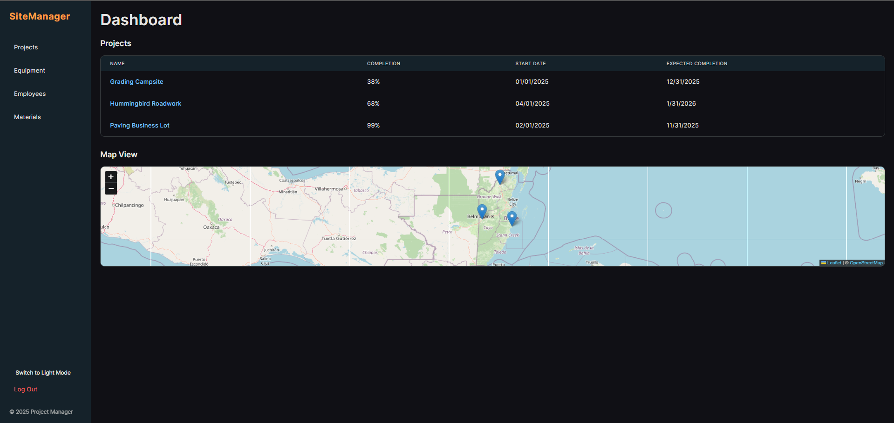 | The user accesses the App’s Dashboard to find project status.
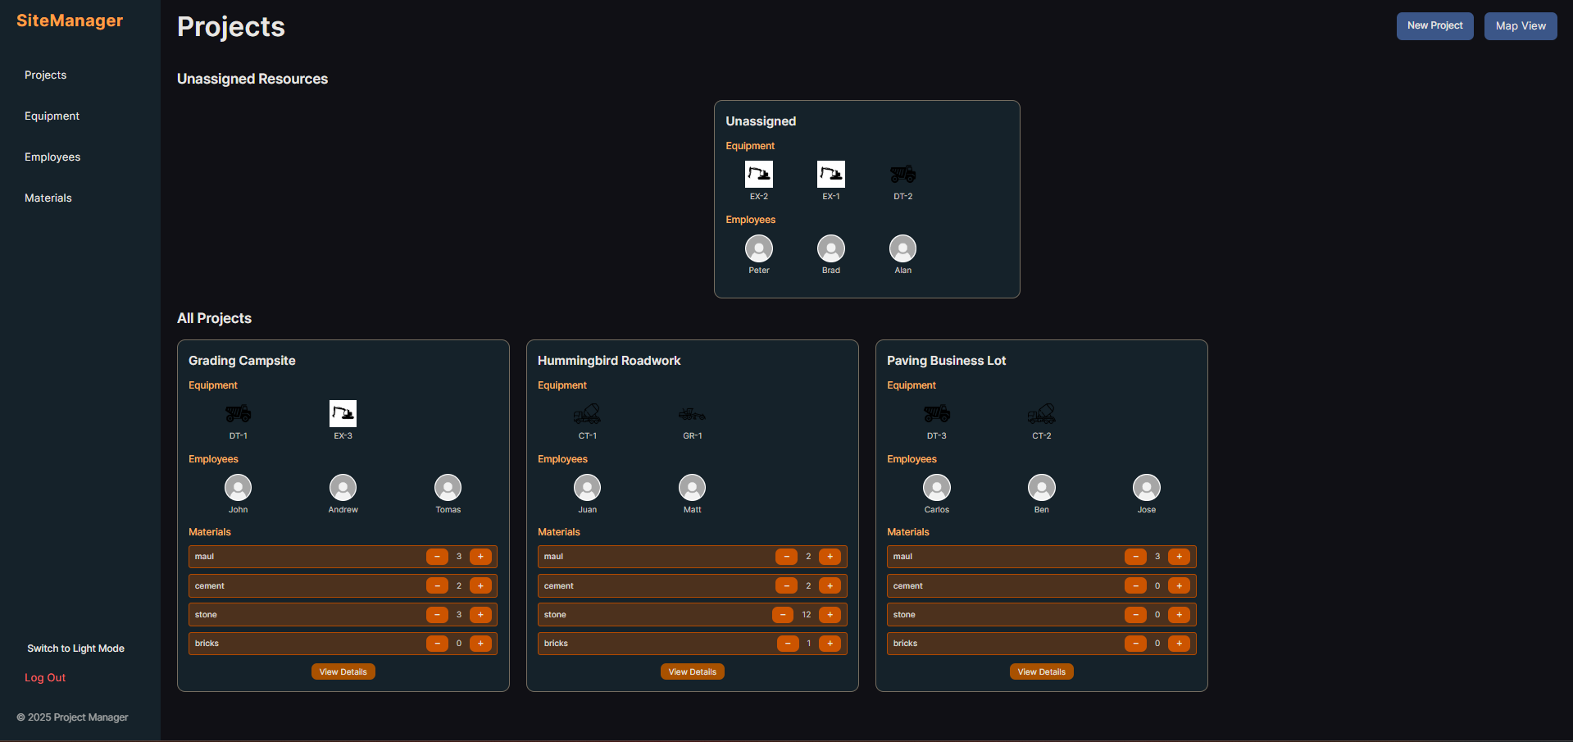 | The user clicks on the “Projects” on the sidebar to view project overview.
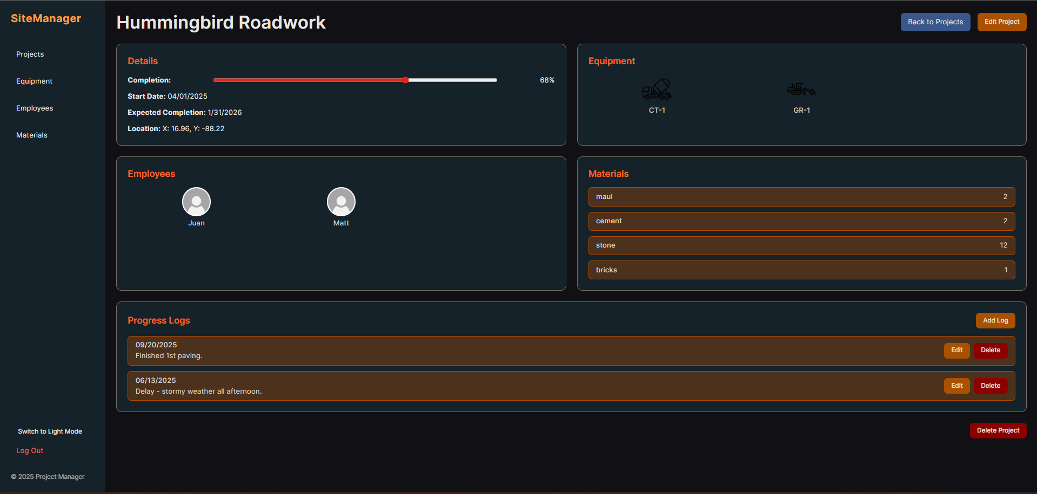 | The user clicks “Hummingbird Roadwork” and views the project’s details.
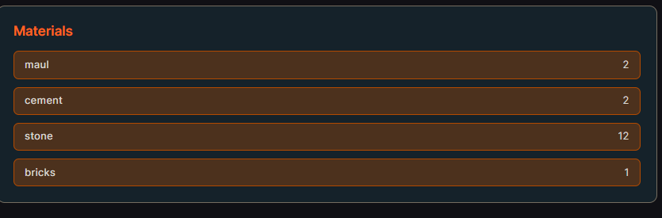 | The user views the ‘Materials’ section to check on the remaining amounts of supplies.
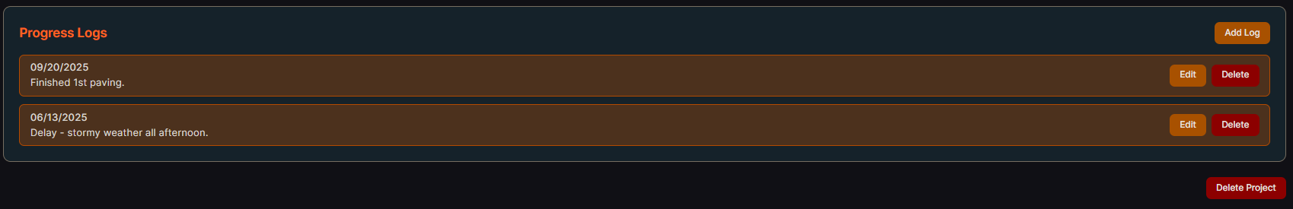 | The user scrolls down the page to the “Process Logs” section and clicks “Add Log.”
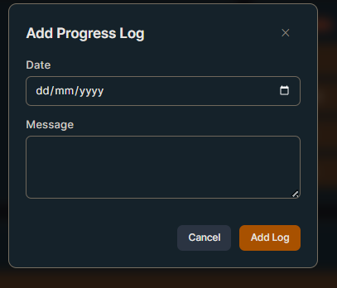 | The user clicks on “Add Log.”
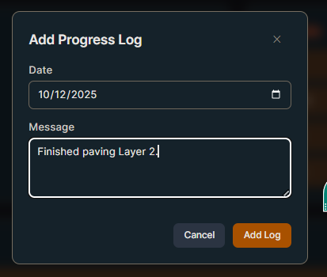 | The user selects the date and enters new progress information, then clicks “save.”
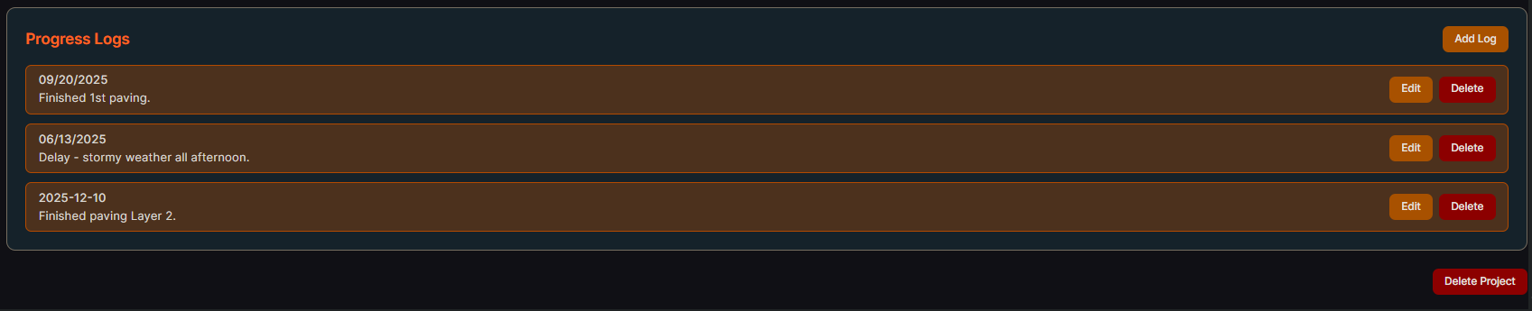 | The new log appears at the top of the “Progress Logs” list with the date.

- Task 3: Show all ongoing projects on an interactive map. Each project contains a list of assigned employees, equipment, and materials that can be edited by the manager.

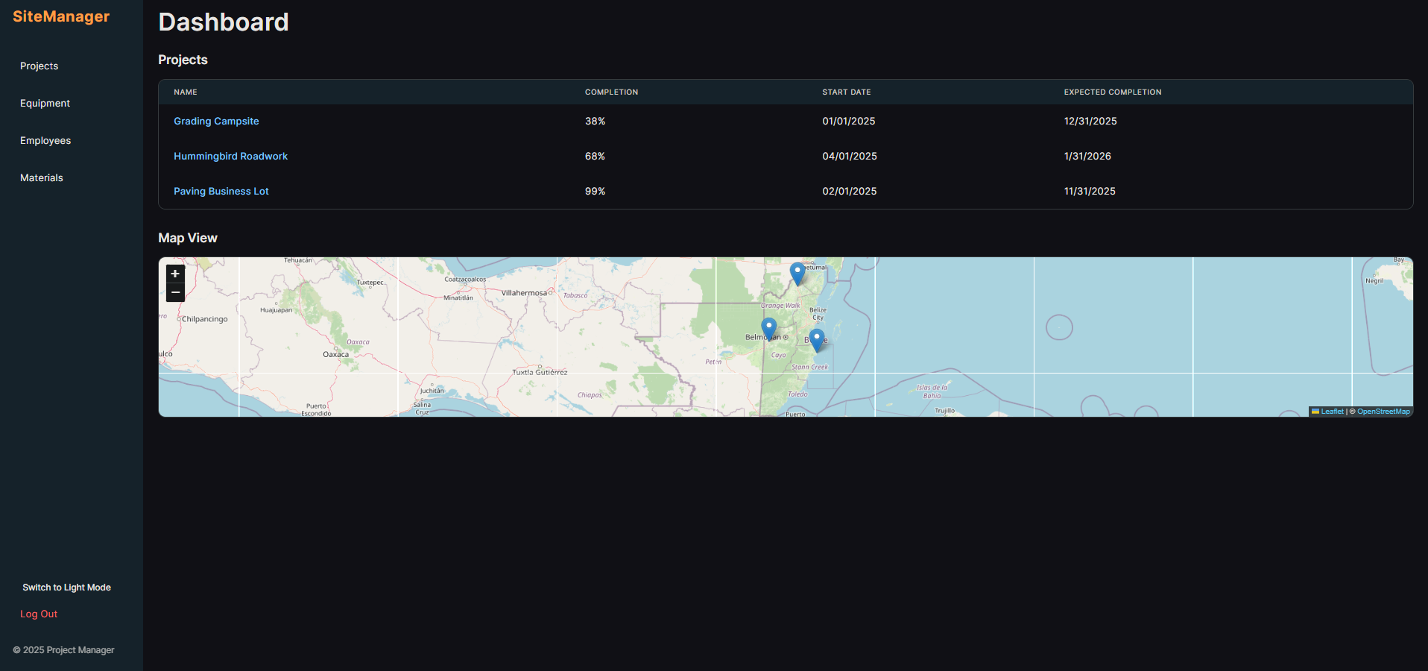 | The user accesses the App’s Dashboard to find the “Map View.”
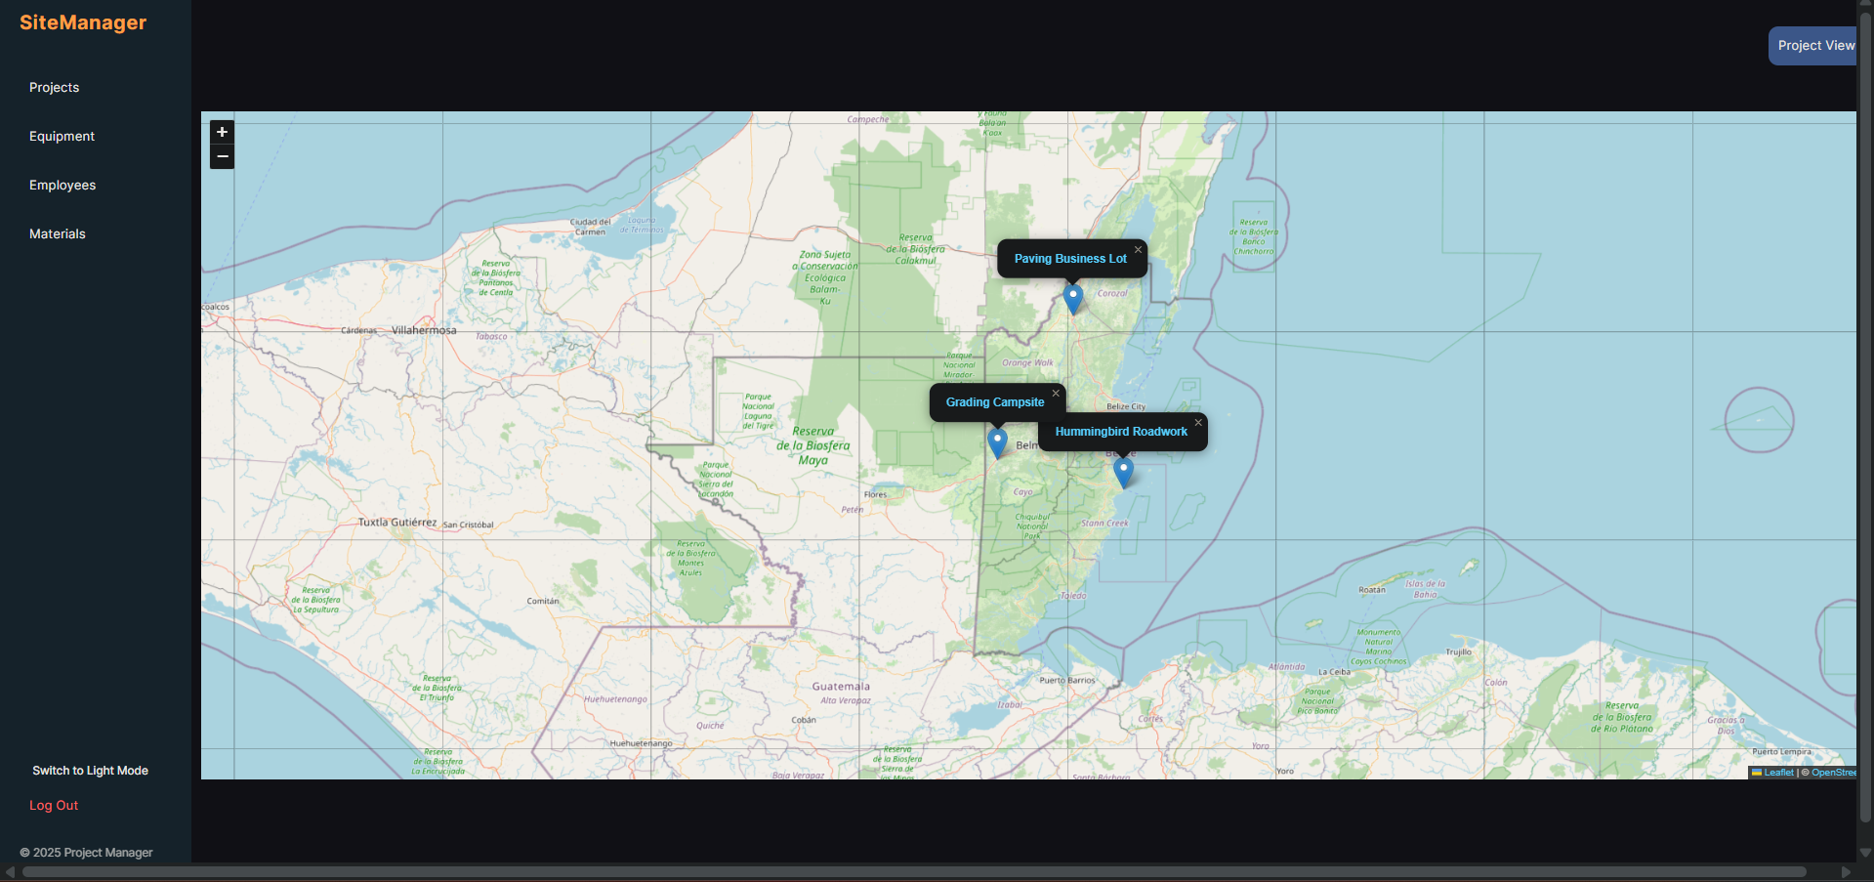 | The user clicks on the “Map View” and searches for ‘Paving Business Lot,” then clicks on it.
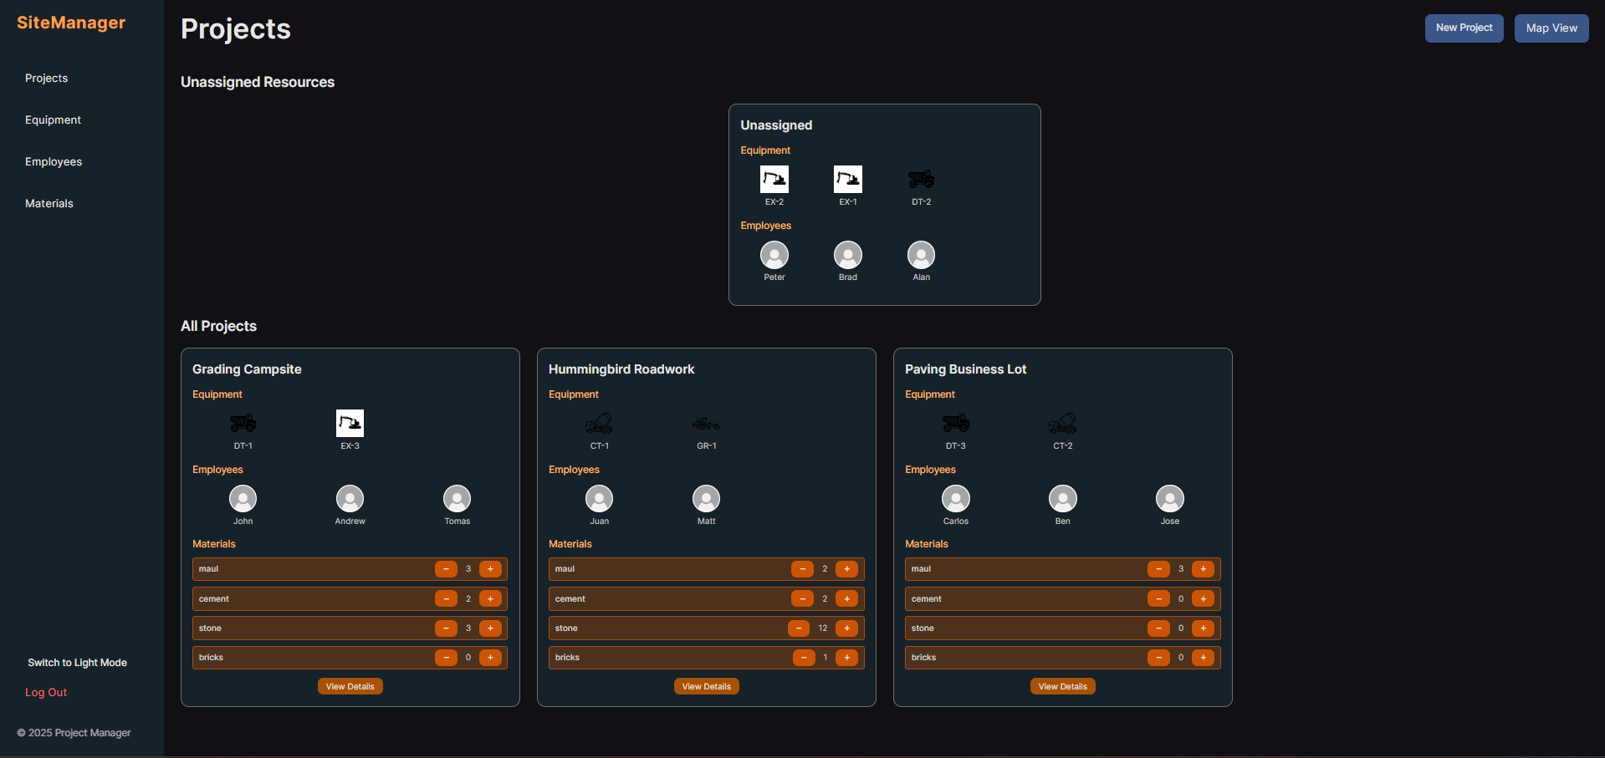 | The user then prompts to open the Projects tab via the pin in the previous step.
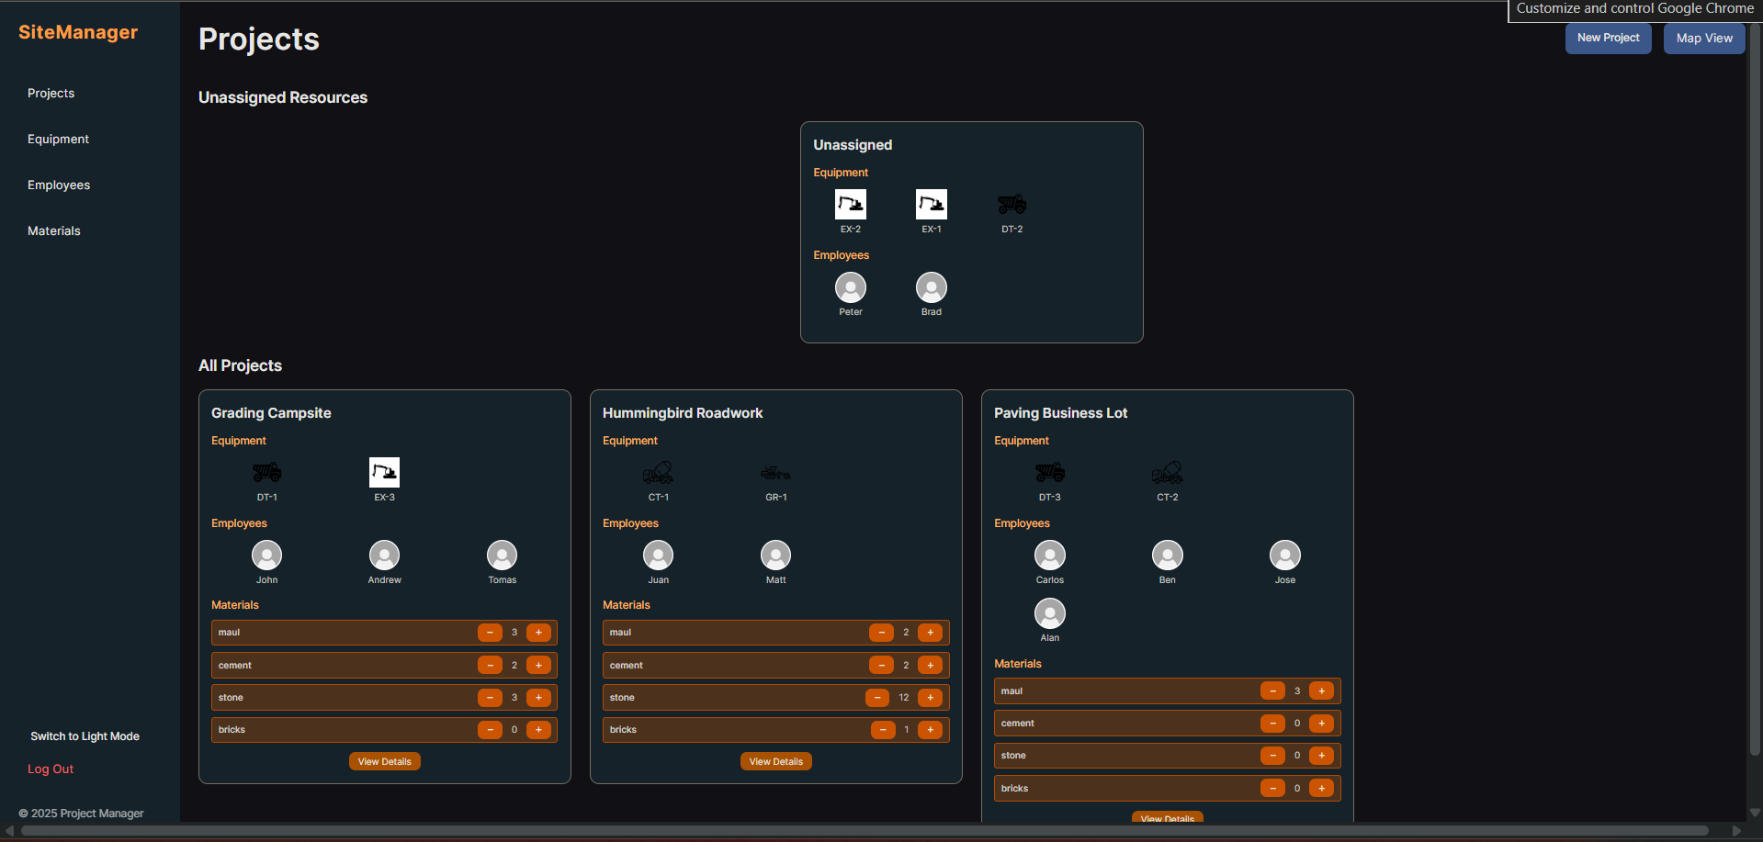 | The user drags and drops ‘Alan’ over to the ‘Paving Business Lot.’ The system updates the ‘Paving Business Lot’ card, showing ‘Alan’ now assigned.
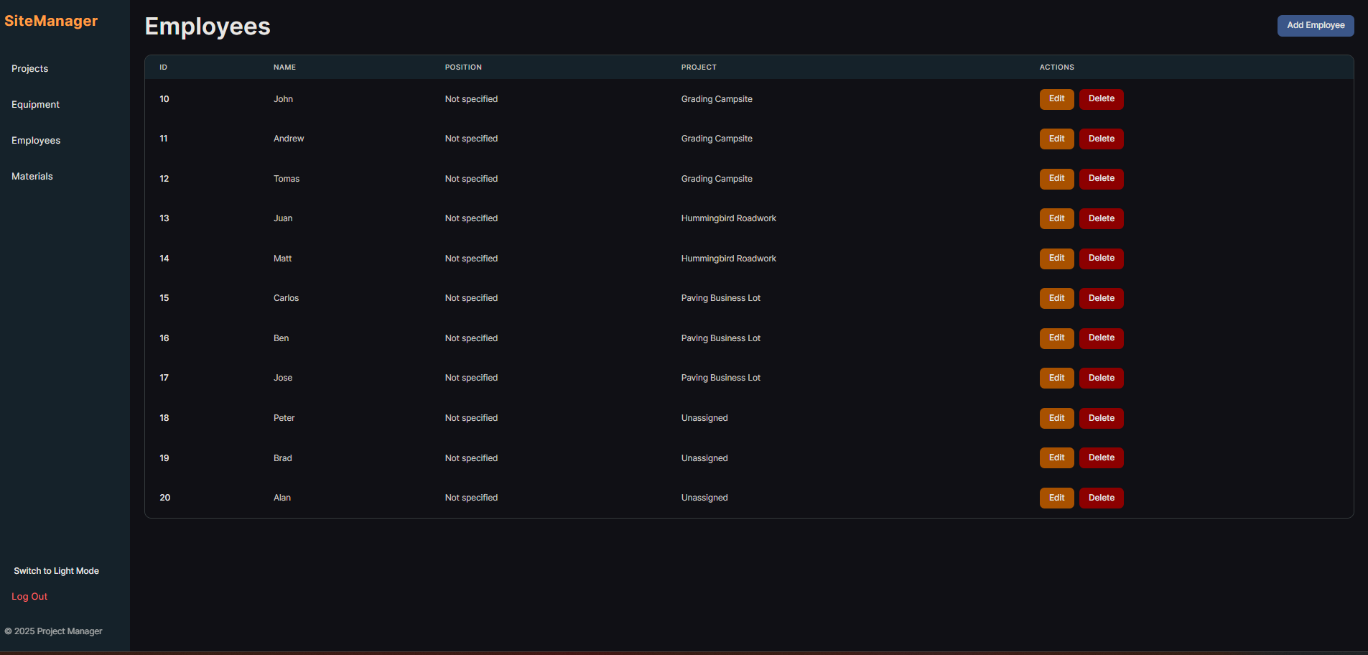 | The user navigates to the “Employees” list via the sidebar. The user verifies that Alan is now listed for the specific project. (In this screenshot, Alan is not shown as assigned because we do not have a backend as yet)

Design Evolution

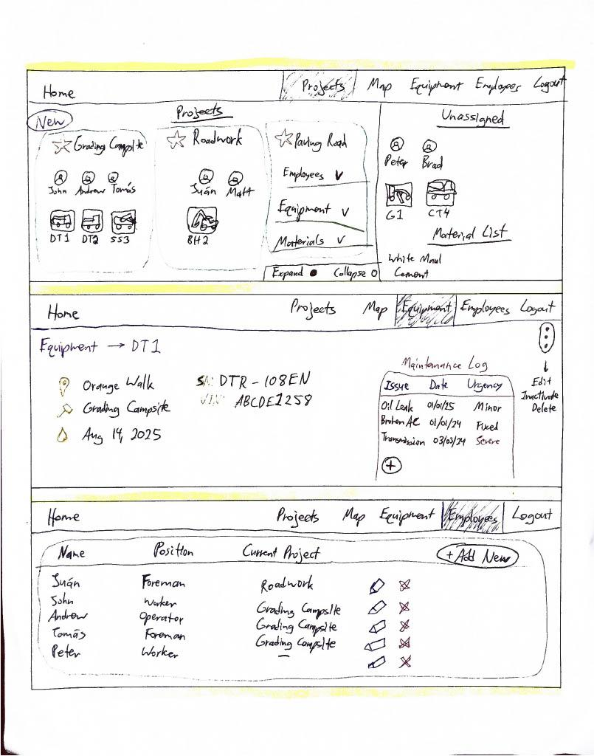
Sketches

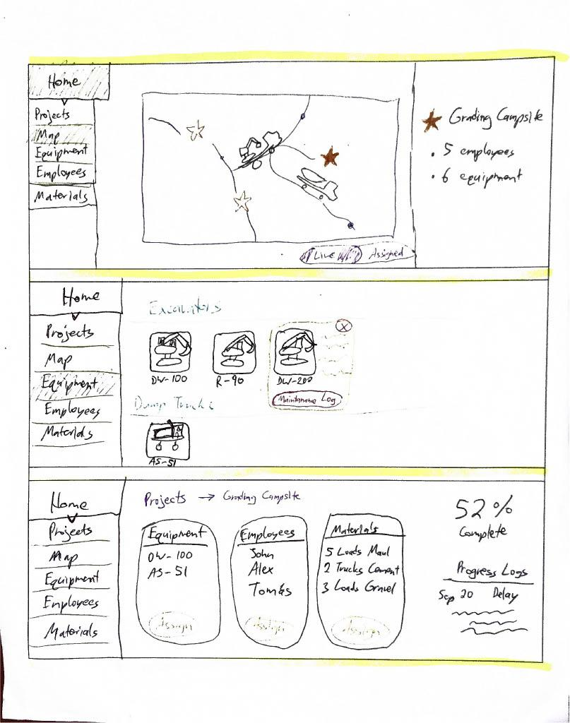

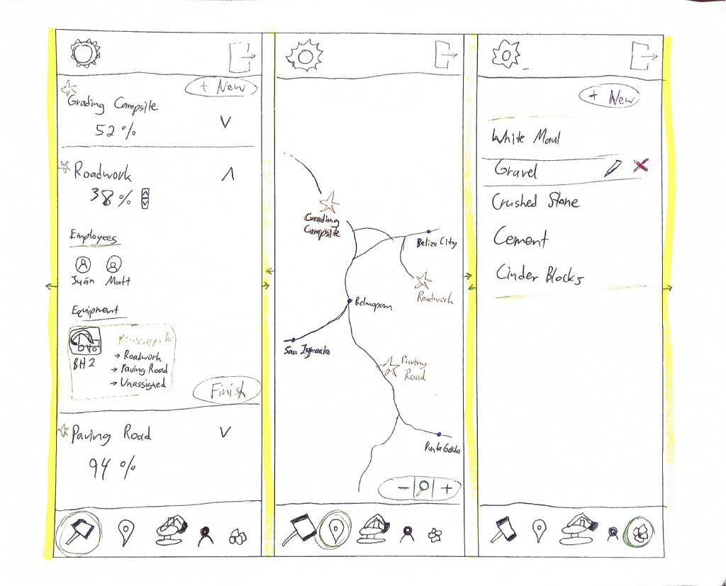

Lo-Fi Prototype
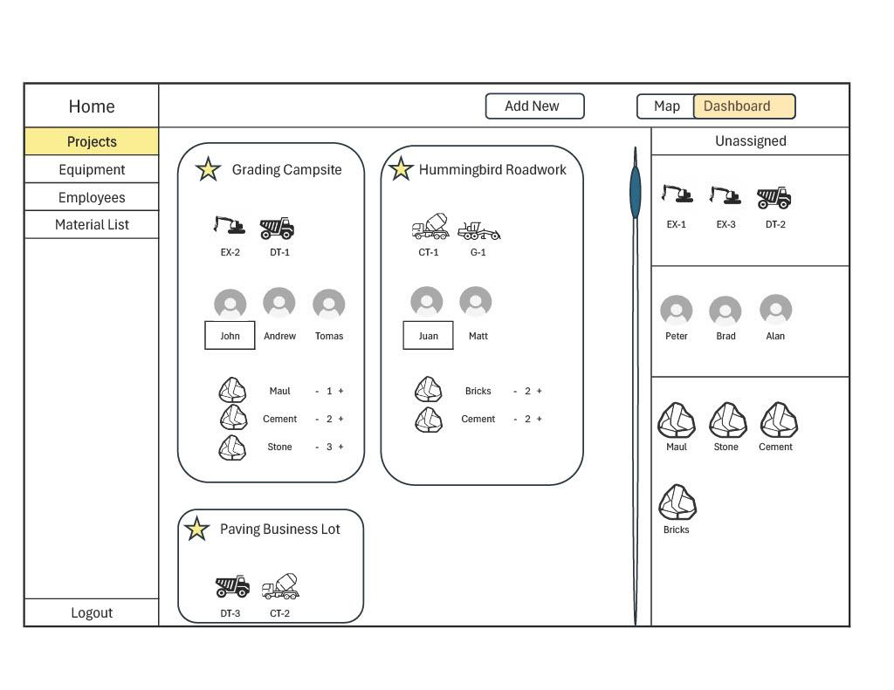
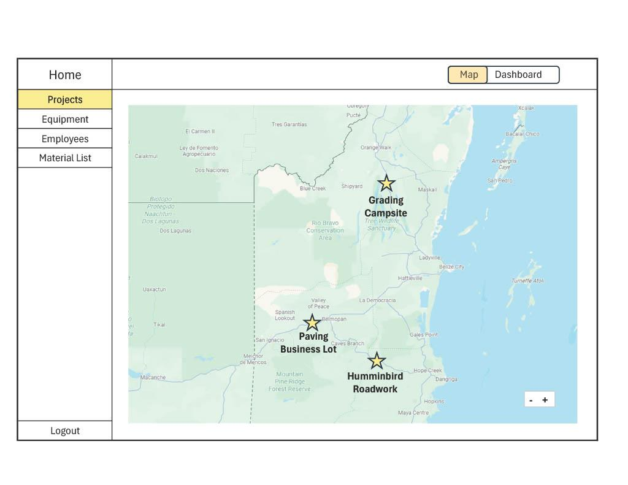

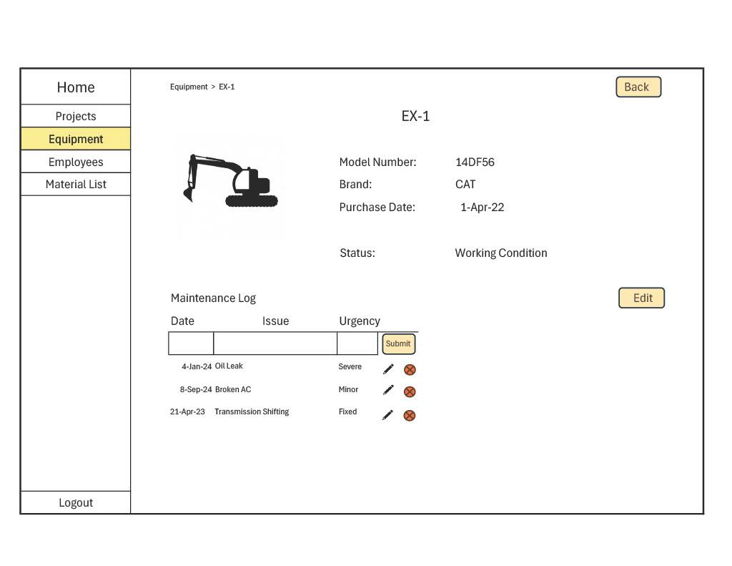

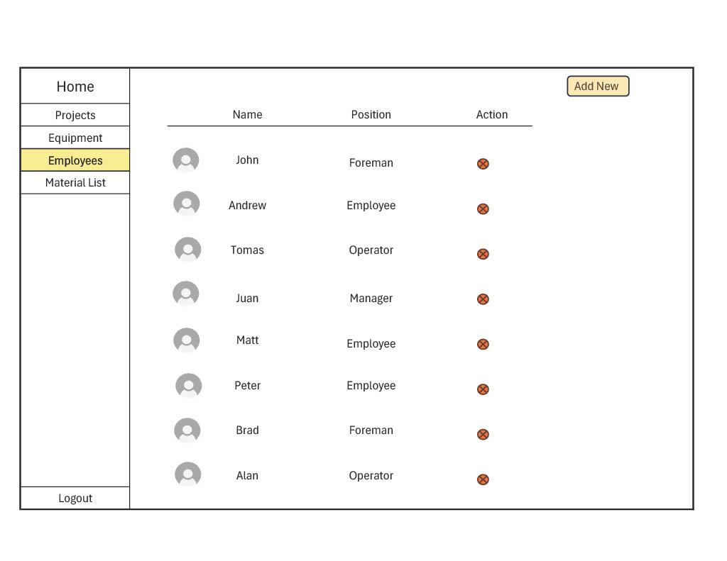

Medium-Fi Prototype
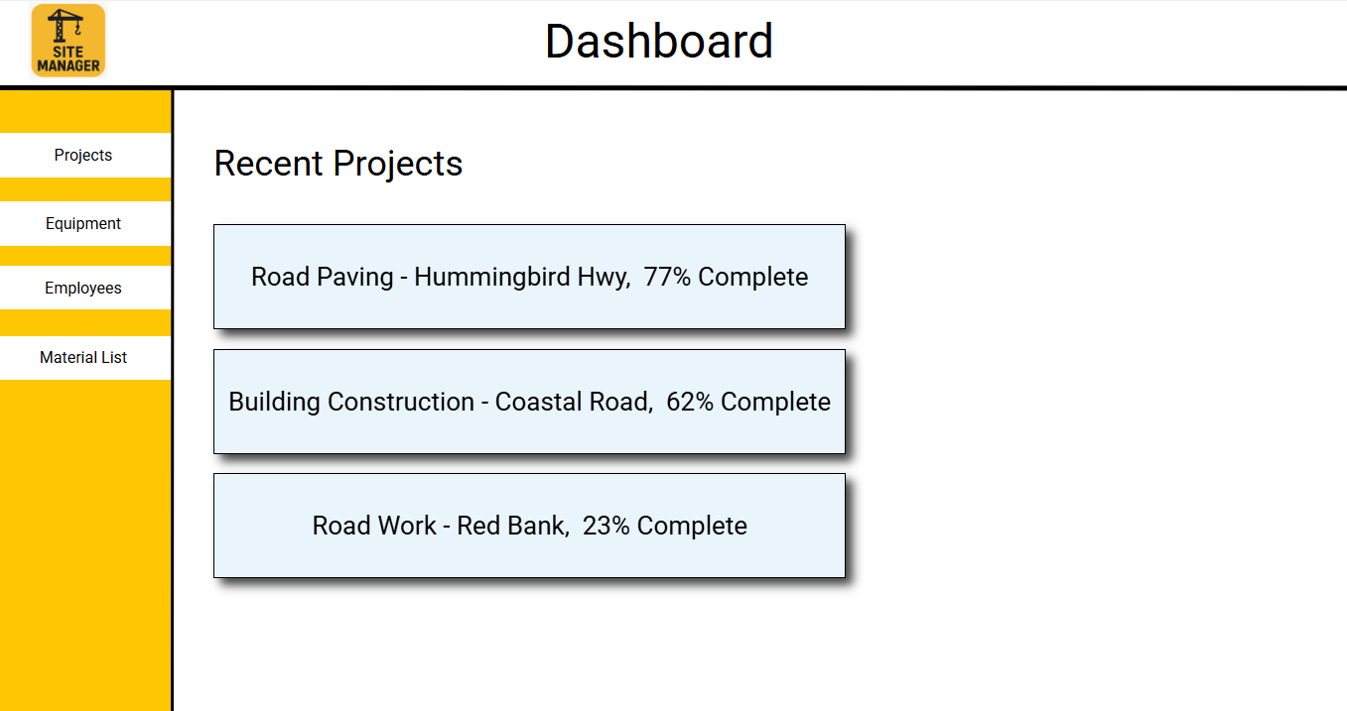

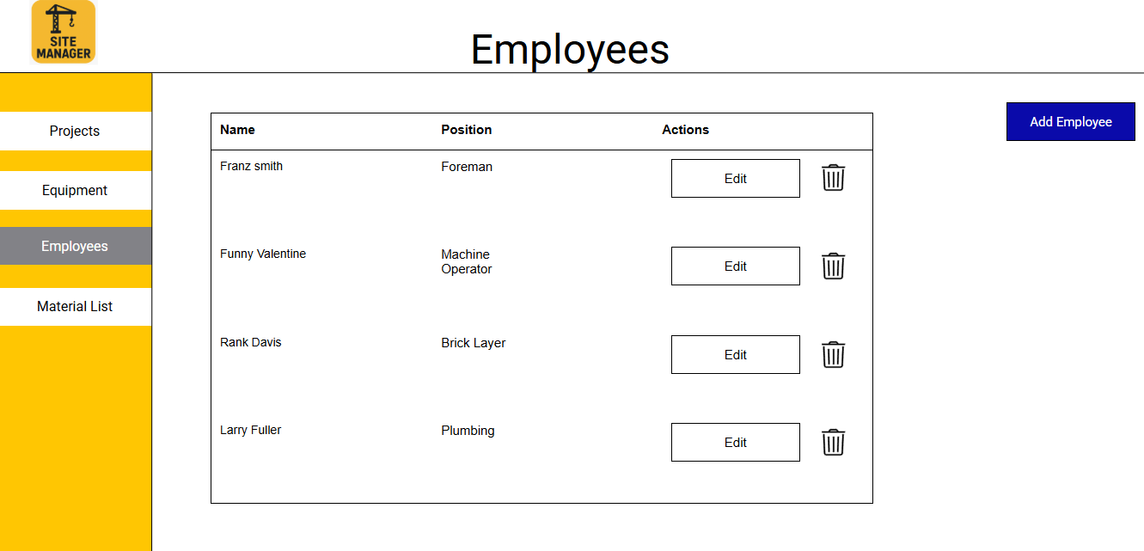

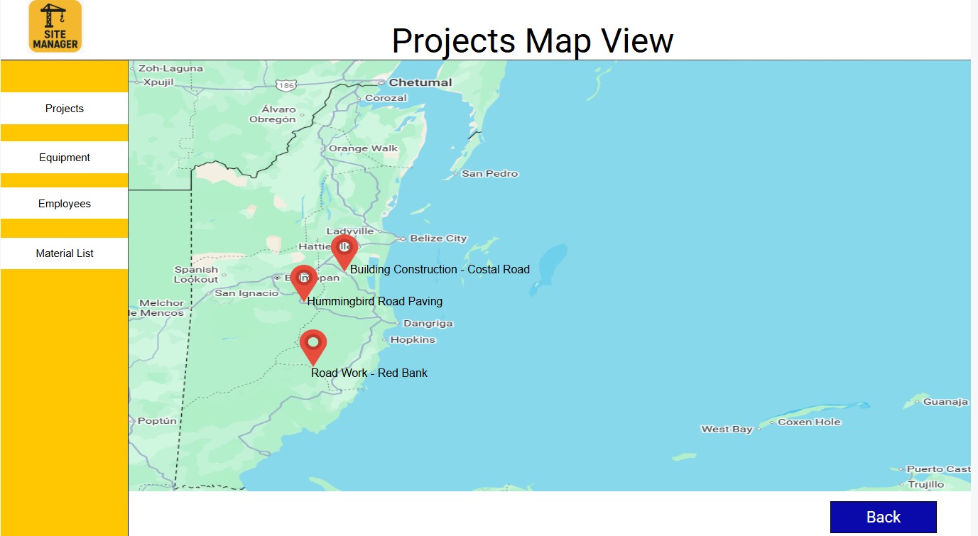

Major Usability Problems Addressed

Map View
Heuristic: Match Between System and the Real World (H2) Severity: Major

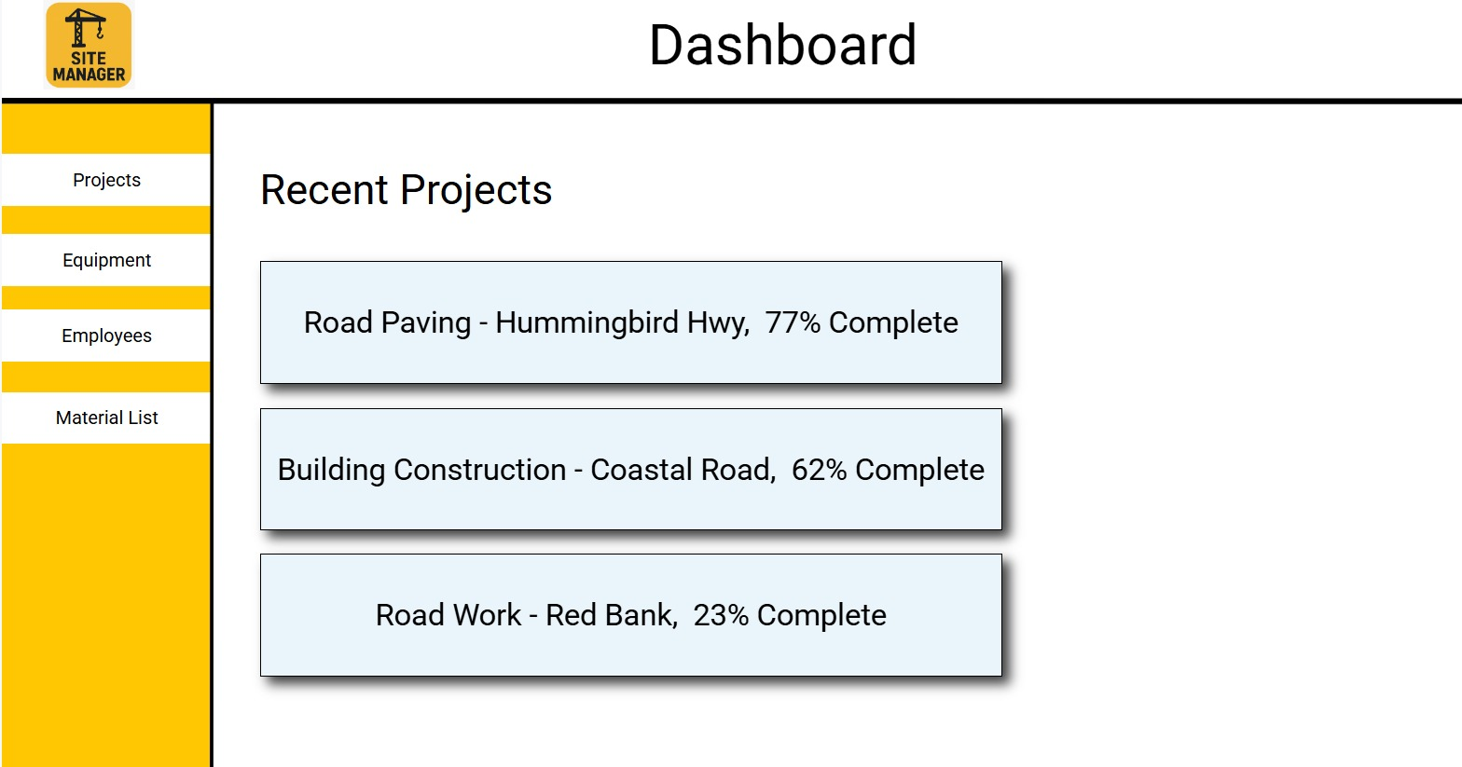
Problem: Users struggled to visualize project locations geographically, forcing them to manually cross-reference text-based lists with external maps. This increased cognitive load and reduced efficiency, especially for managers overseeing multiple projects across different regions.

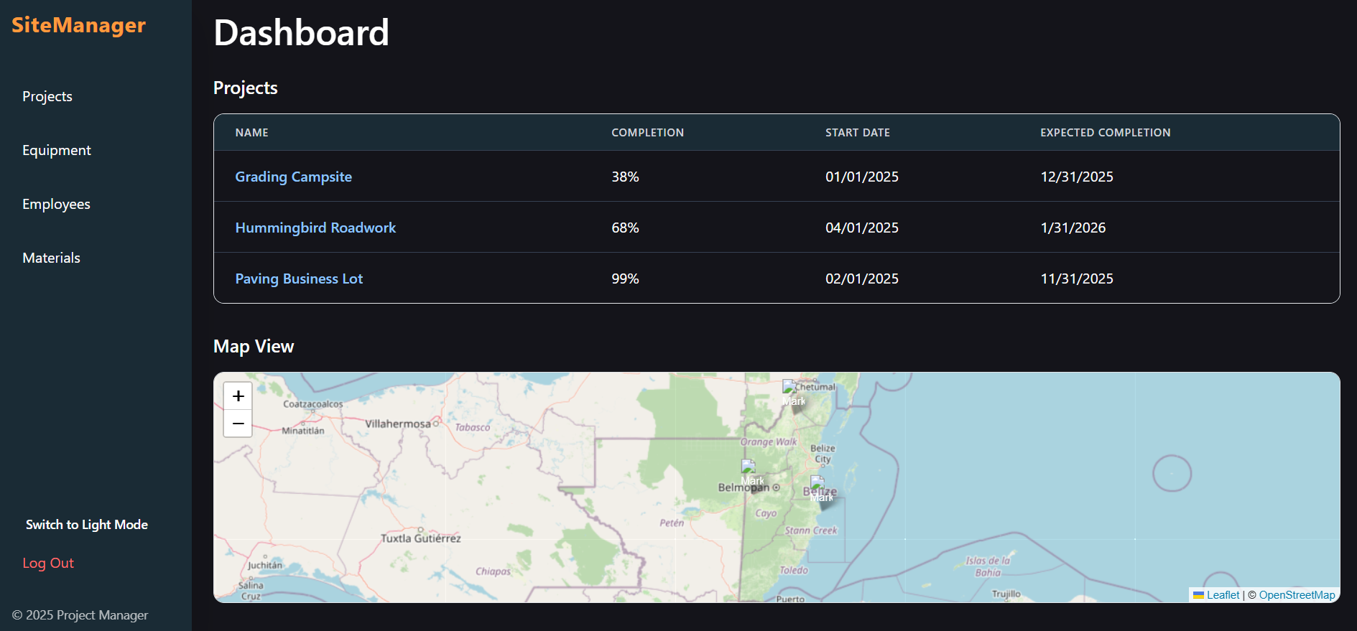
Solution: Introduced an interactive map to display project locations, enabling quick spatial assessment and improving situational awareness.

Unassigned Resources Card
Heuristic: Error Prevention (H5) & Recognition Rather Than Recall (H6) Severity: Major

Problem: Users lacked a centralized view of unassigned resources, leading to inefficiencies, double-booking, or overlooked equipment and employees. This increased the risk of errors in resource allocation.

Unassigned Resources Card
Heuristic: Error Prevention (H5) & Recognition Rather Than Recall (H6) Severity: Major
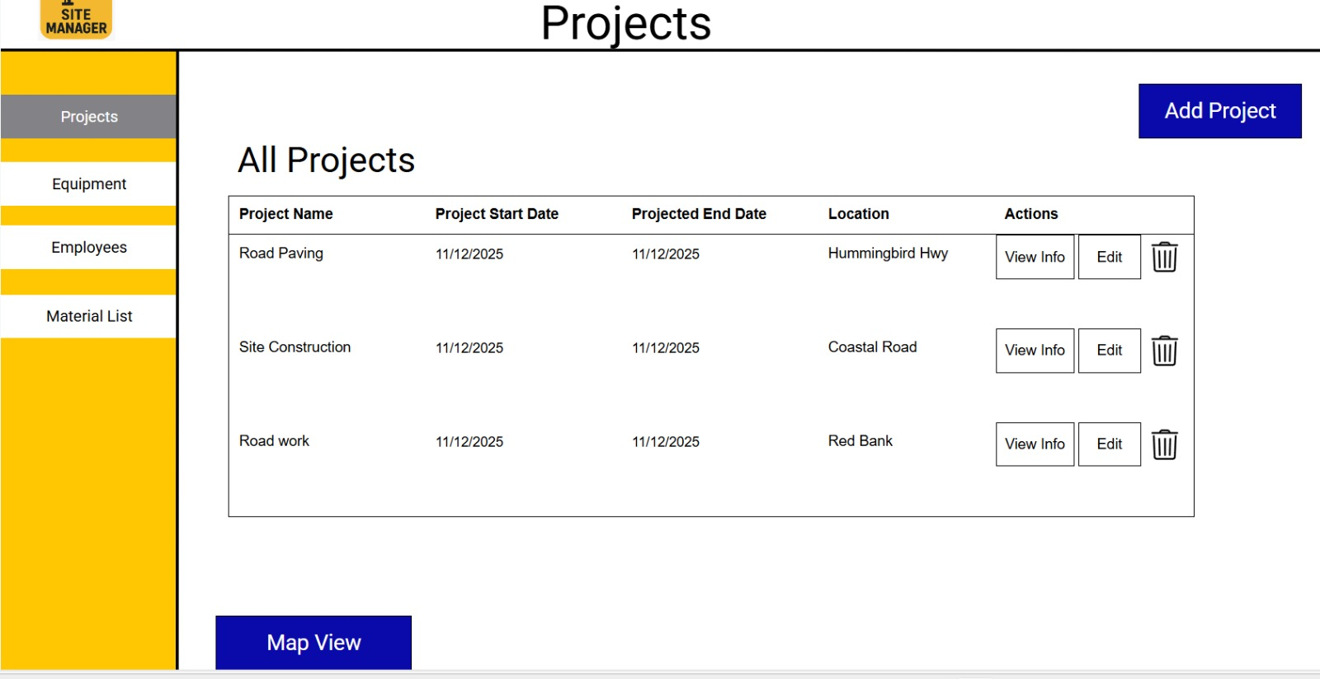
Problem: Users lacked a centralized view of unassigned resources, leading to inefficiencies, double-booking, or overlooked equipment and employees. This increased the risk of errors in resource allocation.

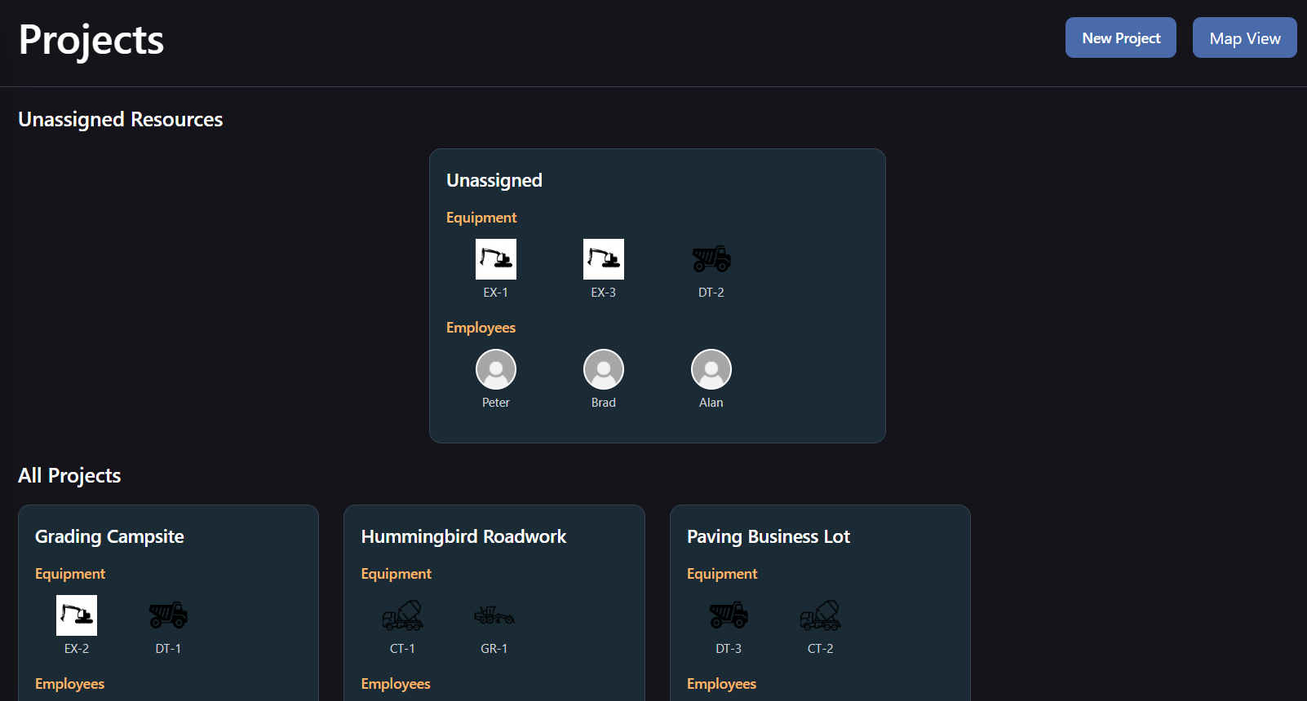
Solution: Added an "Unassigned Resources" card to provide a clear, at-a-glance view of available resources, streamlining allocation and reducing oversight.

Enhanced Edit Equipment Section
Heuristic: User Control and Freedom (H3) & Consistency and Standards (H4) Severity: Major

Edit Equipment
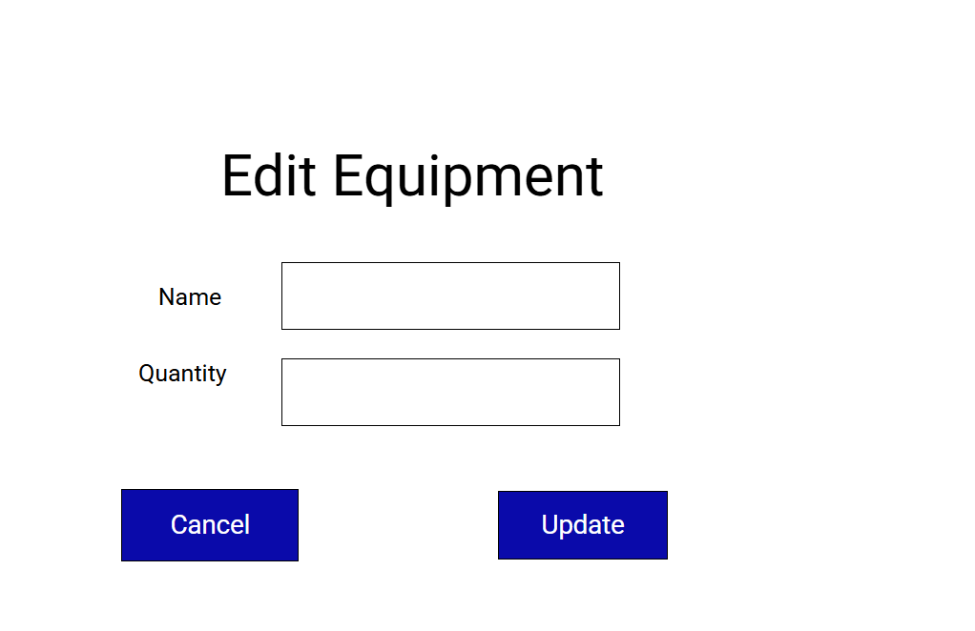
Problem: The "Edit Equipment" section only allowed basic edits (Name, Quantity), missing critical details like Type, Model, and VIN. This limited effective equipment tracking and management.

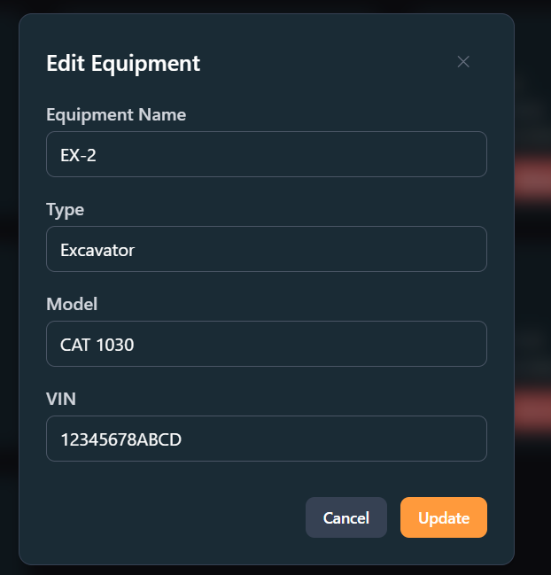
Solution: Expanded the section to include detailed fields (Type, Model, VIN), improving accuracy and usability for equipment management.

Detailed Project Pages
Heuristic: Visibility of System Status (H1) & Recognition Rather Than Recall (H6) Severity: Major
Problem: Project pages lacked structured information about progress, resources, and logs, making it difficult for users to assess project status or history. This led to miscommunication and inefficiencies.
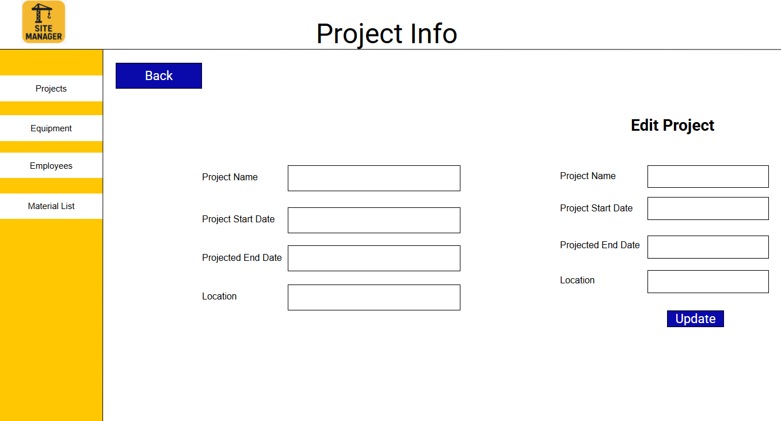

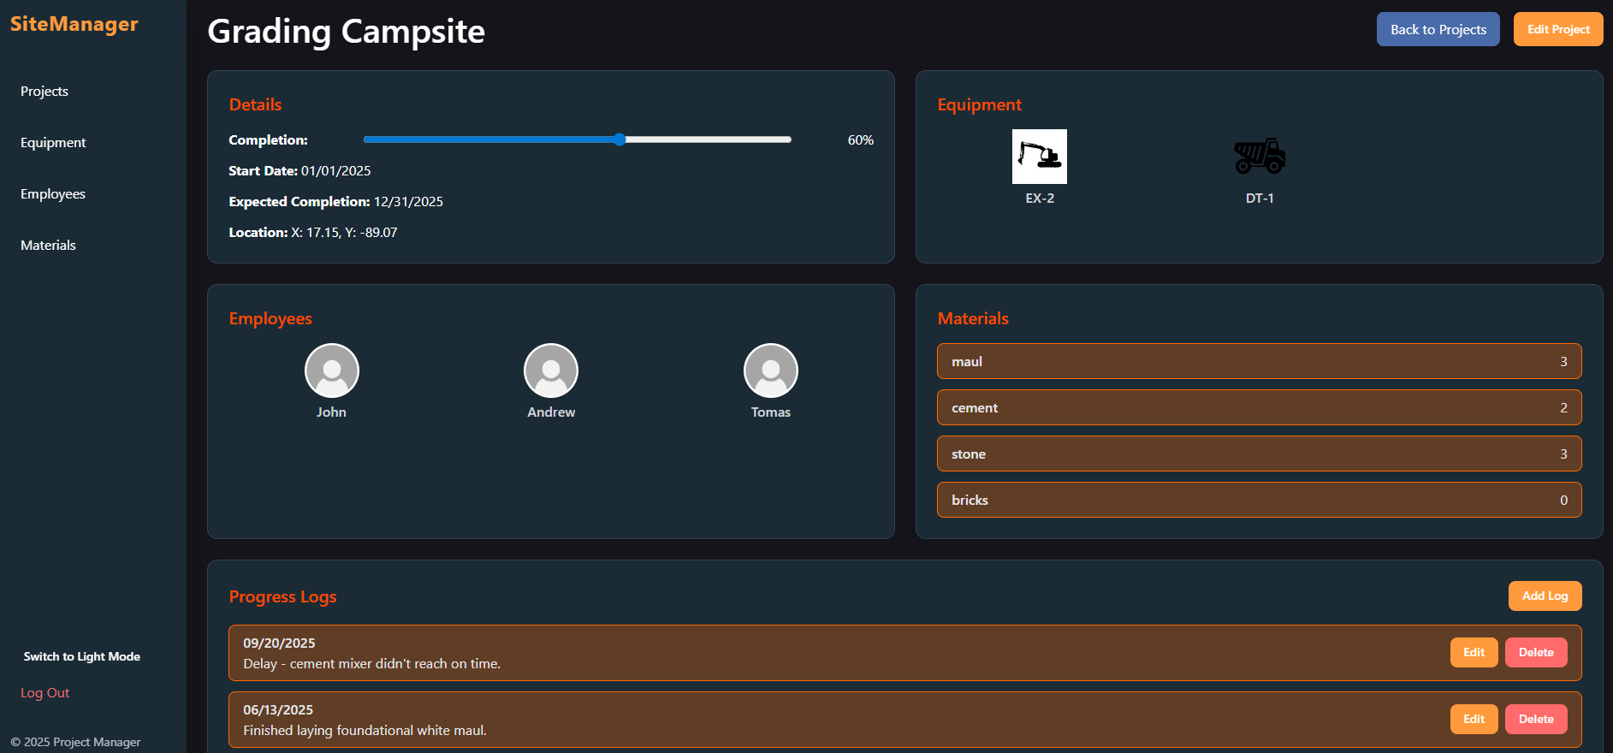
Solution: Added comprehensive sections (Details, Equipment, Employees, Materials, Progress Logs) to provide clarity, transparency, and easy access to project information.

Prototyping Tools:
- GitHub- Asynchronous cooperation is enabled by the use of a version control system. made it possible for the team to coordinate changes, share code, and collaborate effectively without having to be physically there.

- React- chosen due to its component-based architecture. immensely beneficial for designing modular, maintainable user interfaces. It enabled the rapid reuse of UI components (such as buttons and cards), which accelerated development. made sure that all application views followed standards and had a consistent visual style.

- JavaScript-It was picked due to its everyday nature. allowed the entire stack to utilize a single, standardized language (for both the React frontend and potential backend). Debugging became more manageable, and the development team's context switching decreased. enables an easy interaction with common web libraries and APIs.

Conclusion

The development of the SiteManager application was a tremendous learning experience throughout the whole Human-Computer Interaction (HCI) design process. From early manual sketches and low-fidelity planning to interactive Canva prototypes and, finally, a genuine, largely functional high-fidelity prototype, we are grateful to have learnt and mastered a wide range of skills. This project has helped us understand the need of continuous iteration, various types of testing and prototyping, and the critical impact that technological decisions have in achieving usability goals.
Our technical stack was carefully selected to promote collaboration and modularity. We utilized GitHub extensively for version control; its strong asynchronous cooperation features were really useful, allowing the team to share code, coordinate changes, and collaborate effectively without having to be physically present. React was chosen because of its component-based architecture, which is essential for developing modular and maintainable user interfaces. This architecture enabled the rapid reuse of standardized user interface elements (such as buttons, forms, and cards), resulting in significantly faster development while ensuring that all application views adhered to identical visual standards. Finally, JavaScript was selected as the critical bridge since it is widely used and allows the complete stack to communicate in a single, standardized language. This approach enabled easy interaction with common web libraries and APIs to complete the final prototype, accelerated development, simplified debugging, and reduced the team's context switching.
Even though our heuristic review and task-based storyboards validated the essential functionality, the project requires more features (such as strong error handling and full implementation of the map editing feature) before it can be considered production-ready. We greatly appreciate the extensive design and technical experience gained via this process, and we look forward to completing the remaining stages of this project for our next class.

