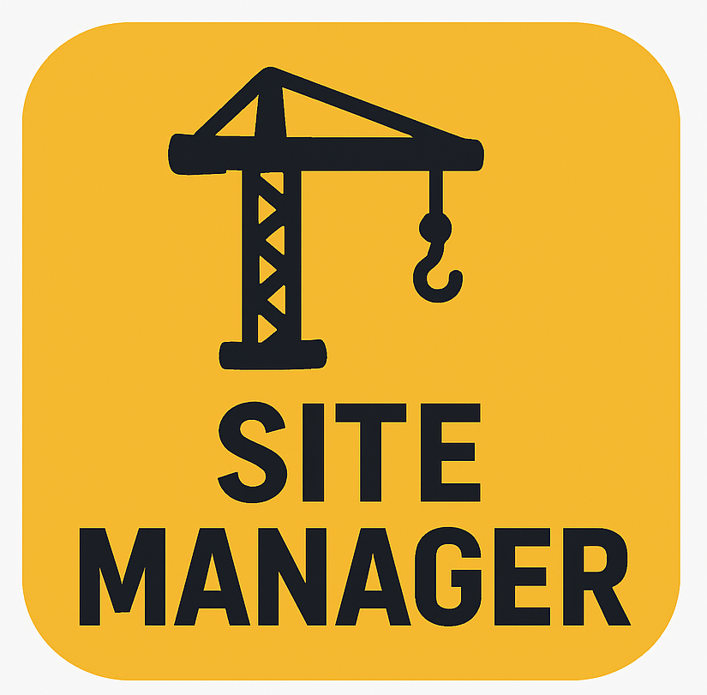

SiteManager
Enrique Garcia,
Kelvin Gordon, Joseph Koop

Table of Contents

Introduction 1
Value Prepositions ……………………………………………………………………………….1
Problem…………………………………………………………………………………………..1
Solution…………………………………………………………………………………………1
Sketches 2
Sketches 3
Selected Interface 4
Final Prototype 5
Final Prototype 6
Selected Interface Design 7
Method 8
Procedure 9
Results 10
Challenges 11
Consent Form 12
Consent Form 12

Introduction

Value Proposition

“Right people. Right equipment. Right on time.”

Problem

Construction companies require a digital dashboard to track all projects, employees, and equipment in one centralized location, as current systems often lack real-time visibility, resulting in inefficiencies. Managers frequently have to rely on manual reports, calls, or spreadsheets to understand what resources are available or where progress is being delayed, which slows down operations and leads to scheduling conflicts.

Solution

Our solution is to create a live map that links to projects and shows exactly which employees, equipment, and materials are needed at each location. By combining this information into one dashboard, SiteManager helps construction managers make faster, data-driven decisions, reduce downtime, and improve communication between teams on different sites. The result is a smoother, more efficient workflow that keeps projects on track and on schedule.

Sketches
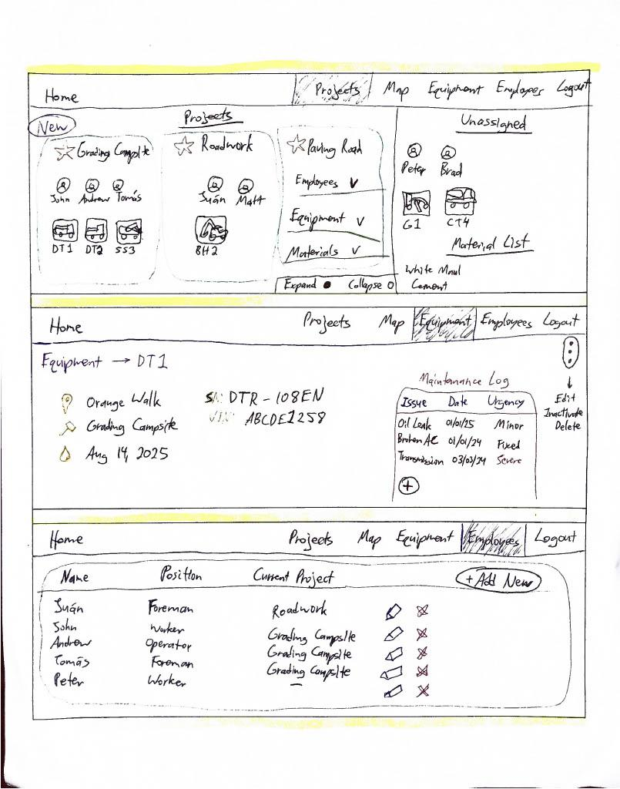
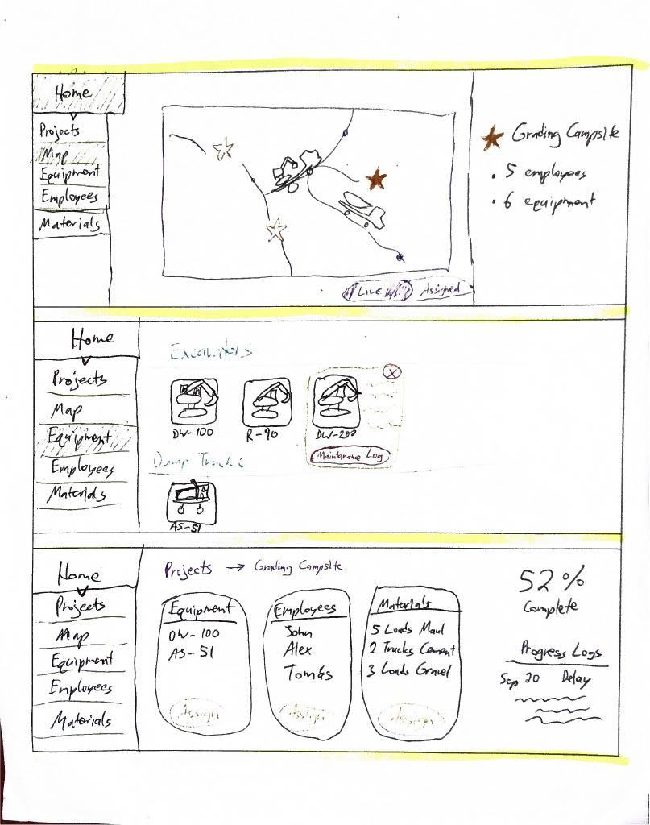

Figure 1: Webpage Figure 2: Webpage
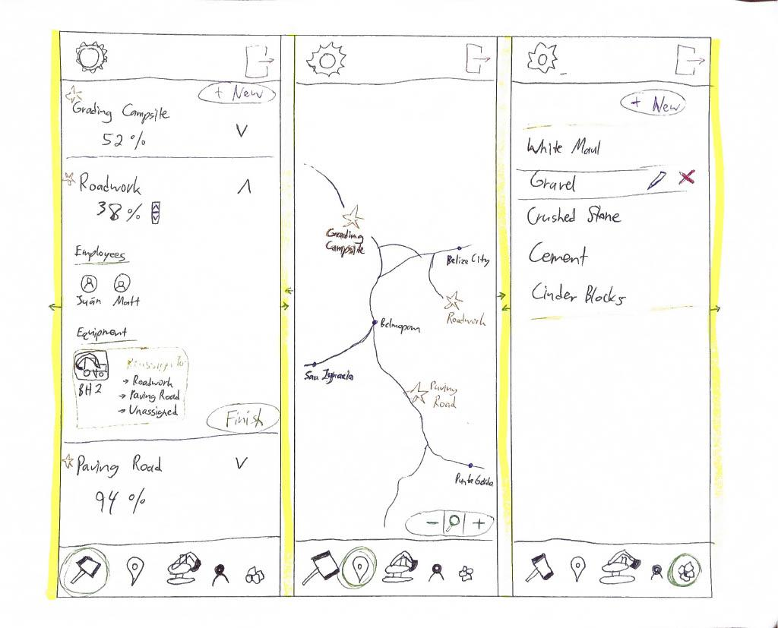

Figure 3: Mobile
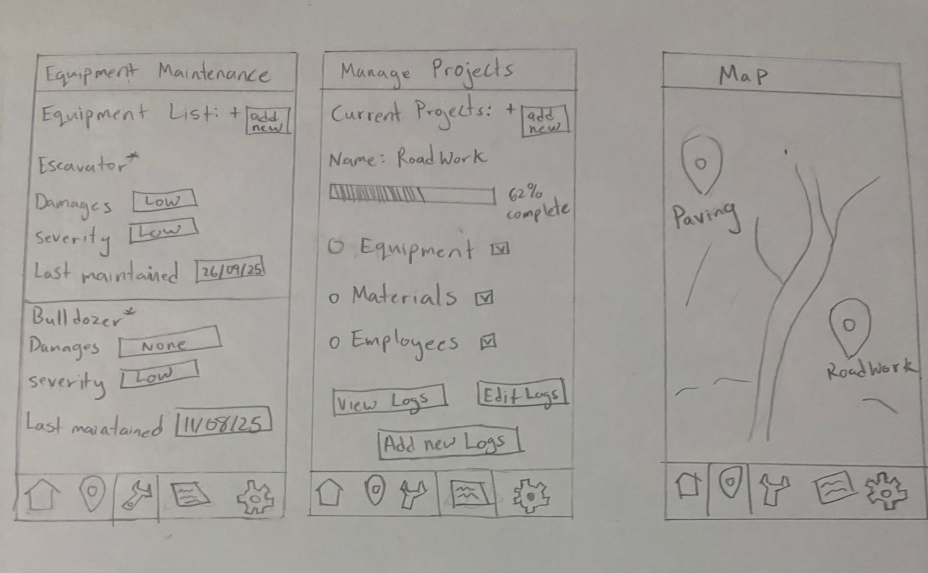

Figure 4: Mobile

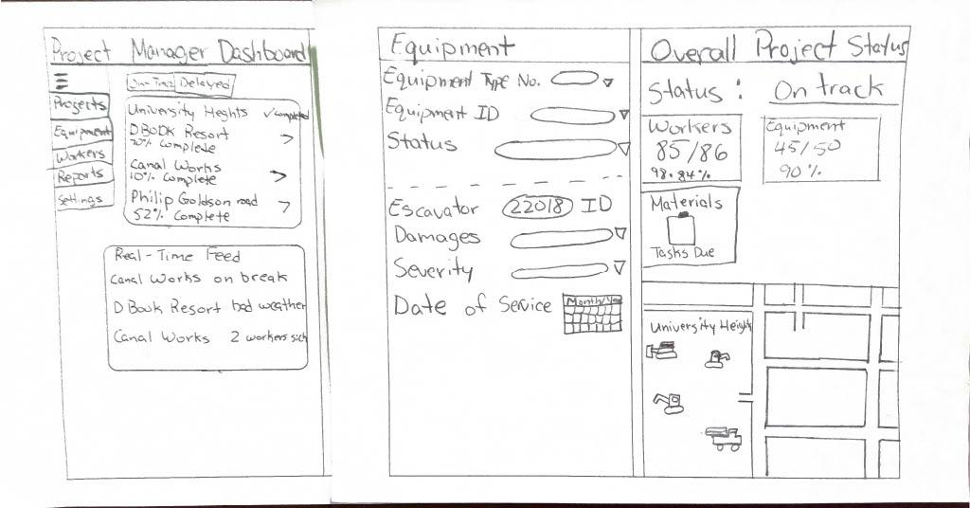

Figure 5: Tablet

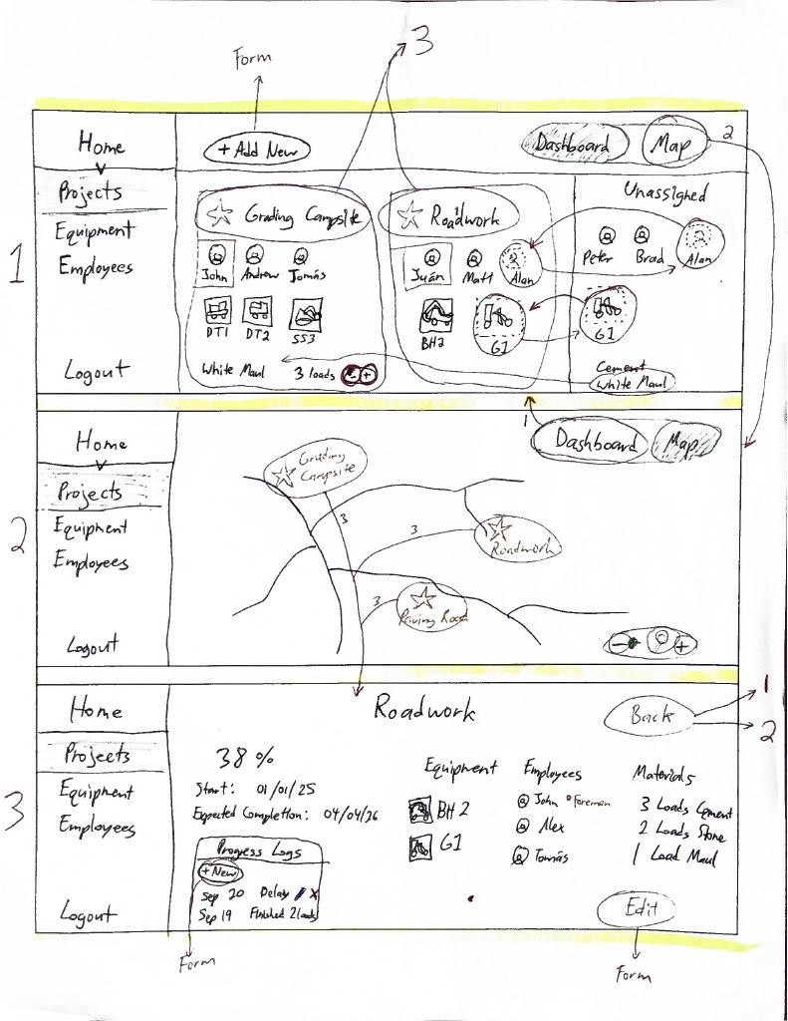
Selected Interface

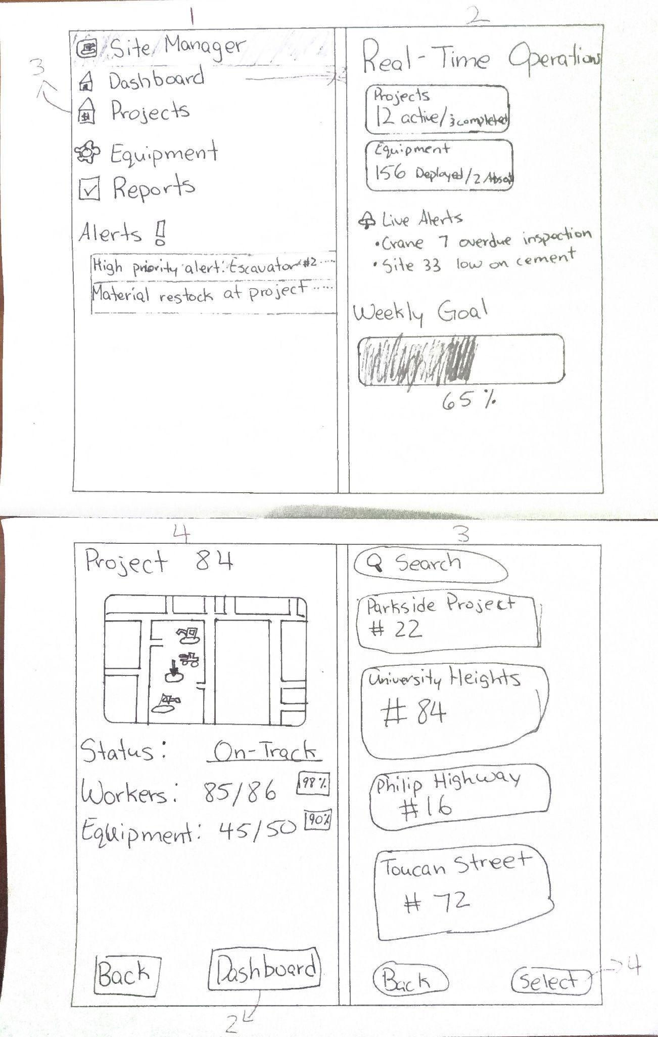

#1 Pros / Cons | #2 Pros / Cons
Web based | Mobile based
Simple navigation | More alerts/feedback
More workable | More simplistic
Figure 6: Webpage Figure 7: Tablet

Final Prototype
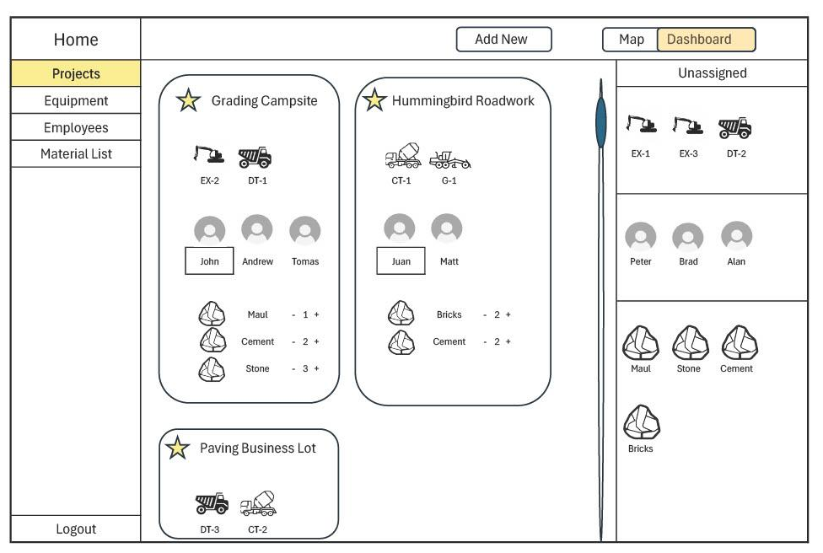
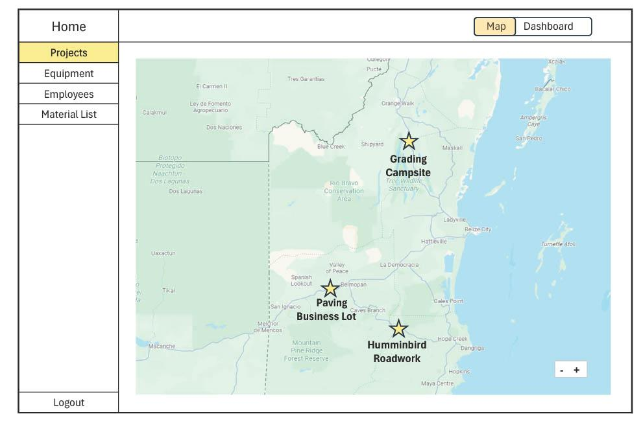

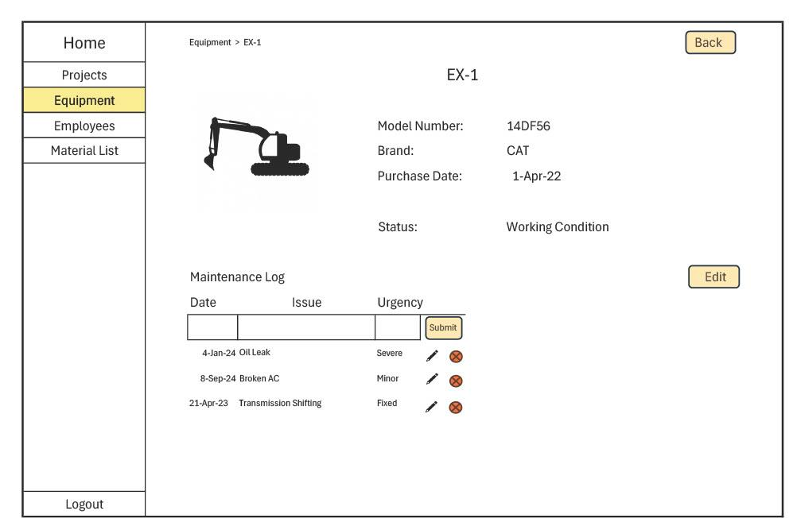
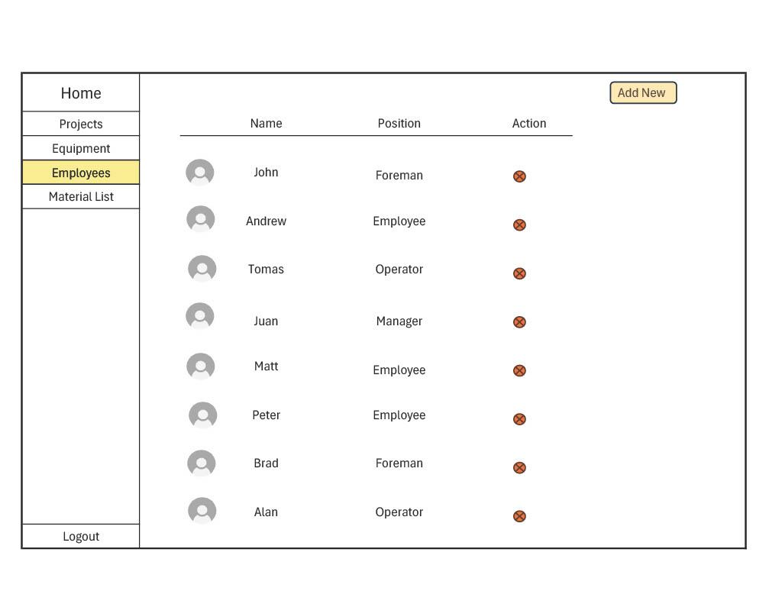

Selected Interface Design

After comparing the usability of all interface sketches, we selected the combined web and mobile design as our final low-fidelity prototype. This version prioritized simplicity, accessibility, and efficiency.

UI Storyboards

We created three storyboards to represent key user tasks managers would perform:
1. Easy Task – Add Maintenance Log: The user selects an excavator (EX-1), adds a new maintenance log for “Busted Hydraulic Hose,” updates its status to Being Repaired, marks another log as Fixed, and returns to the projects page.
2. Medium Task – Update Project Progress: The user adds a progress note to the Grading Campsite project, records completion on December 24, 2025, marks the project as Complete, and returns to the project list.
3. Hard Task – Manage Assignments and Materials: The user reassigns equipment and employees across multiple projects (e.g., assigning DT-2 and CT-2 to Hummingbird Roadwork, adding or removing loads of materials), and finally reviews the overall map view for confirmation.

Prototype Description

The low-fidelity prototype was created using simple digital mockups and paper-based layouts that represented real navigation and task flow. Each screen simulated interactions such as selecting equipment, updating project details, or switching between project maps.
Prototype Features:
- Interactive dashboards for project summaries.
- Simulated buttons for adding logs or progress notes.
- Dropdown lists for assigning employees and resources.
- A map page linking all projects with quick access to details.
Method

Participants

Two volunteer participants were recruited from the university computer lab to test the prototype. They were not familiar with the app beforehand, which allowed them to provide unbiased feedback.

Environment

Testing was conducted in a quiet lab setting. Both participants performed tasks under observation, with the facilitator guiding them through the test objectives, while the observer logged down their comments and actions.

Tasks

Each participant was asked to perform the three UI task flows described earlier: Add a maintenance log for equipment, add a project progress note and mark the project as complete, and assign multiple resources across different projects.

Procedure

1. The facilitator introduced the purpose of the prototype and explained the basic navigation.
2. Participants were given printed task descriptions and asked to complete each task independently.
3. Observers noted any errors, hesitation, or confusion points.
4. After each session, participants shared feedback on what they found intuitive or unclear.

Team Member Roles

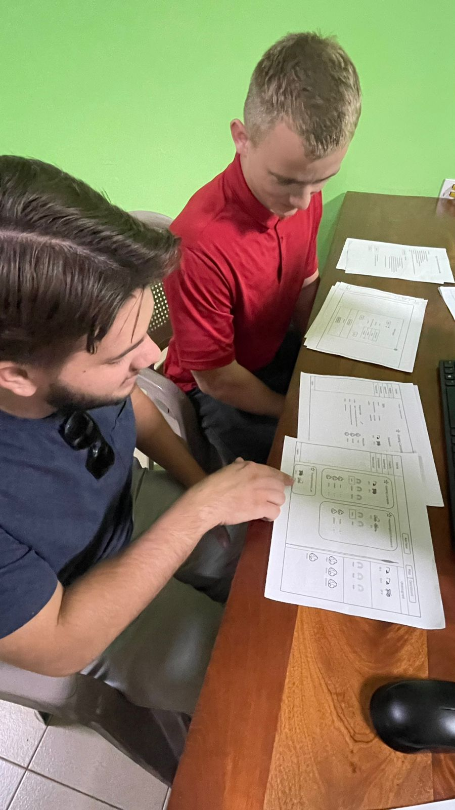

Facilitator & Computer: Joseph Koop

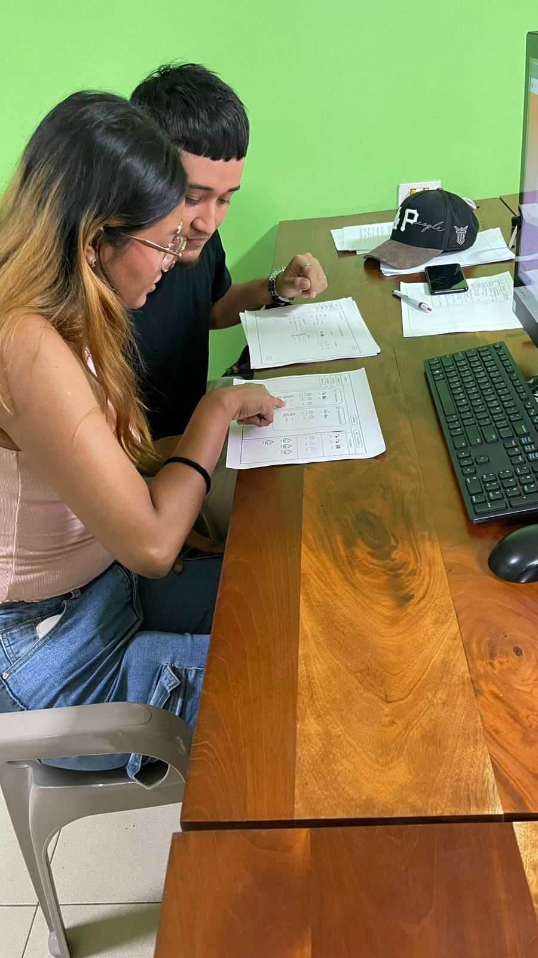

Observer & Notetaker: Enrique Garcia, Kelvin Gordon

The team collaboratively reviewed user feedback after testing to identify trends and possible improvements.

Results

Participant 1 Feedback:

- Vibe: Understandable and straightforward.
- Comments: “Once everything is color-coded, it’s pretty easy to follow.”
- Suggestions: Box related items together to make sections easier to follow.

Participant 2 Feedback:

- Vibe: Enjoyable and engaging.
- Comments: “This is kind of fun.”
- Issues Found: Some icons did not directly link to their expected pages, Progress Notes link lacked visual emphasis, and drag-and-drop reassignment took extra time to figure out.

General Findings

Both participants initially visited incorrect sections but were able to backtrack and complete tasks independently. Color-coding and clearer icon labeling would significantly improve navigation. Users appreciated the map view but desired clearer feedback when assigning equipment or employees.

Discussion

The low-fidelity test provided valuable insights into how users might interact with SiteManager in real-world contexts.

What Worked Well:

- Users quickly grasped the main purpose and workflow.
- The app’s structure felt logical, especially once visual cues were understood.
- Participants found the layout appealing and the map overview particularly useful.

Challenges Identified:

- Visual clarity: Without enough color distinction, users occasionally clicked the wrong icons.
- Grouping and spacing: Items needed better visual containment to reduce confusion.
- Feedback and responsiveness: Some interactive elements (e.g., drag features) were unclear without visible confirmation.
- Link visibility: Buttons such as “Progress Notes” required more obvious placement.

Proposed Improvements:

1. Introduce color-coded categories (Projects, Equipment, Employees).
2. Add visible borders and containers to group related sections.
3. Improve drag-and-drop functionality by providing hover indicators or click alternatives.
4. Enhance progress link visibility using underlined text or icon cues.
5. Implement drop-down arrows to expand or collapse detailed sections.

Conclusion
Testing showed that this prototype can help solve key problems faced by construction project managers due to keeping everything in one place. Users found the system easy to understand and useful for tracking people, equipment, and project progress.
The prototype successfully demonstrated how the app will work, though it needs clearer visuals and better navigation. With a few improvements, SiteManager can become a practical, easy-to-use tool that helps companies stay organized and finish projects on time.

