PYFILE

## A Python-Tkinter File Explorer

Author: Joseph Lay

Version: 1.0.0

Table of Contents:

* Introduction: The Purpose of PyFile
* Chapter 0: Installation
* Chapter 1: First Glance
* Chapter 2: The Properties Window

Introduction

The Purpose of PyFile

PyFile is a basic file explorer. Currently, PyFile can only navigate the directory tree and display basic information about files. However, in the future, hopefully, further development will result in more uses available.

Chapter 0

Installation

To install and rune PyFile, follow these instructions. First Lastly, make sure you have Python 3 installed on your computer. Next, visit GitHub.com/Joseph-Lay/Pyfile. From there, download the source files into a single folder. **Make sure to keep all the files in the same folder!** If you do not, an error will almost certainly occur. Next, make the folder in which you put all the source files in your working directory. Now you can use PyFile!

Chapter 1

First Glance

Before you can try out PyFile, you must launch it. The first way is to open the terminal, (type cmd.exe into windows run), type “cd <path to Pyfile folder>”, then type <path-to-Python-installation> PyFile.py. The second way is to open IDLE, select “open file” from the file menu, choose Pyfile.py, and in the new window either press f5 or click “run module” under the run menu.

Once you have opened PyFile, take a look around. At first glance, you should see the navigation bar in blue at the top of the window and the file selection box in the bottom part.

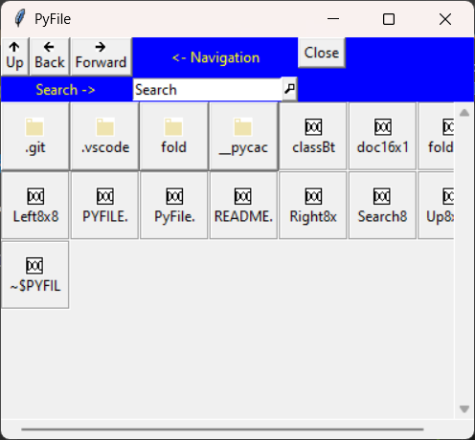 When you inspect the lower part of the screen, you can see two different buttons. There are folders at the top, with small folder icons, and files towards the bottom with an icon with the letters “DOC.” If you click on a file button, the properties window will appear. You can read more about that in [Chapter 3.](#chapter 3) If you click a folder button, the current set of buttons will be removed and a new one placed as the current folder is changed to the one you clicked.

Inside the navigation pane, you will see three buttons and the search bar. Clicking the button labeled “Up” will change the current folder to the parent of the one you are in now. The “Back” button will return you to the previous folder, if you have previously moved from a different folder. Pressing the “Forward” button will return you to the previous folder after you pressed the “Back” button.

The search bar can be seen at the middle of the navigation bar. Type in some text and either press “Enter” or click the magnifying glass to the box’s right. If there are any files or folders with the text in their name they will appear in the bottom part of the screen.

Lastly, clicking the button labelled “Close” will exit the program.

Chapter 2

The Properties Window

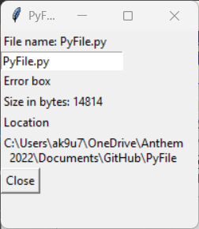 When you click on a file button, a new window will appear. This window is call *The Properties Window.* In it you can change the name of a file and view the details concerning that file. At the top of the list is the name of the file followed by an entry box. If you want, you can change the name of a file by typing the new name in the entry box and pressing enter. If the file name has no illegal characters, PyFile will update the name of that file.

Once you are done inspecting a file, you may close the window by either clicking the ‘X’ in the upper-right corner or clicking the “Close” button at the bottom.