Permian Basin RRC Production Comparison
Midland, Martin, Howard, Reeves, and Loving Counties
Prepared by Joseph Luongo | August 2026
Executive  Summary | Martin delivered the strongest 2020-2025 growth profile, while Reeves remained the largest gas producer. A key cross-basin adjustment is condensate: it represented 54% of Reeves liquids and 36% of Loving liquids in 2025, so oil-only comparisons understate Delaware Basin liquids scale. Howard showed the largest increase in gas intensity, and reported operator concentration varied materially across the counties.

Key County Metrics
County | 2025 Oil  MMbbl | Oil Growth  20-25 | 2025 Gas  Bcf | 2025 Liquids  MMbbl | 2025 GLR | Condensate  Share
Midland | 241.7 | 26.1% | 982.6 | 242.5 | 4.05 | 0.3%
Martin | 258.3 | 76.8% | 749.7 | 258.7 | 2.90 | 0.2%
Howard | 98.6 | 1.7% | 426.0 | 98.6 | 4.32 | 0.0%
Reeves | 82.0 | -10.6% | 1,218.9 | 179.9 | 6.78 | 54.4%
Loving | 113.8 | 36.9% | 702.0 | 177.5 | 3.95 | 35.9%

1. Scope and Methodology
Data source. Texas Railroad Commission Production Data Query exports for Midland, Martin, Howard, Reeves, and Loving Counties. Each query uses Well Type = Both and the period January 2020 through March 2026.
Core definitions. Gas = casinghead gas + GW gas. Total liquids = oil + condensate. Gas-to-liquids ratio (GLR) = gas MCF / total-liquids BBL. Full-year growth comparisons use 2020 versus 2025; partial 2026 data are used only as a directional run-rate check.
Why GLR instead of only GOR. GOR remains useful for continuity with Part 1, but condensate is material in Reeves and Loving. GLR provides a more comparable product-mix measure across the five counties.

2. Production Scale and Growth
Martin is the standout growth county. Oil production increased 76.8% from 2020 to 2025 and gas increased 155.1%. Martin also reached 258.3 MMbbl of oil in 2025, exceeding Midland in the five-county set.
Reeves follows a different profile. Oil declined 10.6% between 2020 and 2025, but 2025 gas production reached 1,218.9 Bcf, the highest of the comparison group. Howard was nearly flat in oil (+1.7%) while gas increased 127.3%.
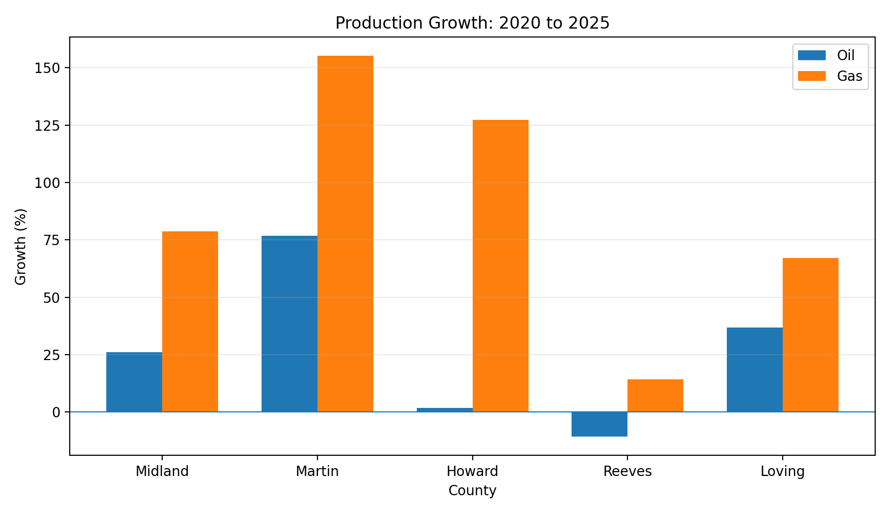
Figure 1. Oil and gas production growth from 2020 to 2025.
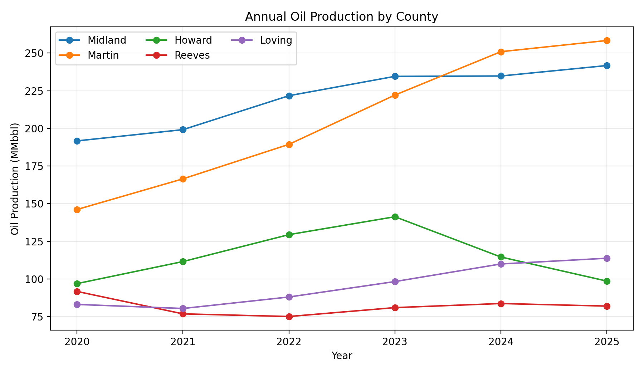
Figure 2. Annual oil production by county, 2020-2025.

3. Product Mix and Gas Intensity
Condensate changes the Delaware Basin comparison. In 2025, condensate represented 54.4% of Reeves liquids and 35.9% of Loving liquids. Reeves produced only 82.0 MMbbl of oil, but 179.9 MMbbl of total liquids after condensate is included. Loving increased from 113.8 MMbbl of oil to 177.5 MMbbl of total liquids.
Howard shows the largest shift toward gas. Its GLR rose from 1.93 MCF/BBL in 2020 to 4.32 in 2025, a 123% increase. Reeves remained the most gas-intensive county at 6.78 MCF/BBL of total liquids in 2025.
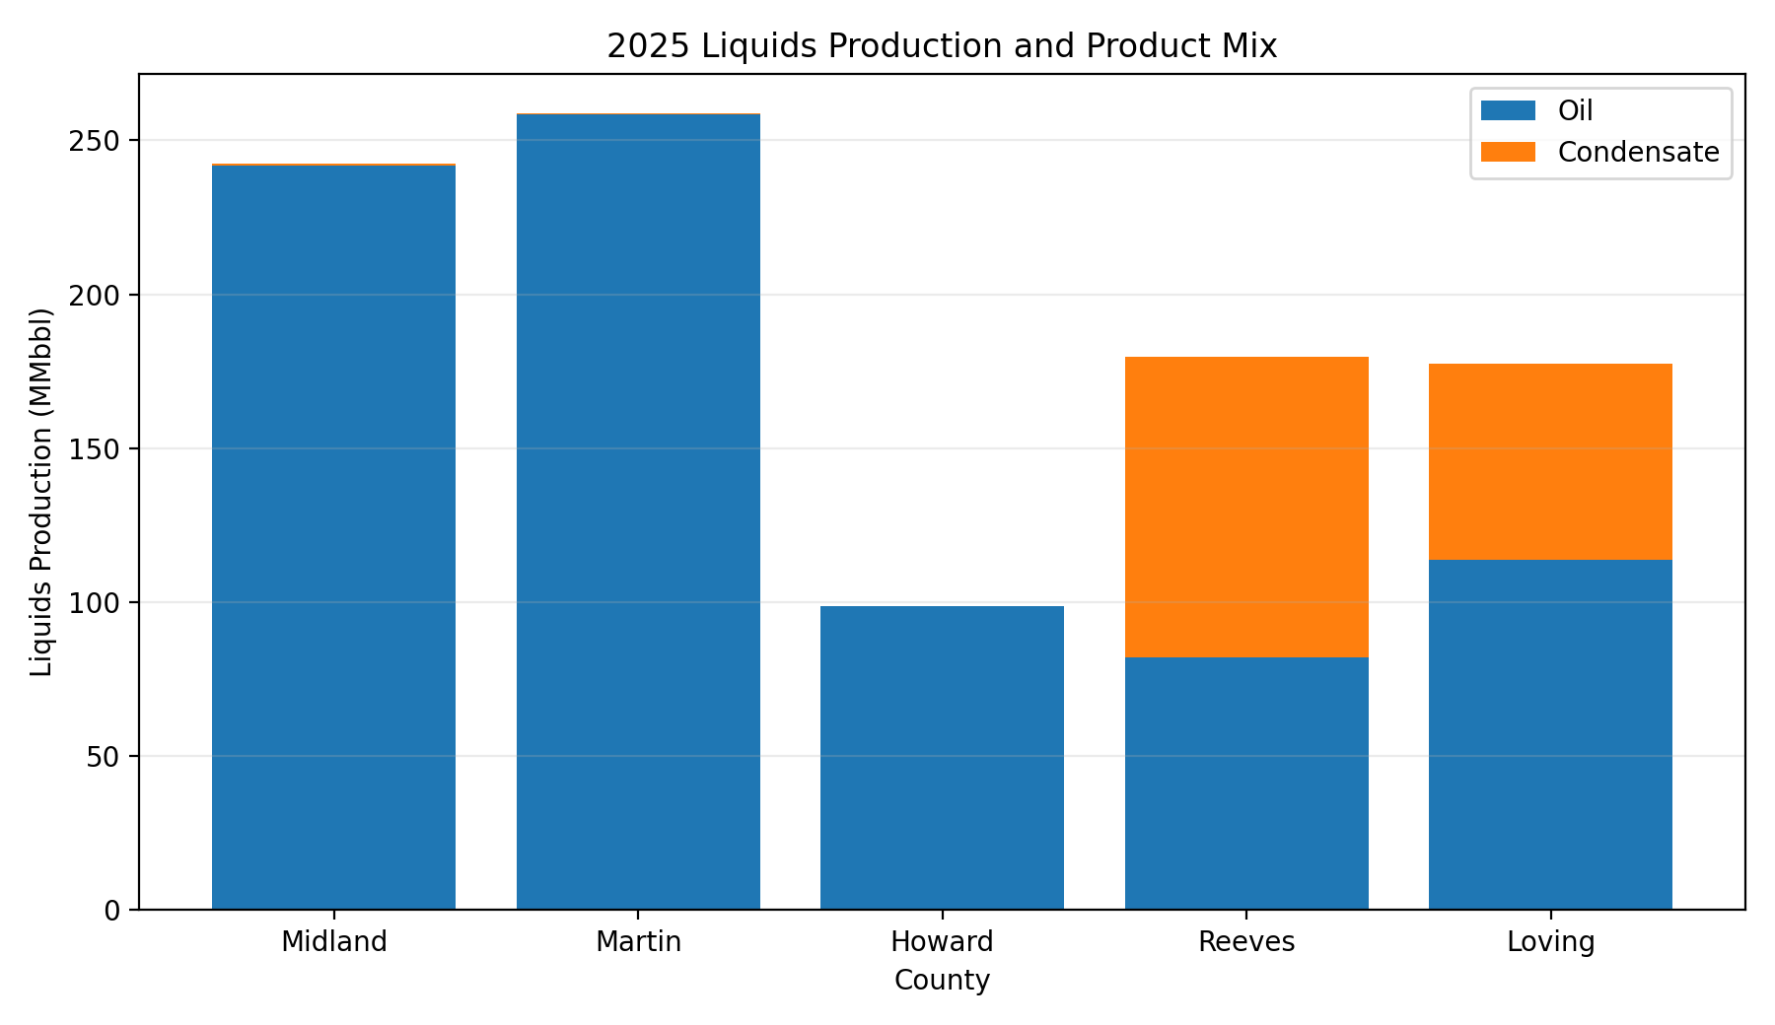
Figure 3. 2025 oil and condensate composition by county.
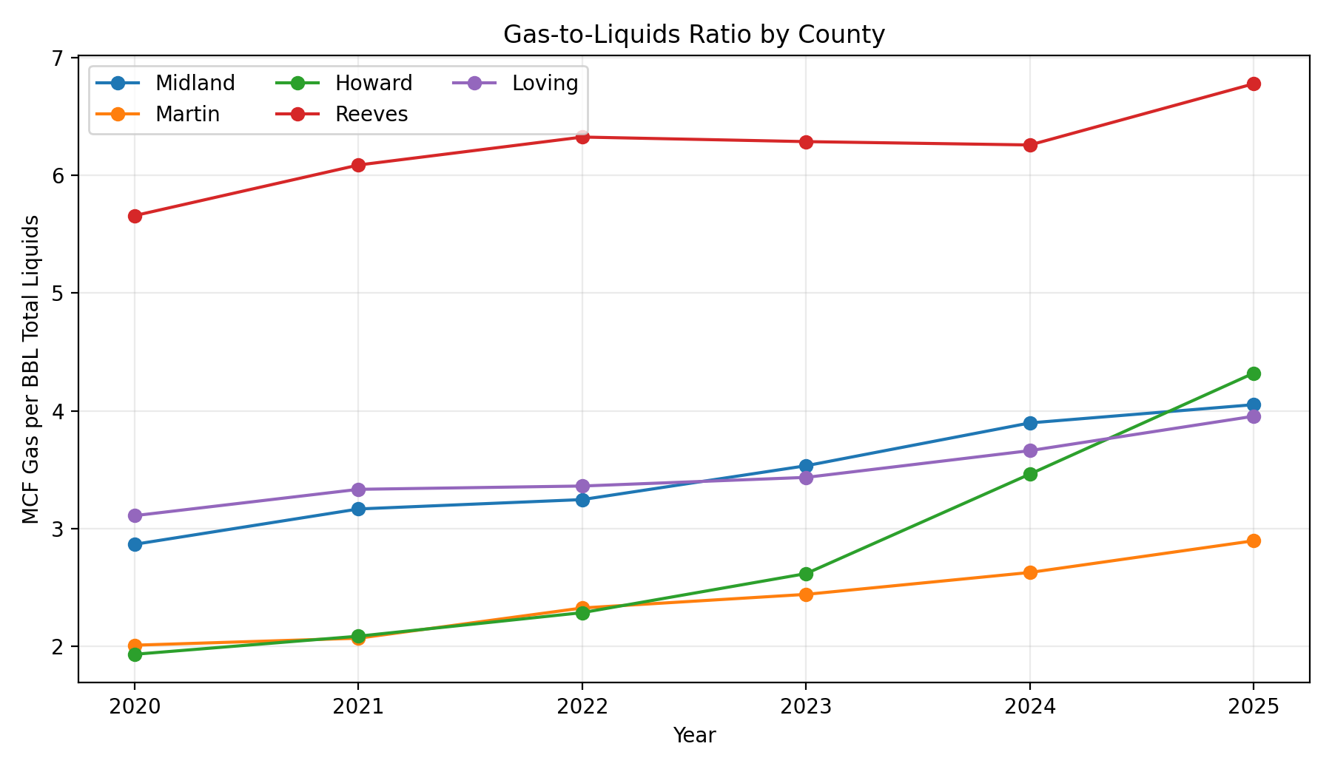
Figure 4. Annual gas-to-liquids ratio, 2020-2025.

4. Competitive and Field Concentration
Reported operator concentration varies meaningfully. The top five reported operators account for 77.9% of cumulative oil in Loving and roughly 71% in Midland and Martin, compared with 51.8% in Howard and 47.6% in Reeves. This points to a more fragmented historical production base in Reeves and Howard.
Field concentration tells a different story. Spraberry (Trend Area) accounts for about 97% of cumulative oil in both Martin and Howard, while Reeves is more diversified: Wolfbone (Trend Area) is the largest field at about 40%. Loving is heavily concentrated in Phantom (Wolfcamp), at about 84%.
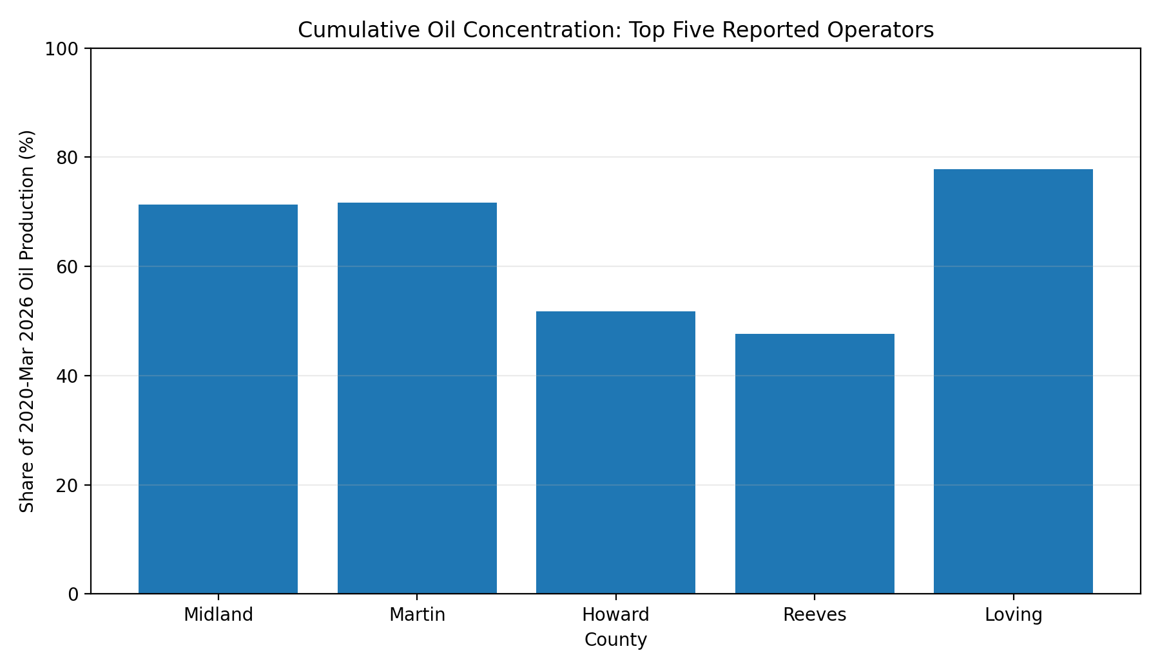
Figure 5. Share of cumulative oil attributed to the top five reported operators.
County | Top Reported Oil Operator | Top-5 Operator Share | Top Oil Field | Top Field Share
Midland | PIONEER NATURAL RES. USA, INC. | 71.3% | SPRABERRY (TREND AREA) | 81.1%
Martin | DIAMONDBACK E&P LLC | 71.7% | SPRABERRY (TREND AREA) | 96.7%
Howard | SM ENERGY COMPANY | 51.8% | SPRABERRY (TREND AREA) | 97.2%
Reeves | NOBLE ENERGY INC | 47.6% | WOLFBONE (TREND AREA) | 39.8%
Loving | ANADARKO E&P ONSHORE LLC | 77.9% | PHANTOM (WOLFCAMP) | 83.7%

5. Q1 2026 Run-Rate Check
Q1 2026 is partial-year data, so it is compared with the average monthly rate in 2025 rather than treated as a full-year growth result. Oil run rates are below the 2025 average in every county. Martin (-0.9%) and Loving (-1.8%) are the most stable, while Howard (-21.0%) shows the largest decline. Martin is the only county with a positive gas run-rate change (+3.2%).
County | Q1 2026 Oil vs 2025 Avg | Q1 2026 Gas vs 2025 Avg
Midland | -7.3% | -5.3%
Martin | -0.9% | 3.2%
Howard | -21.0% | -3.5%
Reeves | -9.8% | -6.2%
Loving | -1.8% | -1.7%

6. Business Implications
• Growth screening: Martin stands out as the clearest high-growth county in the five-county set and is the strongest candidate for deeper well-level development and decline-curve analysis.
• Product-mix screening: Reeves and Loving require condensate-aware comparisons; oil-only rankings can misstate the scale and economics of their liquids production.
• Gas exposure: Howard has become materially more gas-intensive, while Reeves remains structurally gas-heavy. Gas takeaway, processing, and pricing therefore matter more to interpreting these counties than a simple oil-volume ranking suggests.
• Competitive structure: Reeves and Howard show lower reported operator concentration than Loving/Martin/Midland, which can matter for asset-screening, peer selection, and transaction context.

Limitations
This project is a public-data screening analysis, not a reserve report or economic evaluation. It does not include well-level decline curves, acreage quality, drilling/completion costs, operating costs, realized pricing, NGL yields, midstream constraints, or current ownership mapping. RRC operator reports aggregate the full query period; historical operator names can remain after acquisitions or asset transfers.

Data and Reproducibility
The GitHub-ready project package includes the raw RRC exports, cleaned CSV outputs, formula-driven Excel workbook, Python script, executed Jupyter notebook, figures, report, and presentation.
RRC Production Data Query: https://webapps2.rrc.texas.gov/EWA/ewaPdqMain.do
Part 1 repository: https://github.com/Joseph-Luongo/Midland-County-RRC-Production-Analysis

