|  |  |  |  |
| --- | --- | --- | --- |
| Sample_ID | Total number of reads | Number and percentage of the reads mapped to the genome (uniquely or not) | Total number of reads in the genes |
| SRR3414629 | 21106089 | 21106089 reads; of these:  21106089 (100.00%) were unpaired; of these:  241125 (1.14%) aligned 0 times  18573461 (88.00%) aligned exactly 1 time  2291503 (10.86%) aligned >1 times  98.86% overall alignment rate | 18573461 |
| SRR3414630 | 15244711 | 15244711 reads; of these:  15244711 (100.00%) were unpaired; of these:  168292 (1.10%) aligned 0 times  13320476 (87.38%) aligned exactly 1 time  1755943 (11.52%) aligned >1 times  98.90% overall alignment rate | 13320476 |
| SRR3414631 | 24244069 | 24244069 reads; of these:  24244069 (100.00%) were unpaired; of these:  279699 (1.15%) aligned 0 times  21159559 (87.28%) aligned exactly 1 time  2804811 (11.57%) aligned >1 times  98.85% overall alignment rate | 21159559 |
| SRR3414635 | 20956475 | 20956475 reads; of these:  20956475 (100.00%) were unpaired; of these:  242049 (1.16%) aligned 0 times  18637017 (88.93%) aligned exactly 1 time  2077409 (9.91%) aligned >1 times  98.84% overall alignment rate | 18637017 |
| SRR3414636 | 20307147 | 20307147 reads; of these:  20307147 (100.00%) were unpaired; of these:  233558 (1.15%) aligned 0 times  18032641 (88.80%) aligned exactly 1 time  2040948 (10.05%) aligned >1 times  98.85% overall alignment rate | 18032641 |
| SRR3414637 | 20385570 | 20385570 reads; of these:  20385570 (100.00%) were unpaired; of these:  236905 (1.16%) aligned 0 times  18043360 (88.51%) aligned exactly 1 time  2105305 (10.33%) aligned >1 times  98.84% overall alignment rate | 18043360 |



Fig 1. FastQC SRR3414629



Fig 2. FastQC SRR3414630



Fig 3. FastQC SRR3414631

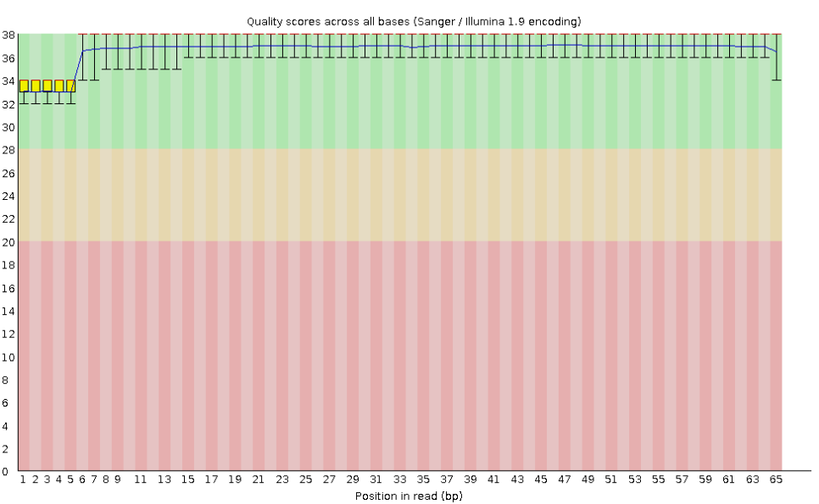

Fig 4. FastQC SRR3414635



Fig 5. FastQC SRR3414636

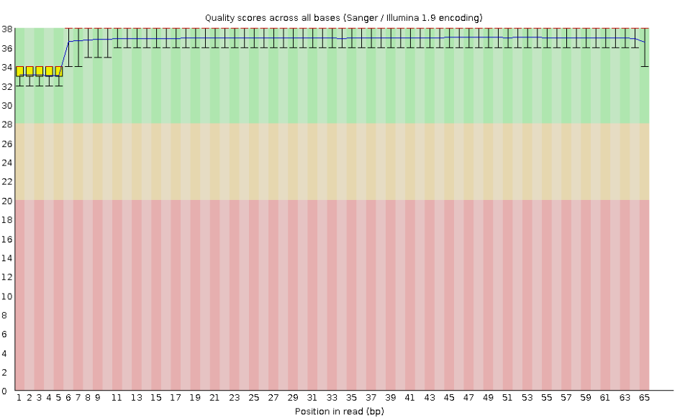

Fig 6. FastQC SRR3414637