The Impact of Climate Change on Food Security in Nigeria: A Review of Empirical and Theoretical Evidence
Draft review paper (journal-article format).
Author(s): [Your Name(s)]
Affiliation(s): [Your Department/Institution]
Date: 2026-05-09

Abstract
Climate change poses escalating risks to food security in Nigeria through interacting pathways affecting agricultural production, food prices and incomes, nutrition and health, and the stability of food systems. This review synthesizes empirical and theoretical evidence on climate–food security linkages in Nigeria and summarizes policy-relevant adaptation options reported in recent literature. To complement the evidence synthesis, we provide a lightweight benchmarking analysis using public national-level datasets: monthly temperature and precipitation from NASA POWER and annual food/agriculture indicators from the World Bank World Development Indicators. The benchmarking analysis indicates a positive long-run trend in annual mean temperature of approximately 0.053 °C/year (≈2.32 °C over the observed period) and substantial interannual variability in precipitation (standard deviation ≈356 mm/year). Correlation patterns and simple time-series cross-validated baselines illustrate that climate variables alone explain only a limited share of variation in national food security proxies, underscoring the importance of socioeconomic mediators and adaptation capacity. We conclude by highlighting key mechanisms, vulnerable populations and regions, and research gaps for more causal and subnationally resolved evidence.

Keywords
Nigeria; climate change; food security; agriculture; rainfall variability; temperature; adaptation; vulnerability; benchmarking

1. Introduction
Nigeria faces persistent food security challenges shaped by demographic pressures, macroeconomic conditions, market integration, infrastructure constraints, and exposure to climate hazards such as droughts and floods. Climate change can affect food security through direct biophysical impacts on crop and livestock productivity and through indirect pathways including prices, incomes, health burdens, and conflict and displacement. A synthesis that combines empirical evidence with theory-based pathway framing can support clearer policy prioritization and identify evidence gaps.
This paper has two contributions. First, it provides a structured synthesis of empirical and theoretical evidence on climate change and food security in Nigeria. Second, it presents a transparent, reproducible benchmarking analysis using public national-level datasets to summarize climate trends and their association with widely used food and agriculture indicators.

2. Conceptual Framework
We organize evidence using the FAO four pillars of food security—availability, access, utilization, and stability—embedded within a food-systems perspective (production–processing–distribution–consumption). Climate risk is interpreted using a hazard–exposure–vulnerability framing. Outcomes are mediated by households’ assets, institutions, and adaptation options (e.g., irrigation, diversification, improved varieties, storage, extension services, social protection).

3. Methods
3.1 Literature approach. This draft is based on an organized set of Nigeria-relevant peer-reviewed and grey-literature sources compiled during an initial search. For journal submission, this section should be expanded into a PRISMA-style workflow (databases, search strings, screening criteria, and extraction template).
3.2 Benchmarking analysis. We curate (i) NASA POWER monthly climate series for an approximate Nigeria centroid point and (ii) World Bank World Development Indicators (WDI) annual series for Nigeria. Monthly climate is aggregated to annual means (temperature) and totals (precipitation). WDI indicators are merged by year with climate aggregates, and exploratory analysis includes time-series plots, correlation matrices, and simple time-series cross-validated baseline models. This benchmarking is descriptive and not causal.

4. Benchmarking Results (Public National-Level Data)
Figure 1–3 summarize climate trends and cross-variable correlations for the merged annual dataset. The benchmarking is intended to provide transparent, reproducible context for the review rather than causal attribution.
Figure 1. Nigeria annual mean temperature (NASA POWER point).
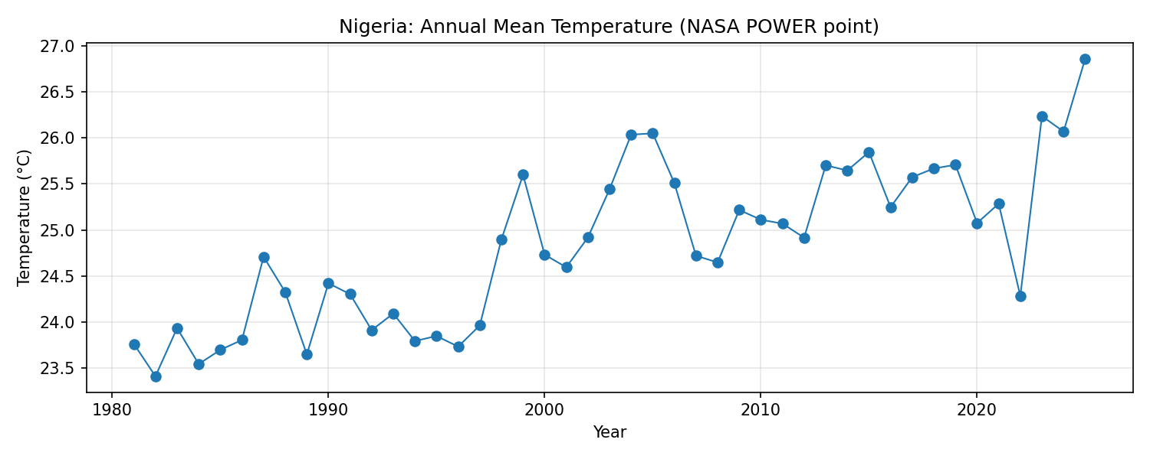
Figure 2. Nigeria annual total precipitation (NASA POWER point).
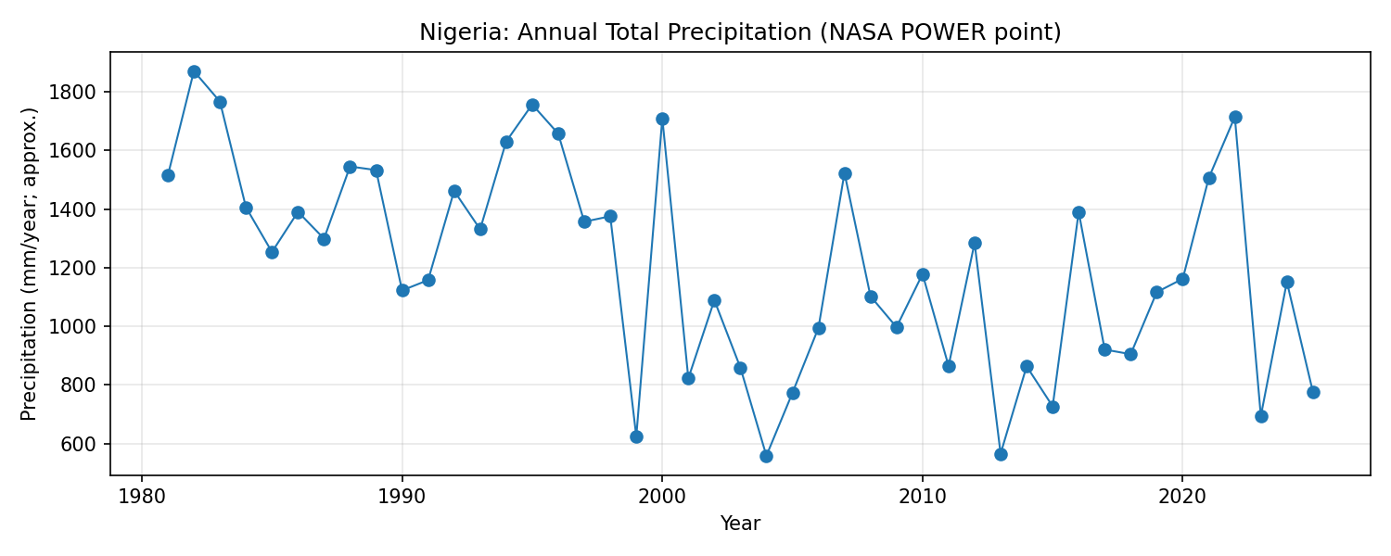
Figure 3. Correlation matrix across annual series (climate + WDI indicators).
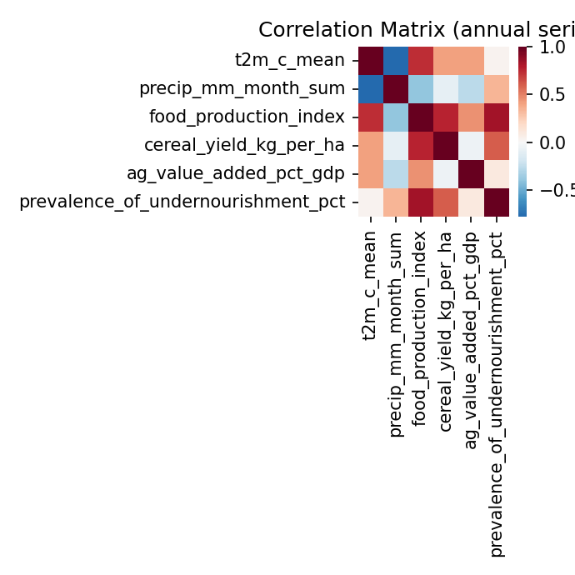

Table 1. Missingness summary (top 15 columns)
column | missing_%
moderate_or_severe_food_insecurity_pct | 86.4
prevalence_of_undernourishment_pct | 65.2
ag_value_added_pct_gdp | 33.3
t2m_c_mean | 31.8
precip_mm_month_sum | 31.8
food_production_index | 6.1
cereal_yield_kg_per_ha | 3.0
year | 0.0

Table 2. Simple benchmark baselines (time-series CV R²)
target | model | n_obs | cv_r2_mean | cv_r2_std
cereal_yield_kg_per_ha | linear | 44 | -17.332792465101633 | 10.929344185577616
cereal_yield_kg_per_ha | ridge | 44 | -17.144527341036593 | 10.049590163352462
food_production_index | linear | 42 | -27.339537733543573 | 28.948740747073792
food_production_index | ridge | 42 | -30.417726946014422 | 32.212247728816386
prevalence_of_undernourishment_pct | linear | 23 | -30.193136587676964 | 27.4643699969438
prevalence_of_undernourishment_pct | ridge | 23 | -30.686604949102257 | 27.790408808568586

5. Evidence Synthesis: Empirical and Theoretical Literature (Draft)
This section provides a structured narrative scaffold. For final submission, populate each subsection with extracted study details (setting, method, climate exposure, outcome, effect direction/magnitude, and limitations).

5.1 Availability (production and supply)
Studies in this strand typically examine temperature and rainfall variability, drought/flood exposure, and implications for crop yields, livestock productivity, fisheries, and post-harvest losses. Nigeria-specific evidence includes subnational and crop-focused analyses as well as time-series and panel econometric work.

5.2 Access (prices, incomes, livelihoods)
Evidence on access emphasizes market-mediated effects of climate shocks: food price changes, income volatility for agricultural households, and spatial differences tied to market access and infrastructure.

5.3 Utilization (nutrition and health)
Utilization outcomes include dietary diversity and nutrition indicators, mediated by water and sanitation constraints and climate-sensitive disease burdens. National indicators can mask household-level heterogeneity.

5.4 Stability (shocks, volatility, compounding risks)
Stability concerns relate to interannual variability and extremes, including flood and drought shocks and their compounding interactions with conflict, displacement, and macroeconomic stressors.

5.5 Adaptation and resilience
The adaptation literature assesses strategies such as irrigation, crop diversification, improved seed, extension, storage, and social protection. Effectiveness depends on finance, governance, and institutional capacity.

6. Discussion
The benchmarking analysis highlights a warming signal and high precipitation variability, but climate variables alone provide limited explanatory power for national food security proxies. This aligns with pathway-based theory: climate hazards operate through multiple mediators (markets, incomes, conflict, health) and are moderated by vulnerability and adaptation.
Policy implications include: strengthening climate information services and early warning; scaling climate-smart agronomy and water management; reducing post-harvest losses; investing in rural roads and market access; improving extension services and access to finance; and targeting social protection to climate-exposed, food-insecure populations.
Research gaps include: (i) more subnational, high-frequency outcome measurement; (ii) clearer identification strategies for causal inference; (iii) better integration of nutrition and price data with climate hazards; and (iv) rigorous evaluations of adaptation interventions under realistic constraints.

7. Conclusion
Climate change is a material and growing risk to food security in Nigeria. The empirical literature—spanning econometric, geospatial, and case-study approaches—highlights multiple mechanisms across the four food security pillars. Our public-data benchmarking provides reproducible context but should be interpreted descriptively. Strengthening adaptation capacity and addressing socioeconomic mediators are central to reducing climate-induced food insecurity.

References (links from initial search)
Emeagha K.N. et al. (2025). The Effects of Climate Change on Food Security in Nigeria: A Review. https://rsisinternational.org/journals/ijrsi/articles/the-effects-of-climate-change-on-food-security-in-nigeria-a-review/
(2025). Multi-impacts of Climate Change and Mitigation Strategies in Nigeria: Agricultural Production and Food Security. https://pmc.ncbi.nlm.nih.gov/articles/PMC12166404/
Ani et al. (2021). The Impact of Climate Change on Food and Human Security in Nigeria. https://www.emerald.com/insight/content/doi/10.1108/ijccsm-11-2020-0119/full/html
Adokwe et al. (2025). The Impact of Climate Change on Food Security in Nigeria (Empirical Review). https://www.seahipublications.org/wp-content/uploads/2025/01/IJIFER-M-31-2025.pdf
Ngukimbin R.A. & Shinku B. (2021). Climate Change and Food Security Challenges: Empirical Investigations in Nigeria. https://gssrr.org/index.php/JournalOfBasicAndApplied/article/view/11582
(2025). Impact of Climate Dynamics on Food Security in Burkina Faso and Nigeria Using FMOLS and Geospatial Analysis. https://link.springer.com/article/10.1007/s43621-025-01518-w
Fagbemi F. et al. (2024). Carbon Emissions and Food Production: Why Climate Change is a Threat to Nigeria's Food Security. https://link.springer.com/article/10.1007/s13412-024-00916-2
(2025). Assessing the Impact of Climatic Factors on Underutilized Crops: Novel Evidence from Nigeria. https://link.springer.com/article/10.1007/s00704-025-05709-3
(2025). Climate Change, Crop Yield, and Food Security in Sub-Saharan Africa (includes Nigeria). https://link.springer.com/article/10.1007/s43621-025-01580-4
Tajudeen T.T. et al. (2022). The Effect of Climate Change on Food Crop Production in Lagos State. https://pmc.ncbi.nlm.nih.gov/articles/PMC9778574/
(2022). Agriculture and Food Security in Northern Nigeria, Part I: The Implications of Climate Change. https://www.sciencedirect.com/science/article/pii/S2452263522000064
(2026). Observed Climate Change Factors and Food Crop Production in a Typical Rural Farming Community in Nigeria. https://link.springer.com/article/10.1007/s44279-026-00493-8
(2025). Assessing the Impact of Climate Change and Farmers' Adaptation Strategies on Agricultural Crop Production in Southwestern Nigeria. https://link.springer.com/article/10.1186/s40066-025-00561-0
(2025). Vulnerability Assessment of Food Crop Production and Climate Change in Nigeria. https://www.sciepublish.com/article/pii/525
Akinkuolie et al. (2024). Resilience to Climate-Induced Food Insecurity in Nigeria: A Systematic Review. https://www.frontiersin.org/journals/sustainable-food-systems/articles/10.3389/fsufs.2024.1490133/full
(2024). Climate Smart Agriculture? Adaptation Strategies of Traditional Agriculture to Climate Change in Sub-Saharan Africa (includes Nigeria). https://www.frontiersin.org/journals/climate/articles/10.3389/fclim.2024.1272320/full
(2025). Mainstreaming Climate Action into Agriculture and Food Security in Nigeria. https://afripoli.org/mainstreaming-climate-action-into-agriculture-and-food-security-in-nigeria
(2024). Climate Change and Food Security in Selected Sub-Saharan African Countries (includes Nigeria). https://nursing.jhu.edu/wp-content/uploads/2024/03/Climate-change-and-food-security-in-selected-Sub-Saharan-African-Countries-1.pdf
(2025). Multi-Omics and AI-/ML-Driven Integration of Nutrition and Metabolism in Cancer (methodological model). https://www.medrxiv.org/content/10.1101/2025.07.29.25332402.full.pdf

