# 1. Introduction

Dataset: Analysis of sales reports of an organization for different products over the three years and apply Business Intelligence using Excel.

Link: https://www.kaggle.com/datasets/yesrahulkr/sales-analysis-report-on-power-bi

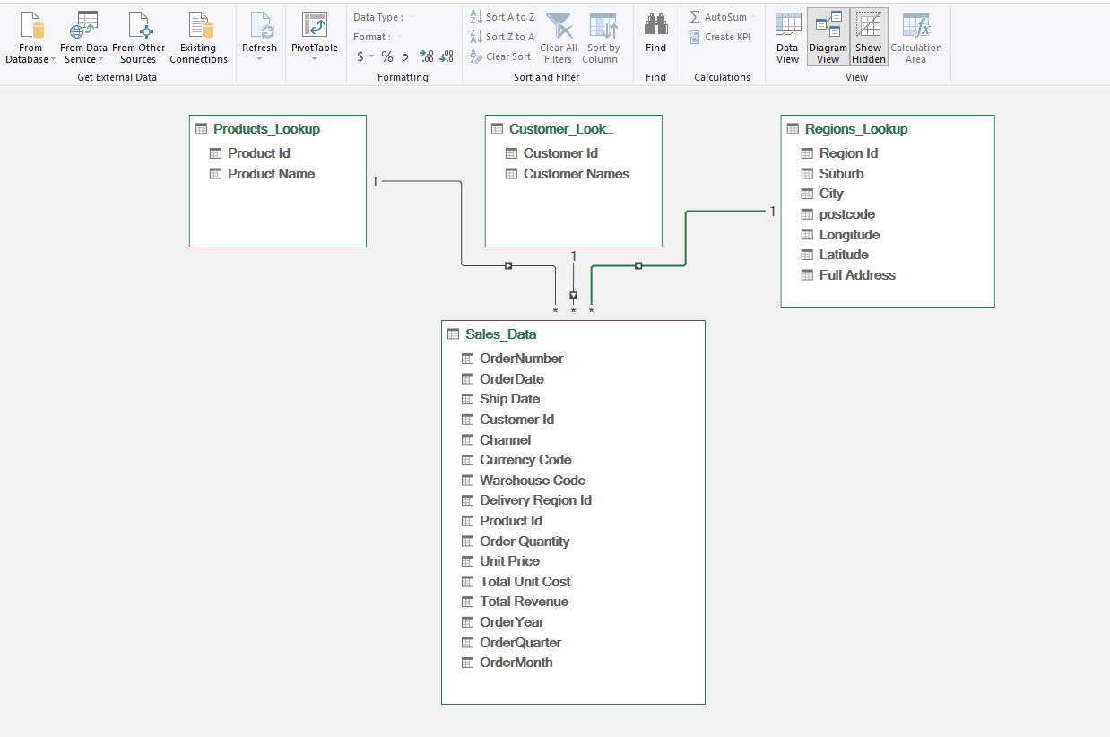

Table relationship with Data Model

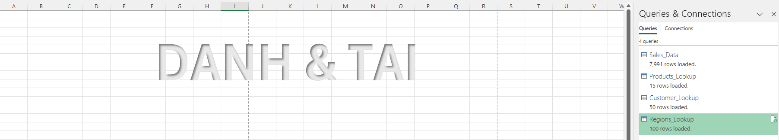

Connections

# 2. ETL operation using Power Query Editor

Take example few operations Simple description , at least 2 screenshot + watermark

Lookup on top, data down

# 3. Data analysis (Using Dax)

At least 2 DAX New columns , new measure

Show Pivot table using the measure, new columns.

Conclusion 1

Conclusion 2

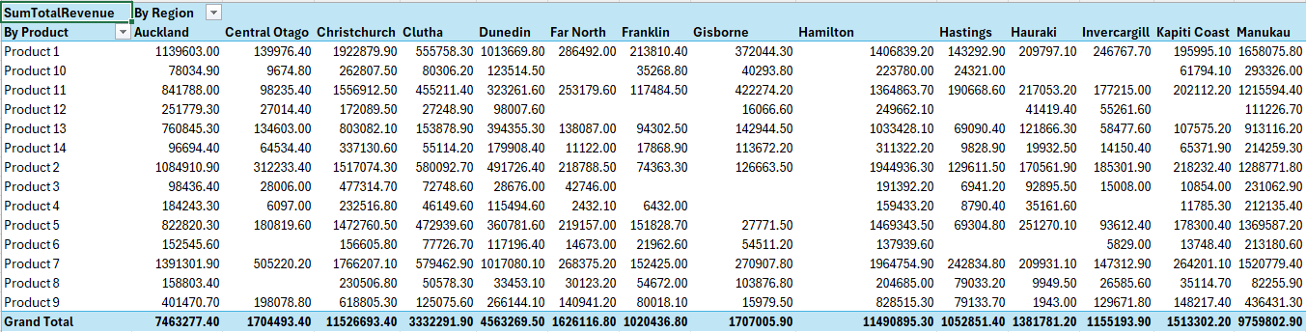

This table can identify which product generates the most revenue in different regions. This helps in understanding regional product performance

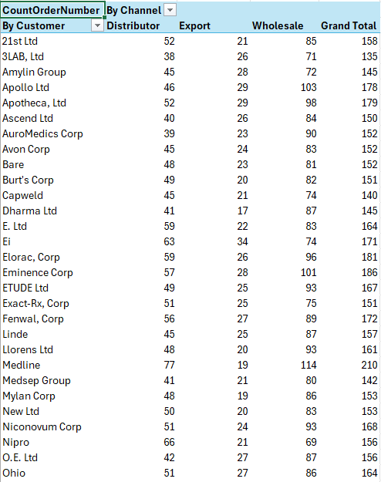

This will help determine which customers place the most orders and through which sales channel

This shows the average revenue generated per order across different years and quarters

# 4. Data analysis (using Calculate)

Show Pivot table

Conclusion

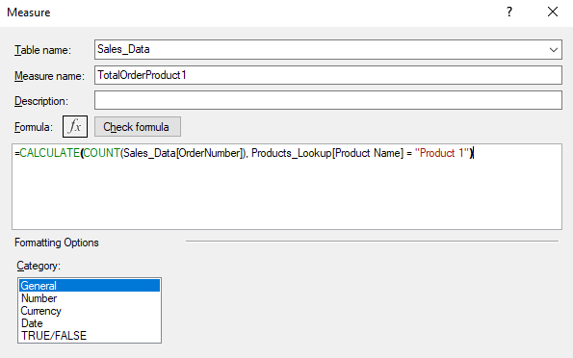

This calculation counts how many times "Product 1" was ordered. It helps to assess the popularity and sales frequency of the product, providing insights into customer demand for specific products.

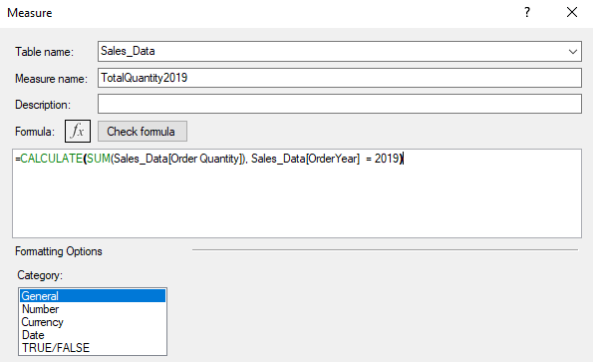

This will help track the total quantity of products ordered in 2019. It provides insight into the volume of orders, which could highlight market demand and operational load during that year.