**Business Intelligence using Excel**

Danh.N – Tai.N

School of Information and Communications Technology, SaskPolytech

COMP 604 Web Analytics and Business Intelligent Tools

Himanshu Patel Ph. D

Oct 15, 2024

Table of Contents

1. Introduction 3

2. ETL operations using Power Query Editor 4

3. Data analysis (Using Dax) 4

3.1. Understanding regional product performance 6

3.2. Understanding customer order though sales channel. 7

3.3. Insight average revenue across years and quarters. 8

3.4. Identifying the sales channel that generates the highest revenue and profit. 9

3.5. Gain insights into sales performance by year and quarter 10

3.6. Obtain insights into sales performance for each customer 11

4. Data analysis (using Calculate) 12

4.1. Evaluate product performance 13

4.2. Get insights order quantity of a year 14

4.3. Revenue generated by a specific customer 14

5. Conclusion 15

# Introduction

This report provides an analysis of an organization's sales data for various products over a three-year period, utilizing ETL and DAX techniques in Excel.

The dataset was sourced from Kaggle <https://www.kaggle.com/datasets/yesrahulkr/sales-analysis-report-on-power-bi>. It comprises four tables with the following relationships:

1. Sales_Data (Data table)
2. Product_Lookup (Lookup table)
3. Customer_Lookup (Lookup table)
4. Regions_Lookup (Lookup table)

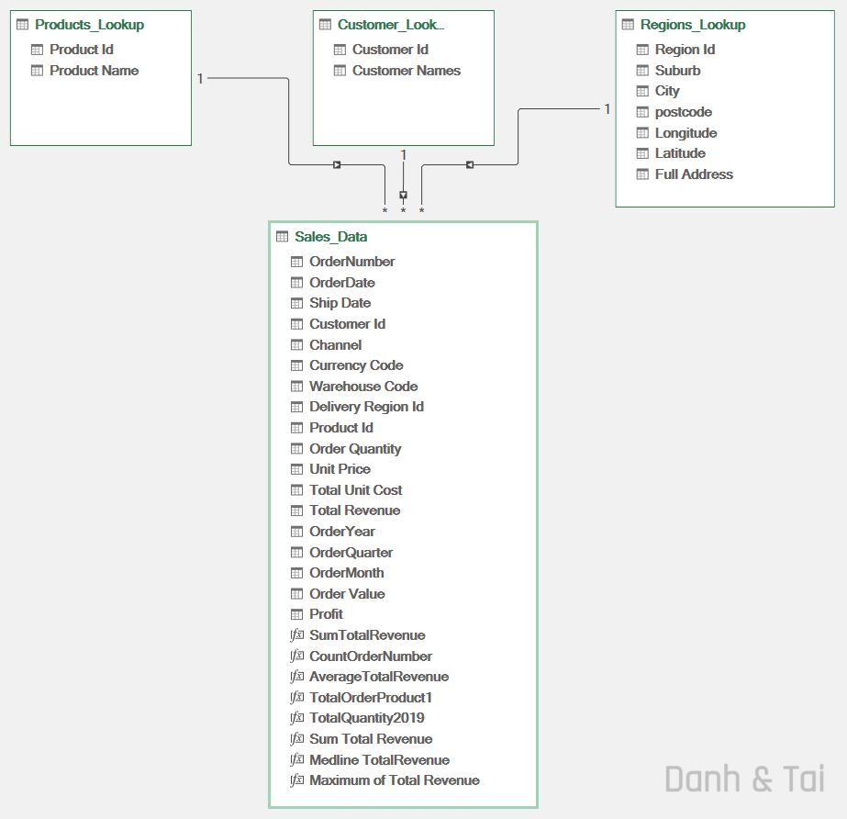 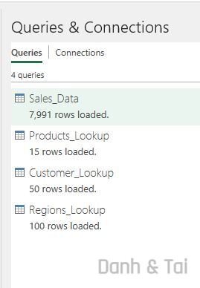

It is essential to create Query Connections only, rather than loading the data directly into Excel.

# ETL operations using Power Query Editor

Several ETL operations are applied to the Sales_Data table, including extracting Year, Quarter, and Month from the Order Date, changing the column data types, column duplication, as well as adding new columns.

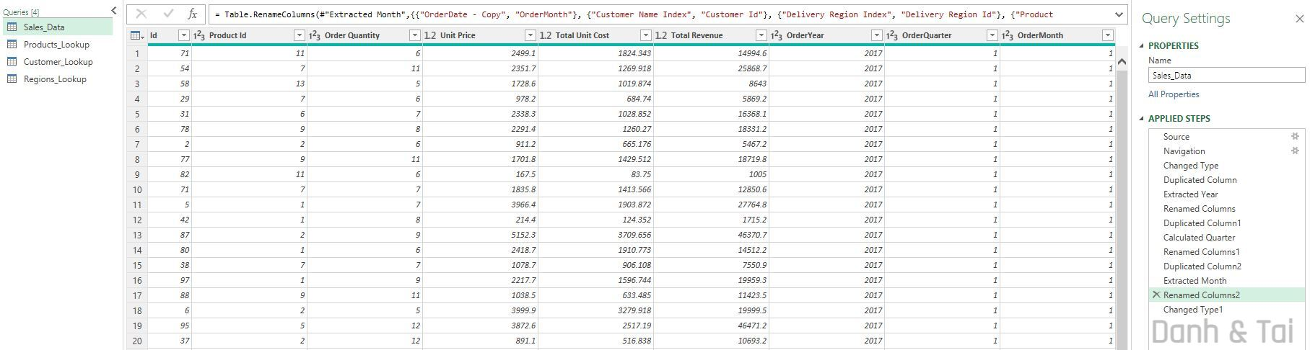

Change the data type of the Total Revenue, Unit Price, and Total Unit Cost columns to Currency.

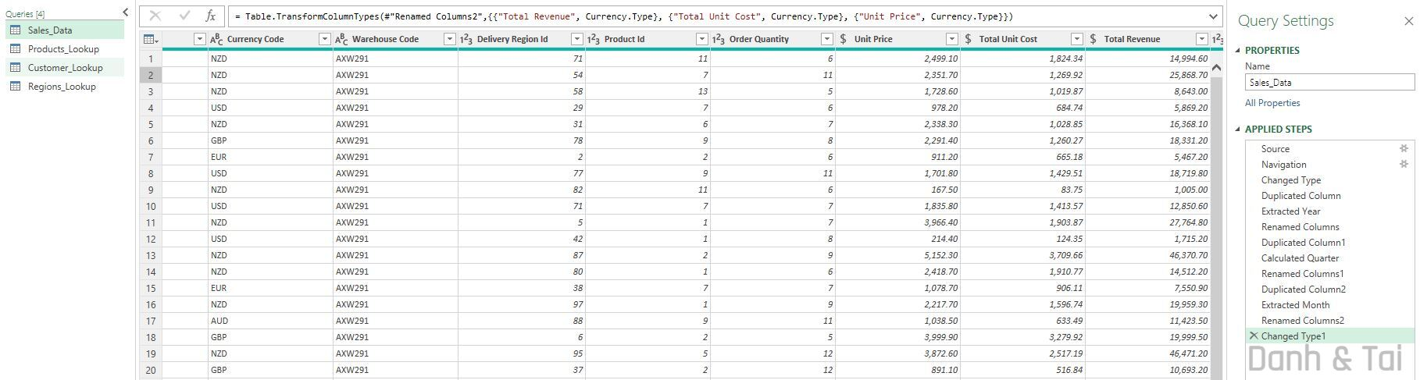

# Data analysis (Using Dax)

Several measures can be applied to the table to generate meaningful insights, including the Average of Total Revenue, Count of Total Orders, Total Quantity, and Sum of Total Revenue...

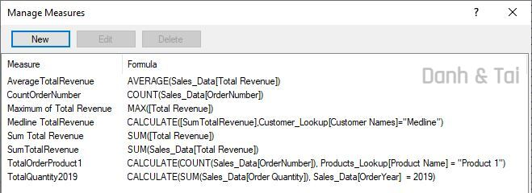

DAX also allows the addition of new columns using various DAX functions, including mathematical, statistical, logical, filter, and datetime functions.

A new column can be added using DAX to categorize the Order Value as LOW, MEDIUM, or HIGH based on the total revenue.

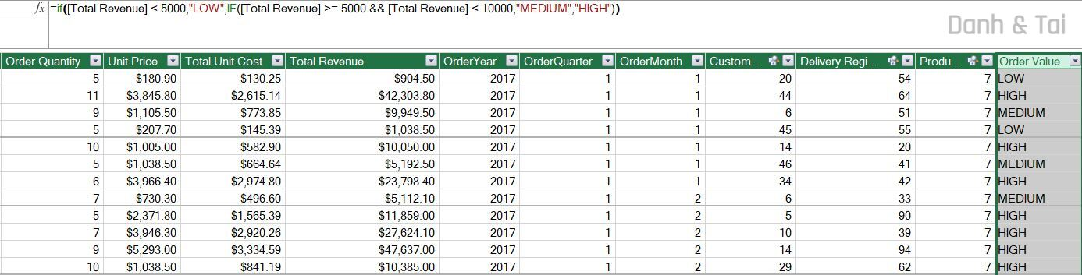

A new Profit column can be easily calculated by subtracting the total unit cost from the total revenue.

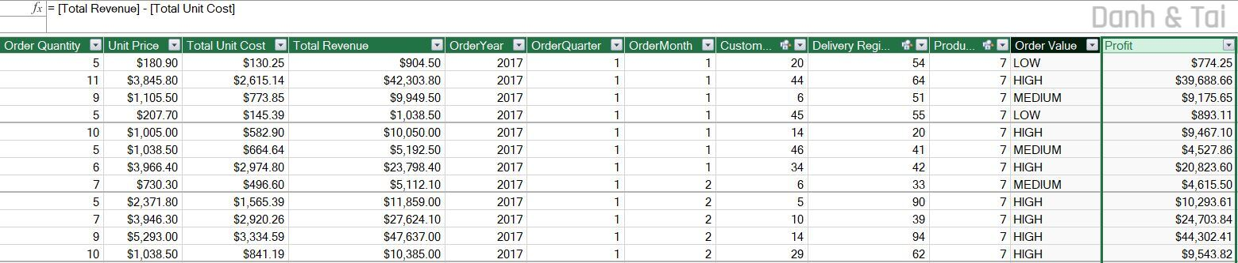

## Understanding regional product performance

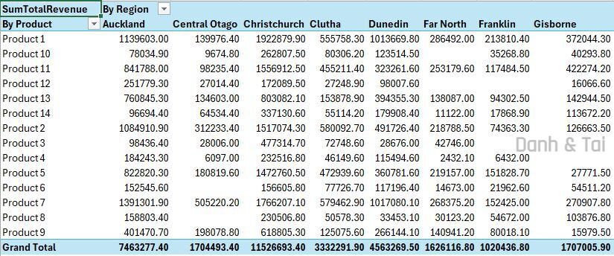

This table can identify which product generates the most revenue in different regions. This helps in understanding regional product performance. **Product 7** is the top performer with a revenue of $**1,391,301.90**. Focus marketing efforts or promotions on **Product 7** to maintain or increase its leading performance.

## Understanding customer order though sales channel.

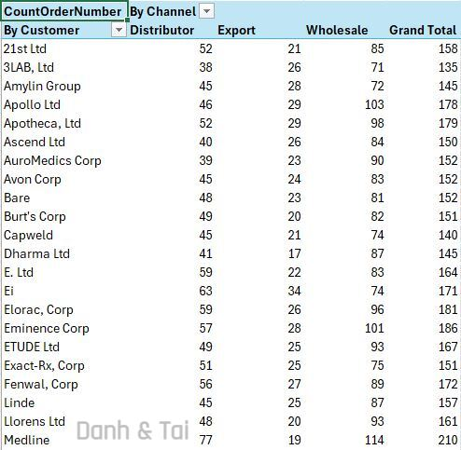

This will help determine which customers place the most orders and through which sales channel. **Medline** is the top customer overall with the highest number of orders (77 total), particularly in the **Wholesale** channel (114 orders). **Medline** could be a strategic partner for wholesale business, and it may be beneficial to focus on maintaining or even enhancing this relationship and offering targeted deals.

## Insight average revenue across years and quarters.

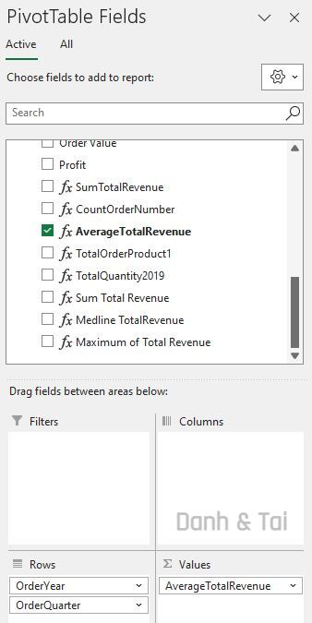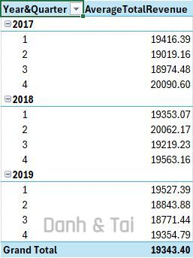

This shows the average revenue generated per order across different years and quarters. **2019** shows a slight decline in average total revenue compared to previous years. The declining trend in **2019** indicates potential challenges that may have impacted sales or overall revenue. It's essential to investigate this decline further to identify root causes and implement corrective measures to reverse the trend.

## Identifying the sales channel that generates the highest revenue and profit.

By using DAX measures to calculate total revenue and leveraging Power Pivot to group by sales channels, we can determine the revenue generated by each channel and identify which one contributes the most.

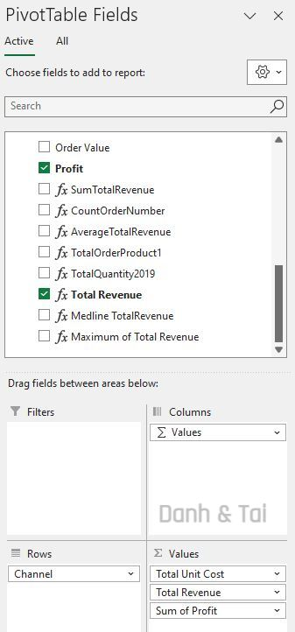

The report reveals that the **Wholesale** channel generates the **highest revenue and profit** for the company.

## Gain insights into sales performance by year and quarter

By using DAX to extract the Year, Quarter, and Month from the Order Date, we can gain deeper insights into sales trends by year and quarter.

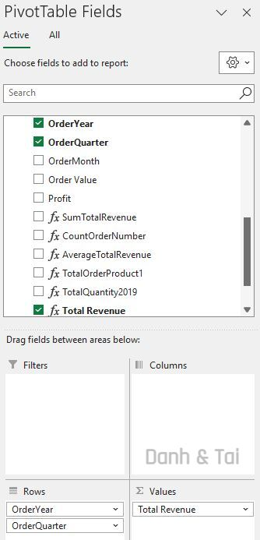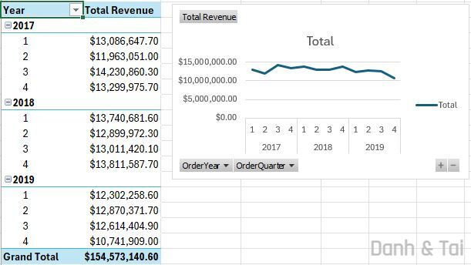

Sales show a **slight decline**, with the **lowest revenue** recorded in **Q4 of 2019**.

## Obtain insights into sales performance for each customer

By utilizing PivotTables and DAX measures, we can gain insights into the sales performance of each customer. The following report shows that **Medline has the highest total revenue**.

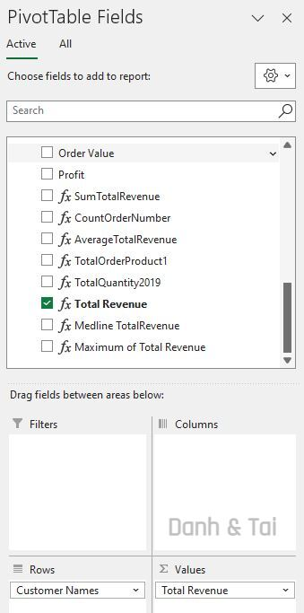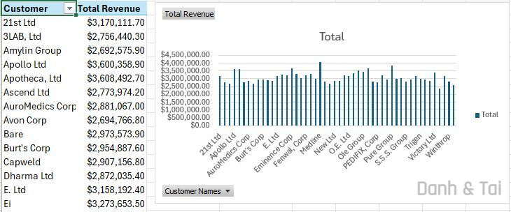

# Data analysis (using Calculate)

The DAX’s Calculate function is one of the most powerful and frequently used functions for modifying the context in which a measure or calculation is evaluated. It allows you to change or filter the data context to return a result based on certain conditions.

For example, we can use Calculate function to display the **revenue generated by a specific customer (Medline)**

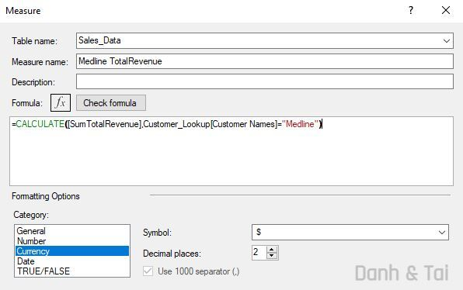

## Evaluate product performance



This calculation shows that **Product 1** was order **1314 times** with total revenue of **$154,573,140.60**. It helps to assess the popularity and sales frequency of the product, providing insights into customer demand for specific products.

## Get insights order quantity of a year

This will help track the total quantity of products ordered in 2019. It provides insight into the volume of orders, which could highlight market demand and operational load during that year.

## Revenue generated by a specific customer

Using the Calculate function to display the revenue generated by a specific customer (Medline) and categorize it by order value.

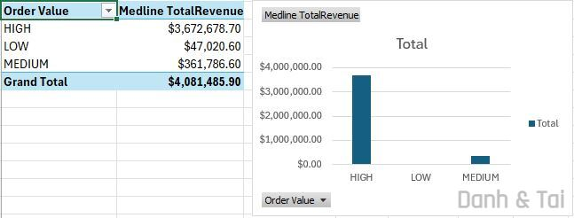

For the customer **Medline**, **"High" orders** contribute more than **90% of the total revenue**.

# Conclusion

Excel ETL and DAX are powerful tools for data analysis. However, it is crucial to thoroughly understand the data before applying any transformations or formula. From raw data, various insights, conclusions, and recommendations can be generated, depending on business objectives and user perspectives.