**Power BI Dashboard**

Danh.N – Tai.N

School of Information and Communications Technology, SaskPolytech

COMP 604 Web Analytics and Business Intelligent Tools

Himanshu Patel Ph. D

Nov 17, 2024

Table of Contents

1. Introduction 3

2. Final Dashboard 5

3. Formatting and DAX operation 6

3.1. Formatting 6

3.2. Measures 7

3.3. DAX 7

4. Dashboard Details 9

4.1. Filter and Slicers 9

4.2. Overrall Summary Cards 9

4.3. Top 10 Countries won the most Medals 10

4.4. Top 10 Players 11

4.5. Top 10 Sports 12

4.6. Summer vs. Winter Medals over Years 13

4.7. Distribution of Medals by Gender 14

5. Conclusion 14

# Introduction

The **Olympic Dashboard** in Power BI is designed to provide a comprehensive overview of the Olympic Games, focusing on key insights about athletes, countries, sports, and medal distributions. This dashboard enables users to gain actionable insights and explore the legacy of the Olympic Games in a visually compelling manner.

**Purpose**

The dashboard aims to:

* Analyze and visualize the performance of athletes and countries across different Olympic events and years.
* Identify trends in medal wins by Season, Sport, and Countries and Years.
* Offer an interactive platform for exploring Olympic history and achievements.

**Target Audience**

This dashboard is intended for:

* Sports Analysts: To study trends and performance metrics.
* Sports Enthusiasts: To explore Olympic data interactively.
* Organizations and Media: To present data-driven stories about Olympic achievements.
* Researchers and Academics: For conducting in-depth analyses of athlete performance and global sports dynamics.

**Data**

The dataset was sourced from Kagge https://www.kaggle.com/datasets/ishivamkedia/olympics-data/data. The dataset encompasses historical data from 1896 to 2016, covering both Summer and Winter Olympic events. It comprises 2 tables with the following relationships:

1. Athlete_events (Olympic Data table)
2. Country (Lookup table)

# Final Dashboard

The final report provides a comprehensive analysis of Olympic history, offering insights into medal achievements **from 1896 to 2016 across both Summer and Winter Games**. It features interactive **filters and slicers** for exploring data by season, year, country, and sport, enabling users to tailor their analysis effortlessly. Key highlights include **four summary cards** showcasing total counts of medals, countries, sports, and athletes. The report also presents **Top 10 rankings** for countries, players, and sports based on medal counts, providing a quick view of the most successful participants. A line chart compares medal trends between **Summer and Winter Olympics over the years**, while a **gender distribution pie chart** offers insights into participation dynamics. This dashboard is designed to engage analysts, enthusiasts, and researchers by delivering a rich, interactive exploration of Olympic achievements.

# Formatting and DAX operation

## Formatting

* Replace value “NA” in columns Age, Height and Weight to *null* value

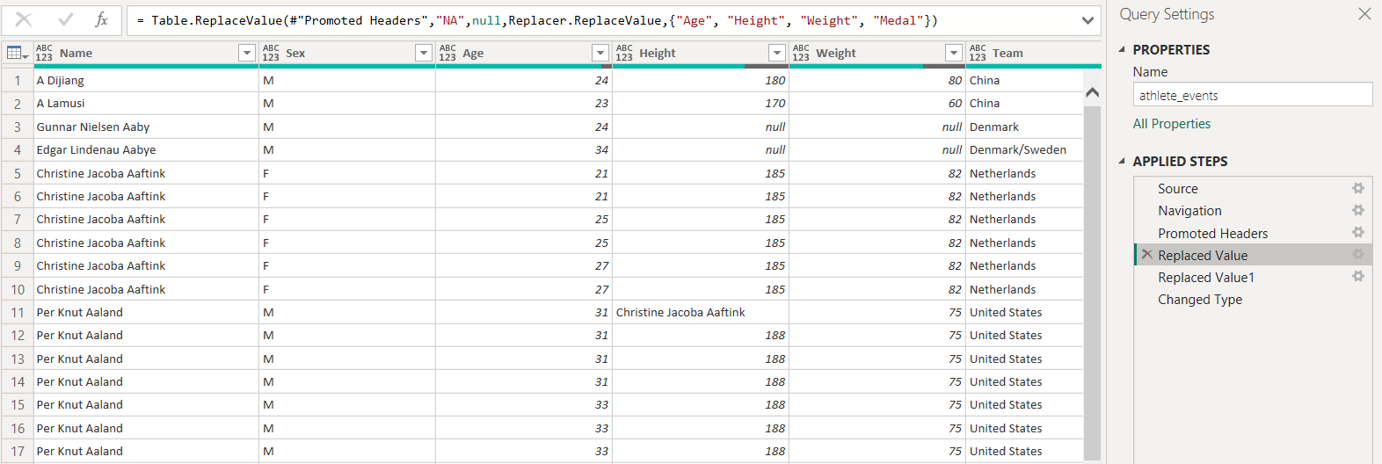

* Replace error value “Christine Jacoba Aaftink” in column Height to *null* value

* Change data type all columns correspond to existing value

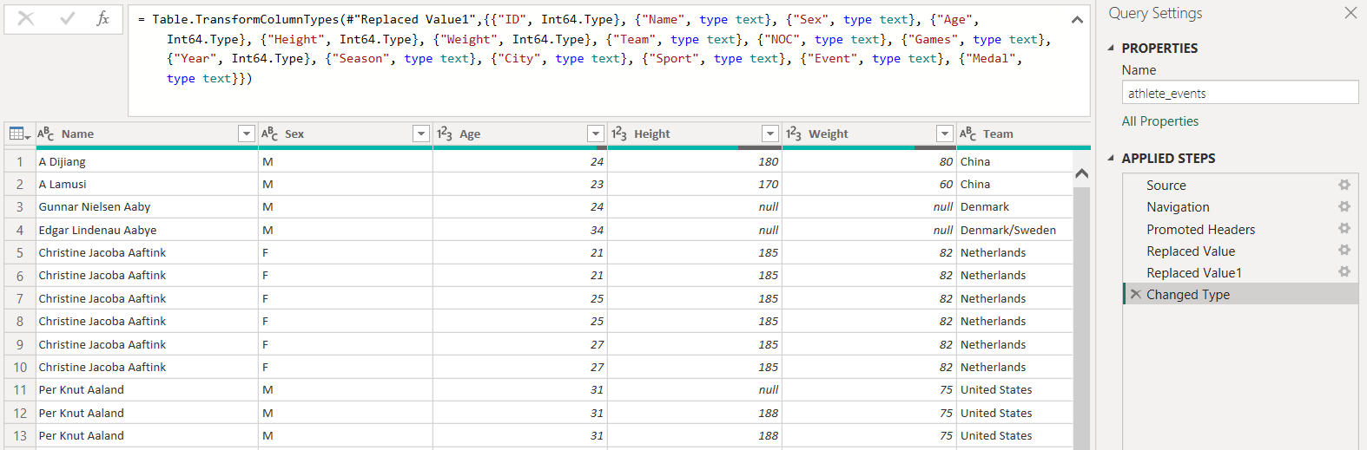

## Measures

* Create measures to count medals by season (Summer or Winter) for supporting the Summer vs. Winter Medals over Years trend chart.

## DAX

* Create a DAX to fill *null* values in column Age with Average Age by Sport

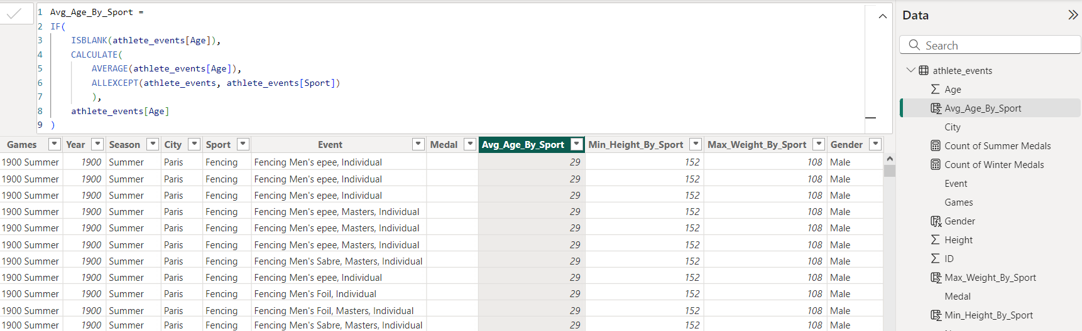

* Create a DAX to fill *null* values in column Height with Minimum Height by Sport

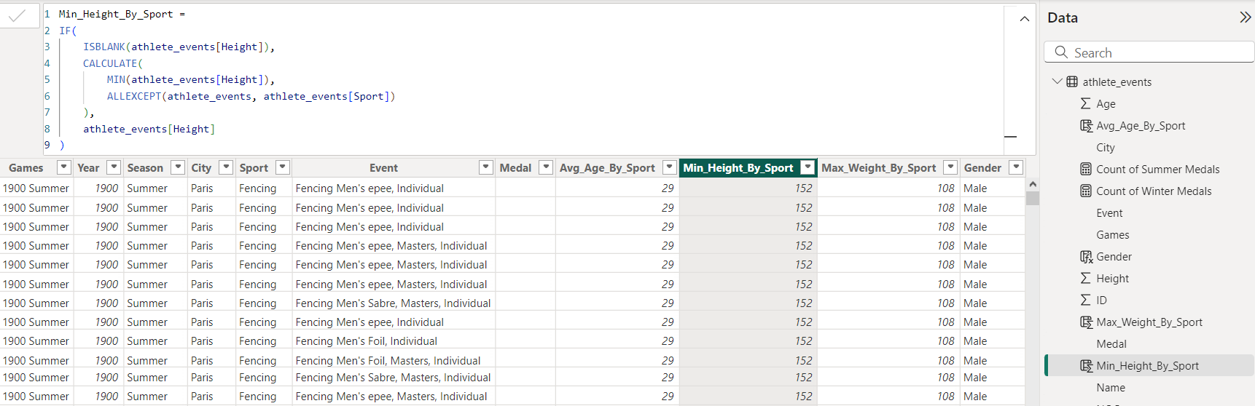

* Create a DAX to fill *null* values in column Weight with Maximum Weight by Sport

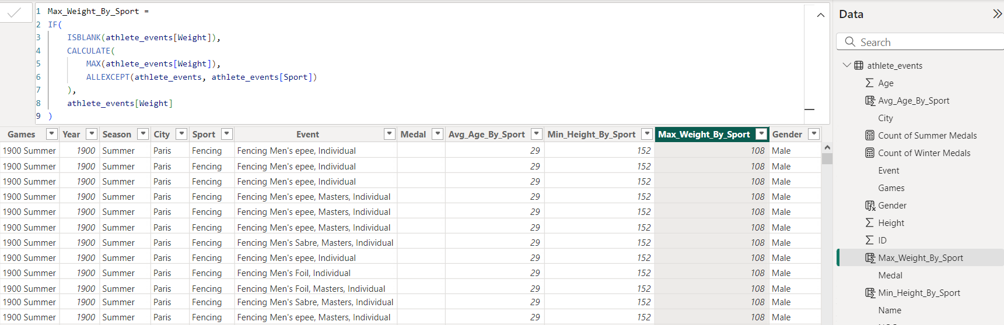

# Dashboard Details

## A screenshot of a survey Description automatically generated Filter and Slicers

The Filter and Slicers is to enable users to slice and dice the data by Season, Year, Country and Sport.

## Overrall Summary Cards

This section provides four summary cards showcasing **Total counts of medals, countries, sports, and athletes**.

|  |  |
| --- | --- |
| The summary cards display the total counts of medals, countries, sports, and athletes, providing an overview of the dataset at a glance |  |

## Top 10 Countries won the most Medals

The report reveals that the **United States, Russia, and Germany** have historically been the top-performing countries in terms of total medals won, with impressive counts of 5,637, 3,947, and 3,756 medals, respectively.

|  |  |
| --- | --- |
| This table utilizes the built-in Top N filter by Country. It is important to note that the table should be refined further to display only gold, silver, and bronze medals |  |

## Top 10 Players

The report highlights **Michael Phelps as the most successful athlete in Olympic history**, securing a total of 26 medals, including 23 golds. He is followed by **Larysa Latynina** with 18 medals and **Nikolay Andrianov** with 15 medals.

|  |  |
| --- | --- |
| The **Top 10 Players** and **Top 10 Sports** sections use bar charts to highlight the most successful athletes and the most medal-winning sports. These visualizations are specifically filtered to exclude entries where medal data is marked as "NA," ensuring only valid medal records are considered for accuracy and relevance. |  |

## Top 10 Sports

This bar chart visualizes the distribution of bronze, gold, and silver medals for the top 10 sports. **Athletics leads with the highest medal** count including 1.3k medals for each Gold, Silver and Bronze, followed by Swimming and Rowing.

## Summer vs. Winter Medals over Years

This line chart compares the medal counts for Summer and Winter Olympics from 1896 to 2020.

* **Summer Medals** (red line): The count has consistently been higher than Winter medals, showing a steady increase over the years, with significant growth post-1920 and a notable rise after 1980, reflecting the expansion of events and participation in the Summer Olympics.
* **Winter Medals** (yellow line): The count remains significantly lower, with gradual growth starting around 1924. Growth remains steady but far below summer levels.

## Distribution of Medals by Gender

The pie chart shows the proportion of medals won by males and females. **Males dominate with 28.53K medals, accounting for 71.71%** of the total, while females contribute 11.25K medals, representing 28.29%. This significant disparity indicates that male athletes have historically won more medals, potentially reflecting greater male participation or opportunities in past Olympic events.

# Conclusion

The Olympic data analysis provides valuable insights into the history and performance dynamics of the Games from 1896 to 2016. Key observations from the report include:

1. **Dominance of Leading Nations**: The United States, Russia, and Germany have emerged as the most successful countries in Olympic history, collectively amassing an extraordinary number of medals, showcasing their sustained excellence and participation.
2. **Athletics as a Medal Leader**: Among sports, Athletics dominates with the highest medal counts across all categories, reflecting its central role in the Olympics, followed closely by Swimming and Rowing.
3. **Michael Phelps' Historic Legacy**: Michael Phelps stands out as the most decorated Olympian with an unprecedented 26 medals, including 23 golds, setting a benchmark in Olympic history.
4. **Summer vs. Winter Trends**: The Summer Olympics have consistently outpaced the Winter Games in medal counts, especially after significant growth periods like post-1920 and the 1980s, reflecting a larger number of events and broader participation.
5. **Gender Disparity**: A significant gender gap in medal distribution is evident, with male athletes winning 71.71% of all medals, likely due to historical differences in participation and opportunities.

This comprehensive report highlights the evolution of the Olympics, showcasing standout performances, dominant sports, and trends that shape the legacy of this global event.