1. oracle-node.py compiled and deployed to an address on the Sepolia test network

Sepolia Testnet deployed contract:

https://sepolia.etherscan.io/address/0xA0608a544e61f722aee541BE90DCf483d05628AF

2. MyOracle.sol compiled and can check the updated ETH price in USD

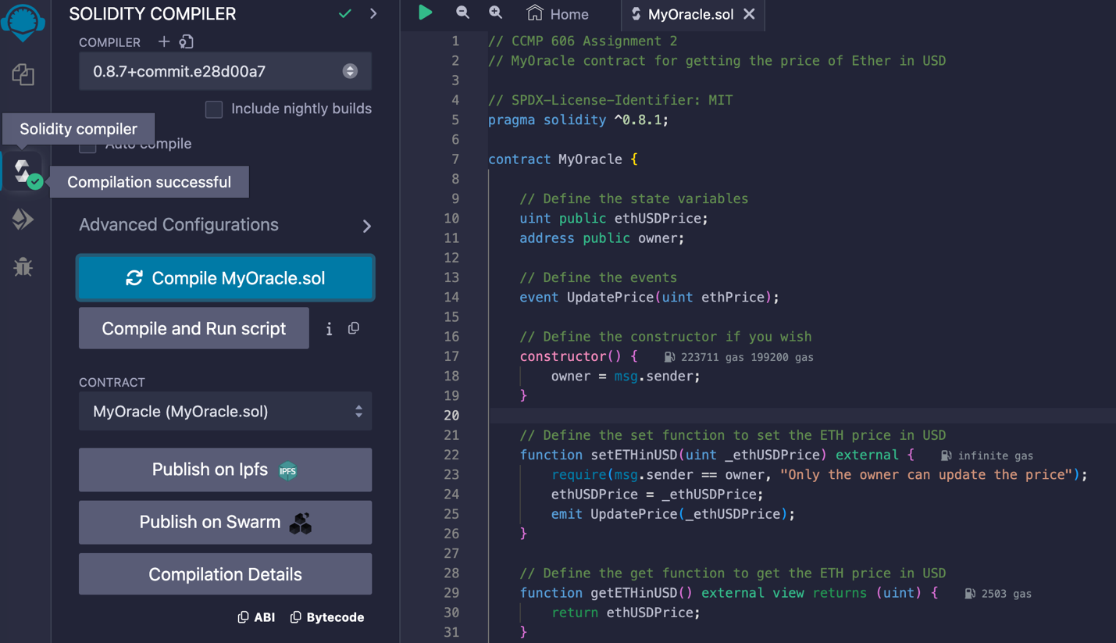

Check the newest price after update the price to the blockchain

3. Oracle has pulled the new ETH price in USD and writen it to the blockchain

Sepolia Testnet block 5522613

