Canadian Recalls App
Assignment 1

Joseph Visconti – John Selmy
032-751-117 – MAP524A
April 28, 20145 – February 27, 2015

Table Of Contents

1.0 – Executive Summary

2.0 – Why A Mobile App?

3.0 – Features
3.1 – View Recent Recalls
3.2 – Search Related Recalls
3.3 – Notifies of new Recalls

4.0 – User/Market Space
4.1 – People
4.2 – Language

5.0 – Mockups
5.1 – Main Menu
5.2 – Recent Recalls
5.3 – Search Recalls

6.0 – Use Cases
6.1 – Viewing all recent recalls for Health category
6.2 – Searching for recalls related to “Ford”

7.0 – Conclusion

1.0 – Executive Summary

The milk you picked up last night; the prescription your doctor gave you last week; the lawn mower you bought last month; the new car you acquired last year. All of these products, at any given moment, could be recalled and how would you know? Currently in Canada there is no good way for clients to be informed about the recalls of their products. In fact the only way for someone to find out there has been a recall is by if they happen to hear it by word of mouth. Whether it comes from the news channel on TV or their best friend. They will only happen to know about it if they happen to be in the right place at the right time asking the right questions, or else they might never even come across it and never know.

The app that I am interested in creating is a Canadian Recall Notifier App. The purpose of the app is to help bridge the gap in the currently flawed system Canada has in place right now. What my app proposes to do is to allow clients to quickly and easily see whenever a product gets recalled that way they will never have to wait for someone else to tell them. With a couple taps on the screen, they will be able to see any recently recalled product or even search to see if anything they have currently has an outstanding recall on it. With my app the gap between the company's and the clients will be brought closer together, and hopefully be able to eliminate the need of a middle man to inform the clients about recalls.

2.0 – Why A Mobile App?

As previously mention in the executive summary, there is currently a gap between the company's and their clients. A big part of this gap is based on the fact the only way for clients to learn about recalls is through word of mouth from other clients. The issue with this approach is that at certain times some clients will not hear about the recall at all or might not hear about the recall in time before something bad could happen.

A Canadian Recall Notifier works great as a mobile app because it provides a way for clients to get inform right away as they need it. Making it an app bridges the gap because it eliminates the need to have a middle man because once the middle man would have found out, all the other clients would know at the same time. An added bonus of it being a mobile app is that all the information would be on the clients phone and will be able to get notified right away as opposed to the next time they would have seen their middle man. Lastly, at any given point a client can search a product to quickly verify any concerns they might have had about a product.

3.0 – Features

3.1 – View Recent Recalls
One of the main features that my app will have is the ability to see any recently recalled product. It will allow clients to easily check in the past 15 recent recalls. A feature like this is useful for the client because if check periodically the client will never be out of the loop on a recalled product.

3.2 – Search Related Recalls
The ability to search any for any related recalls to a product is extremely important to a client when they are considering purchasing a product. The more the client knows about a product, whether it is good or bad, is always a plus and can help when considering a purchase.

3.3 – Notifies of new Recalls
The client will be able to setup notifications to repeat either, daily, weekly, or monthly, that will keep track of and inform the client of all new recalls that they have missed over their desired time frame. A feature like this is useful because recalls dont happen at any specific intervals and clients will never know exactly when to look at the app. With a feature like this they wont have to look at it all the time and just get reports every so often of the recent recalls.

4.0 – User / Market Space

4.1 – People
An app like this could appeal to a wide range of people. Anyone that is old enough to start working and make their own money could be interested in an app like this. Young children and teens wont really be interested because they don’t have their own money and therefore wont really be caring about the state of their purchase. Adult will care because they do make their own money and know how hard they work for it, so they will want to make sure they get the best bang for their buck.

4.2 – Language
The API that i am using to search a database full of recalls allows me to get the results in English and also French. That also being said, this is an app for Canadian recalls only and in Canada the two official languages are English and French so the app should be able to support both.

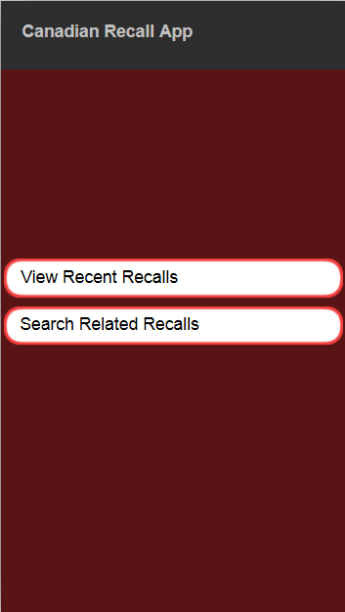
5.0 – Mockups

5.1 – Main Menu

5.2 – View Recent Recalls
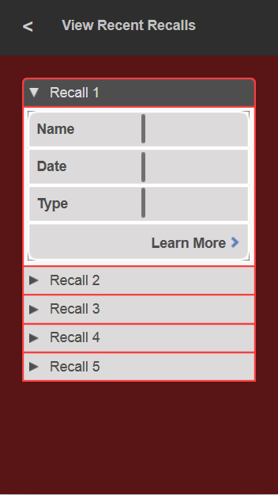

5.3 – Search Related Recalls
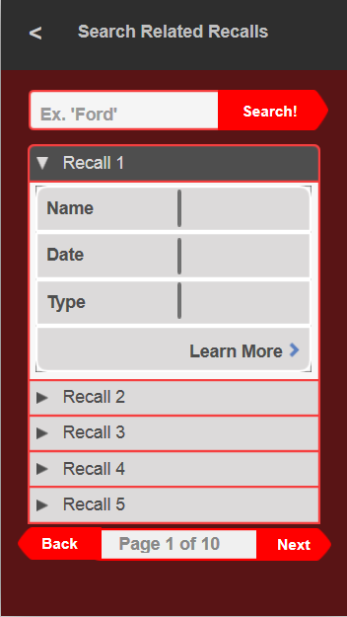

6.0 – Use Cases

6.1 – Viewing all recent recalls for Health Category
1. Load up the app.
2. Tap “View Recent Recalls”.
3. Tap the briefcase with a + in the middle
4. Review recent health recalls

6.2 – Search for recalls related to “Ford”

1. Load up the app.
2. Tap “Search Related Recalls”
3. Tap the area at the top that says “Ex. 'Peanuts'”
4. Type the word “Ford”
5. Tap “Search!”
6. Review related recalls

7.0 – Conclusion

I am interested in learning about JSON API's and how android can make use of them. JSON API's are used frequently in the Web Development world and knowing how Android apps can make use of these will open up a vast amount of opportunities for an Android Developer.

