Canadian Recalls App
Assignment 2

Joseph Visconti – John Selmy
032-751-117 – MAP524A
April 29, 20145 – April 10, 2015

Table Of Contents

1.0 – Executive Summary

2.0 – Final App Comparison

3.0 – Features List

4.0 – Snapshots
4.1 – Main Menu
4.2 – Recent Recalls
4.3 – Search Related Recalls
4.4 – Recall Details

5.0 – Conclusion

1.0 – Executive Summary

The milk you picked up last night; the prescription your doctor gave you last week; the lawn mower you bought last month; the new car you acquired last year. All of these products, at any given moment, could be recalled and how would you know? Currently in Canada there is no good way for clients to be informed about the recalls of their products. In fact the only way for someone to find out there has been a recall is by if they happen to hear it by word of mouth. Whether it comes from the news channel on TV or their best friend. They will only happen to know about it if they happen to be in the right place at the right time asking the right questions, or else they might never even come across it and never know.

The app that I am interested in creating is a Canadian Recall Notifier App. The purpose of the app is to help bridge the gap in the currently flawed system Canada has in place right now. What my app proposes to do is to allow clients to quickly and easily see whenever a product gets recalled that way they will never have to wait for someone else to tell them. With a couple taps on the screen, they will be able to see any recently recalled product or even search to see if anything they have currently has an outstanding recall on it. With my app the gap between the company's and the clients will be brought closer together, and hopefully be able to eliminate the need of a middle man to inform the clients about recalls.

2.0 – Final App Comparison

The overall idea of the Canadian Recall App has not changed since my initial proposal. Clients are still able to see recent recalls for their products and still be able to search for related recalls. What has changed is now when the user selects to see more info about any recall it will take them to another activity within the app which will have more info about that specific recall as opposed to just going straight to the Canadian recalls website. When viewing recent recalls the client now has the option to filter the results based on Food, Vehicles, Health, and Consumer Products categories. Also the recall notifications feature that was promised in the initial proposal has been had to be left out.

3.0 – Features List

Working
1. View recent recalls
2. Filter recent recalls on certain categories
3. Search related recalls
4. Detailed recall screen
5. Quick links to useful websites

Incomplete
1. Recall notifications
2. Ability to change the language to french

4.0 – Snapshots

4.1 – Main Menu

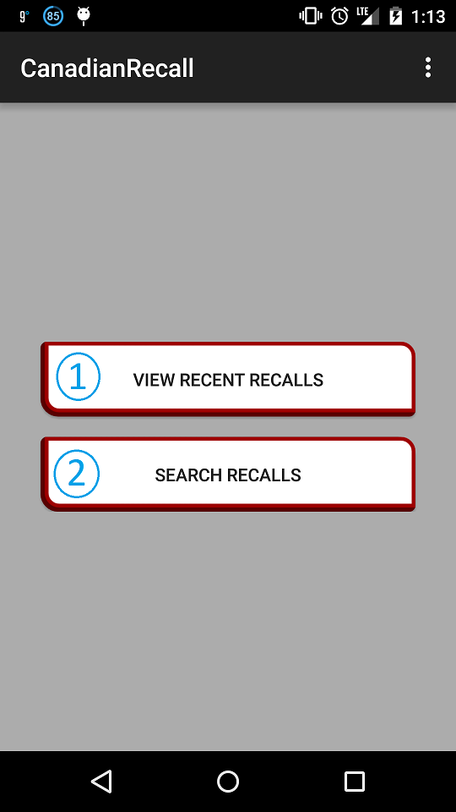
1. Button that leads to the recent recalls activity.
2. Button that leads to the search recalls activity.

4.2 – View Recent Recalls
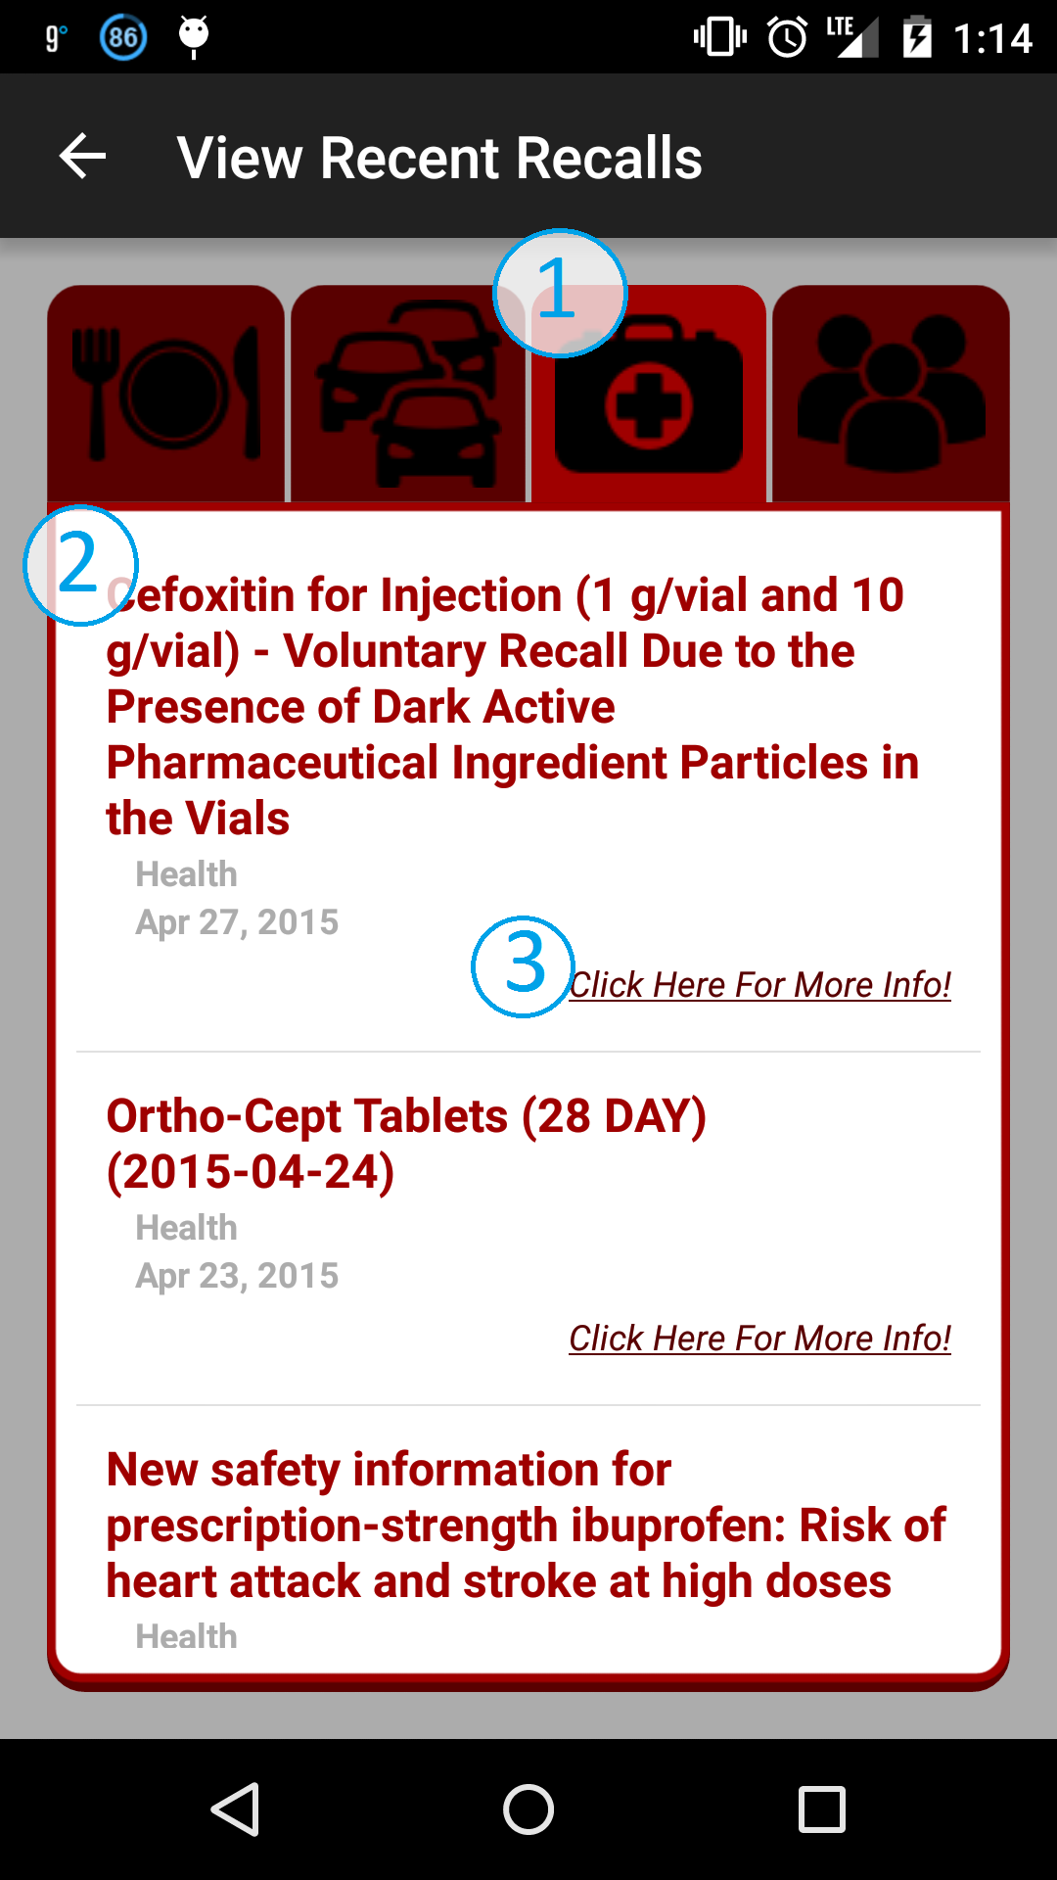
1. Filter Categories. In order from left to right are: Food, Vehicles, Health, Consumer Products.

2. Recent recall snippet.

3. Tapping this link will show more info, within the app, for the related recall.

4.3 – Search Related Recalls
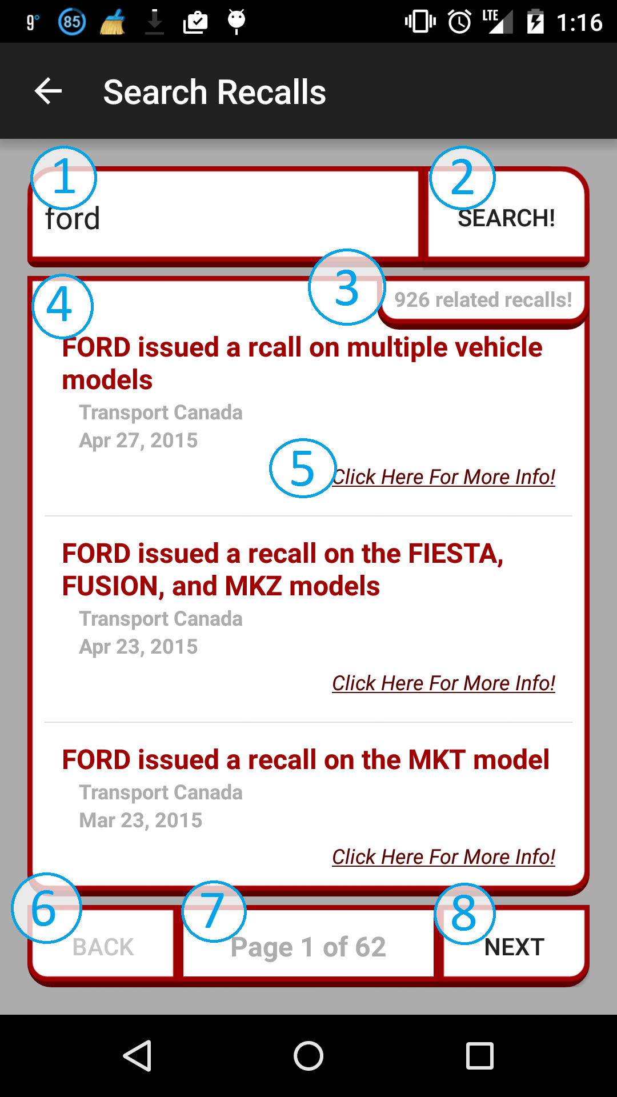
1. Enter anything you want to search here.
2. Tap the search button after entering your search.
3. The total number of recalls found that are related to your search.
4. A recall snippet that is related to your search.
5. Tap the more info link to be taken a detailed activity for that recall.
6. Tap the back button to go back one page
7. The page number you are on out of the total number of pages.
8. Tap the next button to go to the next page and view more related recalls.

4.4 – Recall Details
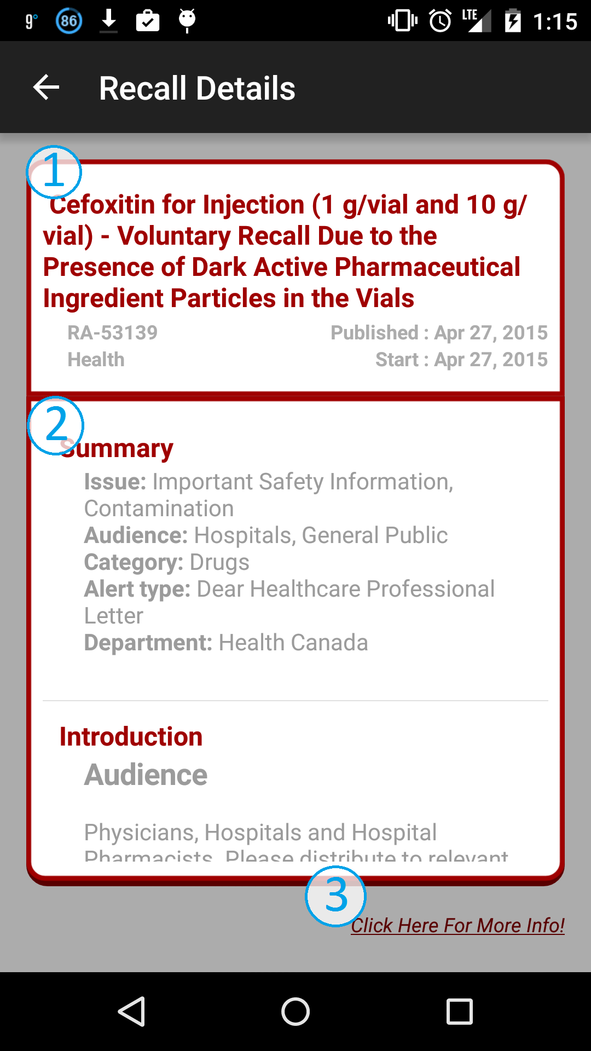

1. The recalls main header information

2. Different panels full of information for the user to view

3. More information link that will open up a web browser to the related recall on the Canadian Recalls website.

5.0 – Conclusion

Some features that weren’t added because I simply didn’t know how to them nor did I have the time to learn how to do them due to poor project management. After my initial proposal I decided to add a the detailed recalls activity so that the client could quickly and easily view more information about the recall without having to go straight to the website. If i had more time i would defiantly add in the initially promised notifications feature because that will take this app to the next level and make it even more useful.

My overall impression with this app is that i am actually pretty happy with it. I think an app like this could actually turn out to be useful for people in the future. With the database I am using, it seems to be getting updated daily, so having an app like this to display that information in the database could prove to very useful.

