OV7670
VGA Camera

Explore
Software

Table of Contents
Why Exploration Software 6
Development of the Exploration Software 6
Chip Resolution Modes 7
Common Chip Functions 8
Overall Program Layout 8
Commands Implemented by the Exploration Code 9
help 9
Command Detail Description 15
d 15
t 15
testread or r 15
testwrite or w 15
rs 16
reset 16
fr 16
pr 16
par 16
dr 17
listfiles 17
remove 17
flags? 17
setreg 17
dumpreg 18
histocoloron 18
histocoloroff 18
histolumon 18
histolumoff 18
histoUon 18
histoUoff 18
histoVon 18
histoVoff 19
showhisto 19
clearhisto 19
color 19
black 19
colorbaryes 19
colorbarno 19
color= 19
dcolor 20
logon= 20
logoff 20
script= 20
nowrite 20
write 20
ph= 20
pw= 20
pos= 21
pix 21
bmp= 21
Modes Setup 21
aec? 21
aecon 22
aecoff 22
aecslow 22
aecfast 22
aechistogram 22
aecaverage 22
aechistogram 22
aecoperating= 22
aeclimits= 23
aecwindow= 23
hae1-6 AEC Histogram 23
AEC-nib= 23
AEB-nib= 24
agc? 24
agcon 24
agcoff 24
agcfreeze 24
agcunfreeze 24
agcgain= 24
agclimit= 25
bright= 25
banding? 25
banding= 25
contrast= 25
denoise? 26
denoiseon 26
denoiseoff 26
denoisethreshold= 26
denoisereg77= 26
edge? 26
edgevalue= 26
flipyes/flipno 26
mirroryes/mirrorno 26
lightmode? 27
lightmode= 27
yuv? 27
floatyuv 27
fixyuv 27
kr= 27
k1g= 27
k2g= 27
kb= 28
output? 28
Output= 28
saturation? 28
saturation= 28
scale? 28
uvavgno/uvavgyes 30
window? 30
window= 31
Special Effects 31
antique 31
bluish 31
greenish 31
reddish 31
bw 31
colornegative 32
bwnegative 32
normal 32
YUV Conversion from Bayer 32
matrix? 32
yuvmatrixon 33
yuvmatrixoff 33
yuvmatrixdoubleon 33
yuvmatrixdoubleoff 33
gamma= 33
Some Photos 34
VGA Truncated to Fit FIFO 34
34
QVGA in Full Resolution 35
QQVGA in Full Resolution 35
CIF in Full Resolution 36
QCIF in Full Resolution 36
Q8060 in Full Resolution 36
Q4030 in Full Resolution 37
VGAW in Controlled Window Mode 37
Hardware Description 38
Appendix A 41
Register Names Alpha Order 41
Appendix B 42
Register Names Numeric 42

Why Exploration Software
All the software I have seen for this camera is a canned loading of the control registers to put it into some mode where a picture can be taken. Mostly this has been a VGA, QVGA or a QQVGA mode. Much of the software relies on just a series of mystery values for some of the registers that are marked “reserved” RSVD. The output of the program is usually to a small QVGA/TFT color screen, some software skips this and just outputs the picture data directly to a file on an attached SD card which is then plugged into a PC to process the picture.
Aside from taking fuzzy pictures of your cat there is little utility in any of these programs. This camera has many modes and resolutions that could be exploited for various “vision” projects. The small amount of RAM memory of the typical Arduino single board computer will not allow the processing of even a modest resolution photo. How about going to the absolute minimum the camera will allow (40 x 30) and then processing the really low resolution image and when necessary then using the windowing function in the VGA mode to select a portion of the image of interest for further processing? This would seem to be a reasonable solution to the memory problems without going to the larger and more expensive “Arduino DUE” which is fast and has 64Kb of contiguous ram which would allow processing a 250 x 250 picture with just the luminance values. The 3.3 volt interface might be nice also.
The OV7670 low resolution modes are easy to enter and use. The VGA “windowing” mode allows even further reduction if necessary, at a sacrifice of field of view. The image taken can then be processed as a black and white image saving half of the space of a color image. Consider a monitoring application were the low resolution image is processed looking for a change in as little as one pixel. Once the change is detected then the pixel location can be mapped on to the VGA resolution and a “window” generated around the pixel and a photo taken with greater resolution. At this point perhaps even color can be used to further process the change. Robot vision does not have to be high resolution for many tasks and the cost of the camera (with a FIFO) is minimal, somewhere in the range of $10.

Development of the Exploration Software
As almost all Arduino projects start with a downloaded software from various sites thats how I got this started. I had a small QVGA/TFT color “touch” display with the usual SD card slot. The hardware was assembled as a OV7670 Camera with an AL422B FIFO that had 385K bytes capacity, the display an SD card and a Arduino “Mega” single board computer. The AL22B FIFO spec sheet says that it can hold up to 819x480 bytes of picture data. This is NOT enough to process a VGA photo in color. It can hold the data from a QVGA color photo. It is more than enough for lower resolutions.

The LCD/TFT display has an ILI9241 controller chip. I soon discovered that a simple loop loading the pixel address and then the pixel (two bytes) produced a very very slow display, unfortunately thats all I had available in the software library for the display. Also there was no mode to accept RGB565 data. I added both of the routines. UTFT.cpp did have a “setXY(x,y,x1,y1)” used internally. I coded a RGB565 and added a wrapper for “setXY”. I then added this code to the downloaded source and started making changes to the main code to correct what I considered some problems with the original. I the long run all but a few lines of the original code has been replaced by code that explores the chip. It still does not do anything useful but it will allow you to explore the chip and select the modes that you can use. Unfortunately the code is too large to run on a chip smaller than the Mega, its almost 100K bytes and uses 4000 bytes of RAM although some of this is allocated to the SD card buffers.

Chip Resolution Modes
The code as it is implemented will support the following resolutions.
- VGA – a 504 x 380 version of the full chip resolution that supports color and fits into the FIFO.
- VGAP – output a full 640 x480 picture in the “PROCESSEDBAYER” data stream mode with the black and white option selected. This output signal is the luminance only.
- VGAW – the VGA mode with user selected windows. All output modes are available.
- QVGA – 320 x 240 this mode would match the LCD/TFT except for changes that are made to increase the speed of the display.
- QVGAC – 320 x 240 output in the RGB565 format.
- QQVGA – 160 x 120
- CIF – 352 x 240 this mode has a problem with YUV processing.
- QCIF – 174 x 144 same problem as above.
- Q8060 – 80 x 60 low resolution can be useful.
- Q4030 – 40 x 30 the lowest resolution the chip supports.
These modes are requested by name and the chip is setup when the command is given to take a picture. The chip mode is “remembered” and not selected again till the resolution is changed.

Common Chip Functions
Many of the capabilities of the chip carry over from one resolution mode to another. The functions are implemented to be selected on the fly while the chip is in a specific resolution mode. They are saved and applied to any mode changes. The important thing is that functions can be changed on the fly. This allows the user to experiment with various functions to choose the best one for a final implementation in your project.
The major portion of this documentation will be an enumeration of the functions and their mode of selection. There are separate descriptions of the registers and their interactions that implement these functions in vendor documents. There are also routines in this code to view registers, set the value of registers and save the current registers to a “script” file to allow return to a know status. The script function can also be used to log a series of commands and the play them back. There are descriptive comments written to the terminal on significant changes. There is a command that selects a “verbose” mode that details almost all actions taken.

Overall Program Layout
The program is in multiple sections. The main is were all the “command lines” are processed. Usually by calling routines in the “camera_routines.cpp”. There are several header files:
- I2C_defs.h – the I2C error parse defines and the OV7670 I2C address are here.
- camera_routines.h – define all the routines in the camera_routines.cpp that are called by the main program.
- Gamma.h – two gamma curves and a register list with the gamma registers defined for storage in ROM.
- reg_defines.h – OV7670 registers, flags and some macros used in flag testing.
- saturation.h - five sets of color saturation matrix values and a register list defined for storage in ROM.
A cpp file with the camera routines in it is the largest special purpose code section.
There are five special “Arduino” library header files call by the main:
- SD.h - setup for calls to the SD card library functions.
- SPI.h - setup for the “Serial Program Interface”.
- Utouch.h – the touch screen code interface.
- UTFT.h - the LCD/TFT display library ( modified – functions added ). See UTFT.cpp – lines 1389 to end, put_pix, put_pix_word and set_rect are routines added. Wrappers really, to make it easier to code the display routine.
The camera routines module “camera_routines.cpp calls the Wire.h to setup the I2C functions for the camers.

Commands Implemented by the Exploration Code

help
The command to find out the rest of the commands is likely the most important. Entering “help” or “h” at the command line (terminating with a CR) produces the following display.
................ Help Menu ..................
d - Display Current Camera Command
t - Take Photograph using current Command and Parameters
testread - Tests reading files from the SDCard by reading and printig the contents of test.txt
testwrite - Tests writing files to SDCard
Resolution Change Commands: VGA,VGAP,VGAW,QVGA,QQVGA,CIF,QCIF,Q8060,Q4030
FPS Parameters: ThirtyFPS, NightMode
AWB Parameters: SAWB, AAWB
AEC Parameters: AveAEC, HistAEC
YUV Matrix Parameters: YUVMatrixOn, YUVMatrixOff,YUVMatrixDoubleOn,YUVMatrixDoubleOff
Denoise Parameters: DenoiseOn, DenoiseOff
Edge Enchancement: EdgeYes, EdgeNo
Automatic Black Level Calibration: AblcON, AblcOFF
ADDED COMMANDS FOR TESTS
w - write to SD card test
r - read SD card test
rs - Issue software reset of entire system
reset - reset the camera registers to defaults
fr - fill a table with the camera's current register values
pr - print the contents of the current register table and the camera registers
par - print ALL the contents of the register table and the camera registers
dr - print the difference of the current table and the current registers
listfiles - print the files on the SD card
remove = remove=<filename> removes the file from the SD card
flags? - display the control flags and some constants
setReg = setReg=##,## - two digit hex register number and two digit hex register value
write - set a flag that allows writing of photo to SD card file - default
nowrite - set a flag that prevents writing of photo data to SD card file
dumpreg = <file_name> dumps a file with the contents of the camera register in a format that
can be called as a script
MODE COMMANDS
histocoloron - compute a 64 bucket histogram of the RGB colors from the YUV computation
histocoloroff - stop the collection of histogram data
histolumon - compute lumance histogram
histolumoff - stop the collection of histogram data
histoUon - compute U - Cr histogram
histoUoff - stop the collection of histogram data
histoVon - compute V - Cb histogram
histoVoff - stop the collection of histogram data
showhisto - display the columns of the color histogram
clearhisto - clear the histogram array to zeros.
color - Display picture in YUV color on LCD, likely overridden by 'output' command
black - Display picture in Blank and White on LCD using Y of YUV data
colorbaryes / colorbarno - Test Pattern 8 color bar - on/ off
color=r,g,b Set a color for display in rectangle defined by pos -(r,g,b are integers 0-255)
LCD color display - dcolor - cycles through colors
logon - start a log file on the SD card. Record all commands.
logoff - close an existing log file
script=<file name> -- starts execution of commands from a script file, one command per line
ph = # - set the global PHOTO_HEIGHT - this overrides the current setting till next resolution change call.
pw = # - set the global PHOTO_WIDTH as above.
pos=x1,y1,x2,y2 - no spaces, sets rectangle for fill
pix - write a black rectange at pos
QVGAC - take color pic using rbg565
BMP=<file.name> - display BMP on the TFT
BMP24=<file.name> - display BMP using 8 bit RGB color on the TFT
Detail=[t/f] - display verbose data on capture photo
CAMERA MODES SETUP
aec? - report the Automatic Exposure Control AEC
aecon - set AEC ON
aecoff - set AEC OFF
aecslow - sets slow automatic exposure control on
aecfast - sets fast automatic exposure control
aechistogram - set histogram based AEC on
aecaverage - set Average based AEC on
aecoperating=#,# - Set average AEC stable operating limits Lower and Upper
aeclimits=#,# - Set average AEC Control Zone limits Lower and Upper
aecwindow=# - set Luminance window size 0 = full, 1 = one half, 2 = one quarter, 3 = one quarter
hae1=# - AEC Histogram 'High Reference Luminance 0 -254
hae2=# - AEC Histogram 'Low Reference Luminance 0 -254
hae3=# - AEC Lower Limit of Probability for HRL 0-254
hae4=# - AEC Upper Linit of Probability for LRL 0-254
hae5=# - AEC Threshold Probability for Low Reference Luminance 0 - 254
hae6=# - AEC Threshold Probability for High Reference Luminance 0 - 254
AEC-nib=# - Luminance High Threshold for AEC/AGC speed control 0 - 15
AEB-nib=# - Luminance Low Threshold for AEC/AGC speed control 0 - 15
agc? = report the AGC settings
agcon - set AGC ON
agcoff - set AGC OFF
agcfreeze - set the AGC freeze bit in the camera
agcunfreeze - clear the AGC freeze bit in the camera
agcgain=#### setup a manual gain, not used if in automatic mode
agclimit=### 1 to 128 Set gain limit for AGC
bright=<1|2|0|-1|-2> Sets reg 55x - brightness levels for exposure
banding? - show the current light banding parameters
banding=[50hz|60hz|auto|off]
contrast=<2,1,0,-1,-2> Sets reg 0x56 for contrast
denoise? - display the denoise registers
denoiseon - turn on denoise ( automatic mode)
denoiseoff - turn denoise to manual mode
denoisethreshold=##, sets 0x4c DNSTH for manual adjustment - denoiseOff
denoisereg77=##, sets 0x77 REG77 for denoise offset in automatic mode, default = 0x10 - denoiseOn
edge? - Show the edge enhancement values
edgevalue=## - set Enhancement adjustment - 0 - 15
Flip vertical - flipyes/flipno
mirror - mirroryes, mirrorno - sets and resets the flip the x axis mode
lightmode? - prints the current setting for light mode
lightmode=auto|sunny|cloudy|office|home - sets RED & GREEN gain and turn on/off Automatic White Balance
yuv? - print out the fixed point cofficenets for YUV conversion
floatyuv - set a floating point YUV conversion
fixyuv - set a fixed point YUV conversion
kr=# set the red conversion value
k1g=# set the first green conversion value
k2g=# set the second green conversion value
kb=# set the blue conversion value
output? = print the current data output format
output=[yuyv,yvyu,uyvy,vyuy,rgb565,rgb555,rgbx444,rgb444x,bayerraw,processedbayer]
saturation? - print out the saturation value -2,-1,0,1,2
saturation=# - set the saturation value for YUV conversion
scale? = print out the scaling factors
UVAverage - uvavgyes/uvavgno
window? - print the scan window parameters
window=Hstart,Hstop,Vstart,Vstop - Hstart must be > 130, offsets are horizontal = 136, vert = 12
SPECIAL EFFECTS
antique - brownish picture
bluish
greenish
reddish
bw - hardware generated black and white image
colornegative
bwnegative - hardware generated black and white negative
normal - default
YUV CONVERSION FROM BAYER
matrix? - print the values of the YUV matrix in the camera
yuvmatrixon - enables the non default conversion values
yuvmatrixoff - sets saturation to 0 and turns off matrix_on
yuvmatrixdoubleon - set the camera register flag to double the conversion values
yuvmatrixdoubleoff - set the camera back to normal YUV conversion
gamma =# - set a gamma curve from the set of predefined curves - see gamma.h f

Command Detail Description

d
Display the current command. The display shows:
Current Command:
Command: QVGA
FPSParam: 30FPS Mode
AWBParam: Simple Automatic White Balance is ON
AECParam: AEC is ON
AEC Histogram function is ON
AEC Fast mode in ON
YUVMatrixParam: Default Saturation Matrix
DenoiseParam: Denoise is OFF
EdgeParam: Edge is OFF
ABLCParam: Automatic Black Level Control is ON

t
Take a photo using the current command setup.

testread or r
Read a file written to the SD card for testing functionality.

testwrite or w
Write a file to the SD card containing data to be read back with testread.

rs

Rs is a software reset that executes the Arduino executive setup function. It is equivalent to pressing the reset button on the computer board.

reset
This command issues a reset command to the OV7670 only, by setting COM7[7] to one. This may be used to reset the camera to a known state prior to issuing commands for “mode” changes.

fr
This command fills an internal RAM array with the values of the current OV7670 control registers. All of them. It is used in conjunction with the print_registers “pr”, print_all_registers “par” and difference_registers “dr” commands. These commands will be described below.

pr
This command will print the registers that have data that can be modified by the program, that are not in the “exclusion list” in the main program. Lists are kept in ROM that define the register alpha name as well as the exclusion list. Modify the exclusion list to add or delete registers from the this printout. The printout format is:
0 GAIN: ............... T 6 R 6
1 BLUE: ............... T 82 R 80
2 RED: ................ T 80 R 80
3 VREF: ............... T 0 R 0
4 COM1: ............... T 1 R 1
7 AECHH: .............. T 40 R 40
The register number is the first value, the alpha name of the register is the second, the letter 'T' indicates that the value on the right is taken from the RAM list filled in by the 'fr' command, the letter R indicates that the right value is the current contents of the named register. This gives the values of all the registers NOT in the exclusion list.

par
This printout routine prints ALL the registers in the same format as the pr command. Registers marked as reserved are printed out with the ALPHA name of 'RSVD'.

dr
This routine prints the “registers” who's values are different from those values stored in the RAM list of registers filled in by the 'fr' command. The format is the same as 'pr' and 'par'. This routine is great for finding out what happened when testing.

listfiles
This routine will list the files on the SD card. The message “Failed to open file # = xx” is printed after the last file is listed. The number is the number of files.

remove
This command is used to remove a file from the SD card. The format is “remove=<file.name>. The case can be upper or lower. The command processing changes all input to lower case.

flags?
This command prints the status of all the internal flags that control the camera modes that are set.
This is an example of the default flags as set on program startup.
Automatic Exposure Control is ON
AEC is using Histogram Control
Automatic Exposure Control is FAST
YUV Matrix is normal
Automatic Black Level Control is ON.
The floating point YUV conversion is being used

setreg
This command is used to set the contents of a register by number. All numbers used are HEX values.
The format is: setreg=#,# - the first number is the register address the second is the value to be stored into the register. The hex numbers are a maximum of two hex digits (0-9 & A-F). Upper or lower A-F values are accepted. The converted values are printed out when the register is set. Example:
Entry: setreg=b3,80
Converted register Hex number is B3
Converted value Hex number is 80
setreg=b3,80 sucessfully set ...

dumpreg
This command will dump all the registers to a named file on the SD card in a format that can be read back into the registers by the execution of the 'script' command and giving the same file name. This a allows you to save the state of the camera for the next time. There should be a routine – maybe I will write one – that writes out a couple of lines of ROM storage commands so the register list can be ported to a program that does something. It should incorporate a difference mechanism so a reset can do most of the work.

histocoloron
This command will produce a 64 bucket histogram of the RGB colors from the YUV computation. The buckets are computed as bucket[R >>2]++,bucket[G >>2]++,bucket[B >>2]++. Not a lot of information but can be a start on the brightness of an image.

histocoloroff
This command turns off the accumulation of data for the histogram above.

histolumon
This command turns on a histogram of the luminance signal in a picutre. Same method as in the color histogram.

histolumoff
This command stops the accumulation of data for the luminance histogram.

histoUon
This command starts the accumulation of data for the U value of the YUV triad.

histoUoff
This command stops the accumulation of data for the U value.

histoVon
This command starts the accumulation of data for the V value of the YUV triad.

histoVoff
This command stops the accumulation of data for the V value.

showhisto
This command prints out the histogram data. The data index is multiplied by four to showmoreclosely the actual value of the bucket index.

clearhisto
This command clears the histogram to zeros. It is not needed really because turning on a given histogram zeros the buckets before data collection is started.

color
Turns on the color display for the LCD module. It operates in the display routine only. The output command sets up the actual color information output by the camera.

black
This command turns off the color display (software only) and shows a black and white image of the photo taken using luminance.

colorbaryes
This command will setup the camera hardware to output the eight color “color bar” output rather than the scene from the lens. This is good for testing the display any output board processing. You still must issue a “t” command.

colorbarno
This command turns off the color bar output from the camera. The the photo will contain data from the scene in front of the lens.

color=
This command receives three byte values: Red,Green and Blue, as three byte values expressed as decimal digits 0-255. The format is “color=##,##,##. An internal color is set and used by “pix” command to be described below.

dcolor
The LCD display cycles through colors once. This routine uses a routine in the command line processing and not the regular display. This routine is executed when the command is given just once. It needs work to format the colors better.

logon=
This command starts a file that will contain all commands input until the “logoff” command is given. The format is logon=<file.name>.

logoff
This commands closes the file generated by the “logon=” command and the sucessive commands input.

script=
This command will open a file, given as part of the command and begin passing the text of the file to the input routine that processes the commands. The format is “script=<file.name>. The script execution stops at the end of the file only, there is no way to stop the script once it is executing.

nowrite
This command stops the data in a photo from being written to the SD card. It can save a small amount of time in the display and clutter in the SD card directory.

write
This command starts writing data from all photos taken to the SD card with the file name of the resolution mode plus the photo count since the beginning of the program with an extension indicating the output mode – YUV, RGB etc.

ph=
This command overrides the current photo “height” with a new decimal value. It does not change the camera output. This can be use to try to find the actual number of rows in the height of a special formats.

pw=
This command overrides the current photo “width” with a new decimal value. It does not change the camera output. This can be use to try to find the actual number of pixels in a row for special formats.

pos=
This command defines a position on the LCD display where data can be written for testing. The format of the command is: pos=x1,y1,x2,y2, x and y are in decimal and should not be greater than the size of the display. X1 and Y1 are the top left corner and X2,Y2 is the bottom right corner of the rectangle. A command is sent to the controller ILI9341 that sets up a block that can receive a continuous stream of pixels to be written to the area.

pix
This command writes into the area specified by the “pos=” command using the color specified by the “color=” command, the default is black ie r,g,b == 0.

bmp=
This command take a file as a parameter. The format is bmp=<file.name>. The file on the SD card is opened and the parameter data is displayed before the photo is displayed on the LCD screen. This allows a photo be be either processed outside the program or from another source and then shown. This can be used to check the accuracy of the display colors etc. The BMP format is standard, the color data is in RGB565.

Modes Setup

aec?
This command queries the “Automatic Exposure Settings” and prints the results in this format.

AEC is Enabled
AEC Fast Mode
Histogram based AEC algorithm enabled
Exposure time = 0.0333 Seconds
The Luminance is calculated over the Full Window
HAECC2/LRL Low Reference Luminance = 144
HAECC1/HRL High Reference Luminance = 176
HAECC3/LPH Lower Limit for Probability for HRL = 216
HAECC4/UPL Upper Limit for Probability for LRL = 216
HAECC5/TPL Probability Threshold for LRL = 240
HAECC6/TPH Probability Threshold for HRL = 144
AEW/TLH High Nibble of Luminance High Threshold = 7
AEB/TLL High Nibble of Luminance Low Threshold = 6
Don't worry you will find out all about these values by reading the rest of the documents.

aecon
This command turns on the AEC.

aecoff
This command turns off the AEC.

aecslow
This command turns slow AEC on.

aecfast
This command turns on the fast AEC.

aechistogram
This command turns on the AEC histogram mode.

aecaverage
This command turns on the AEC average mode. There are problems with this mode.

aechistogram
This command turns on the AEC histogram mode.

aecoperating=
This command sets two values,the lower and upper limits of the stable operating points. The format of the command is “aecoperation=##,##. The two numbers are hex digits <= 254. They are tested by the routine before being set. See the documentation “Implementation Guide” pg 16 & 17 for more details.

aeclimits=
This command sets the limits for the AEC lower and upper control zones. The format is as in the “aecoperating=” command and refer to the same pages in the implementation guide.

aecwindow=
Sets the Luminance window size. This window determines how much of the image is used for the Automatic Exposure Control AEC computation. Values are: 0 = Full Image, 1 = Center one half image. 2 = One quarter of the image center and 3 which is the same as 2, go figure. See Implementation Guide Table 3-7 page 17 for information.

hae1-6 AEC Histogram
These six commands set the AEC histogram values that determine the “histogram” mode of Automatic Exposure Control. This is the mode that works best for the camera. All the values that can be set into the registers range from 0 – 255, the registers are 8 bits. The first two hae1 and hae2 can be changes to produce brighter pictures. The rest of course can be experimented with. They are set into the camera registers when the command is executed. The values are stored in global variables and used to setup the camera on any mode changes until a program reset (RS/rs). The definitions are in the bullet list below.
- hae1 “High reference luminance”
- hae2 “Low reference luminance”
- hae3 “Lower Limit of Probability for High reference luminance HRL”
- hae4 “Upper Limit of Probability for Low reference luminance LRL”
- hae5 “Threshold Limit of Probability for LRL”
- hae6 “Threshold Limit of Probability for HRL”
Section 3.3.4.2 Histogram-based AEC/AGC (page 18) in the Implementation Guide details the algorithm and the registers.

AEC-nib=
This command will set the AEW (0x24) register with a value 0 – 1510. This is the AEC/AGC stable Operating Upper Limit. This is used by the “Average Based AEC” algorithm. The command AEC-nib stands for “Automatic Exposure Control Nibble. See Implementation Guide, Section 3.3.4.1 Average-based AEC/AGC and Table 3-7 for details for this command and the one below AEB-nib.

AEB-nib=
This command will set the AEB (0x25) register with a value 0 – 1510. The is the AEC/AGC stable Operating Lower Limit. This is used by the “Average Based AEC” algorithm.

agc?
Report the AGC settings. An example is shown below:

AGC is Enabled
Gain Setting = 24
Gain Limit is 32
AGC freeze bit is NOT set
This command can be used in conjunction with testing the AEC/AGC register settings.

agcon
Turn on the AGC system.

agcoff
Turn off the AGC system. You should set the AGC gain manually if you do this.

agcfreeze
This command will set the AGC freeze bit. This will halt action of the AGC and leave the current settings in place.

agcunfreeze
This command will place the AGC system back in operation by resetting the “freeze bit”.

agcgain=
Sets the manual gain value for the Gain control system. This value is 10 bits, the registers can only be set is the “AGC freeze bit” is set, otherwise the registers are read only.

agclimit=
This command is used to set the AGC gain limit value. The value is from 0 – 128 in powers of 2. The register is 0x14 COM9[6:4]. See camera data sheet for full description.

bright=
This sets the “brightness” levels for the exposure. The values are -1,-1,0,1,2. Register 0x55 is set with the decoded value. The values are defined in the Application Notes for the OV7670 camera. Section 11.3 page 17. This reference is from the Table of Contents. There are no page numbers! If you are viewing the PDF the Table of Contents can be “clicked”.

banding?
This will display the current light banding parameters. The banding is the result of using florescent light source for illumination. The exposure times for the camera can be in excess of the time the light are on ( they blink 120 times a second). The banding is a way to compensate for this effect. The commands are shown below.

banding=
This command has a set of “canned” parameters.
- B50 Sets the banding frequency detection to 50 hertz.
- B60 Sets the banding frequency detection to 60 hertz.
- BAUTO Sets the banding frequency detecton to automatic ( 50 or 60 Hertz - default)
- BOFF Turns off the banding.
See Section 5. Removing Light Band in the Implementation Notes for a description. Also the Implementation Notes Section 3.3.2 has a discussion on how to set the banding and the exposure time by setting Manual Exposure Mode and setting AECHH & AECHL to a defined exposure time.

contrast=
This command set a contrast. Like the Brightness command the values are from a fixed set of values; -2,-1,0,1,2. The translation of these values into register settings are given in the Application Notes Section 11.3 Contrast page 18.

denoise?
This command will printout the values for the “Denoise” function.

denoiseon
This command turns on the denoise function (the default at reset) in the automatic mode.

denoiseoff
Set the denoise function to the manual mode.

denoisethreshold=
Set the denoise register value. Only in manual mode. 0X4c DNSTH is set to the value 0-254. Again see the documentation both the Implementation Guide and the Application Note.

denoisereg77=
This is the denoise offset. A bias applied to processing. The default is 0x10. See documentation.

edge?
Show the edge enhancemant values. Example display is shown below.
Edge is OFF, enhancement value is 0 decimal.
REG75 Lower value is 15
REG76 Upper value is 1

edgevalue=
This is used to set the edge enhancement adjustment, a value 0 – 15. Makes the photo appear sharper.

flipyes/flipno
These two commands invert the image scan (flipyes) and restore the image (flipno). The image is normally scanned right to left with the right side being the top of the image. This scan is the result of using a ILI9341 command “setrectangle” to setup a “window” to fill when drawing the image. Using setpixel will draw a landscape image but takes much longer as setpixel has to be called for each pixel.

mirroryes/mirrorno
These two commands reverse the image scan of the rows. The normal scan is (in the mode I use ) is to scan a row from top to bottom. This command (mirroryes) will scan from the bottom to the top. This produced a mirror image of the photo.

lightmode?
Prints the current settings for the light mode. An example of the defaults is shown below.
Automatic White Balance is OFF
RED Channel gain is 138
BLUE Channel gain is 154

lightmode=
This command sets the red and green gain and turns on/off the Automatic White Balance. The command has fixed input one of “auto | sunny | cloudy | office | home”. The values for the reg/green gains are described in the Applications Note page 16. The “Auto” mode turns on the Automatic White Balance, all the other modes turn it off.

yuv?
This command prints out the conversion coefficients for the fixed point YUV conversion routine.

floatyuv
Turn on the floating point conversion of the YUV data to RGB. This is the default condition.

fixyuv
Turn on the fixed point conversion of the YUV data to RGB. This is faster but some colors are not the same as the floating point version.

kr=
Sets the red fixed point conversion value. This is a byte value equal to the floating point value desired multiplied by 256, in other words scaled +B8. The other values described below are handled the same

k1g=
Sets the first coefficient value in the green conversion equation. See kr= for value details.

k2g=
Sets the second coefficient value in the green conversion. See kr= for value details.

kb=
Sets the first and only coefficient value for the blue conversion. See kr= for value details.

output?
Query the current camera data output format. The result is a one line, like this:
The Output Format is UYVY

Output=
Sets the camera data output type. The types supported by the camera according to the data sheet are:
YUYV, YVYU, UYVY, VYUY, RGB565, RGB555, RGBx444,RGB444x, BAYERRAW and PROCESSEDBAYER. Some of these data conversion work, some don't and others show up when the resolution is changed. RGB565 is supported by the LCD/TFT display I use. The RGB565 data output by the camera produces a picture full of speckles and strange colors but a recognizable image. If the mode is QVGA and UYVY is the chosen output then a presentable picture is displayed. When the mode is switched to CIF then the reds are blue, the greens are red and the blue is green. Switching the camera output to VYUY gives a good color output.

saturation?
Prints out the color saturation value - 2, -1, 0, 1, 2. The saturation values are defined in the Application Note Section 11.2. Changing the saturation involves changing the values of the conversion matrix for YUV. The five sets of values are given and are titled as in the output.

saturation=
Set a value of the saturation. This caused the conversion matrix to be loaded with predefined values as specified above. The accepted value is one of the following: -2,-1,0,1,2.

scale?
Query the scaling factors and the dividers used to alter the picture size. A printout for the resolution value Q4030 is:
Scaling Factors

COM3[3] is set to a one, "Scaling is enabled"

COM3[4] is not set to a one, "Down Sampling NOT enabled"

COM14[3] is set to a one, "Manual scaling for predefined resolution"

The allowed values for the next two registers ranges from 0x20 to 0x40 - x1 to x1/2
REG70 - "Horizontal Scaling Ratio" = 40
REG71 - "Vertical Scaling Ratio" = 40

SCALING_PCLK_DELAY - "Horizontal Size factor" = 2

PCLK_DIV is enabled. PCLK_DIV value is 4
Vertical average calculation = Vertical Truncation
Vertical down sampling option = Vertical Truncation
Vertical down sampling rate = Vertical downsample by eight
Horizontal Average Calculation option = Horizontal Truncation
Horizontal Downsampling Rate = Horizontal down sample by eight
This is the lowest (smallest?) picture that can be produced according to the data sheet for the chip. When the resolution is set to VGA the largest picture that can be produced it reads like this:
Scaling Factors

COM3[3] not set. "Scaling is NOT enabled"

COM3[4] is not set to a one, "Down Sampling NOT enabled"

COM14[3] is zero, "Manual scaling NOT enabled for predefined resolution"

The allowed values for the next two registers ranges from 0x20 to 0x40 - x1 to x1/2
REG70 - "Horizontal Scaling Ratio" = 3A
REG71 - "Vertical Scaling Ratio" = 35

SCALING_PCLK_DELAY - "Horizontal Size factor" = 2

Vertical average calculation = Vertical Truncation
Vertical down sampling option = Vertical Truncation
Vertical down sampling rate = Vertical downsample by two
Horizontal Average Calculation option = Horizontal Truncation
Horizontal Downsampling Rate = Horizontal down sample by two

uvavgno/uvavgyes
UV Averaging is turned on and off by these two commands. If the UV averaging is turned off the picture has less bright colors. There is more information about the UV average in the Implementation Guide by searching for “UV”.

window?
Prints out the window parameters. These parameters have the dimensions of pixels. The camera scans from 131 to 776. The actual scan count is set by the HSTART, HSTOP registers and the VSTRT, VSTOP registers. Only in the VGA mode do they make much sense. The registers have a start count that starts outputting pixels after the end of the horizontal retrace pulse. The size of the retrace is adjustable by some other registers. Experimenting with the values for the HSTART it appears that the smallest value must be greater than 130 for the windowing command to work. The vertical registers are not so picky and can be set closer to the actual line count. An output from the windowing mode default setting is shown below:
Window Parameters
H Start = 296 H Stop = 616
V Start = 122 V Stop = 342
Picture Height = 220 Picture Width = 320
No DCW setting active
The resolution mode VGAW can be used to select a window size within a large range if the restrictions on the horizontal start value is respected and the restrictions on the FIFO are met.

window=
This command takes four numeric values. The first is the start of the horizontal scan line, the second is the stop of the horizontal scan line, the third is the start of the vertical scan line and the fourth is the stop value of the vertical scan line. The default value is window=136,776,12,492. This is a full 640 x 480 VGA resolution picture. It also illustrates the overflow of the FIFO. The bottom of the photo is the first to display followed by a chunk midway down the actual picture. The normal VGA command restricts the size to not overflow the FIFO but is overridden by this command.

Special Effects
The operations take place within the camera. They mainly have to do with setting bits in the 0x3A TSLB register and then placing fixed values into the registers holding “manual” values of the U (0x69 MANU) and V (0x70 MANV) parts of the normal YUV output. The details are in the “Application Note Section 11.5 pg 18”.

antique
This produces a brownish picture by setting the MANU and MANV registers and forcing their use rather than the normal output of the processing. All effects in the following list are created by the same method.

bluish

greenish

reddish
These all operate exactly as the antique by setting values into U and V registers.

bw
This function set a bit in the TSLB register to force luminance while holding U and V at fixed values that translate to zero color.

colornegative
This command set a bit in the TSLB to produce a negative image.

bwnegative
This command set a bit in the TSLB to produce a black and white negative image.

normal
This is the default mode. Use it to get out of any of the other modes. This is needed when switching from VGAP for example, in “VGAP” the output is set to “ProcessedBayer”. The “output” command can also be used.

YUV Conversion from Bayer
There are multiple sets of coefficient values for the RGB to YUV conversion. See the “saturation” command. The conversion matrix registers are Read/Write (MTXS and MTX1 – 6). They are preset to “saturation=0” values at chip reset. The in camera processing can also “double” the matrix, what that means if left unclear. Below are the commands to operate these functions.

matrix?
Display the current values used to convert “Processed Bayer” to YUV. An example printout is below:
Current Values for the YUV in the internal camera Conversion Matrix
Matrix1 fixed = 128 Float = 1.00
Matrix1 fixed = -128 Float = -1.00
Matrix3 fixed = 0 Float = 0.00
Matrix4 fixed = -34 Float = -0.27
Matrix5 fixed = -94 Float = -0.73
Matrix6 fixed = 128 Float = 1.00
The format of this output is both the fixed ( 1 byte scaled +B8) values as stored in the camera registers and the value that is used in producing the conversion, the unscaled value.

yuvmatrixon
This turns on the flag that is used to indicate that the matrix conversion values stored in the program are to be used rather than the set set in place when the chip reset command is issued.

yuvmatrixoff
This turns the flag that is used to indicate the matrix conversion values stored in program are to be discarded and the reset values used.

yuvmatrixdoubleon
The matrix double on command set a bit in a camera register that serves to do something to the YUV calculation. It increased the picture brightness a little.

yuvmatrixdoubleoff
This command does nothing that I can see, it does reset the matrix double bit. It looks like the double command is still in effect.

gamma=
This command takes a numeric value as input. The number selects a given gamma curve data set. The range of the number is 1 and 2. See the “Implementation Guide Section 5.2”, I cribbed the second curve from another program – the Linux driver code. The program will give a message if the curve is not in the correct range. To add more curves change the header file “gamma.h” add the curve and change the “max_gamma_curve” value as needed.

Some Photos
The photos below are taken in normal florescent lighting of 44 Lux or 4 Foot Candles as measured by a “Luna-Pro” exposure meter those - of you who may not know what an exposure meter is, they were used in film photography years ago. This is not bright lighting by any standards. When I got the camera I built two posters for testing. The one shown here has sixteen fields and has the aspect ratio of a standard VGA format. It is not positioned correctly to fill the camera field of view. The other poster has the divided fields as primary colors, red, blue, green and also yellow, dark blue and purple with a two by two center of two black and two white blocks.

VGA Truncated to Fit FIFO
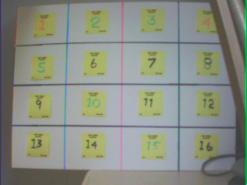

The yellow squares are “Post-It” notes with the number of the square on them in various pastel colors using “highlighters”. Whites are not white in any of the photos that I have taken and there have been hundreds in the last six months. This photo is 504 x 380 or 191,520 pixels, at two bytes per pixel that is 383,040 which just about fills the FIFO which is 384,000 x 8 bits.

QVGA in Full Resolution

This photo is 320 x 240 and taken at the QVGA resolution.

QQVGA in Full Resolution
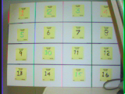

This photo is 160 x 120 and is in the QQVGA format. I did not enlarge the image. It is a raw JPG from the Image-Magic software package.

CIF in Full Resolution
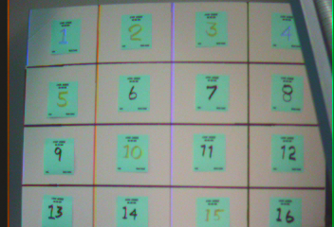

This photo is 351 x 240 in the CIF format. It was taken with the output set to UYVY as were the previous photos. The color is not correct. The color only comes out correctly when the format is selected as VYUY. This is a problem with either the camera or my software.

QCIF in Full Resolution
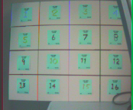

The QCIF photo is 174 x 144. The color is still a complement of what it should be. Again my software or the camera.

Q8060 in Full Resolution
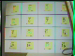
This photo is an 80 x 60 image. The colors are good, that is the UYVY for is working for this image. The photo at 4800 pixels is beginning to be something that could be used in “robotic vision” with a small processor. The picture in black and white (just the Y of the YUV) would be only 2400 bytes.

Q4030 in Full Resolution
This little sucker is 40 x 30 and is a prime candidate for crude “ robotic vision” with a processor like the “MEGA”.

This one is enlarged to show the pixels ( or lack of them). If you use the luminance values it will fit into 1200 bytes. A two to one compression would fit it in to only 600 bytes. Detection of a change in pixel can be used with the “windowing” mode of the full VGA resolution.

VGAW in Controlled Window Mode
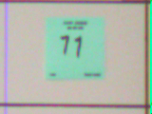

This image is 160 x 140 just one sixteenth of the screen. Any region on the screen may be reached via the “windowing” mode of the camera with any sized picture you want up to the maximum VGA size, if your FIFO is large enough. The color is inverted and requires that the mode be set to “output=vyuy” if you want correct color. The photo can be done in black and white and just the luminance used. The window parameters for this photo are: 451,611,220,340. The position in the field of view is just below and to the right of center. The horizontal offset used was 131 and no vertical offset was applied. The poster is not quite positioned to correctly fill the camera view.

Hardware Description
The hardware is scattered around on my workbench and needed termination resistor packs for some of the control lines to prevent serious oscillations of the data lines during the “loading” of the program.
The hardware is very simple. There is the OV7670 camera and FIFO and the associated level converters to be able to use the 5 volt signals from the Arduino MEGA computer board. The LCD/TFT display in QVGA size. This board also has a “touchscreen” controller and an on board SD card slot. It is mounted on a 'bread board' with the necessary level converters. The controller for the whole assembly is the Arduino MEGA single board computer. The camera board is powered by a single 78L33. The LCD/TFT board has another 78L33 for its supply. The circuits are built on Radio Shack wireless circuit boards.
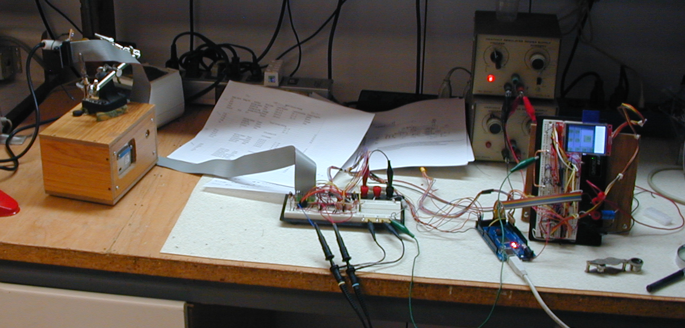

Camera Hardware on Bench
The level converters used to convert the MEGA 5 volt signals to the camera, LCS and SD cards 3.3 volt inputs are 74VLC244AN chips in a 20 pin standard DIP package. The chip is an Octal buffer with a tri-state output. The tri-state function is not used and the enable leads (1,19) are tied to ground. There is one other interface needed for the camera. The camera uses a I2C interface, therefore the controlling data to the camera and the control information data from the camera are transmitted over the same wire. The level converter there is two 2N3904 transistors connected in a level conversion circuit that will perform the level conversion both ways. It is a typical circuit using bipolar transistors.
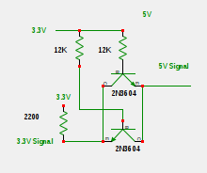

There have been objections to this circuit because the output is not ground. The output level is low enough to meet the requirement for a Vlow input for both sides of the circuit. The camera board pinouts are shown on a separate spread sheet.
The camera interface board is shown below, though given the wire clutter there is little to see.
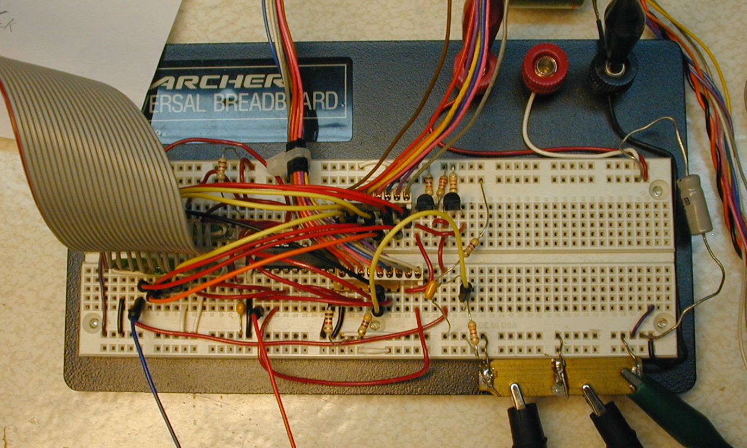

Camera Interface Board
The gray cable on the left goes to the camera. The center wire bundle is the parallel data lines from the camera output to the K port of the MEGA. The bundle on the right is the control information to and from the camera. The bidirectional signal converter is in the upper right mid-way of the board. This board has several terminating resistors to reduce ringing or noise. They are shown on the spread sheet.

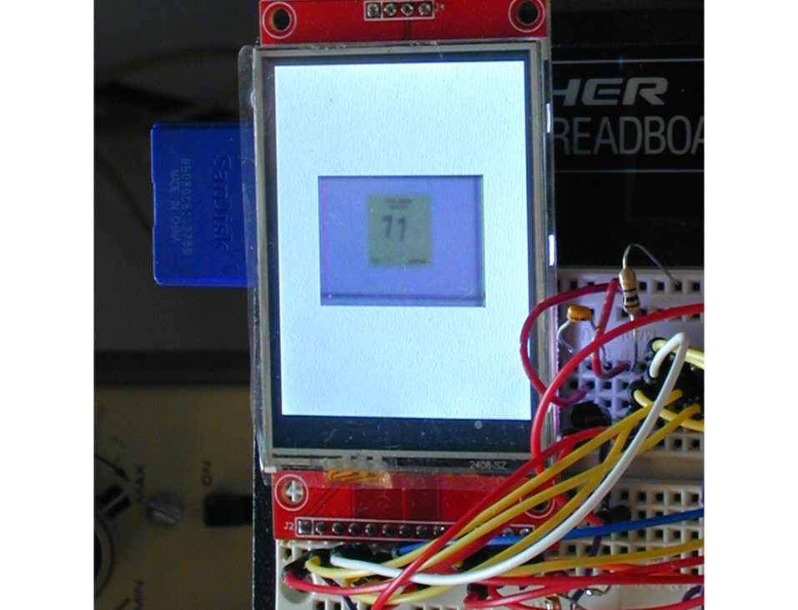

The display unit mounted on a breadboard
The display unit has the LCD/TFT the SD card and a touch interface. The touch interface is not used although there is some stray code that samples the touch signal. The photo shown is the VGAW selection of the lower right mid section of the VGA sector board. The photo is centered by the software that displays the picture.
The camera is mounted on a “third hand” alligator clip based mount. You can see that I added a small circuit board to hold outputs for the “pixel clock” and one of the data outputs “DI0” which I used in getting the lower resolutions to work. Just looking to see that was going on with the pixel clock mainly.

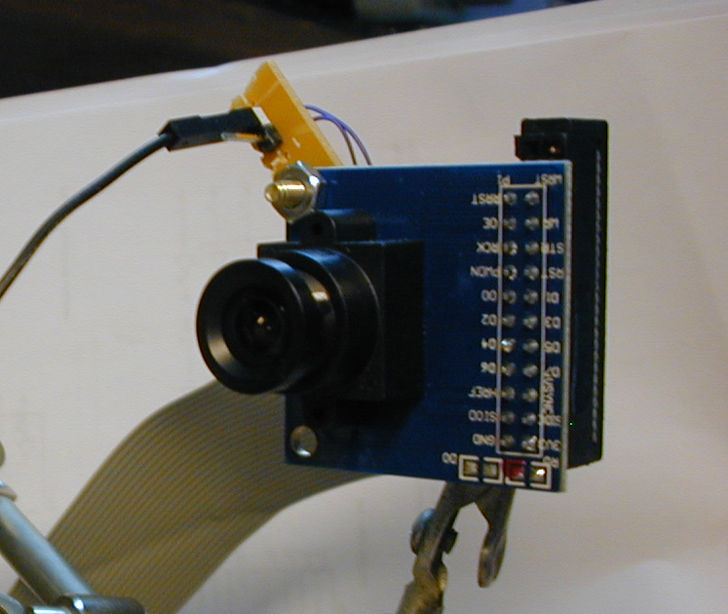

The connector is from a teardown of an old PC, I think it was a ATE hard drive connector.

Appendix A

Register Names Alpha Order
BE .... AD-CHB
C0 .... AD-CHGb
C1 .... AD-CHGr
BF .... AD-CHR
2D .... ADVFL
2E .... ADVHV
25 .... AEB
24 .... AEW
6F .... AWBCTR0
6E .... AWBCTR1
6D .... AWBCTR2
6C .... AWBCTR3
27 .... BBIAS
A5 .... BD50MAX
9D .... BD50ST
AB .... BD60MAX
9E .... BD60ST
55 .... BRIGHT
11 .... CLKRC
15 .... COM10
3B .... COM11
3C .... COM12
3D .... COM13
3E .... COM14
40 .... COM15
41 .... COM16
42 .... COM17
9D .... COM2
C .... COM3
D .... COM4
E .... COM5
F .... COM6
12 .... COM7
13 .... COM8
14 .... COM9
56 .... CONTRAS
57 .... CONTRAS_CENTER
6B .... DBLV
93 .... DM_LNH
92 .... DM_LNL
4C .... DNSTH
3F .... EDGE
2B .... EXHCL
2A .... EXHCT
28 .... GbBIAS
69 .... GFIX
9F .... HAECC1
A0 .... HAECC2
A6 .... HAECC3
A7 .... HAECC4
A8 .... HAECC5
A9 .... HAECC6
AA .... HAECC7
32 .... HREF
17 .... HSTART
18 .... HSTOP
31 .... HSYEN
30 .... HSYST
94 .... LCC6
95 .... LCC7
1C .... MIDH
1D .... MIDL
4F .... MTX1
50 .... MTX2
51 .... MTX3
52 .... MTX4
53 .... MTX5
54 .... MTX6
58 .... MTXS
1E .... MVFP
A4 .... NT_CTRL
A .... PID
1B .... PSHFT
2C .... RBIAS
4B .... REG4B
74 .... REG74
75 .... REG75
76 .... REG76
77 .... REG77
8C .... RGB444
C9 .... SATCTR
72 .... SCALING_DCWCTR
A2 .... SCALING_PCLK_DELAY
70 .... SCALING_XSC
71 .... SCALING_YSC
73 .... SCALING-PCLK_DIV
AC .... STR-OPT
B5 .... THL_DLT
3A .... TSLB
B .... VER
26 .... VPT
30 .... VREF
1A .... VSTOP
19 .... VSTRT

Appendix B

Register Names Numeric
3 .... VREF
9 .... COM2
11 .... CLKRC
12 .... COM7
13 .... COM8
14 .... COM9
15 .... COM10
17 .... HSTART
18 .... HSTOP
19 .... VSTRT
24 .... AEW
25 .... AEB
26 .... VPT
27 .... BBIAS
28 .... GbBIAS
30 .... HSYST
31 .... HSYEN
32 .... HREF
40 .... COM15
41 .... COM16
42 .... COM17
50 .... MTX2
51 .... MTX3
52 .... MTX4
53 .... MTX5
54 .... MTX6
55 .... BRIGHT
56 .... CONTRAS
57 .... CONTRAS_CENTER
58 .... MTXS
69 .... GFIX
70 .... SCALING_XSC
71 .... SCALING_YSC
72 .... SCALING_DCWCTR
73 .... SCALING-PCLK_DIV
74 .... REG74
75 .... REG75
76 .... REG76
77 .... REG77
92 .... DM_LNL
93 .... DM_LNH
94 .... LCC6
95 .... LCC7
1A .... VSTOP
1B .... PSHFT
1C .... MIDH
1D .... MIDL
1E .... MVFP
2A .... EXHCT
2B .... EXHCL
2C .... RBIAS
2D .... ADVFL
2E .... ADVHV
3A .... TSLB
3B .... COM11
3C .... COM12
3D .... COM13
3E .... COM14
3F .... EDGE
4B .... REG4B
4C .... DNSTH
4F .... MTX1
6B .... DBLV
6C .... AWBCTR3
6D .... AWBCTR2
6E .... AWBCTR1
6F .... AWBCTR0
8C .... RGB444
9D .... BD50ST
9E .... BD60ST
9F .... HAECC1
A .... PID
A0 .... HAECC2
A2 .... SCALING_PCLK_DELAY
A4 .... NT_CTRL
A5 .... BD50MAX
A6 .... HAECC3
A7 .... HAECC4
A8 .... HAECC5
A9 .... HAECC6
AA .... HAECC7
AB .... BD60MAX
AC .... STR-OPT
B .... VER
B5 .... THL_DLT
BE .... AD-CHB
BF .... AD-CHR
C .... COM3
C0 .... AD-CHGb
C1 .... AD-CHGr
C9 .... SATCTR
D .... COM4
E .... COM5
F .... COM6

