WWVB Receiver
using
Switched Capacitor
Filters
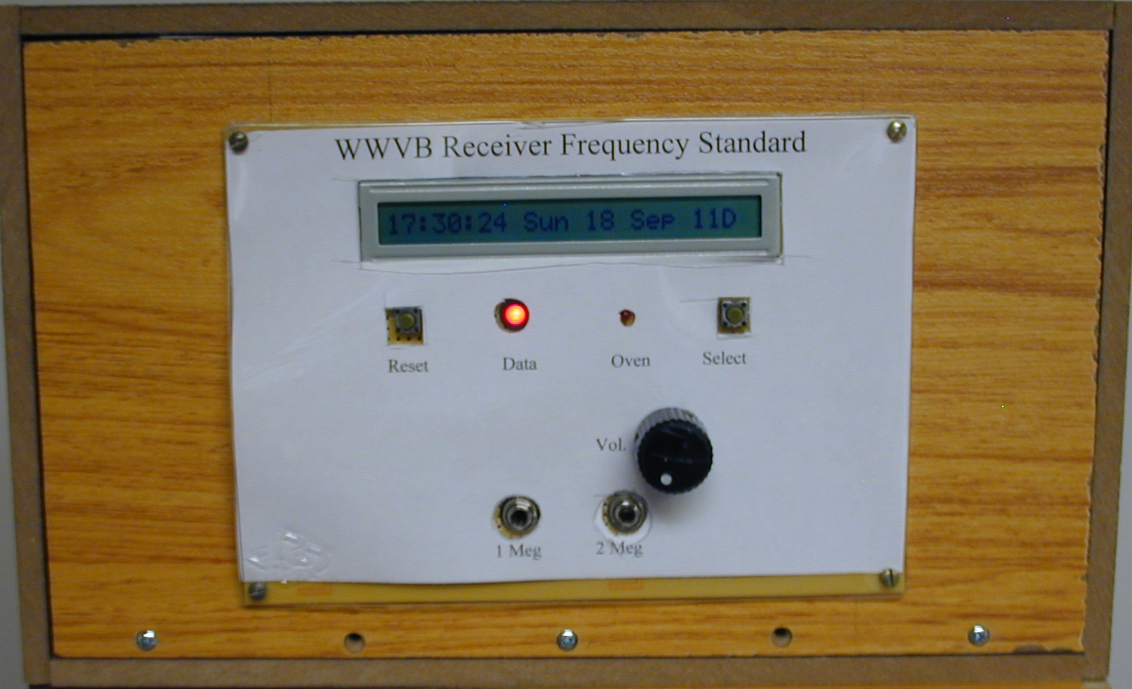
Table of Contents
Some History 3
The Input Signal 3
Introduction to the Receiver 4
Changes due to BPSK Introduced in Late 2012 4
The Original Receiver 4
Overview of the Receiver 6
The Front End 8
IF Amplifiers 10
Data and AGC Circuits 13
Audio Output 14
Phase Detector Circuit 15
Divider Chain 17
Buffered Output 18
The VCXO Circuits 19
The VCXO Oven Construction 19
Oven Control Circuits 20
The VCXO Circuit 21
The Control Computer 22
Computer Support Circuits 24
Bandwidth Plots and Photographs 26
Output of the Low Pass Filter 28
Data Demodulation 28
CDS/LED Control Element 29
Some Contstruction Details 30
Final Assembly 33
Front Panel 34
Oven Control Board 35

Some History

This receiver is the fifth WWVB receiver I have constructed. I have tried various type of receivers over the years. Each has functioned but had one or two problems that needed to be corrected. The designs started with a “Tuned Radio Frequency” (TRF) receiver with a crystal filter to narrow the bandwidth to a point that could receive the signal from WWVB twenty-four hours a day. The whole reason that I want to receive WWVB twenty-four hours a day was not to tell the time of day, it was to run a frequency synthesizer that could be used to generate accurate frequencies and also to drive the local oscillator in frequency counters. The signal from WWVB is used by many people for the accuracy of the carrier frequency as well as the time. I happen to live in a neighborhood where there are many old growth trees and they make using a GPS based frequency standard impossible. GPS receivers require a four satellite lock to maintain accurate 1PPS output, at my location I could only get a time lock about four hours a day. Four satellites above 45 degrees are needed to get a time lock, and the trees around my lot are too tall.

One other receiver (prototype 4) is currently working and will maintain a lock twenty-four a day. This receiver is just an experiment to see how simple a receiver could be and still recover both frequency and time. It is the first receiver that I have done that does not have crystal filters in the RF section. The easy availability of sixty kilohertz crystals (perhaps due to the popularity of the “Atomic Clocks”) make building a very narrow bandpass TRF circuit relativity easy. Recovery of the time modulation from a receiver that has a bandpass of nearly one hertz is not too hard but something with a wider bandpass would allow the edges of the signal to be a great deal sharper. In the case of this receiver a rise/fall time of 25 milliseconds versus the nearly 200millisecond rise/fall times of the crystal filtered receiver.

The Input Signal
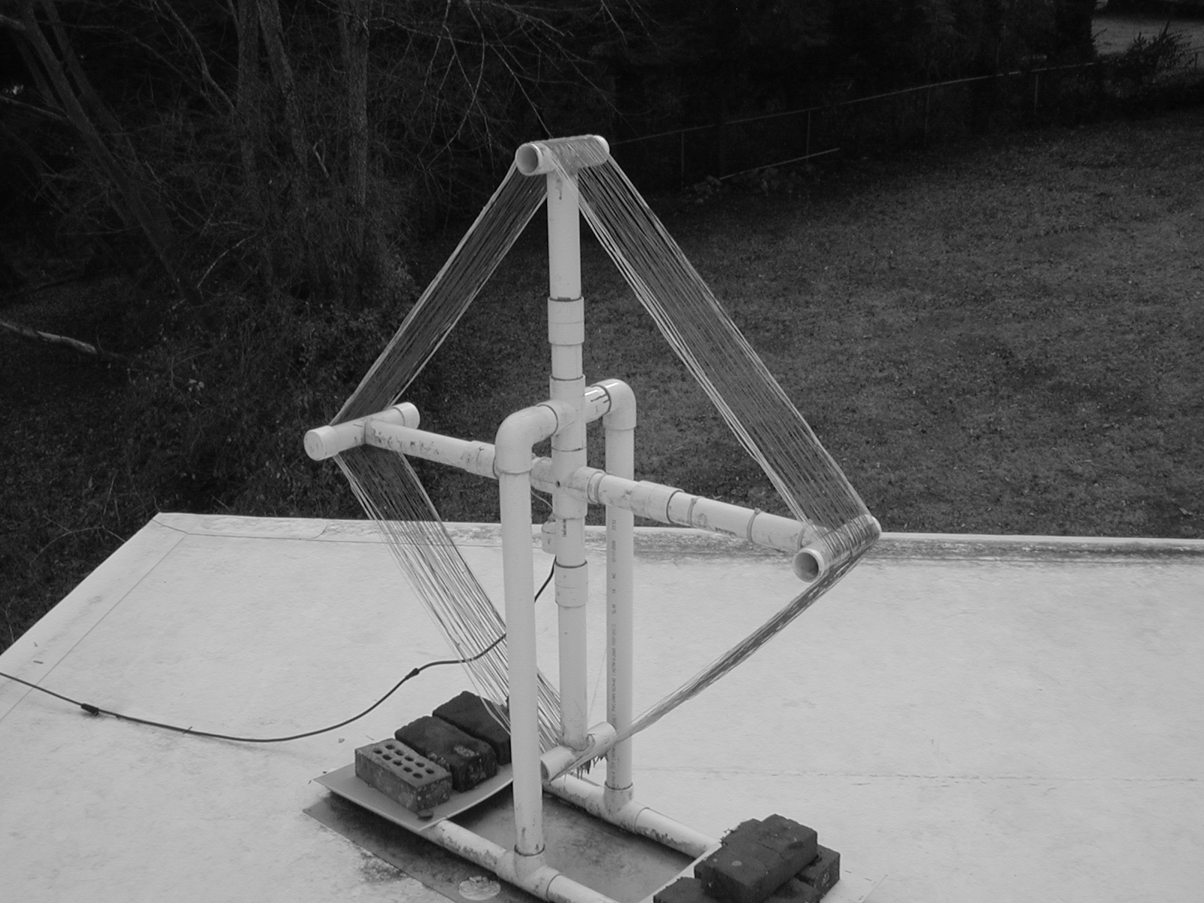
The signal from WWVB is received at this site by an antenna make from PVC pipe and #24 gauge solid wire. See the picture.

The antenna is a loop, having an area of 0.58 meters, fifty turns of wire and a Q factor of forty. The signal is picked off the antenna by a one turn loop that is made from a ground center tap and a center conductor tap at one turn. The cable is ordinary 75 ohm TV coax. The signal is several times the signal predicted by all the loop antenna equations that I could find (about 18 microvolts at the end of the coax). The signal is input to a distribution amplifier with three outputs. One for each of the receivers currently on line plus a spare. The distribution amplifier has a gain of about 7Db. The receivers do not have to be high gain to receive a good signal, with a 40 microvolt input.

Introduction to the Receiver

Changes due to BPSK Introduced in Late 2012
In order to improve reception of the WWVB signals NIST has begun using a “binary phase shift keying” BPSK modulation in addition to the “negative” AM that has been the standard. This caused all of the frequency standards using phase locked loops, locked to the WWVB carrier to be “bricked”. This receiver was one of them. This receiver was modified to lock on to the BPSK signal. That modification consisted of adding a second phase detector to the lock loop driven by a reference signal in quadrature with the IF signal. This turned out to be very simple; one dual oneshot (74HCT123) and an added phase detector using an unused XOR in a quad package already in place. This signal was presented to the controller CPU using an analog to digital input pin, just as the original phase detector was sampled by the software. The discussion below describes the original receiver. The additional phase detector is discussed in the phase detector section.

The Original Receiver

The receiver is a superhetrodyne based receiver. The IF frequency is 2500 Hertz. The IF is chosen so that a standard “switched capacitor” filter can be used both as the gain element and the filter element. The side effect of an audio frequency for the IF is that the IF can be passed to a speaker and the user can hear the signal, or interference to the signal.

Another reason to chose the 2500 Hertz IF frequency is that the frequency is one one hundredth the clock frequency needed by the filter circuits and that it can be derived from a 4 megahertz crystal. An ideal frequency would be 1000 Hertz. That frequency would require that the main control crystal have some binary multiple of 100 kilohertz while at the same time producing a frequency for the “local oscillator” that would generate a difference frequency of sixty one kilohertz or fifty nine kilohertz. Complications to this scheme; PLL etc. made it unsuitable. Twenty five hundred Hertz can be used and the filter Q still be set high enough that it will have suitable bandwidth to recover the phase and amplitude information from the WWVB signal.

A simple binary divider chain is used to divide the four megahertz down to 250000 hertz and 62500 hertz. These two frequencies are use to drive the switched capacitor filters used as the IF filter/amplifiers and to drive the mixer that produces the IF frequency.

Two divide by ten chips are used to divide the 250000 hertz down to 2500 hertz to drive the phase detector. This phase detector is used to control the frequency of the four megahertz crystal so that the result is both a frequency standard and as a by product a clock display that keeps UTC and shows the date.

A PIC18F2620 computer is used to control the frequency of the four megahertz crystal and to decode the time signals and display the time and the date. The programs are written in standard C and are compiled using a version of MPLab, the Microchip IDE for their hardware. Note: all the receivers use some form of a computer for PLL control and other functions. All the computers are the MicroChip PIC 18F series units.

The receiver has a twenty-four character LCD display, used to display the time and date and information about the internal status of the receiver. There are two LEDs on the main panel, one shows the received data and the other shows when the internal voltage controlled crystal oscillator (VCXO) oven is powered on. There is a potentiometer used to control the output of a small speaker to allow the IF signal to be monitored. Two pushbuttons are used: One resets the on-board computer, the other is used to signal the computer that the display should be used to display various internal states of the unit. The display is changed by pressing this button for longer than one second. The display cycles through the display of AGC voltage, low pass output voltage, noise sum derived from the detector output, the tuning voltage applied to the VCXO, the state of the PLL and the variance in phase samples and finally the display of the time and date. Time and date are the power on defaults.

There are two jacks on the front panel to allow access to the one megahertz and the two megahertz frequency signals. There is one jack on the back of the unit that has a one megahertz signal output.

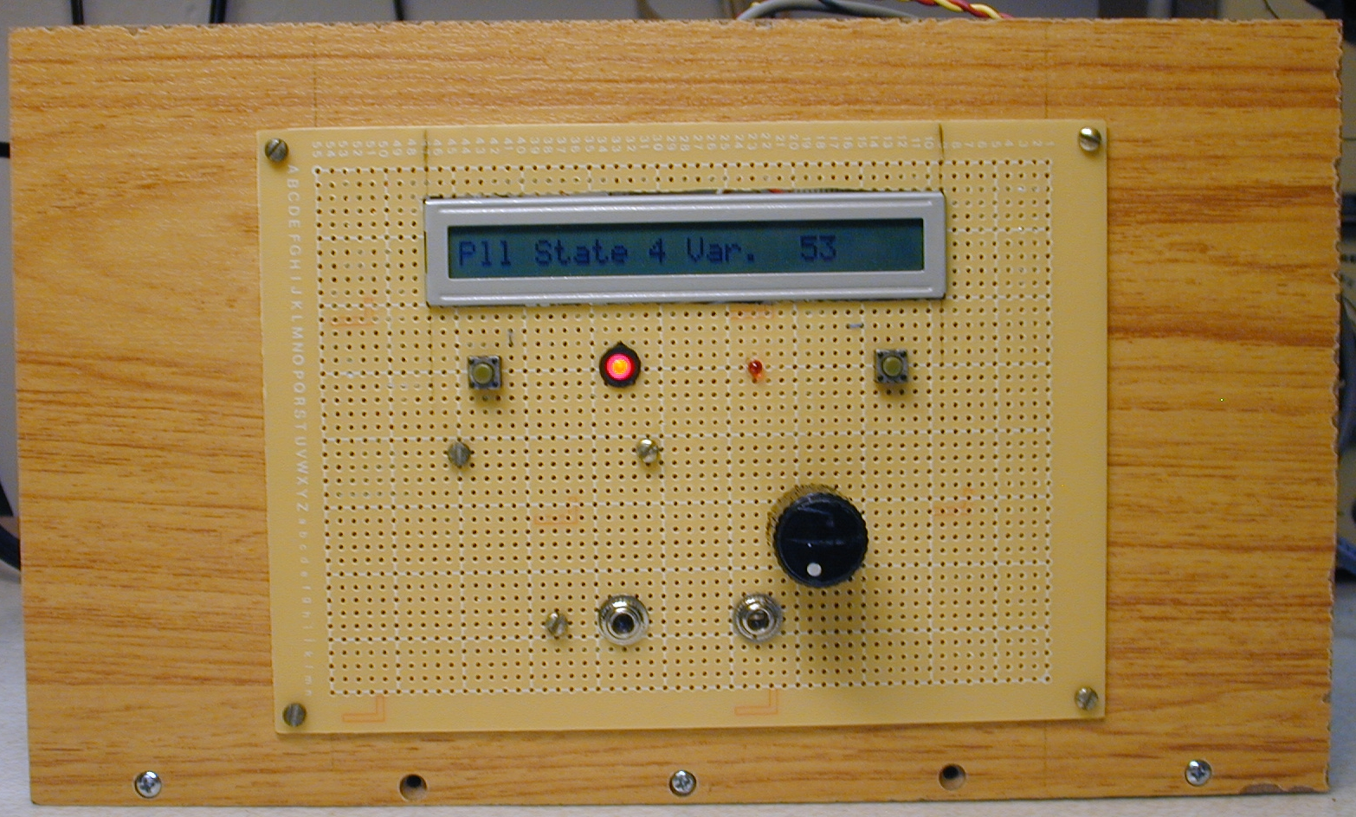
The Front Panel Assembly During Construction

Overview of the Receiver
As stated earlier the receiver is a superhetrodyne circuit. The receiver also has one other characteristic that should be noted. The receiver uses the IF signal to phase lock a local oscillator to the carrier being received. This is the “frequency standard” part of the receiver. This phase lock is done via an embedded computer that samples the phase relation between the IF and the 2500 hertz local signal once each second at 0.9 seconds after the modulation starts. The WWVB signal has a decrease in carrier level (negative) modulation rather than the more familiar AM format of variation about a 50 percent carrier level. The signal is reduced by 17Db at the beginning of each second and is held there for one of three intervals. A data Zero is 0.2 seconds, a data One is 0.5 seconds and a Marker is 0.8 seconds. These three symbols are the only amplitude information broadcast. There are other signals on the BPSK signal but currently they are not decoded by the receiver.

The sampling of the signal near the end of the second is to catch the signal in a stable moment. There is a problem both with the switched capacitor filters, LC filters and crystal filters that should be mentioned. Change in the amplitude of the signal can cause a change in the phase of the output signal. The filter must be tuned exactly to the 60 kilohertz frequency to avoid the “driving” of the signal phase. I have not been able to tune any filter exactly to the incoming frequency to avoid this phase shift. Over the total time of the one second interval it is not a big problem for stability of the VCXO but it exists. One receiver I built used a “hard limiter” in the crystal filter circuits to avoid as much of the momentary phase shift as possible.

The circuits used in this receiver are not unique, or even well designed in the sense that the circuit has been optimized for the function versus cost or some other metric. The circuits are simple, easy to construct and they work. There are many options that can be used to modify the receiver to your needs. Your don't have to have a display, or a computer. You might get away with eliminating the oven for the VCXO. What you will need is an oscilloscope, voltmeter and a reasonable knowledge of electronics, and the construction skills needed to assemble electronic circuit boards.

Check the appendix for the software used to produce the drawing in this document as well as the schematics that are separate entries. All the documentation was done under Ubuntu using “free software”.

The Front End
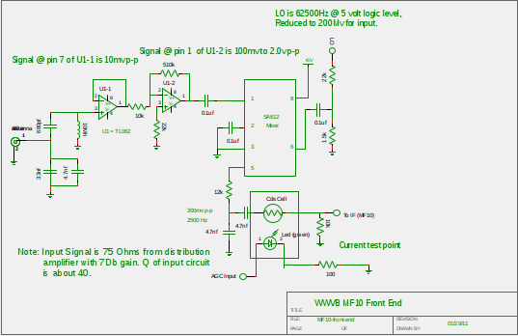
Front End Schematic

The front end of the receiver is a single tuned circuit followed by an impedance converter and an amplifier, a mixer and an AGC signal control. The tuned circuit is a capacitor coupled variable inductor circuit. There are two capacitors used to tune the inductor. The two capacitors match the input signal (about 75 ohms) to the tuned circuit. The impedance of the L and C at the resonant frequency is about 3663 ohms. The LC pair is coupled to an operational amplifier used as a voltage follower. This circuit has an extremely high input impedance. This allows the LC circuit to have a “quality factor” (Q) that is as high as possible. This tuned circuit is driven from either the antenna or the distribution amplifier the signal is transformed (voltage wise) by the Q factor to a larger voltage. The output of the voltage follower is fed to a standard operational amplifier circuit with a DC gain of fifty-one. Note – this gain is not achieved in practice at 60 kilohertz the gain is only about ten. This is strictly the amplifier used given a greater “gain bandwidth product” you can get more gain. You also get problems with oscillation at random frequencies.

The schematic above has notation about the signal levels the signal output to the IF circuits can be as high as 750 millivolts peak to peak (measured during the day!). The total voltage gain of the tuned circuit and the two amplifier stages is 450. The mixer has 17Db of gain (measured by the manufacturer at 45 megahertz). The mixer stage is a single chip that has its own built in bias circuits and receives the “local oscillator” signal from the divider, a square wave. The 5 volt logic signal is reduced to the required input signal by a simple voltage divider. The output of the mixer can be taken from pin four and five. This allows split winding IF coils at higher frequencies. I just take the signal from pin five and filter out the upper sideband, 122500 hertz with an RC circuit before passing the signal to the AGC control element.

The AGC control element is a simple way to control the input signal to the IF amplifier. The availablity of ICs to control gain is limited. Most are operational amplifiers with a control voltage. I have had success with a Motorola MC1350 chips. They are an IF for TV sets and have gain and a good AGC input. They are obsolete now, but you can get them on the replacement market. I chose to use a simple resistor attenuator made from a CDS photocell and a green LED stuffed into a piece of black shrink tubing and sealed with black paint (Goth style finger nail polish). Given the input impedance and gain of the IF strip this was fine. The only constraint was that the AGC amplifier had to turn on the LED to max brightness by driving current into it during startup. The front end voltage gain total is 70DB (including the mixer). The attenuation of the AGC circuit is about 26Db under daylight conditions and more at night. So you can see half of the gain of the front end is thrown away to maintain a stable output from the IF strip. The recovered modulation must be a close reproduction of the signal to recover the data and time (0.9 second mark) in a reliable fashion. The front end has enough gain that some change in the antenna can be made, reducing its size from 0.58 meters. But be warned gain is cheap and easily controlled, nothing can make a signal buried in noise better. See Antenna section.

IF Amplifiers
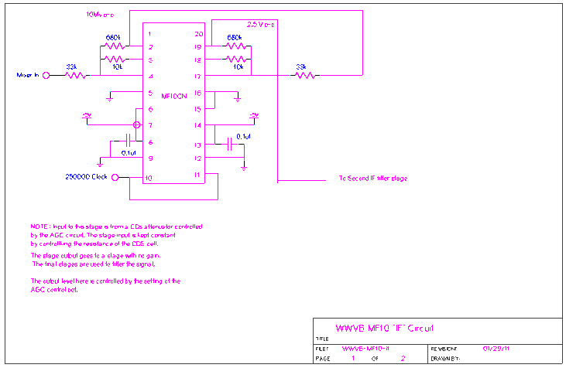
The IF amplifiers are two MF10 switched capacitor filter chips. Each chip has two filter sections. The type of filter is a “state variable” filter. It consists of a sum junction and two integrator stages. All three types of filters can be implemented: low pass, high pass and bandpass. This filter type used here is the bandpass. All four stages are identical with the exception of the stage gain. See the MF10 data sheet section on “Mode 4 – bandpass”. All the stages are set to have a Q of sixty eight. The gain of the stage is controlled by the ratio of input resistor to the same resistor that controls the Q. The first two stages have the gain set to 20. The total gain is 400 or 52Db. The schematic above shows the “gain” stages of the IF amplifier.
The second filter chip is used at a gain of one. and serves to narrow the bandwidth more than just two stages. The total measured bandwidth is discussed later.

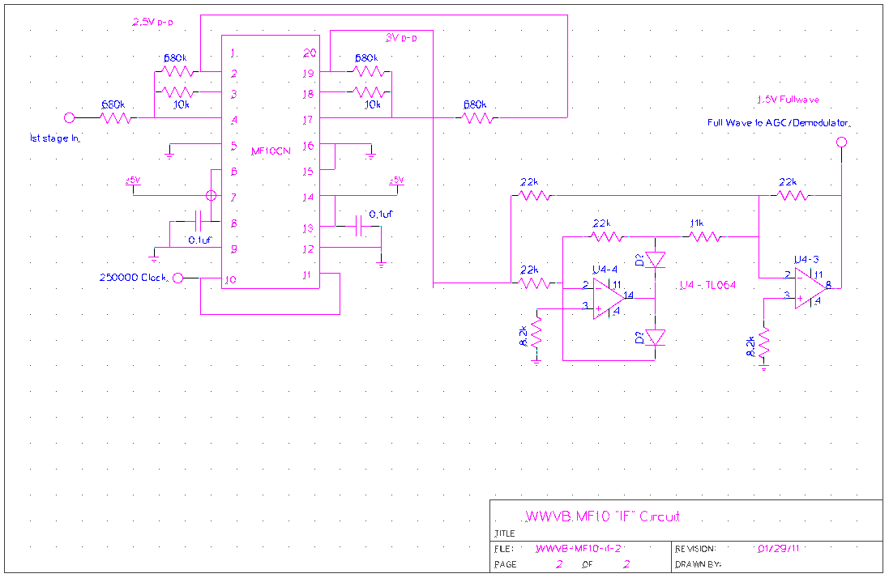
This schematic shows the last two stages of IF filtering and the detector. The detector is a full wave operational amplifier based active rectifier. This signal is processed to derive the data modulation and to control the AGC circuits. The detector circuit can be replaced by a simple diode and filter with the corresponding reduction in signal output. Adjustment to the AGC to have more output from the IF would be needed. The linear detection offered by the active diode rectifier makes processing the signal somewhat easier but changes to the detector will reduce cost.

Data and AGC Circuits
The output from the detector is used to derive the data signal to be fed to the computer for the display of time and date. If you don't want this you can leave out the LMF40-100 low pass filter and the offset amplifier and logic level circuits. However it is nice to have a signal that the receiver is picking up something.

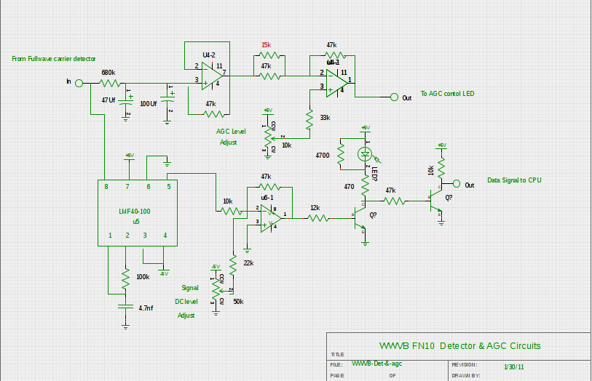
The AGC filter and output amplifier are shown at the top of the schematic. The signal is supplied to the AGC filter where the time constant is extended by a factor of about 14 by use of the capacitor multiplier effect. The 680K and the 47K resistors act as a voltage divider to slow the charging of the input capacitor. The calculated time constant is over 300 seconds. In actual fact because of the AGC action limiting the input to the filter it takes the receiver two or three minutes to establish the final gain value for the IF output value. The potentiometer marked “AGC Level Adjust” is just that. The AGC amplifier reference is established by this voltage and AGC control is used to set the peak value of the detector to drive current into the LED in the CDS/LED control element to hold that level. The long time constant is needed to avoid (as much as possible) changes in the signal amplitude during the transmission of the “MARKER” symbol or multiple ONEs.

The data is recovered once the AGC is stable by taking the output of the low pass switched capacitor filter and changing the signal level from zero to positive to a signal that is bipolar. Zero volts becomes the “slicer” level for data detection. The signal is inverted by the level shifter so that the data symbols that are transmitted as reduction in carrier become positive signals. The positive portion of the signal drives the LED display transistor and is inverted to drive the data to the computer as a logic level with “true” data signals.

Audio Output
The IF frequency is a an audible frequency and an amplifier and speaker was added to the receiver to allow the signal to be heard. The input is from the IF output. The amplifier is a National Semiconductor Corp. LM386 audio amplifier chip.

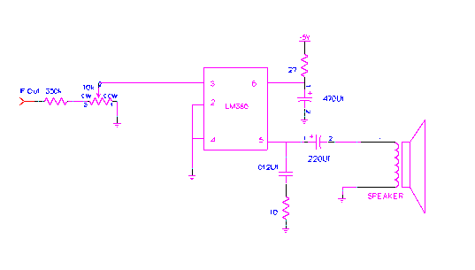
The IF signal is attenuated by the 350k resistor and a 10k potentiometer for input to the amplifier.
The power to the chip is bypassed by the 27 ohm resistor and the 470 uF capacitor. The amplifier drives a low impedance speaker, 8 Ohms and can motor boat at high volume. Again, to simplfy the circuits you can leave out the speaker and amplifier.

Phase Detector Circuit
To lock the VCXO to exactly 4 megahertz it is necessary to be able to measure the phase of the incoming carrier with reference to the local oscillator. The amplitude of the signal has to be large enough to compare with simple circuits. The output of the IF amplifier is a 2500 hertz, this frequency is derived from the mixer which uses a 62500 hertz signal derived from the VCXO as the local oscillator. It is necessary to have a 2500 hertz signal derived from the VCXO to perform the comparison. This is easily accomplished by using two divide by ten chips (CD4017) to divide the clock for the IF filters down to the IF frequency (you can use a 74xxx390 chip, it has two decade counters in a single package).

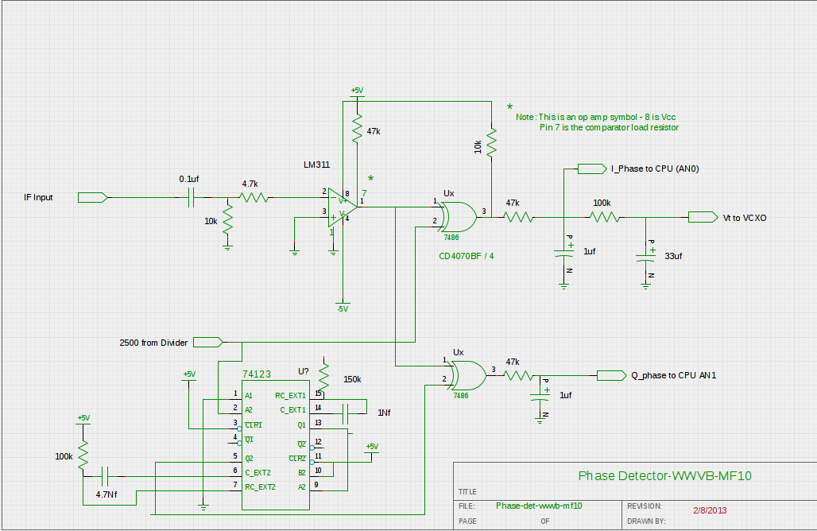
The IF input to the phase detector is hard limited by using an LM311 comparator chip to clip the signal at the zero crossing. The output of the comparator is fed to an exclusive OR circuit (CD4070). The output of the exclusive OR is a waveform at twice the IF frequency. The range of the phase detector is only 180 degrees and the desired output is at 90 degrees, a square wave. Two filter sections are shown in the schematic for the I-phase. There is a tap off the first section that is passed to the computers A/D converter (pin 2 [AN0]) and the second tap is passed to a jumper block that allows this signal to be used to control the VCXO. This was true before the WWVB signal was changed to allow for both AM and BPSK modulation. There are two jumper blocks on the circuit board. One allows the selection of a constant signal of 2.5 volts for VCXO setup/tuning, and the other is the I-phase. The output of the selection on the first block goes to the second where a selection can be make via jumpers to select the computer PWM output, with a filter, or the phase detector/fixed voltage input. Added to the phase detector because of the new modulation addition is a second phase detector. The second detector is an exclusive OR gate (pins 4,5 and 6 rather than the ones shown on the schematic. It is fed both the IF signal and the 2500 hertz signal from the VCXO. The 2500 hertz signal is phase shifted by plus ninety degrees to recover the Q-signal. The quadrature signal should remain at a steady voltage even during the BPSK modulation, if the VCXO in in phase with the carrier. This new signal is passed to the computer by replacing the AGC current sensor tap with the output of the Q-signal filter, pin 3 AN1.

Divider Chain
The VCXO generates a four megahertz signal that is input to a divider chain that consists of three chips. The main divider is a 74HCT4040 ripple divider with 12 stages. Only six stages are used to provide the four outputs used in the receiver. The first stage output ( two megahertz) is buffered and available on the front panel, as is the second stage ( one megahertz). The third stage (500 kilohertz) is not used. The fourth stage (250000 hertz) is used to drive the IF filters. The final stage, Q6 (62500 hertz) supplies the local oscillator signal to the mixer chip.
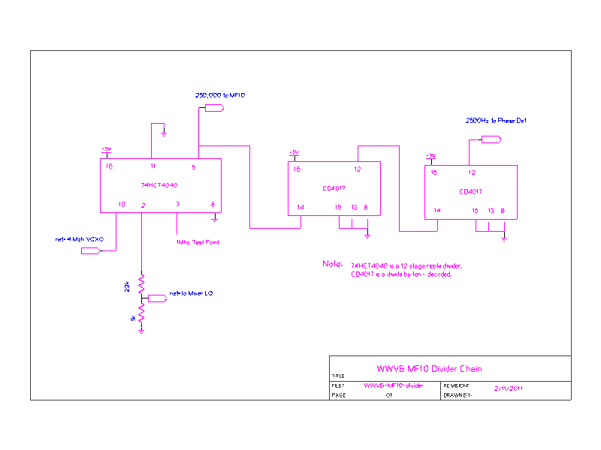
The stage that drives the IF filter (pin 5) is passed to two CD4017 chips in series to be divided to the 2500 hertz used in the phase detector.

Buffered Output
The standard frequencies output: 2 megahertz and 1 megahertz are buffered by logic level chips.
The outputs of three stages of an old 7400 two input NAND are paralleled by using 220 ohm resistors. This allows the output to be matched to 75 ohm cable as well as to be shorted at will.

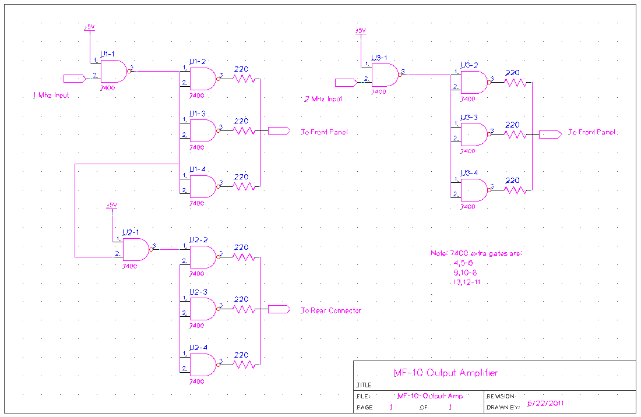

The buffer amplifiers are on a separate board and are connected to the front and rear panel by plug cords. The input is from the main receiver board by a receptacle on a fixed three conductor wire.

The VCXO Circuits
The VCXO needs some introduction because it is separate from the receiver board and is constructed as a self contained unit, including a separate power supply.

The separate power supply is needed because I used an off the shelf switching supply to drive the receiver which uses almost no current (less than 100 milliamperes), the VCXO oven heater has a resistance of 14 ohms and operates on 12 volts.

The oven control electronic and the power supply are on a separate board . The VCXO its self lives in an oven kept at a temperature of forty degrees centigrade. This temperature is not the turning point of the crystal that temperature is undetermined for the cheap off the shelf crystals that I used. I simply try to keep the crystal in an environment that has a constant temperature and rely on using a tuning voltage from the phase detector/computer to keep it on frequency.

The VCXO Oven Construction

The oven is constructed from (wait for it!) two tomato cans. The outer can is an 14.5 Oz. Hunt's Whole Tomatoes. The inner can is a 6 Oz Hunt's Tomato Paste can. The smaller can is mounted inside the larger can and separated by foam rubber (rug padding). The inner can is recessed so the opening is about 3/8ths of an inch from the open top of the larger can.

The inner can (the oven) is wound with a layer of #35 magnet wire. The wire is attached at the ends of the can by a wrap of ordnary black electrical tape, after leads are attached to the magnet wire “heater”.

The heater has a thermistor mounted in the middle of the coil (Radio Shack 10k @ 75 degree) to sense the temperature of the assembly. Once the oven is assembled the VCXO is built on a circuit board that fits into the can and is mounted on a piece of metal that fits snugly against the inner can. I built the VCXO board to have the tuning capacitors facing two holes in the metal lid for adjustment. The final assembly is to cut a piece of rug padding to fit over the open end of the can. I ended up with two receptacles having connections to the VCXO. The first receptacle has four connections. Two leads for the heater and two for the thermistor. The second receptacle has the connections for the oscillator. These are: ground, +12 volts, tuning Voltage ( 0-5 volts) and the 4 megahertz output signal.

The header/thermistor receptacle is plugged into a header on the oven control board. The second is plugged into a header on the receiver board.

These details are sketchy but I don't want to take apart the oven to take photographs.

Oven Control Circuits
The oven control circuits operates all the time and is a “bang/bang” servo, just like your furnace thermostat. It depends on the close coupling of the thermistor and the oven heater to cycle rapidly enough that the mass of the oven and the VCXO circuit board smooths out the variation in temperature.

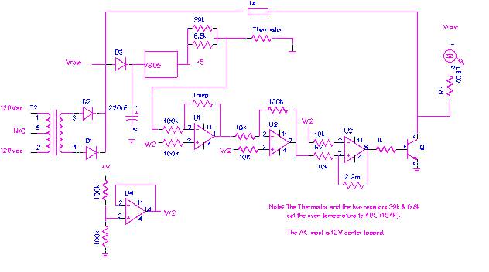
The VCXO Oven Control Circuit

The transformer is a 24V center tapped unit rated at three amperes. First the full wave unfiltered DC is passed to the oven heater. The unfiltered DC is then passed via another diode (D3) to a 220 uF filter capacitor and then to a 78L05 regulator. The operational amplifiers are a quad LM324.

The thermistor is placed in a bridge by driving current into the thermistor via resistors having a paralled resistance equal the resistance of the thermistor at 40 degrees Centigrade ( 104 degrees Fahrenheit). This signal is passed into the operational amplifiers where it is amplified by a factor of 100. That signal is then passed to the last operational amplifier which is used as a comparator. The output of the comparator drives a power transistor to operate the oven. The LED is mounted on the front panel to be able to monitor the operation of the oven.

The circuit can sense the temperature of the oven to a few hundreds of a degree. Offsets in the operational amplifiers are ignored. The idea is to keep the crystal in the VCXO at a fixed temperature not necessarily a known one.

It is tempting to attempt to use a PID circuit for smooth control, it is difficult to avoid long term oscillations in a PID circuit and not worth the extra complexity.

The VCXO Circuit
The VCXO is a simple Peirce crystal oscillation circuit with a Varactor to control the output frequency. The tuning voltage is 0-5 volts. The circuit is able to be tuned about one cycle in either direction by the tuning voltage. The effect of the tuning voltage is non-linear because of two factors, the square law response curve of the varactor and the low voltage at which it is operated. This does not affect the control over low frequency changes however.

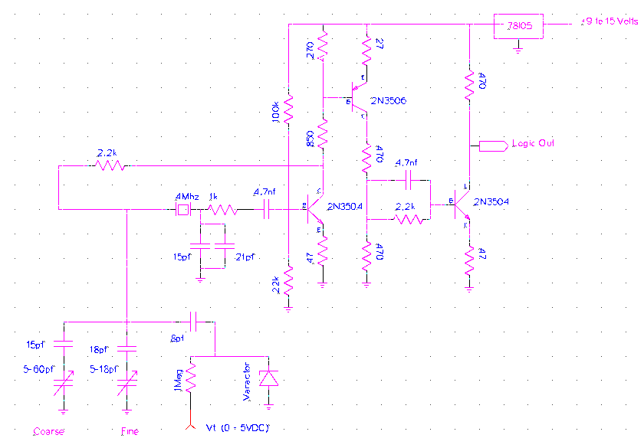
The Varactor diode is a 12pf unit. The rest of the circuit is a standard Peirce with buffer amplifiers. One improvement I would make if I had this circuit to do over is to add a pair of diodes to the feed back loop to limit the amplitude of the signal. It would tend to make the oscillation more stable. The VCXO is fed from 12 volts and has its own regulator inside the oven. This is a must. There is simply too much trash on the logic supply and the switched mode regulator has no real low level regulation. The schematic does not show it but there is a 20uf capacitor on the input and a 0.1uf on the output of the regulator.

The Control Computer
The computer used to display the data and to phase lock the local oscillator to the WWVB signal is a MicroChip PIC18F2620 in a 28 pin DIP package. There are just enough pins to service the needs of the receiver. There are two pins that are setup as an RS232 type serial circuit and they are connected to an on-board RS232 converter circuit make up of discrete components. They are shown on the CPU Power On Circuits “POR” schematic.

The computer is fed with the four megahertz VCXO input and it is multiplied by four by the internal circuits of the CPU to give a sixteen megahertz clock. The CPU is pipelined and needs four clocks to execute an instruction so the actual execution rate is four megahertz. This is more than enough to perform all the functions required. The program cycle being the one second data transmission rate of WWVB.

There is a 24 character LCD display used to display the time, date and other information as needed. The pinouts for the CPU are:

1. MCL - master clear POR & programmer
2. AN0 – I-Signal Phase Detector Filter stage 1 ( 0 - 5.0 volts)
3. AN1 – Q-Signal Phase Detector filter output (0-5.0 volts)
4. AN2 - Detector LP output (range 0.5 to 2.0 volts)
5. RA3 - Logic Level Data Slicer AM modulation
6. RA4 - Used for LCD Reset
7. RA5 – Control Push Button pullup and input
8. Gnd.- VSS
9. OSC1 - External clock input 4 megahertz
10.OSC2/RA6 N/C
11. RC0 - LCD "Enable"/Clock
12. RC1 - 25H signal, test of the RTC function
13. RC2 - PWM signal to control VCXO
14. RC3 - Test point - Pulse signal for debug (250nSec)
15. RC4 - R/~W for LCD Display
16. RC5 - R/S (data/command) for LCD Display
17. TX - for USART
18. RX - for USART
19. Ground (VSS)
20. +5V (VDD)
21 - 28. B0 - B7 Data to LCD Display and 27,28 also ISP programming terminals

The CPU is programmed via a USB dongle (PICkit 2) that has: programming signals, serial data, serial clock signals that are used in passing the program, there is also a signal “master clear/program” to control the CPU and a +5volt power/power detect signal. The program to drive this device runs under Windows – Win 98, Win XP, Linux and maybe Win 7. The PICKit 2 is available from Microchip and it can be used to program many of the microchip CPUs. The C program to run the receiver are written using an IDE “MPLAB X that runs under Microsoft and Linux. I used the Ubuntu version of Linux.

Computer Support Circuits
The PIC18F2620 has a normal run mode that starts when the power supply rises to 3 volts. The MCL input (pin 1) has in inverted signal that can hold the computer in the “reset” mode till the supply is at operating voltage, it can also be used to reset the computer at any time needed. There is a pushbutton on the front panel connected to MCL for that purpose.

It is normal that a Power On Reset (POR) circuit be provided to hold the CPU reset till things quiet down during power on sequencing. The LCD display needs some time to go through its reset sequence in parallel with the CPU.
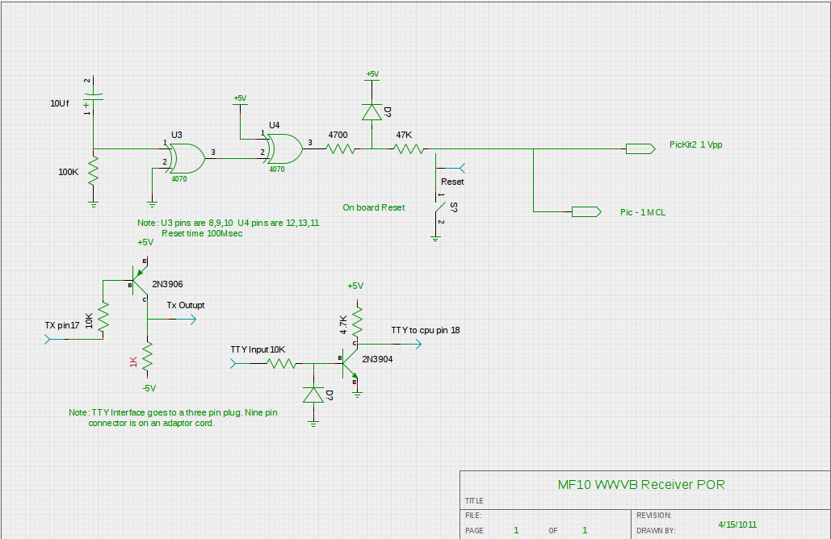
The POR circuit uses some of the gates in the XOR logic chip used in the phase detector. The power supply signal (rising ) is passed through the 10uf capacitor to the input of U3 and from there to U4 which is setup not to invert the negative going signal. The signal is then passed to the network formed by the 4700 ohm resistor the 47kilo ohm resistor and the diode connected to the +5V supply line.

The network is used because the programming signal voltage from the programmer is +12 volts. The XOR circuit would be damaged by this signal. The 47 kilo ohm resistor is high enough that the 12 volts from the programmer is not loaded down by clamping to +5 volts. The push button and the pinouts to the programmer and the CPU are shown.

One other note about the POR circuit. There should be a diode (anode to ground) attached to the XOR input from the capacitor and the 100 kilo ohm resistor to prevent a negative voltage spike to the input when the power is turned off.

Support for TS232 teletype input and output is also on this schematic. There is a three pin header used to attach these signals to a 9 pin connector so that they can be used to drive a “terminal” program on a PC. The baud rate currently supported is 57500 baud. It can be lowered, the tty driver in the program operates under interrupts.

Bandwidth Plots and Photographs
The MF10 filters used in this receiver have a bandwidth curve as shown in the plot below.

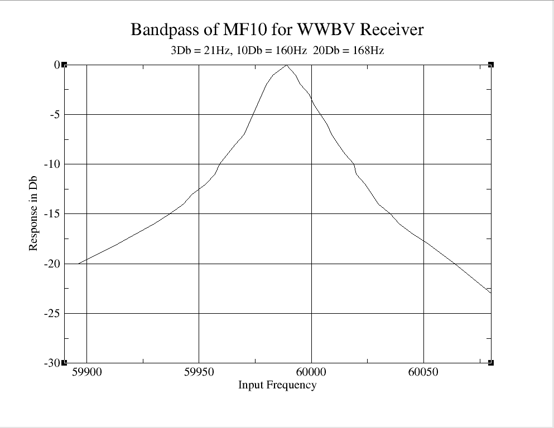
The first thing to notice is that the center is not at 60,000 hertz. This is an artifact in the way the bandwidth was measured. A frequency synthesizer was used to input the signal and there was no attempt to lock the local VCXO to 4 megahertz. The text at top of the graph shows the bandwidth for -3Db, -10Db and -20Db. The graph is rather ragged, I used manual methods to plot the graph and then processed it with “Grace” a shareware plot package with no attempt at smoothing. Each of the four stages of filtering are set to a Q value of 68 by resistors and the frequency is set by the sampling frequency ( one hundred times the center frequency).

The success of filtering is to be shown in the data collection after the filter. There are several photos shown on the next page of signals taken from the operational unit.

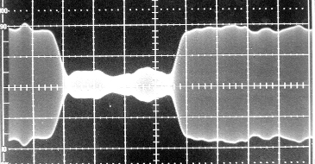
This photograph shows a digital “Zero” being broadcast. The time units are 50 milliseconds and the voltage units are 1 volt per division. This photo was taken by a Tektronix 435 Oscilloscope using a digital camera.

The photograph shows the rise and fall times of the signal 0Db to -17Db of twenty five milliseconds. This can be taken to a bandwidth by doubling the fall time and taking the reciprocal of the time.
In this case .05 seconds which equals 20 Hertz. Noise can be seen on the waveform envelope but it is small compared to the signal its self. This photograph was taken during the day at about 2PM.

Contrast the photograph of a crystal filter with the same symbol being broadcast.

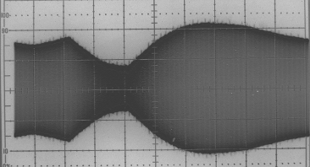

The time is 100 milliseconds per division and the vertical scale is 2 volts per division.
First the fall time is nearly 200 milliseconds, using the same criteria as above that makes the bandwidth only two and one half Hertz. The overshoot after the zero time is an artifact of the AGC in the receiver and in part a characteristic of the filter. This photograph was taken from the output of the TRF receiver in the oldest of the WWVB receivers. This is before the hard limiting of the signal to recover the phase information. The fuzz on the photograph of the crystal filter output is the result of opening the shield on the receiver in order to place a scope probe in the signal source. The trigger for the signal was a one second tick generated from a frequency synthesizer and divider, the frequency of the input to the divider can be changed to move the start of the second to any point needed.

Output of the Low Pass Filter
The low pass filter output of the MF10 is shown below for signals during the daylight hours at 14:00.
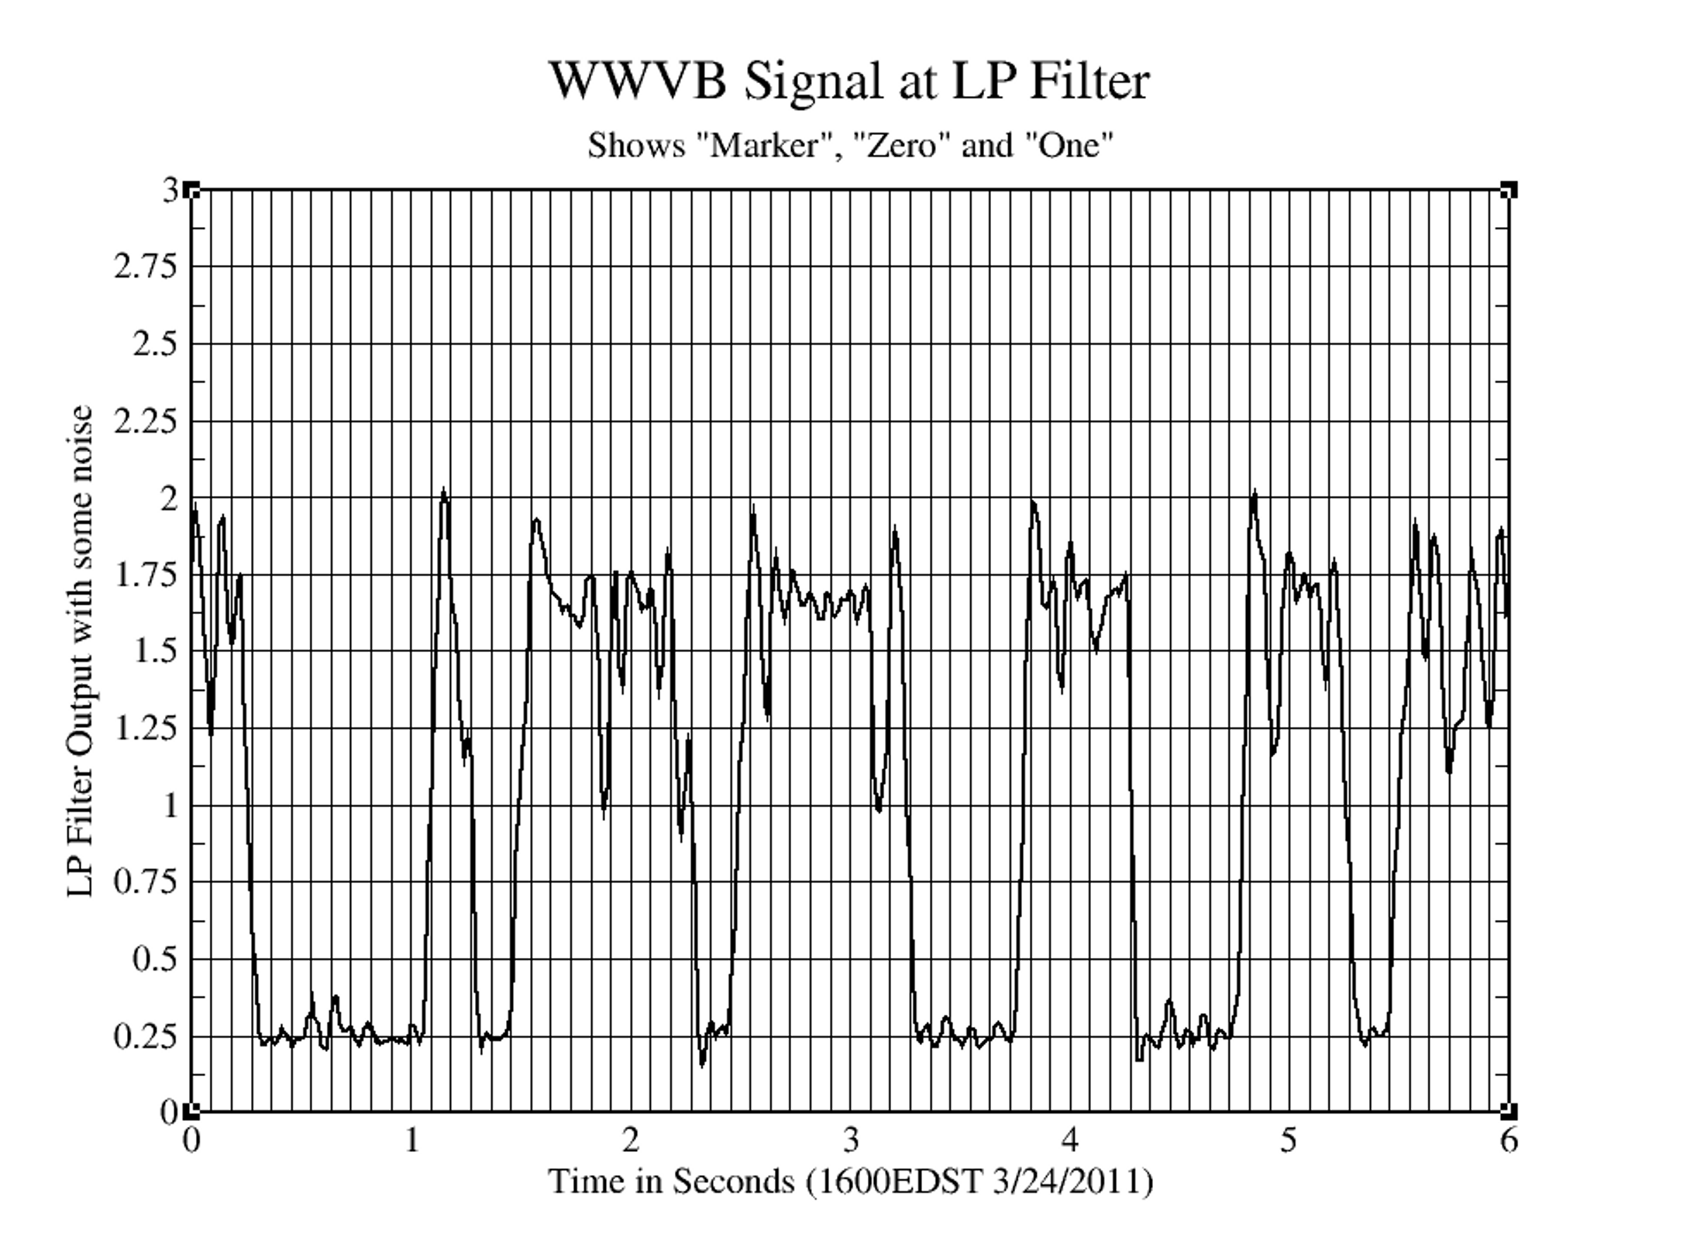

The label at the top of the graph is deceptive, the graph shows the three symbols; marker, zero and one. The data read from left to right is “marker, zero, zero, one, one, zero”. The signal is easily decoded by slicing at 0.75 volts. The noise on the top is pretty typical of the received data except at night during exceptional conditions.

Data Demodulation
The data is recovered by the Detector circuit after passing the full-wave rectified signal through a LMF-40-100 low pass filter. See “Data and AGC Circuits” section. This filter is self-clocked by the RC circuit formed by the 100 kil0-ohm resistance and the 4.7 nF capacitor. The filter is clocked at 100 times the low-pass cutoff frequency.
The RC pair causes the clock to run about 1200 hertz. This gives a 12 hertz output for the filter. The output of the filter is passed to a signal slicer circuit formed by an operational amplifier that is used to set the signal reference with reference to ground. The output of the low-pass filter goes from nearly zero volts to about 1.5 volts. The off set of the operational amplifier is adjusted by the 50 kilo ohm potentiometer. The negative signal offsets the positive signal to give a bi-polar output which drives the transistor that inverts the signal to drive a LED (mounted on the control panel) and to another transister which inverts the signal to logic levels for the CPU.
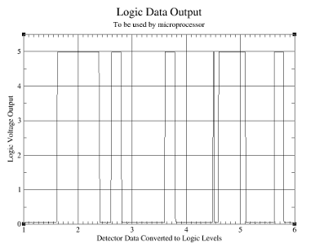
The signal shown in the graph above is: a marker, zero, zero, noise glitch, a one and another zero. The CPU measures the amount of time that the signal is at a logic one by sampling the input fifty times a second. Short glitches like the one shown are rarely caught.

CDS/LED Control Element
The control element for the AGC in the receiver is just a conductive photocell driven by a green LED. The two face each other in a piece of black plastic “shrink” tubing. The ends have been make opaque by using black acrylic paint.

The LED is driven by the output of an LM324 operational amplifier that is powered from +5 volts and -5 volts. Only the positive value is used. Due to the voltage swing of the amplifier only about 3.8 volts are available for use. The conductance of the CDS cell are shown in the graph.

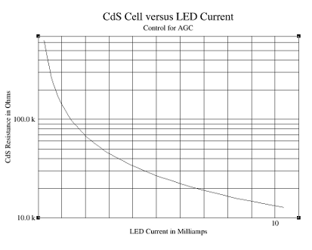
The graph is log in Y in order to show the change in resistance better. The input resistor to the first MF10 filter is 33 kilo ohms so the minimum resistance shown is a little high but the receiver is usually operated with the AGC setting the gain down by 10 to 20 Db. A different pair of parts would have a better ratio of resistance to current. I used the smallest CDS cell in my junk box. It was just about 3/16th of an inch in diameter. The green LED had a similar diameter. Clarex used to make a device called a “photomod” that had a CDS cell and an incandescent lamp pair ( before the LED was invented, cira 1960) that had a much lower resistance and used a 0.4 inch CDS cell. A Google search shows that they are still available but use a voltage input, and have a < 300 ohm lower level resistance. There is a CLM7000 series that have a LED light source, price about $6.

Some Contstruction Details
The circuits were all built on perf boards purchased at the local Radio Shack. The larger boards measured about 4.5 by 6 inches. The oven control and the output buffers are on smaller boards.

The method of construction that I use is to connect the DIP socket pins to resistors etc. using a “pen” that has a roll of #38 “solder through” magnet wire. The pen can be used to wrap the wire around any pin that is not round. If the pin is round I route the wire so that the round pins (resistors capacitors etc) are the second or third item to be connected. If that can't be done then tin the end of the wire and solder it in place to anchor the start end and then wrap the rest and solder.

The temperature to use for the solder through is 750 degrees Fahrenheit, I have never had a failure of a component (resistor, capacitor or transistor) because it is possible to solder very quickly at that temperature. The board has a copper donut around each hole in the board, you have to be careful at high temperatures around the donuts, the cement that holds the copper to the board fails at that temperature.

I also use “wire wrap” wire (this is a Kevlar insulated 30AGWwire) for power supply leads and long runs where the magnet wire might get damaged. The magnet wire can be held in place (around curves for example) by using a plastic cement, I use clear finger nail polish. Its cheap, Q dope can be used but it comes with a larger brush.

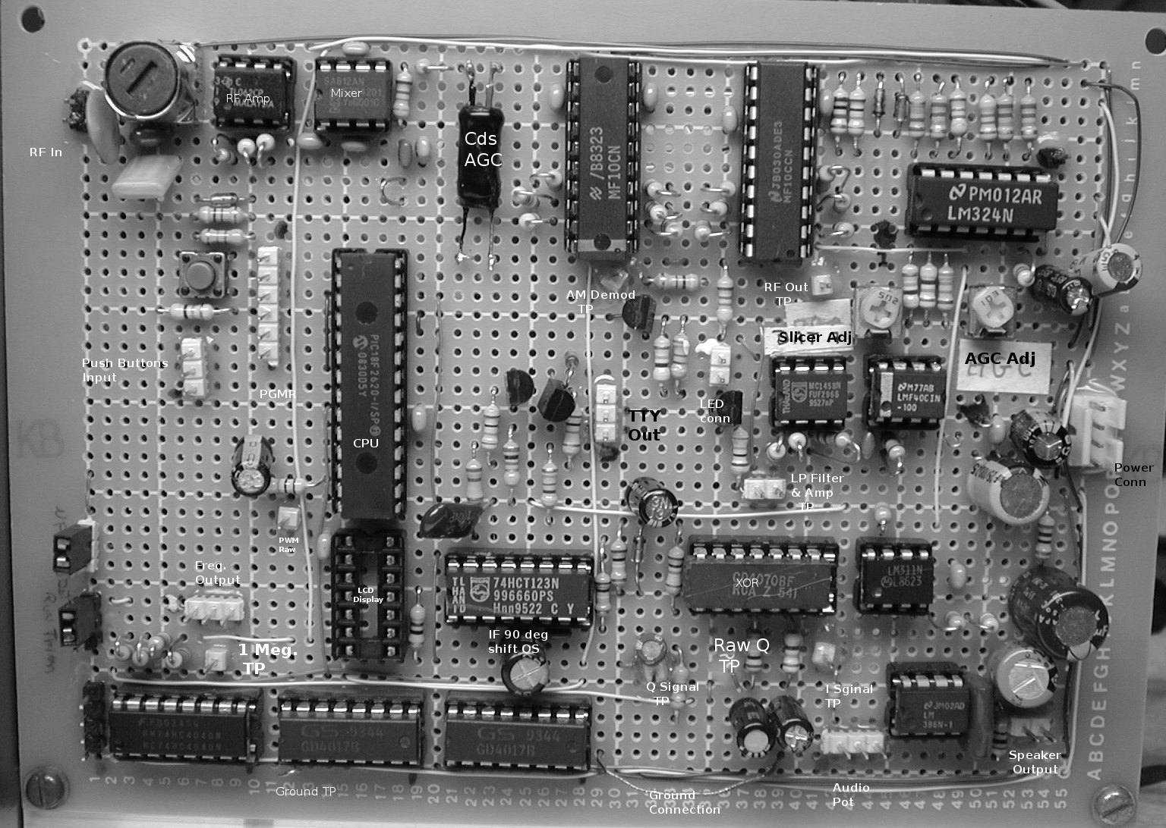

This is the main board with annotations as to the function each part plays. In the upper left corner there is an antenna connector, the one and only LC circuit, the operational amplifiers for preamplifier, the mixer and the CDS/LED AGC control element. That's it for the receiver front end! The next two chips (MF10) are the IF circuits and feed the LM324 quad operational amplifier on the top right that serves as the full wave detector and AGC amplifier.

The second row of components are the CPU on board reset pushbutton some connectors for the front panel, the programmer (PICkit2) connector for the CPU and mounted vertically is the PIC18F2620 chip and below it the empty 14 pin DIP takes the connection to the 24 character LED display unit that is driven by outputs from the CPU.

The right side of the second row has the data offset amplifier and the low pass filter. Above the low pass filter are two potentiometers that are used to set the AGC value and the DC offset of the output of the low pass filter.

Just below the amplifier and LP test points are the phase detector circuits. An XOR chip and a LM311 comparator along with the low pass RC filters use to recover the inphase voltage (I-Signal) and the quadrature signal (Q-Signal). The dual oneshot to the left of the XOR chip is used to generate the quadrature signal. The first OS is set to 100 microseconds and triggers a second OS set for 200 microseconds. This is the signal used to drive the Q-Signal phase detector.
In the lower right corner is the audio amplifier and plugs for the potentiometer and the speaker.

The lower left corner has the counter chips that are used to generate the filter clock and the IF local oscillator signals as well as the 2500 hertz compare signal for the phase detector circuit.

Final Assembly
Once all items have been constructed they are assembled into this configuration.
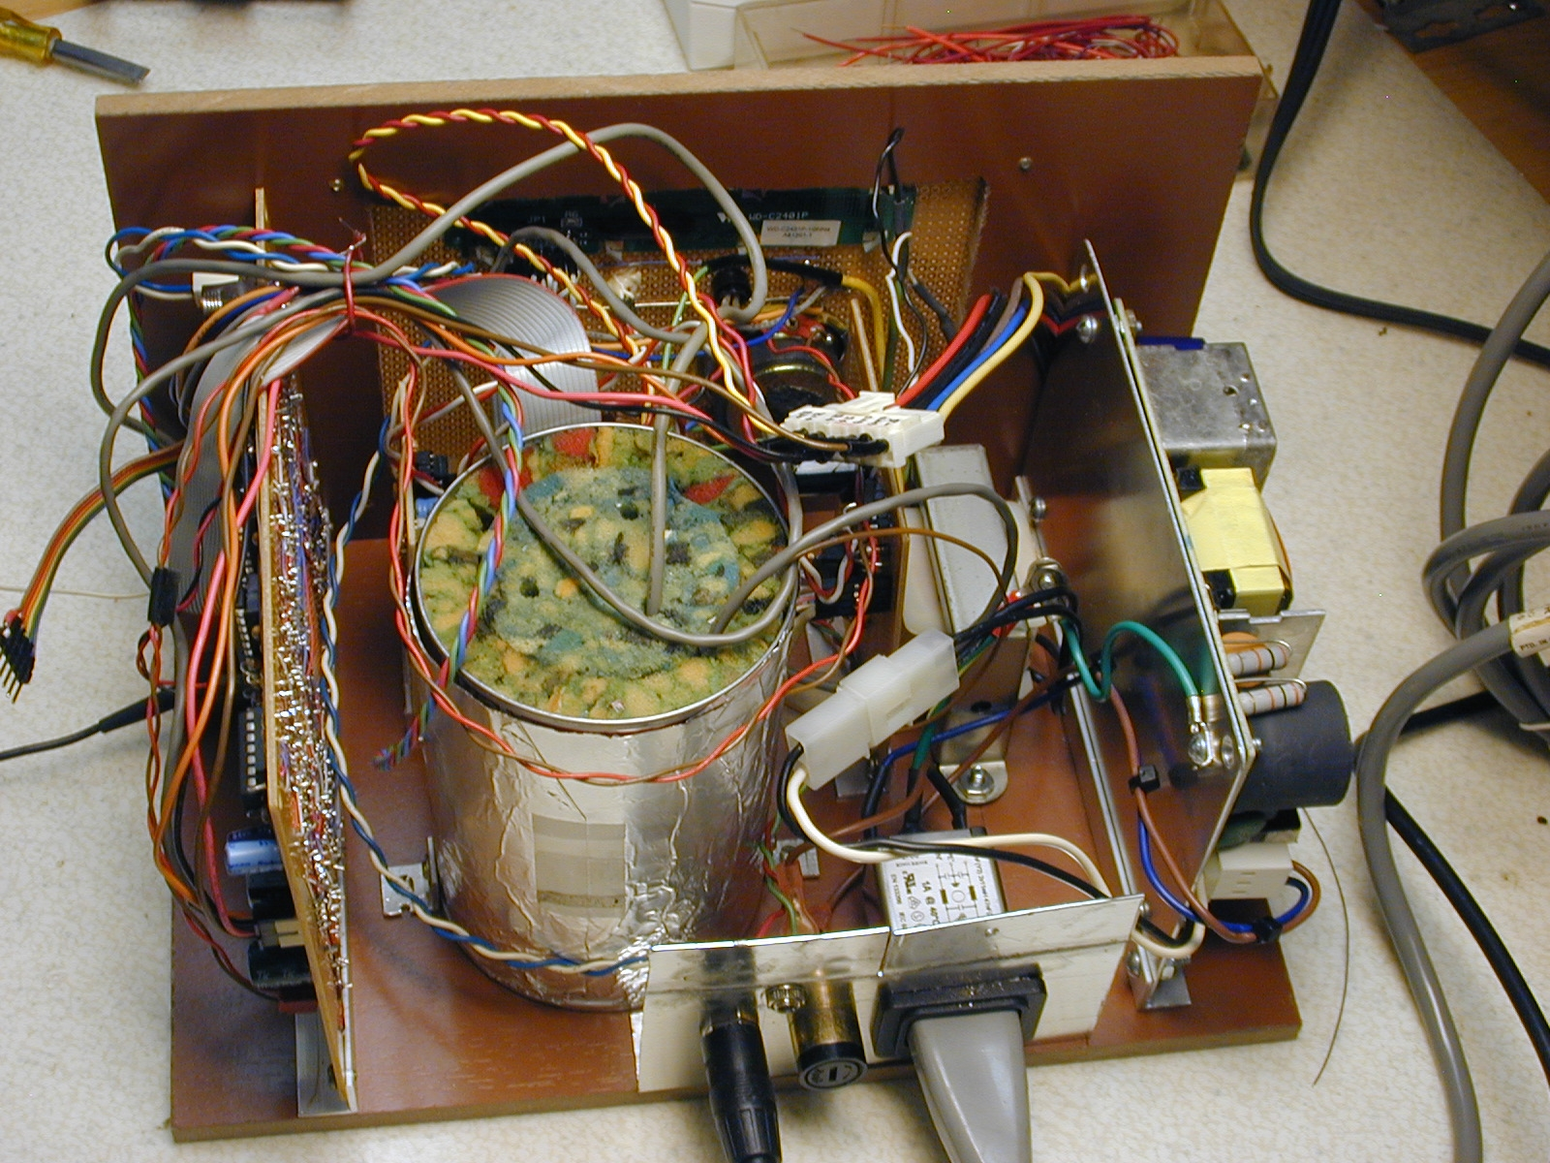
From left to right, the main circuit board, the oven for the VCXO, to the rear of the oven is the buffer amplifiers for the output frequencies, to the right of the oven is the oven control board and to its right is the 24volt CT transformer used to power the oven and on the are right is the switching power supply. Mounted on the metal plate in the rear center are the one megahertz output, the antenna connector, a fuse holder and the AC power connector.

Front Panel
The front panel assembly is shown below, this is before the panel is labeled.

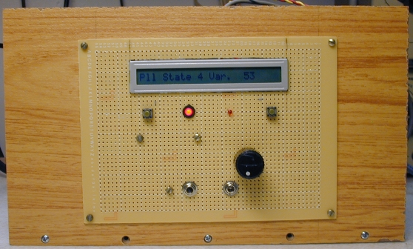
The LCD display is at the top (showing one of the detail messages) below are the two pushbuttons that (left) reset the unit and (right) select the detail messages. In the center are the two LEDs, the left one shows the decoded data and the right one is on when the oven heater is turned on. The knob (right center is a volume control for the IF audio output. The two jacks on the bottom row are the 1 and 2 megahertz signals.

Oven Control Board
The oven control board has a linear supply and the operational amplifiers used to hold the oven at a fixed temperature.

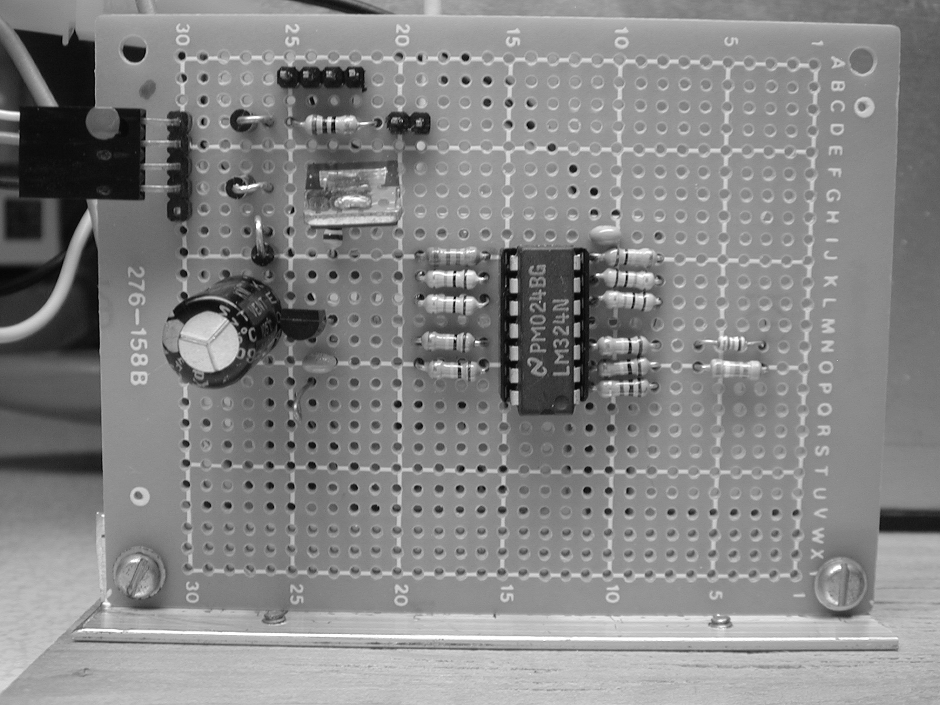

The left plug/receptacle is the power input 24 volts CT. at the top mid left is a four pin connector for the oven heater and the thermistor. Below and to the right is a two pin connector that brings a LED out to the control panel.

Operational Photographs
The unit in operation is illustrative of the type of reception that can be expected.
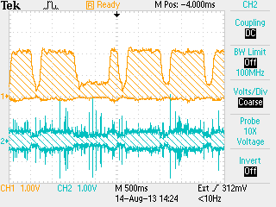
This photograph shows the input (lower trace) and the output of the IF system after detection (upper trace) the signals are from a DSO and are taken in the “peak detect” mode.
The output of the phase detectors illustrate the BPSK signals with reference to the AM modulation.
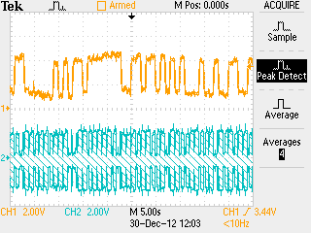
This photograph shows the output of the I signal phase detector (upper trace) and the output of the raw IF signal (lower trace.

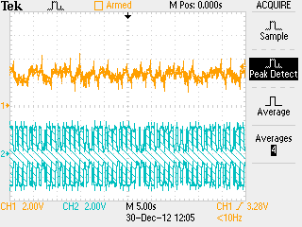
This photo shows the Q signal (upper trace) and the raw IF (lower trace). The upper trace shows the phase shift in the IF as the level of the signal changes. The computer samples the phase detector output at 0.9 seconds after the IF signal has been stable for at least 100 mSec.

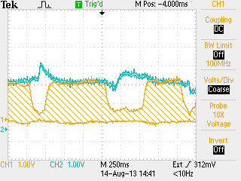
This photograph shows the Q phase signal (upper trace) superimposed on the output of the detected signal(lower trace). The Q signal is sampled at 0.9 seconds after the start of the second, the falling edge of the AM modulation. As can be seen the Q signal is stable and at a relative fixed amplitude at this time. The Q Signal is averaged in the control computer. First by two, then by four, then by eight and finally by 16 once the PLL is locked for a period of time, 100 seconds for each stage.

The BPSK data is modulated by shifting the phase of the carrier 180 degrees 0.1seconds after the start of the second. The photograph below shows this modulation for two symbols periods.
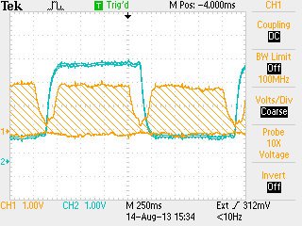
The first symbol is a zero (AM modulation) as is the second. The zero symbol is 0.2 seconds wide. Notice that the phase change happens mid point in the AM zero symbol.

The BPSK data has a synchronization word (Barker Word) to indicate the start of the minute.
This signal is shown below.
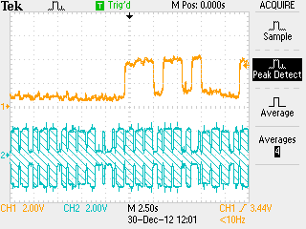
Notice that it comes near the two markers that represent the 59th and the Zeroth second. The barker word is defined as a 14 bit symbol. It starts at the 59th second and extends to the 12th second starting from zero. The value of the barker word is 0X3B40, this is referred to as the left shifted barker code in the program for prototype 4 where the code is decoded but not displayed.

