**Testing:**

***The Menu before logging in:***

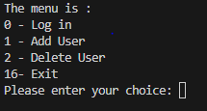

***Choice 1 adding a user:***

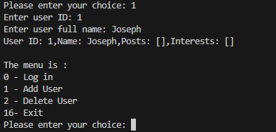

***We created multiple users:***

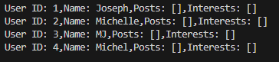

***Choice 0 to log in:***



***The Menu after logging in:***

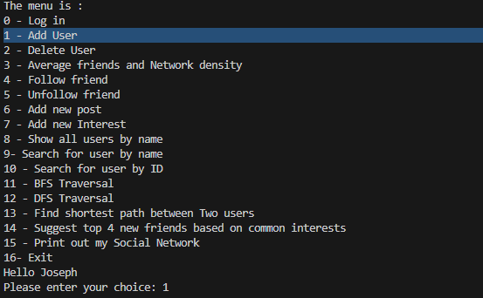

***Choice 4, Joseph with user ID 1 follow users ID: 2, 3, and 4.***

***Choice 9 searching user by name:***

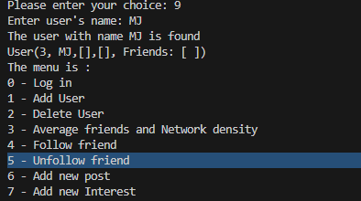

***Choice 10 searching user by ID:***

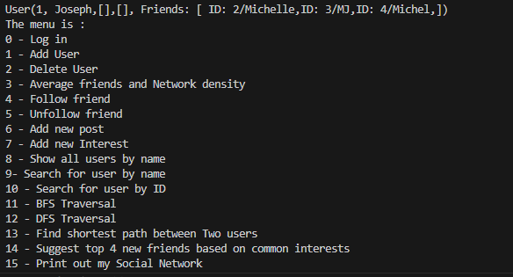

***Choice 3 statistics and network density:***

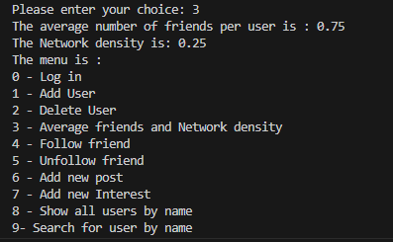

***Choice 5, Joseph with user ID 1 Unfollow user ID: 4.***

***Choice 10 searching user by ID(user ID =1):***

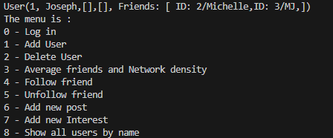

***Choice 6, Joseph with user Id 1 added a new post:***

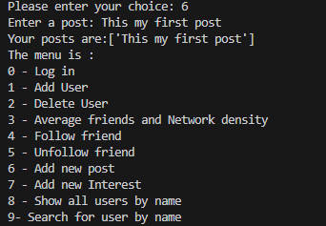



***Choice 7, Joseph with user Id 1 added a new interest:***

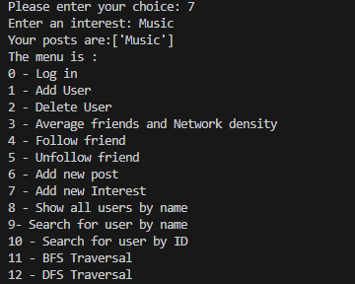



***Choice 8 show all users sorted by name:***

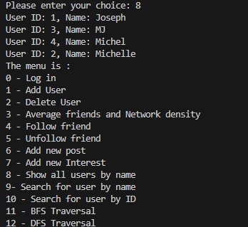

***Choice 11 BFS Traversal:***

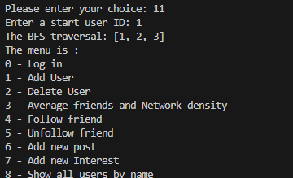

***Choice 12 DFS Traversal:***

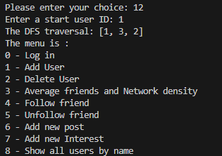

***Choice 13 shortest path between two users:***

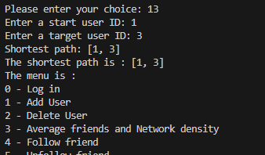

***Choice 14 Suggest Top 4 new friends based on common interests after following some friends by Joseph with User ID 1:***





***Choice 15 print out my social network:***

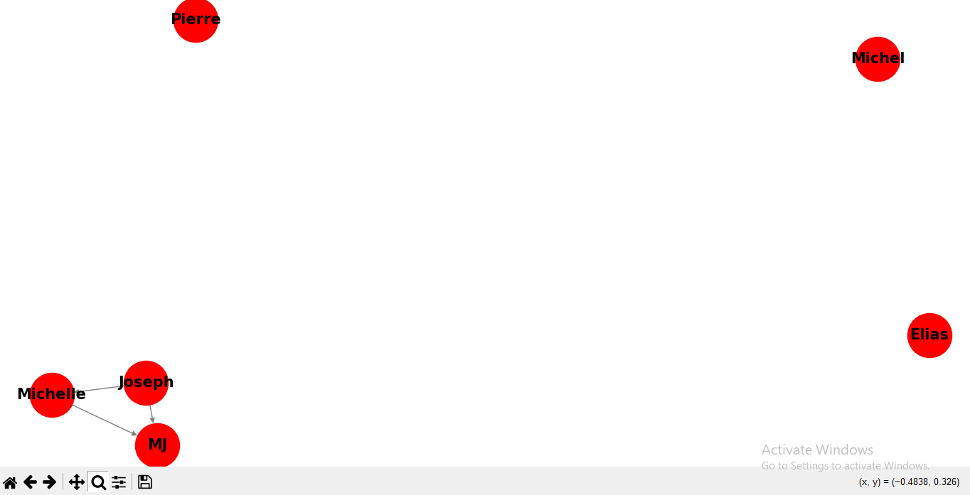

***Choice 16 Exit the Social network system:***

