Pre-design:
Characterizing the affordances and physical properties of your object:
Our object is a bookshelf. Our object is not portable, nor small. Our object is meant to be in a household room, on the floor. Usually it has shelves with books on them. Sometimes bookshelves are smaller, bedside additions. Our bookshelf will be a large standard bookshelf like:
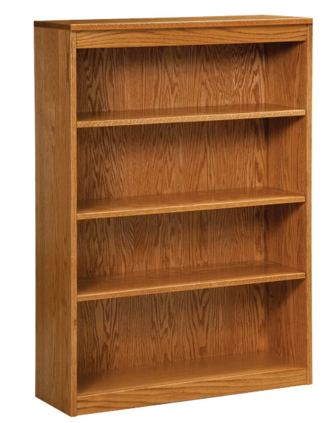
Capturing user needs:
Interview 1: Anonymous
Q1 – What features would you want a smart bookshelf to have?
A2 – I'd like the smart bookshelf to automatically add my books when I place them on the shelf, maybe using ISBN barcode scanning. I would like to be able to view my catalog of books on an app when I’m away from the library.
Q2 – What would you like to see for your collection of books?
A2 – I would like to see the books I have or have not read, the progress or my notes for the books. I would like my collection to be sorted the way I like. I would like to see the books I have lent to other people or the books I have forgotten to place back on the bookshelf.
Q3 – How simple would you like the smart bookshelf to be?
A3 – I would like my bookshelf to be very simple, where I can just add or remove books without interruption.
Interview 2: Anonymous
Q1 – What features would you want a smart bookshelf to have?
A1 - A way to track my reading, and features that support organization. I guess reminders will also be good to help with consistency for my reading goals. Will also be a plus if my bookshelf is beautiful.
Q2 – What would you like to see for your collection of books?
A2 - Genres and authors. Reading speed; tracking the time it takes me to finish a book might be fun.
Q3 – How simple would you like the smart bookshelf to be?
A3 – Easy to use; not a steep learning curve. Powerful but seamless.
Interview 3: Anonymous
Q1 – What features would you want a smart bookshelf to have?
A1 - I would like to be able to see how often I’m grabbing certain books and how many books I have on it at any time
Q2 – What would you like to see for your collection of books?
A2 - I would like to be able to see the genre, a synopsis, the author, and other important details about each book
Q3 – How simple would you like the smart bookshelf to be?
A3 – I would like the bookshelf to be as simple as possible and look just like a normal bookshelf. I would also like the UI to be simple and quick to use as well.
State your assumptions:
- Bookshelf can detect and scan new book being added (via cameras/scanners), and detect a book being removed.
- Bookshelf can store history or books over time.
- Bookshelf has smart led lights to highlights books for user.
Written list of user needs and design requirements:
- Need to see books
- Need to be able to see book details (title, summary, author, etc.)
- Need ability to add and remove books
- Need ability to sort/find books using led lights
- Need ability to track usage of books (on/off) shelf
- Need ability to store history of bookshelf

Sketches:

10 by 10:

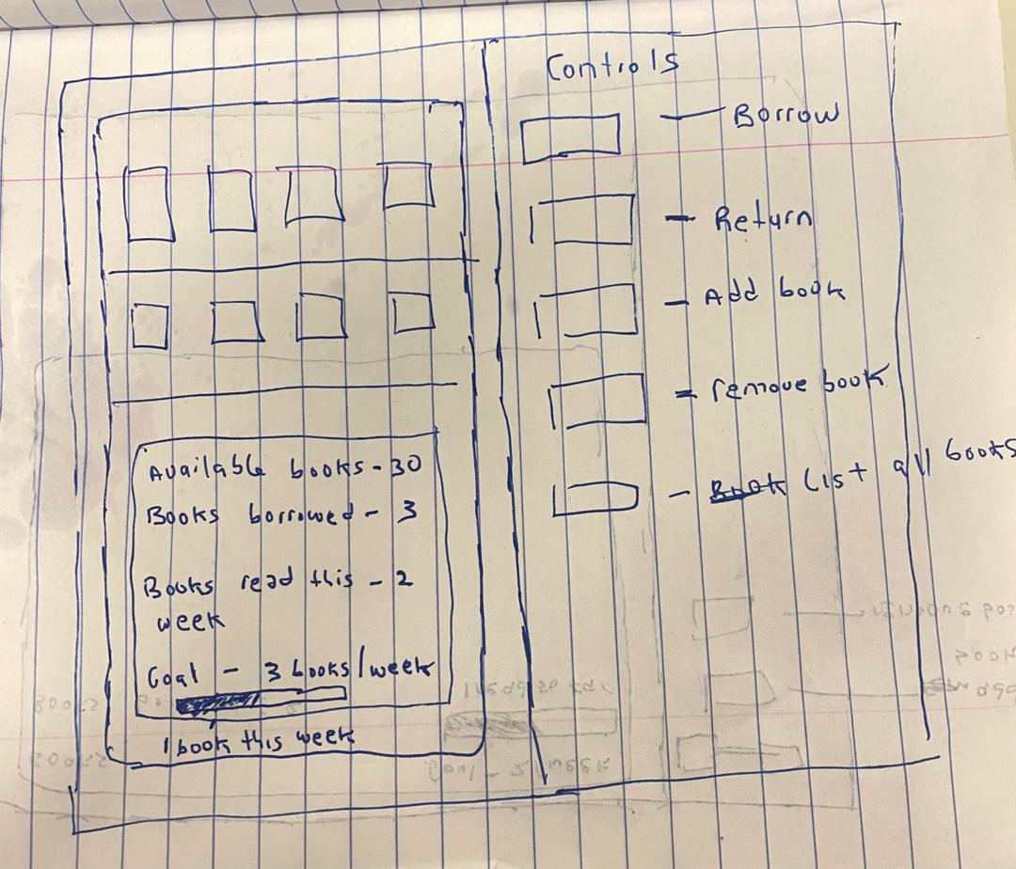
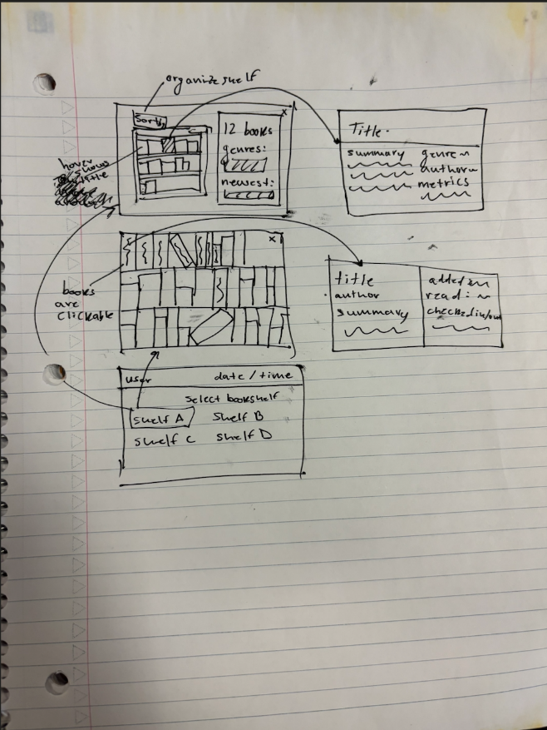

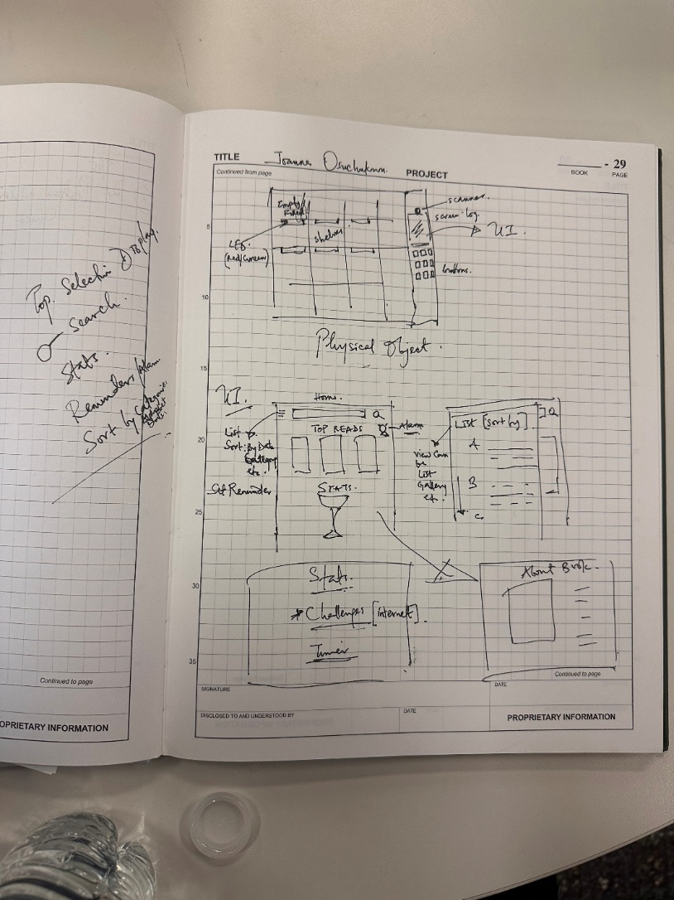

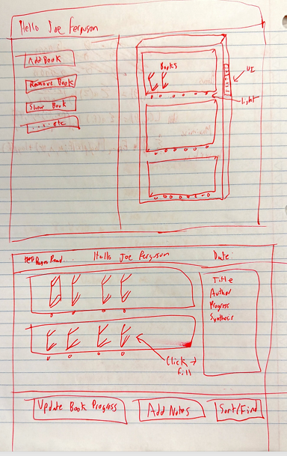

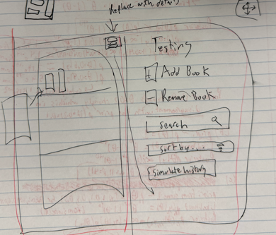
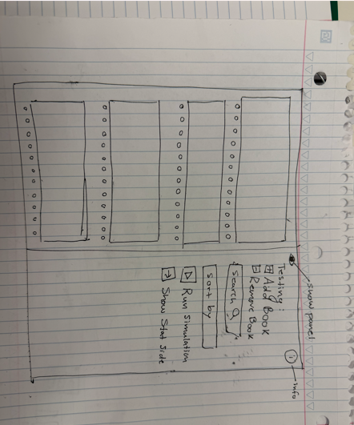
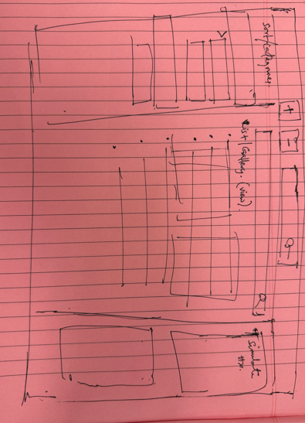
Ideas generated – Led Lights, Update Book / Add notes, Sort and Find using LEDS.
Front page scanner, search button, sort (alphabetically, by categories, author, date, etc), timer/reminder, stats & tracked metrics, about book/book summary, online challenge options (gamification).

Hybrid sketching
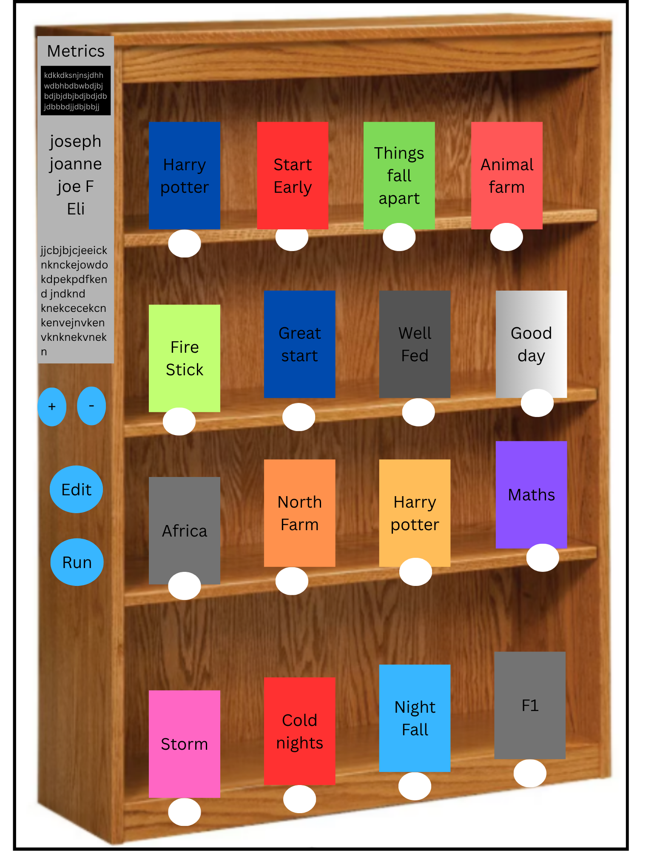

Vanilla Sketch:
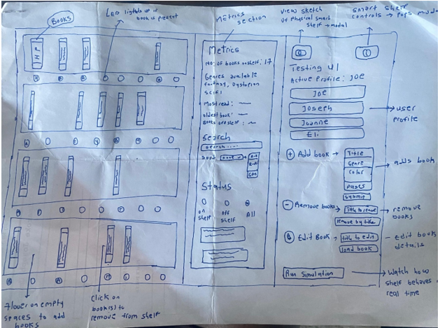

Storyboard Sketch:
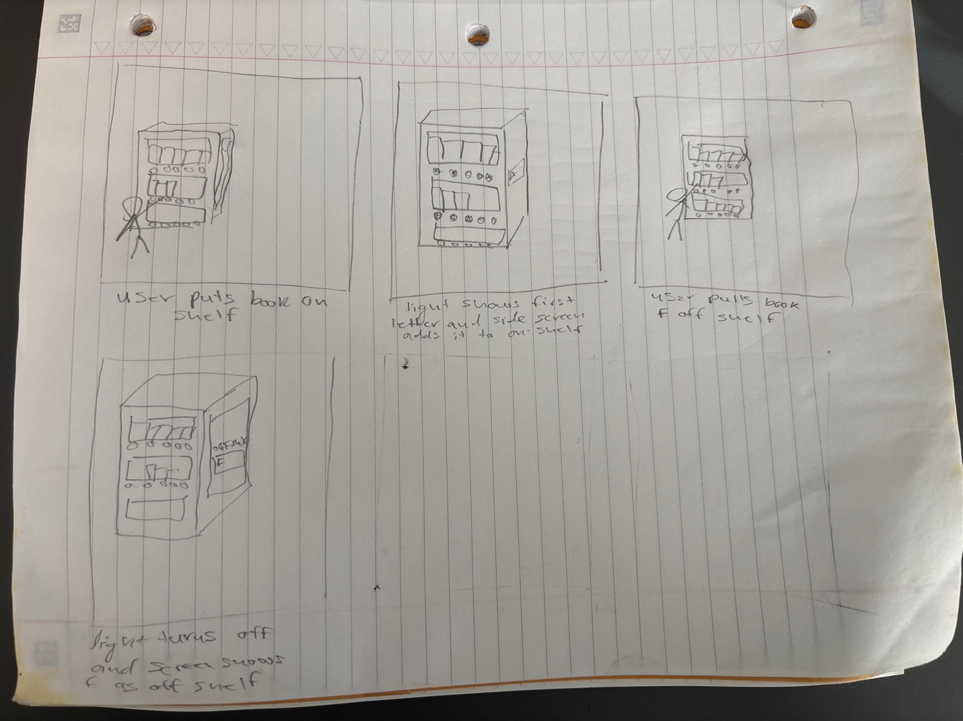
Progress:
10/18/2025 – 4:00pm
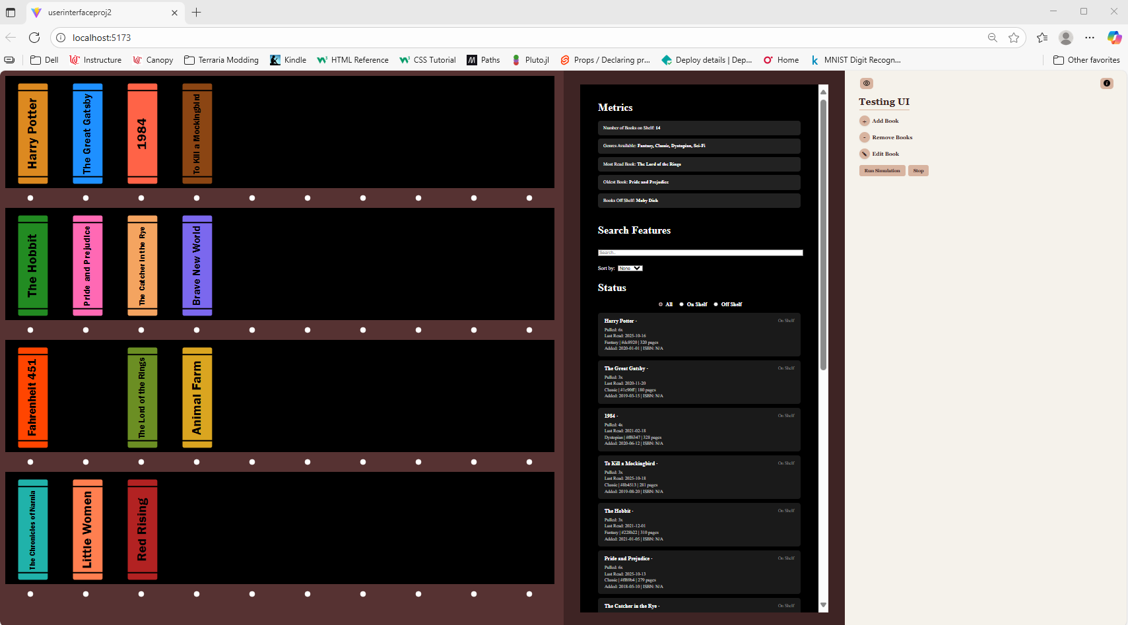
Books are dynamic to respond to testing UI changes, better formatting and responsiveness across the design. Sort & search need improved, lights need functionality, refined design choices need.
10/19/2025 – 5:30pm
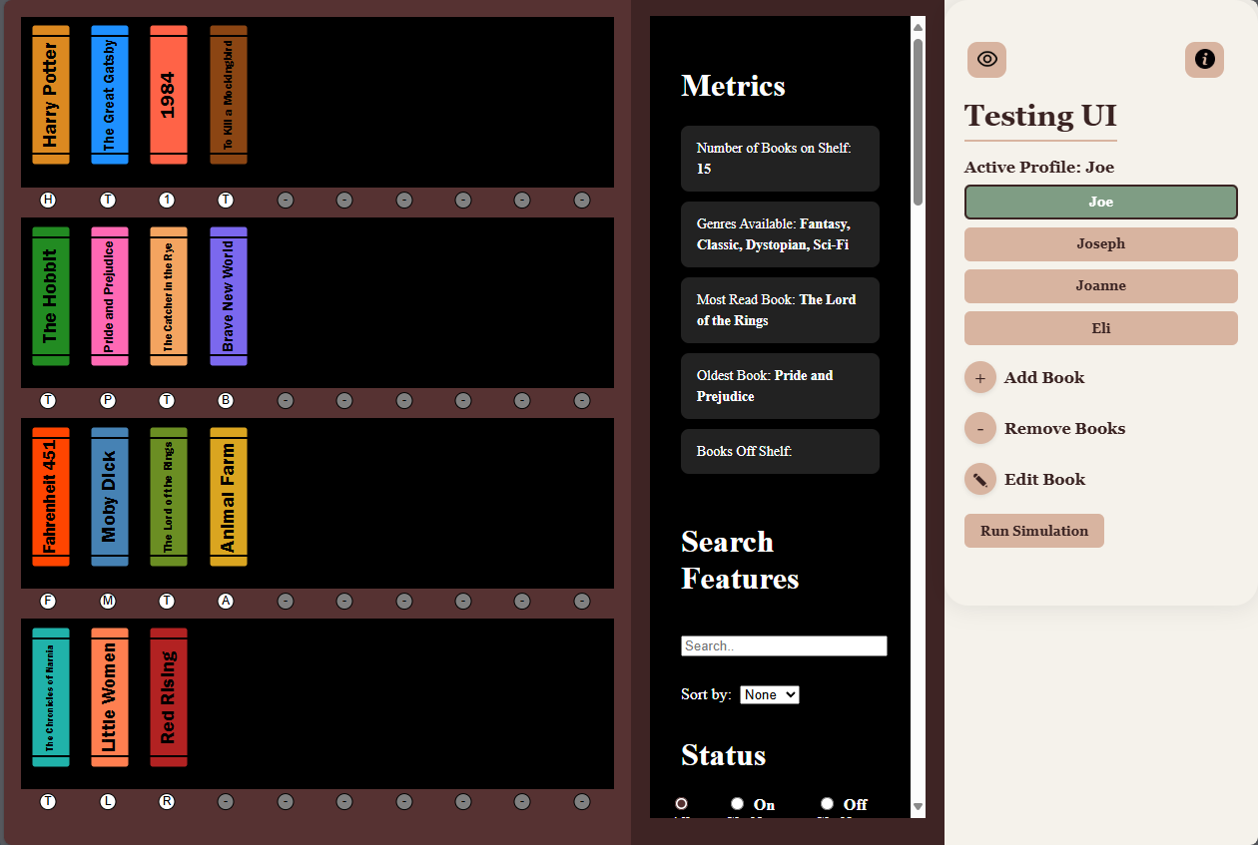
Settled on 1200 by 800 resolution, formatting fixes, book clickable actions are done, simulation is done, profiles have been added. Left: eye button updates, lights updates.
10/18/2025 – 10:00pm – Final Version
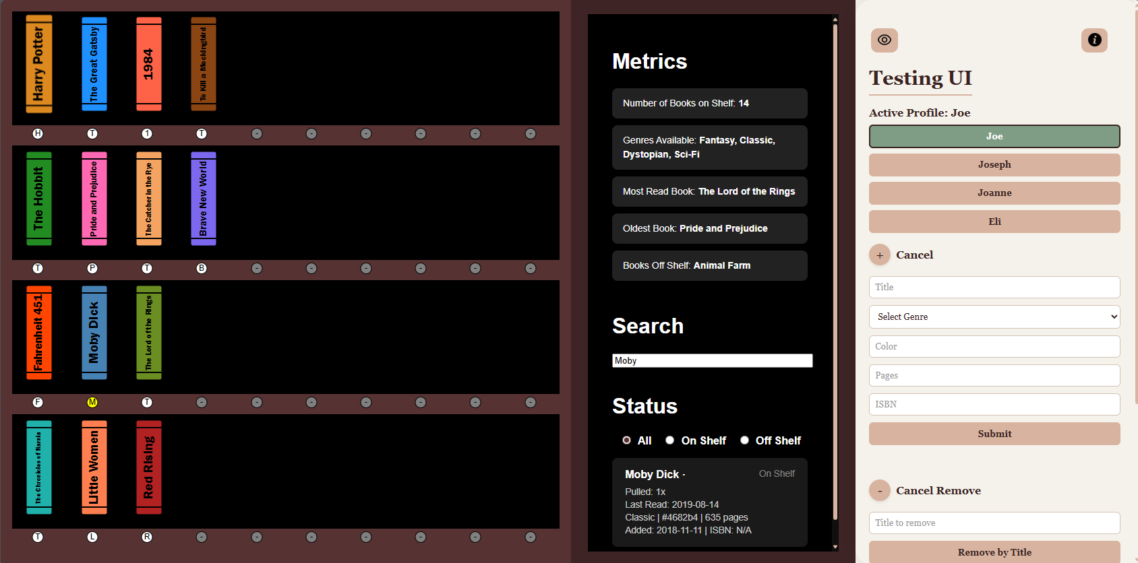
Eye and info button updated, lights, function. More formatting and design fixes, and user experience improvements.
Documentation:
For documentation: assume that someone is encountering your project for the first time. This documentation must be publicly available through one group members portfolio page. I strongly recommend making a personal copy on your portfolio page, and copying the repo to your git account, in case your team mates someday take their portfolio page down.
- Describe the project
Our project is a smart bookshelf. This smart bookshelf tracks metrics about your usage for each book, the dates of the books, and characteristics of each book. It also has a search and sort feature that utilizes led lights on the bookshelf to help you find books on your bookshelf.
- Present your design work-
Listed in the first half of the document. Essentially we started with idea gathering, which then led us to the idea of the smart bookshelf. Then, we each did 10x10 sketches with the idea in mind. After that we talked about what we liked and disliked from each sketch, and then we did more. After that we formulated a list and loose layout of what we wanted, and we started the template development. During this process, we narrowed down the design until we had a solid boilerplate and vanilla sketch. After this the rest was development and implementation.
- Describe your interface in detail:
  - Explain the features and controls. Include plenty of screenshots to illustrate your interface and different actions users can perform within it.


On the user interface, the shelves are displayed for you. You can click on a book to remove it or click on an empty spot to add a book in.
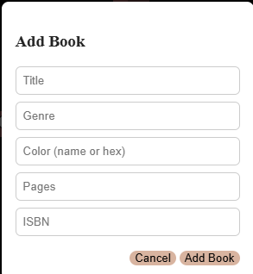
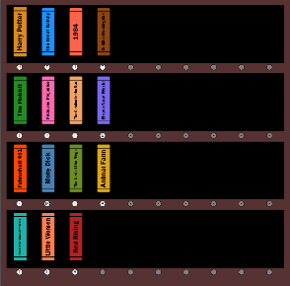

You can also do this in the testing panel. Additionally in the testing panel, you can select a different profile for each person, you can edit details for a book, and you can run a simulation to see changes that could happen to the bookshelf over time.
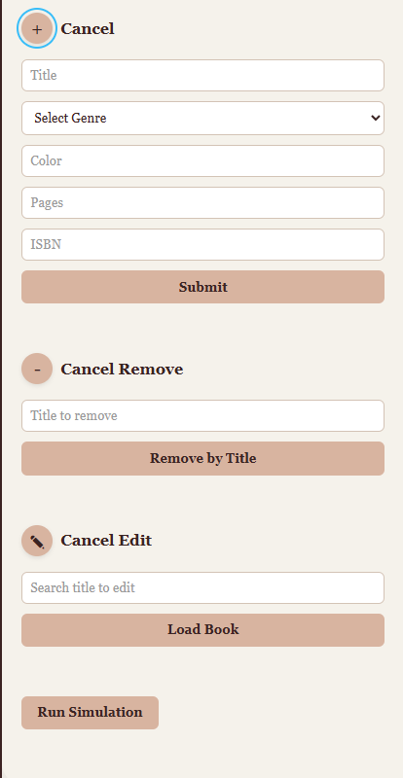
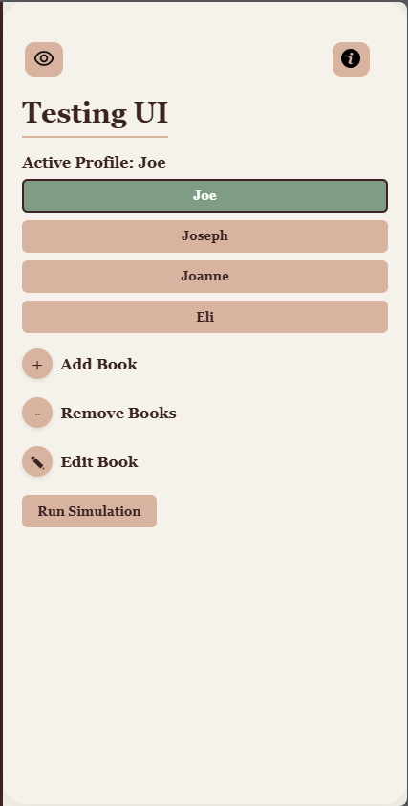
You can also click the eye icon to see where the UI panel would reside on the physical smart bookshelf. You can click on the info button to see how to use the panel.
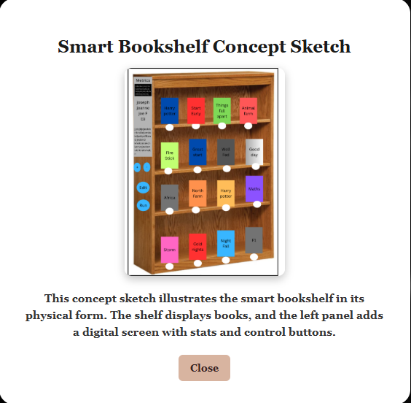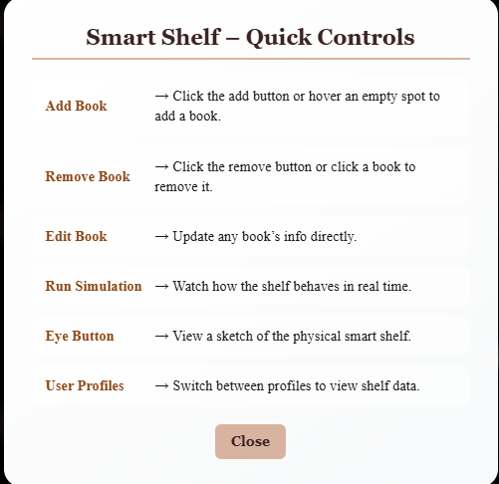
On the metrics panel, you can see how many books you have on the shelf, books that are currently off the shelf, the genres of those books, your most read book, and the oldest book you have. You can also search and sort the books to your liking.
On the bookshelf itself, you can see the books you have represented. You can click on a book to remove it from the shelf, or you can click on an empty spot to add a book there.
- Explain how you implemented this application (libraries, code structure....)
We did not use any libraries for this project. Because it was a team project, we split our code into separate svelte files for each part of the project so that everyone could work on a part of the project without conflicting with another individual’s changes. We used git & GitHub for project management that really helped our workflow.
- Optional- Use of AI- If you used AI, describe how. Did you identify strengths/limitations of using AI for your application.
We used AI as an aid for specific problems we ran into. For instance, we had a problem with the BookSvg svelte file having text overflow the size of the book, but only on different profiles than the default one. To solve this problem, we utilized the built-in copilot to change the text size to update when the user selects a different profile.
We also used AI for data generation, specifically the 70+ books and details we store for the different profiles. This would have taken a lot of time to type out manually, so AI was used for this.
For everything else, including boiler plating and design work, everything was done without AI.
- Future work- No project is ever fully done. What would you do next? This is also a place to discuss the work you attempted but could not fully complete before the project deadline- include screenshots to illustrate and document your progress.
We believe the scale of the project can be improved in the future. For instance, our capacity of 40 books may not be enough for dedicated readers. Also, we can further develop the smart bookshelf to make it into a family smart bookshelf. This would be a single shared bookshelf where everyone can see their books using the LEDs, instead of separate bookshelves for each individual (which is what we are displaying now).
We can also integrate a secondary, mobile app so that users can see their bookshelf from anywhere. It could also include more tracking information such as reading sessions & pages read, prices of books online, purely virtual books in their bookshelf, and more. Searching will update the led lights to show which books match the search terms.
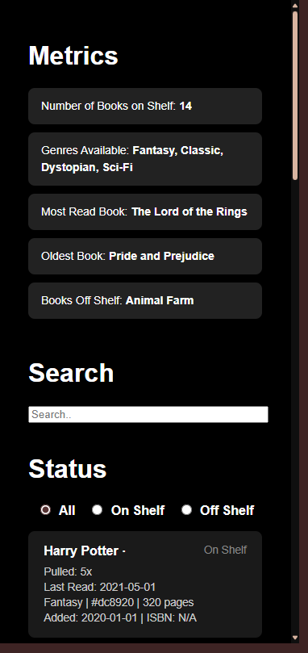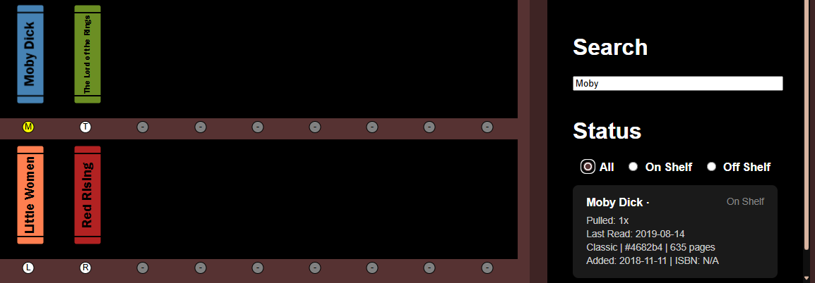
- Include a 2-3 minute demo video, showing your interface in action.
  - The easiest way to record this is with a screen capture tool, which also captures audio- such as Quicktime. Use a voiceover to explain your application. Include the name of the project, your name, the project components, and how your application works. You can present it on your webpage or on youtube, but it must be linked on your webpage.
- Include a link to your source code on github and a link to the publicly hosted application
https://github.com/JosephAFerguson/-UserInterface-Proj2
https://jf-userinterfaceproj2.netlify.app/

