CS6037 Machine Learning Assignment 1
Group 13
Maxwell Eichelberger, Joe Ferguson

Attribution
Maxwell Eichelberger - Code and Program Bug Fixes, Writeup Fixes
Joe Ferguson - Initial Code, Initial Writeup

Figures
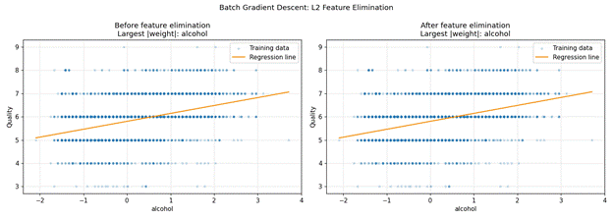
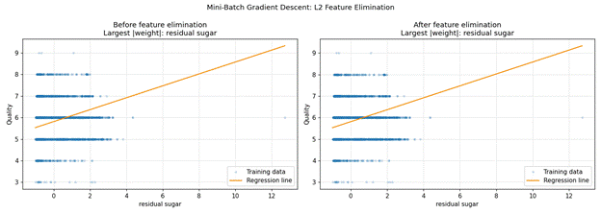
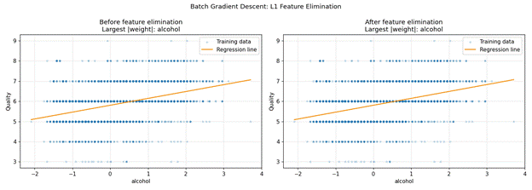
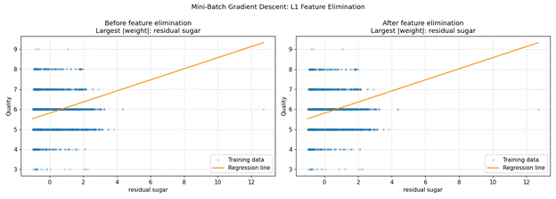

Written Analysis
Both the L1 and L2 regularization approaches removed citric acid as the attribute whose weight shrank closest to zero. Looking at the distribution for this attribute:
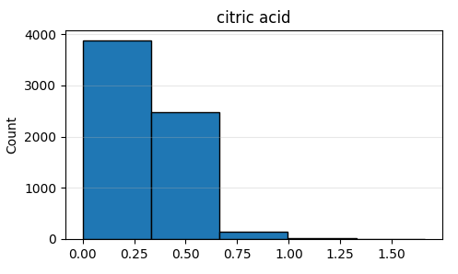
We can see it is heavily skewed right, with a longer tail towards the higher end, which, after the standardization applied to minimize training time and reduce noise, with the data not having a lot already, results in a very minimal amount of information to be extracted from this attribute due to it being clustered near a singular point.

The MSE Results of all Six Models
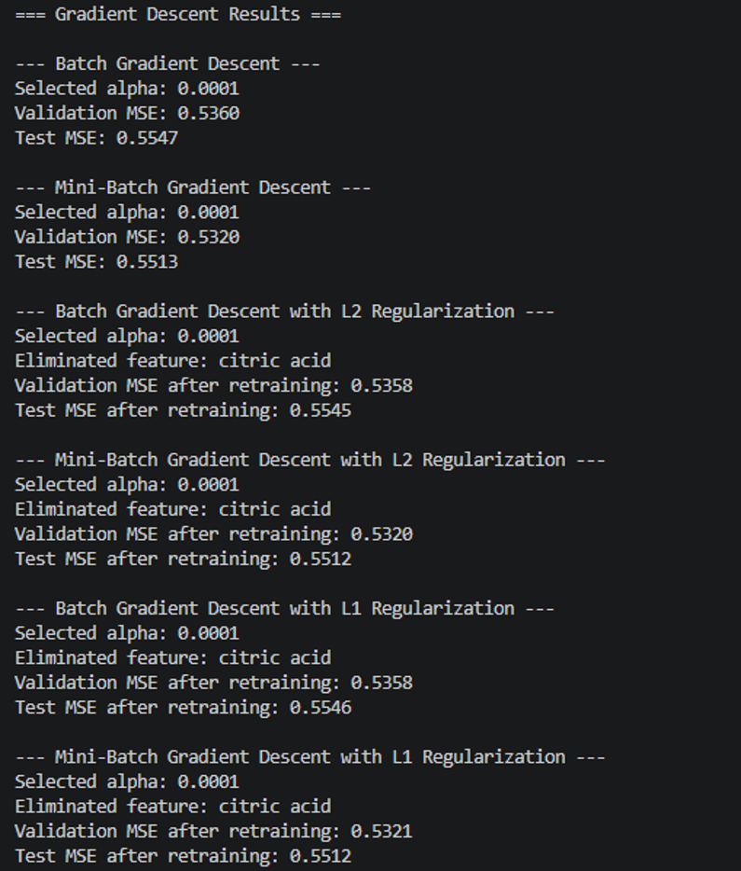
Model | Train MSE | Validation MSE | Test MSE
Batch, no regularization | 0.5377 | 0.5360 | 0.5547
Mini-batch, no regularization | 0.5348 | 0.5320 | 0.5513
Batch, L2 (ridge) | 0.5374 | 0.5358 | 0.5545
Mini-batch, L2 (ridge) | 0.5348 | 0.5320 | 0.5511
Batch, L1 (lasso) | 0.5374 | 0.5358 | 0.5545
Mini-batch, L1 (lasso) | 0.5348 | 0.5320 | 0.5511

From this, we can see the MSE results are close. This can be attributed to the simplicity of the approach, as well as each being done with a learning rate of 0.01 and with 300 epochs. This explains why all approaches settled in the same “minimum” area for the gradient descent. The Mini-batch performs slightly better which is to be expected.
Alpha was selected to be 0.0001 by all, shown below:
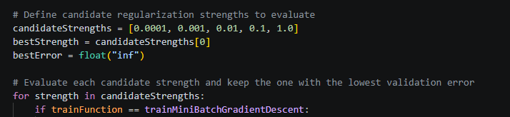
It was selected by comparing the error of different values for alpha, and selecting the one with the lowest error. Not much regularization is needed for the data, so the lowest value won for each approach.
Other observations include the noticeably faster training for the mini-batch approach, which is also to be expected.

