REPORT
  - Joe Ferguson

Introduction

Part 1: Single CART Trees

1a
Rounding to 4 decimal points:
Gini Decrease:
- For the node with 40 samples (25A, 15B), the Gini impurity is 1 – (25/40)^2-(15/40)^2 = 0.46875
- For the left child with 22 samples (20A, 2B), the Gini impurity is 1- (20/22)^2-(2/22)^2 = 0.1653
- For the right child with 18 samples (5A, 13B), the Gini impurity is 1- (5/18)^2-(13/18)^2 = 0.4012
- Then the Gini split would be the sum of the weighted impurities - G_split = 22/40 *(0.1653) + 18/40(0.4012) = 0.2715
- The final gini decrease would be the parent node impurity minus the gini split – 0.46875 – 0.2715 = 0.1973
Information Gain:
- For node with 40 samples (25A, 15B), the Entropy is = -(25/40)log_2(25/40) – (15/40)log_2(15/40) = 0.9544
- For the left child with 22 samples (20A, 2B), the Entropy is = -(20/22)log_2(20/22) – (2/22)log_2(2/22) = 0.4395
- For the right child with 18 samples (5A, 13B), the Entropy is = -(5/18)log_2(5/18) – (13/18)log_2(13/18) = 0.8524
- Then the weighted gain would be the sum of the weighted entropies = (22/40)*0.4395 + (18/40)*0.8524 = 0.6254
- The final information gain would be the parent entropy minus the gain = 0.9544 – 0.6254 = 0.329
Gini and Entropy Functions for binary classification
- Gini function(p,1-p) = 1 – p^2 – (1-p)^2
- Entropy Function(p,1-p) = -(plog_2p + (1-p)log_2(1-p))
  - H/2 = -1/2(plog_2p + (1-p)log_2(1-p))
Misclassification Error
- 1 – max(p,1-p)
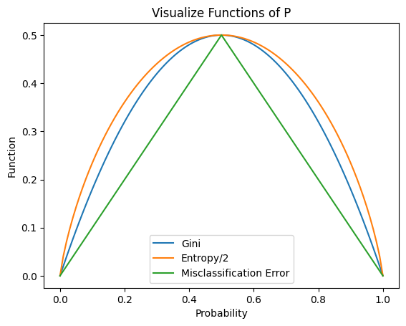
CART prefers G or H because they are smooth functions (unlike misclassification error) that are more sensitive to changes/details within the classes. I.e, they can provide distinguish which split improves node purity better, as seen by the curve being above misclassification error. Entropy, as shown does tend to produce more balanced classes then gini, however gini is faster to compute.

1b
I started by looping through each max depth and fitting and predicting each, grabbing the accuracies in lists. I then wrote functions to calculate the variance of each across 5 random seeds, plotting and showing tables for the results. For showing how often the two criteria choose the same feature, I wrote an iterative function to grab the nodes of each, and a loop to compare the nodes at each level.
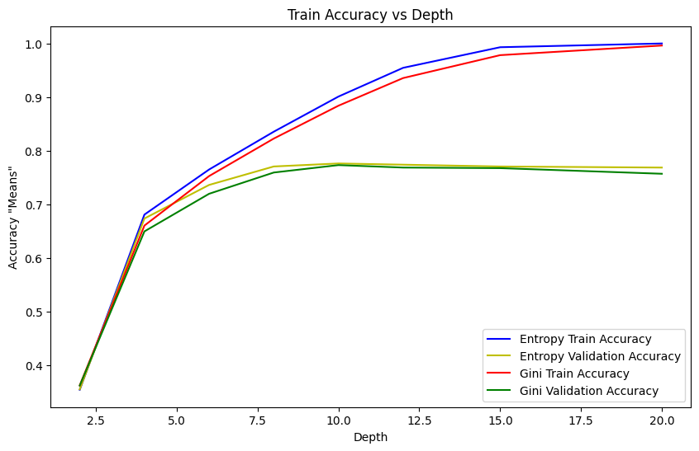

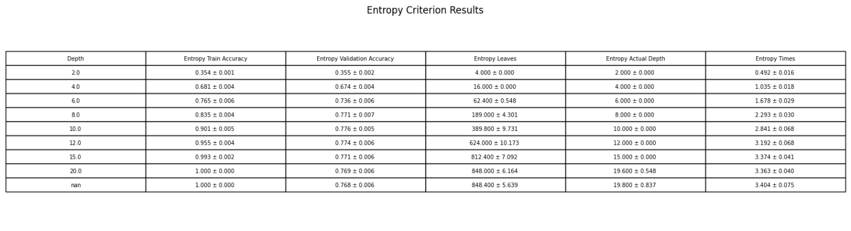
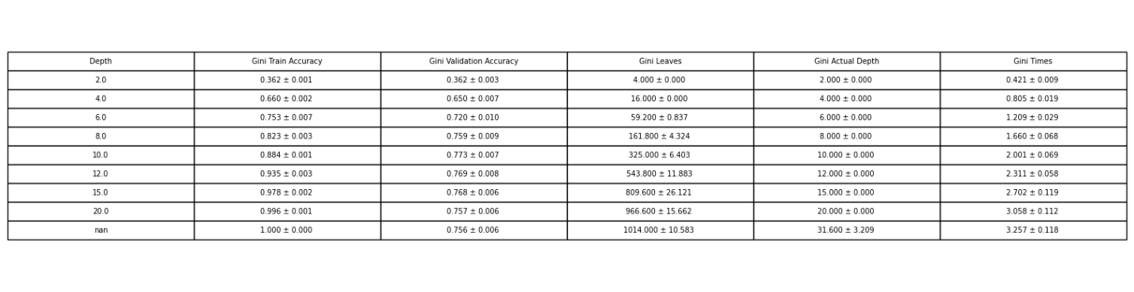
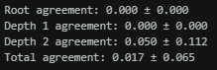
Looking at the graphics, we can say the criteria matter very little compared to the depth the trees are allowed.

1c
I started by computing the cost complexity path for each random seed, just using gini as the criteria. I then computed the variances and plotted the results.
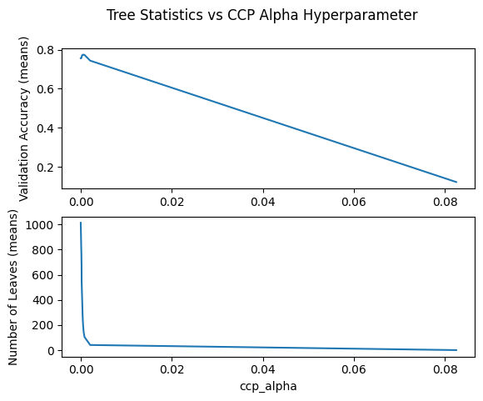
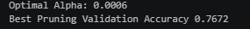
As we can see the optimal alpha for CCP beats the best depth-limited tree on the test sets, this is due to the pruning, which reduces the amount the tree will overfit, thus making it generalize better on unseen data.
Trying min_samples_leaf, we get:
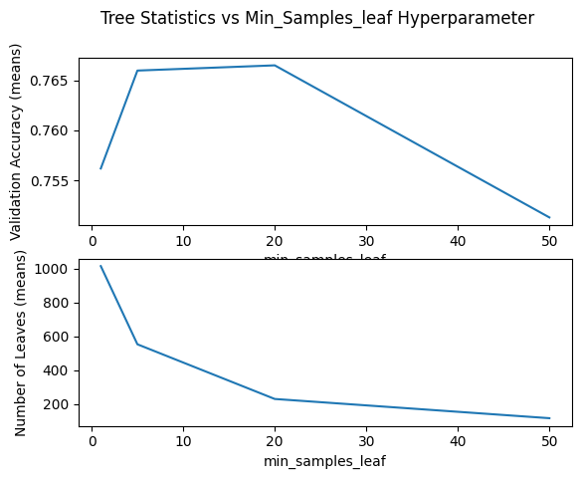
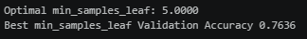
As we can see the optimal min_samples_leaf also beats the best depth-limited tree, for the same reason. Although it looks like 20 should be the optimal value based on the chart, GridSearch determined 5 was the optimal value for random seed 1.
For both optimal values, I did not average the values over 5 runs as GridSearch is very compute intensive and would take my labtop ~ 1 hour to run.
However, the charts show the averaged means.

1d
I started by looping over the random seeds and creating trees using the three metrics. Notice that friedman_mse is deprecated now for sklearn. I then compared every model while evaluating using the same metric across each. Then I iterated through every metric/model and saved the one with the best validation error. I used this to show the top 3 levels of the tree and the step-function predictions
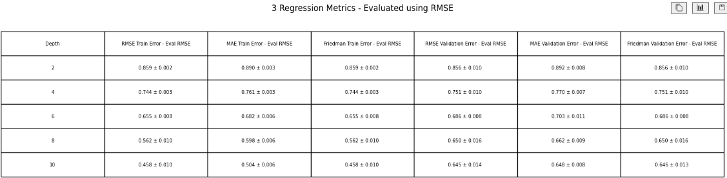
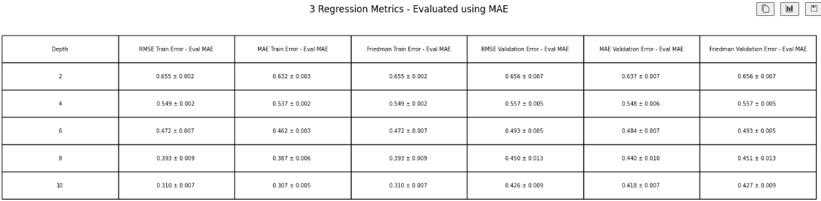
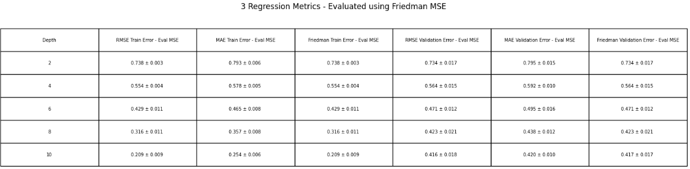
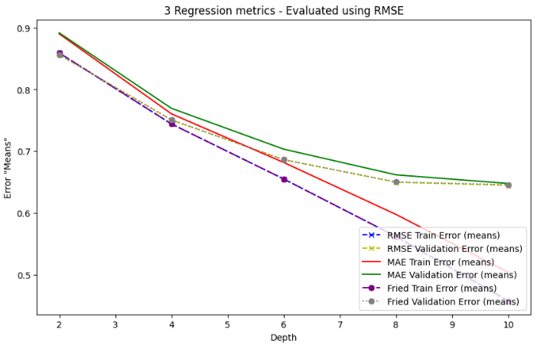
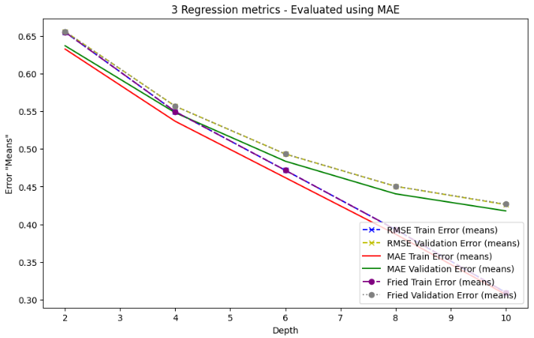
As we can see Friedman mse and RMSE are equivalent as they are mathematical proportional to each other, which can result in identical trees, for the trees trained on one metric, they are better when evaluated on that same metric then for another one. This is to be expected logically, as they are minimizing that metric through training.
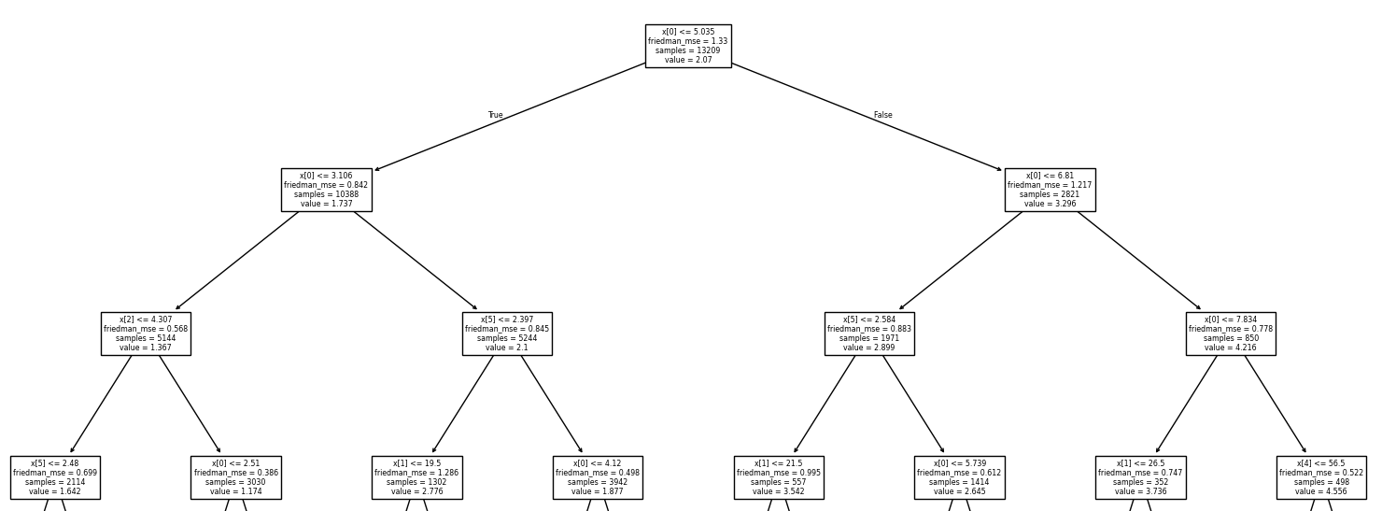
The root and depth-1 levels are splitting based on MedInc, which means it has the most feature importance and purity. Further down, HouseAge, AveRooms, AveOccup, and Population start to be considered. This is to be expected, we should not be seeing the Latitude or Longitude near the top of the tree.
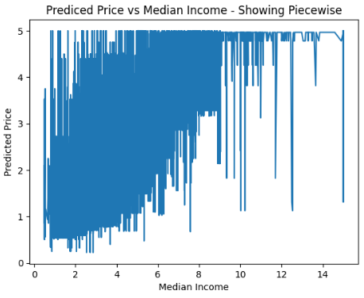
This shows the step-function (piecewise) behavior of the regression tree. Although cluttered, we can see the steps “up the staircase” when median income increases.

Part 2: Sampling-based ensembles

2a
I started again by looping through the random seeds and fractions for each model. For random patches I had to loop twice through, and for the table I had to average and show the accuracies for row and column averaged. I then plotted the heatmap.
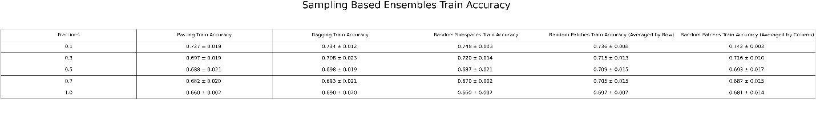
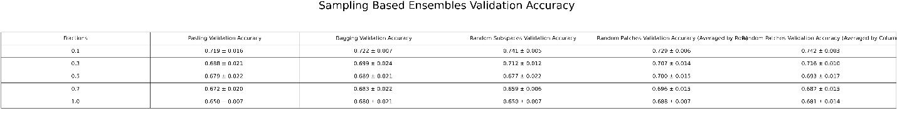
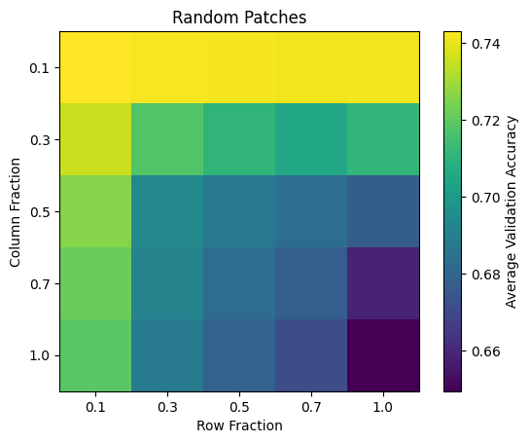

2b
I started by training the bagging classifier by using n_estimators = [1,25,50,100,200,300] then collecting validation accuracy and oob score.

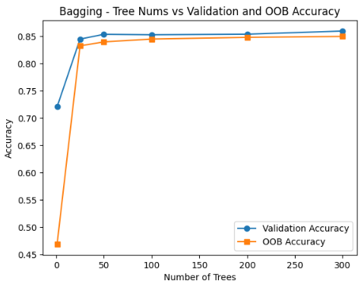
The validation accuracy and OOB estimate are very close, both estimate how well the model generalizes to unseen data. Pasting does not have one because it samples, without replacement, so it will use every sample from the subset.

2c
I got 10 different bootstrap resamples from the data and then collected the predictions for each model, I then compared them using a bar chart.
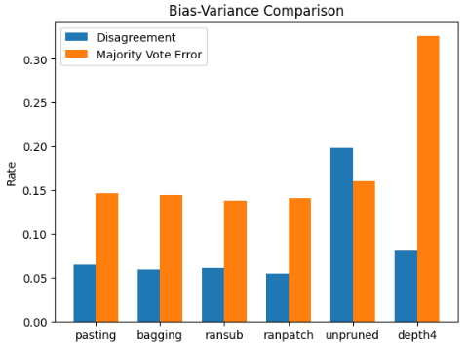

2d
I began by sweeping through the fractions and training the models. For random patches, to show on a table I had to average the stats by fixing row and column. The heatmap will show the best accuracies for each row and column fraction anyway.
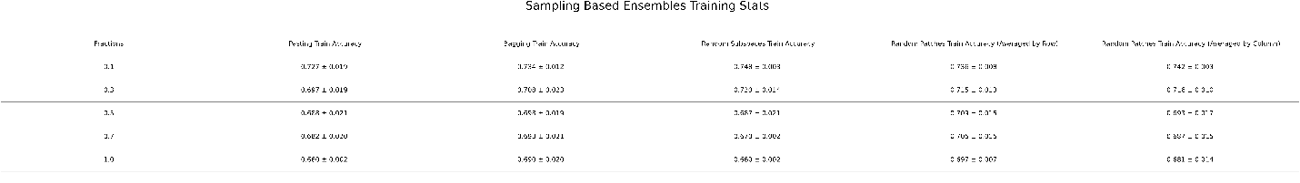
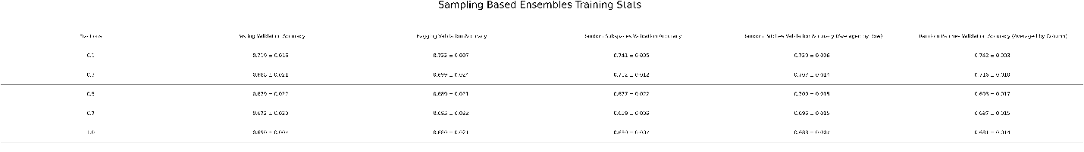
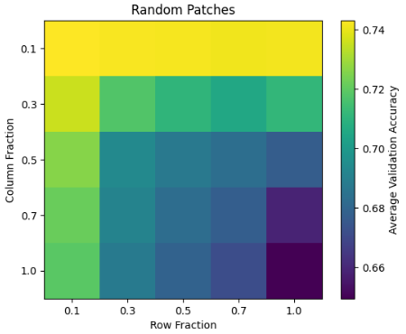
Shallow trees have high bias but lower variance, i.e they underfit, so bagging does little since it reduces variance. However for deep trees, which have higher bias, bagging can help reduce the variance which improves their performance a lot more.

Part 3 – Random Forests and Extra Trees

3a
I started by sweeping the max features and random seeds for random forests on entropy vs gini and extra trees entropy and gini for fair comparison across all. I then created the graphics to compare them.
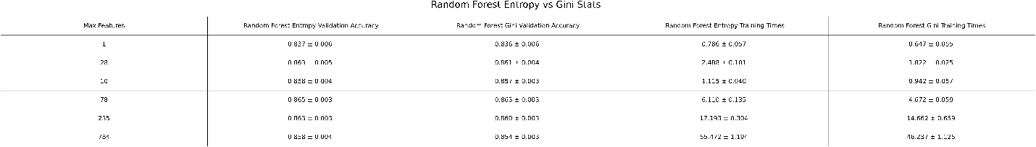
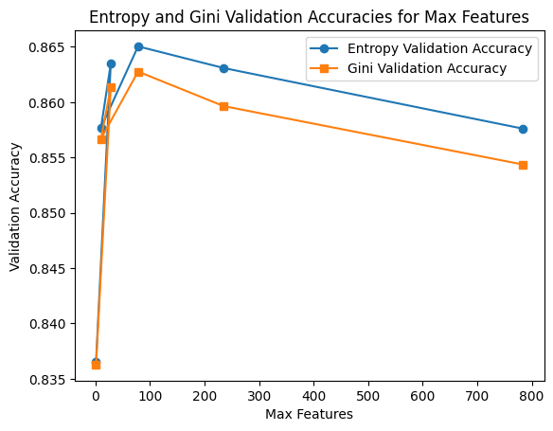
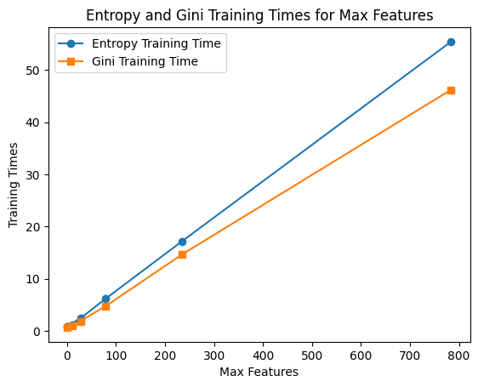
As we can see the initial values of Max Features result with an increase in validation accuracies which diminish as the hyperparameter increase. Also to be noted is that entropy does result in slightly better accuracy at the cost of slightly longer training times.

3b
Using the statistics obtained from 3a’s process I just created the graphics to compare random forest vs extra trees across 5 seeds.
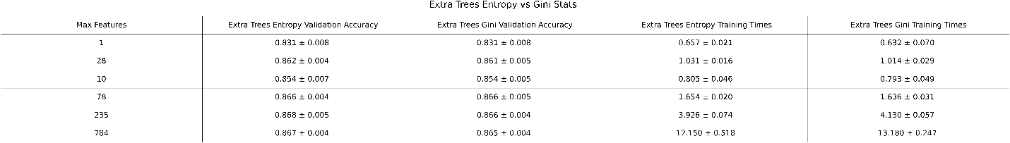

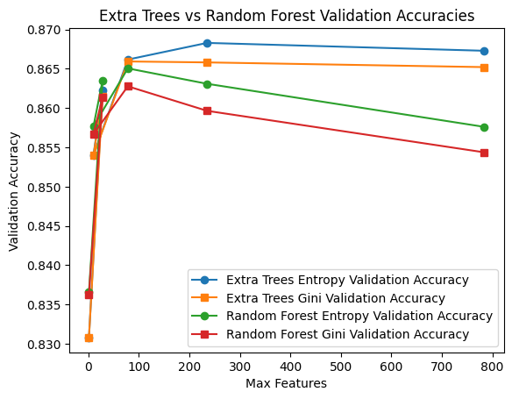
The extra trees seems to perform better
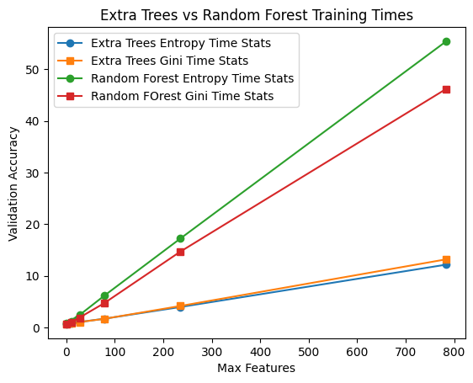
The extra trees performs better across both accuracy and training time, with similar variance if we compare the table in 3b to 3a.

3c
For the classification I used the best model, extratrees, with entropy and max features set to 200. For regression, because there is no previous results I used extratrees and squared error. I then used sklearn’s permutation importance and .feature_importances_ to obtain those, and then I created the plots.
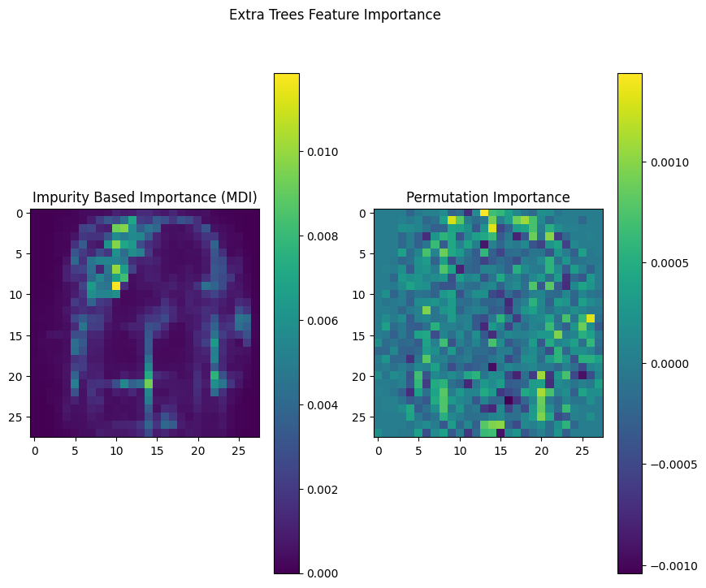
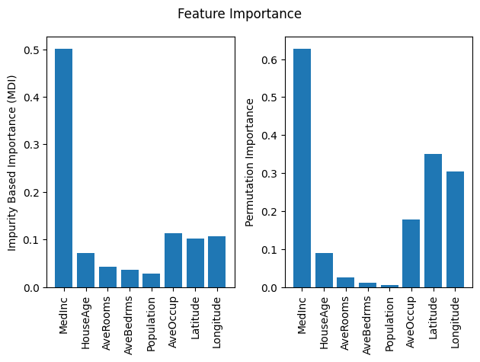
The difference between MDI and Permutation importance is that MDI measures total reduction in impurity for a feature, while the other measures the increase in prediction error when a feature’s values are randomly shuffled. Impurity importance can be biased towards high-cardinality features since they allow more splitting thresholds (more distinct values), which increases the chance of having a large impurity reduction.

Part 4 – Boosting

Part 5 – Combining Classifiers

Part 6 – Final Comparison and Report

