Group 15 – Garrett Gerver, Joe Ferguson, Anas Khairy, Ali El Homayassi, Ameya Saraf, Jason Bellerjeau
Background
Being students in UC’s CEAS program, subleasing an apartment might be the most cost-effective option, especially if you are co-oping out of state. Having a dedicated platform for students who either want to sublease their apartment or are looking to sign a sublease for a semester makes for an easier, more secure way to go about this process.
Goals
- Support up to 1,000 hosting and searching users in finding sublease opportunities for their apartment.
- 100% student authentication by school email.
- AI recommendation algorithm within 90% user approval.
- Fully functional frontend and backend that supports hosting and finding subleases with 10 example listings.
Scope
- What is included? What are you going to do?
  - Full-stack application, React frontend and Flask Backend for both types of users (those finding a place, those hosting a place).
  - Possible DB integration.
  - Possible AI/ML component to help users search for subleases by their requirements.
  - Possible google map or other location integration.
- What is excluded? What are you not going to do?
  - Payment, security implementation, redundancy & network protocols.
  - Testing or quality assurance.
  - Probably not implementing in-application messaging feature (just shows contact information).
Key Stakeholders
Client | University students/Professor Aurek
Sponsor | University of Cincinnati – CEAS
Project manager | Anas Khairy
Project team members | Responsibilities | Anas Khairy -> university email authentication & profile building, assist front-end  Joe Ferguson -> ML model, assist front-end  Ali El Homayassi -> Oversee UX & assist front-end design  Ameya Saraf -> Assist ML with integration & Backend  Jason Bellerjeau -> Assist DB integration & todo  Garrett Gerver -> Backend & DB integration
Risks
Each team member has other classes/obligations--this project is more like a volunteer basis. This means it is possible for a project to get behind if team members aren’t motivated, especially due to tight time constraints.
Since we are working on a POC for most of the semester, we want to operate under as little cost as possible (preferably $0). This means we will have to develop and test with less-than-ideal equipment and servers.
Stakeholder Benefits
Clients/users get rewarded with the application so that they can find and host subleases, instead of relying on networking through Facebook, Snapchat, etc.
Sponsor and team members get rewarded with recognition/prestige. Potential for full-scale implementation, i.e. compensation through hosting ad services or other forms.
Project Milestones
[Identify the significant project milestones: start date, end date and invoicing dates to the client.]
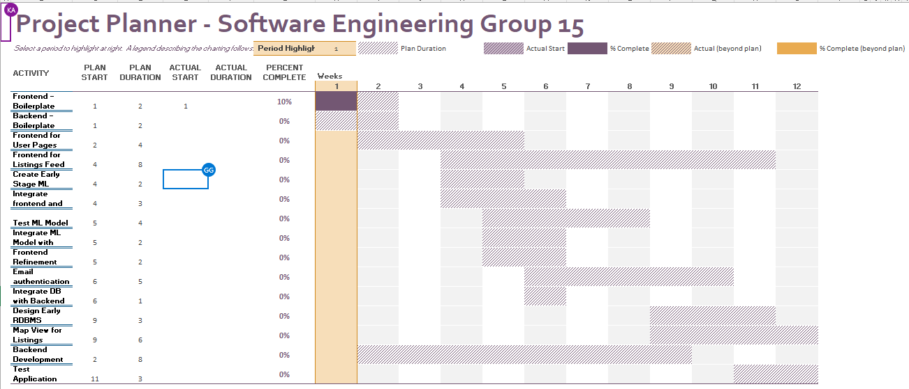
Brief Overview:
- Boilerplate & Initial Design by Week 3
- Frontend and Backend (with DB) developed and integrated by Week 9
- ML model developed and integrated by 6
- Email authentication and profile building integrated by Week 10
- Tested and finalized by Week 12
Project Budget
Development hours (assuming all team members spend 20 hours a month, 120 hours) and hosting costs (preferably self-hosting as POC, so $0). If we need to migrate hosting, we will use AWS free EC2 plan which preserves $0 hosting cost.
Constraints, Assumptions, Risks and Dependencies
Constraints | Project has to be finished on time (April 4th). Project is also bound by size of the team (6 developers) and experience of the developers.
Assumptions | Assuming not many concurrent users (less concerned about throughput, more pure speed).  Assuming we can use RDBMS for data and avoid using persistent graph/vector DB for ML model.
Risks and Dependencies | Need to incorporate Python service into the backend for ML model (preferably gRPC). This adds more complexity to the backend, leading to more opportunities for bugs.  Need to integrate database solution to the backend, which allows for SQL injections and other networking errors.  Using React with Vite for frontend, which means the team needs to be comfortable using these technologies.

Approval Signatures
For Professor to Sign |  | To be Signed by UC? |  | Anas Khairy
[Name], Project Client |  | [Name], Project Sponsor |  | [Name], Project Manager

