Requirements Document – Group 15
  - Joe Ferguson, Garrett Gerver, Anas Khairy, Ali El Homayssi, Jason Bellerjeau, Ameya Saraf

Functional Requirements – Ranked by Priority
- Users can create and publish a sublease for others to see.
- Users can browse and search for available sublease listings.
- Users can create a profile and select their preferred sublease details.
- Users can send and receive messages with each other on the app about sublease details.
- Users can submit reviews for other users after both parties confirm the sublease has ended.
- Users can sign up or login to access the website.
- Users must authenticate their university email to use the website.

Non-Functional Requirements – Ranked by Priority
- The website shall provide an interface which allows new users to navigate the pages without external help.
- The website shall protect user data through authentication and authorization mechanisms.
- The website shall display available listings within seconds of users opening the web application.
- The website shall allow users to disable location sharing for their listings.
- The website shall recommend listings to users based on their preferences and interaction history.
- The website shall function correctly across major web browsers such as Chrome, Firefox, and Edge.

Context Diagram
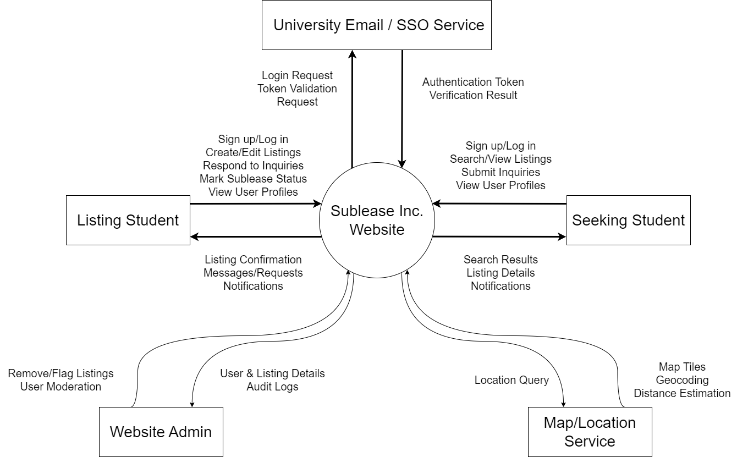

Scenarios and Use Case diagrams (Minimum 3 of each)
- Scenario 1:
Initial: A student at a university wants a way to help their friend find a sublease for their apartment. He has plenty of time to find one, but the friend is picky and only wants an individual that is similar to them and is trusted. This is because their previous experience with subleasing was bad as the last sublease was unclean and did not pay the last month’s rent.
Normal: The student goes to SubleaseInc., creates a validated account with their university email address. They are then able to create a listing for their friend’s apartment. After a few weeks, they see a few requests from people looking to stay at their apartment. The student is able to see the reviews for each individual, and he is able to message one of the individuals whose reviews said he cleans up after himself and pays rent on time. From that point they are able to message each other and setup the sublease agreement.
What could go wrong: Some users might leave inaccurate or biased reviews of others, which could lead to misrepresentation of the qualities of the other users they can see on the website.
Other activities: Other users will concurrently be creating profiles, viewing or hosting listings and communicating with other users. Users may look and communicate about several listings at a time to search for a suitable apartment.
System state of completion: The users communicate with each other in the web application. Afterwards they will gather each other’s preferred method of contact and then complete a lease agreement either via an apartment company’s website or a mutual pact. Sublease inc. does not facilitate the lease agreement so the state ends with each other “confirming” the match on the web application and reviewing the other person’s profile.

- Scenario 2:
Initial: A student got a co-op out of state for the next semester. Because of the location, the student isn’t able to live on campus for that next semester and doesn’t have a lot of time to sublease their apartment. The student needs an easy and stress-free way to handle their situation.
Normal: The student goes to the “SubleaseInc.” website, quickly creates a validated account with their school email address, and in a matter of minutes is able to create a listing using the “Create Listing” feature. This posts a listing for their apartment for the designated semester, showcasing the apartment’s location and any pictures of the apartment. Then, other students using the website can browse sublease options, find our student’s listing, and send a message to our student asking for more information. From there, our student can check their inbox for offers from other students.
What could go wrong: The student creating the listing is not guaranteed to get offers on their apartment, especially if the personalized algorithm to show users available listings doesn’t think others will like the apartment. This may create a struggle for users to try and use SEO techniques to prioritize their apartment over others in the algorithm. This creates an edge for students with more SEO experience, which seems unfair and inauthentic.
Other Activities: Other users will concurrently be creating profiles, viewing or hosting listings and communicating with other users. Users may look and communicate about several listings at a time to search for a suitable apartment.
System State of Completion: The users communicate with each other in the web application. Afterwards they will gather each other’s preferred method of contact and then complete a lease agreement either via an apartment company’s website or a mutual pact. Sublease inc. does not facilitate the lease agreement so the state ends with each other “confirming” the match on the web application and reviewing the other person’s profile.
- Scenario 3:
Initial: A student is interning in Cincinnati for the semester and needs to find a sublease in a short timeframe. The sublease has several specific requirements, like location, number of roommates, and affordability, that must be met.
Normal: The student goes to the “SubleaseInc.” website, quickly creates a validated account with their school email address, and in a matter of minutes is able to find several listings for apartments near their university. The user can also add more requirements for apartments to their profile and the algorithm will find them places better suited for them. Then, when the student finds an apartment they like, they can message the “hosting” individual and request more information.
What could go wrong: The student may put in certain requirements that no listings fit the description of, therefore recommending them listings they may not like. The “hosting” individual may not accept their request.
Other Activities: Other users will concurrently be creating profiles, viewing or hosting listings and communicating with other users. Users may look and communicate about several listings at a time to search for a suitable apartment.
System State of Completion: The users communicate with each other in the web application. Afterwards they will gather each other’s preferred method of contact and then complete a lease agreement either via an apartment company’s website or a mutual pact. Sublease inc. does not facilitate the lease agreement so the state ends with each other “confirming” the match on the web application and reviewing the other person’s profile.

- Use Case Diagram 1:
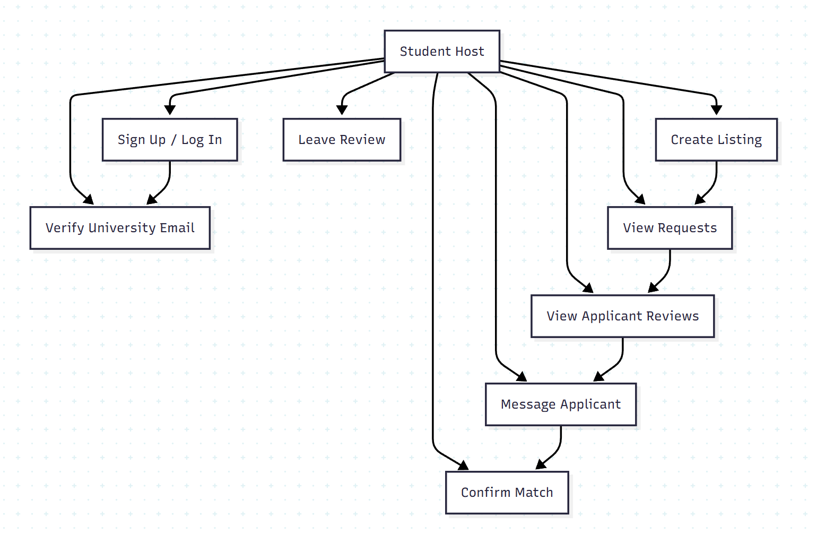
- Use Case Diagram 2:
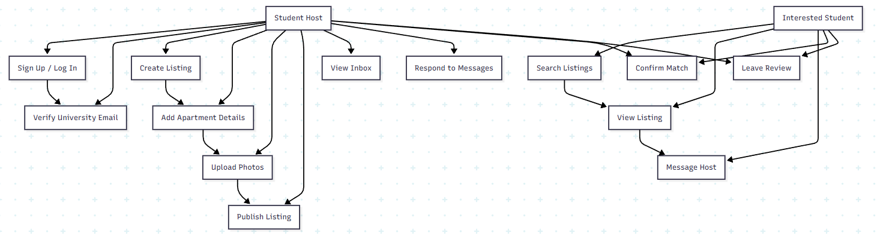
- Use Case Diagram 3:
