1. Write a Java program to copy a file from HDFS to LFS.

PROGRAM:

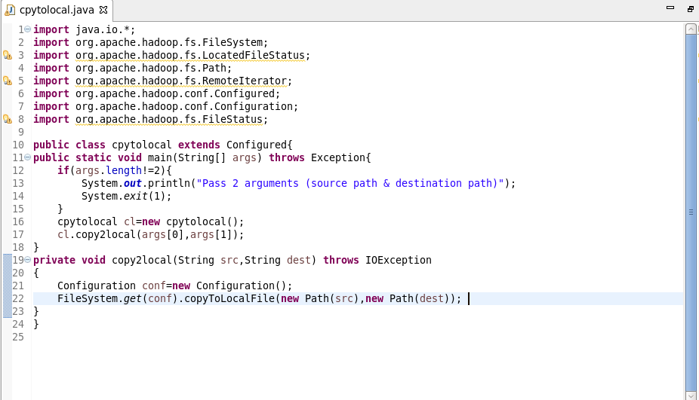

OUTPUT:

