# CS 255 System Design Document Template

Joseph A Manzano

CS-255-T3292

February 25, 2023

## UML Diagrams

### UML Use Case DiagramScreenshot 2023-02-25 at 11.28.22 PM.png

### UML Activity DiagramsScreenshot 2023-02-25 at 9.45.41 PM.png

### DriverPass Use Case Activity Diagram: Schedule Driving Instructor Lesson

### *Screenshot 2023-02-25 at 9.54.30 PM.png*

### UMLUseCaseSequenceDiagram.pdf

### UML Sequence Diagram

### UML Class Diagram

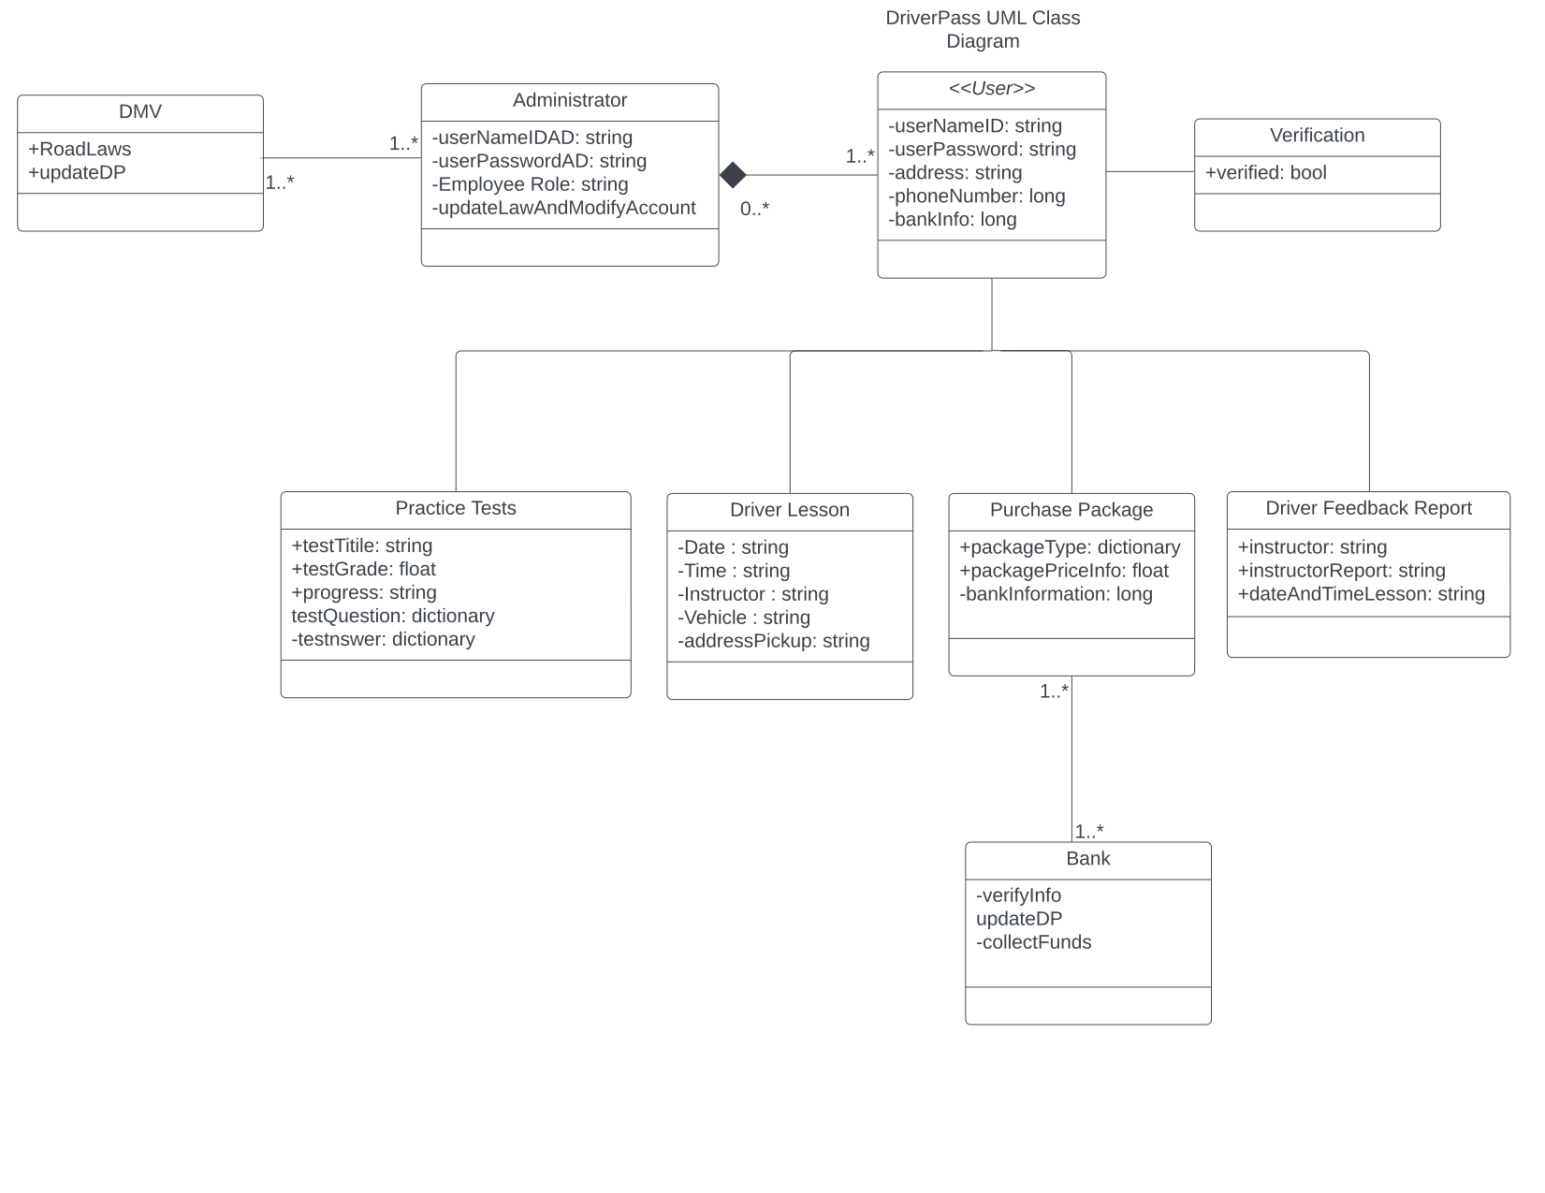

## Technical Requirements

For the driver pass system to be of use, a user will need a device with access to the Internet, and can run a web browser. All information, such as account profile, practice test score, and Account information will be stored using a cloud-based hosting system. I will be no download requirement necessary, so a user will have their information saved in the cloud. A user will also need their device to have a form of input to enter their information when logging in or making a purchase. The form of payment will also be required to purchase a package within the system. User name and password will be created, and will need to be inputted by the user every time to login.