Report

David Keyes

10/7/2019

# Introduction

This report looks at schools in five Western states (California, Oregon, Washington, Montana, and Idaho). By looking at the enrollment of schools in these states, we can get a sense of how large or small these schools are.

# Methods

We downloaded data from the Urban Institute Education Data portal. In total, there were 15716 schools in the five states which we are focusing on.

| **State** | **Number of Schools** |
| --- | --- |
| California | 10406 |
| Washington | 2464 |
| Oregon | 1259 |
| Montana | 830 |
| Idaho | 757 |

# Findings

The states examined have a wide range of enrollment. As the graph below indicates, California has the highest absolute number of schools. California also has the largest individual schools, with some up having nearly 6000 students. In contrast, sMontana has the highest concentration of small schools.

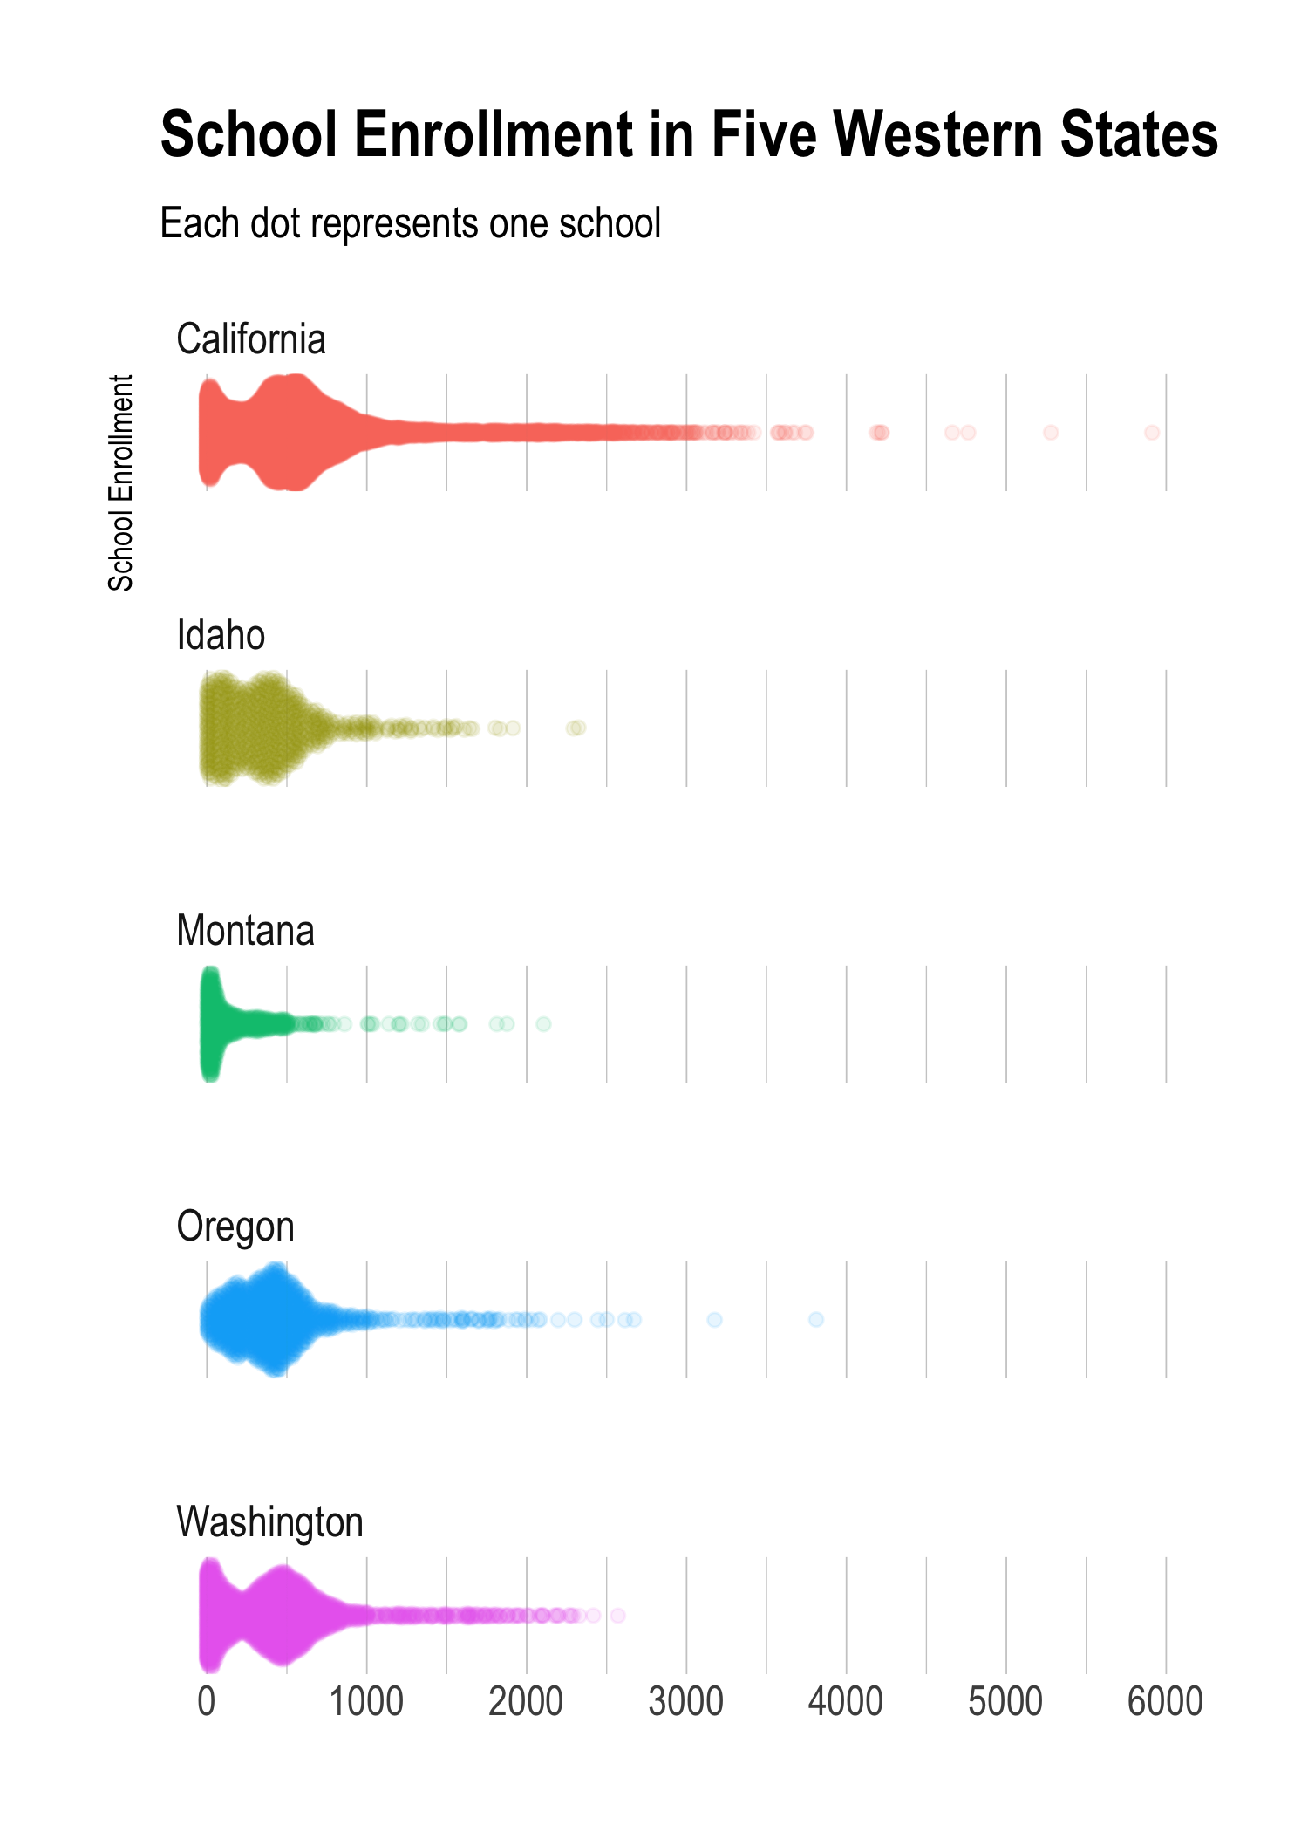

# Conclusion

Schools in the Western United States have a wide range of enrollment.

California, being the largest state by poulation, has the most schools by far. California also has a higher number of larger schools than Idaho, Montana, Oregon, or Washington.

In contrast to California, Montana has a high percentage of very small schools, likely reflecting the rural nature of much of the state.