Joseph Brooksbank, A2
A) E/R Diagram:
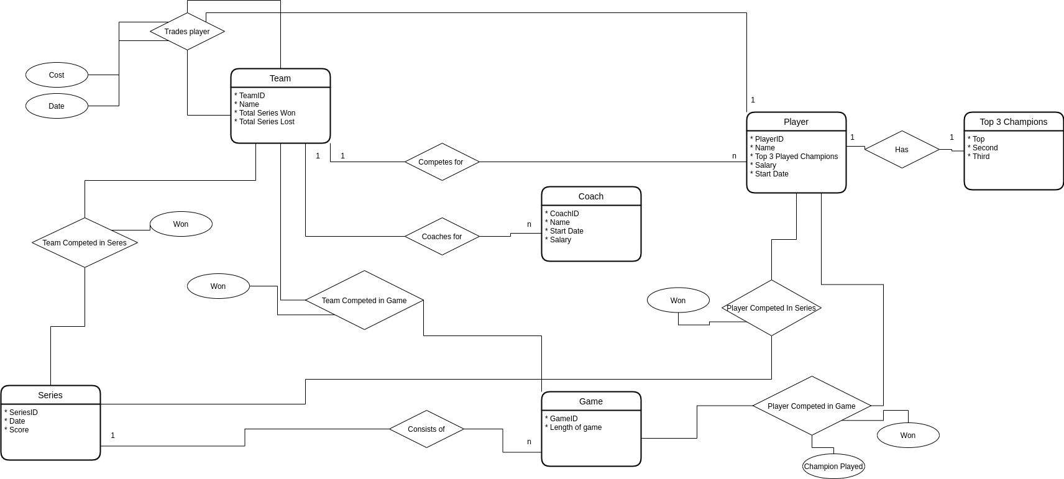
Relational Model:
- Team(TeamID, Name, Total Series Won, Total Series Lost)
- Player(PlayerID,Name, Salary, Start Date, TeamID)
- Top3Champions(PlayerID, Top, Second, Third)
- Coach(CoachID, Name, Start Date, Salary, TeamID)
- Game(GameID,Length, SeriesID)
- Series (SeriesID,Date,Score)
- TradesPlayer(Team1.TeamID, Team2.TeamID, PlayerID, Cost, Date)
- TeamCompetedInSeries(TeamID,SeriesID, Won)
- TeamCompetedInGame(TeamID, GameID, Won)
- PlayerCompetedInSeries(TeamID, SeriesID, Won)
- PlayerCompetedInGame(TeamID, GameID, Champion Played, Won)

B: Schema File:
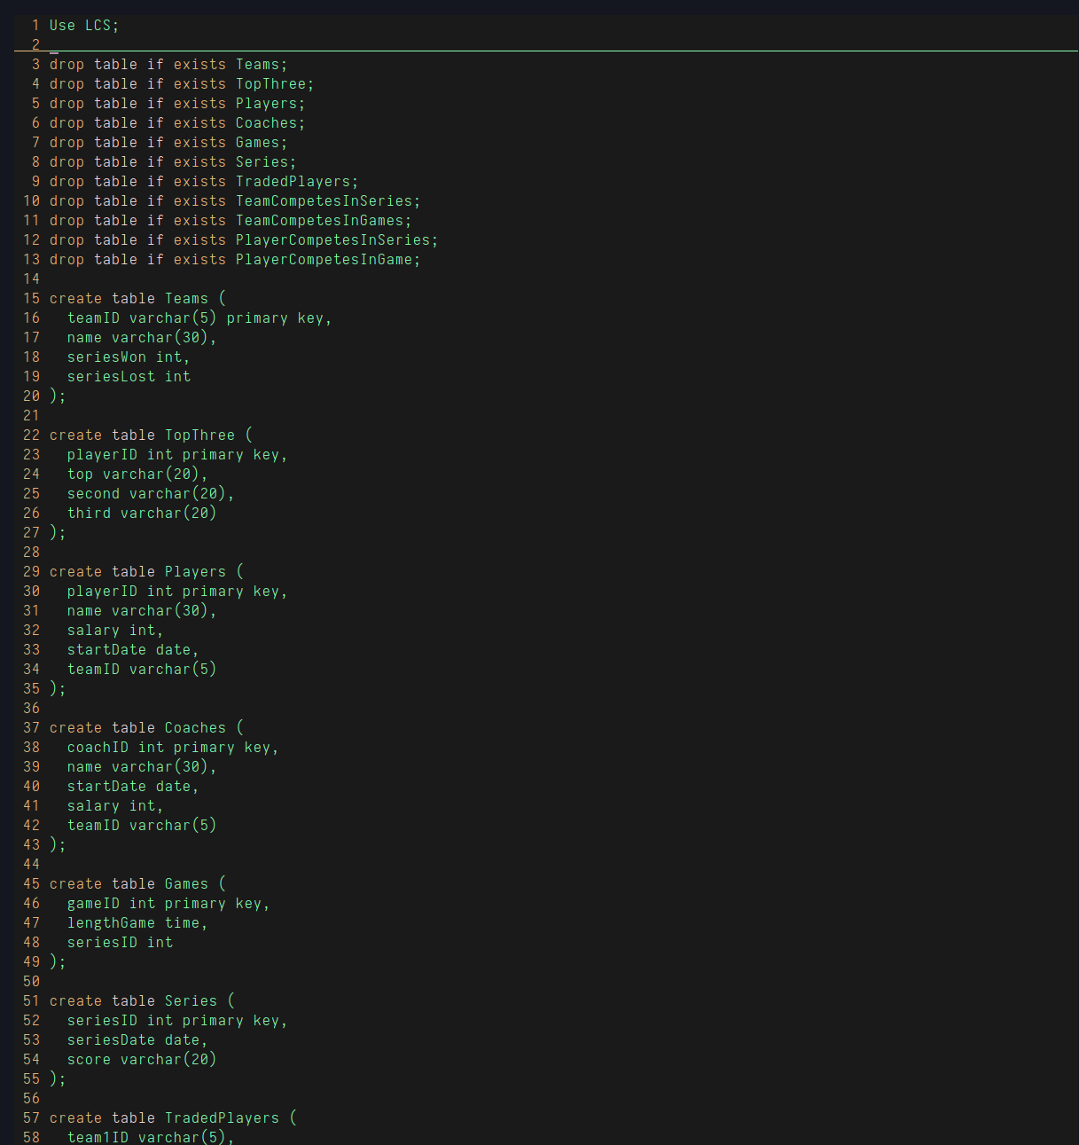
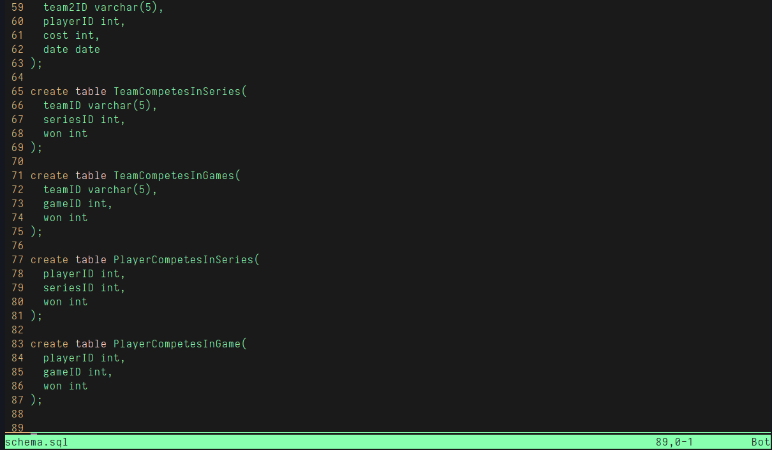
MySQL Output:

Script started on 2021-01-25 21:14:39-07:00 [TERM="xterm-256color" TTY="/dev/pts/2" COLUMNS="80" LINES="24"]
#]0;jbrooksbank@ubuntuDesk: ~/databases##[01;32mjbrooksbank@ubuntuDesk#[00m:#[01;34m~/databases#[00m$ sudo mysql
[sudo] password for jbrooksbank:
Welcome to the MySQL monitor. Commands end with ; or \g.
Your MySQL connection id is 11
Server version: 8.0.22-0ubuntu0.20.04.3 (Ubuntu)

Copyright (c) 2000, 2020, Oracle and/or its affiliates. All rights reserved.

Oracle is a registered trademark of Oracle Corporation and/or its
affiliates. Other names may be trademarks of their respective
owners.

Type 'help;' or '\h' for help. Type '\c' to clear the current input statement.

mysql> source schje #[19G#[K #[18G#[Kema.sql
Reading table information for completion of table and column names
You can turn off this feature to get a quicker startup with -A

Database changed
Query OK, 0 rows affected (0.00 sec)

Query OK, 0 rows affected (0.02 sec)

Query OK, 0 rows affected (0.00 sec)

. . .

Query OK, 0 rows affected (0.02 sec)

mysql> show tables;
+------------------------+
| Tables_in_LCS |
+------------------------+
| Coaches |
| Games |
| PlayerCompetesInGame |
| PlayerCompetesInSeries |
| Players |
| Series |
| TeamCompetesInGames |
| TeamCompetesInSeries |
| Teams |
| TopThree |
| TradedPlayers |
+------------------------+
11 rows in set (0.00 sec)
mysql> describe *;
ERROR 1064 (42000): You have an error in your SQL syntax; check the manual that corresponds to your MySQL server version for the right syntax to use near '*' at line 1
mysql> worth a try
mysql> describe Coaches;
+-----------+-------------+------+-----+---------+-------+
| Field | Type | Null | Key | Default | Extra |
+-----------+-------------+------+-----+---------+-------+
| coachID | int | NO | PRI | NULL | |
| name | varchar(30) | YES | | NULL | |
| startDate | date | YES | | NULL | |
| salary | int | YES | | NULL | |
| teamID | varchar(5) | YES | | NULL | |
+-----------+-------------+------+-----+---------+-------+
5 rows in set (0.01 sec)
mysql> describe Games;
+------------+------+------+-----+---------+-------+
| Field | Type | Null | Key | Default | Extra |
+------------+------+------+-----+---------+-------+
| gameID | int | NO | PRI | NULL | |
| lengthGame | time | YES | | NULL | |
| seriesID | int | YES | | NULL | |
+------------+------+------+-----+---------+-------+
3 rows in set (0.00 sec)
mysql> describe PlayerCompetesInGame;
+----------+------+------+-----+---------+-------+
| Field | Type | Null | Key | Default | Extra |
+----------+------+------+-----+---------+-------+
| playerID | int | YES | | NULL | |
| gameID | int | YES | | NULL | |
| won | int | YES | | NULL | |
+----------+------+------+-----+---------+-------+
3 rows in set (0.00 sec)
mysql> describe PlayerCompetesInSeries;
+----------+------+------+-----+---------+-------+
| Field | Type | Null | Key | Default | Extra |
+----------+------+------+-----+---------+-------+
| playerID | int | YES | | NULL | |
| seriesID | int | YES | | NULL | |
| won | int | YES | | NULL | |
+----------+------+------+-----+---------+-------+
3 rows in set (0.01 sec)
mysql> describe Players;
+-----------+-------------+------+-----+---------+-------+
| Field | Type | Null | Key | Default | Extra |
+-----------+-------------+------+-----+---------+-------+
| playerID | int | NO | PRI | NULL | |
| name | varchar(30) | YES | | NULL | |
| salary | int | YES | | NULL | |
| startDate | date | YES | | NULL | |
| teamID | varchar(5) | YES | | NULL | |
+-----------+-------------+------+-----+---------+-------+
5 rows in set (0.00 sec)
mysql> describe Series;
+------------+-------------+------+-----+---------+-------+
| Field | Type | Null | Key | Default | Extra |
+------------+-------------+------+-----+---------+-------+
| seriesID | int | NO | PRI | NULL | |
| seriesDate | date | YES | | NULL | |
| score | varchar(20) | YES | | NULL | |
+------------+-------------+------+-----+---------+-------+
3 rows in set (0.00 sec)
mysql> describe TeamCompetesInGames;
+--------+------------+------+-----+---------+-------+
| Field | Type | Null | Key | Default | Extra |
+--------+------------+------+-----+---------+-------+
| teamID | varchar(5) | YES | | NULL | |
| gameID | int | YES | | NULL | |
| won | int | YES | | NULL | |
+--------+------------+------+-----+---------+-------+
3 rows in set (0.00 sec)
mysql> describe TeamCompetesInSeries;
+----------+------------+------+-----+---------+-------+
| Field | Type | Null | Key | Default | Extra |
+----------+------------+------+-----+---------+-------+
| teamID | varchar(5) | YES | | NULL | |
| seriesID | int | YES | | NULL | |
| won | int | YES | | NULL | |
+----------+------------+------+-----+---------+-------+
3 rows in set (0.00 sec)
mysql> describe Teams;
+------------+-------------+------+-----+---------+-------+
| Field | Type | Null | Key | Default | Extra |
+------------+-------------+------+-----+---------+-------+
| teamID | varchar(5) | NO | PRI | NULL | |
| name | varchar(30) | YES | | NULL | |
| seriesWon | int | YES | | NULL | |
| seriesLost | int | YES | | NULL | |
+------------+-------------+------+-----+---------+-------+
4 rows in set (0.01 sec)
mysql> describe TopThree;
+----------+-------------+------+-----+---------+-------+
| Field | Type | Null | Key | Default | Extra |
+----------+-------------+------+-----+---------+-------+
| playerID | int | NO | PRI | NULL | |
| top | varchar(20) | YES | | NULL | |
| second | varchar(20) | YES | | NULL | |
| third | varchar(20) | YES | | NULL | |
+----------+-------------+------+-----+---------+-------+
4 rows in set (0.01 sec)
mysql> describe TradedPlayers;
+----------+------------+------+-----+---------+-------+
| Field | Type | Null | Key | Default | Extra |
+----------+------------+------+-----+---------+-------+
| team1ID | varchar(5) | YES | | NULL | |
| team2ID | varchar(5) | YES | | NULL | |
| playerID | int | YES | | NULL | |
| cost | int | YES | | NULL | |
| date | date | YES | | NULL | |
+----------+------------+------+-----+---------+-------+
5 rows in set (0.00 sec)
mysql> insert into Players VALUES("1", "Doublelift", 120000, DATE '2020-05-01', "TSM");
Query OK, 1 row affected (0.01 sec)
mysql> insert into Players VALUES("2", "Meteos", 120000, DATE '2020-07-02', "100T");
Query OK, 1 row affected (0.01 sec)
mysql> insert into Players VALUES("3", "Pobelter", 120000, DATE '2020-11-23', "CLG");
Query OK, 1 row affected (0.01 sec)
mysql> SELECT * FROM Players;
+----------+------------+--------+------------+--------+
| playerID | name | salary | startDate | teamID |
+----------+------------+--------+------------+--------+
| 1 | Doublelift | 120000 | 2020-05-01 | TSM |
| 2 | Meteos | 120000 | 2020-07-02 | 100T |
| 3 | Pobelter | 120000 | 2020-11-23 | CLG |
+----------+------------+--------+------------+--------+
3 rows in set (0.00 sec)

mysql> exit
Bye
#]0;jbrooksbank@ubuntuDesk: ~/databases##[01;32mjbrooksbank@ubuntuDesk#[00m:#[01;34m~/databases#[00m$ exit
exit

Script done on 2021-01-25 21:28:06-07:00 [COMMAND_EXIT_CODE="0"]

