**Before start.**

It is important to keep always the same folder structure. For each sample, we should have 3 main folders as follows:

* images
* fibers
* segmentation

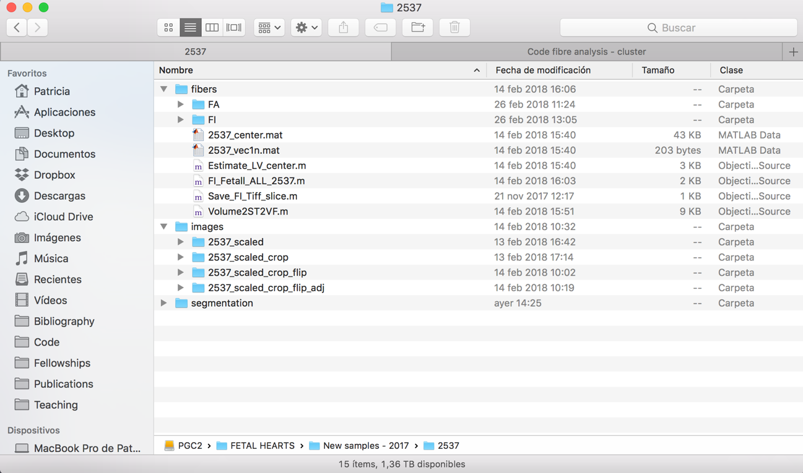

In “image “subfolder we will keep always all the previous step. We should first do the scaling (0.5 factor), then the circular crop, then flip the images in Z to have first the most apical image, and last to adjust the contrast (useful for *Ilastik* segmentation). We have to calculate the fibre orientation in the flipped but NON-adjusted dataset (example: 2537_scaled_crop_flip).

**Defining LV long axis**

First, you need to define two points to calculate the long axis of the LV. To do that, open the flipped image dataset in Fiji (flipped means that the first image is the most apical one). Do not select Virtual Stack.

Then, once the image volume is opened, select the orthogonal view: Image > Stacks > Orthogonal Views.

* Select the most **apical point in the centre of LV**. Keep the x, y, z coordinates of this point. Sometimes, like in this example, it is a bit tricky to identify this point, even more when the heart is abnormal (sometimes the LV looks the RV and viceversa).

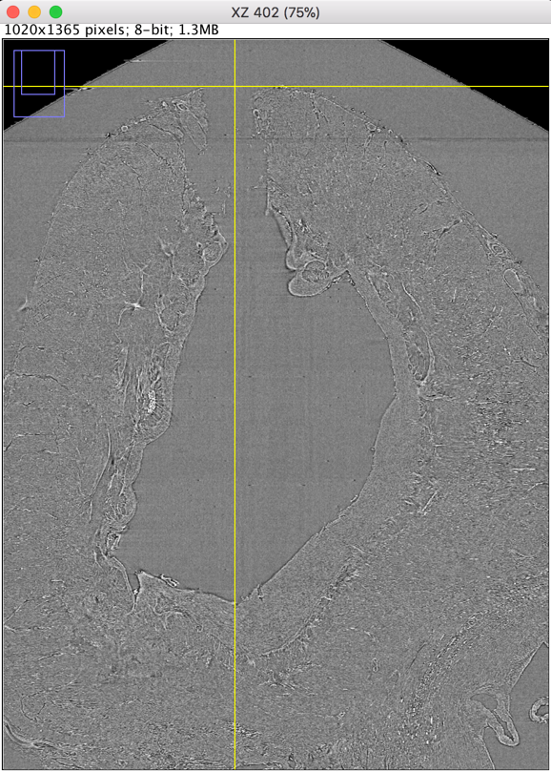

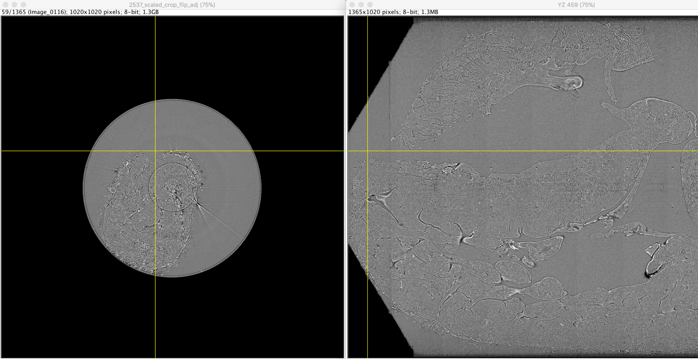

* Select a point in the centre of the **mitral valve**. Keep the x, y, z coordinates of this point.

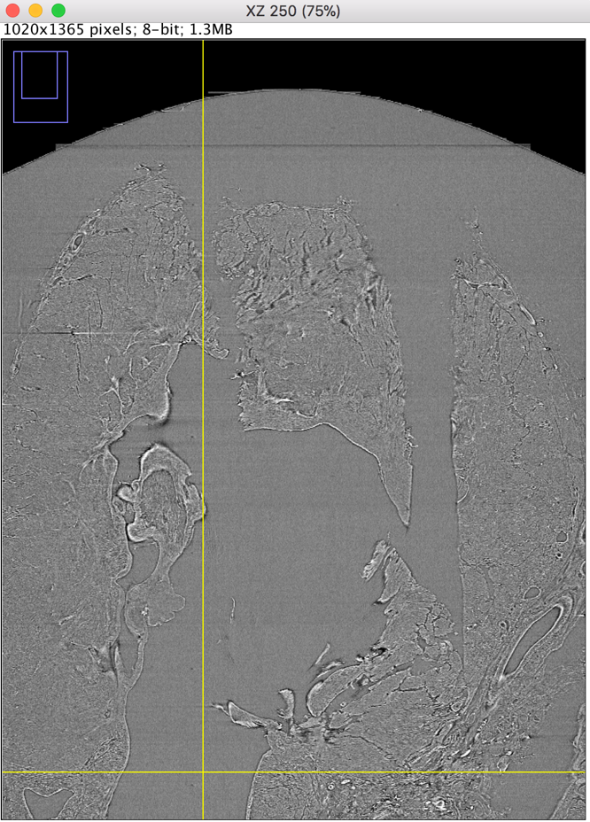

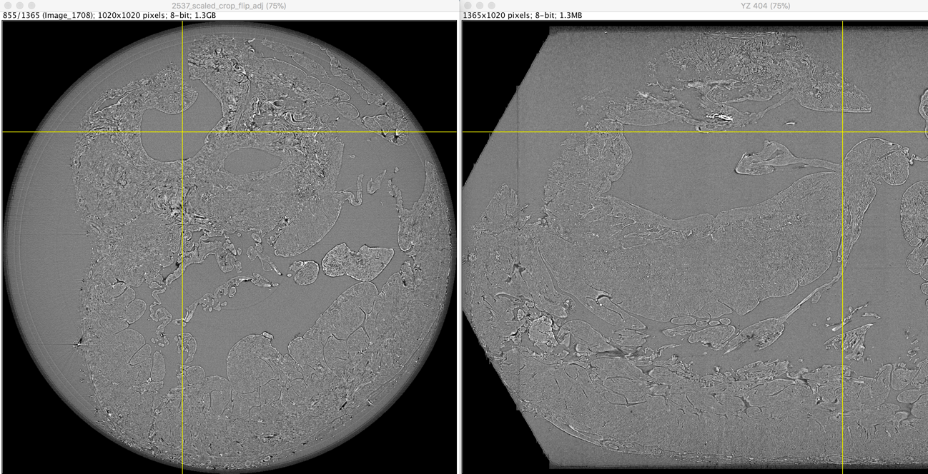

Once you have the coordinates of these 2 points, execute the Matlab script “*Estimate_LV_longaxis.m*”. This script calculates the LV long axis and its normalised vector, necessary to compute the fibre orientation. It will generate two .*mat* files saved in ../fibers/ directory.

**Calculating fibre orientation**

Open the Matlab script *MAIN_FibreOrientationCalculation.m*

Change all the input variables accordingly (bool_flip, bool_correct, paths, etc…) and execute to compute the fibre orientation. This script call to the function *Volume2ST2VF.m* which is the one that compute everything. See the header for all the information about input and outout parameters.