**Lab 1 - SIMON encryption/decryption**

Group 4:

Joseph Burke  
Idan G. Kanter  
Seth Rausch

ECE 459 - Secure & Trustworthy Computer Hardware Design

Spring 2017

Dr. Garrett S. Rose

January 28 2017

Instructor Signature: ________________

**Abstract/Introduction**

The field of security in software and hardware was always an important subject. A few encryption algorithms were introduced including the older Data Encryption Standard (DES), and the newer Advanced Encryption Standard (AES). AES is considered to be a very strong non-Feistel encryption algorithm; however, it is also considered heavyweight; AES requires heavy usage of the system resources as memory, area, and power. Due to the rising need of a more lightweight encryption algorithm for FPGAs, ASICs, Internet of Things (IOT), embedded systems, and more, a team at the National Security Agency (NSA) introduced the SIMON block cipher algorithm which is optimized for hardware. SIMON is a Feistel encryption algorithm that uses less system resources than the AES, which makes it suitable for small systems that were introduced above.

The purpose of the lab is to learn how SIMON works and to implement some of its functions. After reading two papers about the implementation of SIMON, the round and the key expansion function are implemented. After the algorithm is completed, some test benches are run to simulate the encryption. Next, the program is synthesized, implemented, and is generated to a bit file for testing on a Nexys-4 FPGA board. Finally, the implementation is programmed to the board and the program encrypts two image files. In addition, the FPGA is used to test the decryption of the images since SIMON is a Feistel algorithm. During the whole process, interesting features, observations, and shortcomings of SIMON are recorded.

**Results**

**Observations**

**Appendix**

**ROUND_CIPHER.vhd**

library IEEE;

use IEEE.STD_LOGIC_1164.ALL;

use IEEE.NUMERIC_STD.all;

use IEEE.STD_LOGIC_ARITH.all;

use IEEE.STD_LOGIC_UNSIGNED.all;

entity round_cipher is

port (

blockcipher : in std_logic_vector(31 downto 0);

key_word : in std_logic_vector(15 downto 0);

cipher_text : out std_logic_vector(31 downto 0)

);

end round_cipher;

architecture your_code of round_cipher is

component shift_left1 is

port (

input1 : in std_logic_vector(15 downto 0);

output : out std_logic_vector(15 downto 0)

);

end component shift_left1;

component shift_left2 is

port (

input1 : in std_logic_vector(15 downto 0);

output : out std_logic_vector(15 downto 0)

);

end component shift_left2;

component shift_left8 is

port (

input1 : in std_logic_vector(15 downto 0);

output : out std_logic_vector(15 downto 0)

);

end component shift_left8;

component xor16bit is

port (

input1 : in std_logic_vector(15 downto 0);

input2 : in std_logic_vector(15 downto 0);

output : out std_logic_vector(15 downto 0)

);

end component xor16bit;

component and16bit is

port (

A : in std_logic_vector(15 downto 0);

B : in std_logic_vector(15 downto 0);

Y : out std_logic_vector(15 downto 0)

);

end component and16bit;

component ctext_reg is

port (

clk : in std_logic;

reset : in std_logic;

round : in std_logic_vector(7 downto 0);

input1_16bits : in std_logic_vector(15 downto 0);

input2_16bits : in std_logic_vector(15 downto 0);

flop32 : out std_logic_vector(31 downto 0);

text_flag : out std_logic

);

end component ctext_reg;

-- Will need to declare intermediary signals

signal left_shift_1_block : std_logic_vector (15 downto 0); -- upper block after left shift by 1 bit

signal left_shift_2_block : std_logic_vector (15 downto 0); -- upper block after left shift by 2 bit

signal left_shift_8_block : std_logic_vector (15 downto 0); -- upper block after left shift by 8 bit

signal and_1_8_blocks : std_logic_vector (15 downto 0); -- AND of the 1 and 8 left shifts

signal and_XOR_lower : std_logic_vector (15 downto 0); -- XOR of and result with lower_block

signal sl2_XOR_xor1 : std_logic_vector (15 downto 0); -- XOR of the left shift by 2 block with the upper xor

signal lower_block : std_logic_vector (15 downto 0); -- lower block of blockcipher

signal upper_block : std_logic_vector (15 downto 0); -- upper block of blockcipher

signal xor2_XOR_key : std_logic_vector (15 downto 0); -- xor of middle xor and the key

begin

sl1 : shift_left1 port map (blockcipher(31 downto 16), left_shift_1_block); -- upper block shift left by 1

sl8 : shift_left8 port map (blockcipher(31 downto 16), left_shift_8_block); -- upprr block shift left by 8

and_1_8 : and16bit port map (left_shift_1_block, left_shift_8_block, and_1_8_blocks); -- AND the 1-bit left shift and the 8-bit left shift blocks

sl2 : shift_left2 port map (blockcipher(31 downto 16), left_shift_2_block); -- upper block shift left by 2

xor1 : xor16bit port map (and_1_8_blocks, blockcipher(15 downto 0), and_XOR_lower); -- XOR the result of the AND operation with the lower block of the blockcipher

xor2 : xor16bit port map (left_shift_2_block, and_XOR_lower, sl2_XOR_xor1); -- XOR the result of upper xor with the 2-bit left shift block

xor3 : xor16bit port map (sl2_XOR_xor1, key_word, xor2_XOR_key); -- XOR the result of middle xor with the key

lower_block <= blockcipher(31 downto 16); -- new lower block is the upper block

upper_block <= xor2_XOR_key; -- new upper block is the result of bottom xor

cipher_text <= upper_block & lower_block; -- attach the two blocks together to form the cipher text - output

end your_code;

**KEY_EXPANSION.vhd**

library IEEE;

use IEEE.STD_LOGIC_1164.ALL;

use IEEE.std_logic_signed.all;

entity key_expansion is

port (

round : IN std_logic_vector(7 downto 0);

sel : IN std_logic;

key_word : IN std_logic_vector(63 downto 0);

clk : IN std_logic;

reset : IN std_logic;

key_expansion : OUT std_logic_vector(15 downto 0)

);

end key_expansion;

architecture your_code of key_expansion is

component reg16 is

port (

clk : in std_logic;

reset : in std_logic;

input_16bits : in std_logic_vector(15 downto 0);

flop16 : out std_logic_vector(15 downto 0)

);

end component reg16;

component mux2to1 is

port (

SEL : in std_logic;

A : in std_logic_vector (15 downto 0);

B : in std_logic_vector (15 downto 0);

X : out std_logic_vector (15 downto 0)

);

end component mux2to1;

component shift_right1 is

port (

input1 : in std_logic_vector(15 downto 0);

output : out std_logic_vector(15 downto 0)

);

end component shift_right1;

component shift_right3 is

port (

input1 : in std_logic_vector(15 downto 0);

output : out std_logic_vector(15 downto 0)

);

end component shift_right3;

component xor16bit is

port (

input1 : in std_logic_vector(15 downto 0);

input2 : in std_logic_vector(15 downto 0);

output : out std_logic_vector(15 downto 0)

);

end component xor16bit;

component u_bit is

port (

round : in std_logic_vector(7 downto 0);

u_out : out std_logic_vector(15 downto 0);

u_int : out std_logic_vector(15 downto 0)

);

end component u_bit;

component xor16bit_triple is

port (

input1 : in std_logic_vector(15 downto 0);

input2 : in std_logic_vector(15 downto 0);

input3 : in std_logic_vector(15 downto 0);

input4 : in std_logic_vector(15 downto 0);

output : out std_logic_vector(15 downto 0)

);

end component xor16bit_triple;

-- Will need to declare intermediary signals here

signal uout0 : std_logic_vector(15 downto 0); -- 'C'

signal uout1 : std_logic_vector(15 downto 0); -- 'Z'

signal XOR4_out : std_logic_vector(15 downto 0); -- output of XOR 'C', 'Z', key0, XOR2_out - "bambam"

signal mux1_out : std_logic_vector(15 downto 0); -- output of left mux1

signal mux2_out : std_logic_vector(15 downto 0); -- output of 2nd from the left mux2

signal mux3_out : std_logic_vector(15 downto 0); -- output of 3rd from the left mux3

signal mux4_out : std_logic_vector(15 downto 0); -- output of right mux4

signal key3 : std_logic_vector(15 downto 0); -- output of register key3

signal key2 : std_logic_vector(15 downto 0); -- output of register key2

signal key1 : std_logic_vector(15 downto 0); -- output of register key1

signal key0 : std_logic_vector(15 downto 0); -- output of register key0 - "fred"

signal sr3_out : std_logic_vector(15 downto 0); -- output of the shift_rt3

signal key1_XOR_sr3 : std_logic_vector(15 downto 0); -- output of xor01, input are key1 and sr3

signal sr1_out : std_logic_vector(15 downto 0); -- output of the shift_rt1

signal xor2_out : std_logic_vector(15 downto 0); -- output of xor2_out - "Wilma"

begin

u_find : u_bit port map (round, uout0, uout1); -- round -> 'C' and 'Z'

xor4 : xor16bit_triple port map (uout0, uout1, key0, xor2_out, XOR4_out); -- xor 4 inputs -> input of mux1

mux1 : mux2to1 port map (sel, key_word(63 downto 48), XOR4_out, mux1_out); -- mux xor4_output and key -> key3

key3_reg : reg16 port map (clk, reset, mux1_out, key3); -- register 3

mux2 : mux2to1 port map (sel, key_word(47 downto 32), key3, mux2_out); -- mux key3 and key -> key2

key2_reg : reg16 port map (clk, reset, mux2_out, key2); -- register 2

sr3 : shift_right3 port map (key3, sr3_out); -- key3 shift right by 3 bits

mux3 : mux2to1 port map (sel, key_word(31 downto 16), key2, mux3_out); -- mux key2 and key -> key1

key1_reg : reg16 port map (clk, reset, mux3_out, key1); -- register 1

mux4 : mux2to1 port map (sel, key_word(15 downto 0), key1, mux4_out); -- mux key1 and key -> key0

key0_reg : reg16 port map (clk, reset, mux4_out, key0); -- register 0

xor1 : xor16bit port map (key1, sr3_out, key1_XOR_sr3); -- xor key1 and shift_rt3

sr1 : shift_right1 port map (key1_XOR_sr3, sr1_out); -- xor01 shift right by 1 bit

xor2 : xor16bit port map (sr1_out, key1_XOR_sr3, xor2_out); -- xor shift_rt1 and xor01

key_expansion <= key0; -- output

end your_code;

**encrypt_tb.vhd – Simulation Output Snapshot**

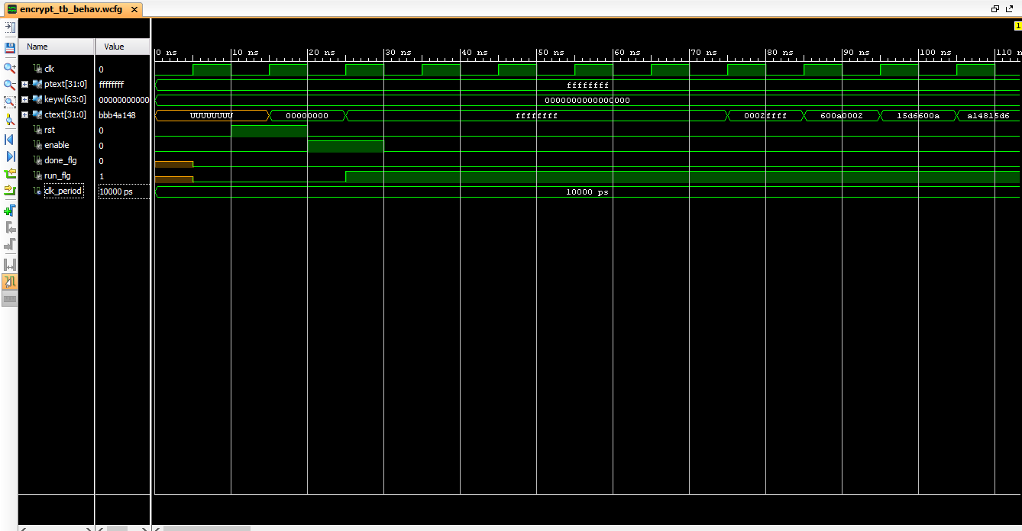 10 ns – 110 ns

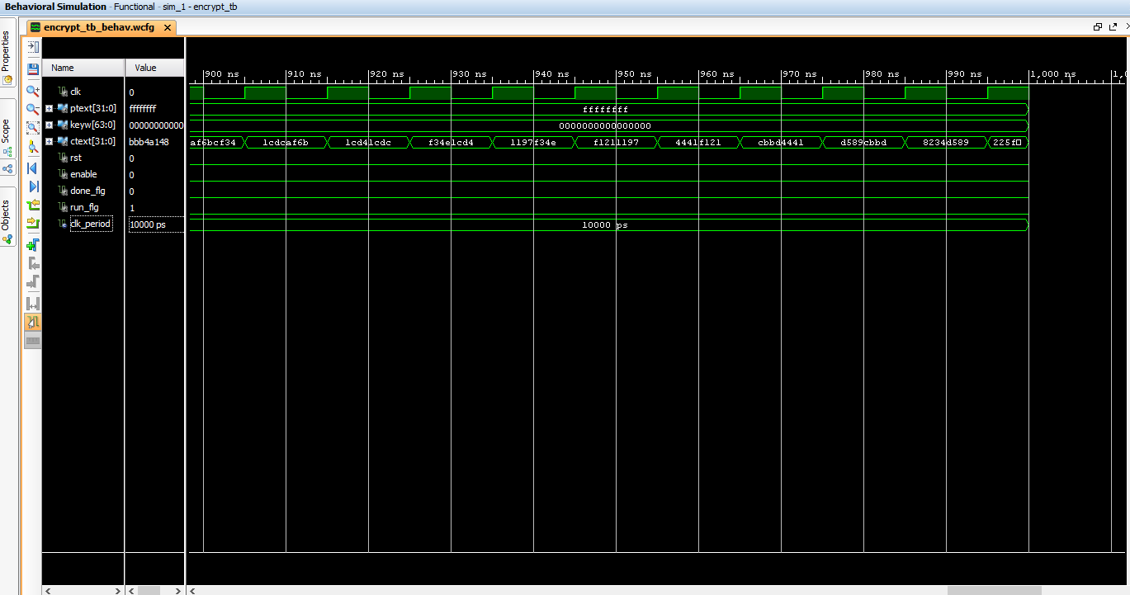900 ns – 1000 ns