REPORT NO. [0001] CONFIDENTIAL · BETA AUDIT
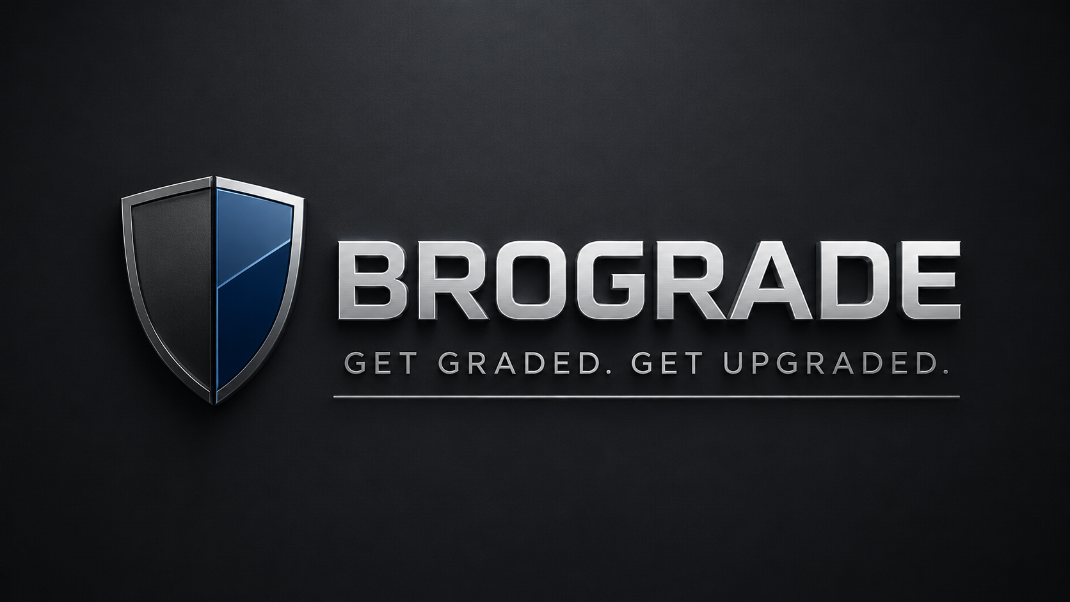

STYLE HAIR PHYSIQUE GROOMING PHOTOS PREPARED FOR
[Client First Name]

CLIENT DOSSIER
NAME | [Client First Name]
DATE | [YYYY-MM-DD]
AUDIT GOAL | [Client’s Primary Objective]
CURRENT PRESENTATION | [Client’s self-described current style]
TARGET AESTHETIC | [Target aesthetic, in the client’s exact words]
PRIMARY ENVIRONMENT | [School / Professional / Dating / Casual / Nightlife]
PROCUREMENT BUDGET | [Client Budget]

ADVISORY
This audit provides objective, practical feedback on style, grooming, physique direction, posture, and visual presentation based on submitted materials. It does not constitute medical, dermatological, mental health, or certified fitness advice. All recommendations are general self-improvement directives.

01
EXECUTIVE SUMMARY

THE BROGRADE METRICS
CURRENT BASELINE  [X.X] / 10  Where you stand today. | UPGRADE POTENTIAL  [X.X] / 10  Where you can be in 90 days.
PRIMARY LIABILITY  [Inconsistent fit, sub-optimal grooming, posture] | IMMEDIATE ROI  [Tailored pant break, structured layering]
LONG-TERM OBJECTIVE
[Upper chest hypertrophy over a 6 to 12 month macrocycle]

THE VERDICT
“ Your foundational traits are strong. The overall presentation is currently compromised by unstructured garments and a lack of visual cohesion. ”
02
THE BRUTAL TRUTH

Based on your visual data, your current baseline reads as [basic, decent, inconsistent, under-optimized].
The primary friction point holding back your presentation is [specific issue]. Currently, your visual footprint signals a [current impression] aesthetic, which directly conflicts with the [desired impression] you are aiming for.
The advantage here is that your required upgrades are entirely logistical. You do not require a full reinvention. By correcting [issue 1], [issue 2], and [issue 3], your presentation will transition to a highly [masculine, polished, athletic, intentional] standard.

03
THE SCORECARD

CATEGORY | SCORE | METRIC DEFINITION
Style & Outfit Fit | [X]/10 | Garment drape, silhouette alignment with frame, aesthetic cohesion.
Hair Architecture | [X]/10 | Cut, shape, texture, volume, facial framing execution.
Grooming Polish | [X]/10 | Facial hair precision, skin presentation, overall maintenance.
Physique & Proportion | [X]/10 | Visual structure, posture, localized muscular development needs.
Digital Presence | [X]/10 | Lighting, angle mastery, confidence, digital translation of the look.
Wardrobe Utility | [X]/10 | How efficiently your current inventory serves your target aesthetic.
OVERALL BROGRADE | [X]/10 | Cumulative visual presentation.

SCORING LEGEND
9–10  Elite, intentional | 8–8.9  Strong, minor tweaks | 7–7.9  Solid foundation | 6–6.9  Under-optimized | 5–5.9  Inconsistent | < 5  Full reset required

04
VISUAL ASSETS & LIABILITIES

ASSETS THAT DRIVE YOUR LOOK
ASSET 01
[Solid Frame Foundation]
You have a naturally broad clavicle structure that easily supports tailored outerwear.

ASSET 02
[Title]
[Explanation of objective advantage.]

ASSET 03
[Title]
[Explanation of objective advantage.]

LIABILITIES COMPROMISING YOUR LOOK
LIABILITY 01
[Shoulder Collapse in Shirts]
The lack of structure in your tops creates an artificial narrowing of the shoulders, hiding your actual frame.

LIABILITY 02
[Title]
[Explanation of visual detriment.]

LIABILITY 03
[Title]
[Explanation of visual detriment.]

05
STYLE & FIT ARCHITECTURE

AESTHETIC GAP ANALYSIS
CURRENT READ | [basic, sporty, random, streetwear, business casual]
CURRENT IMPRESSION | [immature, underdressed, inconsistent]
TARGET READ | [old money, clean mature, athletic, mafia sleek]
THE GAP | [Small, Medium, Large]. [Precise disconnect between current and target state.]
FIT DIAGNOSTICS
TOPS
PROBLEM Currently [too tight, lacks structure, poor neckline], which visually [narrows shoulders, makes torso boxy].
THE FIX Transition to heavyweight cotton tees and structured overshirts.

TROUSERS & DENIM
PROBLEM Current pants suffer from [too skinny, wrong rise, heavy ankle stacking], which [shortens legs, ruins silhouette].
THE FIX Move to a slim-straight fit with no break at the shoe.

FOOTWEAR
PROBLEM Current shoes read as [too casual, bulky, worn down], which [ruins polish, breaks formality].
THE FIX Implement clean white leather minimalism.

OUTERWEAR & LAYERING
PROBLEM Currently suffering from [no layering, cheap fabric, poor length].
THE FIX Source a minimal leather jacket or suede bomber.
COLOR & TEXTURE DIRECTIVES
CORE PALETTE | [Navy, Charcoal, Black, Cream]
ACCENT PALETTE | [Olive, Burgundy, Brown]
STRICT AVOIDANCE | [Neons, loud graphics, washed-out tones]
TEXTURE PRIORITY | Implement more [heavy cotton, suede, leather, knitwear]. Eliminate [thin polyester, shiny fabrics].

THE GOLDEN RULE
“Less ‘I just got dressed.’ More ‘I know exactly what I am doing.’”

06
GROOMING & FACIAL FRAMING

HAIR OPTIMIZATION
Your current hair reads as [flat, overgrown, un-styled]. While the [current strength, e.g. length] works in your favor, the [current weakness, e.g. lack of intentional styling] creates an accidental look.
RECOMMENDED CUT | [Low taper textured fringe]
LENGTH & STYLING | [Matte paste, keep length on top]
BARBER INSTRUCTIONS
Show your barber this exact text:
COPY VERBATIM
“I want a [cut type]. Keep [specific area or length], clean up the [sides or neckline], and ensure the top can be styled [direction]. Do not take too much off [area].”
FACIAL HAIR & SKIN
Facial hair. Currently [patchy, messy, weak neckline]. Transition to [sharp goatee, short stubble, clean shave] to properly frame your jawline.
Skin presentation. Based on visual data, focus on managing apparent [oiliness, texture, dark circles].
BASELINE SKINCARE PROTOCOL
MORNING  Gentle cleanser. Moisturizer. SPF. | NIGHT  Cleanser. Moisturizer.

07
PHYSIQUE & PROPORTION STRATEGY

VISUAL BASELINE | [skinny-fat, average, athletic, bigger build]
HIGHEST ROI OPPORTUNITY | [Build upper chest, reduce waist emphasis, correct posture]
DIAGNOSTICS
Shoulders & chest. Upper body requires more shoulder and upper chest density to force a V-taper and improve garment drape.
Midsection. Avoid drawing visual weight to the waist. Utilize structured tops and dark denim.
Lower body. If glutes and legs are dominant, avoid aggressive tapers. Utilize straight fits.
Posture. Rounded shoulders currently project low confidence. Fix this for an instant visual upgrade.
TRAINING PROTOCOL (AESTHETICS FOCUS)
Assuming a [frequency] training split, prioritize:
PRIORITY 01  Upper Chest  Incline movements. | PRIORITY 02  Side Delts  Lateral raises. | PRIORITY 03  Posture Control  Face pulls. Rear delts.

08
DIGITAL PRESENCE · PHOTO AUDIT

Currently, your photos project a [awkward, stiff, low-effort, decent but unoptimized] presence.
CURRENT LIABILITIES
- [Identify issue with lighting, angle, pose, expression, or background.]
- [Identify a second visible issue.]
- [Identify a third visible issue.]
CORRECTIVE ACTION
LIGHTING | Utilize natural window or shade light. Cease overhead lighting use.
ANGLE | Chest-height camera placement. Eliminate extreme high or low angles.
POSE | Stand tall. Relax shoulders. Angle slightly to the lens.
ENVIRONMENT | Clean the background. Clutter ruins the frame.

SOCIAL & DATING NOTE
The objective is not to look like a model. It is to look clear, intentional, and socially competent. Minimum required stack: one clear face, one full-body, one activity, one polished casual.

09
WARDROBE PROCUREMENT & GAP ANALYSIS

OPERATIONAL ASSETS · KEEP
- [Current functional item 1]
- [Current functional item 2]
SYSTEM LIABILITIES · STOP BUYING
- [Loud graphic tees]
- [Overly skinny jeans]
- [Random hoodies]
PROCUREMENT LIST
If you procure only one item, acquire [Priority 01 Item]. Reason: [Why this single item changes the silhouette most.]

# | ASSET REQUIRED | COLORWAY | FIT PARAMETER | EST. BUDGET
01 | [Item] | [Color] | [Fit] | [$]
02 | [Item] | [Color] | [Fit] | [$]
03 | [Item] | [Color] | [Fit] | [$]
04 | [Item] | [Color] | [Fit] | [$]
05 | [Item] | [Color] | [Fit] | [$]

10
EXECUTION PROTOCOLS

THE 7-DAY SPRINT
DAY  1 | BASELINE  Capture unposed reference photos: front, side, face, best and worst outfit.
DAY  2 | GROOMING RESET  Execute [haircut, beard trim, eyebrow cleanup].
DAY  3 | OUTFIT ARCHITECTURE  Assemble one flawless outfit using existing assets: top, pants, shoes, accessory.
DAY  4 | PHYSIQUE CALIBRATION  Execute one targeted session on priority weak points: incline press, lateral raises, face pulls.
DAY  5 | PROCUREMENT  Source one to three priority items. Strict fit over brand name.
DAY  6 | DIGITAL TRANSLATION  Retake reference photos using the new lighting and angle rules.
DAY  7 | DELTA REVIEW  Compare Day 1 against Day 6. Identify what is still soft.

THE 30-DAY TRAJECTORY
WEEK 1  Correct Liabilities  Grooming, baseline outfit, one strong photo. | WEEK 2  Fix the Fit  Pants, tops, footwear. Purge anything wrong. | WEEK 3  Build Proportions  Consistency in targeted training and posture. | WEEK 4  Lock the System  Establish two to three repeatable uniforms: Work, Dating, Casual.

11
FINAL DIRECTIVES

Your baseline is intact. The presentation simply lacks ruthless intentionality. The primary objective is to align your styling, grooming, and physical presence into one unified signal: [Desired Image].

EXECUTE THESE FIRST
01 | [Priority 01 Fix]  WHY [Explanation of why this matters most.]  ACTION [Exact step the client must take this week.]

02 | [Priority 02 Fix]  WHY [Explanation of why this matters most.]  ACTION [Exact step the client must take this week.]

03 | [Priority 03 Fix]  WHY [Explanation of why this matters most.]  ACTION [Exact step the client must take this week.]

Execute these consistently. Your visual presentation will shift in 30 days.

WE DEMAND EXCELLENCE
Submit feedback on your BroGrade Audit to getbrograde@gmail.com. What was lethal? What missed the mark? Are you executing the protocol?


END OF AUDIT
BROGRADE · GET GRADED. GET UPGRADED.

