Bug Report

# Bug ID

|  |  |
| --- | --- |
| ID Number | 0001 |
| Title | TypeError on ‘Debugging_Exercise.py’, line 4 |
| Reporter | Joseph D Sullivan <[JSulli40@Student.SCF.edu](mailto:JSulli40@Student.SCF.edu)> |
| Submit Date | January 25, 2025 |

# Bug Overview

|  |  |
| --- | --- |
| Summary | Receive error in file ‘Debugging_Exercise.py’ when executing directly from within PyCharm. |
| URL | <https://github.com/JosephDSullivan/COP2373/blob/main/src/chapter01/jsulli40_chapter01_assignment02.py> |
| Screenshot | <https://github.com/JosephDSullivan/COP2373/blob/main/src/chapter01/jsulli40_chapter01_assignment02_error.png> |

# Environment

|  |  |
| --- | --- |
| Platform | PC |
| Operating System | Windows 11 Home |
| PyCharm | PyCharm 2024.3.1.1 (Professional Edition) |

# Bug Details

## Steps to Reproduce

1. Download file ‘Debugging_Exercise.py’ from Canvas (<https://scf.instructure.com/courses/57982/files/11995559/>)
2. Renamed file to ‘jsulli40_chapter01_assignment02.py’ to fit into instructed naming convention.
3. Attempted to execute code directly. Error arose. Please see attached / linked screenshot.
   * 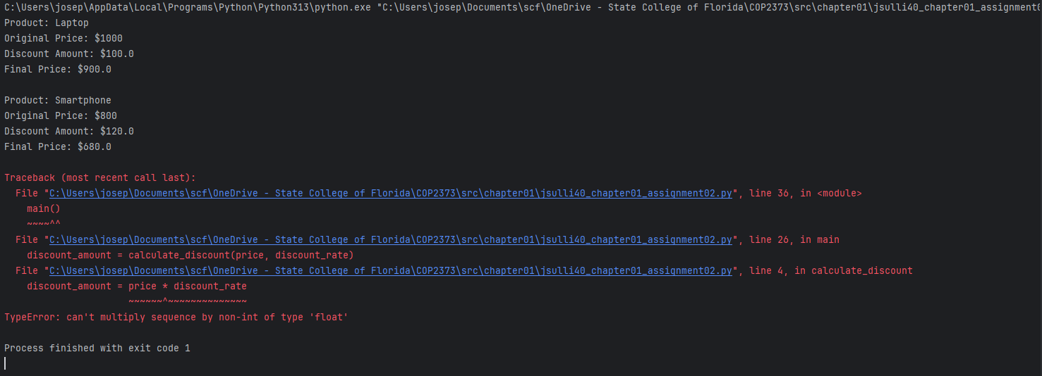

## Expected Results

Product: Laptop

Original Price: $1000

Discount Amount: $100.0

Final Price: $900.0

Product: Smartphone

Original Price: $800

Discount Amount: $120.0

Final Price: $680.0

Product: Tablet

Original Price: $500

Discount Amount: $100.0

Final Price: $400.0

Product: Headphones

Original Price: $200

Discount Amount: $10.0

Final Price: $190.0

## Actual Results

File "…\jsulli40_chapter01_assignment02.py", line 4, in calculate_discount

TypeError: can't multiply sequence by non-int of type 'float'

## Analysis

Error indicates that python is expecting a numeric value and does not see one.

The first two products are displayed correctly per the screenshot. The failure appears to be at product name Tablet.

Tablet is storing price as a string instead of as an integer or float (line 18).

The long term solution to the problem is to add data validation to calculate_discount() and apply_discount() so neither function causes the program to fail. I leave it up to the project manager to schedule this modification.

The short term solution to the problem is to change the data type of price for Tablet from string to integer.

# Resolution

Changed data type of price for Tablet from string to integer. Please see commit titled “Commit for bug 0001.”

# Testing

Reloaded file into PyCharm after making modifications. Executing the code directly returns the expected results. No additional testing or modification necessary at this point.