# Output

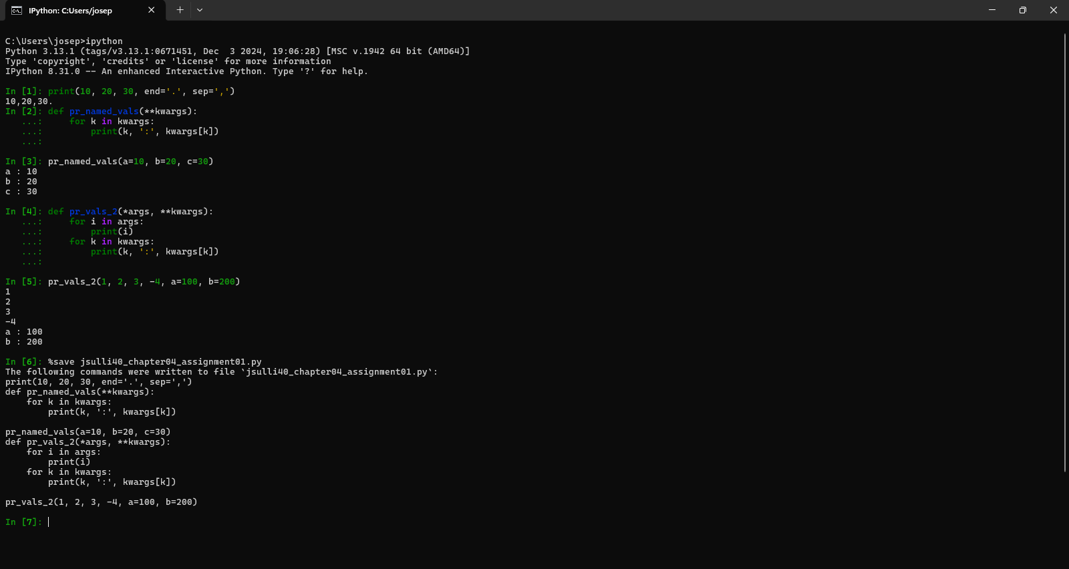

# Advantages of **kwargs

1. Allow functions to accept a variable number of arguments, as illustrated in the avg example from the book.
2. Improve code readability by explicitly specifying names for arguments.
3. New parameters can be added to functions dynamically without breaking existing code.

# Disadvantages of **kwargs

1. May be more difficult to debug because of the dynamic nature of calling the function.
2. More difficult to document because function calls can be structured differently / inconsistent.
3. Less efficient (speed and memory) than *args.

# 4.8.2 Pictures

