# The Feasibility of Implementing the CRISPR/Cas9 Gene Drive Enzyme into Wild Ecosystems

Joseph Dillman

301317623

jdillman@sfu.ca

October 31, 2016

# **Acknowledgements**

I would like to thank my TA Mike Hegedus for the valuable and responsive feedback throughout the production of this paper. I would also like to thank the members of my LA26 Omega tutorial group for providing feedback through peer editing. Finally I would like to thank Steve Whitmore for his valuable lectures and advice during the drafting and revising portions of this paper

# The Feasibility of Implementing the CRISPR/Cas9 Gene Drive Enzyme into Wild Ecosystems

# **Introduction**

Clustered Regularly Interspaced Short Palindromic Repeats (CRISPR[1]) or CRISPR associated protein 9 (Cas9) is a genome editing tool that allows for the replacement, removal, addition and alteration of genes in virtually any sexually reproducing organism [5, 6]. Programmed alterations to deoxyribonucleic acid (DNA) will be forced upon offspring to a near perfect efficiency and resist natural chromosomal crossover once implemented into the genome of an organism [2, 3, 4]. Forcing a particular set of genes onto offspring as accomplished by CRISPR is known as gene drive.[2] The applications of this technology have shown to be very promising according to two recent studies published in the *Proceedings of the National Academies of Science* [3] and *Nature* [4] where CRISPR/Cas9 technology have effectively been implemented into mosquitoes such that 99.5% of offspring will carry a plasmodium (malaria) resistant portion of their genome. Given that malaria results in over 400 thousand casualties each year [5] and is considered to be the most deadly disease in human history, it is clear that CRISPR technology shows significant implications.

Despite the immediate urge to release CRISPR mosquitoes into the wild, there are very reasonable controversies associated with altering the genome of an entire species. As stated in a report by the *National Academies of Science, Engineering, and Medicine* [6], there are a plethora of ecological and social factors to clarify before releasing an unstoppable domino effect of forced hereditary edited genes. For example, an ecosystem could fail if a gene drive caused harm to a keystone species [6]. It is also unsure who has the right to release a gene driven species that could affect an entire biome or the entirety of earth. CRISPR/cas9 technology has the immense potential to save millions of lives but is also a recent technology with the potential to irreversibly affect an ecosystem. This paper will explore the various controversies associated with CRISPR/Cas9 technology and the viability of its release into the wild in a balanced review in order to motivate further research such that a better understanding of gene drive consequences may be understood.

# **The Gene Drive Process**

The idea of building “selfish genes” which remain unchanged through sexual reproduction was first outlined by Austin Burt in 2003 [8]. Naturally, an organism that reproduces sexually passes 50% of its genes to offspring.[3] Even if malaria resistant genes could be edited onto an organism, the malaria resistance will be lost without a way to ensure offspring will receive all of the intact edited genes. The CRISPR/Cas9 tool allows the edited genes to remain dominant during chromosomal crossover [1, 2, 3, 4]. This concept can be shown in fig.1.

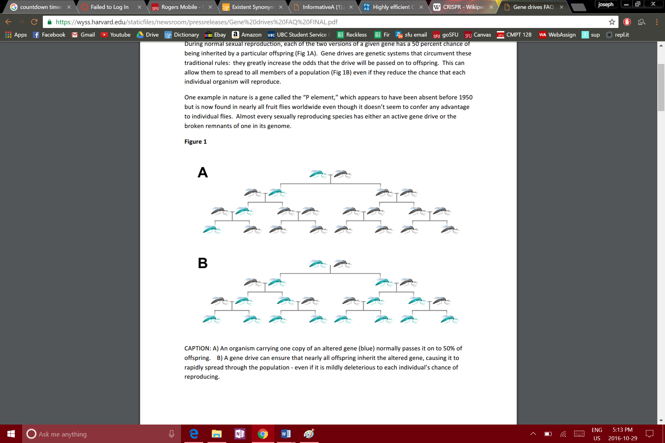

Figure 1: Case A shows the genes of a wild parent passing to offspring. Case B shows the genes of a CRISPR/Cas9 parent passing to offspring [10].

With gene drive, essentially all offspring will carry the specific edited genes. Theoretically this could mean a single gene driven organism would have the potential to change the genome of its entire species given enough time.

In 2010, an early CRISPR/Cas9 system was developed using inspiration from ribonucleic acid (RNA) interference found in eukaryotic organisms [9]. CRISPR/Cas9 can be thought of as an acquired immunity to foreign genetic elements similar to those found in plasmids and phages [9]. Bacteria use a CRISPR system to recognize, remember, and store DNA from invading viruses [8, 10]. The Cas9 enzyme is particularity efficient in cleaving DNA at very specific points specified by the RNA. The RNA can then be programed to add, remove or edit genes. When a gene driven parent mates with a wild parent, the wild chromosomes are cleaved and replaced by the specific gene drive DNA to ensure heritability [1, 2, 3, 4, 9, 10]. This process can be shown in fig.2.

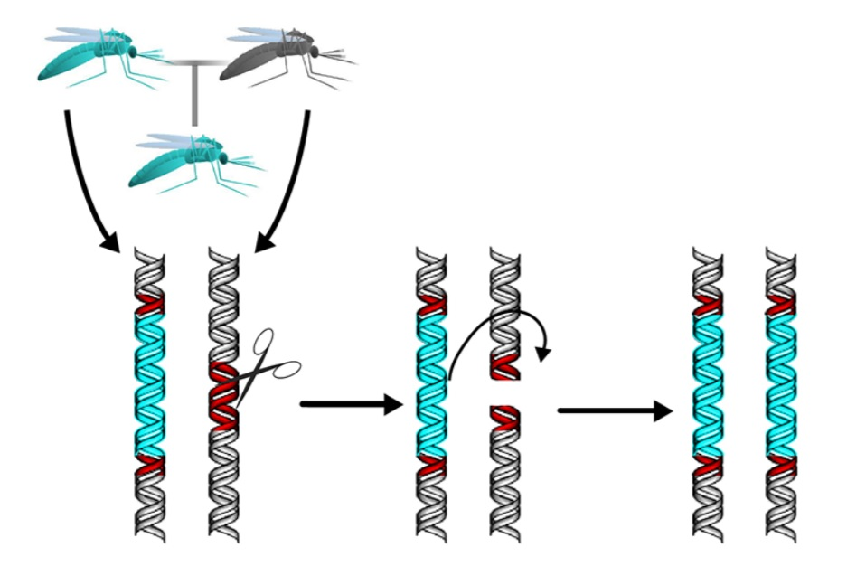

Figure 2: CRISPR/Cas9 genes (left) replacing wild genes (right) [10].

As shown in fig.2, only the specific edited genes programmed by the RNA are passed onto offspring and not the entire code of DNA from the CRISPR/Cas9 parent. Therefore, offspring still have unique randomized DNA from its parents with the exception of the gene driven portion.

Researchers of the malaria resistant gene drive study published in *PNAS* [3] concluded that the Cas9 enzyme would begin and end cleaving the genetic element at the correct sections to ≥98% efficiency while including all of the genes within the separation points. Once the gene can been correctly cleaved, 99.5% of offspring would inherit the gene drive system. Researchers of the study published in *Nature* [4] estimated that given real world situations and the number of current gene driven mosquitoes, it would take eleven mosquito generations or about a year for virtually the entirety of the Anopheles gambiae species[4] to carry the gene drive system.

# **Uses and Limitations of CRISPR/Cas9**

Although there are many proposed uses, the current model of CRISPR/Cas9 is to eradicate malaria. According to the World Health Organization [5] about 3.2 billion people are at risk of contracting malaria. In 2015 alone, an estimated 200 million contracted the disease resulting in 400 thousand casualties.[5] Preventing the spread of malaria has proved extremely difficult as the disease travels almost entirely by mosquito as they both contract and infect animals and humans when biting. If the 30 or so species of mosquitoes that carry malaria could be removed, the spread of the disease to and between humans will dramatically decrease [7]. Although eliminating all mosquitoes is not an option, using CRISPR to force a malaria resistant gene onto all offspring could bring an end to the spread of malaria in under a year and better millions of lives. Treatment for malaria exists but it is expensive and won’t effectively prevent future outbreaks. Gene drive is likely the only viable option in removing malaria as the lack of treatment is primarily caused by poverty and instability [4]. There are also proposed uses involving the eradication of dengue fever and zika [7]. It could be argued that releasing CRISPR mosquitoes is a moral obligation as the more time that passes without CRISPR mosquitoes, the more people die.[6]

Although CRISPR/Cas9 can theoretically work on work on all sexually reproducing organisms, there are limitations. Ideal gene driven organisms must reproduce sexually in order for RNA cleavage to occur, have a short generation time to speed the inheritance process, and to have a relatively simple genome to edit. Due to these factors, gene drive technology in humans or livestock would not likely be achievable as it would take decades or even centuries for the gene drive to reach the entire target population [11, 12]. Other limitations include the CRISPR/Cas9 genes ineffectively spreading to offspring or possibly ceasing to drive genes due to random errors in the RNA cleavage, according to Bruce Hay, designer of the drosophila[7] gene drive [11]. It could be possible that a gene drive simply doesn’t sustain itself over multiple generations as both parents will contain similar gene driven DNA and cause infertile offspring with poisoned genetics[8] [7,11]. The result would be a destroyed local group of mosquitoes only to be replaced by surrounding insects. However, the complete limitations of CRISPR/Cas9 technology have not been fully explored due to a lack of research.

# **Risks and Considerations**

CRISPR/Cas9 is a powerful tool capable of altering the genes of an entire species after a mere eleven generations. It is possible if not likely that once a perfected gene drive system is released, the process will not be halted. It has been proposed that an out of control gene drive system could only be reversed by releasing a second, updated gene drive to reverse the effects of the original CRISPR/Cas9 system [10]. However, this may only cause more problems as it involves implementing more gene drive technology. It has also been proposed that engineering an immunized population of organisms resistant to the gene drive system could be kept in order to be later released if problems occur [10], however this too involves more genetic engineering and will never fully reset the organism back to its original natural genome. An essential consideration of gene drive technology lies at the heart of how sure one must be before releasing a gene driven species. Every gene drive is different and thus releasing gene drives must also be considered on a case by case basis.

Possibly the most important ecological issue regarding gene drive systems is the possibility of harming keystone species and upsetting an ecosystem [7]. A gene drive is designed to be implemented to one target species at a time, however it is possible for a drive to cross into other subspecies and cause harm [7]. A report by *The National Academies of Science, Engineering, and Medecine* [6, 13] recommends that gene drive technology be studied further before its use in the wild. Misuse of the technology, biosafety, biosecurity, and assurance that drives will only affect target species are reasons to withhold the release of any gene driven organisms [6, 13]. The report recommends a “step by step approach to research” [6] to ensure risk assessment. The scientific community and policy makers must work closely to ensure best practices with the technology as CRISPR/Cas9 can work towards the betterment and deterioration of the environment. The report finally suggested controlled field trials that mimic the natural environment in order to gain a better understanding of the technology [6]. Kevin Esvelt who has participated in gene drive research [1] praised the report but stated that field trails pose too much of a risk as a single organism has the potential to create a snowball effect of hereditary genes [13]. The mere uncontrollability of self-regulating CRISPR/Cas9 genes is enough to provoke disagreement regarding its possible use in the wild.

There are a great deal of ethical and political considerations that must be taken into account when dealing with a technology harbouring such immense global implications. Given that gene drives could possibly upset ecosystems and cause irreversible damage[9], it is crucial to specify exactly who or which groups of people have the right to alter nature and the global population [7]. Despite the malaria resistant mosquitoes having been created in the United Kingdom and United States of America, malaria remains prevalent in Africa and Asia. As stated by several studies [6, 10, 12, 13], the scientific community, policy makers, and general public should agree on any decisions to use gene drive. However the extent to which this agreement must be satisfied is ambiguous. If the inhabitants of Africa and Asia reject the implementation of gene driven mosquitoes, deciding whether or not to release the organisms becomes even more of an issue.

It should also be taken into consideration that using gene drives will essentially undo millions of years of evolution and natural selection which crafted the genome of insect species. Anthony James from UC Irvine describes gene drive as making mosquitoes less fit [11]. Those opposing genetically modified organisms, the use of animal testing, and other forms of genetic engineering will likely seek similar stances of CRISPR/Cas9 and gene drive. The notion that humans have the right to enter the realm of nature and adjust its processes will always remain controversial.

# **Conclusion**

CRISPR/Cas9 is a technology that been studied for less than twenty years and yet already poses a multitude of questions regarding its future in society. If used correctly, the technology could end one the deadliest diseases in human history and better millions of lives across the globe. However, gene drive will likely be an unstoppable, irreversible domino effect that must be designed to absolute perfection in order to prevent ecological damage. Issues such as policy, social agreement, and further scientific research have been strongly recommended should CRISPR/Cas9 eventually be implemented. With each passing day as CRISPR/Cas9 is researched, tested, and considered for use, roughly a thousand humans will perish to malaria. Ultimately, time is of the essence.

# **References**

|  |  |
| --- | --- |
| [1] | K. Esvelt, A. Smidler, F. Catteruccia and G. Church, "Concerning RNA-guided gene drives for the alteration of wild populations", eLife, vol. 3, 2014. |
| [2] | L. Cong, F. Ran, D. Cox, S. Lin, R. Barretto, N. Habib, P. Hsu, X. Wu, W. Jiang, L. Marraffini and F. Zhang, "Multiplex Genome Engineering Using CRISPR/Cas Systems", Science, vol. 339, no. 6121, pp. 819-823, 2013. |
| [3] | V. Gantz, N. Jasinskiene, O. Tatarenkova, A. Fazekas, V. Macias, E. Bier and A. James, "Highly efficient Cas9-mediated gene drive for population modification of the malaria vector mosquito Anopheles stephensi", Proceedings of the National Academy of Sciences, vol. 112, no. 49, 2015. |
| [4] | A. Hammond, R. Galizi, K. Kyrou, A. Simoni, C. Siniscalchi, D. Katsanos, M. Gribble, D. Baker, E. Marois, S. Russell, A. Burt, N. Windbichler, A. Crisanti and T. Nolan, "A CRISPR-Cas9 gene drive system targeting female reproduction in the malaria mosquito vector Anopheles gambiae", Nat Biotechnol, vol. 34, no. 1, pp. 78-83, 2015. |
| [5] | WHO, "World Malaria Report 2015", World Health Organization, p. V, 40, 2015. |
| [6] | NASEM, "Gene Drives on the Horizon: Advancing Science, Navigating Uncertainty, and Aligning Research with Public Values", The National Academies of Science, Engineering and Medicine, p. 215, 2016. |
| [7] | A. Regalado, "The Extinction Invention", MIT Technology Review, 2016. [Online]. Available: https://www.technologyreview.com/s/601213/the-extinction-invention/. [Accessed: 16- Oct- 2016]. |
| [8] | A. Burt, "Site-specific selfish genes as tools for the control and genetic engineering of natural populations", Proceedings of the Royal Society B: Biological Sciences, vol. 270, no. 1518, pp. 270, 921-928, 2003. |
| [9] | L. Marraffini and E. Sontheimer, "CRISPR interference: RNA-directed adaptive immunity in bacteria and archaea", Nature Reviews Genetics, vol. 11, no. 3, pp. 181-190, 2010. |
| [10] | "FAQs: Gene drives", harvard.edu, 2016. [Online]. Available: http://wyss.harvard.edu/staticfiles/newsroom/pressreleases/Gene%20drives%20FAQ%20FINAL.pdf. [Accessed: 16- Oct- 2016]. |
| [11] | L. DeFrancesco, "Gene drive overdrive", Nat Biotechnol, vol. 33, no. 10, pp. 1019-1021, 2015. |
| [12] | K. Oye, K. Esvelt, E. Appleton, F. Catteruccia, G. Church, T. Kuiken, S. Lightfoot, J. McNamara, A. Smidler and J. Collins, "Regulating gene drives", Science, vol. 345, no. 6197, pp. 626-628, 2014. |
| [13] | J. Abbasi, "National Academies Hit the Brakes on Gene Drive–Modified Organisms", JAMA, vol. 316, no. 5, p. 482, 2016. |

1. Pronounced [**kris**-per].
2. CRISPR/Cas9 is the editing tool while gene drive is the process for which genes are forced onto offspring. The terms CRISPR, CRISPR/Cas9, and gene drive are used somewhat interchangeably.
3. A mean average figure given the random nature of chromosomal crossover.
4. A species of mosquito commonly hosting malaria
5. The 200 million figure is especially significant given the painful symptoms of malaria. The number of casualties have been slowly decreasing and are small in comparison to casualties in the past. However, contraction of malaria is not as preventable as death from malaria [5].
6. An argument of consequential ethics; the possible risks associated with releasing gene driven mosquitoes are outweighed by the possible benefits to millions of people. However, a deontological ethics view states otherwise given that the initial risk should not be condoned.
7. Commonly known as a fruit fly
8. The 98% efficiency in RNA cleavage may also cause errors and random mutations in the genome which will accumulate over time.
9. The complete remove of pre-gene-drive species and their natural DNA.