# The Elimination of Plasmodium with the CRISPR/Cas9 Gene Drive Enzyme

|  |  |
| --- | --- |
| Name: | Joseph Dillman |
| Student ID:  Email | 301317623  jdillman@sfu.ca |
| Lab Group: | (LA 26 Omega) |
| TA: | Mike Hegedus |
| Date: | Dec. 2, 2016 |
| Course: | ENSC 105W |

# **Audience, Purpose and Genre**

The intended audience of this paper is the National Institute of Health (NIH), a biomedical research facility located in Bethesda Maryland capable of providing funds to biomedical and health related research. The purpose of my paper is to advocate the further research of CRSISPR/Cas9 mosquitoes in wild, controlled, trials. This paper may be thought as a project grant application however, since I am not personally asking for funding and do not have a specific research procedure I plan on carrying out myself, this paper is more of a pre-grant application or opinion letter. I wish to persuade the NIH to consider funding research into CRISPR/Cas9 in the future as opportunities emerge. I will provide persuasive arguments in favour of and rebut arguments opposing CRISPR/Cas9 research.

# **Acknowledgements**

I would like to thank my TA Mike Hegedus for the valuable and responsive feedback throughout the entire production of this paper. I would like to thank the members of my LA26 Omega tutorial group for providing feedback through peer editing. Finally, I would like to thank Steve Whitmore for his valuable lectures and advice during the drafting and revising portions of this paper.

# The Elimination of Plasmodium with the CRISPR/Cas9 Gene Drive Enzyme

# **Introduction**

A recent innovation in genetic engineering with monumental implications in preventing human death and suffering has engrossed the biomedical engineering community. The technology known as Clustered Regularly Interspaced Short Palindromic Repeats (CRISPR[1]) or CRISPR associated protein 9 (Cas9) is a genome editing tool that allows for the replacement, removal, addition and alteration of genes in virtually any sexually reproducing organism (Esvelt et. al., 2016; Gantz et al., 2015). Programmed alterations to deoxyribonucleic acid (DNA) can be forced upon offspring to a near perfect efficiency and resist natural chromosomal crossover once implemented (Cong et al., 2013; Gantz et al., 2015; Hammond et al., 2015). The applications of CRISPR/Cas9 or gene drive[2] technology have shown to be remarkably promising according to two recent studies published in the *Proceedings of the National Academies of Science* (Gantz et al., 2015) and *Nature* (Hammond et al., 2015) where CRISPR/Cas9 technology implemented into mosquitoes resulted in 99.5% of offspring carrying a plasmodium (malaria) resistant genome. Given that malaria travels primarily by mosquito, results in over 400 thousand casualties each year (WHO, 2015), and is arguably the deadliest disease in human history, it is clear that CRISPR technology shows significant implications.

Despite the immediate urge to release CRISPR mosquitoes into the wild, further research must be completed in order to resolve all possible risks associated with altering the genome of an entire species or sub-species. As stated in a report by the *The National Academies of Science, Engineering, and Medicine* (2016), gene driven species should not yet be released into the wild as several ecological and social factors must be clarified. Opponents of CRISPR technology argue that an ecosystem could fail if a gene drive caused harm to a keystone species and genetic engineering may result in issues of intellectual property and the unethical alteration of nature (Abbasi, 2016). A species has never been genetically engineered to this level and thus opponents of CRISPR technology also argue that a fully ethical use of gene drive in organisms is unclear or problematic (Ormandy, Dale, & Griffin, 2011; Regalado, 2016). However, with the acceptance of CRISPR technology into research facilities for controlled field testing, malaria may be eliminated faster than ever possible. It should be brought to the attention of the National Institute of Health that further research in the form of natural, wild, controlled trials should not only be considered but advocated for the betterment of millions of lives.

# **The Essential Application of CRISPR/Cas9**

Although there are a plethora of possible uses involving CRISPR/Cas9 technology, the most important and indisputable duty is eradicating malaria. According to the World Health Organization (2015) roughly 3.2 billion people are currently at risk of contracting malaria. In 2015 an estimated 200 million cases of malaria resulted in over 400 thousand casualties.[3] Preventing the spread of malaria has proved extremely difficult as the disease travels almost entirely by mosquito through contracting and infecting other animals and humans with the disease. If the 30 or so species of mosquito that carry malaria could be removed, the spread of the disease to and between humans would dramatically decrease (Regalado, 2016). Although eliminating all mosquitoes is not an option, using CRISPR to force a malaria resistant gene onto all offspring could bring a painless end to the spread of malaria in under a year and better millions of lives. Treatment for malaria currently exists but it is expensive and won’t effectively prevent future outbreaks. Gene driven mosquitoes resistant to malaria exist in laboratories at this very moment. They are undoubtedly the only viable option in removing malaria as the lack of treatment is primarily caused by poverty and instability (Hammond et al., 2015). As a thousand lives a day are consumed by malaria, a solution stands idle, waiting to be used. The only barrier standing in its way is the lack of research and attention from the scientific community. It is unquestionably a moral obligation to allow the further research of this technology in wild, controlled trials as the more time that passes without CRISPR mosquitoes, the more lives are lost.[4]

Adversaries of CRISPR/Cas9 technology and those opposing genetically modified organisms (GMOs) argue that applications of genetic engineering in mosquitoes may lead to the genetic engineering of animals or possibly humans however, these outcomes are unpractical and unlikely. Although CRISPR/Cas9 can theoretically work on work on all sexually reproducing organisms, ideal gene driven organisms must also have a short generation time to speed the inheritance process, and have a relatively simple genome to edit. Successful gene drives in humans or livestock would take decades or even centuries to cover the entire target population (DeFrancesco, 2015; Oye et al., 2014). The reason gene drives have been successful in mosquitoes is due to their rapid rate of sexual reproduction and their reasonably short genome. Having taken into account concerns of future applications of gene drive, it is clear the technology has one definitive application currently and that is to save lives.

# **Rewriting Evolution and Satisfying Ethical Considerations**

Arguments against gene drive technology also include animal welfare and the prevention of altering evolutionary traits of organisms created over millions of years. In addressing these issues, it is integral that the process of CRISPR technology is understood. In 2010, an early CRISPR/Cas9 system was developed using inspiration from ribonucleic acid (RNA) interference found in eukaryotic organisms. CRISPR/Cas9 can be thought of as an acquired immunity to foreign genetic elements similar to those found in plasmids and phages (Marraffini & Sontheimer, 2010). Thus the gene drive process is not inherently unnatural or artificial. Bacteria use a CRISPR system to recognize, remember, and store DNA from invading viruses (Burt, 2003; FAQs, 2016). The Cas9 enzyme allows for very specific cleavage of DNA at points specified by the RNA, which can be programmed to add remove, or edit genes as shown in fig. 1.

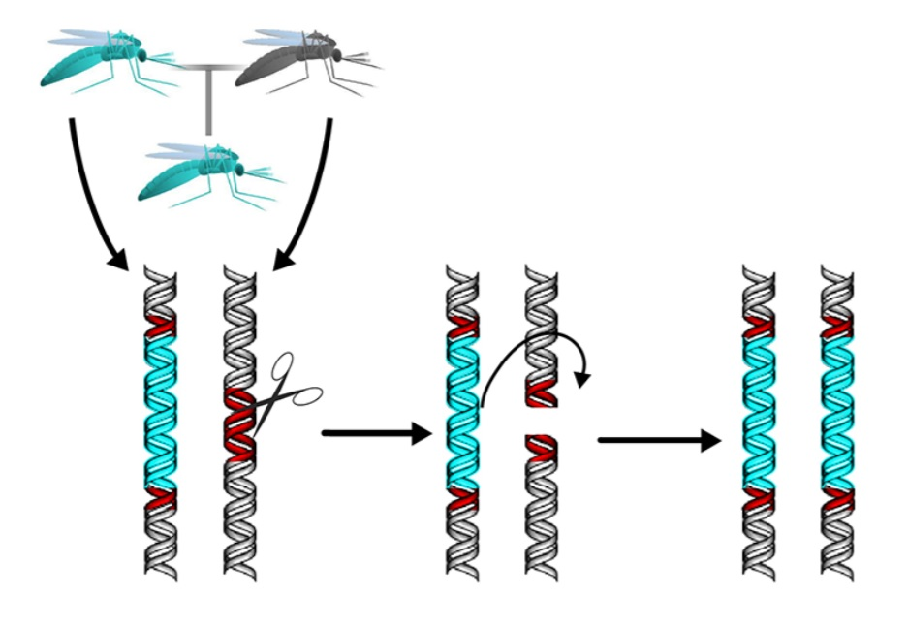

Fig. 1: CRISPR/Cas9 genes (left) replacing wild genes (right) (FAQs, 2016).

According to research by Hammond et al. (2015) and Gantz et al. (2015) the Cas9 enzyme would begin and end cleaving the genetic element at the correct sections to ≥98% efficiency while including all of the genes within the separation points. Once the gene has been correctly cleaved, 99.5% of offspring would inherit the gene drive system. What this means is that despite an organism naturally passing only 50% of its genes to offspring, edited genes via CRISPR/Cas9 remain dominant during chromosomal crossover, virtually passing all of its specified edited genes onto offspring as shown in fig. 2 (Esvelt et al., 2014; Cong et al., 2013).

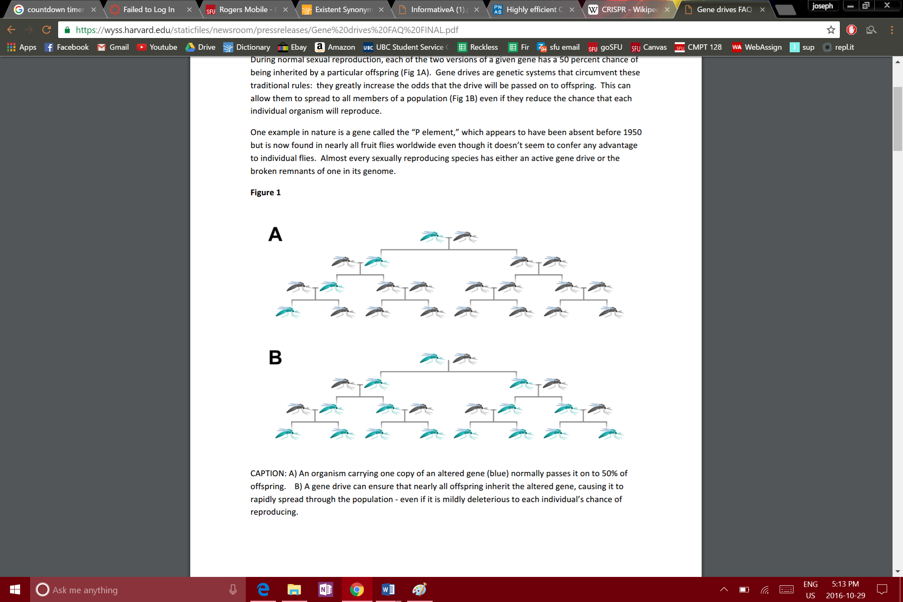

Fig. 2: Case A shows the genes of a wild parent passing to offspring. Case B shows the genes of a CRISPR/Cas9 parent passing to offspring (FAQs, 2016).

Theoretically a single gene driven organism would have the potential to change the genome of its entire species given enough time. Researchers Hammond et al (2015) estimated that given real world situations and the number of current gene driven mosquitoes, it would take eleven mosquito generations or about a year for the entirety of the Anopheles gambiae species[5] to carry the gene drive system.

Several arguments opposing CRISPR technology arise from the idea of rapidly enhancing of an entire species’ genes. Altering inherited genes has always been a controversial topic according to bioethicist Arthur Caplan. Those opposing genetically modified organisms, the use of animal testing, and other forms of genetic engineering will likely seek similar stances of CRISPR/Cas9 and gene drive. Anthony James from UC Irvine describes gene drives as making mosquitoes “less fit” (Defransesco, 2015). Using gene drives will essentially undo millions of years of evolution and natural selection which crafted the genome of insect species and to have hereditary genes altered by humans is a sensitive issue (Chant & Nelsen, 2014). Although evolutionarily crafted genes have taken millions of years to develop, they are not perfect and arguing against research purely from the un-natural viewpoint is an appeal to nature fallacy. What is natural is not necessarily perfect or morally or physically correct. Humans adapt environments to themselves and if possible, the genome of a species should be subject to change for the betterment of humanity. This is where research on CRISPR technology will be essential in order to ensure the safety of humans and the species being driven. Surely, the decision to use CRISPR mosquitoes would have to be unanimous and supported by research.

Several arguments in opposition to gene drive research also arise through ethical considerations when dealing with genetic engineering. The use of animals in scientific research require the reduction, replacement and refinement of the number of animals involved which simply cannot be satisfied if the experiment affects an entire species (Ormandy, Dale, & Griffin, 2011). In addressing this issue, it should be noted that mosquitoes, as well as humans, will be benefitted from the removal of malaria and the use of gene drives. While it is true that an entire population of mosquitoes will have an altered genome, the mosquitoes and surrounding organisms that also contract malaria will be no longer be affected by the disease. Consequently, CRISPR technology works towards the betterment of all animals and humans. For these reasons, defending ethical research into gene driven mosquitoes would not be as difficult a task as some believe.

# **Regulating a Self-Sustaining Drive**

CRISPR technology has received criticism in being described as an unstoppable force posing possible threats to the environment. Kevin Esvelt, who has partaken in several gene drive studies (Esvelt et al., 2014; Oye et al., 2016) argues against field trials as any modified organisms that escape into the wild will spread their genes out of any control of researchers (Abbasi, 2016). While this statement holds some truth, there are a few factors to consider before CRISPR research should be dismissed this quickly. The objective of a gene drive is to ensure that an entire population will contain a specific programmed gene. Giving a malaria antidote to every living mosquito is clearly impossible but a self-sustaining gene drive will accomplish the task at the source, DNA. Gene drives are programmed to specific species. If a gene driven mosquito were to escape and spread its genes to its entire species, not only would that indicate a successful gene drive but it would only affect its own species, one of several hundred. Bruce Hay, a designer of the drosophila[6] gene drive described a worst case scenario as follows; it could be possible that a gene drive simply doesn’t sustain itself over multiple generations as both parents will contain similar gene driven DNA and cause infertile offspring with poisoned genetics[7] (DeFrancesco, 2015; Regalado, 2016). The result would be a destroyed local group of mosquitoes only to be replaced by surrounding insects. It is considerably more likely that a gene drive will die off rather than randomly mutate across to other subspecies and cause irreversible harm. A lack of research in this area must be recognized and further research must be encouraged in order to fully understand and perfect gene drives.

# **Governance and Intellectual Property**

Arguments against the use of CRISPR technology in the wild will also point towards the issue of intellectual property. Designing a gene drive indicates an owner or designer of the genetically modified organism. This would inevitably lead to ownership issues of the mosquito species. It also remains unclear who is responsible for the consequences of a gene drive that may affect the entire globe (Regalado, 2016). If gene drives were to be granted to the free market and scientific community, issues of intellectual property will limit data sharing and create a culture of confidentiality. This could possibly result in the duplication of gene drives and conflict with the ethical consideration of reducing animal involvement (Ormandy, Dale, & Griffin, 2011). With many GMOs comes patented license agreements such as those found from Monsanto which will require royalties for the use of their product and continuously force payments as long as the GMO is in use (Monsanto 2011).

In order to combat these concerns scientists and politicians must work closely with communities in order to establish a mutual and focused plan to release CRISPR organisms, as recommended by The National Academies (2016) and numerous other sources (FAQs, 2016; Oye et al., 2014; Abbasi, 2016). If a gene drive were ever to be released, it would have to have the consent of all parties involved, especially including the intended region of the gene drive location. Obtaining a social license would be essential to the implementation of CRISPR organisms. The privatization of gene drives should be avoided to prevent unnecessary, excess gene drives being released. Should privatization occur, research and interest would increase however, heavy standards should be put in place to prevent the disingenuous competition of the free market. Although intellectual property and governance is a large consideration in releasing gene drives, it is by no means a basis to prevent future research.

**Conclusion**

CRISPR/Cas9 is a technology with the potential to end arguably the most harmful disease in human history. CRISPR edited mosquitoes exist at this very moment, being withheld on grounds of safety. Opponents of CRISPR technology have argued that the technology may lead to unethical CRISPR uses in animals or humans despite the unpracticality and unlikelihood of those conditions. The fallacious appeal to nature argument stating that rewriting evolutionarily genes is wrong and arguments of ethical standpoints claiming the use of gene drive is immoral both completely disregard the clear benefits to humans, mosquitoes, and nature in ending malaria. Other arguments state the technology poses a threat to nature, despite the extremely small probabilities of gene drive from affecting non-target species. Issues of intellectual property have shown to be important but do not in any way discourage the further research of CRISPR technology.

Issues such as policy, obtaining social licensees and agreement, and further scientific research have been strongly recommended by numerous agencies. The National Academies (2016) suggested controlled field trials that mimic the natural environment in order to gain a better understanding of the technology. This is absolutely essential to the future of CRISPR technology. The National Institute of Health will become vital to ending malaria and as opportunities in the future become apparent, CRISPR research must be promoted and defended. With each passing day as CRISPR/Cas9 mosquitoes are withheld from safeguarding millions of people, more than a thousand humans will perish to malaria. The power lies in the hands of the scientific community and time is of the essence.

# **References**

Abbasi, J. (2016). National Academies Hit the Brakes on Gene Drive–Modified Organisms. Journal of the American Medical Association, 316(5), 482. doi:10.1001/jama.2016.8830.

Burt, A. (2003). Site-specific selfish genes as tools for the control and genetic engineering of natural populations. Proceedings Of The Royal Society B: Biological Sciences, 270(1518), 921-928. [doi:10.1098/rspb.2002.2319](http://dx.doi.org/10.1098/rspb.2002.2319)

Chant, T. & Nelsen, E. (2014). Genetically Engineering Almost Anything. NOVA Next. Retrieved 1 December 2016, from http://www.pbs.org/wgbh/nova/next/evolution/crispr-gene-drives/

Cong, L., Ran, F., Cox, D., Lin, S., Barretto, R., & Habib, N. et al. (2013). Multiplex Genome Engineering Using CRISPR/Cas Systems. Science, 339(6121), 819-823. [doi:10.1126/science.1231143b](http://dx.doi.org/10.1126/science.1231143b)

DeFrancesco, L. (2015). Gene drive overdrive. Nat Biotechnol Nature Biotechnology, 33(10), 1019-1021. doi:10.1038/nbt.3361

Esvelt, K., Smidler, A., Catteruccia, F., & Church, G. (2014). Concerning RNA-guided gene drives for the alteration of wild populations. Elife, 3. doi:10.7554/elife.03401

FAQs: Gene drives. (2016). Wyss.harvard.edu. Retrieved 16 October 2016, from http://wyss.harvard.edu/staticfiles/newsroom/pressreleases/Gene%20drives%20FAQ%20FINAL.pdf.

Gantz, V. M., Jasinskiene, N., Tatarenkova, O., Fazekas, A., Macias, V. M., Bier, E., & James, A. A. (2015). Highly efficient Cas9-mediated gene drive for population modification of the malaria vector mosquito Anopheles stephensi. Proceedings of the National Academy of Sciences Proc Natl Acad Sci USA, 112(49). doi:10.1073/pnas.1521077112

Hammond, A., Galizi, R., Kyrou, K., Simoni, A., Siniscalchi, C., & Katsanos, D. et al. (2015). A CRISPR-Cas9 gene drive system targeting female reproduction in the malaria mosquito vector Anopheles gambiae. Nature Biotechnology, 34(1), 78-83. doi:10.1038/nbt.3439

Marraffini, L. & Sontheimer, E. (2010). CRISPR interference: RNA-directed adaptive immunity in bacteria and archaea. Nature Reviews Genetics, 11(3), 181-190. [doi:10.1038/nrg2749](http://dx.doi.org/10.1038/nrg2749)

Monsanto Technology/Stewardship Agreement (2011). Monsanto.

Ormandy, E. H., Dale, J., & Griffin, G. (2011). Genetic engineering of animals: Ethical issues, including welfare concerns. The Canadian Veterinary Journal, 52(5), 544–550.

Oye, K. A., Esvelt, K., Appleton, E., Catteruccia, F., Church, G., Kuiken, T., Collins, J. P. (2014). Regulating gene drives. Science, 345(6197), 626-628. doi:10.1126/science.1254287

The National Academies of Science, Engineering, Medicine (2016). Gene Drives on the Horizon: Advancing Science, Navigating Uncertainty, and Aligning Research with Public Values, 215. doi:10.17226/23405

Regalado, A. (2016, April 13). The Extinction Invention. MIT Technology Review. Retrieved September 26, 2016, from https://www.technologyreview.com/s/601213/the-extinction-invention/

WHO. (2015). World Malaria Report 2015. World Health Organization. ISBN:978 92 4 156515

1. Pronounced [**kris**-per].
2. CRISPR/Cas9 is the editing tool while gene drive is the process for which hereditary genes are forced onto offspring. The terms CRISPR, CRISPR/Cas9, and gene drive are used somewhat interchangeably.
3. The 200 million figure is especially significant given the painful symptoms of malaria. The number of casualties have been slowly decreasing and are small in comparison to casualties in the past. However, contraction of malaria is difficult to prevent and remains just as much of a problem as death from malaria (WHO, 2015).
4. An argument of consequential ethics; the possible risks associated with releasing gene driven mosquitoes are outweighed by the possible benefits to millions of people.
5. A species of mosquito commonly hosting malaria
6. Commonly known as a fruit fly
7. The <2% inefficiency in RNA cleavage may also cause errors and random mutations in the genome which will accumulate over time.