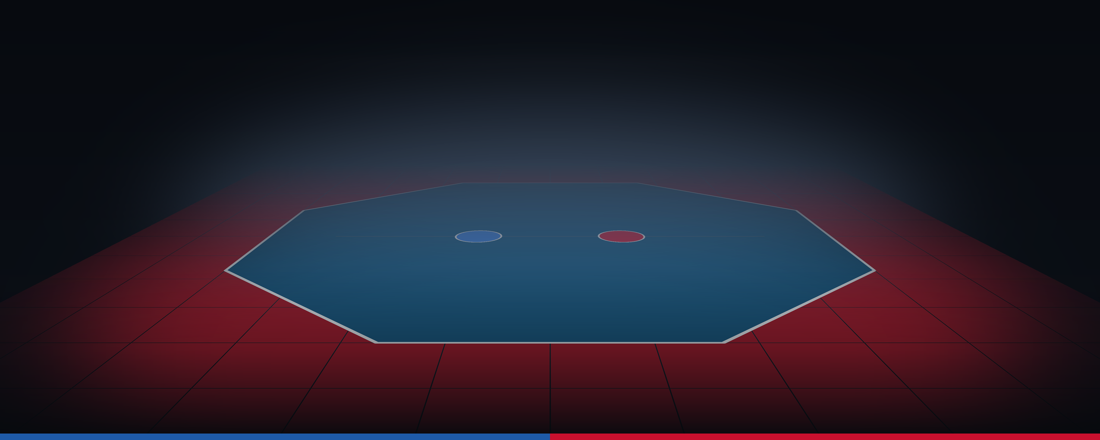
BCIT Capstone · 2026–2027
Open Stance
겨루기 Gyeorugi · Game Design Document
Real taekwondo sparring, one on one: read the distance, choose your kick with a flick of the Skill Stick, and land it before your opponent does.
Version | 0.5 draft · updated 2026-09-21
Author | Joseph Driedger
Programme | BCIT Capstone
Institution | British Columbia Institute of Technology
Engine | Unreal Engine 5.8 · DirectX 12
Platform | PlayStation 5 and Xbox Series X|S · Windows PC (development)
Status | Pre-production — draft, not yet reviewed

Contents
1 Overview 60
1.1 Working Title 6
1.2 Current Status 6
1.3 Concept Statement 7
1.4 Genre 7
1.5 Target Audience 7
1.6 Concept and Unique Selling Points 8
1.7 Design Pillars 8
1.8 Player Experience 9
1.9 Key Moments 9
1.10 Art, Sound and Music 10
1.11 Current Target Platform 11
1.12 Competition 12
1.13 Monetization 13
1.14 Scope and Team 13
2 Player Objectives and Progression 14
2.1 The Player 14
2.2 Goals 14
2.3 Moment-by-Moment Gameplay 14
2.4 Core and Outer Loops 15
2.5 Interactivity 15
2.6 Progression Through the Game 16
3 Game Modes 17
3.1 Play 17
3.2 Progress 17
3.3 Other Sparring Formats 17
3.4 Connected 17
3.5 Referee Mode [Future] 18
4 Career 21
4.1 Weekly Loop 21
4.2 Event Tiers 21
4.3 People 22
4.4 Long-Term Career [Future] 22
5 Progression and Levelling 23
5.1 XP Sources 23
5.2 Level Curve 23
5.3 Ranks 23
5.4 Attributes 24
5.5 Technique Unlocks 26
5.6 Balance Rules 26
6 Game World 27
6.1 World Fiction 27
6.2 Venues 27
6.3 Contest Area 28
6.4 Movement and Physics 28
6.5 Easter Eggs 29
7 User Interface 30
7.1 Controller Layout 30
7.2 Skill Stick Moves 31
7.3 Guards 31
7.4 Input Notes 31
7.5 Screen Flow 32
7.6 HUD 32
7.7 Help System 33
7.8 Game Options 33
7.9 Accessibility 33
8 Core Sparring Systems 34
8.1 Systems Overview 34
8.2 Match Format 34
8.3 Scoring 35
8.4 Penalties 35
8.5 Referee Commands 36
8.6 Skill Stick 36
8.7 Stance and Guards 36
8.8 Active Defense 36
8.9 Stamina 37
8.10 Hit Reactions 37
8.11 Video Replay Request [Future] 37
8.12 Rulesets [Future] 38
8.13 Epics and User Stories 38
9 Techniques 40
9.1 Kicks 40
9.2 Spinning and Jumping Kicks 40
9.3 Punches, Movement and Other Actions 41
9.4 Techniques Not Yet Mapped 41
10 Customization 42
10.1 Options 42
10.2 Side Colours 42
10.3 Natural Appearance 42
10.4 Unlock Sources 43
11 Game Objects and AI 44
11.1 AI Opponents 44
11.2 Officials 44
11.3 Equipment and Props 44
12 Online and Community [Future] 46
13 Presentation 47
14 Localization 48
15 Tools 49
16 Technical Design 50
16.1 Stack 50
16.2 Animation Architecture 50
16.3 Data and Simulation 50
16.4 Major Technical Risks 51
16.5 Project Structure and Naming 51
16.6 Data Formats 52
16.7 AI and Autonomous Systems 52
16.8 Test Cheats 52
17 Ideas and Expansions 54
17.1 Later Platforms 54
18 Unresolved Questions 55
18.1 Open 55
18.2 Resolved 56
19 Prototypes 57
20 Development Schedule and Milestones 58
20.1 Milestone Success Criteria 58
21 Change Log 59
22 Glossary 59

1 Overview
Open Stance captures the rhythm and decision-making of real taekwondo: distance, timing, stance, guard, counters and scoring. It starts as a sparring game built around motion capture of real practitioners, and grows into the home of competitive taekwondo sparring: tournaments, team events, online competition and para taekwondo. Open Stance is only about sparring; forms (poomsae) and breaking are out of scope.
This main page states what the game is, why it is worth playing and building, and where the project stands. Detailed design starts at section 2; the Contents lists every section.
Phases. Everything in this document is part of v1.0, the game this capstone delivers: the First Half builds the sparring core, the Second Half adds Career (1.14). A [Future] tag marks the exceptions: expansion planned for after v1.0.

1.1 Working Title
Open Stance: Gyeorugi. In taekwondo sparring, an open stance is the position where the two fighters lead with opposite legs, so their trunks face each other and the roundhouse kick is open. Gyeorugi (겨루기) is the sport’s own word for sparring. The title tells the player that the game is about stance, position and competitive sparring, presented in taekwondo’s own terms.

1.2 Current Status
Status on 2026-09-21: pre-production, in the proposal phase of the First Half. The design is a draft that has not been reviewed, and no gameplay prototype exists. The character and venue art pipeline works. The project is on schedule for the October 2026 proposal.
Report | Items
Complete | Preliminary project plan complete.  Controller layout fixed on 2026-09-14 (section 7).  Base fighter: MetaHuman body (175 cm, medium build) in seven wardrobe pieces: dobok jacket and trousers, belt, chest protector, helmet, gloves and foot guards, with Chung and Hong materials; passed a full-body range-of-motion test.  Referee roster: six MetaHuman referees in uniform, with Chaos cloth on ties and trousers.  Staging levels L_CompetitionArena (8 m octagon mat in a 12 m square) and L_TrainingDojang.  Motion capture shots planned.
In progress | BCIT proposal: requirements, research, architecture and feasibility (due October 2026).  This document.
Blockers | None.
Debt and major issues | The controller layout leaves several details open, such as which right-stick direction gives a roundhouse or hook kick and what Active Defense Mode does (18.1).  The runtime module Source/OpenStance has no gameplay code yet, so the Skill Stick stays untested until Milestone 1.  Stamina, movement and hit-reaction values are starting values that have not been playtested.  Second Half dates are not published.

1.3 Concept Statement
Real taekwondo sparring, one on one: read the distance, choose your kick with a flick of the Skill Stick, and land it before your opponent does.
A match lasts 5 to 8 minutes and one exchange lasts 1 to 3 seconds. One player spars the AI, or two players spar on one console.

1.4 Genre
3D one-on-one sports fighting game. From fighting games, Open Stance takes committed attacks with startup, active and recovery phases, reads, fakes and counters. From sports simulation, it takes a real ruleset: World Taekwondo scoring, electronic protectors, penalties and ranks. There is no health bar and no combo string; matches are won on points, as in the real sport.

1.5 Target Audience
Audience | Who | Games they play | What they want
Fighting-game players | Ages 16–35, controller players | Street Fighter 6, Tekken 8 | Depth through spacing and timing rather than long combo strings; a high skill ceiling; local versus
Combat-sports game players | Ages 16–40 | EA Sports UFC 5, Undisputed | A realistic sport with simulation controls and a career
Taekwondo practitioners | Athletes, coaches and club members, age 13 and up | Taekwondo Grand Prix, or none | Their sport shown accurately: real rules, techniques and etiquette
Martial arts schools [Future] | Clubs and coaches | — | Tactics teaching and remote sparring leagues

Motivations: mastery (a fair, readable system where skill decides the match), competition (winning on points against a friend or rival) and authenticity (real technique and rules).
ESRB target: E10+ (Everyone 10+), Mild Violence. Contact is full but sporting: no blood, no injuries shown and no taunts. The ESRB assigns the final rating; online interactions are not rated.

1.6 Concept and Unique Selling Points
A match is a series of short exchanges on an 8 m octagonal mat. Each fighter bounces in guard and manages distance with the left stick. The right stick, the Skill Stick, chooses the kick: up for a side or cut kick, left or right for a roundhouse or hook kick, and circles and other motions for axe, spinning and tornado kicks (7.2). Holding RT kicks with the back leg, holding RB aims at the head, and holding LB fakes the attack. Hits score the way the electronic scoring system does: 1 point for a punch, 2 for a body kick, 3 for the head, 4 for a spinning body kick and 6 for a spinning head kick (8.3). Stamina limits how often a fighter throws big techniques. Players learn in the training dojang and spar the AI or a friend; Career then takes a created fighter from white belt at a local club to a world final, unlocking techniques rank by rank. The look is realistic: MetaHuman fighters in white doboks and blue or red gear, animated from motion capture of real practitioners.
Unique selling points
- The Skill Stick. Kicks are right-stick gestures, and two held modifiers choose the leg (RT) and the target (RB), so a small set of gestures covers the sport’s main kicks at body and head height.
- Real sparring, real scoring. World Taekwondo rules: 2-minute rounds, electronic protector scoring, 1 to 6 point techniques, gam-jeom penalties, and a 12-point gap.
- Distance and commitment decide matches. Attacks never home in from out of range, and every technique can be punished on recovery (1.7).
- Motion captured from real practitioners. Techniques, stance switches, reactions and falls come from taekwondo athletes.
- Respect for the sport. Real ranks, competition colours and etiquette, and nothing that affects a match is ever sold (1.7).
Prototype: none yet. The Milestone 1 proof of concept and its video link here when complete (section 19).

1.7 Design Pillars
Pillar | Meaning
Taekwondo first | Techniques and movement that work in real sparring. Nothing is added because it looks flashy in other fighting games.
Distance matters | Attacks don’t magnetically connect from unrealistic range. Small spatial correction is fine; bad distance still misses.
Commitment matters | Startup, active and recovery phases create counter openings. Big techniques are big risks.
Score and stamina are separate | Score decides who is winning. Stamina decides what the fighter can execute well right now.
Animation serves gameplay | Mocap is cut into reusable states, transitions and reactions that gameplay drives.
Respect the sport | Real ranks, real competition colours, real skin, hair and eye colours. Skill decides matches, never purchases.

1.8 Player Experience
Question | Answer
Who is the player | A taekwondo athlete at a competition, in dobok and full sparring gear. In Career the same created fighter grows from a white-belt beginner to a black-belt international competitor.
Setting | The present-day sport: a training dojang and competition venues. There is no scripted plot and no fantasy setting (6.1).
Fantasy | Being a sharp, composed sparring athlete: reading an opponent, landing the head kick at the right moment and winning under scoreboard pressure.
Emotions | Tension while circling at kicking distance; the snap of a clean score; pressure when behind on the clock; pride in a disciplined win; respect at the bow.
Length | A session: 20 to 40 minutes of lessons and matches. A Career season: 3 to 5 hours, with an estimated 30 hours to reach 3rd dan (level 40, 5.2). Match and round lengths: 2.4.
What keeps them playing | Every exchange is a new read, the score and clock change the right decision, and improvement shows as more points from fewer, better techniques.
Major phases | 1. Learn: Training lessons for movement, the Skill Stick and scoring (first 15 minutes).  2. Compete: Sparring against the AI and local friends.  3. Master: harder AI, spinning and jumping kicks, clean matches without penalties. Career (v1.0) and Online [Future] extend Compete and Master (sections 4 and 12).

1.9 Key Moments
Moment | When | What happens
First score | Minutes 1–5 | In a Training lesson the player pushes the right stick  sideways. The lead leg throws a roundhouse kick into the protector, the scoreboard shows +2 and the protector sound confirms it.
First read | First AI match | The AI advances; the player dashes back  and meets its approach with a side kick . Timing and distance, not button speed, won the point.
The wall | A harder AI or a first match against a friend | The opponent cut-kicks every approach and the player falls 4 points behind. Fake attacks  and switching sides  get the player past the cut kick.
The comeback | Final round, last 10 seconds | Down by 3, the player fakes an attack, then throws a spin hook kick  +  for 6 points as the clock runs out.
The podium | Career: world series final | In a black dan dobok, the fighter bows to the rival who beat them two seasons earlier, then takes gold.

1.10 Art, Sound and Music
Visual style. Realistic and clean, like a broadcast of a World Taekwondo event. Fighters are MetaHuman bodies in white doboks with blue (Chung) or red (Hong) protectors and helmets. Arenas use bright, even light so limbs and scoring zones stay readable. The Chung-blue and Hong-red convention runs through the mat, gear, scoreboard and HUD, so the player always knows which side is which. The training dojang is warmer: daylight, wood, and walls of kicking pads.
Reference images (Resources/References) set tone and layout. They are not used in the game.
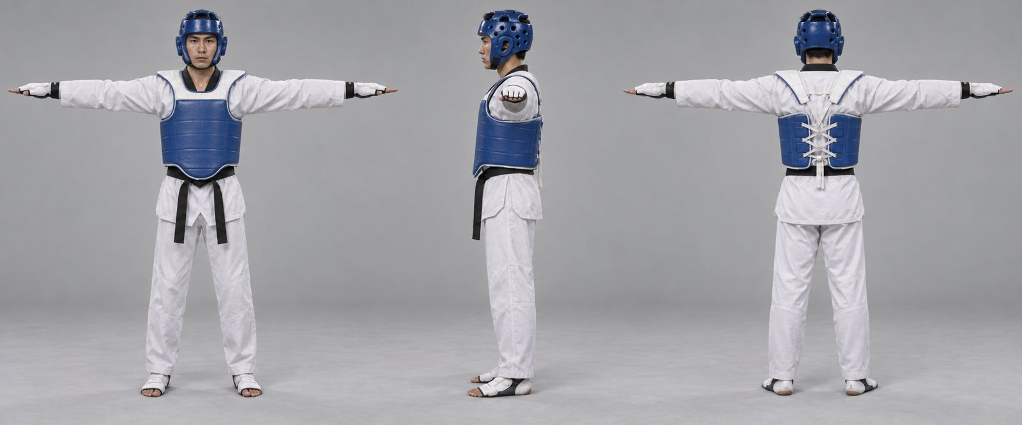
Fighter: dobok, Chung protector and helmet, gloves and foot guards (front, side, back)
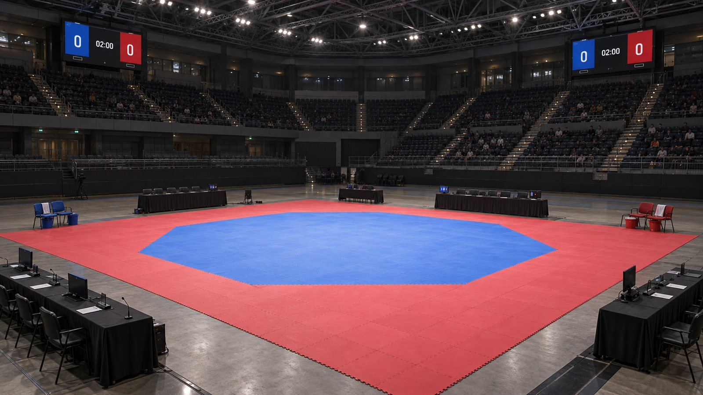  Competition arena: octagon mat, scoreboards, officials’ tables, coach chairs | 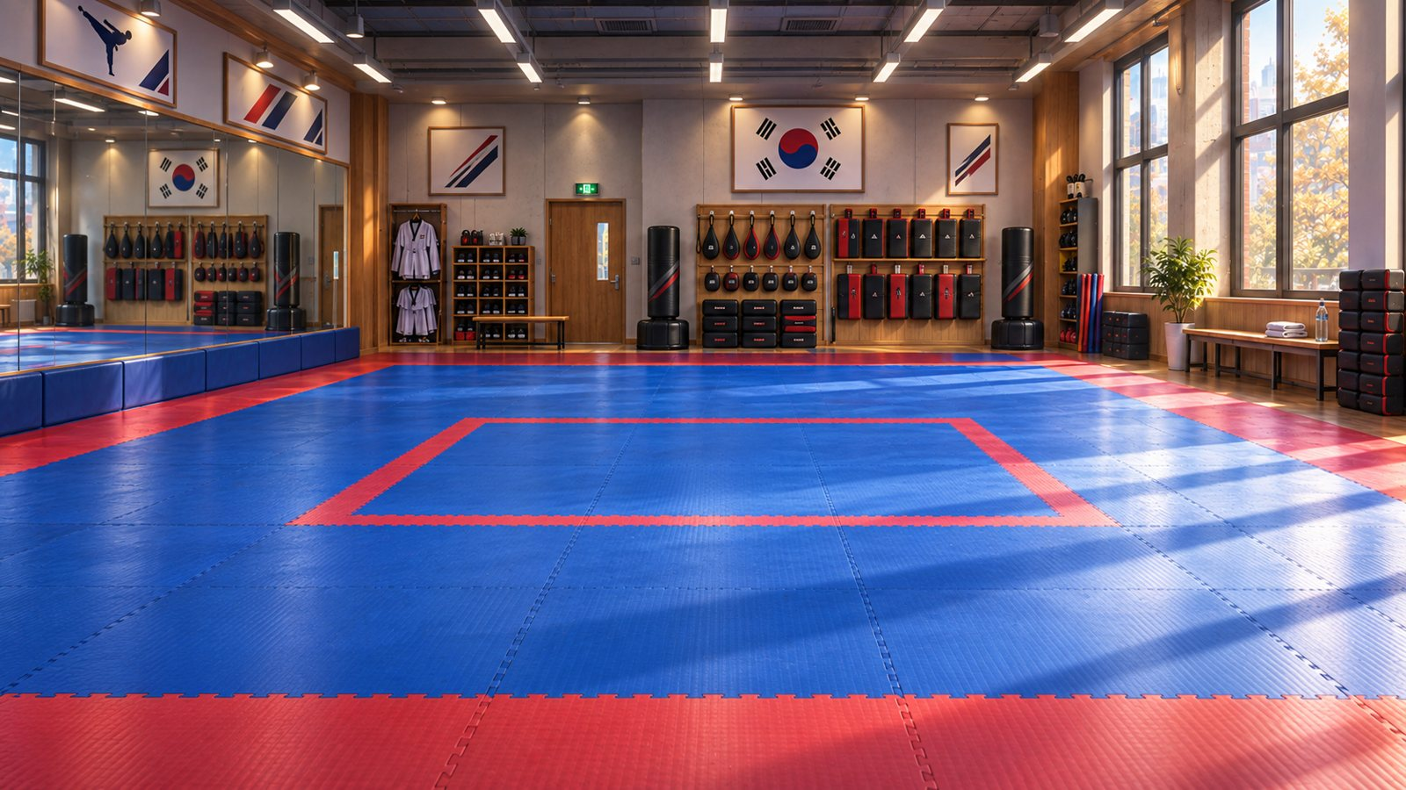  Training dojang: kicking pads, heavy bags, mirrors
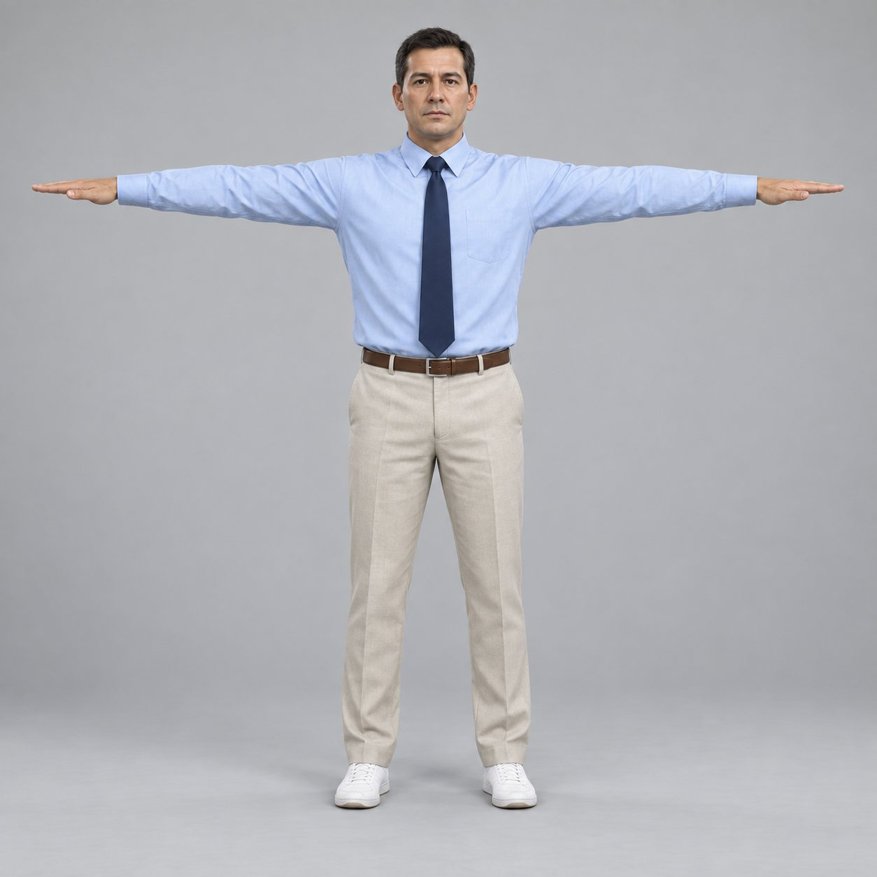
Referee uniform
Sound. Sound carries information: the protector impact changes with the points scored (1 to 6), feet squeak and slap on the mat, and the referee calls commands in Korean with English subtitles. Crowd size and reverb grow with the venue, from a quiet club night to a full arena.
Music. Music plays in menus, loading screens and round breaks only; rounds have no music, so impacts and footwork stay readable. Style: modern electronic tracks with Korean percussion. Whether music is commissioned or licensed is unresolved (18.1).
Asset lists. A complete art and audio asset list does not exist yet (18.1). Presentation details: section 13.

1.11 Current Target Platform
Item | Target
Platform | PlayStation 5 and Xbox Series X|S
Development platform | Windows 10 and 11, 64-bit PC. v1.0 is developed and demonstrated here; a console release needs a licensed developer account and devkits that the project does not have (18.1).
Input | Controller only: one per player, two for local versus. There is no keyboard or mouse play.
Engine and graphics | Unreal Engine 5.8; DirectX 12 on Xbox and on the Windows development build, the PlayStation 5 renderer on PS5
Performance | 60 fps during matches: 1920 × 1080 on the Windows development build, 3840 × 2160 on PlayStation 5 and Xbox Series X, 1920 × 1080 on Xbox Series S
Performance verification | Resolution and frame rate measured on the Milestone 3 build (18.1)

A PC release on Steam and cross-play are in section 17.

1.12 Competition
Game | Release | Sales and budget | Description
Taekwondo Grand Prix  Hello There Games | PC, 9 October 2018 | Not published | The closest direct competitor: taekwondo sparring with World Taekwondo rules and scoring, motion-captured movement, local and online play and customization.
Virtual Taekwondo  Refract Technologies with World Taekwondo | VR: PICO 4 and PICO 4 Ultra | Not published | World Taekwondo-endorsed VR sparring with body-worn trackers; the player’s body is the controller. Used for the World Taekwondo Virtual Championships (Singapore, November 2024).
Tekken 8  Bandai Namco | PC, PS5, Xbox Series X|S; 26 January 2024 | About 3 million copies by February 2025 | 3D fighting game with a taekwondo-based character (Hwoarang); health bars, juggles and combos.
Street Fighter 6  Capcom | PC, PS4, PS5, Xbox Series X|S; 2 June 2023 | More than 7 million units by June 2026 | 2D fighting game with a taekwondo-based character (Juri) and simplified Modern controls that widen its audience.
EA Sports UFC 5  EA Vancouver | PS5, Xbox Series X|S; 27 October 2023 | Not published | Mixed martial arts simulation with stand-up striking, stamina, a career mode and online play.
Undisputed  Steel City Interactive | PC early access January 2023; PC, PS5, Xbox Series X|S 11 October 2024 | 1 million copies; about US$18.8 million raised for development | Licensed boxing simulation built on footwork, stamina and realistic punch selection.
Fight Night Champion  EA Canada | PS3, Xbox 360; March 2011 | Not published | Boxing game whose analog-stick punching is the closest precedent for choosing strikes with a stick gesture.

What sets Open Stance apart. Taekwondo Grand Prix, the only direct competitor, is PC only, and Virtual Taekwondo needs a VR headset and body trackers. No taekwondo sparring game ships on PlayStation or Xbox; Open Stance targets both. Open Stance differs from both through the Skill Stick, which gives controller players a readable, expressive way to choose kicks. It differs from Tekken 8 and Street Fighter 6 by using the sport’s real rules and scoring instead of health bars, and from UFC 5 and Undisputed by bringing their simulation approach to a kicking sport neither covers.
Sources: Steam store and Metacritic (Taekwondo Grand Prix); virtualtkd.gg; Bandai Namco via Game Developer (Tekken 8); Capcom investor relations and Gematsu (Street Fighter 6); EA (UFC 5); Forbes and PlayStation Universe (Undisputed). Checked 2026-09-14.

1.13 Monetization
Phase | Model
v1.0 | None. v1.0 is a free portfolio and demonstration build.
Future | A commercial release would be premium: a one-time purchase on the PlayStation Store and the Microsoft Store, with optional cosmetic content only (gear styles, dojang items, ceremonies). Never ranks, techniques, attributes or anything that changes a match. The price is unresolved (18.1).

A premium price suits a competitive sport game built on fairness (1.7): every player has the same techniques, and Ranked would give everyone the same attributes. Free-to-play progression would put purchases between the player and techniques, which the balance rules forbid (5.6).

1.14 Scope and Team
Item | Plan
Team | One developer (Joseph Driedger): design, programming, technical art and production. Volunteer taekwondo practitioners perform the motion capture.
Length | About 8 months, in two halves: the First Half (September to December 2026) builds the sparring core and ends in playable demo gameplay, and the Second Half (January to spring 2027) adds Career and finishes the build.
First playable | Milestone 2, December 2026: two local players complete a basic sparring match. This is the demo gameplay that closes the First Half.
v1.0 content | 1 to 2 premade fighters and the fighter creator’s five body types (5.4.2), the competition arena and training dojang, 8 to 12 captured techniques, Sparring, Training and local Tournament modes, an AI opponent, and Career seasons with training, grading, tournaments, rank-gated technique unlocks and its own venues. Online play, online tournaments, challenges, replays and video review are Future work (section 17).
Time to complete | Sparring and Training have no end state. Career runs about 30 hours to 3rd dan, the level 40 cap (5.2), and the world series final (4.2).
Major risks | Capture of fast kicks, animation workload, responsiveness of mocap-driven attacks, Skill Stick complexity and scope growth. Mitigations: 16.4.

2 Player Objectives and Progression

2.1 The Player
The player controls one taekwondo fighter in a one-on-one match, seen from a side-on camera. In Sparring the player picks a fighter; in Career the player creates one.
What the player knows at the start. Nothing about taekwondo is assumed. The first launch opens Training lesson 1, which explains stance, guard, distance and the scoreboard in under 3 minutes and can be skipped. There is no scripted plot; the season calendar, the rivals and the coach’s notes carry the story (4.3).

2.2 Goals
Horizon | Goal | Shown by
Exchange: 1–3 s | Score a technique, or make the opponent miss and counter | Score pop-up and sound
Round: 2:00 | Lead on points at time, or reach a 12-point gap | Scoreboard and clock
Match: 5–8 min | Win 2 rounds | Round indicators and results screen
Session | Finish lessons, raise drill grades, beat a harder AI | Lesson list, grades, difficulty list
Season | Pass grading exams and qualify for higher event tiers | Career calendar and ranking points
Career | Win the world series final; enter the hall of fame [Future] | Career record

Progression is linear only where rank gates it: Career event tiers and technique unlocks follow rank (5.3, 5.5). Everything else is the player’s choice: which events to enter, what to train and how to fight.

2.3 Moment-by-Moment Gameplay
READ DISTANCE → SET UP → COMMIT → SCORE OR MISS → RESET
- Read distance (0.5–2 s). Both fighters bounce in guard just outside kicking range. The player steps and angles with the left stick  and switches sides with , watching the opponent’s lead leg and weight.
- Set up. A fake attack (hold ), a guard change on the D-pad  or a dash draws a reaction.
- Commit. A Skill Stick gesture throws the technique, with for the back leg and  for the head. Its startup, active and recovery phases (MoveData, 16.3) decide whether it lands before the opponent’s counter.
- Score or miss. A valid hit on the protector or helmet scores on the HUD with a sound matched to the points. A miss leaves the attacker in recovery, open to a counter.
- Reset. Fighters return to guard; the referee calls kal-yeo to separate a clinch. The next read begins.
Controller layout: 7.1. Techniques and inputs: section 9.

2.4 Core and Outer Loops
Loop | Length | Cycle | Why it engages
Exchange (core) | 1–3 s | See 2.3 | Constant small decisions with immediate, readable feedback
Round | 2:00 | Exchanges → score changes → adjust risk to the score and clock | The clock and point gap change which risk is right
Match | 5–8 min | Round → 1:00 break → round | Adapting to an opponent’s habits between rounds
Session | 20–40 min | Train a technique → spar → review results → train | Visible improvement in grades and results
Career week | 10–20 min | See 4.1 | Rank, rivals and events give long-term goals
Expected emergent play: players develop styles (counter fighter, pressure fighter, head-kick specialist) from one shared move list, and in Career a fighting style (5.4.3) supports them; they condition an opponent with repeated fake attacks before throwing the real kick; and they take late-round risks when behind. The loops contain no monetization points (1.13).

2.5 Interactivity
Type | In Open Stance
Action and feedback | Stick gestures and held modifiers map directly to techniques, legs and targets. The score appears the moment a hit registers, with a protector sound and reaction matched to the points.
Short-term cognitive | Reading distance, stance (open or closed) and the opponent’s guard; choosing body or head, fake or commit, in under a second.
Long-term cognitive | Learning an opponent’s habits across rounds; managing stamina and the point gap over a match; planning training and events in Career.
Emotional | Tension at kicking range, relief at a block, pride in a clean spinning kick, respect at the bow.
Social | Local versus on one console; online casual and ranked [Future]; clubs and team events [Future].
Cultural | The sport’s etiquette, Korean commands and ranks; a way for practitioners to share their sport with people who have never trained.

2.6 Progression Through the Game
TRAINING LESSONS → SPARRING VS AI → LOCAL VERSUS → CAREER
The player starts with the six Training lessons (section 3), then spars the AI at rising difficulty and plays friends. Outside Career every technique is available from the start. The Second Half adds Career, with rank-gated progression and technique unlocks (sections 4 and 5); Online play is Future work (section 12). Key moments along this path: 1.9.

3 Game Modes

3.1 Play
Sparring. A single match with no progression attached.
- Player vs player (local) or player vs AI.
- Settings: ruleset options (8.2), arena, AI difficulty, fighters.
- All techniques unlocked; Equal Terms attributes by default (5.6).
Tournament. Single-elimination brackets of 8, 16 or 32, played locally. AI fighters fill every slot the players do not take, so one player can run a full bracket alone. Several local players can enter one bracket.
Team Championship [Future]. Club or national teams in a tag-team format modelled on WT team events: fighters rotate in and out during a bout, and a shared team score decides the match. Up to three local players per team.
Challenges [Future]. Short scenarios with goals, such as “Win the round from 5 points down with 30 seconds left” or “Score a spin hook kick right after switching sides”. Medals unlock cosmetics.

3.2 Progress
Training (도장 dojang)
- Lessons: six guided tutorials: movement; Skill Stick kicks; back leg, head and fake modifiers; switching sides; guards and active defense; stamina.
- Drills: kicking paddles, reaction targets and switch-side timing, with grades.
- Free practice: dummy or AI partner, record and playback, input display, debug overlay.
Career. Take a created fighter from white belt at a local club to world-level events. See section 4.

3.3 Other Sparring Formats
Para taekwondo [Future]. Para gyeorugi under WT Para Taekwondo rules (for example, no kicks to the head), with animation captured with para athletes and classification-accurate fighters. Developed with para practitioners, not approximated.

3.4 Connected
Online [Future]
- Casual: quick match and private rooms.
- Ranked: seasons with a skill rating; Equal Terms always on. See section 12.
Replays [Future]. Saved matches replayed from inputs and scoring events, with free camera, slow motion and clips of scoring exchanges. Photo mode and sharing [Future].
Broadcast [Future]. Spectator and commentator tools for community tournaments: director camera, live scoreboard overlays, instant replay and bracket display.

3.5 Referee Mode [Future]
The player takes the centre referee's place on the mat and officiates a match between two fighters: two AI fighters, two local players, or an online match [Future]. Scoring stays with the electronic protectors (8.3). The referee player runs the match: starting and stopping play, separating clinches, declaring penalties, counting knockdowns and raising the winner's hand, with the commands in 8.5.
- Calls decide the match. Only the penalties the referee player declares are applied. The automatic penalty detection (8.4) still runs, but only as the answer key for grading; it never gives a gam-jeom itself.
- Referee grade. Each match ends with a grade for call accuracy (correct, missed and wrong penalties), call timing, and positioning: keeping both fighters in view without blocking the camera (11.2). The rating meter (3.5.1) tracks the same calls live.
- Camera. An over-the-shoulder referee camera that follows the exchange; the side-on combat camera (section 13) is an option.
- Players. Up to three controllers in local play: Chung, Hong and the referee. The fighters keep the layout in 7.1; the referee has its own layout, below.
- Learning. An extra Training lesson, beyond the six in 3.2, teaches the commands and the penalty list before the first match.
Referee controls
Action | Input
Move on the mat | Left stick
Turn and look |  Right stick
Select Chung (blue, left) | LB
Select Hong (red, right) | RB
SHI-JAK (start) or KYE-SOK (continue) | A
KAL-YEO (break; stops play) | B
GAM-JEOM to the selected fighter |  Hold X, choose the reason with RS, release
KEU-MAN (stop; end of round) |  Y
Knockdown count |  Hold LT: counts one to eight in Korean; release to stop
Raise the selected fighter's hand | RT, after the final KEU-MAN
CHARYEOT and KYEONGRYE (attention, bow) |  D-pad Up
JOON-BI (ready) |  D-pad Down
Pause | Menu button
The gam-jeom reasons on the right-stick wheel follow 8.4: boundary, falling, avoiding or delaying, leg lifting, kicking below the waist or punching the head, and grabbing or pushing. Like the other Korean commands, the knockdown count is shown with English subtitles.

3.5.1 Referee Rating [Future]
A rating meter shows how well the referee player is officiating. It starts every match at 100 and moves with each call, judged against the automatic penalty detection (8.4). The values below are starting values, tuned in playtests like the stamina values in 8.9.
Event | Rating change
Correct call: right command, right fighter, on time | +2
Late call, such as KAL-YEO more than 2 s into a clinch | −3
Missed penalty | −6
Wrong penalty: wrong fighter, or no foul | −10
Missed knockdown count | −10
Blocking the camera, or losing sight of both fighters for more than 3 s | −2 each time
Call overturned by video review [Future] (8.11) | −8
Wrong calls cost more than missed ones: a wrong gam-jeom changes the score, a missed one does not.
- Display. A bar on the referee's HUD that turns amber below 40, like the stamina bar (7.6). In local play the fighters see it too.
- Warning. Below 40, the technical delegate, an off-screen official, sends a warning to the referee's HUD.
- Removal. Below 20, the technical delegate stops the match at the next break in play and an AI referee takes over for the rest of the match. The player's match grade is F. The score stands: calls already made are not corrected, as in the real sport.
- Only the rating removes a referee. Fighters cannot vote a referee out, so removal cannot be used to grief, and the sport is respected (1.7). Fighters challenge calls through video review [Future] (8.11), and an overturned call lowers the rating.
- Online referees [Future]. Referees for community tournaments (3.4) carry a public rating across matches; a low rating takes them off an organizer's referee list.

4 Career
Career follows one created fighter through seasons of training, grading and competition. A season calendar sets training slots, grading dates and the events the fighter enters; tournaments run in several formats (4.2), and ranking points decide which tier opens next. Techniques unlock by rank and are learned in a drill (5.5), so the move list grows with the fighter. There is no scripted plot; rivals, gradings passed and titles won are the record (6.1). Career menus show the fighter out of match gear: in dobok and belt, at the club, on the podium.

4.1 Weekly Loop
PLAN THE WEEK → TRAIN → PREPARE → GRADE OR COMPETE → REVIEW → LEVEL UP
- Plan: a season calendar of training slots, rest days, grading dates and the events the fighter has entered.
- Train: drills and sparring earn XP and attributes, and a newly unlocked technique is learned in a drill before it can be used (5.5). Training without rest lowers readiness for the next event.
- Prepare: before an entered event the coach scouts the bracket and opens drills aimed at one opponent’s habits; the last week is a taper that trades XP for readiness.
- Grade: belt grading exams gate rank (5.3).
- Compete: events award ranking points, XP and unlocks.
- Review: points by technique, stamina use and penalties, with a coach’s note pointing to a drill.

4.2 Event Tiers
Event names are fictional, so no real competition is licensed. Tiers differ in format and venue (6.2) as well as size. A club night is a round robin. The opens and championships are single-elimination brackets, seeded on ranking points from tier 4 up. The world series final splits its eight qualifiers into two pools before the knockout.
Tier | Event | Entry | Format | Bracket
1 | Club sparring night | Any rank | Round robin | 4
2 | City open | Yellow belt | Single elimination | 8
3 | Provincial championship | Green belt | Single elimination | 16
4 | National championship | Blue belt, provincial podium | Single elimination, seeded | 16
5 | Continental open | Black belt, national ranking | Single elimination, seeded | 32
6 | World series final | Top 8 in ranking points | Two pools, then knockout | 8
7 [Future] | Quadrennial world games | Qualification over a 4-season cycle | Single elimination, seeded | 16

4.3 People
- Coach: weekly suggestions, opponent scouting before events, post-match notes.
- Rivals: recurring AI fighters with their own styles who rise through the tiers alongside you.
- Club mates: sparring partners who unlock drills and friendly matches.

4.4 Long-Term Career [Future]
- Age divisions: start as a cadet (12–14, poom rank, helmets with face shields) or junior (15–17) and move up to senior.
- Ageing: peak years, gradual attribute decline and retirement over a long Career.
- Fatigue and minor injuries: knocks that affect readiness, handled with rest and physio choices; never permanent or graphic.
- Hall of fame: retired fighters’ records, medals and signature techniques.

5 Progression and Levelling
Two tracks run side by side. Fighter level comes from XP and grows attributes. Rank (belt and dan) is earned at grading exams and gates events, techniques and dobok style. Neither track lets stats beat skill.
- Match results screen with points by technique
- Fighter level, XP, attributes, ranks and technique unlocks (Career)
- Ranked seasons and skill rating (Online) [Future]
- Ageing, retirement and hall of fame [Future]

5.1 XP Sources
Source | XP | Notes
Match win | 300 | ×1.0–2.0 by event tier
Match loss | 150 | Losing still teaches
Round won | 50 | Per round
Technique variety | ≤100 | 10 per distinct scoring technique in a match
Clean match (no gam-jeom) | 50 | Rewards discipline
Training drill | 40–120 | By grade achieved
Grading exam passed | 500 | Once per rank

5.2 Level Curve
XP to go from level L to L + 1 is 250 + 75 × L. The level cap is 40, and each level grants 2 attribute points. Career drills add attribute points too (4.1). Points raise each attribute up to its cap (5.4.1).
Level | XP to next | Total XP to reach | Roughly
2 | 400 | 325 | First session
5 | 625 | 1,750 | First city open
10 | 1,000 | 5,625 | Green belt range
20 | 1,750 | 19,000 | Red belt range
30 | 2,500 | 39,875 | 1st dan range
40 | — | 68,250 | Cap

5.3 Ranks
Belt colour order varies between schools; this is the game’s standard. A grading exam is a set of technique trials plus a graded sparring bout, available once the level gate is met.
Rank | Belt | Collar | Level gate | Unlocks
10th–9th 급 gup | White | White | 1 | Tier 1 events
8th–7th gup | Yellow | White | 4 | Tier 2 events
6th–5th gup | Green | White | 8 | Tier 3 events
4th–3rd gup | Blue | White | 14 | Tier 4 events
2nd–1st gup | Red | White | 20 | Advanced drills
1st 단 dan | Black | Black | 28 | Tier 5 events, dan dobok
2nd dan | Black | Black | 34 | Signature technique slot
3rd dan | Black | Black | 40 | Tier 6 seeding bonus; second signature technique slot

Under-15 fighters hold 품 poom rank with a red-black belt and collar (cadet careers, 4.4).

5.4 Attributes
Attributes start from a floor of 40, with 70 as baseline. Most cap at 99, but a fighter's specialized attributes can pass 100 (5.4.1). Each point away from 70 changes an attribute's effect by one third of a percent: 40 is −10%, 100 is +10%, and the highest possible rating, 108, is about +13%. Effects stay small, so good timing from a low-stat fighter beats bad timing from a high-stat one.
Attribute | Affects
Power | Impact margin over the trunk registration threshold; reaction severity
Speed | Startup and recovery time of techniques
Flexibility | Head-kick height tolerance
Stamina | Size of the stamina pool
Recovery | Stamina regeneration, including between rounds
Footwork | Step distance and dash cost
Technique | Target zone tolerance and fake-attack cancel window
Composure | Stamina drain under pressure; passivity timer leniency

5.4.1 Overall and Potential
A fighter's overall rating (OVR) is the average of the eight attributes, rounded down. Under Equal Terms every fighter's OVR is 70. A Career fighter starts with every attribute at 64, then applies the modifiers for its body type (5.4.2) and fighting style (5.4.3). The modifiers in each row add up to zero, so every Career fighter starts at OVR 64: body type and style change the shape of the ratings, not the total, and never the potential.
- Potential. Every Career fighter can reach OVR 99, whatever the body type and style. Each attribute caps at 99 plus that attribute's body type and style modifiers, so specialized attributes pass 100 and weak ones cap lower. The modifiers add up to zero, so the caps always average exactly 99: OVR 99 means every attribute at its cap, the mark of a complete Career.
- Growth. Level-up points (5.2) and Career drills (4.1) raise attributes up to their caps, tuned so that a fighter who trains every week reaches OVR 99 around the level 40 cap. Once every attribute is at its cap, no more points are awarded.
- Fairness. A Lean tall Head-kick specialist caps Flexibility at 108 and Technique at 101 but Power at 94 and Stamina at 92. Even at 108, an attribute's effect is only about 13% above baseline (above), so timing still decides exchanges.

5.4.2 Body Types
Each body type has a set height and weight, built on a MetaHuman body (10.1). Height sets reach (6.4). Each body type raises some attributes and lowers others by the same total, so no body type is stronger overall: taller bodies gain reach but give up other attributes (Tall loses Speed and Footwork, Lean tall loses Power and Stamina). The same modifiers move each attribute's cap (5.4.1).
Body type | Height, weight | Base rating modifiers
Compact | 165 cm, 60 kg | Speed +4, Footwork +2, Recovery +1, Power −3, Flexibility −4
Medium | 175 cm, 68 kg | None (the base fighter, 1.2)
Stocky | 172 cm, 80 kg | Power +4, Stamina +3, Speed −2, Flexibility −5
Lean tall | 185 cm, 72 kg | Flexibility +4, Footwork +1, Power −2, Stamina −3
Tall | 192 cm, 84 kg | Flexibility +3, Power +3, Speed −3, Footwork −3
The body type is chosen in the fighter creator and cannot change during a Career.

5.4.3 Fighting Styles
A fighting style shifts base ratings toward one way of sparring. Like body types, styles move points between attributes without changing the total, so every style has the same starting OVR of 64 and the same OVR 99 ceiling; only the attribute caps move.
Style | Plays like | Base rating modifiers
All-rounder | No weak spot; adapts to each opponent | None
Counter fighter | Waits at range and punishes recovery | Composure +4, Technique +2, Footwork −3, Stamina −3
Pressure fighter | Keeps moving forward and forces exchanges | Stamina +4, Footwork +3, Composure −3, Flexibility −4
Head-kick specialist | Hunts 3- and 6-point head kicks | Flexibility +5, Technique +2, Power −3, Stamina −4
Cut-kick blocker | Stops every approach with the lead-leg cut kick | Speed +3, Composure +2, Power −2, Flexibility −3
The style is chosen in the fighter creator. It can change once per season, at the start of the season with the coach (4.3); changing it moves the modifiers, not the points the fighter has earned.
- Equal Terms. Sets every attribute to 70 and ignores body type and style modifiers (5.6). Reach from the body's height still applies.
- AI fighters. Rivals and AI opponents use the same body types and styles; an AI fighter's tactics (11.1) follow its style.

5.5 Technique Unlocks
In Career, techniques unlock by rank and are then learned through a drill. The back-leg and head modifiers arrive with the first technique that needs them. Every other mode has the full move list from the start (section 9).
Rank | Techniques
White | Movement, guards, punch, side and cut kick, roundhouse kick to the body
Yellow | Active defense, fake attack, dash, switching sides
Green | Roundhouse kick to the head, spin side kick
Blue | Hook kick, axe kick
Red | Spin hook kick, jump
Black | Tornado kick, signature variations

5.6 Balance Rules
- Equal Terms: all attributes set to 70. The default in Sparring and Tournament; always on in Ranked [Future].
- Appearance customization (face, skin, hair, eyes and gear) never changes attributes or point values. Body type and fighting style shift Career base ratings between attributes without changing OVR or the OVR 99 ceiling (5.4.1); Equal Terms overrides them.
- Level, rank and techniques are earned in play. They are never sold, in any phase.

6 Game World

6.1 World Fiction
Open Stance is set in the present-day world of competitive taekwondo sparring. There is no invented backstory: the fiction is the sport itself, with its rules, ranks, etiquette and events. Clubs, event names and rival fighters are fictional so no real organization is licensed (4.2). The player meets this world through the venues and the referee and, in Career, through the coach, rivals and calendar. No separate world-fiction document is needed. Career’s writing is calendars, rankings, rival records and coach’s notes, not a script.

6.2 Venues
Venue | Unreal level | Used for | Look and crowd
Training dojang | L_TrainingDojang | Training lessons, drills and free practice. The first area a new player sees. | Warm daylight, wood floor, walls of kicking pads and mirrors. No crowd.
Competition arena | L_CompetitionArena | The default venue for Sparring and local Tournament matches, and for any Career event whose own venue is not built yet. | Neutral broadcast set: four scoreboards, officials’ tables, bright even light. Small crowd.
Club dojang | L_ClubDojang (planned) | Career tier 1, the club sparring night (4.2). | A club’s own training hall. Club mates on benches along the wall, one portable scoreboard.
School gym | L_SchoolGym (planned) | Career tier 2, the city open. | Basketball-court gym with folding bleachers and a few hundred spectators.
Provincial hall | L_ProvincialHall (planned) | Career tier 3, the provincial championship. | Sports hall with several mats running at once and a busy warm-up area.
National arena | L_NationalArena (planned) | Career tier 4, the national championship. | One raised mat in an arena bowl with video screens and a full lower tier of seats.
Continental arena | L_ContinentalArena (planned) | Career tier 5, the continental open. | Larger arena with the competing nations’ flags, broadcast cameras and a louder crowd.
World-final stage | L_WorldFinalStage (planned) | Career tier 6, the world series final. | Darkened arena with a spotlit raised mat, a full crowd and an entrance walk.
World games stadium [Future] | L_WorldGamesStadium (planned) | Career tier 7 [Future], the quadrennial world games. | The biggest venue: opening ceremony, podium and the largest crowd.

Players move between venues through menus; there is no traversal between locations. Every Career tournament tier has its own venue, and Career sets it from the event tier; crowd size, lighting and presentation grow with the tier (1.10). The venues share the contest area and props built by Tools/Unreal/build_arenas.py and differ in set dressing, lighting, crowd and scoreboards, so each new venue is set dressing, not new systems. Sparring and Tournament setup can choose any built venue (7.5).

6.3 Contest Area
Element | Specification
Mat | Blue octagon 8 m across, inside a red safety area; 12 m × 12 m in total (built by Tools/Unreal/build_arenas.py)
Boundary | The octagon’s edge. A fighter with both feet over it receives a gam-jeom (8.4).
Start marks | Chung and Hong marks on the centre line, facing each other. Spacing follows the current WT rules (18.1).
Officials | Referee on the mat; judges’ and recorder tables and four scoreboards around it, two on each side; a coach chair in the blue and red corners (1.10). Smaller Career venues scale this down: the club dojang has one portable scoreboard (6.2)
Camera | Side-on combat camera (section 13)

6.4 Movement and Physics
Movement comes from captured footwork, so step lengths and speeds follow real athletes. The values below are starting values for the Milestone 2 prototype; measurements from the Milestone 1 capture replace them.
Movement | Starting value
Bounce in place | 2 bounces per second
Step (tap) | 40 cm
Advance or retreat (hold) | 1.2 m/s
Dash | 1.0 m in 0.3 s
Side step or circle | 35 cm per step
Back-leg roundhouse kick reach to the body | 0.9–1.2 m between fighters’ centres for the 175 cm base fighter; scales with body height (5.4.2)
Jump height | 40–60 cm
Gravity | Unreal default, 980 cm/s²
Fighter collision | Capsule radius 35 cm; fighters never overlap, and chest-to-chest contact while both fighters press forward starts a clinch

6.5 Easter Eggs
None planned.

7 User Interface
The controller layout is below. In menus, A confirms and B goes back.

7.1 Controller Layout
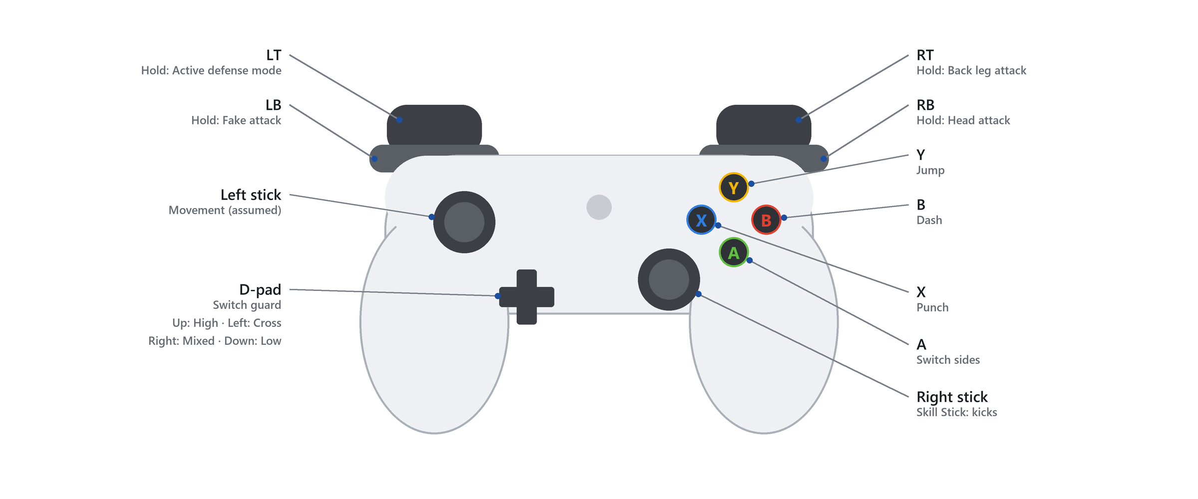
Inputs are written in Xbox button names; the PlayStation equivalents map one to one. The left stick is not assigned yet, so movement is assumed (18.1).
Input | Function
Left stick | Movement (assumed)
Right stick | Skill Stick: kicks (7.2)
Hold | Active Defense Mode
Hold | Back Leg Attack
Hold | Fake Attack
Hold | Head Attack
 | Jump
 | Punch
 | Switch Sides
 | Dash
D-pad | Switch Guard (7.3)

7.2 Skill Stick Moves
Move | Input | Notation
Body Side / Cut Kick |  | RS Up
Roundhouse and Hook Kick |  | RS Left/Right
Axe Kick |  then  | RS Left/Right Quarter Circle Forward, Down
Spin Side Kick | then | RS Down, Up
Spin Hook Kick | + | RT + RS Left/Right Half Circle Down
Tornado Kick | then hold + then release +  | Y, Hold LB + RS Left/Right Half Circle Down, Release LB + RS Left/Right Half Circle Up

Arc icons show one side; each circle motion works from the left or the right.

7.3 Guards
Guard | Input
High Guard | D-pad Up
Cross Guard |  D-pad Left
Mixed Guard |  D-pad Right
Low Guard | D-pad Down

7.4 Input Notes
- Modifiers combine with the Skill Stick. Hold for the back leg and hold for the head, for example hold + for a head roundhouse kick. Kicks without use the lead leg (to confirm, 18.1).
- Legs follow stance. After Switch Sides , the lead and back legs swap and the same inputs still work; the game resolves the physical leg at runtime.
- Distance still decides. The input picks the technique; it never pulls the fighter into range (1.7).
- Accessibility: hold-to-toggle for the four held modifiers [Future] (7.9).

7.5 Screen Flow
TITLE → MAIN MENU → MODE SETUP → FIGHTER SELECT → MATCH → RESULTS
Screen | Contents and flow
Title | Press any button. The first launch goes to Training lesson 1.
Main menu | Play (Sparring, Tournament; Challenges and Referee Mode [Future]), Progress (Training; Career), Connected (Online and Replays) [Future], Customize, Options, Quit
Sparring setup | Players (1P vs AI or 1P vs 2P), ruleset (8.2), AI difficulty, arena
Tournament setup | Bracket size (8, 16 or 32), ruleset (8.2), AI difficulty, arena. The bracket view shows results and the next pairing between matches.
Fighter select | Each player picks a fighter. The side (Chung or Hong) is assigned, never chosen.
Match | Intro ceremony, rounds with the HUD (7.6), 1:00 breaks
Pause | Resume, move list, controls, options, restart, quit match
Results | Winner, round scores, points by technique, penalties; rematch, change fighters or main menu
Training | Lessons, drills with grades, free practice (3.2)
Career | Season calendar, training, event entry, grading and post-match review (section 4)
Customize | Fighter creator (section 10) with gear on and off preview
Options | Settings in 7.8

Wireframe mockups for each screen are not drawn yet (18.1).

7.6 HUD
Element | Position | Contents
Scoreboard | Top centre | Chung score in blue on the left, Hong in red on the right, round and clock in the centre, modelled on the PSS display
Penalties | Under each score | Gam-jeom count for that side
Stamina | Under each fighter’s name | One bar per fighter; turns amber below 25
Score pop-up | Above the scoring fighter | Points scored (+1 to +6), shown for 1.0 s
Referee subtitle | Lower centre | Korean command and English meaning, for example KAL-YEO: Break
Input display and debug overlay | Left and right edges | Training only: controller icons for the last input, leg, move, target, stamina, hit result
Video review cards [Future] | Beside each score | One card per corner

7.7 Help System
- Training lessons: step-by-step tutorials whose prompts show the controller icons and wait for the correct input (3.2).
- Move list: in the pause menu and Training; every technique with an input, its icons and points (section 9).
- Input display: shows the player’s stick gestures and buttons as icons in Training, so a failed input is visible.
- Loading tips: one rule or technique tip per loading screen.
- Coach feedback: drills recommended from recent match statistics.

7.8 Game Options
Option | Settings
Audio | Master, effects, referee voice, crowd and music volume, each 0–100
Video | Resolution, window mode, quality preset (low, medium, high, epic), frame-rate cap (30, 60, 120, unlimited), V-sync
Controls | Vibration on or off; Skill Stick dead zone; gesture window 0.20–0.40 s (default 0.25 s)
Saving | Settings and created fighters save automatically when changed
Career saving | Autosave after every event and at the end of every week; three career slots
Remapping and hold-to-toggle [Future] | See 7.9

7.9 Accessibility
The game is English only: all text, menus and voice-over. Korean referee commands and rank names are kept as the sport’s own terminology, always with English on screen.
- English subtitles for the Korean referee commands.
- Sides shown by position and label, not by colour alone: Chung on the left, Hong on the right, both labelled in text.
- Full button remapping, and hold-to-toggle for the four held modifiers (7.4) [Future].
- Reduced camera motion and screen-shake options [Future].
- Audio cues for incoming attacks and for stamina state [Future].

8 Core Sparring Systems
The systems that make a sparring match: the systems v1.0 needs. The technique list is section 9 and the data behind each technique is 16.3.

8.1 Systems Overview
System | Intent | Type
Match format (8.2) | Matches play like real WT sparring, so practitioners recognize them and tactics transfer | Player-facing
Scoring (8.3) | Harder, riskier techniques earn more points, as in the sport | Player-facing
Hit detection | Only clean, in-range contact during the active phase scores, so distance matters | Internal
Penalties (8.4) | Stops boundary running, stalling and illegal contact | Player-facing
Referee (8.5, 11.2) | Frames the match with the sport’s etiquette and commands | Player-facing
Skill Stick (8.6) | Kick choice is a readable stick gesture; held modifiers choose leg and target | Player-facing
Input recognition and buffer | Turns stick gestures and modifier holds into techniques within a 0.25 s window | Internal
Stance and guards (8.7) | Lead and back legs create open and closed stance matchups; guards change posture | Player-facing
Active defense (8.8) | A held defensive state for answering attacks | Player-facing
Stamina (8.9) | Limits repeated high-commitment techniques without locking controls | Player-facing
Combat state machine | Startup, active and recovery phases create counter windows | Internal
Hit reactions (8.10) | Hits read clearly while the match keeps flowing | Player-facing
AI opponent (11.1) | A sparring partner that uses real tactics | Internal
Video review (8.11) [Future] | Players challenge a missed call, as coaches do | Player-facing

8.2 Match Format
The default ruleset follows World Taekwondo (WT) sparring. Values here are the game’s reference; confirm them against the current WT Competition Rules before locking a release, and update them when WT revises its rules.
Rule | Default | Options
Rounds | Best of 3 | Single round, best of 3
Round length | 2:00 | 1:00 · 1:30 · 2:00
Break between rounds | 1:00 | Skippable in local play
Round win | Most points at time, or point gap | Point gap on/off
Point gap | 12 points | Off · 12 · 20
Contest area | Octagonal mat with boundary line | Arena choice
Sides | Chung blue and Hong red | Assigned per match, never chosen as a colour

8.3 Scoring
Hits register the way the electronic protector and scoring system (PSS) does: the trunk protector needs a valid kick above an impact threshold or a valid punch, and the head needs valid kick contact. In game, a hit registers when the attacking limb’s trace reaches the target zone during the active phase with enough impact.
Technique | Target | Points
Punch | Trunk protector | 1
Kick | Trunk protector | 2
Spinning kick | Trunk protector | 4
Kick | Head | 3
Spinning kick | Head | 6
Opponent penalty (감점 gam-jeom) | — | +1

Tie-breaks follow WT order (higher-value techniques first, then referee decision). Verify the current tie-break order and per-round penalty limit.

8.4 Penalties
A gam-jeom gives the opponent one point, and a fighter who reaches the penalty limit loses the round. Penalties the game detects:
- Stepping both feet over the boundary line.
- Falling down, when not caused by an opponent’s penalized action.
- Avoiding or delaying: turning the back, crouching, or not engaging (a passivity timer).
- Lifting the leg to block or impede kicks for more than 3 seconds.
- Kicking below the waist, or striking the head with the hand.
- Grabbing, holding or pushing, detected from contact in a clinch.

8.5 Referee Commands
Command | Meaning | Command | Meaning
CHARYEOT 차렷 | Attention, before the bow | KAL-YEO 갈려 | Break, fighters separate
KYEONGRYE 경례 | Bow | KYE-SOK 계속 | Continue
JOON-BI 준비 | Ready | KEU-MAN 그만 | Stop, end of round
SHI-JAK 시작 | Start, the clock runs | GAM-JEOM 감점 | Penalty declared
HANA … YEODEOL 하나 … 여덟 | Knockdown count, one to eight

8.6 Skill Stick
The right stick is the Skill Stick. A direction or motion chooses the kick (7.2); held modifiers change it: kicks with the back leg, aims at the head and turns the input into a fake attack. Every technique with an input is listed in section 9.
Animation flow for every kick (captured, then driven by gameplay):
BOUNCE → CHAMBER → TECHNIQUE → RECHAMBER → LAND → BOUNCE

8.7 Stance and Guards
- Stances: Left Lead and Right Lead. Switch Sides plays a visible switch animation; the fighter is never instantly mirrored. Open and closed stance matchups emerge from positioning.
- Guards differ in posture, readiness and transition timing, not stat bonuses. Each guard’s posture and strengths are not defined yet (18.1). All four guards ship in v1.0; their inputs are in 7.3.

8.8 Active Defense
Holding puts the fighter in Active Defense Mode. What the mode does (blocking, parrying, evading, or reading the Skill Stick as defensive directions) is not defined yet (18.1). Candidates are arm blocks to the head and body, a sway, a leg check and stepping out of range.

8.9 Stamina
Stamina is short-term explosiveness. Low stamina lengthens recovery and reduces explosiveness; it never locks out controls.
Action or state | Effect | Starting value
Stamina pool | — | 100 (Equal Terms; the Stamina attribute changes it in Career)
Normal footwork and bouncing | No cost | 0
Punch | Small cost | 3
Basic kick | Small cost | 8
Dash | Moderate cost | 12
Jump or spinning kick | High cost | 20
Tornado kick | Highest cost | 30
Low stamina | Longer recovery, less explosive techniques | Below 25: recovery phases 30% longer, impact 20% lower
Regeneration | Starts after low activity | 15 per second after 1.0 s without spending stamina
Round break | Refill | Back to 100

Starting values for the Milestone 2 prototype, tuned in playtests (18.1).

8.10 Hit Reactions
Severity | Response | Control lost
Minor | Additive torso or head reaction; movement continues | 0 s
Normal | Partial or full-body reaction | 0.3–0.5 s
Heavy | Captured stagger or loss of balance | 0.8–1.2 s
Knockdown | Captured fall, grounded state and get-up | 2.5–4.0 s
Physical falls [Future] | Animation-to-ragdoll blend for off-balance falls | As knockdown

8.11 Video Replay Request [Future]
Each corner has one video review per match. During a stoppage a player can challenge a missed score or a penalty; the game replays the exchange from scoring data. A successful challenge corrects the score and keeps the review.

8.12 Rulesets [Future]
- Custom rules: round count and length, point values, point gap, penalty limits, saved as named presets and shareable online.
- Historical WT rules: earlier scoring eras for exhibition matches.
- Other styles: additional sparring formats (for example ITF-style continuous point sparring) as separate rulesets with their own gear and techniques, if licensing and research allow.

8.13 Epics and User Stories
v1.0 work breaks down into these epics. Each story is a testable requirement for its milestone (section 20).
Epic | User stories | Milestone
E1 Skill Stick input | As a player, I push the right stick up to throw a side kick, and hold RT to throw it with my back leg.  As a player, I see my last input as controller icons on the input display, so I know why a kick did not come out. | M1
E2 Stance and legs | As a player, after I switch sides with A, holding RT still kicks with my new back leg. | M1
E3 Combat states and hit detection | As a player, a kick that reaches the protector during its active phase scores, and a kick thrown from out of range misses. | M1
E4 Motion capture pipeline | As the developer, I turn one captured roundhouse kick into a retargeted MetaHuman animation in Unreal, by whichever capture method Milestone 1 selects. | M1
E5 Match rules and scoring | As two players, we play a best-of-3 match with 2:00 rounds, WT point values, penalties and a 12-point gap. | M2
E6 Stamina | As a player, repeating spinning kicks drains my stamina and slows my recovery, but I never lose control. | M2
E7 Local versus | As two players with two controllers, we finish a full match on one console. | M2
E8 Production animation | As a player, techniques, transitions and reactions use production mocap and blend without visible pops. | M3
E9 Game flow and UI | As a player, I go from the title screen through setup, a match and results, and back, without restarting the game. As a solo player, I run a local tournament bracket to its final, with AI fighters filling every slot no player takes. | M4
E10 AI opponent | As a solo player, I spar an AI that manages distance, fakes and counters at a difficulty I choose. | M4
E11 Training mode | As a new player, I finish the six Training lessons listed in 3.2. | M4
E12 Career season | As a career player, I plan a training week, enter a tournament, pass a grading exam, and see my rank, ranking points and newly unlocked techniques change. | M4
E13 Balance and polish | As a tester, my beta feedback changes MoveData tuning values without code changes. | M5

9 Techniques
Every technique with an input, its points and the input that performs it; techniques still waiting on an input are in 9.4. Points follow 8.3. Holding RB takes any kick to the head for the head point value (punches ignore RB and only score to the trunk), so each table gives the body value first and the head value where the technique can reach it.

9.1 Kicks
Technique | Target · points | Input | Notation
Side kick / cut kick | Body · 2 / Head · 3 |  | RS Up; RB for the head
Side kick, back leg | Body · 2 / Head · 3 | Hold + | RT + RS Up; RB for the head
Roundhouse kick | Body · 2 |  | RS Left/Right
Roundhouse kick, back leg | Body · 2 / Head · 3 | Hold + | RT + RS Left/Right; RB for the head
Roundhouse kick, head | Head · 3 | Hold + | RB + RS Left/Right
Hook kick | Body · 2 / Head · 3 | Hold + (which direction gives the hook: 18.1) | RS Left/Right; RB for the head
Axe kick | Head · 3 | then | RS Left/Right Quarter Circle Forward, Down

9.2 Spinning and Jumping Kicks
Technique | Target · points | Input | Notation
Spin side kick | Body · 4 / Head · 6 | then | RS Down, Up; RB for the head
Spin hook kick | Body · 4 / Head · 6 | + | RT + RS Left/Right Half Circle Down; RB for the head
Tornado kick | Body · 4 / Head · 6 | then hold +  then release + | Y, Hold LB + RS Half Circle Down, Release LB + RS Half Circle Up; RB for the head

Spinning kicks score the higher trunk and head values (4 and 6) when they register as spinning techniques.

9.3 Punches, Movement and Other Actions
Action | Target · points | Input | Notation
Punch | Trunk · 1 |  | X
Fake attack | — | Hold | Hold LB
Active defense | — | Hold | Hold LT
Jump | — |  | Y
Dash | — |  | B
Switch sides | — |  | A
Movement | — | (assumed) | Left stick (assumed)
Switch guard | — | High Cross Mixed Low | D-pad: Up high, Left cross, Right mixed, Down low

Punches only score to the trunk protector; punches to the head are penalized.

9.4 Techniques Not Yet Mapped
These techniques have no input assigned yet: push kick, front kick, fast lead-leg roundhouse, double and triple kicks, 360° and jumping back kicks, close-range kicks in the clinch, arm blocks, sway, leg check and clinch actions. They stay out of the move list until they have inputs (18.1); candidates for a larger move library are in section 17.

10 Customization
Fighters are MetaHuman bodies wearing the dobok and sparring gear, refit to each body. Gear is a removable layer: matches show full gear; menus and Career show the fighter in dobok.

10.1 Options
Category | Options | Rule
Body | Five MetaHuman body types, each with a set height and weight (5.4.2) | Sets reach, build and Career base ratings
Fighting style | Five styles (5.4.3) | Career base ratings; changeable once per season
Face | MetaHuman face presets and blends | —
Skin | MetaHuman skin-tone chart | Real skin tones only
Hair, brows, facial hair | MetaHuman grooms | Natural pigment only; no dye
Eyes | Iris colour per eye, pattern | Natural eye colours only; no tints
Side colour | Chung or Hong | Assigned by the match (10.2)
Belt | Rank colour | Earned rank
Dobok collar | White, black; red-black for poom | Follows rank
Dobok back | Name and country code | As printed on competition doboks
Defaults | Preferred lead leg, starting guard | Starting state only
Gear models [Future] | Helmet, protector, glove and foot-guard styles | Visual only; side colours still apply
Dojang [Future] | Club space, banners, club emblem | Emblems moderated online
Ceremony [Future] | Entrance walk, podium celebration, respectful gestures | No taunts

10.2 Side Colours
The chest protector and helmet are only ever Chung blue or Hong red, and the match assigns the side. There is no colour picker for gear, in any phase. Hong red is #C8102E; Chung blue is the protector’s baked texture colour.

10.3 Natural Appearance
- Skin: MetaHuman skin-tone chart only; no free tint.
- Hair: melanin, redness, greying and lightness only; dye colours stay off.
- Eyes: natural iris presets (dark brown, brown, amber, hazel, green, blue, grey), set per eye; no tints.

10.4 Unlock Sources
- Rank: belt colours, dan collar, signature technique slot.
- Career milestones and challenges: podium poses, medals and gear styles (10.1) [Future].
- Any future paid content is cosmetic only, never ranks, techniques or attributes [Future].

11 Game Objects and AI

11.1 AI Opponents
Feature | Description
Difficulty levels | Reaction time, read accuracy, stamina management and technique variety scale by level
Uses real tactics | Manages distance, fakes, guards, counters and the boundary instead of reading inputs
Fighter styles | The fighting styles in 5.4.3: all-rounder, counter fighter, pressure fighter, head-kick specialist, cut-kick blocker
Rivals | Named Career opponents who can switch fighting style between seasons, like the player (5.4.3)
Adaptive AI [Future] | Learns a player’s habits within a match (favourite kick, stance, timing) and adjusts
Shadow fighters [Future] | AI trained from a player’s own matches that friends can spar against offline

11.2 Officials
The referee is a non-playable character on the mat. Six referees built from MetaHuman presets (Kelvin, Bo, Jorge, Omari, Walter and Vivian) wear a light-blue shirt, navy tie, beige trousers, brown belt and white sneakers (1.10). Each match picks one at random. The referee speaks only the commands in 8.5. In Referee Mode the player controls the referee instead [Future] (3.5).
Situation | Referee behaviour
Match start | Calls charyeot, kyeongrye, joon-bi and shi-jak from between the fighters, then steps back
During play | Moves to keep both fighters in view without blocking the camera
Clinch | Calls kal-yeo, steps between the fighters, then calls kye-sok
Penalty | Stops play with kal-yeo and declares gam-jeom toward the penalized fighter, including for stalling (8.4), then calls kye-sok
Knockdown | Counts hana to yeodeol (one to eight) while the fighter gets up, then calls kye-sok
End of round and match | Calls keu-man; at match end raises the winner’s hand

11.3 Equipment and Props
Object | Attributes and values | Behaviour
Trunk protector (PSS) | Side colour Chung or Hong; impact threshold (value unresolved, 18.1) | Registers a kick above the threshold, or a punch, as a score (8.3)
Helmet | Side colour Chung or Hong | Registers valid kick contact to the head
Foot guards and gloves | White | Carry the limb traces that score
Mat and boundary | 8 m octagon in a 12 m square | Boundary check on both feet (8.4)
Arena scoreboards | Up to four screens; one portable scoreboard at the club dojang (6.2) | Mirror the HUD scoreboard
Kicking paddles and reaction targets | Height and timing set per drill | Light up to show the target; grade speed and accuracy
Training dummy | Stands still or loops a recorded movement | Free practice target

Technique and object values live in a MoveData data table (16.3) that exports to CSV for review. The table does not exist yet (18.1).

12 Online and Community [Future]
Feature | Description
Rollback netcode | Responsive 1v1 online play; requires deterministic combat simulation (16.3)
Casual and private rooms | Quick match, invite codes, rematch
Ranked seasons | Skill rating; season rank shown on a nameplate, never as a belt
Fair play | Disconnect penalties, report tools, name and emblem moderation
Clubs | Online dojangs with members, internal ladders and club-vs-club team events
Community tournaments | Organizer tools, brackets, check-in, broadcast mode (3.4)
Cross-play | PC and consoles in one player pool

13 Presentation
- Match intro: fighters enter in full gear, then the referee’s opening commands (11.2).
- Camera: side-on combat camera that keeps both fighters and the boundary in frame; 1.5 s cuts on spinning-kick scores.
- Menus: the player’s fighter out of gear in dobok, in a dojang or locker-room setting.
- Arenas: the six Career venues, one for each tournament tier, listed in 6.2.
- Commentary [Future]: play-by-play and colour commentary.

14 Localization
- Plan: English only, in every phase. No other language is planned.
- Korean terminology: referee commands, rank names and technique names appear in romanization with English meaning, for example KAL-YEO 갈려: Break. They are the sport’s terms, not translations.
- String syntax: all player-facing text is FText stored in Unreal String Tables, never hard-coded in Blueprints or C++. Values inside strings use FText::Format arguments, for example {Points}.
- String tables: ST_UI, ST_Techniques, ST_Referee and ST_Career, in Content/Localization/StringTables (planned; the folder does not exist yet).
- Key names: Area.Group.Item, for example UI.MainMenu.Play, Technique.RoundhouseKick.Name, Referee.KalYeo.Subtitle.
- External files: none; String Tables export to CSV for proofreading.

15 Tools
Tool | Purpose | Location
MetaHuman Creator | Fighter and referee bodies, faces, skin, hair and eye presets | Unreal Engine 5.8 plugin
Blender pipeline scripts | Rig, split, mask and refit the dobok and gear onto MetaHuman bodies; bake hidden face maps; build referee outfits and environment meshes | Tools/Blender
Unreal Python scripts | Create fighters and referees, import gear as wardrobe items, set up Chaos cloth, run range-of-motion tests, build the arena and dojang levels | Tools/Unreal
Environment texture generator | Mat and venue textures | Tools/Environment
OpenStanceEditorTools | C++ editor module that exposes cloth creation to Python | Source/OpenStanceEditorTools
Motion capture solver | Turns recorded performance into skeletal animation. Neither the capture method nor the solver is chosen; Milestone 1 compares them | External
IK Rig and IK Retargeter | Retarget mocap onto the MetaHuman skeleton | Unreal Engine
MoveData table | Technique timing, stamina cost, points, target and range, editable without code | Unreal Engine (planned)
Combat debug overlay | Input icons, leg, move, target, stamina, hit result and score in play | In game (planned)
Perforce Helix Core and P4V | Version control for the Unreal project, with binary asset locking | AWS EC2

16 Technical Design

16.1 Stack
Area | Choice
Engine | Unreal Engine 5.8 (source build), OpenStance.uproject
Characters | MetaHuman Creator; dobok and gear as outfit pieces refit per body (Tools/Blender)
Skeleton | MetaHuman body skeleton; gear follows with Leader Pose; mocap retargets with the IK Retargeter
Motion capture | Method not yet chosen. Markerless video capture (MetaHuman Animator, Rokoko Vision) and suit-based capture are both candidates; the Milestone 1 feasibility test decides (18.1, section 19)
Version control | Perforce Helix Core on AWS for the project; Git for tools, docs and portfolio

16.2 Animation Architecture
Need | Approach
Continuous movement | Animation Blueprint and Blend Spaces
Committed attacks | Animation Montages
Hit windows | Anim Notifies driving limb traces and scoring windows
Guards | Layered Blend Per Bone
Mocap retargeting | IK Rig and IK Retargeter
Foot planting | IK correction
Range alignment | Limited Motion Warping
Minor reactions | Additive or layered reactions

16.3 Data and Simulation
- MoveData: animation, input gesture and modifiers, startup / active / recovery timing, stamina cost, point value, target, range, reaction properties. Separate from animation assets so placeholders swap for final mocap without changing combat logic.
- Fighter runtime state: stance, guard, lead and back leg, held modifiers (active defense, back leg, fake, head), combat state, stamina, score, match state.
- Combat states: Idle/Movement, Attack Startup, Attack Active, Attack Recovery, Active Defense, Hit Reaction, Staggered, Knocked Down, Recovering, Match Finished.
- Fighter profile: appearance, body type and fighting style; level, XP, rank, attributes, unlocked techniques and career save.
- Deterministic combat step [Future]: fixed-tick combat simulation separated from rendering and animation, so rollback netcode and input-based replays are possible. Combat code in v1.0 is structured so this refactor stays small.
- Services [Future]: accounts, matchmaking, ranked seasons, club and tournament backend.

16.4 Major Technical Risks
Risk | Mitigation
Capture struggles with fast kicks and spins | Early feasibility test on a roundhouse kick and a spin hook kick, comparing capture methods and solvers before production (section 19)
Animation workload grows too large | Shared transitions, layering, mirroring and a tightly scoped move list
Mocap looks authentic but attacks feel unresponsive | Gameplay timing separate from performance timing: montages, notifies, limited blending and warping
Physics and ragdoll take too long | Authored mocap falls in v1.0; animation-to-ragdoll blending is Future work (8.10)
Skill Stick gestures are hard to perform or misread | Prototype gesture recognition first, with an input-icon debug display and practitioner playtests
Scope grows beyond v1.0 | Online play, online tournaments, challenges, replays, video review and a large roster are Future work (section 17)
A console release needs certification | The game targets PlayStation 5 and Xbox Series X|S but is built on Windows, and developer accounts, devkits and certification are not in place (18.1). Windows stays the demonstration platform until they are, and nothing in the design depends on a console-only feature.
Career is a second mode for one developer | Career reuses the sparring core rather than adding systems: the same match, AI, contest area and scoring, with a calendar, grading and brackets on top. Its events and venues are data and set dressing, so it scales down to fewer events without code changes, and any venue not built falls back to the competition arena (sections 4, 5 and 6.2).

16.5 Project Structure and Naming
Path | Contents
Content/Characters/Fighters | Base fighter, gear wardrobe items, hidden face maps
Content/Characters/Officials | Referees and their outfits
Content/Environment | Materials, meshes and textures
Content/Maps | L_CompetitionArena, L_TrainingDojang; the Career venues in 6.2 are planned
Source/OpenStance | Runtime game module: combat, match, input, AI
Source/OpenStanceEditorTools | Editor-only C++ helpers
Tools/Blender, Tools/Unreal, Tools/Environment | Pipeline scripts (section 15)
Resources | Source art: models, references, textures
Docs | Design documentation

Asset prefixes follow the Unreal conventions already used in the project: L_ levels, MH_ MetaHumans, SK_ skeletal meshes, M_ materials, MI_ material instances, T_ textures, WI_ wardrobe items. Planned: DT_ data tables, AM_ animation montages, ABP_ animation blueprints, BS_ blend spaces, ST_ string tables.

16.6 Data Formats
- MoveData: an Unreal Data Table of a C++ row struct, one row per technique; exports to CSV.
- Saves: settings and fighter profiles as Unreal SaveGame objects; Career slots use the same format.
- Animation and gear imports: FBX in centimetres (UnitScaleFactor 1), matching the MetaHuman export.
- Replays [Future]: input and scoring-event streams replayed by the deterministic combat step (16.3).

16.7 AI and Autonomous Systems
The AI opponent (11.1) sends the same inputs as a player and uses the same MoveData; it never reads the player’s inputs. Planned structure: a State Tree picks a tactic (keep distance, pressure, fake, counter) and a utility score picks a technique from distance, stamina, score and clock. Difficulty scales reaction time from 450 ms at the easiest level to 180 ms at the hardest (starting values), read accuracy, stamina management and technique variety. The game needs no procedural world, no pathfinding beyond the mat and no economy.

16.8 Test Cheats
Unreal console commands, in development builds only.
Command | Effect
os.InfiniteStamina 0|1 | Stamina never drains
os.SetScore <Chung> <Hong> | Sets the score
os.SetClock <seconds> | Sets the round clock
os.AIMode idle|block|mirror|normal | Freezes or scripts the AI
os.ShowHitboxes 0|1 | Draws limb traces and target zones
os.CombatDebug 0|1 | Shows the combat debug overlay with input icons
slomo <scale> | Unreal time dilation, for example slomo 0.25
os.SetRank <rank> | Sets Career rank and its unlocks

17 Ideas and Expansions
Everything beyond v1.0. Throughout this document a [Future] tag marks a deferred feature where it belongs in a system, so each system reads as a whole; this section summarizes them.
v1.0: What this capstone delivers | Future: Every sparring format
Sparring, Training and local Tournament  Career: calendar, training, grading, career events  Levelling, ranks, attributes, technique unlocks  AI opponent, competition arena and training dojang  Career venues for event tiers 1 to 6 | Online casual and ranked, rollback netcode  Challenges and Replays  Video review; animation-to-ragdoll falls  Larger move library, including the techniques in 9.4  Accessibility options: remapping, reduced motion, audio cues  Team Championship, para gyeorugi, cadet and junior careers  Clubs, community tournaments, broadcast  Adaptive and shadow AI  Custom and historical rulesets (8.12)  Commentary (13)  Gear styles, dojang and ceremony customization (10.1)  Ageing, retirement, hall of fame and the world games (4.2, 4.4)  Referee Mode with its own controls (3.5)  PC release and cross-play

17.1 Later Platforms
- PC release on Steam, with keyboard play and full remapping.
- Cross-play across PlayStation, Xbox and PC.

18 Unresolved Questions
Open questions are listed here. When one is resolved it moves to 18.2 with a link to the section that answers it; it is never deleted.

18.1 Open
Controls
- Which of RS Left and RS Right gives the roundhouse kick and the other the hook kick, and whether left and right are relative to the opponent or the screen.
- Whether kicks without RT always use the lead leg.
- The spin hook kick lists RT: whether RT is required for it or only selects the back leg.
- The tornado kick holds LB, which is also Fake Attack: how the game tells the two apart.
- What Active Defense Mode (hold LT) does.
- The posture and strengths of the High, Cross, Mixed and Low guards.
- Inputs for movement (left stick assumed), pause and menus, and whether L3 and R3 are used.
- Inputs for the techniques in 9.4, or whether they are cut.
- Playtest the Skill Stick gestures and the 0.25 s gesture window.
Rules and tuning
- Current WT tie-break order and per-round penalty limit.
- Verify WT values: start-mark spacing, the 3-second leg-lift limit, passivity timer length, and the trunk protector impact threshold.
- Number of AI difficulty levels and their tuning values (16.7); AI complexity for v1.0.
- Tune starting values after Milestone 2 playtests: movement (6.4), stamina (8.9), hit reactions (8.10).
- Final move count for v1.0.
- Referee Mode [Future]: tune the referee rating values and the warning (40) and removal (20) thresholds (3.5.1).
- Whether the attributes taller body types give up balance their reach in Career (5.4.2), and whether reach needs its own balancing under Equal Terms, where body type modifiers do not apply (5.6, 10.1).
- Tune the body type and fighting style modifiers, the starting OVR of 64, the attribute caps, and how many hours of Career play it takes to reach OVR 99 (5.4).
Production
- Motion capture method and solver: markerless video capture (MetaHuman Animator, Rokoko Vision) or a suit-based system. Milestone 1 decides (section 19).
- Amount of Motion Warping.
- Natural eye-colour preset values (iris chart sampling in the editor).
- Wireframe mockups for every screen (7.5).
- Create the art and audio asset spreadsheet (1.10) and the MoveData table (16.3).
- Music: commissioned or licensed (1.10).
- Per-platform performance targets, in resolution and frame rate, measured on the Milestone 3 build (1.11).
- Second Half dates once BCIT publishes the 2027 schedule.
- Console developer accounts, devkits and certification for PlayStation 5 and Xbox Series X|S; v1.0 runs on Windows (1.11).
- Belt colour order for release; Career event names.
- Online service provider and the price of a commercial release [Future].
- Licensing path for any real federation branding or events; research partners for para taekwondo [Future].

18.2 Resolved
Question | Resolution | See
Controller layout | Fixed on 2026-09-14 | Section 7
Engine | Unreal Engine 5.8 source build | 16.1
Version control | Perforce Helix Core on AWS; Git for tools, docs and portfolio | 16.1
Scope of the sport | Sparring only: no poomsae, breaking or club-management mode | Section 1
Gear colours | Protector and helmet are only Chung blue or Hong red, assigned by the match | 10.2
Appearance | Natural skin, hair and eye colours only | 10.3
Character skeleton | MetaHuman body skeleton; gear follows with Leader Pose | 16.1
Contest area size | 8 m octagon in a 12 m square | 6.3
Ragdoll | Authored mocap falls in v1.0; ragdoll blending is Future | 8.10
Languages | English only | Section 14
Target platform | Console-first: PlayStation 5 and Xbox Series X|S, developed and demonstrated on Windows | 1.11
Phases | Two: v1.0 is what this capstone delivers, Future is after it | Main page
Weight classes and divisions | Cut for playability: one open division, no gender split. Body types keep a height and weight, which set reach, build and Career base ratings only (5.4.2) | 5.4.2, 10.1
Head modifier | Holding RB takes any kick to the head, for that target’s point value | Section 9

19 Prototypes
No prototypes exist yet. Each one links here when built.
Prototype | Question it answers | Contents | Milestone
Capture feasibility test | Which capture method records fast kicks and spins accurately? | The same back-leg roundhouse kick and spin hook kick through each candidate method and solver; compare supporting-foot pivot, chamber, hip rotation, trajectory, rechamber and landing | M1
Proof of concept | Are the Skill Stick and lead/back-leg model technically feasible? | Greybox arena, mannequin fighters, idle and movement, side kick, roundhouse kick, spin side kick, Skill Stick and modifier recognition, stance-based leg resolution, attack phases, foot traces for head, body or miss, basic scoring and stamina, one retargeted capture | M1
Combat prototype | Does the system create real sparring decisions: faking, countering, distance, body or head? | 5–6 techniques, local two-player combat, stamina, scoring, rounds, active defense, switching sides, guards, combat camera, debug overlay with input icons | M2

20 Development Schedule and Milestones
The capstone runs to five milestones across two halves. The First Half (September to December 2026) covers the proposal and Milestones 1 and 2, and ends with playable demo gameplay; the Second Half (January to spring 2027) covers Milestones 3 to 5, Career and the gold build. Exact Second Half dates are added when BCIT publishes the 2027 schedule (18.1).
Period | Phase | Deliverables
September–October 2026 | Proposal | Requirements, research, architecture, feasibility, scope and test plan
Fall 2026 | Milestone 1 | Skill Stick and motion capture proof of concept (section 19)
Fall 2026 | Milestone 2 | Playable two-player combat prototype: the demo gameplay that closes the First Half (section 19)
December 2026 break | Buffer | Capture preparation, mocap production and cleanup
Winter 2027 | Milestone 3 | Full combat and animation system with the production mocap library
Winter 2027 | Milestone 4 | Complete game flow, AI opponent, local Tournament and the Career season: calendar, training, grading, tournaments and rank-gated technique unlocks
Spring 2027 | Milestone 5 | Beta testing, balancing, polish and requirement verification
Spring 2027 | Final | Gold build, working demo and final report

20.1 Milestone Success Criteria
Milestone | Success criterion
Proposal | Approved proposal
M1 | Two fighters execute techniques via the Skill Stick; one capture proves the pipeline
M2 | Two local players complete a basic sparring match, playable as a demo
M3 | Planned combat playable with natural transitions
M4 | Startup to finished match against a local player or the AI; a Career season playable from the first club night to a tier 3 final
M5 | Requirements verified; ready for demo

Epics per milestone: 8.13. Beyond v1.0: section 17.

21 Change Log
Date | Version | Author | Changes
September 2026 | 0.1 | Joseph Driedger | Preliminary project plan.
2026-09-12 | 0.2 | Joseph Driedger | Earlier draft, built on an older controller layout.
2026-09-14 | 0.3 | Joseph Driedger | Full rewrite, with controller icons and a layout diagram. Adds the main page, player objectives, game world, user interface, game objects, localization, tools, ideas and expansions, prototypes, schedule and change log; starting values for stamina, movement and hit reactions; unresolved questions with a resolved list.
2026-09-19 | 0.4 | Joseph Driedger | Two phases in place of three: v1.0 is what the capstone delivers and Future is everything after it, so only deferred items carry a tag. Online play, online tournaments, video review, challenges, replays and ragdoll blending become Future work; local Tournament against AI opponents stays in v1.0. Retargets the game to console, with Windows as the development platform. Brings Career into the Second Half, with tournament formats, event preparation and rank-gated technique unlocks. Cuts weight classes and gender divisions. Updates scoring to current WT values: a spinning kick to the head scores 6, and spin hook and tornado kicks reach the body as well as the head. Records that holding RB takes any technique to the head, and that the motion capture method is still undecided. Adds a glossary (section 22), controller notation beside the icons in section 9, and console and Career entries in the risk register. Makes the document self-contained and corrects the scope, rank, scoreboard and cross-reference errors listed in 18.2.
2026-09-21 | 0.5 | Joseph Driedger | Adds Referee Mode with its own controls and a referee rating (3.5, 3.5.1); body types with height and weight, fighting styles, an overall rating and an OVR 99 ceiling for every Career fighter (5.4.1 to 5.4.3). Fixes contradictions: multi-season Careers are part of v1.0, holding RB takes kicks but not punches to the head, punches register on the trunk protector, rivals switch style only between seasons, and the podium moment moves to the world series final. Gives every Career tournament tier its own venue (6.2). A second pass adds the knockdown count (8.5, 11.2), head values for side kicks (9.1), Referee Mode in the main menu (7.5) and the missing Future items (17); a third pass corrects a cross-reference in 1.8 and wording in 1.6 and 6.2. The release is now written v1.0.

22 Glossary
Taekwondo, competition and engine terms as this document uses them. Korean terms are romanized, with the hangul where the sport writes it.
Term | Meaning
Active Defense | A held defensive state on LT. What it does is not yet defined (8.8).
charyeot (차렷) | Referee command: attention, called before the bow (8.5).
Chung (청) | The blue side: blue protector, helmet and corner. The match assigns it; it is never a player’s choice (10.2).
closed stance | Both fighters lead with the same leg.
dan (단) | Black-belt grade, counting up from 1st dan (5.3).
dobok | The taekwondo uniform: jacket, trousers and belt.
dojang (도장) | Training hall. The game’s Training mode is set in one (3.2).
Equal Terms | The option that sets every attribute to 70, so skill alone decides the match (5.6).
gam-jeom (감점) | A penalty. It awards one point to the opponent (8.4).
gup (급) | Coloured-belt grade below black belt, counting down from 10th to 1st (5.3).
gyeorugi (겨루기) | Sparring: the competitive, full-contact form of taekwondo, and the only form this game covers (1.1).
hogu | The trunk protector. In competition it is electronic and registers scoring kicks and punches (11.3).
Hong (홍) | The red side: red protector, helmet and corner (10.2).
joon-bi (준비) | Referee command: ready (8.5).
kal-yeo (갈려) | Referee command: break, separating the fighters (8.5).
keu-man (그만) | Referee command: stop, ending the round (8.5).
kye-sok (계속) | Referee command: continue (8.5).
kyeongrye (경례) | Referee command: bow (8.5).
Leader Pose | The Unreal Engine method that makes each gear piece follow the body’s skeleton (16.1).
MetaHuman | Unreal Engine’s photoreal human character system, used for every fighter and referee (16.1).
MoveData | The data table holding each technique’s timing, stamina cost, points, target and range (16.3).
open stance | The two fighters lead with opposite legs, so their trunks face each other and the roundhouse kick is open. The game takes its name from it (1.1).
OVR | Overall rating: the average of a fighter’s eight attributes. Every Career fighter can reach 99 (5.4.1).
poom (품) | Youth black-belt grade, held under 15, with a red-and-black belt (5.3).
PSS | Protector and Scoring System: the electronic protectors and scoreboard that register hits (8.3).
shi-jak (시작) | Referee command: start, and the clock runs (8.5).
Skill Stick | This game’s name for the right stick, which chooses the kick (8.6).
WT | World Taekwondo, the sport’s international federation, whose competition rules the game follows (8.2).

