class042.R

josephelmaghraby

2025-01-16

x<- 1:50  
plot(x,sin(x))

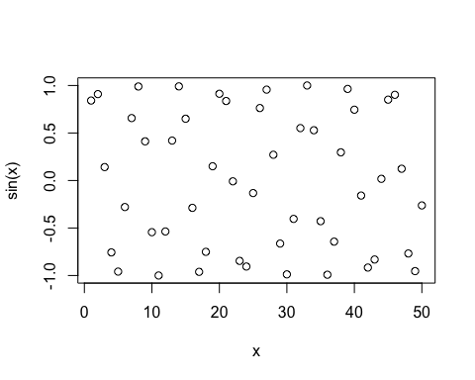

# Make this nicer  
plot(x,sin(x), col="blue", type="l", lwd=3)

