Leather pieces – front side (smooth leather)

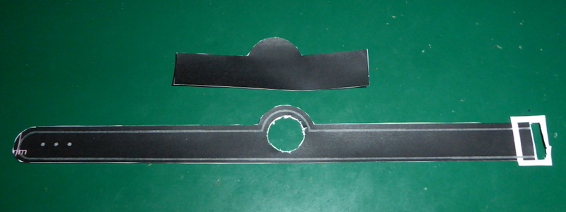

Leather pieces – back side (rough leather)

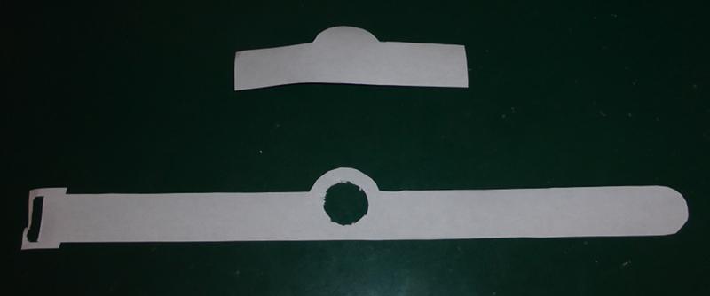

Both parts together:

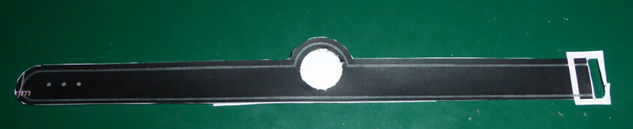

The gray lines are the seams. Sew only along the marked lines.

Finished hatband from behind:

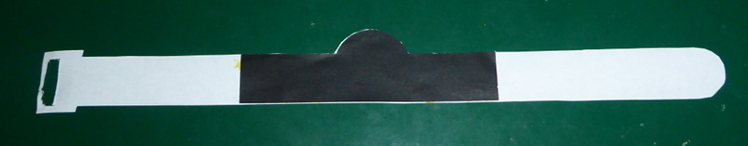

Finished hatband with antenna wire from the front side:

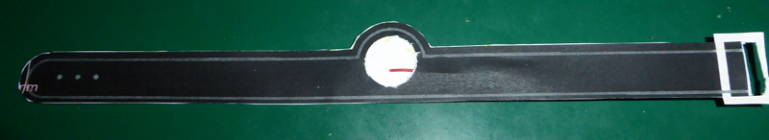

Finished hatband with antenna wire (red) from the back.

