**User Documentation**

**Multiple Choice Quiz Grade Calculator Program**

**Program Name:** Grader.exe

**Programmer:** Joe Ermatinger

**Description:** This program calculates the number of questions a user answered correctly on a multiple-choice quiz as well as their percentage and letter grade they received on the quiz. Input will be accepted from the keyboard and output will be displayed on the screen. The user will be prompted to answer each question with the uppercase letters A, B, C, D, and E. The total number of correct and incorrect answers will be accumulated. The number of correct answers will be used to assign a percentage which will then be used to assign a letter grade. The total number of incorrect answers will be used to warn the user if they make too many mistakes. User input will be validated to ensure they enter only the uppercase letters A, B, C, D, and E. When a wrong answer has been given, the correct answer to that question will be displayed. Once a user has answered more than three questions incorrectly, a warning to be more careful will appear. A progressively stronger worded warning will appear every two mistakes thereafter. The number of questions a user answered correctly are displayed along with their percentage and letter grade.

**Execution Method:** This program may be executed from the command line or executed as part of a batch file.

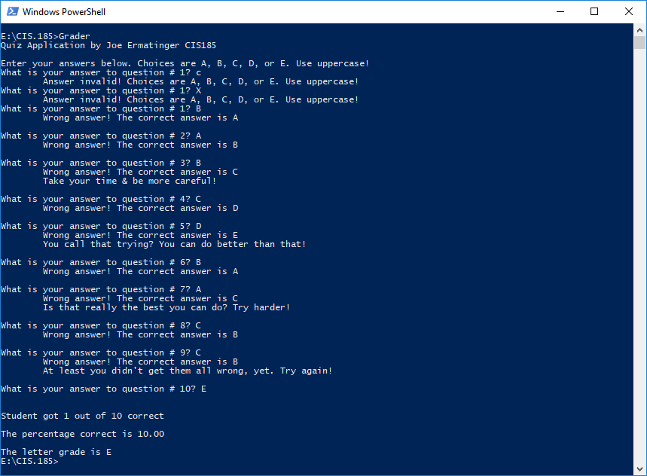**Sample Output:** When executed, the program screen should look like this: