**a)** Reasonable estimates for the prior probabilities are 0.1919 and 0.8081 for the cheetah and background respectively. These values were calculated by dividing the number of elements in the training data for each type by the total number of elements of both sets of training data.

**b)** The values of PX|Y (x|cheetah) and PX|Y (x|grass) can be seen below in Figures 1 and 2 respectively.

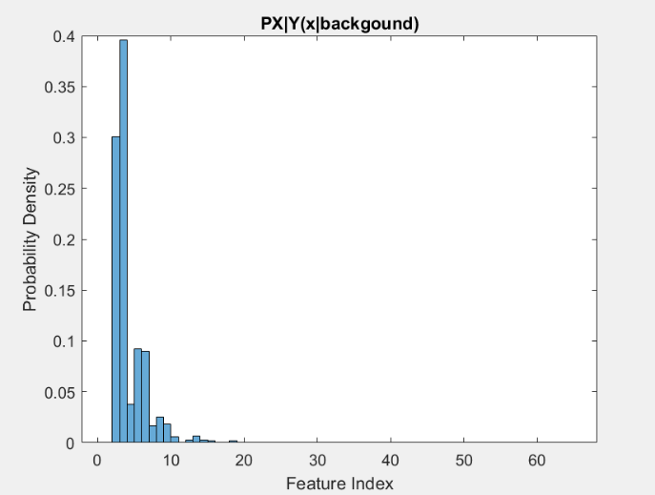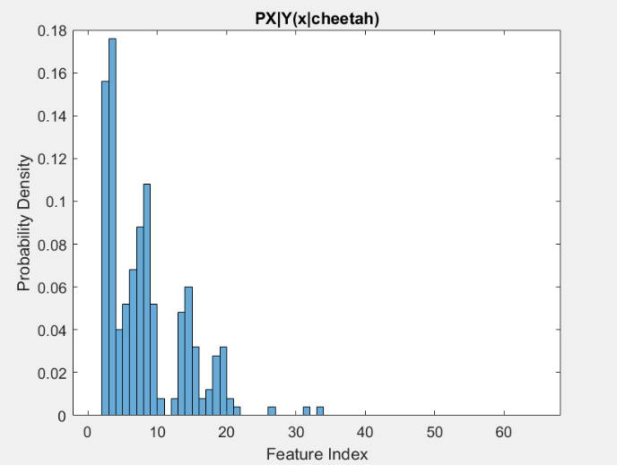

*Figure 1: Histogram of PX|Y (x|cheetah) Figure 2: Histogram of PX|Y (x|grass)*

**c)** Figure 3 was created by combining the data from part a and b and using a 0-1 loss Bayesian Decision Rule

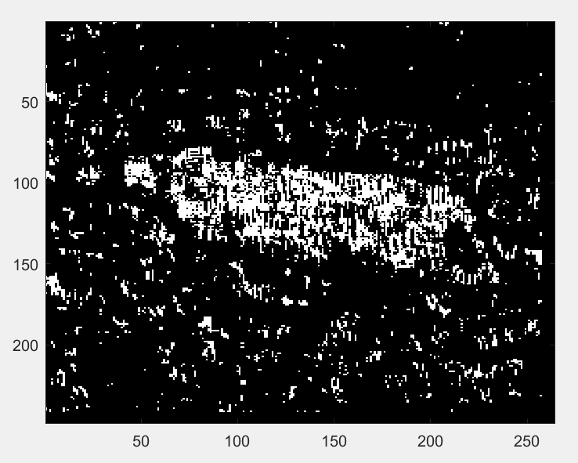

*Figure 3: Picture of state array for each pixel*

**d)** The error probability of the algorithm was computed by plotting the joint probability distributions for the background and foreground together (as seen in Figure 4) and extracting the lesser value for each index value that overlapped (as seen in Figure 5). The sum of the extracted values was computed and resulted in 0.1527, or a 15.27% probability of error. The absolute accuracy of the algorithm was also calculated by tallying the number of pixels in the image in Figure 3 that were in the same state as the pixels in the provided solution mask image and dividing by the total number of pixels in the solution mask image. This resulted in an accuracy of 82.22%, or an error rate of 17.78%.

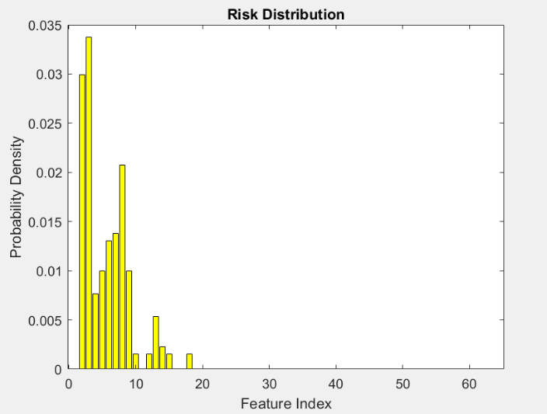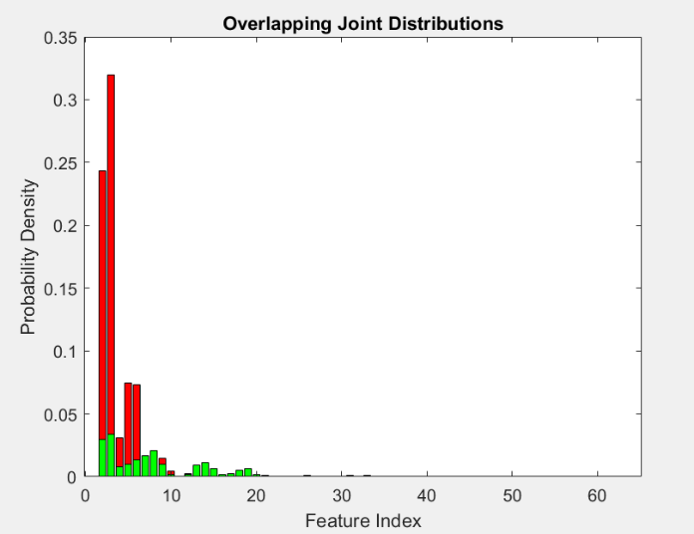

*Figure 4: Overlapping joint distributions Figure 5: Histogram of algorithm risk*