The HR department needs your assistance in creating some queries.

1. Because of budget issues, the HR department needs a report that displays the last name and salary of employees who earn more than $12,000. Save your SQL statement as a file named lab_02_01.sql. Run your query.

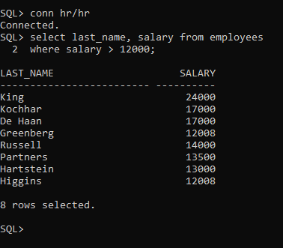

1. Open a new SQL Worksheet. Create a report that displays the last name and department number for employee number 176. Run the query.

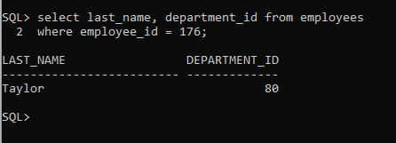

1. The HR department needs to find high-salary and low-salary employees. Modify lab_02_01.sql to display the last name and salary for any employee whose salary is not in the range of $5,000 to $12,000. Save your SQL statement as lab_02_03.sql.

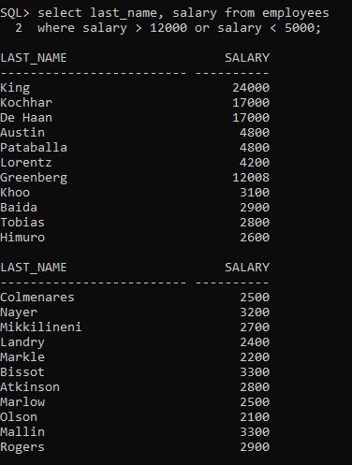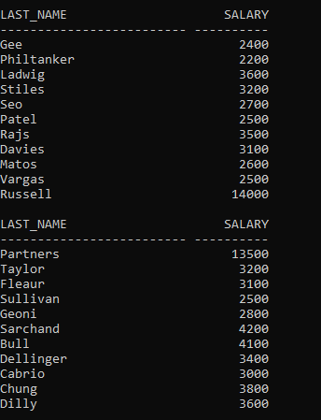

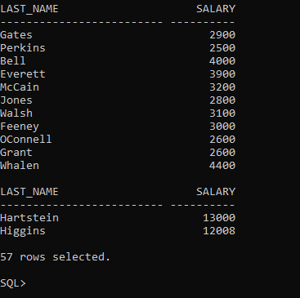

1. Create a report to display the last name, job ID, and start date for the employees with the last names of Matos and Taylor. Order the query in ascending order by the start date.

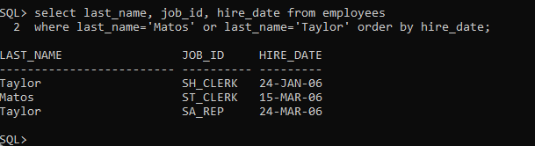

1. Display the last name and department number of all employees in departments 20 or 50 in ascending alphabetical order by name.

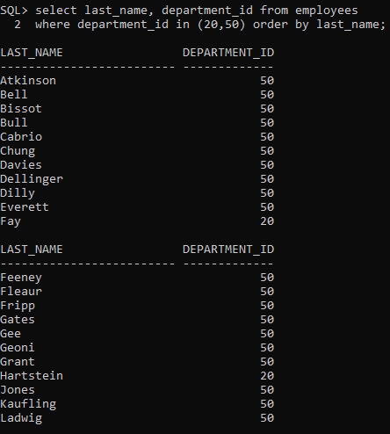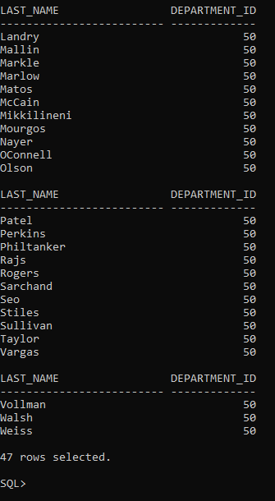

1. Modify lab_02_03.sql to display the last name and salary of employees who earn between $5,000 and $12,000, and are in department 20 or 50. Label the columns Employee and Monthly Salary, respectively. Resave lab_02_03.sql as lab_02_06.sql. Run the statement in lab_02_06.sql.

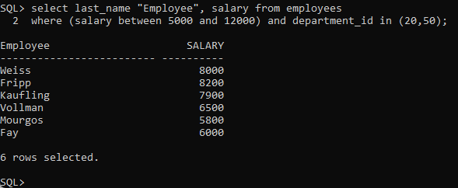

1. The HR department needs a report that displays the last name and hire date for all employees who were hired in 1994.

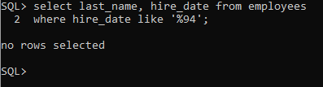

1. Create a report to display the last name and job title of all employees who do not have a manager.

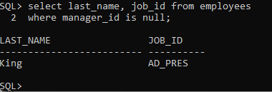

1. Create a report to display the last name, salary, and commission of all employees who earn commissions. Sort data in descending order of salary and commissions.  
   Use the column’s numeric position in the ORDER BY clause.

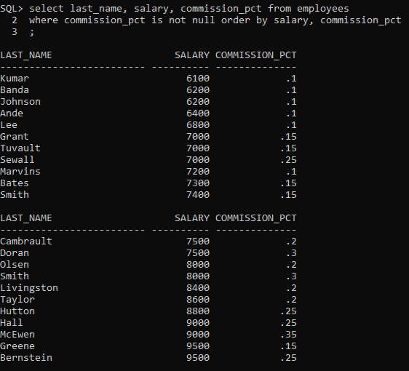

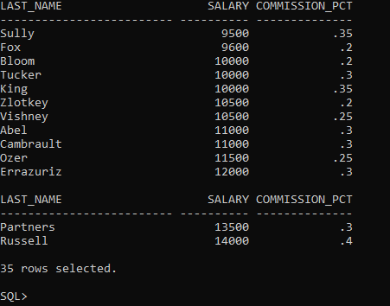

1. Members of the HR department want to have more flexibility with the queries that you are writing. They would like a report that displays the last name and salary of employees who earn more than an amount that the user specifies after a prompt. Save this query to a file named lab_02_10.sql. If you enter 12000 when prompted, the report displays the following results:

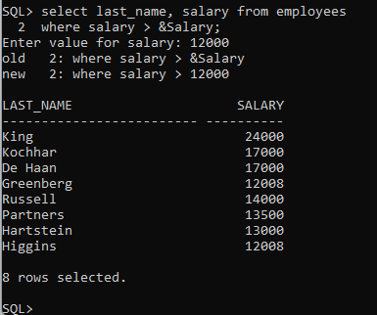

1. The HR department wants to run reports based on a manager. Create a query that prompts the user for a manager ID and generates the employee ID, last name, salary, and department for that manager’s employees. The HR department wants the ability to sort the report on a selected column. You can test the data with the following values:  
   manager_id = 103, sorted by last_name:  
   manager_id = 201, sorted by salary:  
   manager_id = 124, sorted by employee_id:

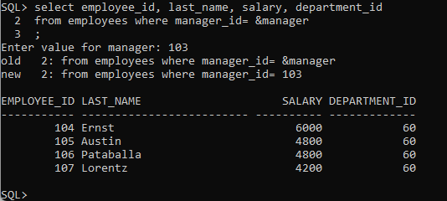

1. Display all employee last names in which the third letter of the name is “a.”

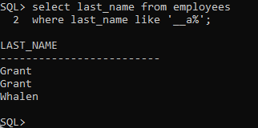

1. Display the last names of all employees who have both an “a” and an “e” in their last name.

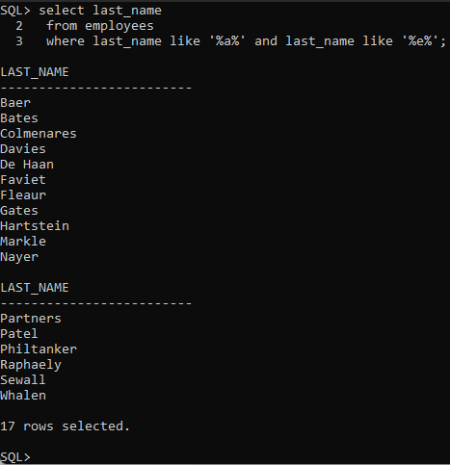

1. Display the last name, job, and salary for all employees whose jobs are either those of a sales representative or of a stock clerk, and whose salaries are not equal to $2,500, $3,500, or $7,000.

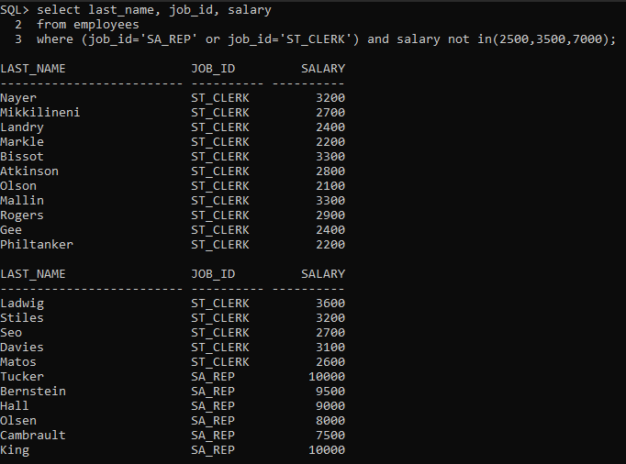

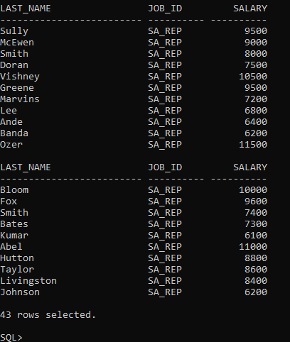

1. Modify lab_02_06.sql to display the last name, salary, and commission for all employees whose commission is 20%. Resave lab_02_06.sql as lab_02_15.sql. Rerun the statement in lab_02_15.sql.

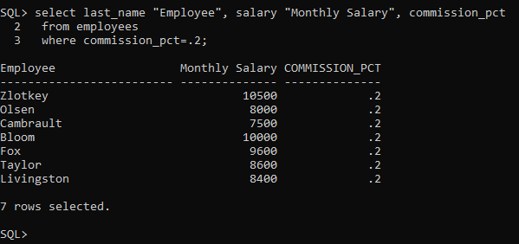

** Put your answers (sql statements & screen capture result) below of each question. Please write down again the question along with your answers.