LAB SESSION 5
TITLE: CLOSURE REPORT
DATE:
Problem Definition:
Create a closure report for the project.
Software used:
Flutter, Firebase, Visual Studio Code, Android Studio, GitHub, Microsoft Word.

Packages/dependencies used:
The various packages/dependencies used in this project are:
- cupertino_icons: Provides iOS-style icons (from the Cupertino design library).
- firebase_core: Sets up Firebase in your Flutter app, allowing access to other Firebase services.
- firebase_auth: Enables Firebase Authentication, supporting login and account management.
- cloud_firestore: Allows interactions with Firebase's Firestore for real-time database functionality.
- intl: Facilitates internationalization and localization, useful for formatting dates, numbers, and text for various locales.
- file_picker: Enables users to pick files (such as PDFs, images, etc.) from the device.
- firebase_storage: Supports storing files in Firebase Cloud Storage.
- google_sign_in: Integrates Google Sign-In for authentication.
- flutter_rating_bar: Offers a customizable rating bar widget.
- provider: A popular state management library in Flutter, useful for managing app state.
- bubble: Adds customizable chat bubbles, ideal for chat or messaging interfaces.
- image_picker: Enables users to pick images from the device's gallery or camera.
- firebase_messaging: Allows handling of push notifications through Firebase Cloud Messaging.
- flutter_lints: Enforces lint rules and helps maintain code quality.
- flutter_test: Provides testing tools for Flutter, covering unit, widget, and integration tests.
- flutter_launcher_icons: Helps in generating app icons for different device sizes.

Theory:
PublicPulse is designed to transform how citizens interact with government departments by creating a streamlined, accessible platform for complaint submission and tracking. The app recognizes the need for a structured, transparent system where citizens feel empowered to report issues and remain actively informed about the progress and resolution of their complaints. This system is intended to promote a responsive and accountable governance model that centers on citizens' voices.

The app offers a centralized hub where users can easily file complaints regarding various civic issues. Instead of the conventional, often cumbersome methods of lodging complaints
such as phone calls, paper forms, or in-person visits—the app allows users to submit complaints directly through their mobile devices. Each submission captures relevant details such as the nature of the issue, specific location, photos, and other pertinent information, providing government departments with comprehensive data for assessing and responding effectively.

A core feature of PublicPulse is real-time status tracking, allowing citizens to monitor the stages of their complaint. The app divides each complaint’s journey into clear stages: Pending, In Progress, and Resolved. This transparent process helps reduce frustration and uncertainty by keeping users informed every step of the way.

The app includes a communication feature that allows government officials to post updates and inform citizens about the progress and resolution of their complaints. This one-way communication function enables department administrators to provide real-time clarifications, share important information, and announce when specific complaints have been resolved.

Finally, PublicPulse includes a structured feedback system that enables citizens to rate their experience based on timeliness, communication quality, and resolution satisfaction. This feature is pivotal in closing the feedback loop, offering government departments valuable insights into their performance and highlighting areas for improvement. Citizens' feedback is a critical component for departments to make iterative changes in their response process, fostering a culture of continuous improvement and accountability.

In essence, PublicPulse isn’t just a tool for complaint submission—it is a transformative approach to governance, creating a connected ecosystem where citizens and government bodies collaborate in real-time to improve public service. This responsive governance model elevates transparency and trust, encouraging citizens to actively participate in the improvement of their communities while providing departments with actionable insights to enhance their service quality.

Key Features:
1. Citizen Registration & Complaint Submission:
• Easy Registration: Citizens can register by providing basic information, including name, email, and contact details.
• Complaint Form: Users can log complaints with relevant details like location, a description of the issue, and optional images. This helps officials understand the concern and respond effectively.

2. Detailed Information Collection:
• Comprehensive Details: Each complaint includes location data, optional images, and descriptive details to provide clarity on the issue.
• Accuracy in Response: Detailed information allows government officials to accurately assess the situation and respond promptly.

3. Real-time Status Tracking:
• Status Updates: Complaints progress through defined stages—such as Pending, In Progress, and Resolved—offering citizens clear insights into their complaint’s current status.
• Continuous Monitoring: Users can actively monitor the status of their complaints by checking the app, ensuring they remain informed and aware of each update throughout the resolution process without needing push notifications.

4. Official Notifications & Chat Feature:
• Department Updates: Upon complaint submission, the relevant department is made aware, allowing for prompt acknowledgment and response.
• Communication Functionality: Administrators can communicate directly with citizens through an in-app chat feature. This allows officials to post updates, clarify details, and inform citizens about the progress of their complaints

5. Feedback System:
• Rating Feedback: Once a complaint is resolved, citizens can rate the resolution based on timeliness, communication, and satisfaction. This feedback helps departments evaluate and improve their service quality.
• Continuous Improvement: Feedback is reviewed by departments to identify improvement areas, promoting accountability..

Benefits:
PublicPulse empowers citizens to voice concerns directly to government departments, creating a bridge for effective complaint management and fostering a responsive governance model. By providing structured status updates—like Pending, In Progress, and Resolved—the app ensures transparent tracking, where citizens can see real-time progress on their complaints. The built-in chat feature enables officials to communicate updates or clarifications directly to citizens, facilitating a smoother resolution process and building trust. Citizens also have the opportunity to leave feedback, helping departments gain insights into service quality and areas for improvement. This feedback, combined with data on complaint trends, provides departments with actionable insights to inform future improvements. The user-friendly mobile interface encourages broad citizen participation, while the app’s structure supports accountability and timely responses, ultimately strengthening the connection between citizens and public services.

Screenshots:
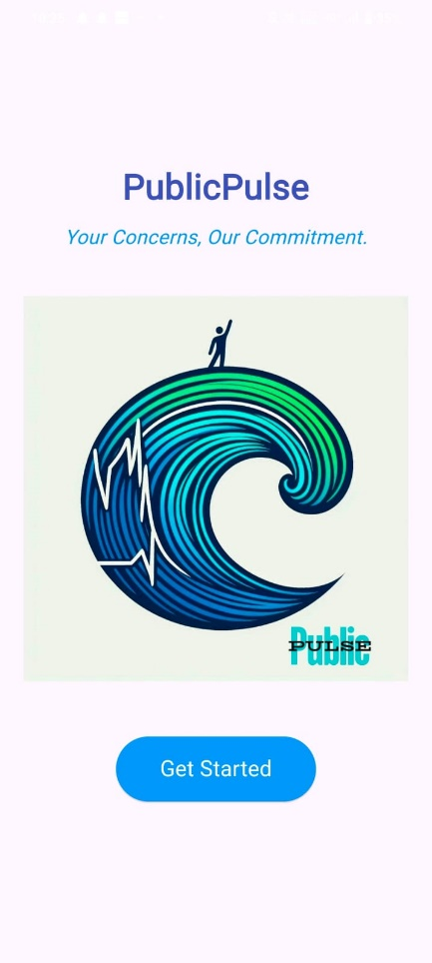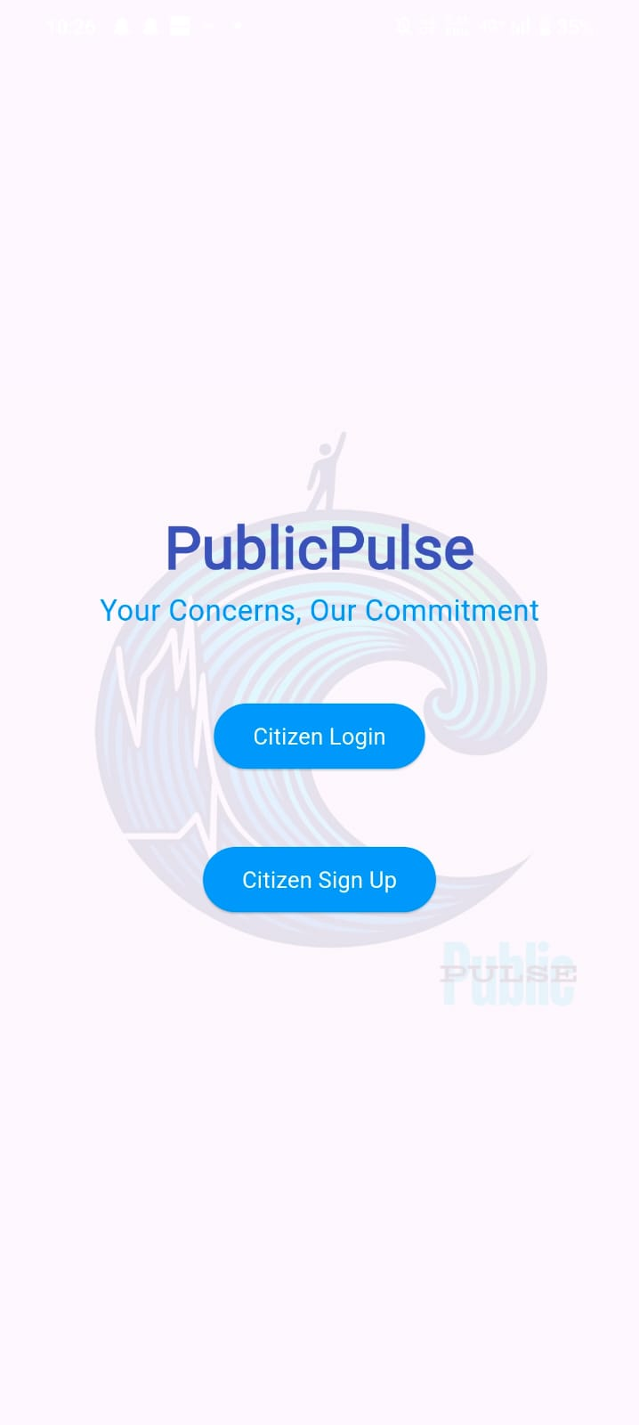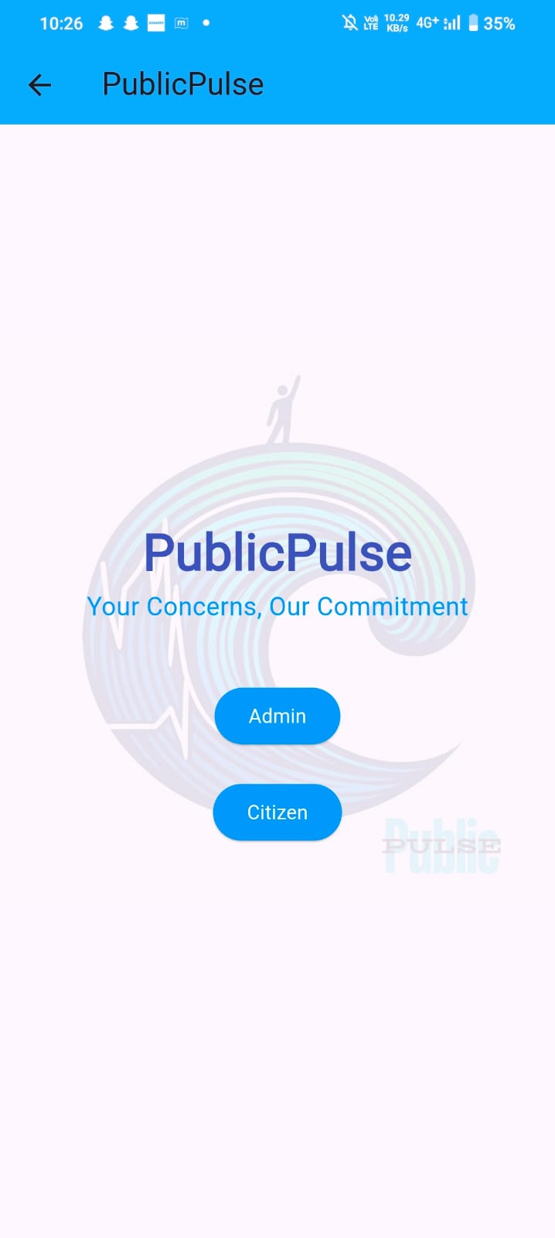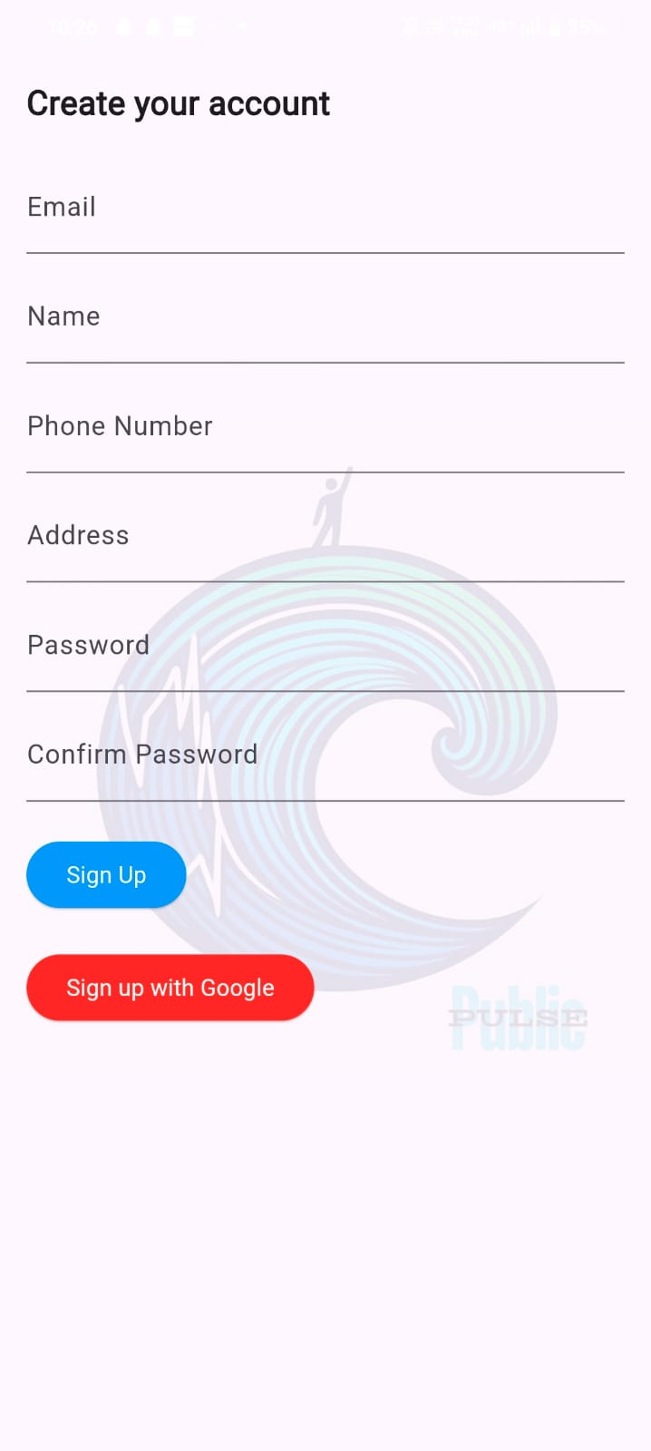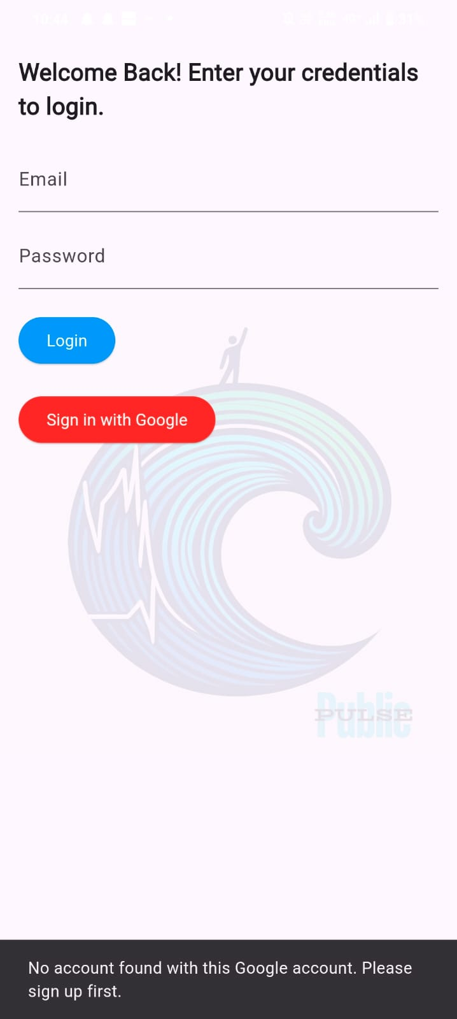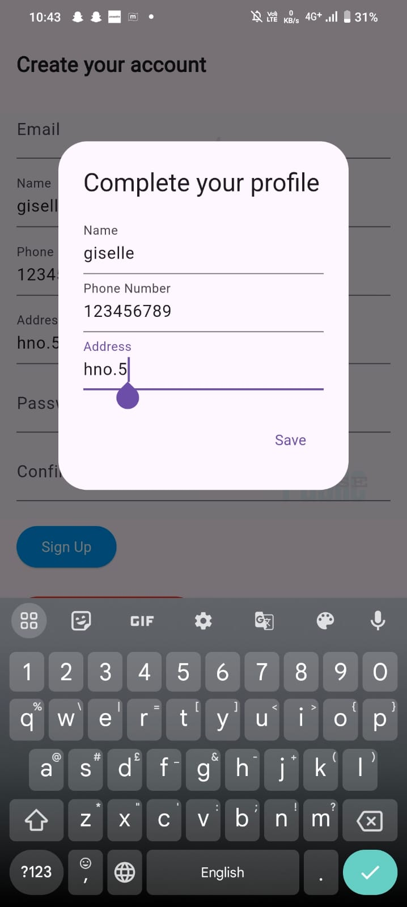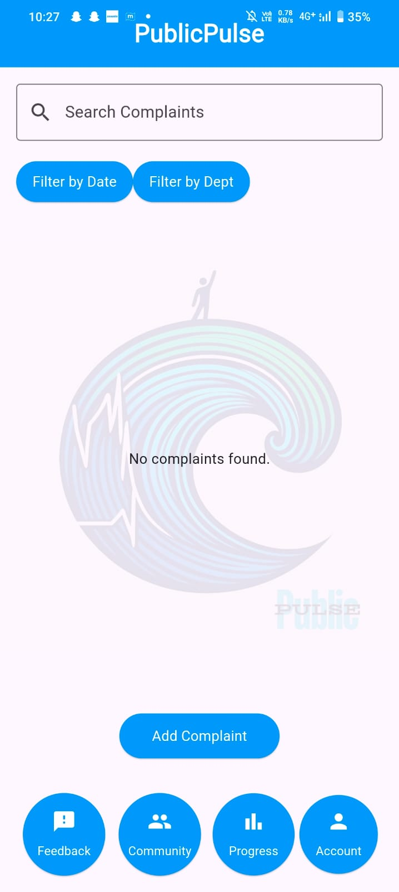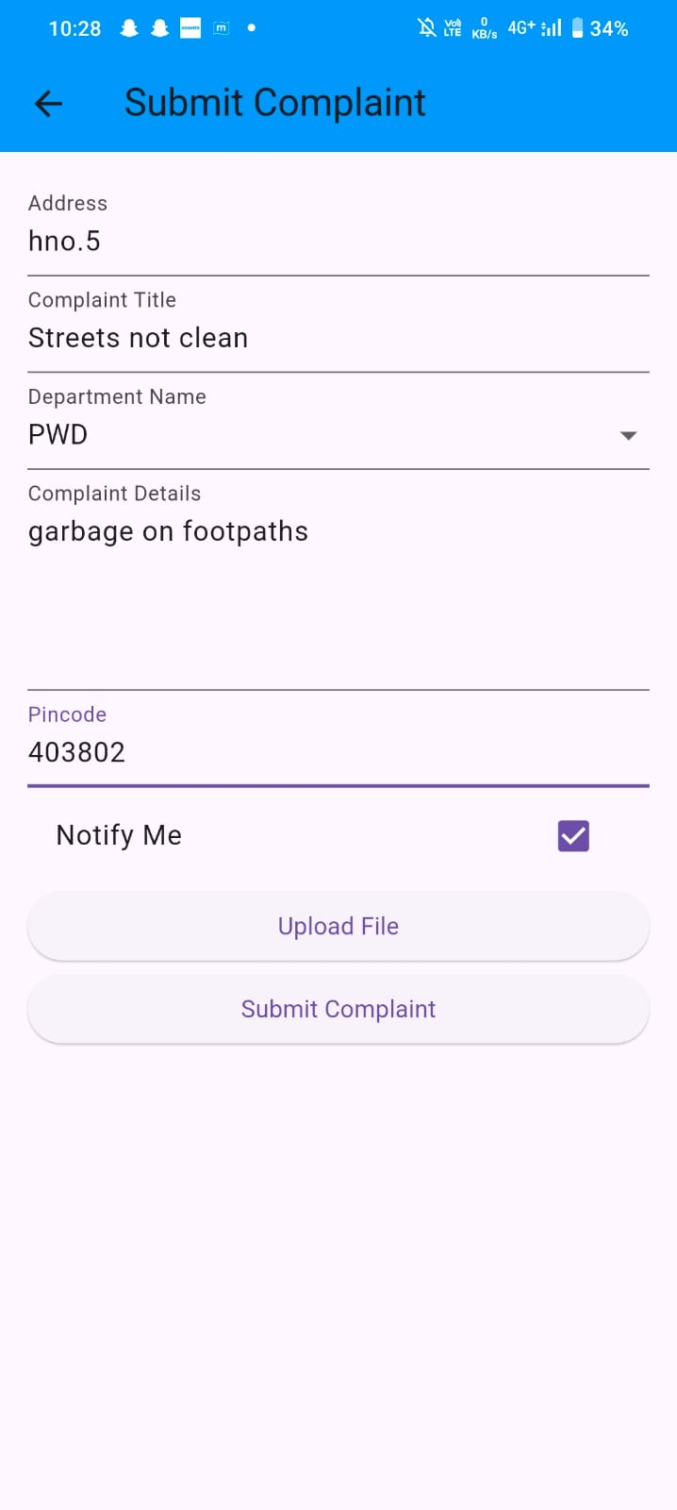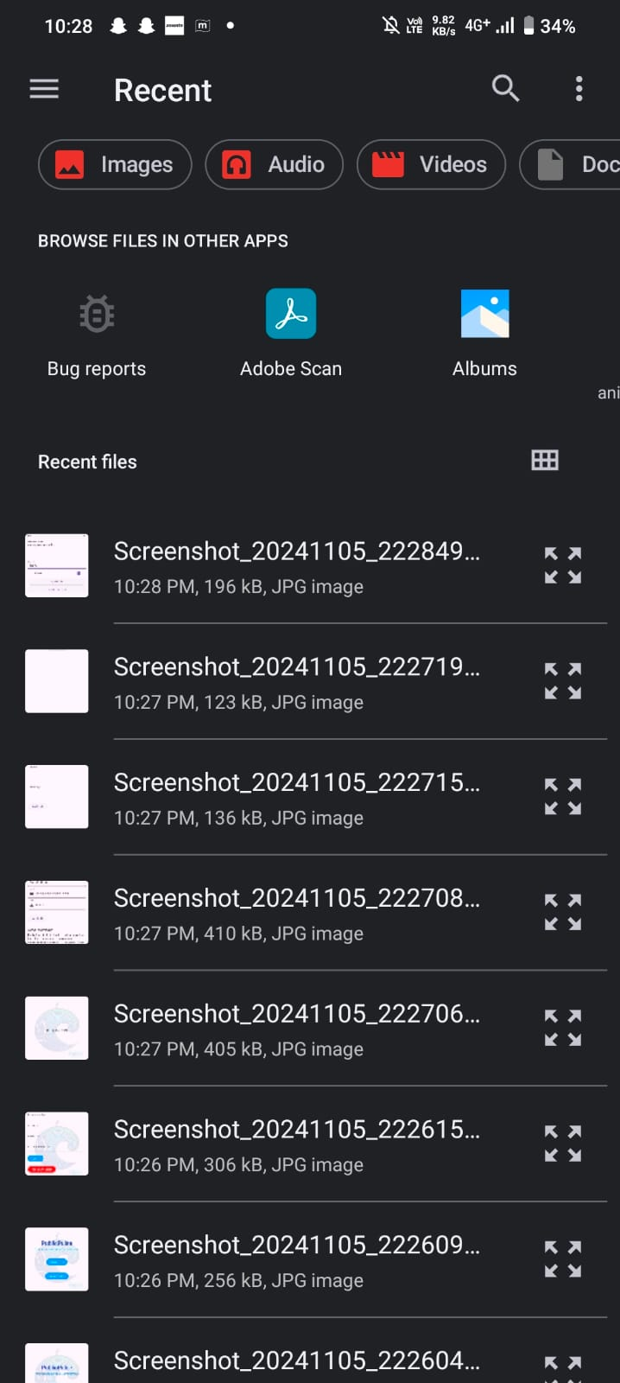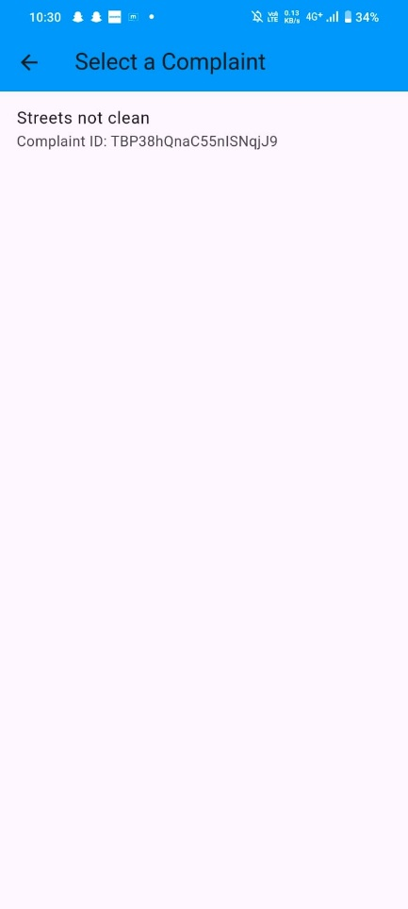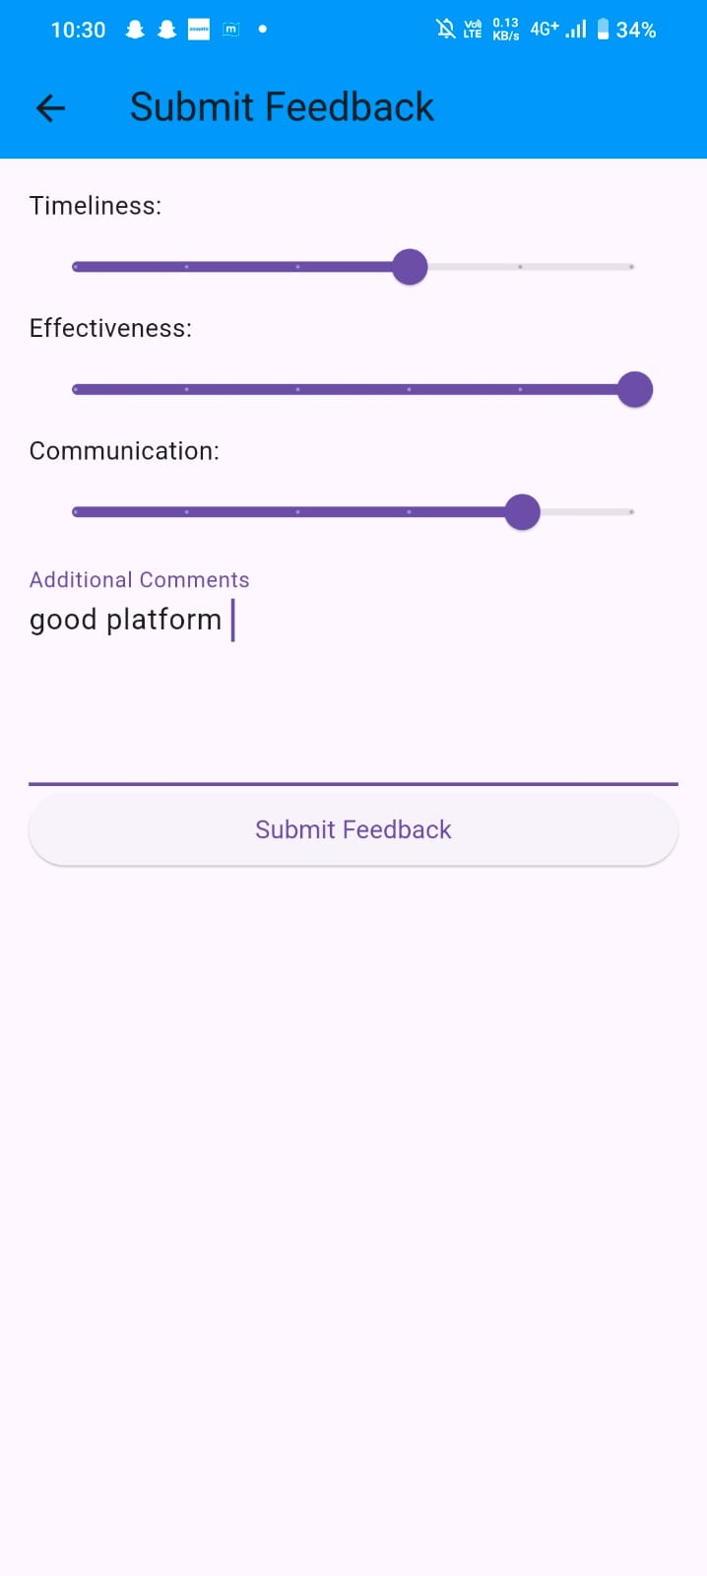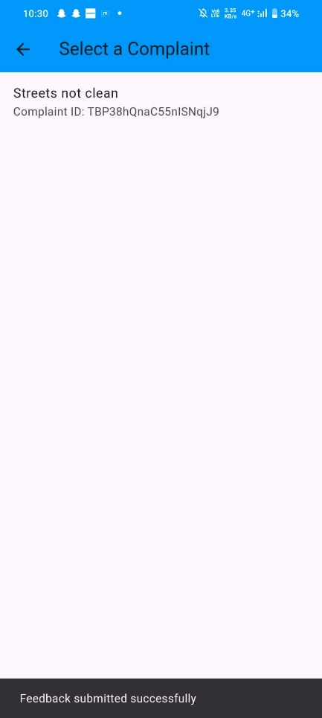
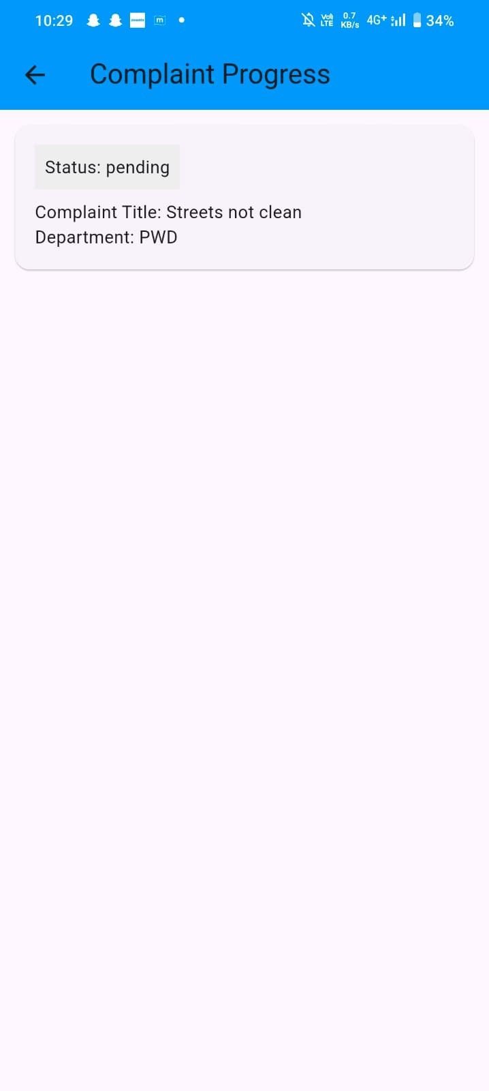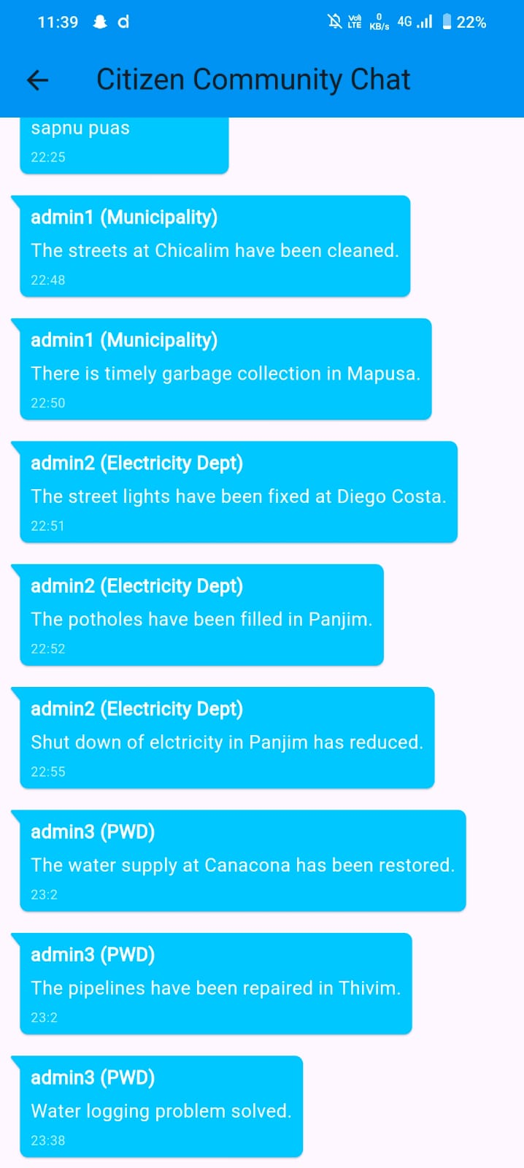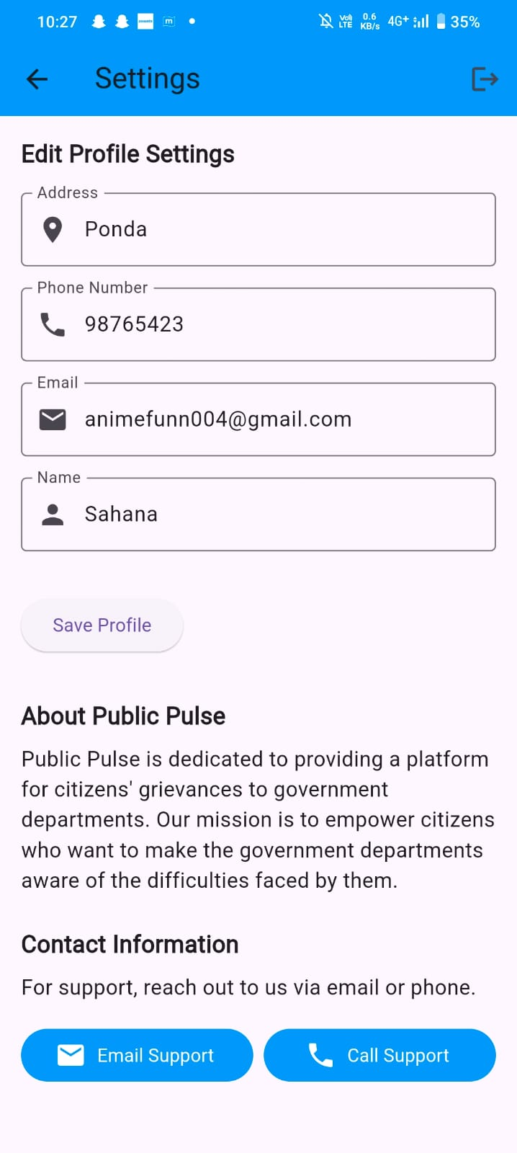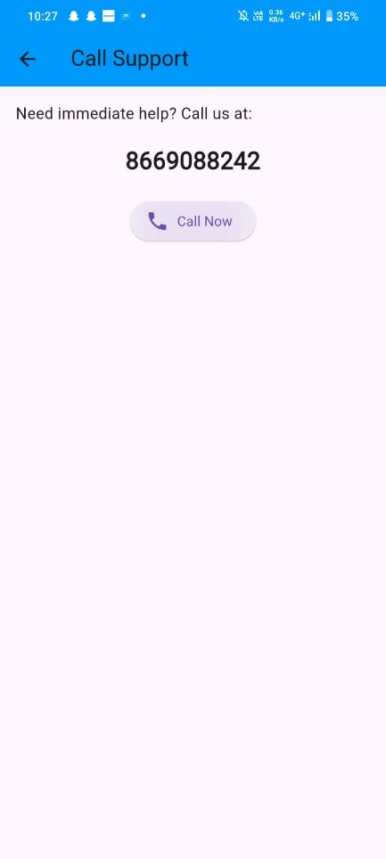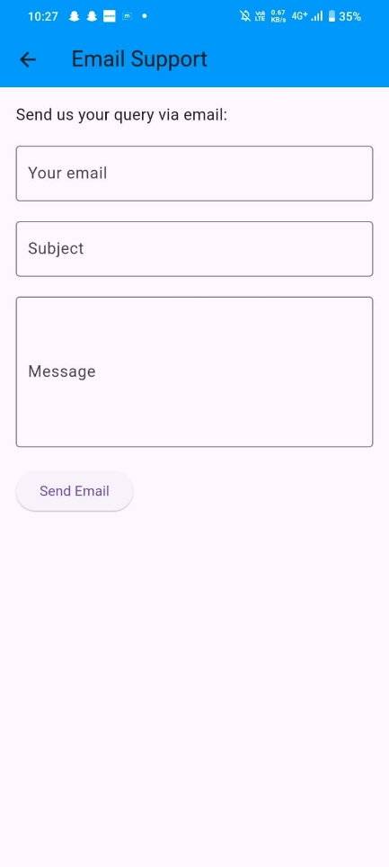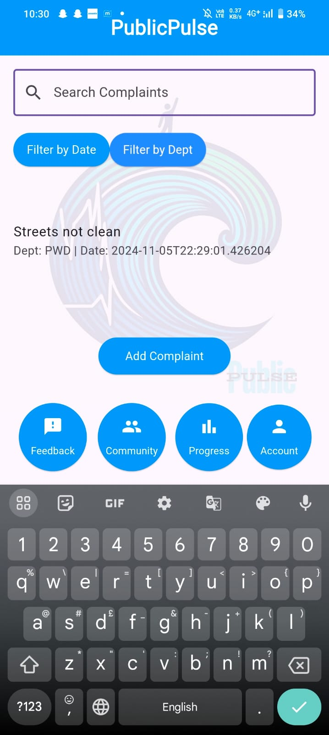
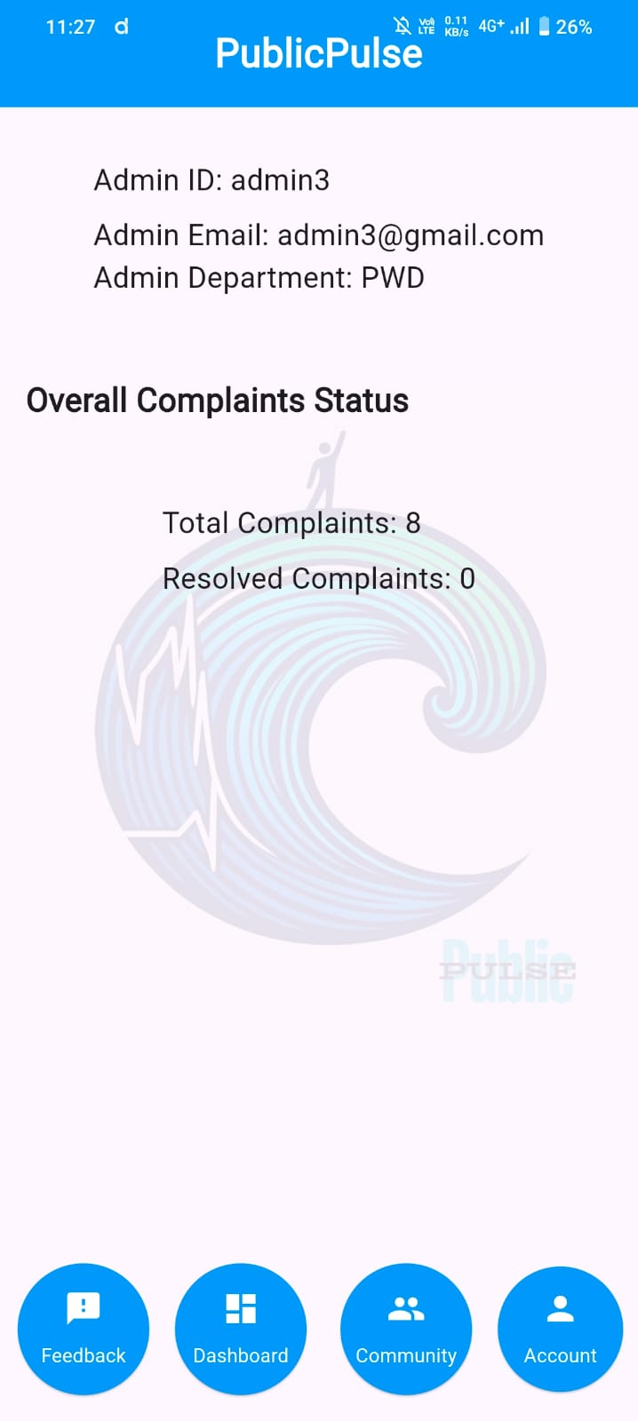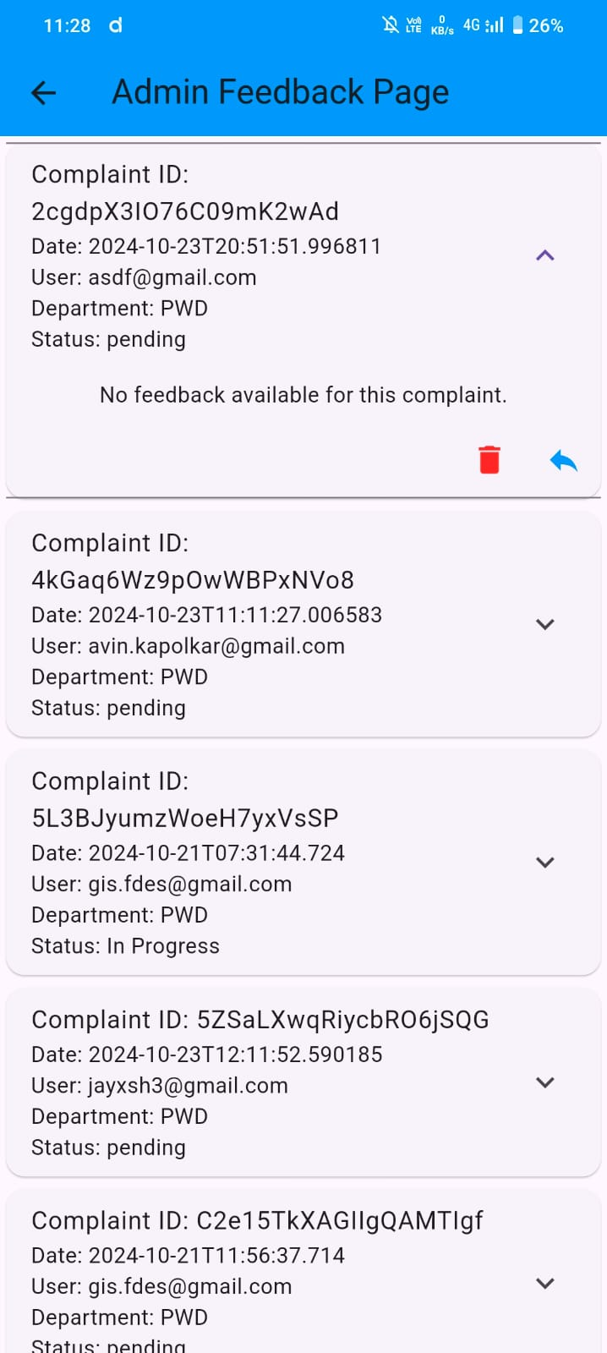
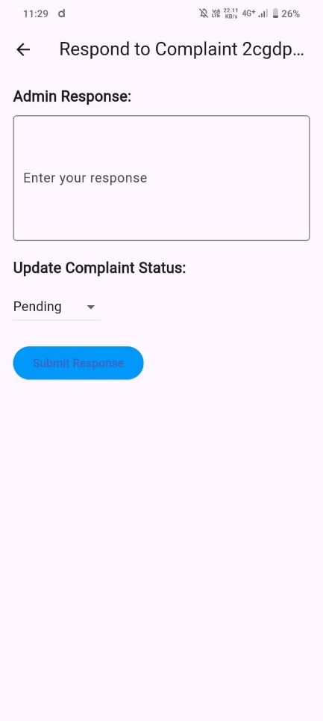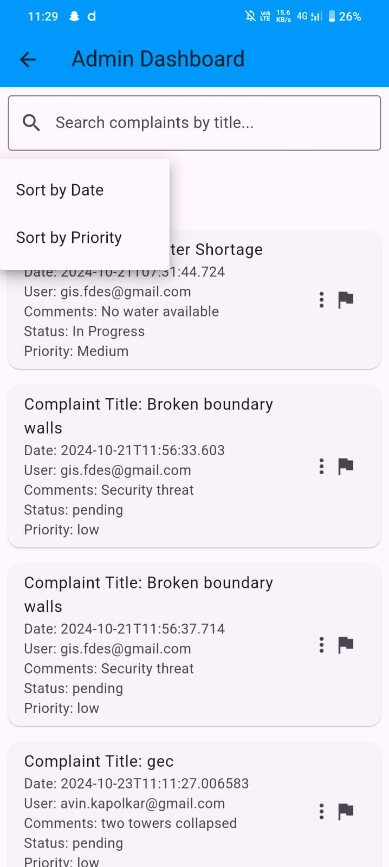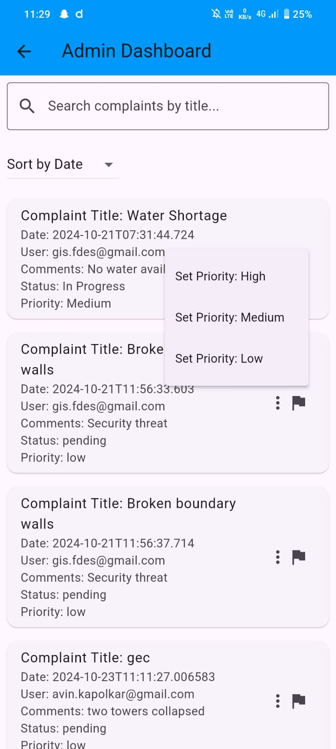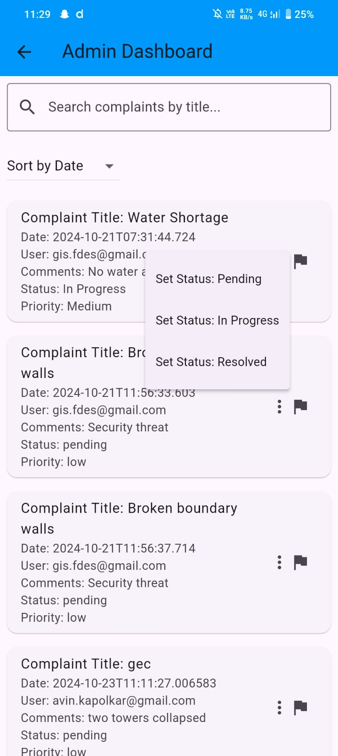
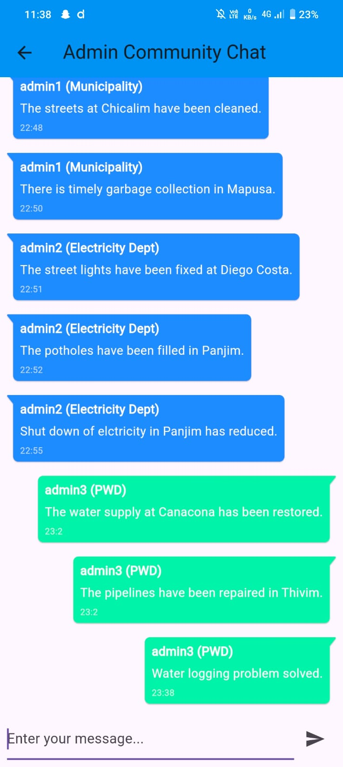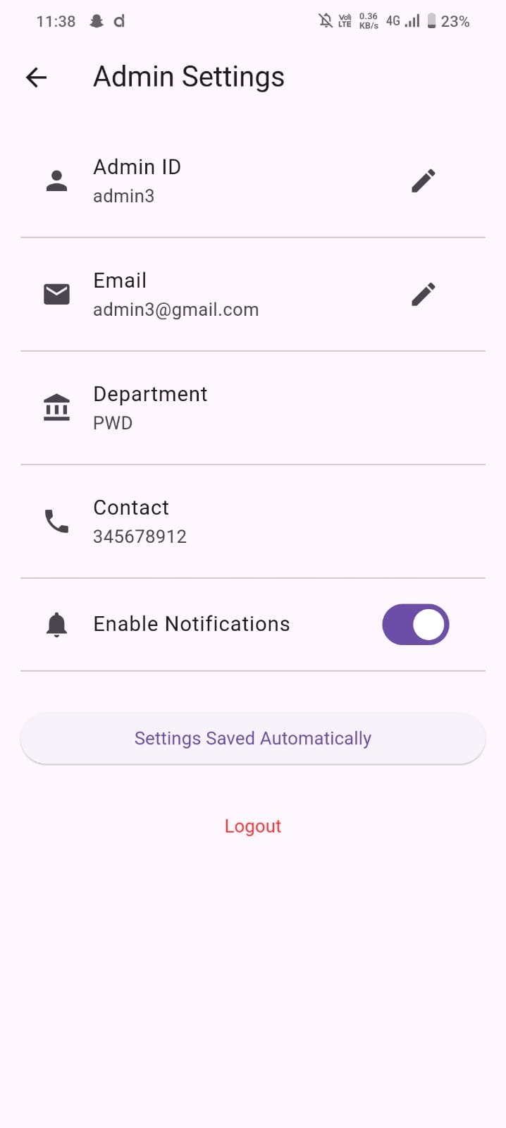

Backend: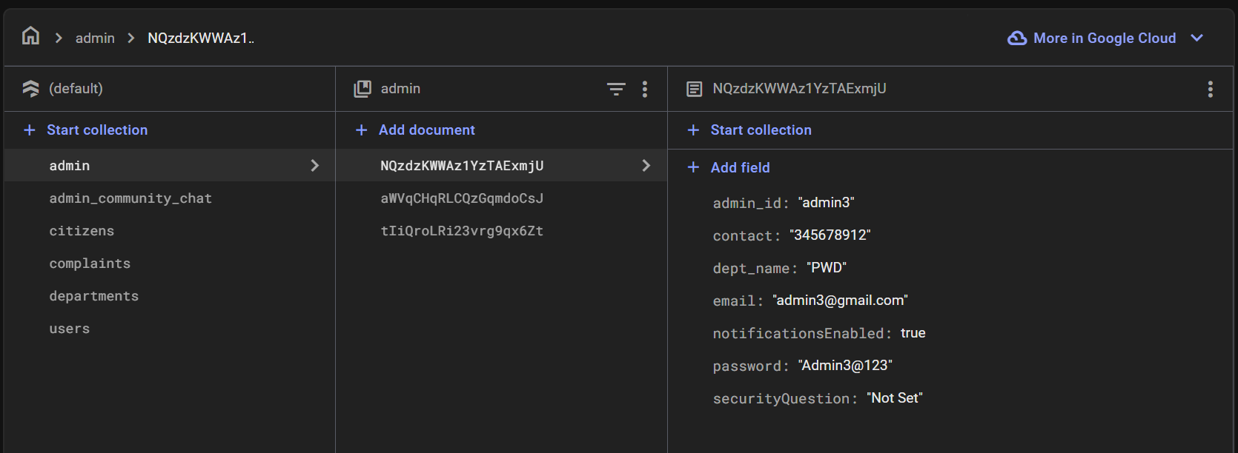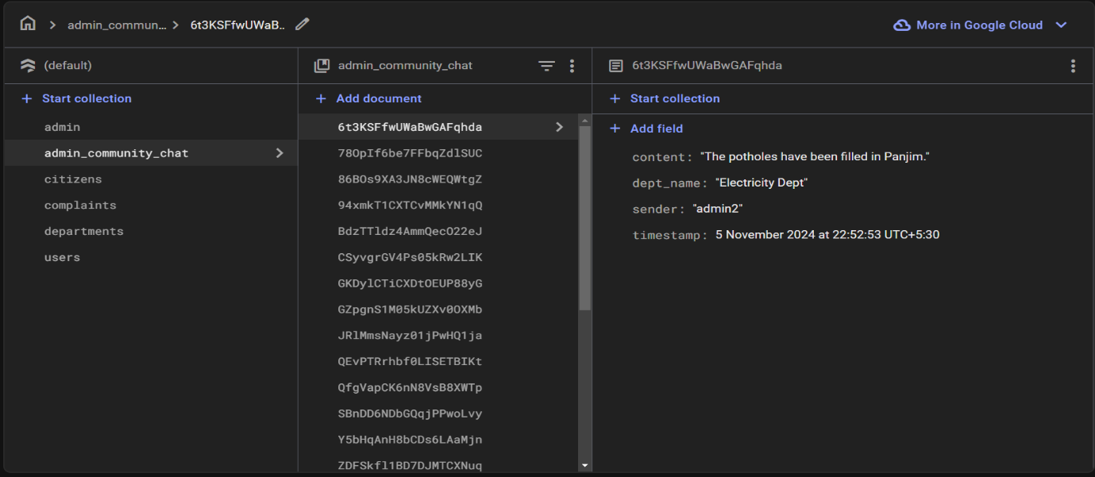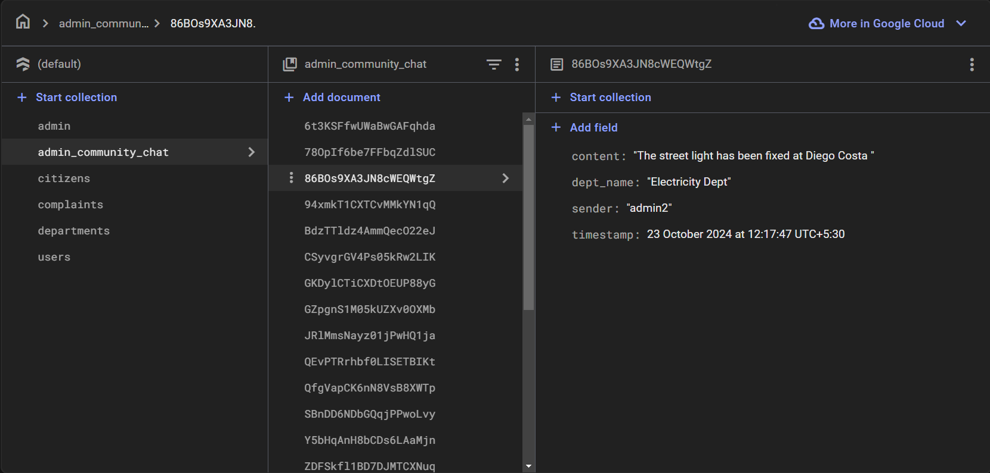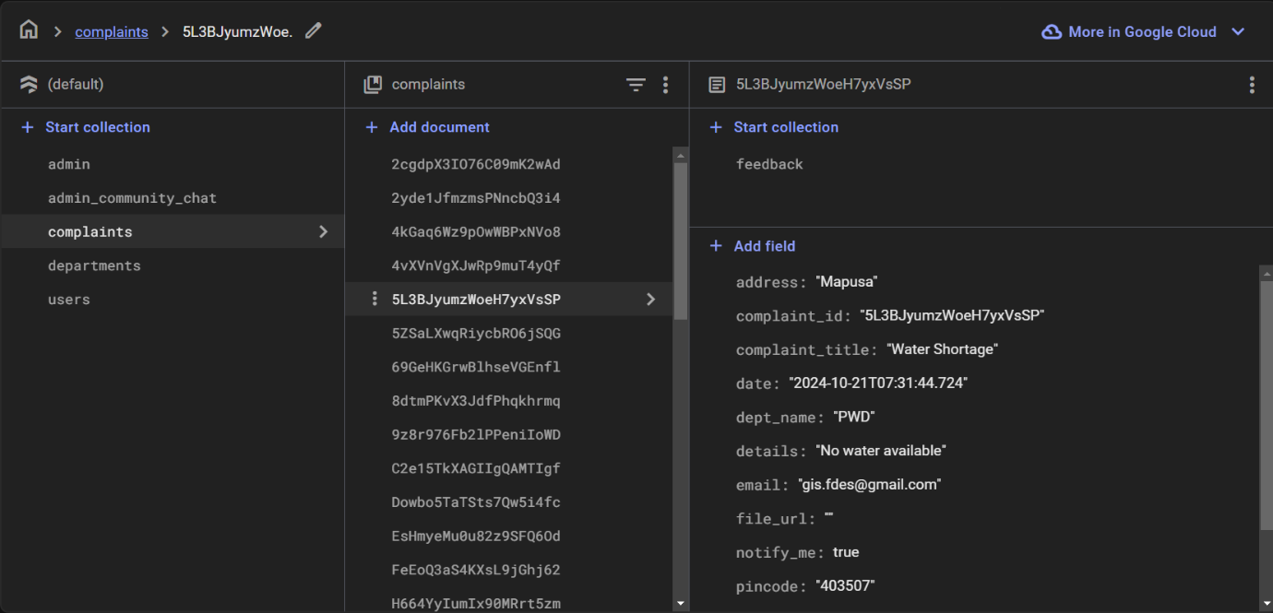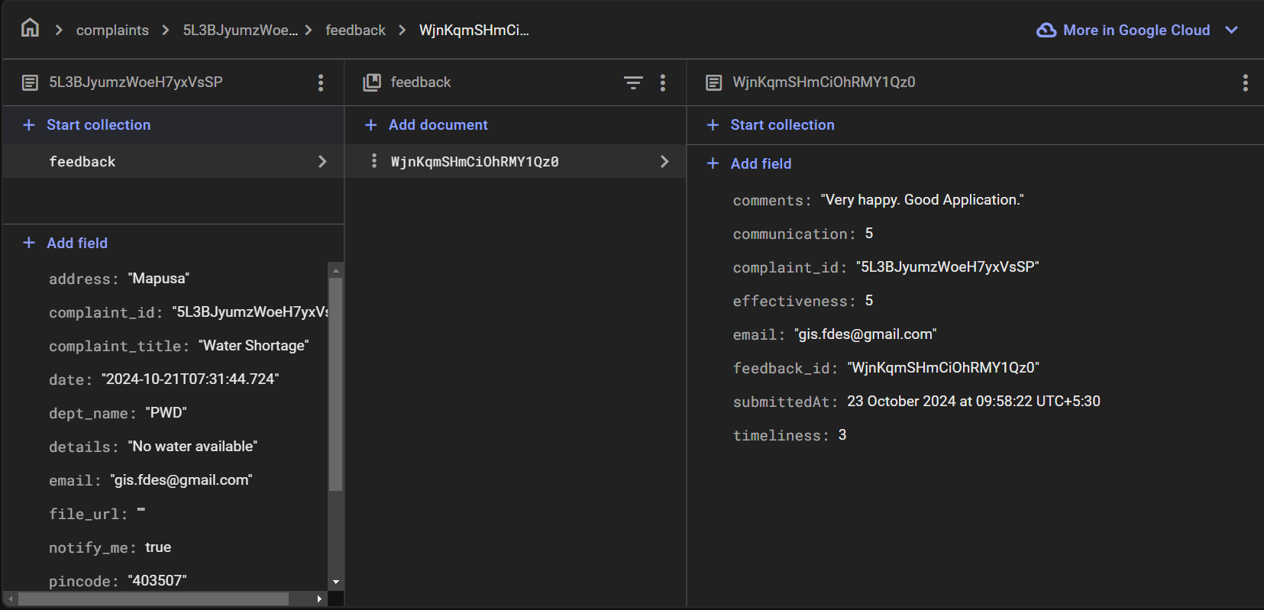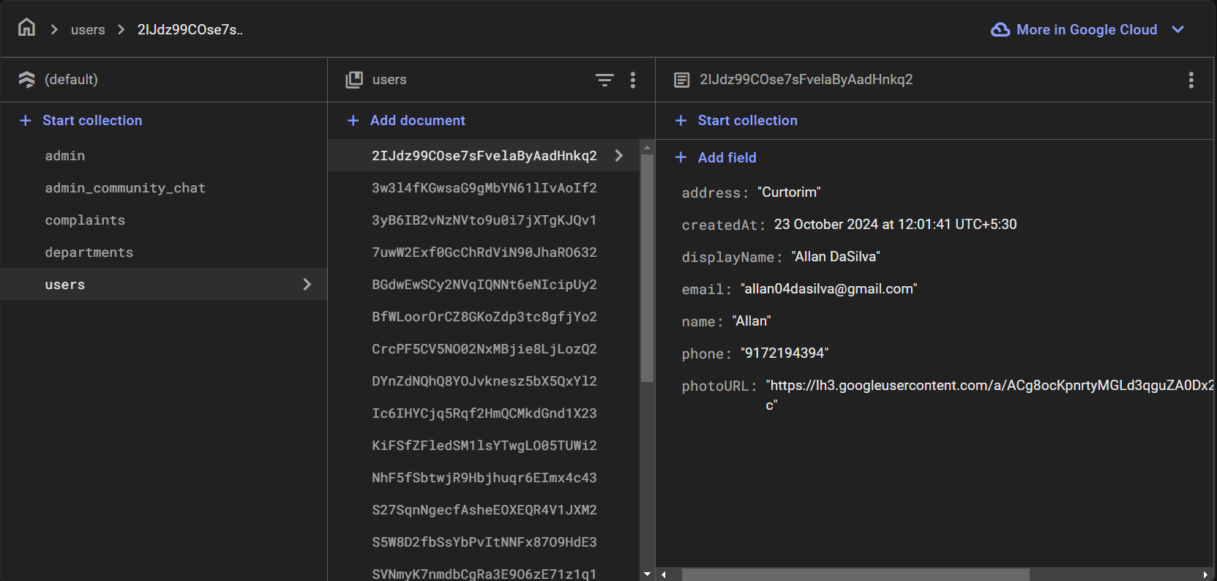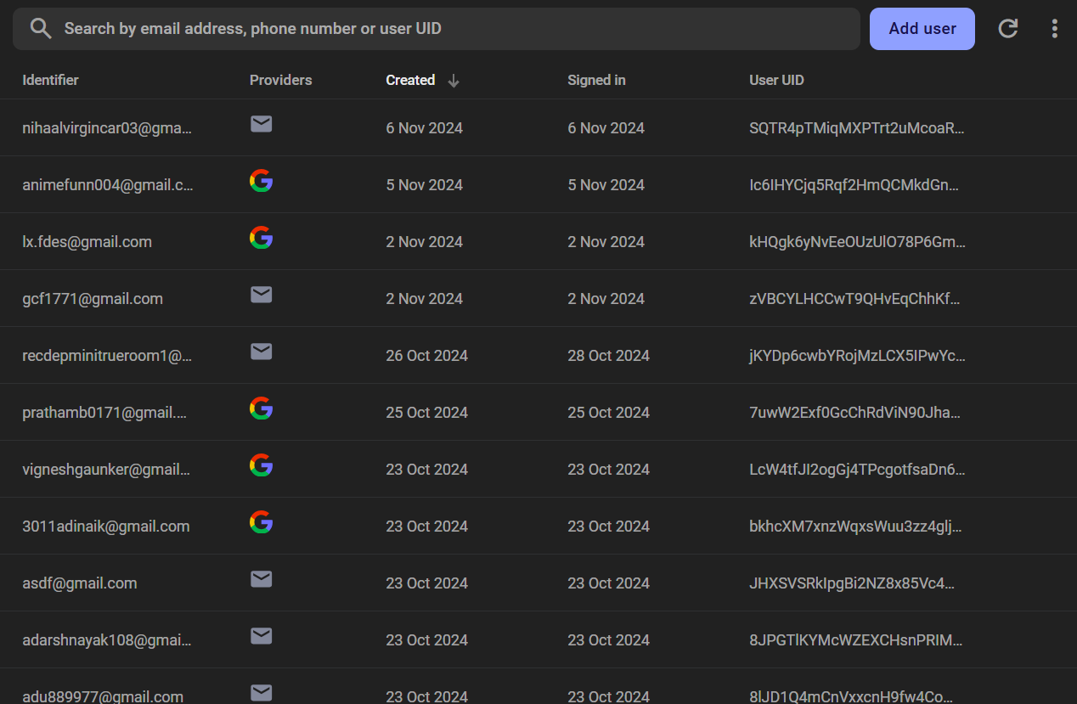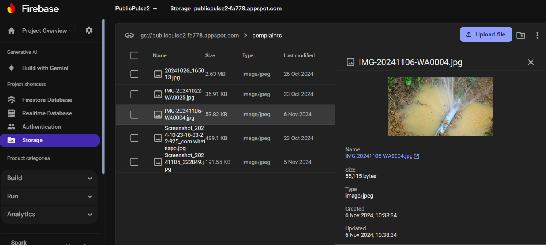

References:
- Firebase Documentation - https://firebase.google.com/docs
- Flutter Documentation - https://docs.flutter.dev/
- Harsh H. Rajpurohit (YouTube ) - https://www.youtube.com/@harshRajpurohit
- GitHub Copilot- https://github.com/copilot
- ChatGPT -https://chatgpt.com/

Conclusion:
Created a comprehensive Closure Report that showcases the well-executed features of our app, highlights key learnings, and provides valuable insights to guide future projects.

