Conclusion Meeting Agenda

**Date:** August 15, 2019 **Time:** 0930 **Location:** TBD

**Attendees**: Mr. Fitch, Mr. Fontaine, Ms. Babiceanu, Joseph Keogh

* **Plan (Where are we in the process)**

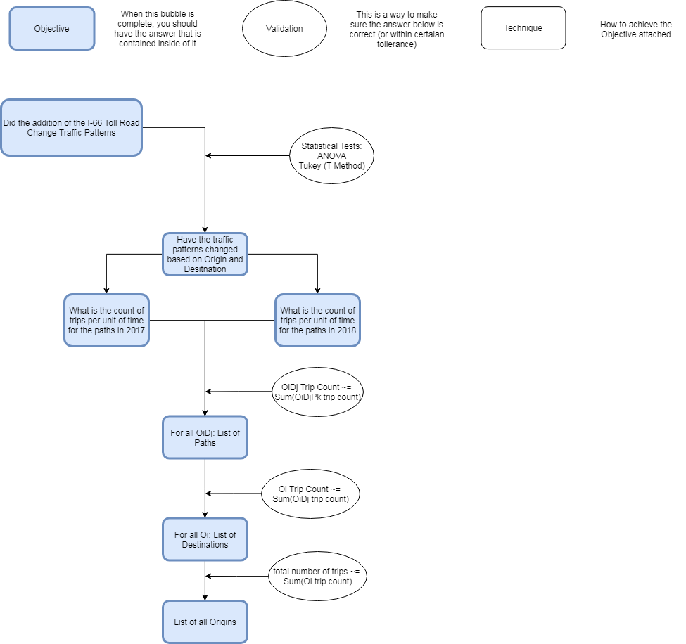



* Problem Introduction
  + I-66 Change
  + Project Purpose
    - “The main focus of the study is to compare how or if the relative volume of a roadway in the Interstate 66 system has changed based on the existence of HOV and toll lanes, respective to the origin and destination of a trip.”
* Inrix Data
  + Third Party Data Collection and Processing
  + Basic information flow
  + Uses
* Methodology
  + Definitions
    - Dates of Interest
    - Origin and Destination Mapping
      * Grids and Points
      * Regions
      * OD Pairs
    - Time Mapping
    - Path Mapping
  + Data Structure
  + Program
    - Overview
    - System Used
    - Analysis
    - Aggregation
  + Post Processing
* Findings
  + Statistical Test Used
  + Sensitivity Analysis
  + Path Proportional Analysis
    - Year to year
    - With Respect to Origin and Destination
    - With Respect to OD and Time
* Conclusion
  + Thoughts on Data sets
  + Thoughts on Confidence in results