

BSc. Software Development

Year II

Project Report-CA3

Joseph Lalor and Ismael Charaf Megrini

C00312883 and C00313241

08/12/2025

Contents
Project Introduction 3
Part 1: Hash Table Application 4
(a) What is a Hash Table ? 4
(b) Description of your Hash Table application 4
(c) Table of the Data used under the following headings: 4
(d) Diagram of the Hash Table produced- with collisions highlighted. 4
Part 2: Graph Application 5
(a) Diagram of Map of Tourist Sites: 5
(b) Description of Data Structure used to store your Map and any helper variables. 5
(c) Diagram of your Map stored in your chosen Data Structure 6
(d) Minimum Spanning Tree of your Graph: 7
(e) Pseudocode of Algorithms 8
Part 3: Code 10
References 14

Project Introduction
This project was created as part of the Data Structures and Algorithms coursework. The assignment focuses on the practical implementation and analysis of two fundamental data structures: Hash Tables and Graphs.
The purpose of this project is twofold. Firstly, to demonstrate an application of hashing by simulating a user authentication system. We implement a hash table to store usernames, handle collisions, and visualize the hashing process through ASCII conversion and index mapping.
Secondly, we model a touristic map system by creating a graph of local tourist attractions in Carlow for a walking tour application. Graphs are essential for representing networks of interconnected locations, and in this context, they enable functionalities such as finding connected sites, inserting new paths, and identifying the nearest attraction.
By completing both parts, this project not only reinforces theoretical concepts but also highlights how data structures are applied in software development—from secure login systems to interactive mapping tools. The implementation is carried out in Java, accompanied by detailed documentation, diagrams, and analysis to ensure clarity and educational value.

Part 1: Hash Table Application
Replace this with your Hash Table application submission under the following headings:
- What is a Hash Table ?
- Description of your Hash Table application
- Table of the Data used under the following headings:

User Name | ASCII Integer | Index after Hash function applied

- Diagram of the Hash Table produced- with collisions highlighted.

0 | 1 | 2 | 3 | 4 | ….. | 19

Part 2: Graph Application
Replace this with your Graph application submission under the following headings:
- Diagram of Map of Tourist Sites:
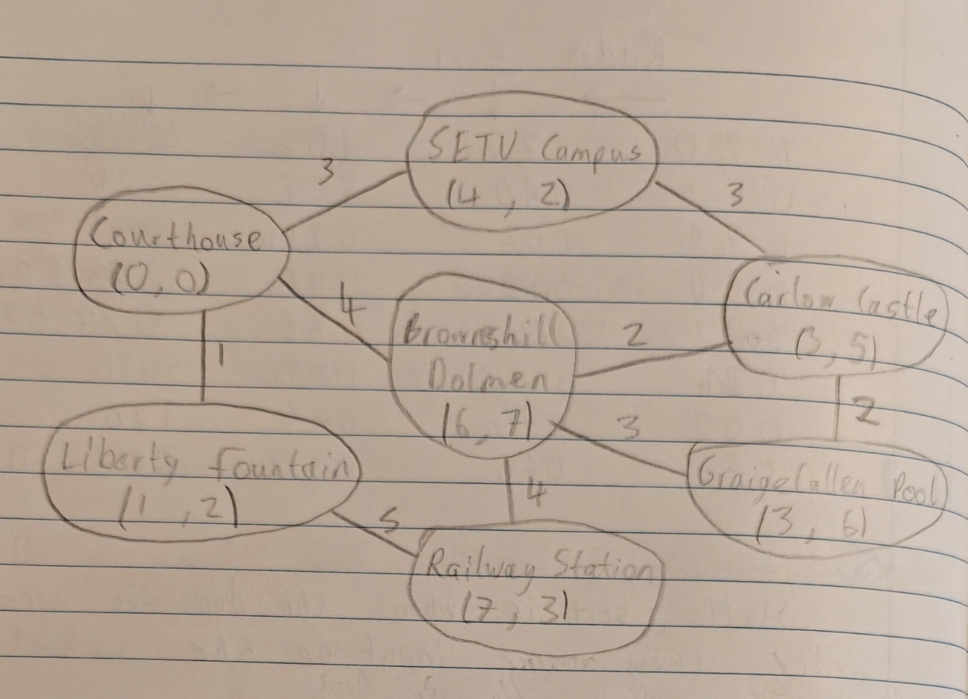

- Description of Data Structure used to store your Map and any helper variables

The graph was stored as three one dimensional arrays and one two dimensional array. The one dimensional arrays served to store the names of the sites, the x coordinates of the sites and the y coordinates of the sites. The two dimensional array stored the weights of connections between sites in an adjacency matrix, giving non connected sites a weight of zero. All of these arrays were coordinated by ensuring that the sites were at the same index in all arrays. Therefore the index of a site in one array could be used to get all the other information about the site from the other arrays. There was also a helper variable “count”, used to store the number of sites (seven in our project) and therefore the length of all the arrays. This was used in the loops.

- Diagram of your Map stored in your chosen Data Structure
This section MUST be handwritten (unless you have a handwriting waiver)
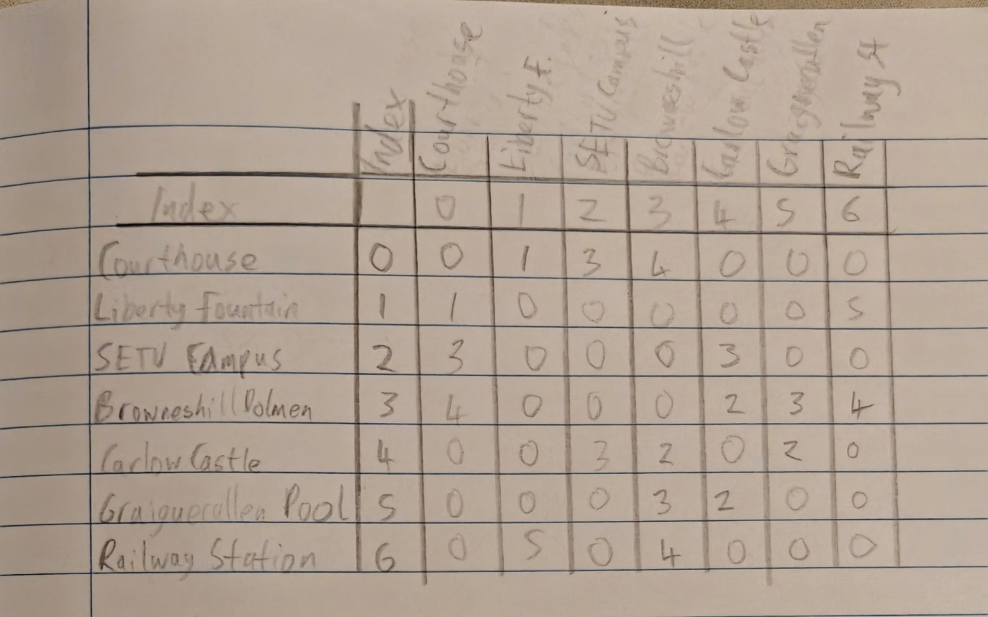

- Minimum Spanning Tree of your Graph:
We used Prim’s Algorithm to find the Minimum Spanning Tree, which produced the graph below in the following order:
- Courthouse
- Liberty Fountain
- SETU Campus
- Carlow Castle
- Browneshill Dolmen
- Graiguecullen Pool
- Railway Station
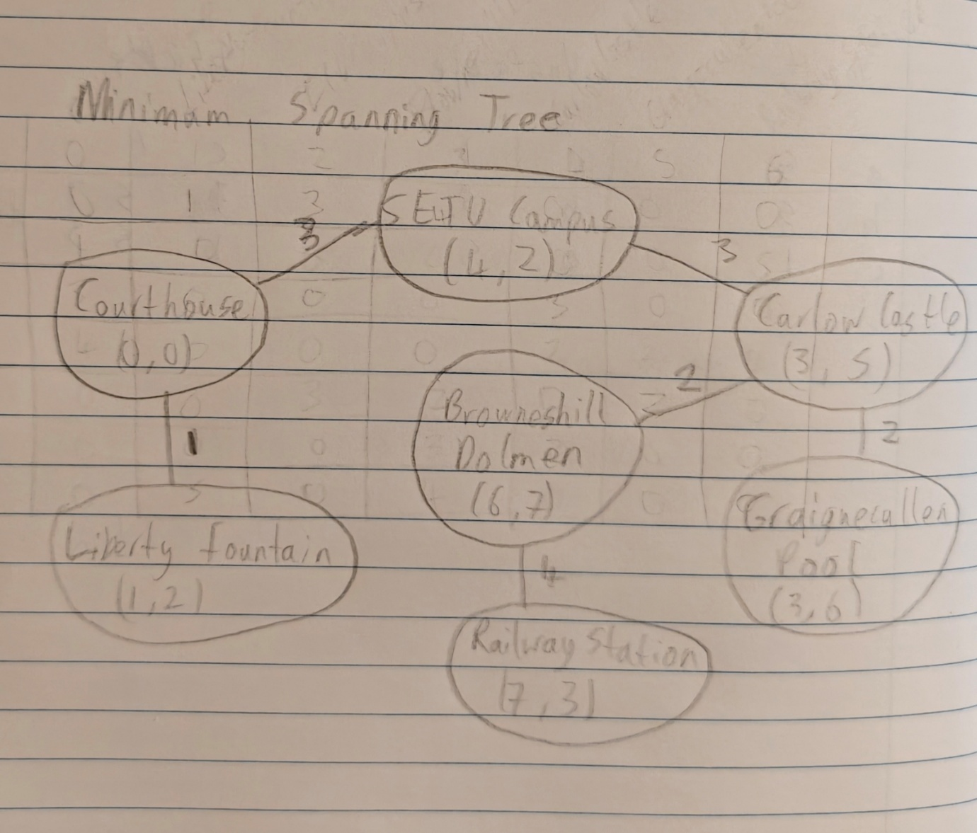

- Pseudocode of Algorithms
Search(site):
{
result = "";
for (i = 0; i < count; i++)
{
if(site.equals(siteName[i]))
{
result = siteName[i] + "X coordinate: " + xCoord[i] + "Y coordinate: " + yCoord[i];
}
}
return result;
}

Insert(site1, site2, weight):
{
i = 0;
while ((i < count) && !site1.equals(siteName[i]))
{
i++;
}

j = 0;
while ((j < count) && !site2.equals(siteName[j]))
{
j++;
}

sites[i][j] = weight;
sites[j][i] = weight;
System.out.println("New edge inserted between " + siteName[i] + " and " + siteName[j] + " with weight " + weight);
}

AllCons(site)
{
connections = "";
i = 0;
while ((i < count) && !site.equals(siteName[i]))
{
i++;
}

for (j = 0; j < count; j++)
{
if(sites[i][j] > 0)
{
connections = connections + "\n" + siteName[j];
}
}
return "Sites connected to " + site + " are:" + connections;
}

Closest(site)
{
closest = "";
closestVal = 1000;
i = 0;
while ((i < count) && !site.equals(siteName[i]))
{
i++;
}

for (int j = 0; j < count; j++)
{
if(sites[i][j] < closestVal && sites[i][j] > 0)
{
closestVal = sites[i][j];
closest = siteName[j];
}
}

return "The closest site to " + site + " is " + closest;
}

Part 3: Code
- /* ============================================================
- Project Name: Graph Application - Project CA3
- File Name: GraphProject.java
- Description: This project creates a graph of touristic sites in Carlow,
- stores them in arrays, and allows the user to navigate through with various methods.
- Authors: Joseph Lalor c00312883 Ismael Charaf Megrini c00313241
- Created: 01/12/2025
- Completed: 08/12/2025
- ============================================================ */

- public class GraphProject
- {
- //helper variable
- static final int count = 7;

- //name of sites array
- static String[] siteName = {"Courthouse", "Liberty Fountain", "SETU Campus", "Browneshill Dolmen",
- "Carlow Castle", "Graigecullen Pool", "Railway Station"};

- //x coordinates array
- static int[] xCoord = {0, 1, 4, 6, 3, 3, 7};

- //y coordinates array
- static int[] yCoord = {0, 2, 2, 7, 5, 6, 3};

- //adjacency matrix for distances
- static int[][] sites = {
- {0, 1, 3, 4, 0, 0, 0},
- {1, 0, 0, 0, 0, 0, 5},
- {3, 0, 0, 0, 3, 0, 0},
- {4, 0, 0, 0, 2, 3, 4},
- {0, 0, 3, 2, 0, 2, 0},
- {0, 0, 0, 3, 2, 0, 0},
- {0, 5, 0, 4, 0, 0, 0}
- };

- //search function, takes a site name and outputs its coordinates
- public static String Search(String site)
- {
- String result = "";
- for (int i = 0; i < count; i++)
- {
- if(site.equals(siteName[i]))
- {
- result = siteName[i] + "\nX coordinate: " + xCoord[i] + "\nY coordinate: " + yCoord[i];
- }
- }
- return result;
- }

- //inserts a new connection between two specified sites
- public static void Insert(String site1, String site2, int weight)
- {
- int i = 0;
- while ((i < count) && !site1.equals(siteName[i]))
- {
- i++;
- }

- int j = 0;
- while ((j < count) && !site2.equals(siteName[j]))
- {
- j++;
- }

- sites[i][j] = weight;
- sites[j][i] = weight;
- System.out.println("New edge inserted between " + siteName[i] + " and " + siteName[j] + " with weight " + weight);
- }

- //outputs names of all connected sites to a specified site
- public static String AllCons(String site)
- {
- String connections = "";
- int i = 0;
- while ((i < count) && !site.equals(siteName[i]))
- {
- i++;
- }

- for (int j = 0; j < count; j++)
- {
- if(sites[i][j] > 0)
- {
- connections = connections + "\n" + siteName[j];
- }
- }
- return "Sites connected to " + site + " are:" + connections;
- }

- //finds closest connected site to a specified site
- public static String Closest(String site)
- {
- String closest = "";
- int closestVal = 1000;
- int i = 0;
- while ((i < count) && !site.equals(siteName[i]))
- {
- i++;
- }

- for (int j = 0; j < count; j++)
- {
- if(sites[i][j] < closestVal && sites[i][j] > 0)
- {
- closestVal = sites[i][j];
- closest = siteName[j];
- }
- }

- return "The closest site to " + site + " is " + closest;
- }
- }
- Functions/methods used: Search(), Insert(), AllCons(), Closest()
- Sample execution screenshots :
Search(“Railway Station”):
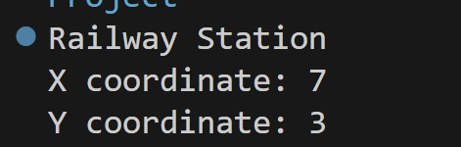
Insert("Railway Station", "Graigecullen Pool", 1):

AllCons("Browneshill Dolmen"):
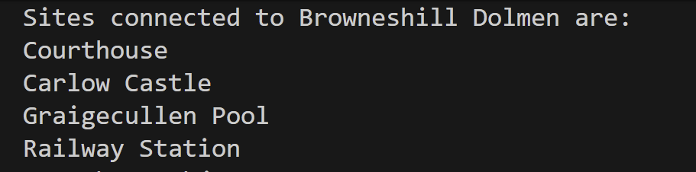

Closest(“Graiguecullen Pool”):

References

Book
Author(s) - family name, initials. (Year). Title of book. Edition. Place of publication: Publisher.
[1] Williams, B. (2023). Professional WordPress: Design and Development. Indianapolis: John Wiley & Sons.

Web-site
Author(s) - family name, initials. (Year, month day). Title of document. [Online]. (URL). Place of publication: Publisher. (Date accessed).
[2] de Valk, J. (2024, May 12). WordPress SEO. [Online]. (URL https://yoast.com/articles/wordpress-seo/). (Accessed 12 February 2025).

Generative AI
Shareable URL generated by the AI Tool:
Name of AI (Year). Medium of Communication, Receiver of communication, Day, Month of communication. Available at: URL
[3] OpenAI ChatGPT (2023) ChatGPT response to Jane Doe 20 October. Available at: https://chat.openai.com/share/f45a1e23-2217-4443-a244-d56ab26ae940

References without shareable URL:
Reference: Name of AI (Year). Medium of communication, Receiver of communication, Day Month of communication.
[4] OpenAI ChatGPT (2023) ChatGPT response to Jane Doe, 20 October.

Format for AI generated Images:
Creator (Year) Title of work [Medium]. Available at: URL (Accessed: date).
[5] Midjourney Inc. (2025) Peacock in the style of Gustav Klimt [Digital Art]. Available at: https://cdn.midjourney.com/fa846dc2-995f-4240-bfd9-b9c4eb3b666e/0_2.png (Accessed: 14 February 2025)

