Joseph maghed fadly fam

Embedded systems assignment 2

**1.Code the PIC and demonstrate at the end of assignment deadline.**

int valADC;

char x[4];

void main(){

//initialise input outputs

trisb.b1=1;

trisb.b2=1;

trisc=0;

portc=0;

//initialise adc

ADC_Init();

//initialise pwm

PWM1_Init(5000);

PWM1_Start();

PWM2_Init(5000);

PWM2_Start();

trisb.b0=0;

while(1){

if(portb.b1==1){//Manual mode is off read moisture sensore

valADC=ADC_Read(0);

if(valADC>500){//below certain level valve on

PORTB.B0=1;}

else{

PORTB.B0=0;

} }else{

if(portb.b2==1){ //Manual mode is on read switch

PORTB.B0=1;

}

else{

PORTB.B0=0;

}

}

PWM1_Set_Duty(255);

PWM2_Set_Duty(255);

portc.rb0=0;

Delay_ms(100);

PWM1_Set_Duty(100);

PWM2_Set_Duty(100);

portc.rb0=1;

Delay_ms(100);

PWM1_Set_Duty(150);

PWM2_Set_Duty(00);

portc.rb0=0;

Delay_ms(100);

}

}

**2.Implementthe circuit for the whole system.**

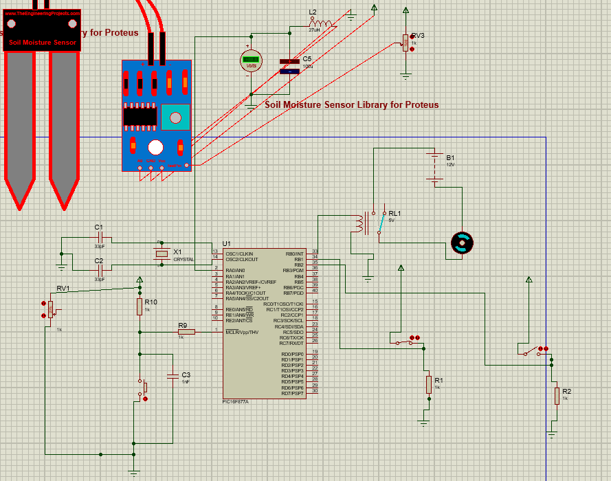

**3.Provide flowchart (software diagram[4]) of your code. Add comments to code lines.**

Valve off

Valve_Switch is on

Valve on

Valve off

Valve on

Moisture_Sensor >500

Manual_Switch is off

**4.Showe vidence of your debugging activities, each time the system did not work as expected.**

**1-Wrong pic version was selected**

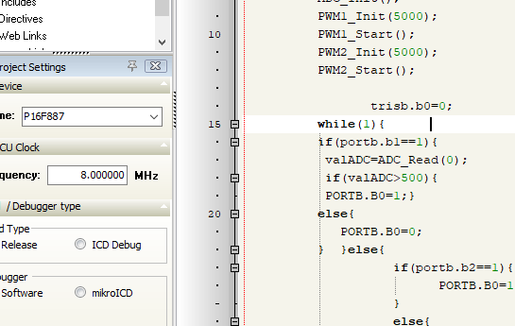

**2-forgot to initialise ADC using ADC init**

**3-Didn’t connect the test pin in moisture sensor**

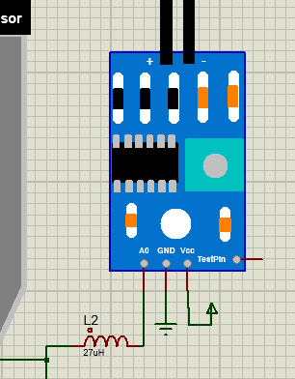

**5-Adaptthe code to produce well-structured and reliable code.**

int valADC;

char x[4];

void main(){

//initialise input outputs

trisb.b1=1;

trisb.b2=1;

trisc=0;

portc=0;

//initialise adc

ADC_Init();

//initialise pwm

PWM1_Init(5000);

PWM1_Start();

PWM2_Init(5000);

PWM2_Start();

trisb.b0=0;

while(1){

if(portb.b1==1){//Manual mode is off read moisture sensore

valADC=ADC_Read(0);

if(valADC>500){//below certain level valve on

PORTB.B0=1;}

else{

PORTB.B0=0;

} }else{

if(portb.b2==1){ //Manual mode is on read switch

PORTB.B0=1;

}

else{

PORTB.B0=0;

}

}

PWM1_Set_Duty(255);

PWM2_Set_Duty(255);

portc.rb0=0;

Delay_ms(100);

PWM1_Set_Duty(100);

PWM2_Set_Duty(100);

portc.rb0=1;

Delay_ms(100);

PWM1_Set_Duty(150);

PWM2_Set_Duty(00);

portc.rb0=0;

Delay_ms(100);

}

}

int valADC;

char x[4];

void main(){

//initialise input outputs

trisb.b1=1;

trisb.b2=1;

trisc=0;

portc=0;

//initialise adc

ADC_Init();

//initialise pwm

PWM1_Init(5000);

PWM1_Start();

PWM2_Init(5000);

PWM2_Start();

trisb.b0=0;

while(1){

if(portb.b1==1){//Manual mode is off read moisture sensore

valADC=ADC_Read(0);

if(valADC>500){//below certain level valve on

PORTB.B0=1;}

else{

PORTB.B0=0;

} }else{

if(portb.b2==1){ //Manual mode is on read switch

PORTB.B0=1;

}

else{

PORTB.B0=0;

}

}

PWM1_Set_Duty(255);

PWM2_Set_Duty(255);

portc.rb0=0;

Delay_ms(100);

PWM1_Set_Duty(100);

PWM2_Set_Duty(100);

portc.rb0=1;

Delay_ms(100);

PWM1_Set_Duty(150);

PWM2_Set_Duty(00);

portc.rb0=0;

Delay_ms(100);

}

}

**6.Evaluate the previous system correctness and speed.**

The previous system uses a test pin for the moisture sensor since there is no soil to test the sensor.

The ADC reading decides whether to activate the valve in automatic mode, while in manual mode the valve is only controlled via a switch.

**Task2**

**1.Code the PIC and demonstrate at the end of assignment deadline.**

PWM1_Init(5000);

PWM1_Start();

PWM2_Init(5000);

PWM2_Start();

While(1){

PWM1_Set_Duty(255);

PWM2_Set_Duty(255);

portc.rb0=0;

Delay_ms(100);

PWM1_Set_Duty(100);

PWM2_Set_Duty(100);

portc.rb0=1;

Delay_ms(100);

PWM1_Set_Duty(150);

PWM2_Set_Duty(00);

portc.rb0=0;

Delay_ms(100);

}

**2.Implement the circuit for the whole system.**

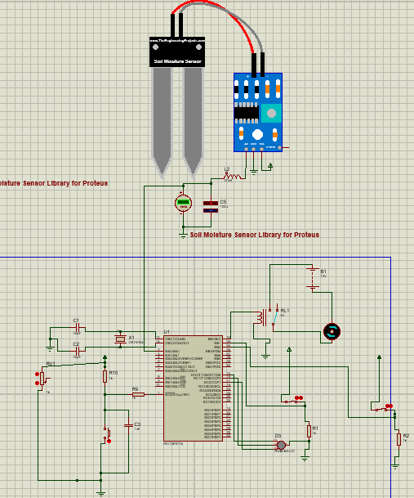

**3.Provideflowchart of your code.**

Delay1000ms

Color2

DELAY

Color1

COLOR3

DELAY

**4.Showevidence of your debugging activities, each time the system did not work as expected.**

Didn’t initialise PWM using PWM start.

Use wrong RGB_LED CA instead of RGB_LED CC

