**(1)**

1. Suppose a network exchange theory experiment is run on the graph below using the one-exchange rule. Which node or nodes would you expect to make the most money? (i.e. receive the most favorable exchanges)
2. Explain your answer.

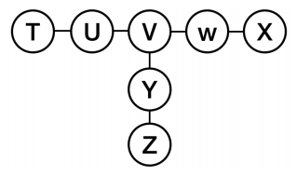

Even though the node in the center “V” appears initially to perhaps be in the best position to earn the most money in this situation, it is in fact not the node that would yield the most power and thus the most money. In graphs of this kind the “central” position in the network is in fact in a weak position when the one-exchange rule is used, because node “V”s opportunities for exchange are with node “U”, node “W”, and node “Y”, however each of these nodes have very attractive alternatives with which to trade that may not even include node “V”. In other words, all of node “V”s partners for negotiation have access to weak nodes as alternatives, and this makes “V” weak as well. With node “V” clearly not in the most powerful position, the nodes that would be in position to make the most money would be nodes “U”, “W”, or “Y”. These nodes are in a position to have options with who to exchange with, meaning that they each have an attractive alternative. For example, node “U” could choose to exchange with node “V”, however alternatively, they could also exchange with node “T”. Having this alternative gives them more leverage power since they can walk away to their alternative.

**(2)**

1. Suppose a network exchange theory experiment is run on the graph below (i.e. a graph that is a 3-node path), using the one-exchange rule. Now you, playing the role of a fourth node W, are told to attach by a single edge to one of the nodes in the network. How should you attach to the network to put yourself in as powerful a position as possible, where power will be determined by the result of a network exchange theory experiment run on the resulting 4-node network?
2. Explain your answer.

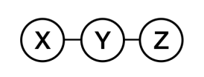

The most advantageous position for me to attach my node W in the above graph would be on the ends to either node “X” or node “Z”. The reason that either of these two positions would yield the most power over attaching to node “Y”, is because attaching to node “Y” would put me in a position where I would be less likely to be exchanged with. Node “Y” in this scenario would have the opportunities to exchange with node “X”, node “Z”, or node “W”. With the competing alternatives, it would be less likely that I would be involved in as many exchanges, and would put me in a weaker position. However, connecting either node “X” or node “Z” would put me in a position where the chances I am exchanged with is greater. These end nodes would be more likely to exchange with me, increasing my probability of being involved in an exchange. From their perspective, they would have two options, node “Y” or node “W” (myself), and they may be more likely to choose to exchange with me, believing that node “Y” has other alternatives they would rather pursue.

**(3)** The graphs below represent the outcomes of a network exchange theory experiment. For each, determine whether the outcome is stable or unstable, and explain your answer.

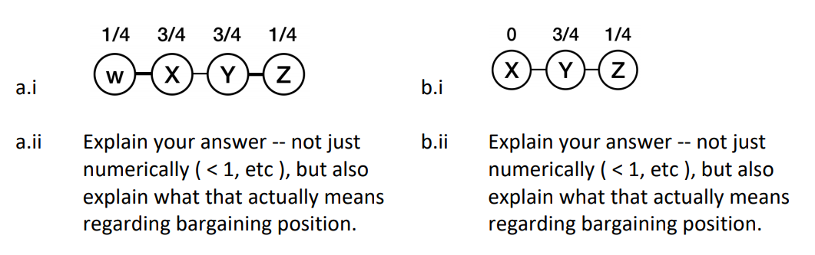

1. This graph is a stable outcome, because numerically, the values of the connecting nodes are not less than 1. The text defines instability of consisting of a matching values for the connected two nodes, X and Y, such that the sum of X’s value and Y’s value is less than 1. The above graph does not meet this definition as the connected nodes’ values are not less than 1. In this scenario, there are no opportunities or incentives to disrupt the status quo, since nodes X and Y aren’t able to improve their circumstances by gaining anything from each other, and W and Z are held captive by X and Y without alternatives of exchanging with a different node. Because of this situation they can’t end up better than they are currently doing and this is a stable graph.
2. This graph is unstable, and that can be determined by looking at the instability definition that states that given an outcome consisting of a matching and values for the nodes, an instability in this outcome is an edge not in the matching, joining two nodes X and Y, such that the sum of X’s value and Y’s value is less than 1. Since the sum of X and Y in the above graph is less than 1, this graph meets the definition of being unstable. Looking at this situation outside of the numerical definition and considering bargaining position, one can think of stability as a situation where no node X can propose an offer to some other node Y that makes both X and Y better off, thus “stealing” node Y away from an existing agreement. In this graph, X can certainly steal Y from the exchange relationship with Z. If X wants to be included and at least get something from an exchange instead of nothing, he could offer an amount less than the ¼ that Z is currently offering, and improve the situation for Y, because Y would then be collecting more value in the exchange with X that she would be with Z. There would be nothing from preventing this scenario from playing out, so this current situation is unstable.

**(4)** The stem graph below represents the outcome of a network exchange theory experiment in which the participants have outside options. In this experiment, A bargained with B and C bargained with D. Use the Nash Bargaining Solution equations to show that this is a balanced outcome. **Show your work.**

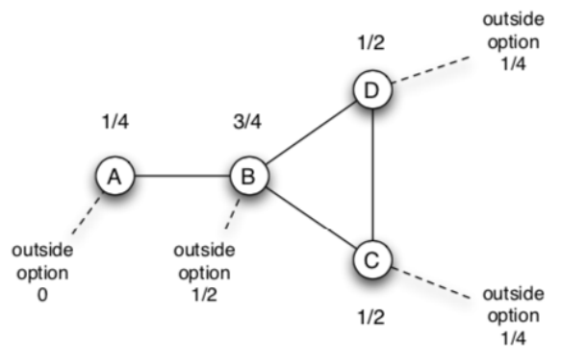

First, we will compute the Nash Bargaining Solution for A—B. In this instance, the surplus or S, is defined as S = 1 – x- y, which would evaluate to S = 1 – 0 – 1/2 = 1/2.

So for A, with the outside option (x) of 0, the computation is x + ½ * S = 0 + ½ * ½.

This evaluates to the Nash bargaining outcome being ¼ for A.

Finally, for B, with the outside option (y) of ½, the computation is y + ½ * S = ½ + ½ * ½ evaluates to a Nash bargaining outcome of ¾ for B.

Therefore the Nash Bargaining Solution is ¼ and ¾, and we can say that the network is balanced for A and B.

For C—D, the Nash Bargaining Solution is computed as follows:

So for D, with the outside option (x) of 1/4 , the computation is x + ½ * S = ¼ + ½ * ½.

This evaluates to the Nash bargaining outcome being ½ for D.

Finally, for C, with the outside option (y) of 1/4, the computation is y + ½ * S = ¼ + ½ * ½ evaluates to a Nash bargaining outcome of ½ for C.

Therefore, the Nash Bargaining Solution is ½ and ½, and we can say that the network is balanced for D and C.

From our computations of the Nash Bargaining Solutions above, none of the nodes in the graph have better outside options, and as such it can be said that the stem graph is balanced.

**(5) Social media influencers are powerful members of social networks, many attracting millions of followers. Write a brief essay (200 words) about an influencer or two that you follow, and why you follow them. If you don’t follow any influencers, then research an influencer or two and discuss their position and influence on social media.**

A social media network that I have found great for following influencers that interest me is YouTube. On this network, you can find influencers that are involved in many different interests, and many of them have amounted an incredible amount of followers. From what I have read, YouTube has become quite a lucrative platform for successful developers that can consistently create content that people want, and there is a lot of really high-quality content at our disposal on the platform. One influencer that I have been following for years goes by the name “Lost LeBlanc”, and he is a travel vlogger that creates travel videos and mini documentaries based on his adventures around the world. I first discovered him, because he started off creating a lot of content in Thailand, because this is where he was living and studying at the time earlier on in his influencer career, and Thailand is a country I visit as often as I can and have family there, so it was something that very much interested me. He takes viewers on his journey from quitting his corporate job as a CPA years ago and following his passion for traveling and film. From his early days in Thailand, he has traveled to countless countries, exploring local traditions and cultures, and taken his viewers with him on unforgettable adventures. He has become very successful, and currently has just shy of 2 million viewers, and has created 726 videos. From what I have gathered by watching content in this niche, he has had quite an influence on many other people and inspired them to do something similar in becoming travel vlogger/influencers themselves.

YouTube is very diverse in the type of content that is available for our consumption, and this translates into a diverse group of influencers I follow. A second influencer that I watch regularly that I also wanted to mention is a software engineer by the name Mayuko. This influencer has also been around for a number of years, and early on in her influencer career, she also worked fulltime as a successful software engineer in silicon valley for some pretty prominent companies in the bay area. She created content about her experiences in the tech world and also made content about many other topics such as lifestyle, hobbies, mental health and just life in general. More recently she decided to pursue her passion of making content for YouTube and social media fulltime, and has focused on this pursuit while leaving her career as a software engineer. She has become quite successful as well, albeit maybe not as successful as Lost LeBlanc. However, she has about 500,000 followers on YouTube and has made hundreds of videos as well. Her genuine insight and reality about life and the tech industry is the reason I follow her, and I feel she has a lot to offer aspiring software engineers in how to navigate their careers and even get started pursuing their passion. I’ve also noticed many of the influencers once they start to generate a large following, diversify from YouTube to other social networks and also offer merchandise, courses, and podcasts to monetize their influence.

**(6) Your company has decided to interview two candidates A and B for a single job. A hiring committee was formed to decide which of the two candidates to hire. Everyone on the committee was interested in making the best possible hire, but after the interviews it was clear that members of the committee had different ideas about which of the two candidates was the best choice. When the committee met to make the final decision they decided to go around the room and ask each person on the committee to announce which of the two candidates they believed to be the best choice for the company. In fact, everyone on the committee said that candidate A seemed to be the best choice, so the offer was made immediately to candidate A without additional discussion. Now that candidate A has worked for the firm for a while it is clear that candidate B would have been a better choice.**

**a. Your boss has asked you to explain how the committee members could have unanimously supported candidate A when she was reasonably certain that before the committee meeting at least some of the members of the committee thought that B was probably the best choice. Based on the teachings of chapter 16, what can you tell her?**

**b. Based on the teachings of chapter 16, can you suggest another procedure that the committee could have used that would have revealed the initially differing opinions about the candidates and which might have avoided the unanimous choice of candidate A and resulted in the actually better choice of candidate B?**

1. Based on the text, there is a phenomenon called information cascade or herding which comes from the work of Banerjee, and others, and it has the potential to occur when people make decisions sequentially, with later people watching the actions of earlier people and from these actions inferring something about what the earlier people know. A cascade develops when people abandon their own information in favor of inferences based on earlier people’s actions. People in a cascade are actually imitating the behavior of others, however note that it is not mindless imitation ,and is rather the result of drawing rational inferences from limited information. I would tell my boss that this phenomenon is likely the culprit in why colleagues reacted the way they did, because each person was asked to announce their decision sequentially in front of each other. Likely the first person or two that chose candidate A as their best choice set off an information cascade where subsequent people aware of the previous decisions abandoned their own information in favor of inferences based on earlier peoples’ actions in the board room.
2. I think the best way to deal with this situation would be to use an alternate procedure where each committee member gets to vote on their ideal candidate privately at the same time without knowledge of others’ decisions. Based off the tallying of this private voting, the candidate with the majority of votes would be offered the role. I think a procedure like this would prevent an information cascade from occurring, where people are abandoning their information and opinions in favor of others and imitating their behavior. Hiring decisions should probably be more defined and procedural instead of just having colleagues vote in front of each other sequentially based off no real criteria. Sequentially voting in public as we saw in this example leads to information cascades, and shouldn’t be the way to make important decisions.

**(7) You have developed a new product which performs the same service as an established product, but your product is much better than the established product. If the number of users of the two products were the same, then each potential purchaser’s reservation price for your product would be twice their reservation price for the existing product. The difficulty that you face is that no one wants to use more than one of the two products. Currently, every potential purchaser is using the established product. Your cost of production and your competitor’s costs of production are exactly the same and they are equal to the price at which your competitor’s product is sold. If all of the potential purchasers switched to your product the maximum price that you could charge (and still have all of them buy your product) would be twice the current price. So clearly you could make a nice profit if you could attract these potential purchasers. Based on the teachings of Chapter 17, what strategies would you use to try to convince users to switch to your product?**

**(8) Consider an on-line news site, such as cnn.com, which consists of a front page with links to many different articles. The operators of these sites generally track the popularity of the various articles that get posted. Suppose that the operators of the site are considering changing the front page, so that next to each link is a counter showing how many people have clicked on the link. (e.g., next to each link it might say: “30,480 people have viewed this story,” with the number getting updated over time.)**

**a. What effect do you think this change will have on the behavior of people using the site? Explain your answer.**

**b. Do you expect that adding this feature will cause the popularity distribution of the articles to follow a power-law distribution more closely or less closely, compared to the version of the site before these counters were added? Explain why or why not.**

1. If the operator of a site like cnn.com were to add a tracker or counter for the popularity of articles linked on their webpage, I theorize that articles/links that have a higher count of clicks will attract more clicks from subsequent users visiting the website. I definitely think that people will prefer to click on articles that have many clicks compared to articles that have less clicks. This example is very similar to a thought experiment discussed in the text where researchers performed an experiment where they created a music download website of obscure songs, and each visitor was shown a table listing the current “download count” for each song. What the study found was that the feedback produced greater inequality in outcomes, and the song chosen was strongly influenced by these types of feedback effects. I think the cnn.com new site will be a similar situation where users are more likely to click popular links over unpopular links, and the findings from creating this feedback click count will be different from before the feedback click count was added to the page.
2. I believe that adding this feature will definitely cause the popularity distribution of the articles to follow a power-law distribution more closely compared to the version of the site before these counters were adopted. When users are presented with the feedback click counter, they are going to be more likely to also click on the popular/more clicked articles than unpopular articles. This will follow the Rich-Get-Richer Effect or power-law distribution that has been observed in so many different instances and studies where the probability that a certain item experiences an increase in popularity is directly proportional to the item’s current popularity. As we saw previously with the information cascade phenomenon, this situation with the power-law distribution will behave similarly where people have a tendency to copy the decisions of people who act before them. This would certainly be the case in this example as well, where the power-law distribution ill be more closely followed with the counter compared to the version of the site before the counters were added.

**(9)**

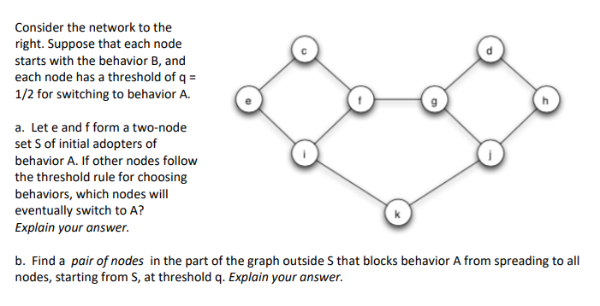

1. The initial adopters of A are shown below, circled in red, and are nodes e and f.

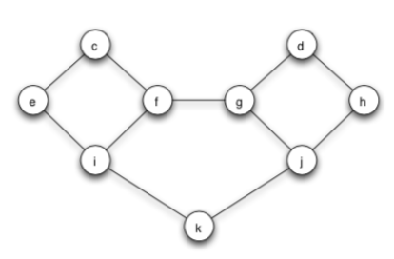

In the first iteration, all nodes will evaluate their neighbors and compare to the threshold q for switching which is ½.

c has two neighbors, which are both adopters of A, therefore the fraction of neighbors is 2/2. As this is greater than q, the threshold of ½, node c would convert to adopt A.

Similarly, node i would evaluate her situation, and she has 3 neighbors, 2 of which are adopters of A. Therefore, node i’s neighbor fraction is 2/3, which is greater than q of ½, therefore, node i will adopt.

Node g evaluates, and the fraction is 1/3 as adopters of A, which is less than the threshold q of ½, therefore node g will not convert at this time.

After this first round of evaluations, the graph is as presented below, with the adopters of A circled in red.



Second Iteration: In the second iteration, node k will evaluate, and determine that the fraction of neighbors is ½, and since ½ is greater than or equal to q of ½, then node k will convert.

Node g will evaluate and determine that the neighbor fraction is 1/3, and since this is less than q of ½, g will not convert at this time.

Nodes j, d, and h will also evaluate and since no neighbors have adopted, their neighbor fractions are clearly less than the q threshold of ½, and will not convert.

The graph after the second round appears as follows, again with the adopters of A circled in red.



Third iteration:

At this point, the remaining nodes would evaluate and find that the fractions are not equal to or greater than the threshold of q of ½, therefore they would not convert.

Nodes g, d, h, and j would compute fractions of 1/3, 0/2, 0/2, and 1/3, respectively.

At this point, no other nodes will be converting, and the cascade that ran in the first two iterations stops while there are still nodes using B.

As such, the final graph is the same as presented above after the second iteration.

1. Find a pair of nodes in the part of the graph outside S that blocks behavior A from spreading to all nodes, starting from S, at threshold q. Explain your answer

In the below graph, where the cascade stopped, we are left with the four right nodes from being converted over to adopting behavior A. There is a relationship between cascades and clusters. A cascade (adoption of behavior A) will stop when it runs into a dense cluster. The right four nodes, g, d, h, and j form a dense cluster that the cascade is not able to penetrate. The text mentions that if the remaining network contains a cluster of density greater than 1 – q, then the set of initial adopters will not cause a complete cascade. Additionally, whenever a set of initial adopters does not cause a complete cascade with threshold q, the remaining network must contain a cluster of density greater than 1 – q.

The cluster is outlined in blue dotted line below. The density of this cluster is 2/3. This is calculated by looking at the nodes and computing the fraction of its network neighbors in the set or cluster. The weakest link(s) would be the density of the cluster, and the computation of the nodes is 2/3 for g, 2/3 for j, 2/2 for d, and 2/2 for h. As the weakest links are 2/3, this is the density of the cluster. If the cluster contains a cluster of density greater than 1 – q, then the cascade will stop. In this example since, q is ½, then 1 – q = ½. As the cluster density is 2/3, and that is greater than ½, then the cascade would not continue into this cluster.

The pair of nodes specifically, that blocks behavior A form spreading into this cluster are nodes g and j (outlined in purple). As discussed above, these two nodes in the cluster possess a density greater than 1-q of ½, and they are responsible for stopping the cascade of adoption of behavior A.



10. Using several sentences, in general terms, in your own words, explain the effect that a tightly-knit community can have on a cascade.

A tightly-knit community is one in which the members of the community would have commonalities, are like-minded and probably interact a lot among themselves, and maybe not as much with others outside the community. This type of community can have an impact on a cascade of stopping the cascade from spreading further, and can act as a type of barrier from the spread of a particular behavior. As a new behavior, technology, trend or innovation makes its way throughout a network, cascading, really the only way that it would be stopped is through a dense cluster of tightly-knit community. The previous example was a great illustration of how homophily may act as a barrier to diffusion, where people who tend to interact with others that are like themselves are presented with an idea from outside their system or closely-knit group, these ideas and innovations may have difficulty penetrating these tightly-knit social communities. In that illustration, nodes g and j both had an outside connection, but they were strongly tied into the cluster. The other nodes had not outside relationships outside their cluster and this structure made it impenetrable.