# Problem 1 - Excercise 60 of Section 1.4 (page 56).

**60.** Let *P(x)*, *Q(x)*, and *R(x)* be the statements “*x* is a clear

explanation,” “*x* is satisfactory,” and “*x* is an excuse,”

respectively. Suppose that the domain for *x* consists of all

English text. Express each of these statements using quantifiers,

logical connectives, and *P(x)*, *Q(x)*, and *R(x)*.

**a)** All clear explanations are satisfactory.

**b)** Some excuses are unsatisfactory.

**c)** Some excuses are not clear explanations.

**∗d)** Does (c) follow from (a) and (b)?

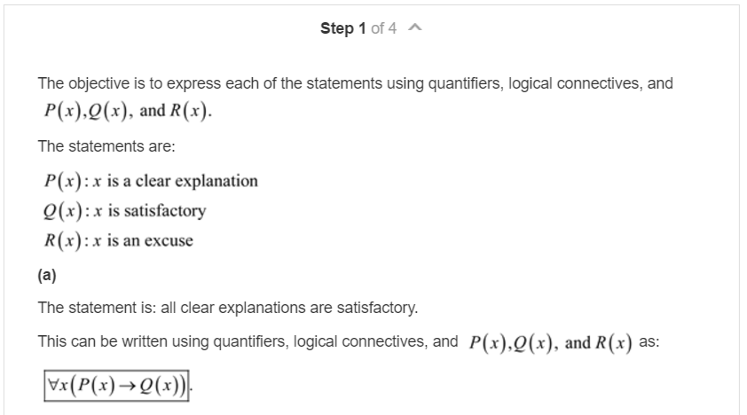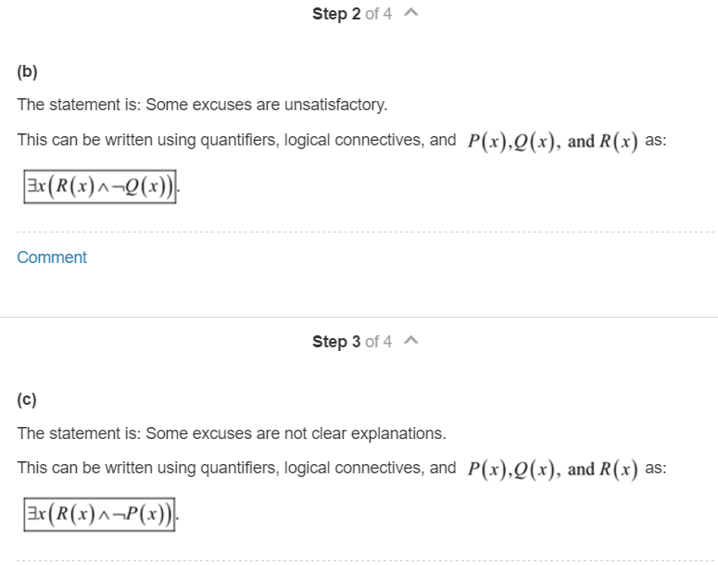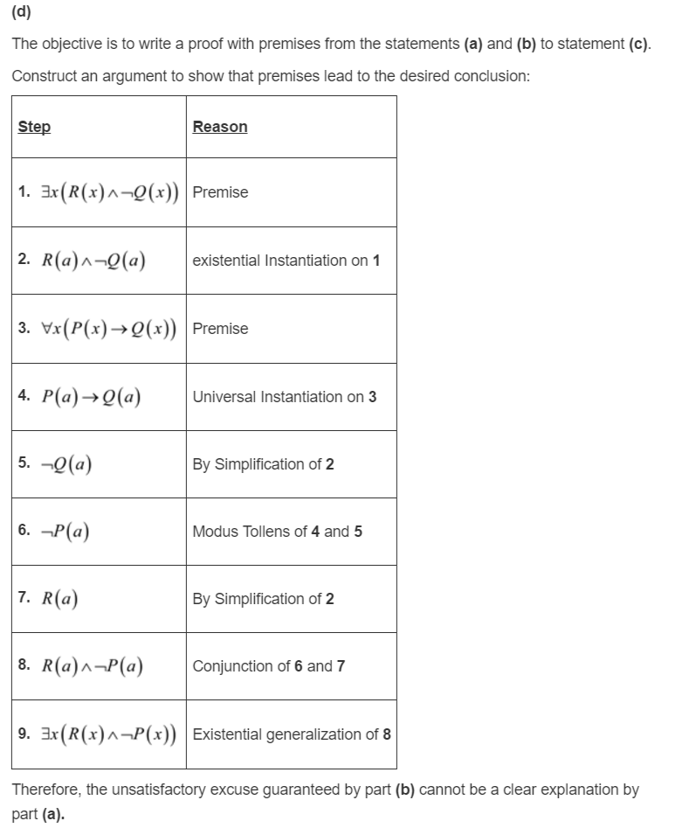

# Problem 2 - Exercise 36 of Section 1.5 (page 68).

**36.** Express each of these statements using quantifiers. Then

form the negation of the statement so that no negation is

to the left of a quantifier. Next, express the negation in

simple English. (Do not simply use the phrase “It is not

the case that.”)

**a)** No one has lost more than one thousand dollars playing

the lottery.

**b)** There is a student in this class who has chatted with

exactly one other student.

**c)** No student in this class has sent e-mail to exactly two

other students in this class.

**d)** Some student has solved every exercise in this book.

**e)** No student has solved at least one exercise in every

section of this book.

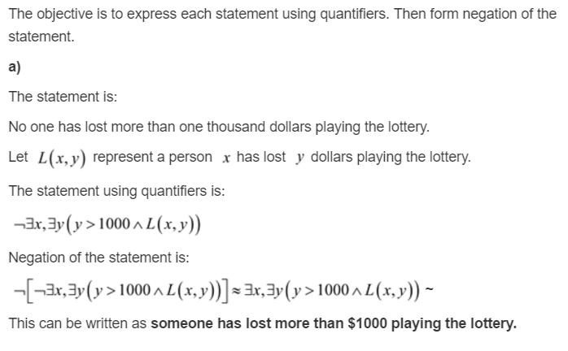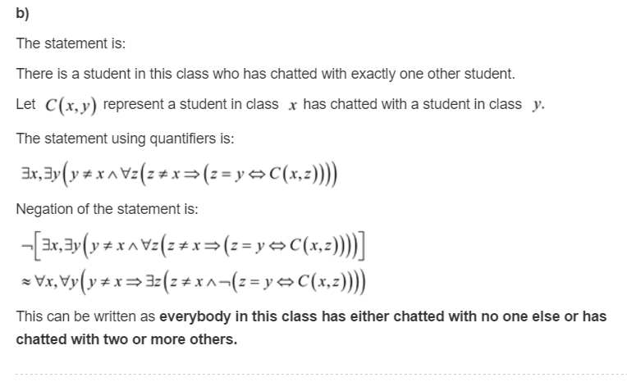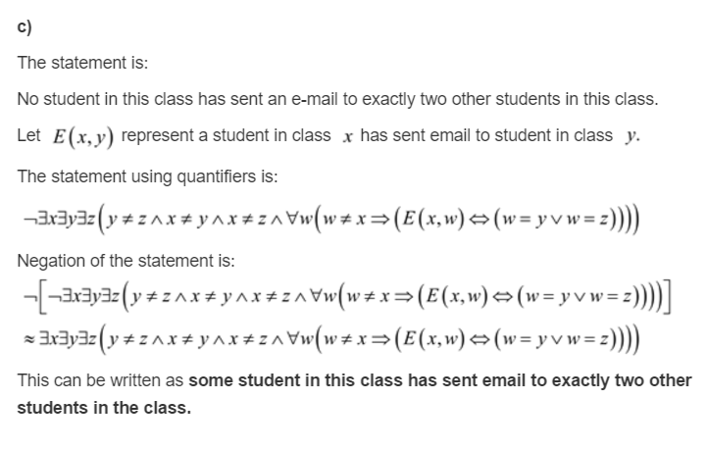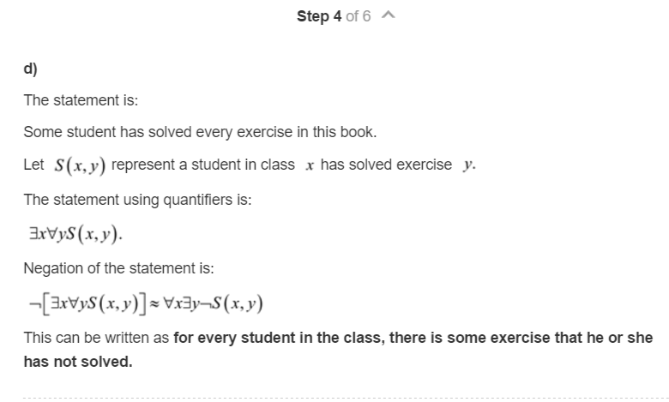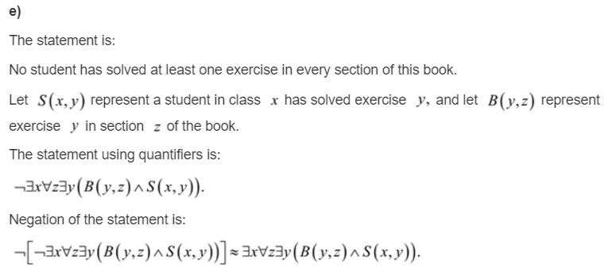

# Problem 3 - Exercise 34 of Section 1.6 (page 80).

**∗34.** The Logic Problem, taken from *WFF’N PROOF, The*

*Game of Logic*, has these two assumptions:

*1*. “Logic is difficult or not many students like logic.”

*2*. “If mathematics is easy, then logic is not difficult.”

By translating these assumptions into statements involving

propositional variables and logical connectives, determine

whether each of the following are valid conclusions

of these assumptions:

**a)** That mathematics is not easy, if many students like

logic.

**b)** That not many students like logic, if mathematics is

not easy.

**c)** That mathematics is not easy or logic is difficult.

**d)** That logic is not difficult or mathematics is not easy.

**e)** That if not many students like logic, then either mathematics

is not easy or logic is not difficult.

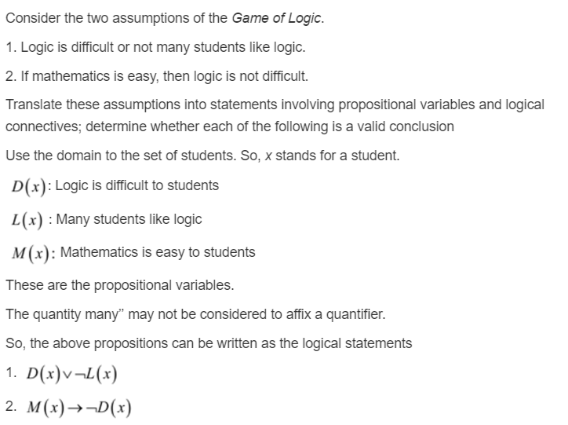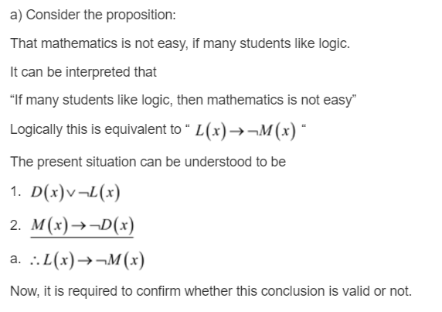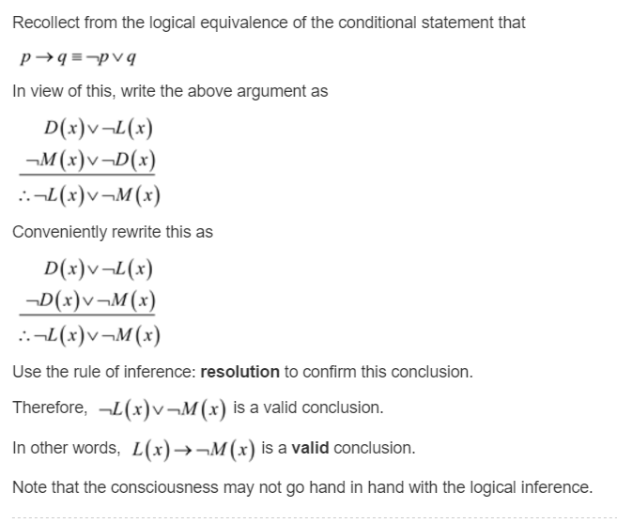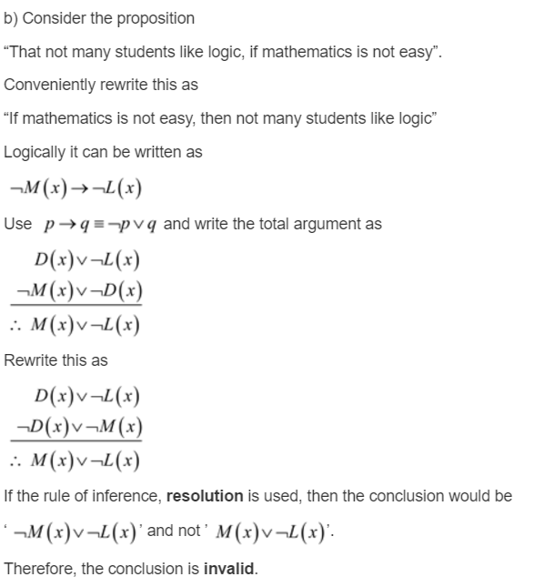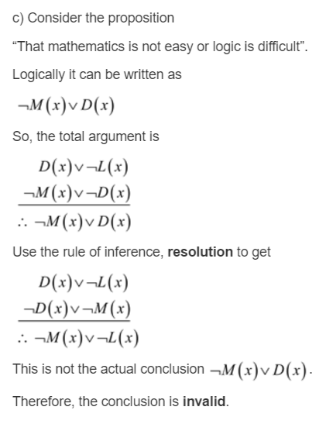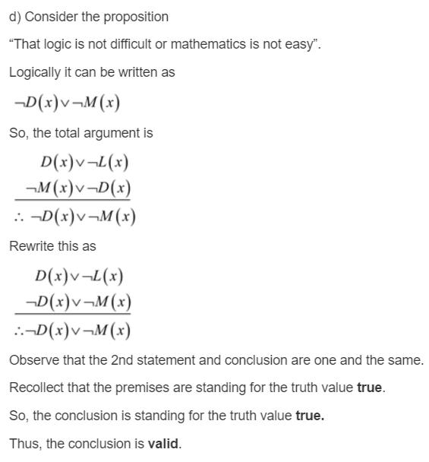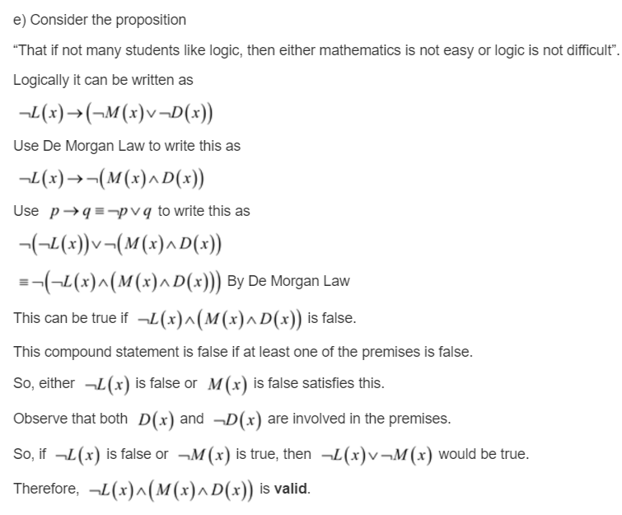

# Problem 4 - Exercises 18 and 30 of Section 1.7 (page 91)

**18.** Prove that if *n* is an integer and 3*n* + 2 is even, then *n* is

even using

**a)** a proof by contraposition.

**b)** a proof by contradiction.

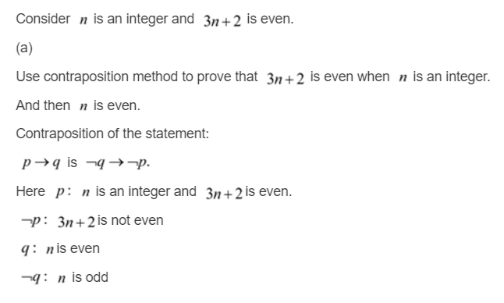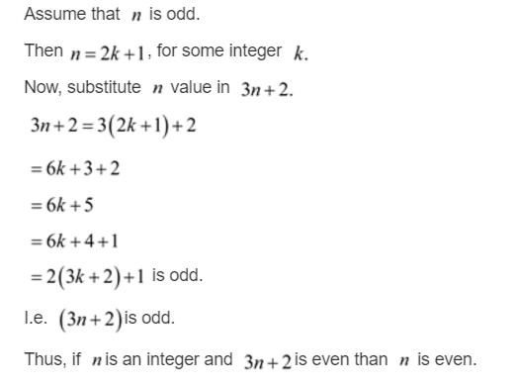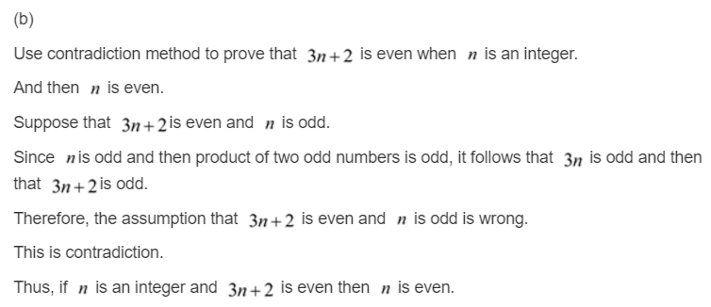

**30.** Show that these three statements are equivalent, where *a*

and *b* are real numbers: (*i*) *a* is less than *b*, (*ii*) the average

of *a* and *b* is greater than *a*, and (*iii*) the average of *a* and

*b* is less than *b*.

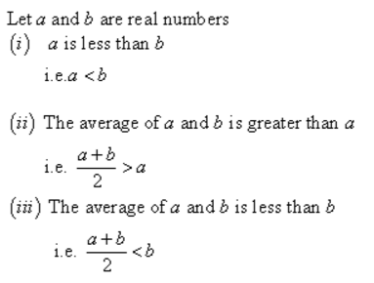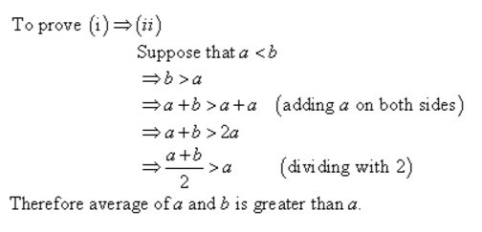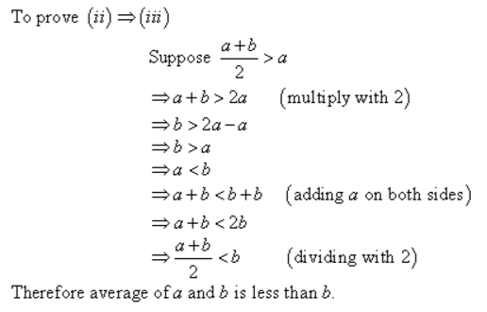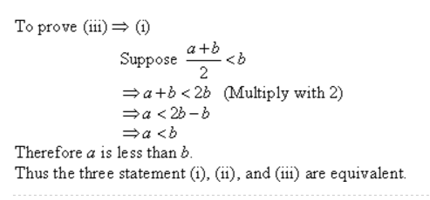

# Problem 5 - Exercises 2, 4, 6, and 8 of Section 1.8 (page 108).

**2.** Prove that there are no positive perfect cubes less than

1000 that are the sum of the cubes of two positive integers.

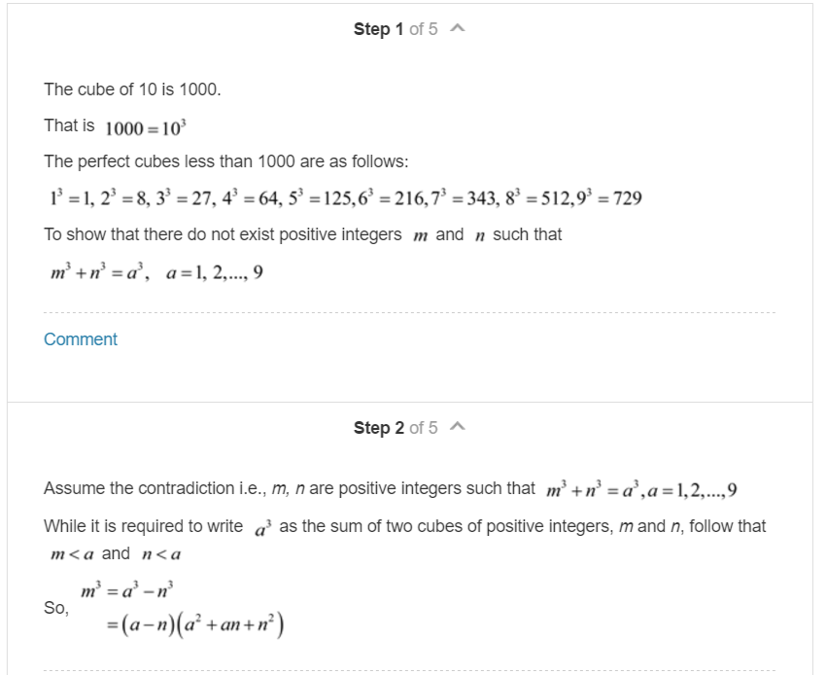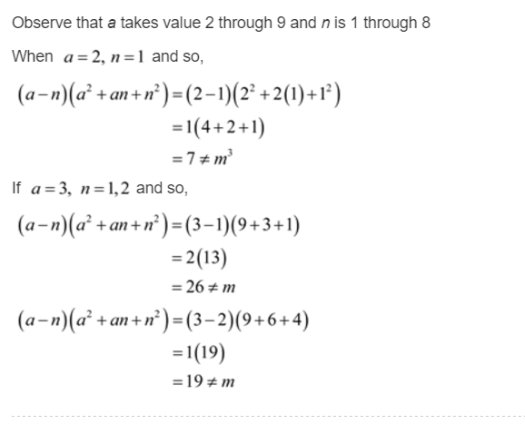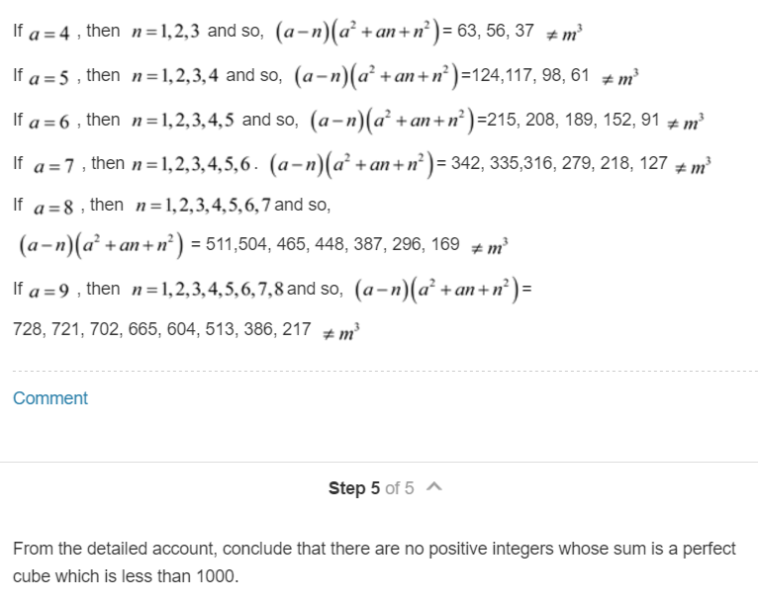

**4.** Use a proof by cases to show that min*(a,* min*(b, c))* =

min*(*min*(a, b), c)* whenever *a*, *b*, and *c* are real numbers

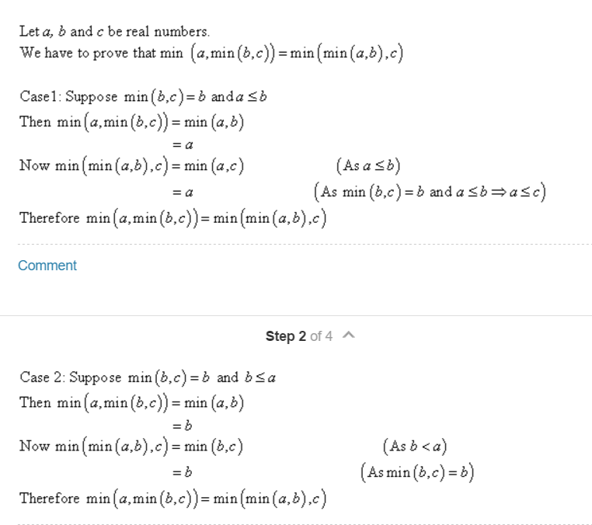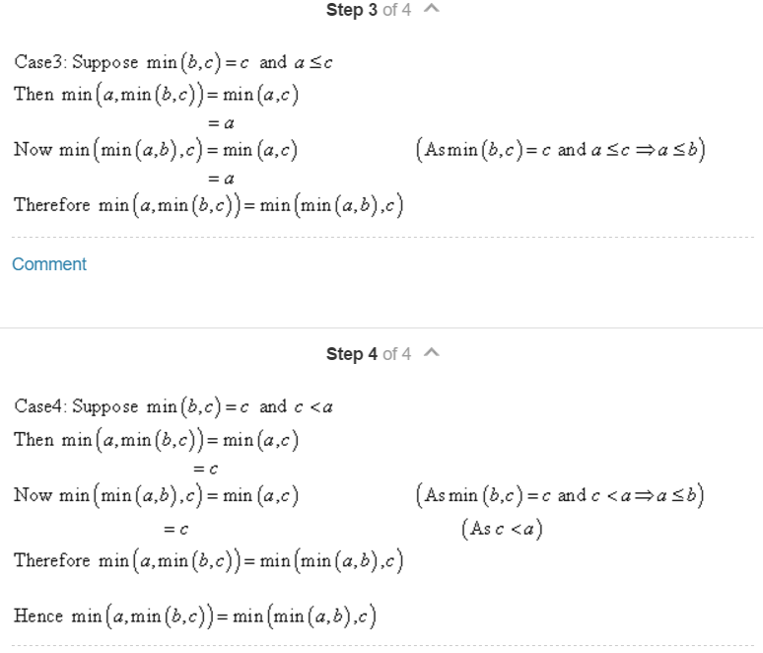

**6.** Prove using the notion of without loss of generality that

5*x* + 5*y* is an odd integer when *x* and *y* are integers of

opposite parity.

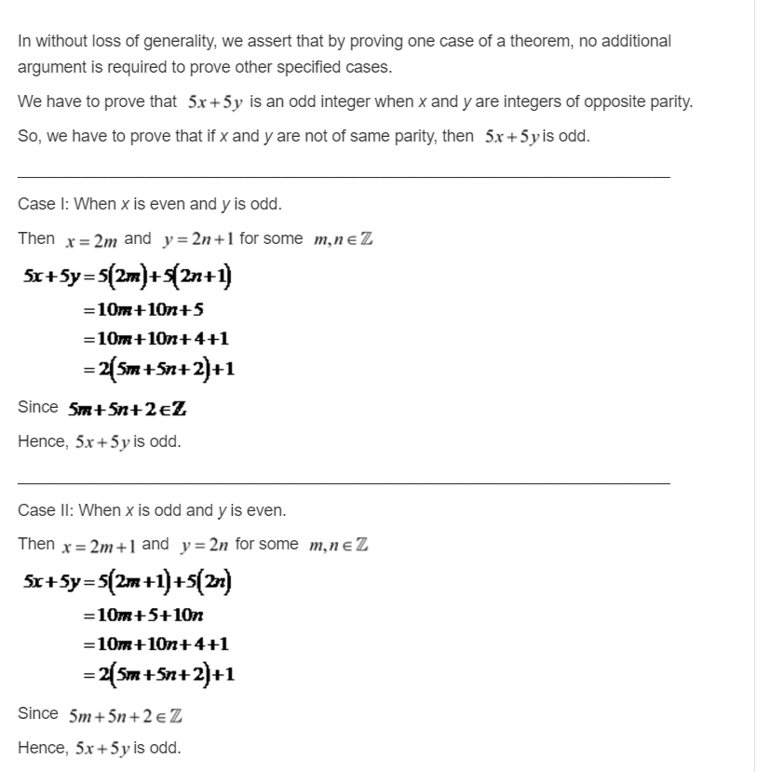

**8.** Prove that there is a positive integer that equals the sum

of the positive integers not exceeding it. Is your proof

constructive or nonconstructive?

