# **Lesson 2**

# App.c

# Uart.c

# Uart.h

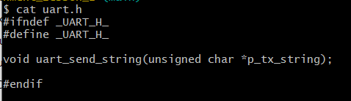

# Sections

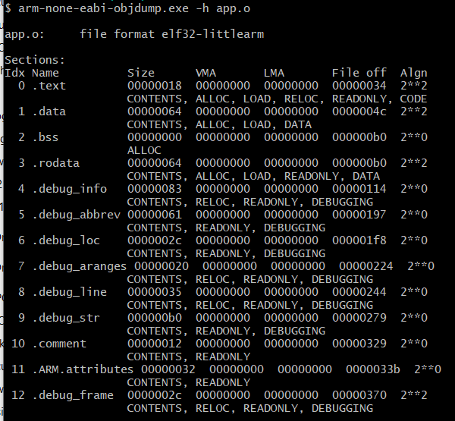

# Diassemply file from bin # arm-none-eabi-objdump.exe -D app.o > app.s

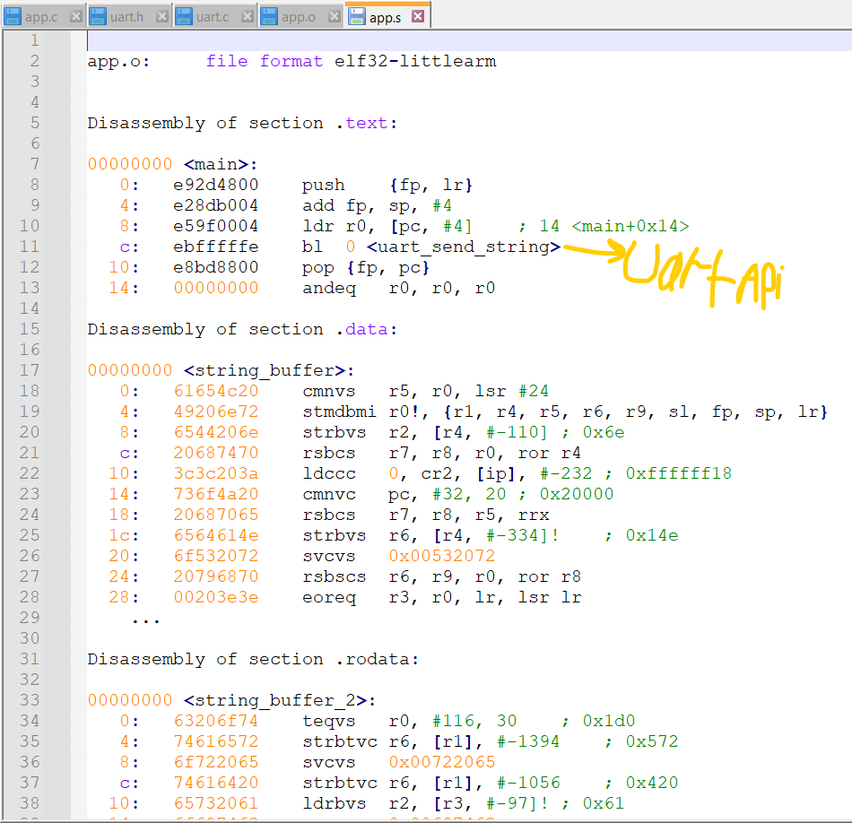

# Display the full content of all sections

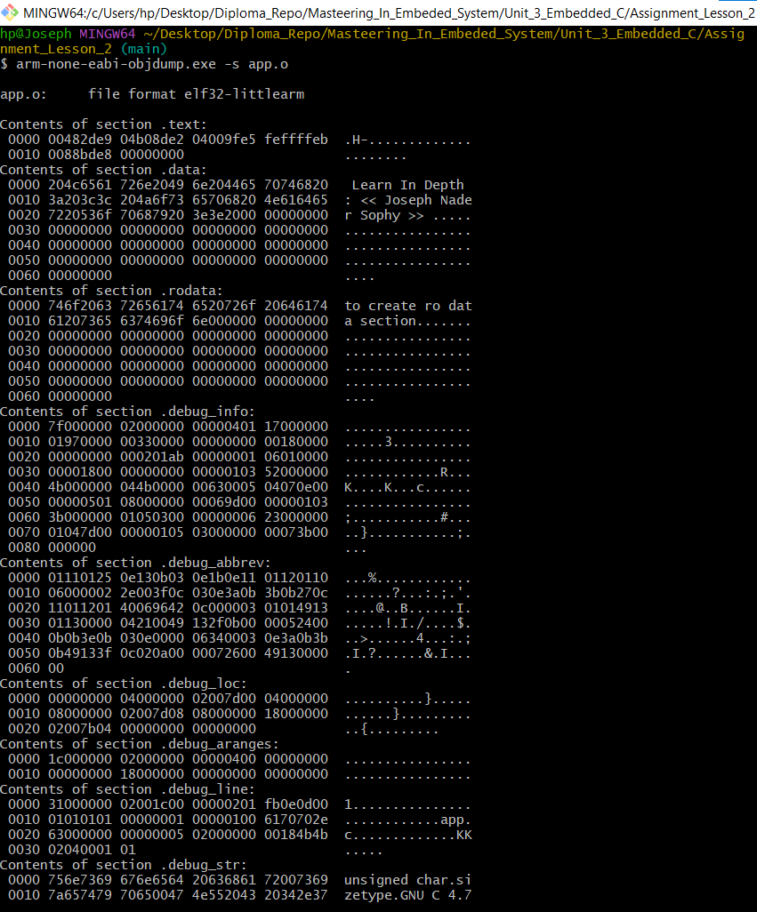

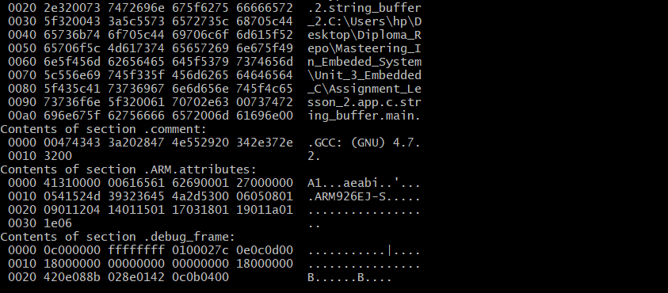

# Startup.s :

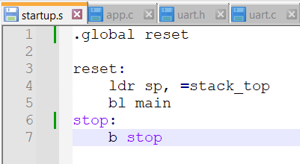

# Compile and analyze it

**$arm-none-eabi-as.exe -mcpu=arm926ej-s startup.s -o startup.o**

**$ arm-none-eabi-objdump.exe -h startup.o**

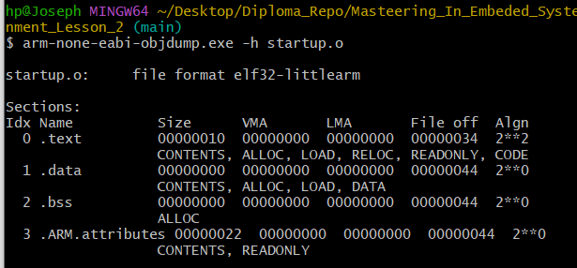

# Linker_Script :

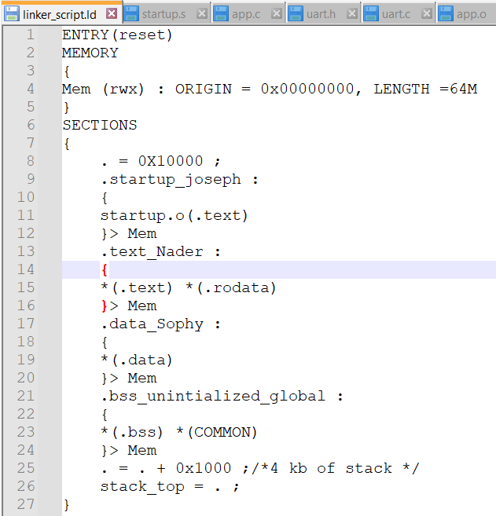

# To read the symbols you can use nm cross tool chain bin utility

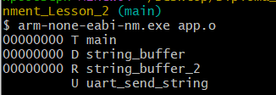



# Let us now to linking all the objects :

**$ arm-none-eabi-ld -T linker_script.ld -Map=output.map app.o uart.o startup.o -o learn-in-depth.elf**

# Analyze the executable file

**$ arm-none-eabi-nm.exe learn-in-depth.elf**

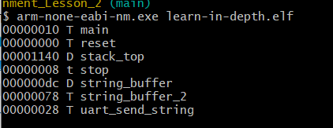

**Sections**

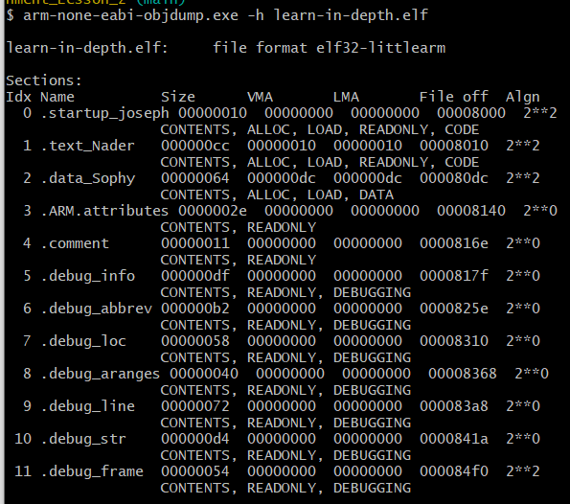

**Output.map**

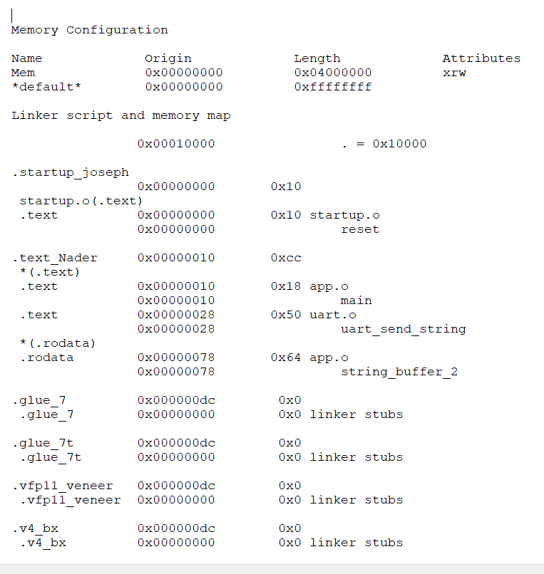

**arm-none-eabi-objcopy.exe -O binary learn-in-depth.elf learnoo.bin**

